Physical Education Hostels
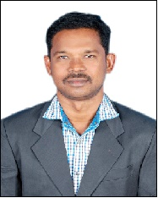


Warden Deputy Warden
Dr. P. Kaleeswaran Dr. S. Dhanaraj
Mobile : 94422 30496 Mobile : 89034 53517

AUCPE Men’s Hostel (I),
AUCPE Men’s Hostel (II) and
AUCPE Research Scholars Hostel Block (Men).

It is a pioneer Institute in South Asia. The Alagappa College of Physical education men hostel block was instituted in 4th August 1957 by honorable Shri.C. Subramanian, Minister for Finance and Education, Government of Madras. Hostel was upgraded with additional 25 new rooms with a total of 51 rooms. The Alagappa College of physical education M.P.Ed hostel has declared and opened by Dr..M.Varadarajan, Vice- Chancellor of Madras University in the Presence of Mrs. Umayal Ramanthan, Correspondent of Alagappa Institutions and Dr.Robson the first and founder Principal on 31st march 1973 with 12 rooms. The College hostels were converted into Alagappa University College of Physical Education Men’s Hostel from 1984 and brought under the control of University. AUCPE Men Hostel (II) has added to AUCPE Men hostels from June 2016 with 37 rooms on the whole three Hostels namely AUCPE Men Hostel (I), AUCPE Men Hostel (II) and AUCPE Research Scholars Hostel (Men). At present, 100 rooms are available and provision to accommodate 300 students. The hostel rooms are furnished and well ventilated. Study chairs and tables are provided to all the students in the Hostel. In each hostel, there is one Reading Room and one Computer laboratory and an Entertainment hall. A computer lab with 11 computers is facilitated to provide computing and internet facilities to the hostel inmates. The hostels have free internet accessibility and wifi facility throughout the hostel premises. The drinking water facility in the hostels is served with Reverse osmosis process. A water dispenser is added for the hot, normal & cold water purposes.

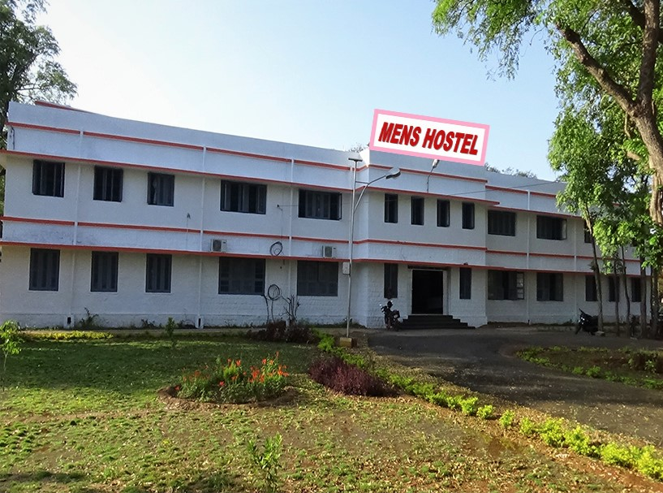
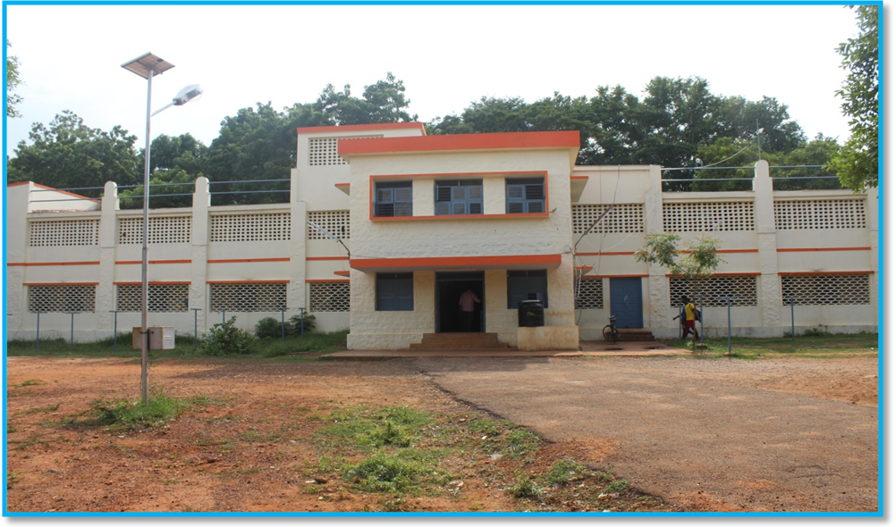
Physical Education Hostel 1 (Men)

Physical Education Hostel –II (Men)

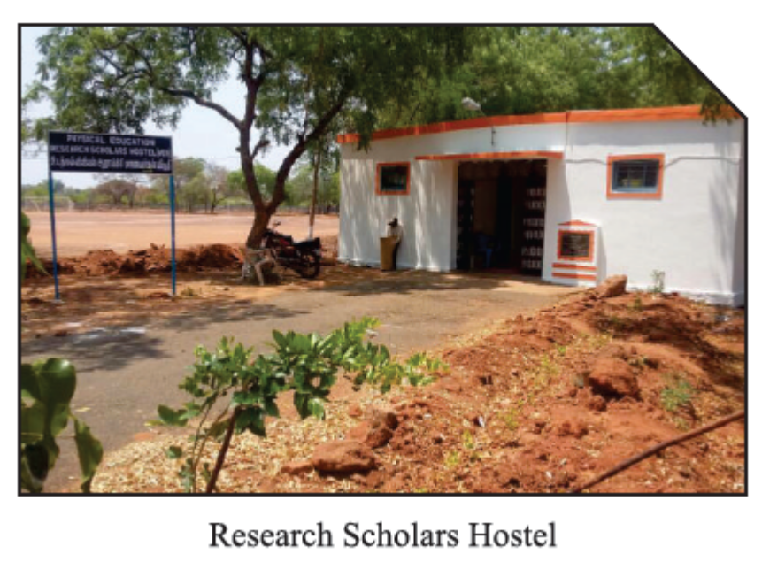

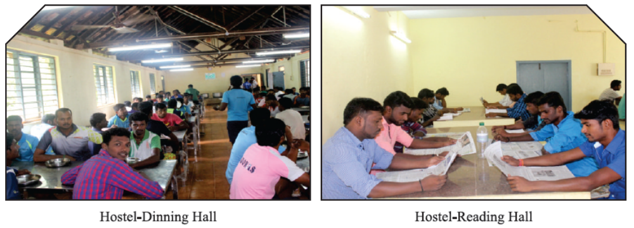

PHYSICAL EDUCATION HOSTELS SUPPORTED FOR SPORTS ACTIVITY IN ALAGAPPA UNIVERSITY

- Tamilnadu State Bharathiyar sports 2016-17

- AIU South Zone – Hockey (Men and women) 2016-2017

- AIU South Zone – Hand ball (Men and women) 2015-2016

- Tamilnadu State Interuniversity SDAT Hockey Tournament

(Men and Women) 2016-2017

- State ALU Cultural Feast 2016-17

- NCC 9th Battalion Combined Annual Training Camp for Boys. Thrice in a year- every year till date. Strength -1000 Nos.

- National Dwarf Athletic Meet 2017

- State Level Para Sports Meet 2016-2017

- Zonal, District and State School Sports Competition from 1984 to till date, every year
- Alagappa University Alumni Football Tournament Every year

- Alagappa university Alumni Cricket Tournament Every year since 2014.

- Alagappa University Intercollegiate Sports and Games Tournament since 2004

- Alagappa university Intercollegiate Athletic Meet since 2004

- Alagappa University Teams coaching Camp since 2004.

- Alagappa University Inter Departmental Games Founders day since 2006.

- Republic Day and Independence Day Celebration Breakfast Arrangement.

- Alagappa University Convocation Tiffin and Lunch arrangement 1985-2010

