ABS-001
Electrical Conductivity and Dielectric Properties of Polyaniline/Manganese Dioxide Nanocomposites(Font:14, Bold, Times new roman)
S. Tamil Selvan¹, E. Kumar², D. Muthurai^{1*}(Font:12, Times new roman)

¹Department of Nanoscience and Technology, Alagappa University, Karikudi, India -630003
²School of Science, Department of Physics, Tamil Nadu Open University, Chennai. Tamilnadu, India.

E-mail: dhjkkiuree@gmail.com*

Abstract
Abstract Format Title: Times New Roman, font- 14 with bold. Title is limited to 25 words ; Authors : Times New Roman, font- 12, Presenting author must be in bold and place asterisk (*) in superscript for corresponding author separate names by comma. Author affiliations should be in: Times New Roman, font- 12 with italic and mentioned no in superscript. Abstract is limited with 200 words in Times New Roman, font- 12 and provide relevant keywords (not more than six). Include one figure/illustration/graph with related caption. Wherever citation is necessary cite the corresponding article with the given format. To investigate the DC electrical conductivity of the as-synthesized materials, the pallets of all the powdered materials were prepared using a hydraulic press. Figure 6b shows current−voltage (I−V) results of as-prepared samples of MnO2, MXene, and MXene/MnO2 composites in potential range −1 to +1 V at room temperature. A two-probe measurement system was used to perform all the measurements.
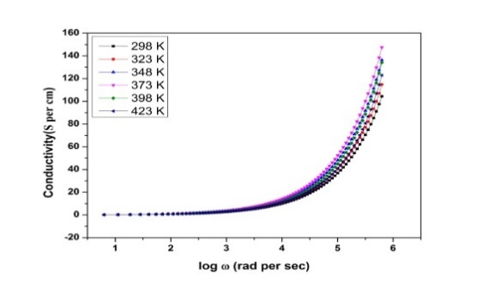
Keywords: MXene; Solar Cell; Super capacitors; Biofuel; Bio nanomaterials,

.

Fig. Graphical Abstract / important figures

Reference : 1. S. Selvasekarapandian, et.al., Physica B 337 (2003) 52.
2. E. Kumar, et.al., J. Matter. Sci 47 (2012) 7148.

