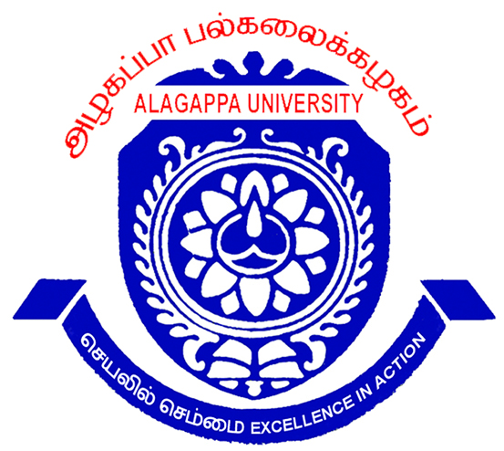
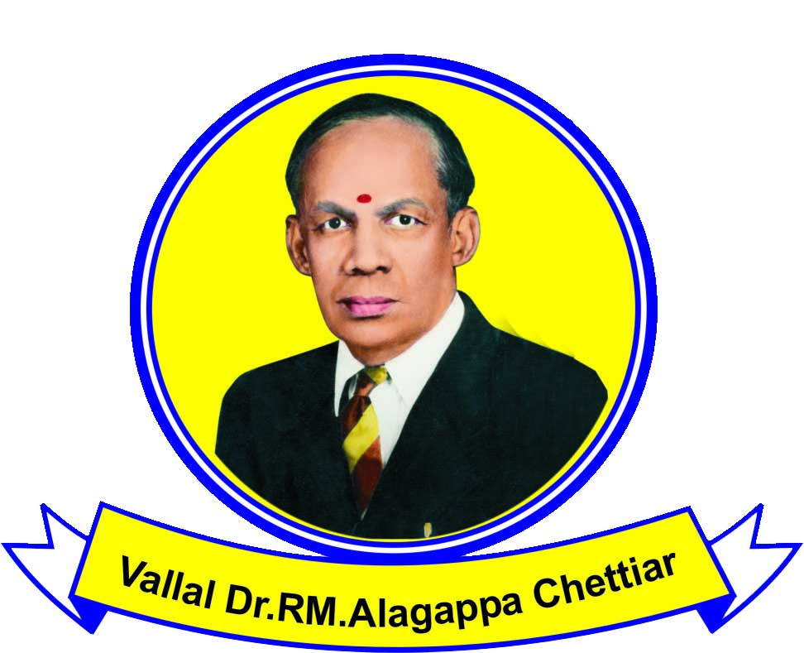
mofg;gh gy;fiyf;fofk;
(Njrpa jueph;zaf;FOthy; kWjukjpg;gPl;by; “V” fpNuL ngw;wJ)
fhiuf;Fb

,Ugj;jp Ie;jhk; gl;lkspg;G tpoh

mofg;gh gy;fiyf;fofj;jpd; 25Mk; gl;lkspg;G tpoh tpiutpy; eilngw ,Uf;fpwJ. mjw;fhf gl;lk; ngw tpUk;Gk;; khzth;fsplkpUe;J tpz;zg;gq;fs; tuNtw;fg;gLfpwJ. 2012 Vg;uy; khjj;jpw;F Kd; mofg;gh gy;fiyf;fofj;jpy; gbj;J Kbj;j khzth;fs; Nkw;fhZk; gl;lkspg;G tpohtpw;F tpz;zg;gpf;fyhk;. Kidth; gl;lk; ngWgth;fs;> jq;fg;gjf;fk; kw;Wk; jur; rhd;wpjo; ngWgth;fs; kl;Lk; jk; gl;lq;fis Nehpilahf gl;lkspg;G tpohtpy; ngWth;. kw;wth;fSf;Fg; gl;lkspg;G tpohtpw;Fg; gpd;dh; mtuth; tPl;L Kfthpf;F mDg;gp itf;fg;gLk;;. njhiyJ}uf; fy;tp thapyhfg; gl;lk; ngw jFjpaile;jth;fs;; ahUk; tpz;zg;gpf;fj; Njitapy;iy. jhkjkhfg; ngwg;gLk; tpz;zg;gq;fs; Vw;Wf;nfhs;sg;glkhl;lhJ.

gjpthsh; mofg;gh gy;fiyf;fofk;>fhiuf;Fb> mth;fsplkpUe;J NehpNyh my;yJ &.5/- jghy;jiy xl;ba RaKfthpapl;l ciw %yk; tpz;zg;gq;fisg; ngw;Wf; nfhs;syhk;. G+h;j;jp nra;ag;gl;l tpz;zg;gq;fs; ,t;tYtyfj;jpw;F te;J Nru Ntz;ba filrpehs; 22.08.2012. tpz;zg;gq;fisg; gy;fiyf;fof ,izajsk; %ykhfTk; gjptpwf;fk; nra;J nfhs;syhk;. ,izajs Kfthp www.alagappauniversity.ac.in.

,lk;: fhiuf;Fb
ehs;: 23.07.2012 gjpthsh; (ngh)

ALAGAPPA UNIVERSITY
(Reaccredited with “A” Grade by NAAC)
KARAIKUDI.

TWENTY FIFTH CONVOCATION

Applications are invited for admission to the Twenty Fifth Annual Convocation of the Alagappa University, Karaikudi to be held shortly.

Those who have qualified for various degrees of this University in the examinations held in April 2012, and prior to that are eligible to apply. Ph.D holders/Medal winners/Rank holders in all disciplines are only eligible to apply in person. Others can apply in absentia. Candidates who have qualified for various degrees in this University under Distance Education Stream need not apply.

The application forms can be had from The Registrar, Alagappa University, Karaikudi – 630 003 directly or on requisition accompanied by a self-addressed Rs.5/- stamped envelope (25 cms x 10 cms.) Last date for the receipt of filled in applications at this office is 22.08.2012. Late applications will not be entertained.

Applications can also be downloaded from the University website: www.alagappauniversity.ac.in.

Place: Karaikudi
Date: 23.07.2012 REGISTRAR i/c

