CENTRE FOR GANDHIAN STUDIES

VISION  &  MISSION | Toimpart the great teachings of Mahatma Gandhi and to encourage Ahimsa, Spirit of Patriotism, Discipline, Dignity, Intelligence and Religious Tolerance among the students community and the general public.
 | To put in to Mahatma Gandhi Educational ideas of imparting life-building, man making and character building skills through Education, Research and Extension.

Name | Designation & Dept./Division/College. | Status
Dr.A.Balu | Principal i/c  College of Education | Director
Dr.K.Ganesamurthy | Assistant Professor  Department of Corporate secretaryship | Member
Dr.T.Sathiamoorthy | Assistant Professor  Department Of Botany | Member
Mrs.T.Maheswari | II M.Ed. | Member
Mr.R.Karthick | II B.Ed. | Member

Range of  Activities  (Suggested) | National Conferences
 | Student studies on rural consumer behavior, their awareness level of consumer Rights, etc.
 | Programs for public/retailers/business

Activities Carried out

Year | Description of Activity | Date | Participants/Beneficiaries
2012 | ,e;jpatpLjiyNth;fis ,isNahh; mwpjy; - fUj;juq;F | 22.03.2012 | B.Ed. khzth;fs;
2014 | GANDHI JAYANTHI CELEBRATION | 02.10.2014 | B.Ed. students
2015 | TEACHERS DAY CELEBRATION | 08.09.2015 | B.Ed. students
2015 | GANDHI JAYANTHI & INTERNATIONAL NON-VIOLENCE DAY | 02.10.2015 | B.Ed. students
2015 | ONE DAY VALUE EDUCATION AND SUPW CAMP | 26.11.2015 | B.Ed. students
2016 | GANDHIAN STUDIES SUPW CAMP | 27.07.2016 | B.Ed. students
2016 | GANDHI JAYANTHI & INTERNATIONAL NON-VIOLENCE DAY | 02.10.2016 | B.Ed. students
Any other

Alagappa University College of Education
Karaikudi- 630 003.

Gandhian Studies SUPW Camp

Date : 27.07.2016

On 27th July 2016, SUPW camp is held in our Alagappa University College of Education seminar hall at 3.00 p.m.Dr.A.Balu, Principal (i/c), AUCE delivered the presidential address.Mrs.S.Indra delivered special address on this function. All the staff members, B.Ed., students teachers are participated.
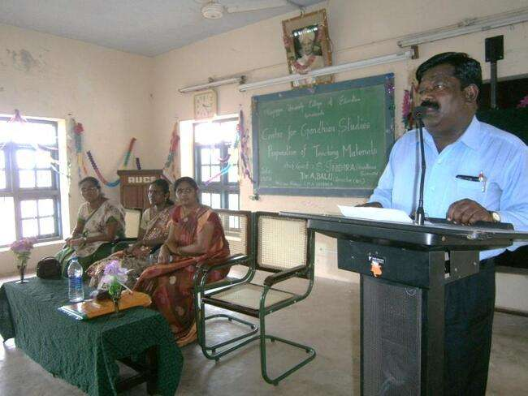

Dr.A.Balu, Principal (i/c), Mrs.S.Indra, Chief Guest, Mrs.A.RubeJesintha, Mrs.EMN.Sharmila
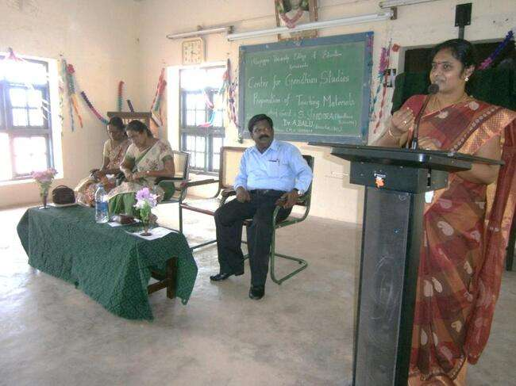
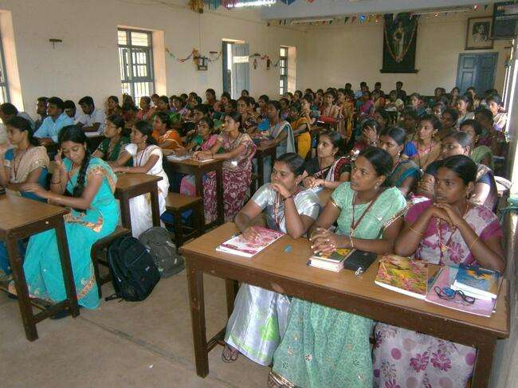
Mrs.S.Indra
M.Ed., & B.Ed., Students

