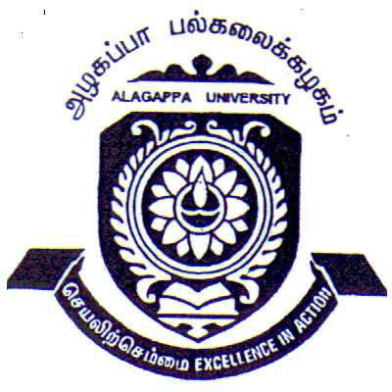CENTRE FOR NEHRU STUDIES
ALAGAPPA UNIVERSITY, KARAIKUDI
(Re-accredited with ‘A’ Grade by NAAC)

Aim and Purpose | To expand the frontiers of knowledge among the citizens/community on Pt. Jawaharlal Nehru’s vision and ideology.
Aim and Purpose | To inculcate the student community with innovative scientific approach to solve the problems of society on the lines suggested by Pt. Jawaharlal Nehru.
Aim and Purpose | To infuse a spirit of Patriotism, National Integration, Social Justice Secularism and Emotional Integration in the minds of the Younger generation.
Aim and Purpose | To re-construct the rural/urban communities by developing leadership with moral and ethical values advocated by Pt. Jawaharlal Nehru.

Name | Designation & Dept./Division/College. | Status
Dr. C. Yogalakshmi | Professor  Department of Bank Management | Coordinator
Dr. B. Dharmalingam | Professor & Director  Alagappa Institute of Skill Development | Member
Dr. D. Maniazhagu | Assistant Professor  Department of Physical Education and Health Sciences | Member
Ms. G. Shanthi | Computer Application | Member
K.Murugesan | II MBA(Banking & Insurance) Student | Member
A. Punitha | III B.Voc. Software Development Student | Member

Range of Activities | I. ACADEMIC  - Offering short-term Courses on Pt. Jawaharlal Nehru’s ideology  - Setting up of Pt. Jawaharlal Nehru Memorial / Documentation Centre
Range of Activities | II. RESEARCH  - Minor research studies on the ideology and contributions of Pt. Jawaharlal Nehru
Range of Activities | III. SEMINAR / CONFERENCE / WORKSHOP  - National /State level Seminars and Special Lectures conducted on Nehru’s ideology and Contemporary Issues
Range of Activities | IV. CAPACITY BUILDING PROGRAMME / EVENTS  - Youth Parliamentary Competition for the University/college students  - Disseminating the ideas and contributions of Nehru through Audio- visual shows, distribution of pamphlets, and posters to the schools and public.  - Essay and Elocution competition on Nehru’s thought at University / college / school level  - Trainings will be conducted to the Nehru Yuva Kendra youth volunteers
Range of Activities | V. PUBLICATION  - Publication of Seminar proceedings and Books  - Translation of Nehru’s writings, ideas, contributions in Tamil language  - Newsletter exclusively for all the UGC Centre for Nehru Studies of other Universities

Activities Carried out
S.No. |  | Description of the Activity |  | Place |  | Date |  | Chief Guest / Resource person(s) |  | No. of Participants
 | Youth Leadership Development Programme |  | Department of Tamil |  | 22nd March 2006 |  | Dr. RM. Chidambaram,  Professor& Head,  Department of Bank Management  Dr. V. Manickavasagam,  Professor& Head  Department of Corporate Secretaryship |  | 100 Students of Tamil Department
 | Youth Leadership Development Programme |  | Corporate Secretary ship Department |  | 22nd March 2006 |  | Dr. P. Murugesan  Reader in Commerce  S.N. College, Madurai.  Dr. S. Kaliyamoorthy  Director, Alagappa Institute of Management |  | 120 Students of Corporate Secretaryship & Commerce Department
 | Youth Leadership Development Programme |  | Alagappa Institute of Management |  | 23rd March 2006 |  | Mr. Rajan Srinivas  Vivekananda Youth  Academy  Chennai |  | 65 Students of Alagappa Institute of Management
 | Youth Leadership Development Programme |  | Alagappa College of Education |  | 23rd March 2006. |  | Dr. S. Kaliyamoorthy  Director  Alagappa Institute of Management |  | 110 Students of Alagappa College of Education and Department
 | Youth Leadership Development Programme. |  | Department of Bank Management |  | 24th March 2006 |  | Mr. S. Muralidharan  Chartered Accountant  Karaikudi.  Mr. S. Palanisamy  Senior Regional Manager, Indian Overseas Bank, Karaikudi |  | 50 Students of Bank Management Department
 | Youth Leadership Development Programme |  | Department of Mathematics |  | 24th March 2006 |  | Dr.T.R. Gurumoorthy  NSS Coordinator ,  Dr. P. Natarajan  Additional Controller of Examination |  | 75 Students of Mathematics Department
 | Elocution competition on Nehru’s Contribution for National Development |  | Centre for Nehru Studies |  | 25th March 2006 |  |  |  | 50 Students of Alagappa University
 | Special Lecture on Jawaharlal Nehru and Modern India |  | Centre for Nehru Studies |  | 31st March 2006. |  | Dr. N. Rajendran, Director, Centre for Nehru Studies, Bharathidasan University,  Dr. R. Madhanagopal, Professor, Dept. of Political Science,  M.K.University,  Prof. B. Dhakshinamoorthy, Dept. of History, Alagappa Govt. Arts College |  | 150 University and Alagappa Arts College students
 | Inaugural function of the Centre for Nehru Studies |  | Centre for Nehru Studies |  | 25th April 2006. |  | Dr. P. Kanniappan, Vice Chancellor, Dr. R.K. Chauhan, Additional Secretary, UGC. |  | 100 students and faculty members
 | A Special lecture on Nehru in commemoration of Nehru Memorial Day |  | Centre for Nehru Studies |  | 27th May 2006 |  | Mr. P. Subbiah Ambalam, Former M.P and Mr. N.S. Ganesan, A.D. Agriculture.  Mrs. Saraswathy Nagappan spoke on Nehru’s Vision on Science & Technology. |  | 100 Nehru Yuva Kendra Volunteers
 | Seminar on Integrated Farming and Soil Health Campaign |  | Centre for Nehru Studies |  | 27th May 2006 |  | Mr. K. Kannan Organic Farming, Cash Crops & Soil Health  Mr.G. Alagumalai  Improved Varieties of Horticulture  Dr.Raya. Chidambaram  Cattle, Coat rearing & Poultry Farming |  | 80 Farmers from Sakkottai and Kallal Block along with Nehru Yuvakendra Youths
 | Children’s Day Celebration ‘2006 |  | Centre for Nehru Studies |  | 14.11.2006 |  | Dr. P. Kanniappan, Vice Chancellor.  Sri Abhay Kumar Singh IPS DIG of Police. Smt. Pooja Kulkarni IAS, Additional Collector & Dr. R. Dhandapani, Registrar |  | 1000 students from 20 schools
 | State level Seminar on Relevance of Nehru’s ideas on Contemporary India |  | Centre for Nehru Studies |  | 13.3.2009 |  | Prof. L. Tharabai, Senior Professor and Head, Department of Sociology Madurai Kamarai University.  Dr.N.Rajendran, Director, Centre for Nehru Studies of Bharadhidasan University |  | 100 Students and Faculties
 | Children’s Day celebration ‘ 2010 |  | L.CT.L. Palaniappa Auditorium |  | 14.11.2010 |  | Dr. Sundara Avudaiyappan, All India Radio, Madurai |  | 400 students from 10 schools participated
 | Children’s Day celebration ‘ 2011 |  | L.CT.L. Palaniappa Auditorium |  | 14.11.2011 |  | Mr. Bala. Natarajan, District secretary of World Tamil Writer’s society, Sivaganga District |  | 400 students from 10 schools participated
 | A special lecture on Jawaharlal Nehru : His Sacrifices and Making of Modern India |  | Centre for Nehru Studies |  | 6th March 2012 |  | Dr. N. Rajendran, Member – ICHR, New Delhi, Dean of Arts / Director for Nehru Studies of Bharathidasan University |  | 100 Research scholars, Students and Faculty
 | UGC-Sponsored Two-day National seminar on Reminiscences of Pandit Jawaharlal Nehru: Contemporary Perspectives |  | Centre for Nehru Studies |  | 28th & 29th March 2012. |  | Dr. P. Moorthy, Professor & Head, Department of Politics & International studies, Pondicherry University, Pondicherry. |  | 150 Research scholars and Faculty
 | Children’s Day celebration ‘ 2012 |  | L.CT.L. Palaniappa Auditorium |  | 15.11.2012 |  | Dr. G. Gnanasambandan, Professor of Thiyagarajar College, Madurai |  | 400 students from 10 schools participated
 | Children’s Day celebration ‘ 2013 |  | L.CT.L. Palaniappa Auditorium |  | 13.11.2013 |  | Prof. P. Namachivayam, Former Professor of Tamil, A.P.S.A. College, Thiruppathur |  | 400 students from 15 schools participated
 | Children’s Day celebration ‘ 2014 |  | L.CT.L. Palaniappa Auditorium |  | 14.11.2014 |  | Mr. K. Joseph Zackaria, Director-Vikaasa School, Madurai |  | 450 students from 15 schools participated
 | Children’s Day celebration ‘ 2015 |  | L.CT.L. Palaniappa Auditorium |  | 13.11.2015 |  | Kavingar MURA @ M. Rajasekar, Madurai, |  | 500 students from 20 schools
 | Children’s Day  celebration “2016 |  | Convocation  Seminar Hall |  | 14.11.2016 |  | Dr.A.M.Moorthy  Vice –Chancellor  Tamil Nadu Physical Education and Sports University,Chennai. |  | 200 Students from 5 schools
Any other
PUBLICATION OF THE CENTRE
- A Book Published on Nehru- Hero of History (Tamil), 2006
(Author: Dr. B. Dharmalingam, Director, CNS)
- A seminar proceedings entitled, “Relevance of Nehru’s ideas on Contemporary India”, published during the State level Seminar on Relevance of Nehru’s ideas on Contemporary India, March 2009
- A seminar proceedings entitled, “Reminiscences of Pandit Jawaharlal Nehru: Contemporary Perspectives”, published on the occasion of UGC-Sponsored Two-day National seminar on Reminiscences of Pandit Jawaharlal Nehru: Contemporary Perspectives, March 2012
- B. Dharmalingam; Pandit Jawaharlal Nehru: The Founding Father of Panchayati Raj Institutions in India, International Journal of Management and Social Science Research Review, Vol.1, Issue.5. (ISSN 2349-6738), May - 2016, p-127-132.
- B. Dharmalingam; Continuum of Nehruvian Discourse in contemporary rural development in India, International Research Journal of Business and Management – IRJBM, Vol. VIII, Issue-8 (ISSN 2322-083X), July- 2016

EQUIPMENTS AND LEARNING RESOURCES AVAILABLE

Library Books | Other Equipments
Library Books – 416 Nos.  (Available at Faculty of Arts – Library) | Photocopier - 1  Scanner - 1  Digital Camera - 1  Amplifier mike & Speaker - 1  Tape recorder - 1  LCD projector Screen - 1  Desktop Computer - 1  DVD player - 1

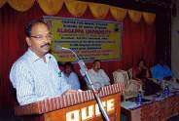

Special Lecture on, “Jawaharlal Nehru: His Sacrifices and Making of Modern India”, 6th March, 2012

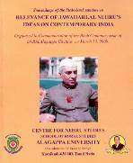

UGC-Sponsored Two-day National seminar on, “Reminiscences of Pandit Jawaharlal Nehru: Contemporary Perspectives”, 28th & 29th March 2012

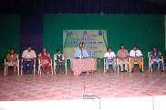
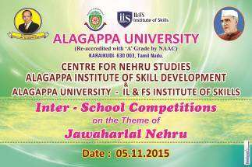

Elocution, Essay writing and Painting competitions on the theme of ‘Pt Jawaharlal Nehru’s ideologies’ at District / Inter-School levels
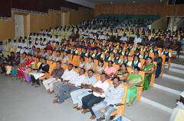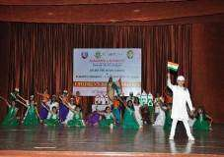
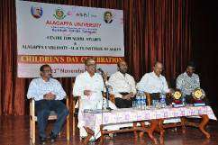

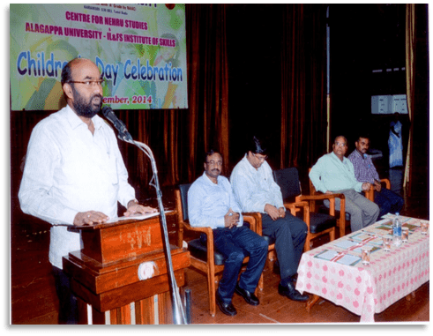

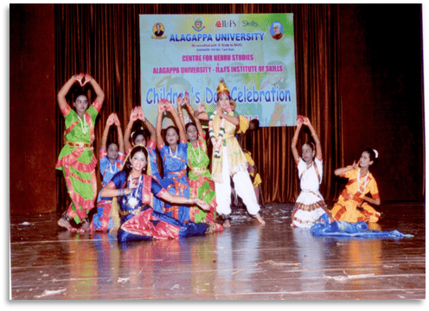

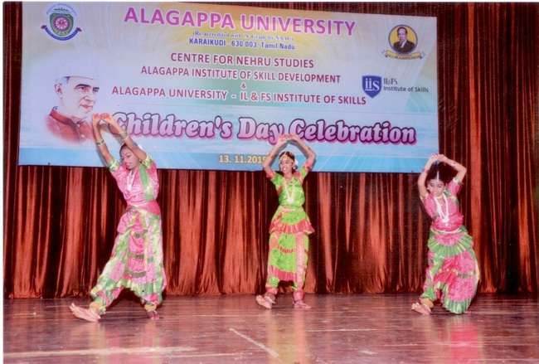
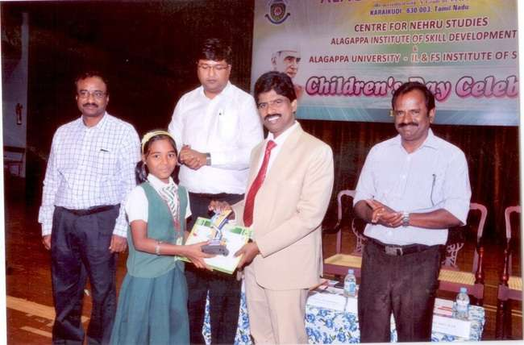
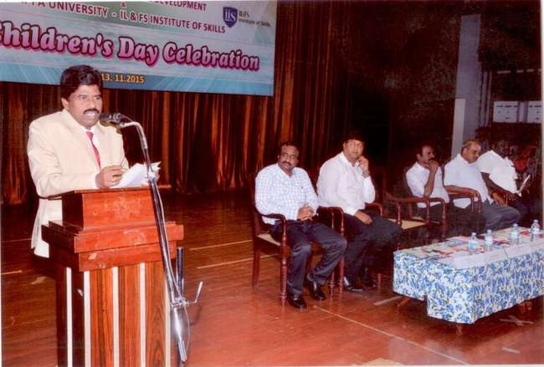

Glimpses of Children’s Day Celebrations
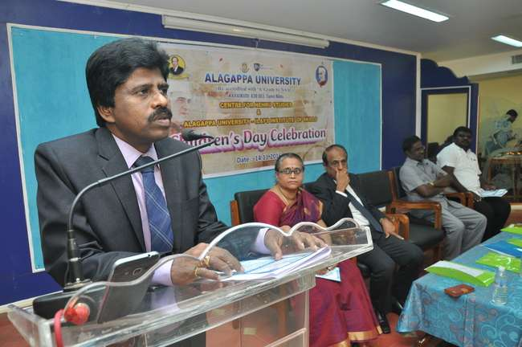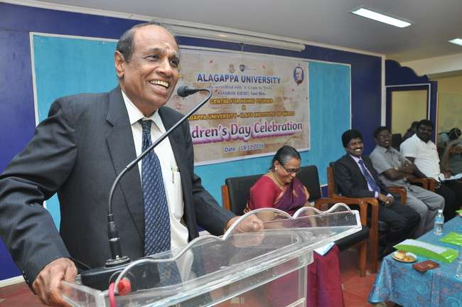
Elocution, Essay writing and Painting competitions on the theme of ‘Pt Jawaharlal Nehru’s ideologies’ were organised for school students.

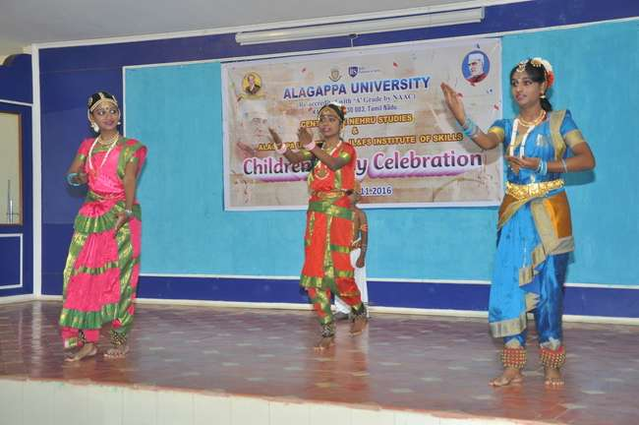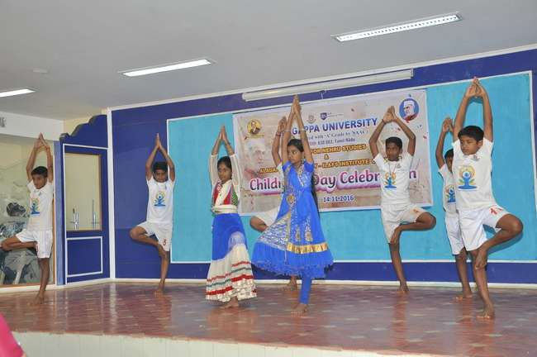
Glimpses of Children’s Day Celebration 2016

