DE–2616
11
DISTANCE EDUCATION
M.Phil (CHEMISTRY) DEGREE EXAMINATION, DECEMBER 2007.
RESEARCH METHODOLOGY OF CHEMICAL RESEARCH
(2006 Batch)
Time : Three hours Maximum : 100 marks
PART A — (10 × 3 = 30 marks)
Answer ALL questions
- What are the essential features of the abstract of a research paper?
- Mention few internet search engines used for chemical research.
- What are the uses of “C++” programming in chemical research?
- Write the structure of a ‘C’ programme.
- Write notes on solvent extraction.
- Write notes on paper chromatography.
- What do you mean by asymmetric synthesis?
- What is synthon approach in retrosynthesis?
- Write notes on student ‘t’ test.
- Write the importance of correlation coefficient in error analysis.
PART B — (5 × 6 = 30 marks)
Answer ALL questions.
- (a) Write an essay on the selection of research problem in chemistry.
Or
(b) Write an essay about the creation of e–mail account for chemical research.
- (a) Explain the various statements available in C++ with example.
Or
(b) Explain the application of “C” programming for chemical research.
- (a) Write an essay on ion–exchange chromatography.
Or
(b) Write an essay on TLC.
- (a) Write an essay on the key starting materials used in organic synthesis.
Or
(b) Discuss the relay approach in organic synthesis.
- (a) Explain the methods of eliminating errors.
Or
(b) Discuss about multiple linear regression in error analysis.
PART C — (4 × 10 = 40 marks)
Answer any FOUR questions.
- Explain how Internet is used for the literature survey on the research topic “Green chemical route for synthesis”.
- Explain the file handling system in “C” programming.
- Write an essay on the handling of explosive and radio–active materials.
- Explain the general methods of purification of chemicals.
- Discuss about protecting a functional group in organic synthesis.
- Calculate the mean and standard deviation for the set of results; 15.10, 15.09, 15.13, 15.10 and 15.12.
—————

DE–2617
12
DISTANCE EDUCATION
M.Phil. (Chemistry) DEGREE EXAMINATION,
DECEMBER 2007.
INSTRUMENTAL METHODS OF ANALYSIS
(2006 Batch)
Time : Three hours Maximum : 100 marks
PART A — (10 × 3 = 30 marks)
Answer ALL the questions.
- Distinguish between chromophore and auxochrome. Illustrate with examples.
- What is the meaning of Forger-Print Region? State its usefulness.
- Illustrate the use of INEPT method in assigning 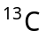 signals.
- State any one cause for Nuclear Overhauser Effect and any one consequence of it.
- What is the significance of hyperfine splitting in Electron Paramagnetic Resource Spectroscopy?
- Define Isomer Shift with reference to Mossbauer Spectroscopy.
- What is Mc Lafferty Rearrangement? Give an example.
- State and explain OCTANT RULE.
- Distinguish between primary caulometric analysis and secondary caulometric method.
- Illustrate Excitation Interference which causes an error in Flame Photometry.
PART B — (5 × 6 = 30 marks)
Answer ALL the questions.
- (a) Discuss the various factors affecting group frequencies in Infra-Red Spectroscopy. (6)
Or
(b) On the basis of Woodward Rules , calculate the 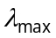 for the following compounds : (4 × 1 = 6)
(i) 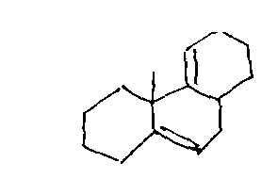
(ii) 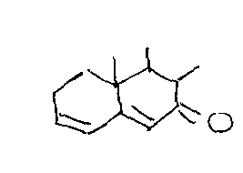
(iii) 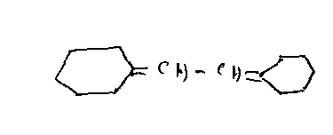
(iv) 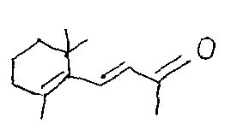
- (a) Give an account of the factors affecting the chemical shift values in N.M.R. spectroscopy. (6)
Or
(b) Write the Karplus Equation and draw the Karplus Curve to explain the vicinal coupling in Proton Magnetic Resonance Spectroscopy. (6)
- (a) Sketch and discuss the Mossbauer spectra of the following carbonyls : (3 + 3)
(i) Fe (CO)₅,
(ii) 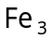(CO)₁₂
Or
(b) Explain the different factors, affecting the magnitude of ‘‘g’’ in Electron Paramagnetic Resonance Spectroscopy. (6)
- (a) What do you understand by the term : Cotton Effect? Predict the Cotton Effect by the sign of the most occupied octant in the following compounds : (2 + 2+ 2)
(i) 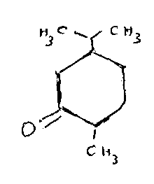
(ii) 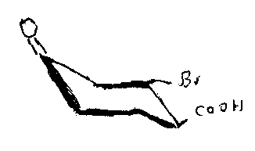
Or
(b) Compare the salient features of Fast Atom Bombardment and Chemical Ionization Methods of Mass Spectral measurement.
- (a) Discuss any two applications of colorimetric measurements.
Or
(b) Give an account of theoretical principles employed in Cyclic Voltametric measurements.
PART C — (4 × 10 = 40 marks)
Answer any FOUR questions.
- (a) What are the different types of electronic transitions observed in ultra voilet and visible spectroscopy? Discuss the effect of solvents on these transitions. (5)
(b) How will you distinguish between the following pairs of compounds by means of Infra Red Spectroscopy :
(i) Acetic Acid and Methyl Formate,
(ii) Ortho Nitro phenol and para Nitrophenol?
(2+ 2)
- Discuss the theory of
(a) Spin-Spin Splitting and
(b) Equivalent and Non Equivalent Protons, as applicable to Proton Magnetic Resonance Spectroscopy. (5 + 5)
- (a) Give an account of the theory of recoil less emission observed in Mossbauer Spectroscopy. (5)
(b) Discuss the significance of Kramen’s Degeneracy observed in Electron Paramagnetic Resonance Spectroscopy. (5)
- Illustrate the usefulness of
(a) Nitrogen Rule,
(b) Ortho Effect and
(c) Retro-Diels Alter Fragmentation as applicable to Mass Spectrometry. (3 + 2+ 5)
- Discuss the principles involved in Electrogravimetric Analysis. How will you determine Cobalt by Constant Current Electrolysis? How will you estimate the percentage of metallic constituents in Brass by Control led Potential Electrolysis?
(4 + 4 + 2)
- Discuss Atomic Absorption Spectroscopy is also known as Absorption Flame Photometry. (10)
—————————

