11
DE–2583
DISTANCE EDUCATION
M.Phil. (Mathematics) DEGREE EXAMINATION, DECEMBER 2007.
COMMUTATIVE ALGEBRA
(Upto 2006 Batch)
Time : Three hours Maximum : 100 marks
Answer any FIVE questions.
Each question carries 20 marks.
- (a) Show that an R-module M is cyclic if and only if 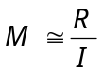 for same ideal I in R.
(b) Define a project module. Show that an R-module P is projective if and only if for any surjective homomorphism  the induced homomorphism 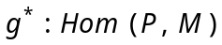 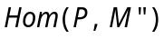 is surjective.
- (a) Show that the tensor product of two free modules of rank m and n is free of rank .
(b) Give three definitions for faithfully flat module and show that they are equivalent.
- (a) Show that 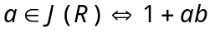 is a unit for all 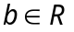.
(b) State and prove the Nakayama Lemma.

- (a) Define 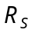 and 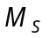. Show that the 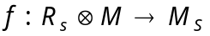 defined by 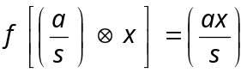 is a well defined isomorphism of -module.
(b) State and prove Hilbert Basis Theorem.
- (a) Show that any finitely generated module over an Artinian ring is Artinian.
(b) State and prove the Jordan Holder Theorem.
- (a) Show that the set of elements of S integral over R is a subring of S containing R.
(b) State and prove Noether's Normalisation theorem.
- Let R be a Noetherian local domain with unique maximal ideal 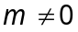 and K the quotient field of R. Show that the following are equivalent
(a) 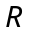 is a discrete valuation ring
(b) R is a principal ideal domain
(c) m is principal
(d) R is integrally closed and every non-zero prime ideal of R is maximal
(e) Every non-zero ideal of R is a power of m.
- (a) Let 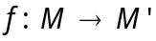be a homomorphism of R-modules, 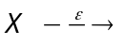 M and 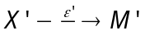 projective resolutions of 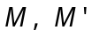 respectively show that there exists a mapping of complexes 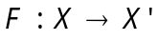 such that 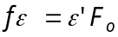 moreover F is unique upto homotophy.
(b) Show that any R-module M can be embedded in an injective R-module.
———————
DE–2584
12
DISTANCE EDUCATION
M.Phil. (Mathematics) DEGREE EXAMINATION, DECEMBER 2007.
MEASURE THEORY
(Upto 2006 Batch)
Time : Three hours Maximum : 100 marks
Answer any FIVE questions.
Each question carries 20 marks.
- (a) State and prove Fatou’s Lemma.
(b) If 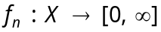 is measurable for 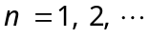 and 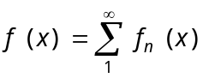 then 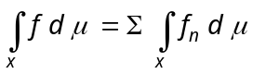.
- Explain briefly regularity properties of Borel measures.
- (a) Let 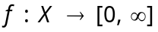 be measurable and 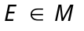 with 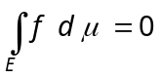 then 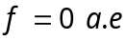 on E.
(b) If 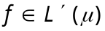 and 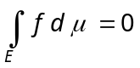 for every measurable set then 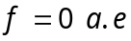 on X.
(c) If and 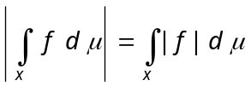 then there exists a constant such that 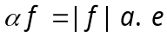 on X.
- (a) Define convex with suitable example.
(b) Prove that a real differentiable function is convex in 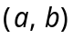 if and only if 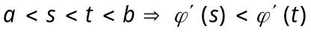.
- State and prove Holder’s inequality.
- Prove that 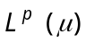 is a complete metric space for 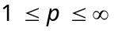 and for every positive measure .
- Prove that for 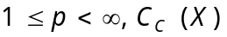 is dense in .
- (a) State and prove the Fubini theorem.
(b) Explain convolutions.

———————
DE–2585
13
DISTANCE EDUCATION
M.Phil. DEGREE EXAMINATION, DECEMBER 2007.
Mathematics
TOPOLOGICAL VECTOR SPACES
(Upto 2006 Batch)
Time : Three hours Maximum : 100 marks
Answer any FIVE questions.
Each question carries 20 marks.
- (a) Define a topological vector space. (5)
(b) Prove that every topological vector space has a balanced local base. (15)
- If  is a locally bounded topological vector space with the Heine-Borel property, then prove that has finite dimension. (20)
- (a) Define a Seminorm on a vector space. (5)
(b) Suppose and  are topological vector spaces and 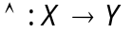 is linear. Then prove that the following properties.
(i) is continuous,
(ii) is bounded,
(iii) If 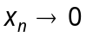 then 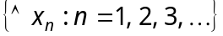 is bounded,
(iv) If then 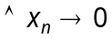, are equivalent. (15)
- Suppose  and 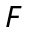 are subspaces of a topological vector space , is closed and has finite dimension. Then prove that 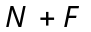 is closed. (20)
- State and prove open mapping theorem. (20)
- State and prove the Banach-Alaoglu theorem. (20)
- State and prove Hahn-Banach theorem. (20)
- (a) Explain the second dual of a Banach space. (5)
(b) Prove that 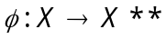 is an isometric isomorphism of onto a closed subspace of . (15)
- Suppose is a Frechet space, is a complemented subspace of ,  is a compact group which acts as a group of continuous linear operators on and 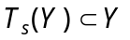 for every 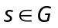. Show that there is a continuous projection 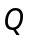 of onto which commutes with every 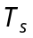. (20)
————————

DE–2586
14 (A)
DISTANCE EDUCATION
M.Phil. DEGREE EXAMINATION, DECEMBER 2007.
Mathematics
FUNDAMENTALS OF DOMINATION IN GRAPHS
(Upto 2006 Batch)
Time : Three hours Maximum : 100 marks
Answer any FIVE questions.
(5 × 20 = 100)
Each question carries 20 marks.
- (a) Prove that a dominating set S is a minimal dominating set if and only if for each vertex 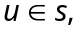 one of the following two conditions holds:
(i) u is an isolate of S
(ii) there exists a vertex 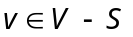for which 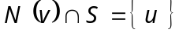. (10)
(b) For the following graph , find 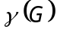 and 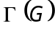 (6)
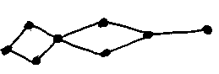

(c) Show that if graph is disconnected, then 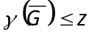. (4)
- (a) Prove that a connected graph G satisfies 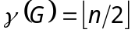 if and only if 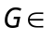 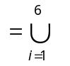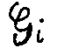 (14)
(b) For any graph , prove that 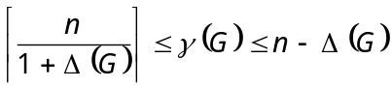. (6)
- (a) For any graph G and hereditary property p, prove that 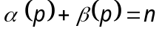. (6)
(b) For any graph G, prove that (7)
(c) For any graph G, Prove that 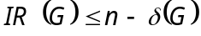. (7)
- (a) Define the following classes with examples CVR, CER and CEA. (6)
(b) If a graph 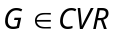 has order 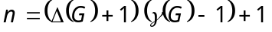, prove that G is regular. (7)
(c) Prove that a graph 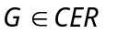 if and only if G is a galaxy. (7)
- (a) If a graph 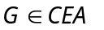, prove that the sub graph induced by 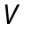° is complete. (7)
(b) If a connected graph 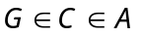 is not complete, prove that 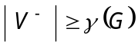. (6)
(c) If is a graph with 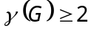, prove that 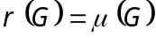. (7)
- (a) If a graph does not contain the star 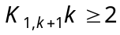, as an induced subgraph, prove that 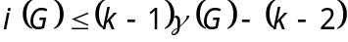.
(8)
(b) If is a connected graph with 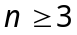 vertices, prove that 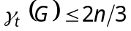 (12)
- (a) Show that 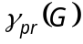 and 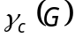 are incomparable. (4)
(b) If a connected graph has 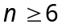 and 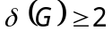, prove that 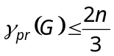. (16)
- (a) Define the following : Multiple domination, locating domination, distance domination, strong domination, global domination and directed domination. (6)
(b) If 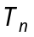 is a tree on 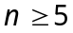 vertices, show that 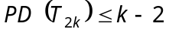 and 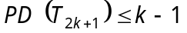. Also show that these bounds are sharp. (14)
- (a) For any graph 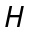 and any t-factoring 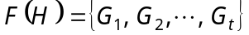 of , prove that 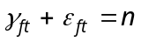. (8)
(b) Show that a necessary and sufficient condition for a set S to be kernel of a digraph 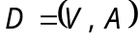 is that its characteristics function 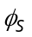 satisfy the condition :
(12)

———————
DE–2587
14 B
DISTANCE EDUCATION
M.Phil (Mathematics) DEGREE EXAMINATION, DECEMBER 2007.
DATA STRUCTURES AND ALGORITHMS
(Upto 2006 Batch)
Time : Three hours Maximum : 100 marks
Answer any FIVE questions.
All questions carry equal marks.
- (a) Discuss the benefits of object-oriented programming. (10)
(b) Explain the concept of polymorphism with an example. (10)
- (a) Discuss Inheritance with an example. (10)
(b) Write a detailed note on the various operators and expressions in C++. (10)
- (a) Explain the various operations performed using circular lists. (10)
(b) How do you insert an element in a doubly linked list? (10)
- Explain Two-Dimensional arrays and multi-Dimensional arrays in detail. (20)
- (a) Discuss the basic stack operations. (10)
(b) Write an algorithm to convert an expression from infix to postfix using stacks. (10)
- (a) How do you implement the insert and delete operations using queues? (10)
(b) Explain circular queue with an illustration. (10)
- (a) Explain the various operations on binary trees. (10)
(b) Write a short note on threaded binary trees. (10)
- Write short notes on the following :
(a) Minimum spanning trees. (10)
(b) Application of graphs. (10)
——————————

