DE–4710
16
DISTANCE EDUCATION
M.Sc.(IT) DEGREE EXAMINATION, DECEMBER 2008.
C++ LAB
(2002 onwards)
Time : Three hours Maximum : 100 marks
Break-Up of Marks
Record : 10
Algorithm and Flowchart : 10
Program : 50
Debugging : 10
Execution : 10
Result : 10
100
Answer TWO questions both (a) and (b).
All questions carry equal marks.
Questions are to be selected by the examiner for each candidate.
Cut here
- (a) A book shop maintains the inventory of books that are bring sold at the shop. The list includes details such as author, title, price and stock position. Whenever a customer wants a book, the sales person input the title and author and the system searching the list and display whether it is available or not. An appropriate message displayed. If its is then the system displays the book details and request for the number of copies required. If the requested copies are available, the total cost of the requested copies is displayed; otherwise the message ‘‘Requested copies not in the stock’’ is displayed.
Design a system using a class called book with suitable member function and constructor. Use new operator in constructor to allocate memory space required.
(b) Assume you want to generate a table of multiples of any given number. Write a program that allows the user to enter the number, generates the table, formatting it into
12 columns and 25 lines.
- (a) An educational institution wishes to maintain a database of its employees. The database is divided into a number of classes. Specify all the classes and define function to create the database and retrieve individual information as and when required.
(b) Write C++ program to concatenate two given strings using dynamic constructors.
Cut here

- (a) Create a base class called shape. Use this class to store two double type values that could be used to compute the areas of figures. Derive two specific classes called triangle and rectangle from the base shape. Add to the base class, a member function get data () to initialize base class data members and as a virtual function and redefine this function in the derived classes to suit their requirements.
Using these three classes design a program that will accept dimensions of triangle or rectangle interactively and display the area.
The two values given as an input will be treated as lengths of two side in the case of rectangle and as base and height in the case of triangles and used as follows :
Area of rectangle = x * y.
Area of triangle = 1/2 * x * y.
(b) Create a C++ class for a stock item abstraction data type. It should have the attributes of stock levels (an integer) and unit price (a-float) Define the methods to return the values of these two attributes and to set them using parameters. Add two more methods to allow stock receipt and issues updating the stock level as appropriate. Write a menu driven C++ program to solve the problem.
- (a) Write a program that will create a data file containing the list of telephone numbers. Use class object to store each set of data.
(b) Define a class to represent a bank account. Include the following member.
Data members :
(i) Name of the depositor.
(ii) Account number
(iii) Types of account
(iv) Balance amount in the account
Member functions :
(i) To assign initial values.
(ii) To deposit an amount
(iii) To display name and balance.
Write a main program to test the program.
Cut here

- (a) Create a class string. Use operator overloaded to display the string manipulation.
(b) Create a class Int to overload all four integer arithmetic operator (+, –, *, /).
If the normal range of integer exceeds from –32,768
–32,767, have a operator print and terminate the program.
- (a) Write a class to represent a vector. Include member function to perform the following task.
(i) To create the vector.
(ii) To modify the value of a given element.
(iii) To modify by a scalar value.
(iv) To display the vector in the form (10, 20, 30...).
Write a program to test your class.
(b) Write a program using polymorphism to calculate the square of any three numbers of integer and float.

Cut here
- (a) Write a C++ program that will ask for a temperature in Fahrenheit and display it in Celsius.
(b) An election is contested by five candidates. The candidates are numbered 1 to 5 and the voting is done by marking the candidate number on the ballot paper. Write a program to read the ballots and count the votes cast for each candidate using an array variable count. Incase, a number read is outside the range 1 to 3 the ballot should be considered as a spoilt ballot and the program should also count the number of spoilt ballots.
Cut here

- (a) Using pointer create a class and write a program to get the n names and display them in ascending and descending order.
(b) Create a class called employee. Include a member function get data () and putdata () Write a main program to exercise this class. Create a array for type employee and invite the user to input data.
————————
DE–4711
17
DISTANCE EDUCATION
M.Sc. DEGREE EXAMINATION, DECEMBER 2008.
Information Technology
DATA STRUCTURES LABORATORY
(2002 onwards)
Time : Three hours Maximum : 100 marks
Break up of marks :
Record Note Book : 10
Algorithm : 10
Program : 50
Debugging : 10
Execution : 10
Result : 10
Total : 100
1. Examiner has to choose TWO questions ONE from Section A and another from Section B for each candidate.
2. Each question carry 50 marks.
3. Candidate has to write algorithm and C++ code.
Cut here
SECTION A
1. Write a C++ program to sort the following list using Bubble sort :
–13, 25, –45, 36, 84, 10, 15, –12, 84.
Cut here
2. Write a C++ program to sort the given set of n numbers using selection sort.
3. Write a C++ program to search an element using Binary search.
Cut here
4. Write a C++ program to copy the content of one file into another file.
Cut here
5. Write a C++ program to search for a given element using linear search.
Cut here
SECTION B
6. Write a C++ program to create linked list and perform its operations using arrays.
Cut here
7. Write a C++ program to add and subtract two m×n matrices.
Cut here
8. Write a C++ to implement stack operations using linked list.
Cut here
9. Write a C++ program to sort the given set of n elements using Quick sort.
Cut here
10. Write a C++ program to sort array elements using insertion sort.

————————
DE-4712
26
DISTANCE EDUCATION
M.Sc.(I.T.) DEGREE EXAMINATION, DECEMBER 2008.
INTERNET PROGRAMMING LABORATORY
(2002 onwards)
Time : Three hours Maximum : 100 marks

Record Note Book : 10
Algorithm : 10
Program : 50
Debugging : 10
Execution : 10
Result : 10
Total : 100
Examiner to select and give ONE question to each candidate.
1. (a) Write a VB Script to create a calendar for a given month and year.
(b) Design a web page to display the details of your University.
cut here
2. (a) Write a Java program to create an applet to display the message “WORK MORE TALK LESS” with different colors and fonts for each click.
(b) Design a web page of your home town in appropriate colors.
3. (a) Write a Java Script to create a window by using the confirm message.
(b) Write a swing program to create buttons with
(i) Image (ii) Short cut key.
cut here
4. (a) Use database connectivity to create a table called ACCOUNT with following attributes:
ACCNO, ACC TYPE, NAME, ADDRESS, BALANCE.
Provide for updating records and display the table contents.
(b) Write a VB script to create a calender for given month and year.
cut here
5. (a) Write a Java program to read students particulars like name, roll number, date of birth, year of study, course, sex and address using frame and text controls. Also display the given details on the screen.
(b) Design a Web page of your Department, explaining the courses offered in the department, faculties in the department, facilities in the department and give suitable headings.
cut here
6. (a) Write a Java script to create a color pallet and display the background in the color chosen from the pallet.
(b) Write a swing program to create the Tabbed panels.

7. (a) Design a web page with a form in it. The form has the following details:
Employee Number, Name, Designation, Basic pay, DA, HRA, PF, and Net pay.
Input: Employee Number, Name, Designation and Basic pay.
Determine other details using the following:
DA = 52% of basic pay
HRA = 8% of basic pay
PF = 12% of basic pay
Net pay = Basic pay + DA + HRA – PF.
(b) Write a Java program using Applet to create the frames and its controls.
cut here
8. (a) Design a web page using HTML code that shows your bio-data.
(b) Write a UB Script to do the following:
(i) Check the given password
(ii) Change the existing password.
————————
27
DE-4713
DISTANCE EDUCATION
M.Sc. (IT) DEGREE EXAMINATION, DECEMBER 2008.
VISUAL PROGRAMMING — LAB
(2002 onwards)
Time : Three hours Maximum : 100 marks
Break-Up of Marks
Record Note : 10
Algorithm : 10
Program : 50
Debugging : 10
Execution : 10
Result : 10
Total : 100
ONE question should be given to each student by lot.
Answer both subdivisions (a) and (b).
Cut here
1. (a) Using control array create a simple calculator in Visual Basic.
(b) Write a Visual C++ program to create a list box in a window.
Cut here
2. (a) Using MS Flex grid control, display the multiplication and addition table of 20 rows and columns.
(b) Write a VC++ program to find out whether a mouse is attached or not; and if attached how many buttons are present.
3. (a) Using built in A_{x} control develop the windows NOTEPAD with File and Edit Menu operation.
(b) Write Visual C++ program to fill background of the client area with a bitmap.
Cut here
4. (a) Create employer details with necessary details and perform the following operations in Visual Basic.
(i) Insert a record
(ii) Search and delete a record
(iii) Modify record.
(b) Write a VC++ program to create a window of desired size using MFC.
Cut here

5. (a) Create a Hospital table with necessary fields and program the following operations.
Insertion, search, delete and modify records.
(b) Write a Visual C++ program to get the status of the shift and toggle keys using MFC.
6. (a) Develop a data report using Employee table
(i) Display all employees
(ii) Display all employees department wise.
(b) Write a Visual C++ program to generate a stator bar and show the status of caps lock, Num Lock and scroll lock in it.

————————
DE–4481
25
DISTANCE EDUCATION
M.Sc. (IT) DEGREE EXAMINATION, DECEMBER 2008.
MULTIMEDIA AND APPLICATIONS
(2002 onwards)
Time : Three hours Maximum : 100 marks
PART A — (10 × 3 = 30 marks)
Answer ALL questions.
1. List the uses of multimedia.
2. What are authoring tools? Explain.
3. What is an Image? How this differ from video?
4. Define Hyper media and Hyper text.
5. Describe Image file formats.
6. Explain about components classes.
7. Discuss media types.
8. How to use text in multimedia?
9. What is meant by MPEG?
10. What do you mean by economic Reforms.
PART B — (4 × 10 = 40 marks)
Answer any FOUR questions.
11. Explain the different Input devices of multimedia systems.
12. Discuss briefly on non-temporal media types.
13. Discuss briefly on the communication devices available for multimedia.
14. What is animation? Discuss on animation tools.
15. Explain about on CD family and the media architecture.
16. Give the recommendation of malhotra committee.
PART C — (2 × 15 = 30 marks)
Answer any TWO questions.
17. (a) Explain in detail on Multimedia platforms.
(b) Give the Importance of development tools.
18. Write short notes on :
(a) JPEG, MPEG.
(b) Storage media for computer communication.
19. (a) Discuss briefly on transform classes and format classes.
(b) Discuss about on multimedia on networks.
————————
DE–4480
24
DISTANCE EDUCATION
M.Sc. (Information Technology) DEGREE EXAMINATION, DECEMBER 2008.
VISUAL PROGRAMMING
(2002 onwards)
Time : Three hours Maximum : 100 marks
PART A — (10 × 3 = 30 marks)
Answer ALL questions.
1. Define : Windows programming.
2. What are the resources available in windows?
3. Write a short notes about DLL.
4. Write a short notes about SDK.
5. List the data types in VB.
6. Write a few properties of the command button.
7. How to create menus using the menu editor?
8. What is meant by record set?
9. What is meant by serialization?
10. Give short notes on exception handling.
PART B — (4 × 10 = 40 marks)
Answer any FOUR questions.
11. Compare the traditional programming paradigms.
12. Describe the different window messages.
13. Explain about flow control (decision making) in VB.
14. Describe about the dialog boxes in VB.
15. Explain MFC file handling.
16. Write a note on ODBC.
PART C — (2 × 15 = 30 marks)
Answer any TWO questions.
17. Explain about the Dynamic Link Library (DLL).
18. Explain the data control with an example in VB.
19. Explain about the VC++ Resources.

——————
DE–4479
23
DISTANCE EDUCATION
M.Sc.(Information Technology) DEGREE EXAMINATION, DECEMBER 2008.
SOFTWARE ENGINEERING
(2002 onwards)
Time : Three hours Maximum : 100 marks
PART A — (10 × 3 = 30 marks)
Answer ALL questions.
All questions carry equal marks.
1. What are the roles of software?
2. Explain about the software Engineering layers.
3. What do you mean by project scope and what are the information necessary for scope.
4. What is technology risk and how to handle it?
5. Write short notes on Timeline charts in scheduling.
6. Write about ISO 9001 standard.
7. Write about the modularity concepts in software design.
8. Define data design.
9. Define cohesion
10. Define white box testing.
PART B — (4 × 10 = 40 marks)
Answer any FOUR questions.
All questions carry equal marks.
11. Write short notes on
(a) The RAD model
(b) Spiral model.
12. Write short notes on Resources in software project planning.
13. Explain in detail about Formal Technical reviews.
14. Write short notes on structured analysis and draw the DFD for Inventory control system.
15. Explain in detail about Human - Computer Interface Design.
16. Write short notes on control structure testing.
PART C — (2 × 15 = 30 marks)
Answer any TWO questions.
All questions carry equal marks.
17. Explain with neat sketch, the evolutionary software process models.
18. Write short notes on
(a) COCOMO model
(b) Decomposition Techniques.
19. Give a brief note on Black-Box Testing.

————————
DE–4478
22
DISTANCE EDUCATION
M.Sc. DEGREE EXAMINATION, DECEMBER 2008.
Information Technology
COMPUTER NETWORKS
(2002 onwards)
Time : Three hours Maximum : 100 marks
PART A — (10 × 3 = 30 marks)
Answer ALL questions.
1. Define network.
2. Differentiate Broadcast networks from point-to-point networks.
3. List any four transmission media.
4. Give example for Data Link Protocols.
5. Write notes on SLIP.
6. Expand : CDFD and GSM.
7. Write about token ring and datagram subnets.
8. Compare virtual circuit and datagram subnets.
9. Explain Internetwork routing.
10. What are the two subsystem of E-mail? Explain briefly.
PART B — (4 × 10 = 40 marks)
Answer any FOUR questions.
11. Discuss the OSI Reference model.
12. Discuss on :
(a) WAN
(b) Wireless Network.
13. Discuss about any two transmission media.
14. Explain a one bit sliding window protocol.
15. Explain the method of releasing a connection.
16. Explain DES algorithm as a product cipher.
PART C — (2 × 15 = 30 marks)
Answer any TWO questions.
17. (a) Write in detail about Data Link Layer Design issues. (10)
(b) Write short notes on multiple access protocols. (5)
18. (a) Discuss on Radio Transmission and microwave transmission.
(b) Describe any two of the data link layer design issues.
19. (a) Explain the wavelength division multiple access protocols.
(b) Explain the concept of Transparent Bridges.
––––––––––––––
DE–4477
21
DISTANCE EDUCATION
M.Sc. (IT) DEGREE EXAMINATION, DECEMBER 2008.
INTERNET PROGRAMMING AND WEB DESIGN
(2002 onwards)
Time : Three hours Maximum : 100 marks
PART A — (10 × 3 = 30 marks)
Answer ALL questions.
1. What are the different types of security used in Internet?
2. What do you mean by Internet?
3. What is platform independent language?
4. What are the functions of JVM?
5. Write any 3 types of scripting language other than Java and VB scripts.
6. What is HTML and what is its importance?
7. What is VDO?
8. What is Telnet?
9. What is framing?
10. What do you mean by Animation?
PART B — (4 × 10 = 40 marks)
Answer any FOUR questions.
11. Explain about the Internet programming.
12. Discuss briefly about the features of Java.
13. Explain in detail about VB script.
14. What are HTML tags and where are they used? Explain.
15. Describe the World Wide Web and its uses and role in Internet.
16. Explain Web graphics and hyper links.
PART C — (2 × 15 = 30 marks)
Answer any TWO questions.
17. (a) Write short notes on Encryption.
(b) Explain about the developing Internet applications.
18. (a) Explain in detail about the perl.
(b) Explain the uses of Microsoft Internet explorer.
19. (a) Explain about creating Netscape Navigator
plug-ins.
(b) Give a brief note about dynamic graphics.
————————
DE–4476
15
DISTANCE EDUCATION
M.Sc. (I.T.) DEGREE EXAMINATION, DECEMBER 2008.
OBJECT ORIENTED DBMS
(2002 onwards)
Time : Three hours Maximum : 100 marks
PART A — (10 × 3 = 30 marks)
Answer ALL questions.
All questions carry equal marks.
1. Mention any three advantages of ‘Database Management System’.
2. What is meant by data independence?
3. Define the terms :
(a) Entities
(b) Attributes.
4. What is the difference between ‘Primary key’ and ‘secondary key’?
5. Write the necessity to define NULL values.
6. What is the use of condition box in QBE?
7. Define functional dependencies.
8. What is a trigger, and what are its parts?
9. What is the main idea behind discretionary access control?
10. What are the main components of an XML document?
PART B — (4 × 10 = 40 marks)
Answer any FOUR questions.
All questions carry equal marks.
11. Write a note on transaction management.
12. Define the concept of aggregation. Give two examples of where this concept is useful.
13. Explain the nested queries, aggregate operators, group by and having clauses with suitable examples.
14. Explain briefly about clustering and indexing.
15. Discuss in detail about the database tuning.
16. Explain the similarities and differences of OODBMS and ORDBMS.
PART C — (2 × 15 = 30 marks)
Answer any TWO questions.
All questions carry equal marks.
17. Draw an E-R diagram for a payroll system. Identify strong and week entities and relationships.
18. Explain first, second and third normal forms with examples.
19. Explain in detail about the distributed DBMS architecture and distributed query processing.
————————
DE–4475
14
DISTANCE EDUCATION
M.Sc. (IT) DEGREE EXAMINATION, DECEMBER 2008.
DATA STRUCTURES AND ALGORITHMS
(2002 onwards)
Time : Three hours Maximum : 100 marks
PART A — (10 × 3 = 30 marks)
Answer ALL questions.
1. What is a data structure?
2. Define : Big ‘O’ notation.
3. Is list a data type? Give a definition.
4. If a string is placed character by character in a stack, will we get the original string or reversed string?
5. Represent the following Binary tree in an array
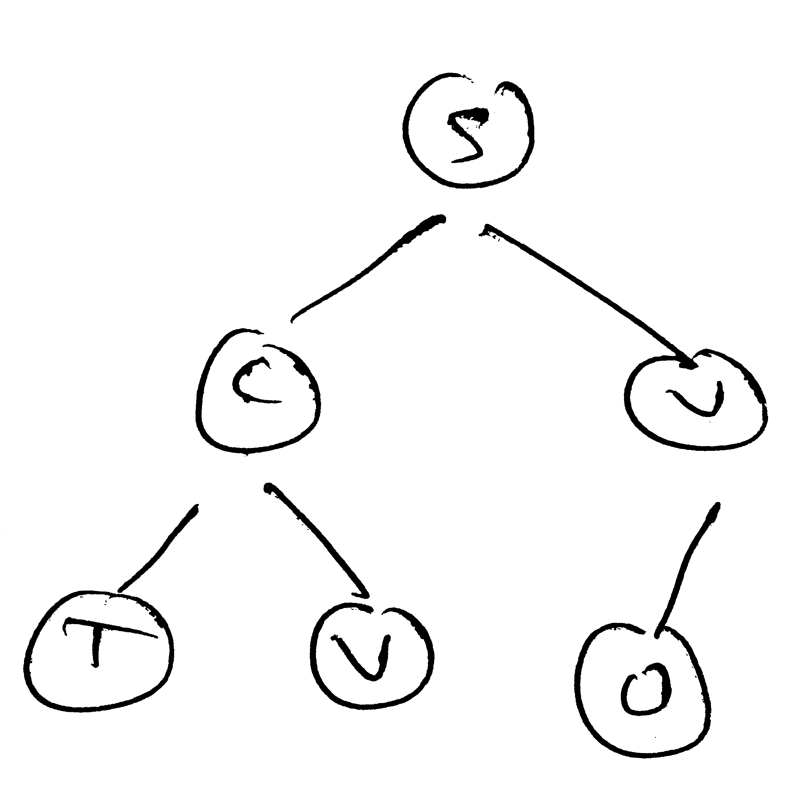
6. Define : Inorder Traversal.
7. What is an adjacency matrix?
8. Differentiate graphs and trees.
9. What is hashing?
10. Can we have a binary tree with 20 nodes if the order is FIVE?
PART B — (4 × 10 = 40 marks)
Answer any FOUR questions.
11. Explain how time complexity is calculated with an example. What are notations used?
12. Give algorithm for counting the number of nodes in a circularly linked list.
13. Explain HEAP SORT with example.
14. Give an algorithm to count number of leaf nodes in a BINARY TREE T. Give its computing time.
15. Give the algorithm for BFS of a graph with examples.
16. For the Graph.
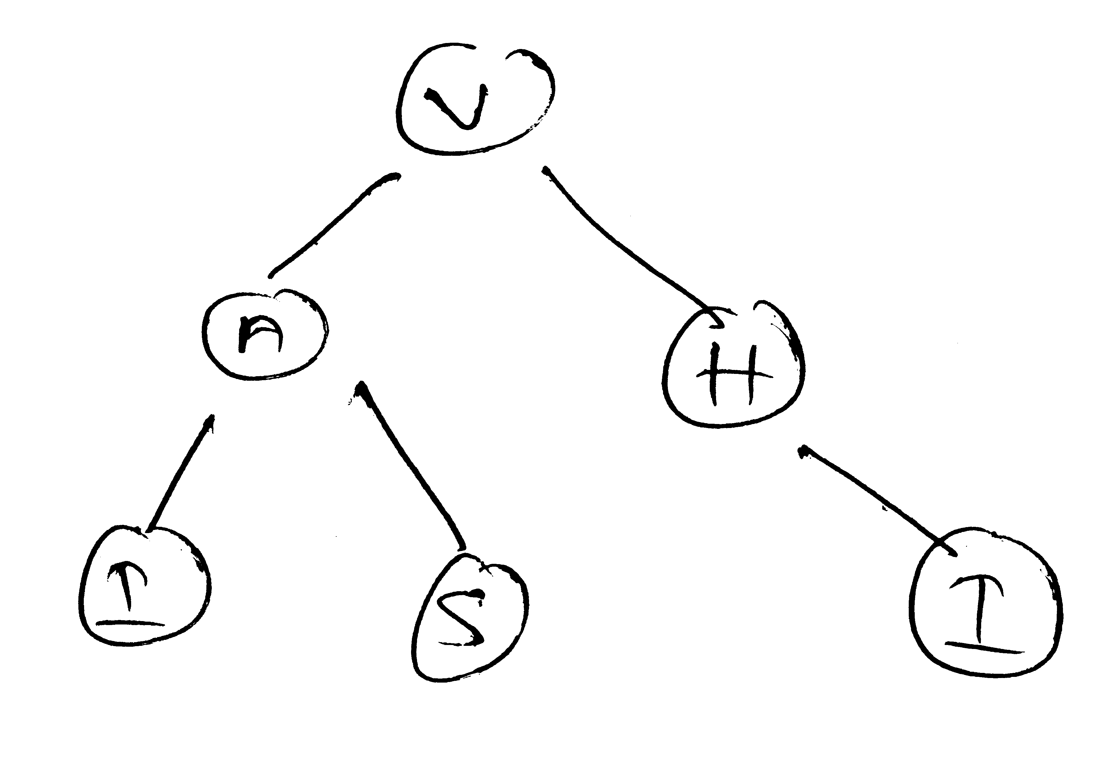
(a) Give adjacency matrix, list
(b) Give order in which DFS is performed
(c) Give indegree of each node.
PART C — (2 × 15 = 30 marks)
Answer any TWO questions.
17. What are STRINGS? How are they represented? Explain pattern matching with example.
18. Write an algorithm SWAPTREE (T) which a binary tree and swaps the left and right children of every node. Find space and time complexity of the algorithm.
19. Let 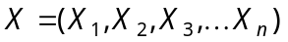
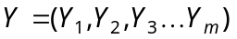
be two linked lists. Write an algorithm to obtain new linked list.
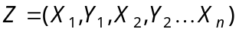 if 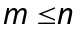 and
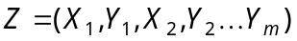 if no additional lists to be used.

————————
DE–4474
13
DISTANCE EDUCATION
M.Sc. (I.T) DEGREE EXAMINATION, DECEMBER 2008.
OBJECT ORIENTED PROGRAMMING AND C++
(2002 onwards)
Time : Three hours Maximum : 100 marks
PART A — (10 × 3 = 30 marks)
Answer ALL questions.
1. What is a class? Give example.
2. What is meant by an object? Give example.
3. List the models of object oriented development.
4. Define the term “control abstraction”.
5. What is the use of this pointer?
6. Write the most general form of a copy constructor.
7. List the operators that cannot be overloaded.
8. What do you mean by default argument?
9. Write the general form of a ‘generic class’.
10. What is an exception?
PART B — (4 × 10 = 40 marks)
Answer any FOUR questions.
11. Explain briefly Encapsulation with example.
12. Discuss various possible relationships between classes.
13. Explain various types of inheritance with an example.
14. Describe the Derived classes and Member functions.
15. List and explain the rules for overloading an operator.
16. Write a C++ program to overload – – operator.
PART C — (2 × 15 = 30 marks)
Answer any TWO questions.
17. Write a C++ program to maintain an inventory file perform the following operations :
(a) add a new item
(b) display the file.
18. List and explain various file handling functions. Give a sample program to create a file of objects.
19. Write short notes on :
(a) Function overloading
(b) Inline function
(c) Virtual function.

––––––––––––––––
DE–4473
12
DISTANCE EDUCATION
M.Sc. (IT) DEGREE EXAMINATION, DECEMBER 2008.
OPERATING SYSTEMS
(2002 onwards)
Time : Three hours Maximum : 100 marks
SECTION A — (10 × 3 = 30 marks)
Answer ALL the questions.
1. Write a short note on system calls for signal management.
2. Explain how OS acts as an extended machine.
3. What is meant by critical section?
4. Why do we need two level Scheduling Algorithm?
5. What is DMA?
6. What is dead lock modeling?
7. How do you realise the Multiprogramming and memory usage?
8. Write an example for Bit Map storage.
9. What is the use of shared file?
10. What is the optimal page replacement algorithm?
SECTION B — (4 × 10 = 40 marks)
Answer any FOUR questions only.
11. Explain the client – server model of structure of O.S.
12. Discuss in detail with an example Round Robin Scheduling Algorithm. What is its Merits and Demerits?
13. Explain the device Independent I/O Software.
14. How do you increase multiprogramming performance by using MVP?
15. How do you simulate LRU algorithm for page replacement?
16. Discuss indetail various file protection mechanisms.
SECTION C — (2 × 15 = 30 marks)
Answer any TWO questions only.
17. Discuss the various proposal method to set up mutual exclusion with busy waiting.
18. Define : Dead lock. Explain deadlock avoidance by using any one method.
19. Describe the important feature of file server.
————————
DE–4472
11
DISTANCE EDUCATION
M.Sc. (I.T) DEGREE EXAMINATION, DECEMBER 2008.
PRINCIPLES OF INFORMATION TECHNOLOGY
(2002 onwards)
Time : Three hours Maximum : 100 marks
PART A — (10 × 3 = 30 marks)
Answer ALL questions.
1. Write the significance of digital computers.
2. Expand :
(a) TCP/IP
(b) ROM
(c) ISDN.
3. What is Hub?
4. List the components of local area network.
5. Give the syntax of assignment statement with example.
6. Write the syntax of switch.. case statement.
7. Define arrays.
8. What is pointer?
9. Define Macros.
10. What is inline functions?
PART B — (4 × 10 = 40 marks)
Answer any FOUR questions.
11. Describe the following in detail :
(a) Internet web browsers
(b) Desktop accessories.
12. Write about cyberethics.
13. Write about telecomputing and virtual offices.
14. Write a ‘C’ program to add a square matrix and check whether it is a symmetric matrix [Hint : A matrix is symmetric if A(i, j) = A (j, i) for all the value of i and j]
15. A man takes a job for 30 days. His pay for the first day is
Rs. 25. His pay for the second day is Rs. 50 and for the third day is Rs 100. Each day’s pay is twice his pay of the previous day. Write a ‘C’ program to calculate his total pay for 30 days.
16. With suitable example, explain how structures are passed as arguments to function.
PART C — (2 × 15 = 30 marks)
Answer any TWO questions.
17. Write short notes on following :
(a) Groupware
(b) Work group computing
(c) Cable modem.
18. (a) Write about pointers to function.
(b) Explain the concept of modularization with examples.
19. Write short notes on :
(a) Internet and Intranet
(b) Video conferencing and picture phones.

––––––––––––

