CENTRE FOR INTERNATIONAL RELATIONS

Aim and Purpose  (Suggested) | To explore opportunities for association with Overseas Universities and Institutes for Collaborative Ventures of mutual benefit.
Aim and Purpose  (Suggested) | To establish Faculty-Students exchange programme to promote the research potentials
Aim and Purpose  (Suggested) | To Review working status of MoU / MoA with Overseas Universities/Institutes
Aim and Purpose  (Suggested) | To evaluate Capability, Character and Candidness of Institutions before forging alliances. In addition to research collaborations,

Name | Designation & Dept./Division/College. | Status
Dr. C. Sekar | Professor & Head,  Department of Bioelectronics and Biosensors | Coordinator
Prof. M. Selvam | Professor & Head,  Department of International Business | Member
Dr. V. Manickavasagam | Professor and Head  Dept. of Corporate Secretaryship | Member
Dr. J. Jeyakanthan | Professor & Head  Department of Bioinformatics | Member
Mr. Jean Claude | Department of Bioelectronics and Biosensors | Member
Mr. Ndayishimiye Dieudonne | Department of Commerce | Member

Range of Activities  (Suggested) | Promotion of international relations and internationalisation of the campus
Range of Activities  (Suggested) | Improving the presence of more number of foreign students
Range of Activities  (Suggested) | Arranging cultural exchanges, events and cross fertilisation of ideas

Activities Carried out
Year | Description of Activity | Date | Participants/  Beneficiaries
2016 | Visit of International students | 11th August 2016 | Participation of students in a conference and future collaborations

Faculty Exchange Program

Name |  | University / Institute
Dr. B. Vaseeharan  Department of Animal Health &  Management | 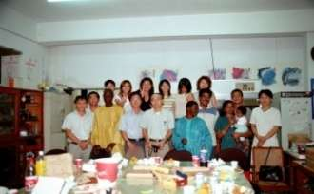 | National Taiwan Ocean University  Taiwan  (5th - 10th Jul, 2009)
Dr. J. Jeyakanthan  Department of Bioinformatics | 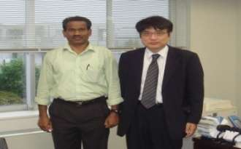 | RIKEN Harima Institute  SPring-8, Japan  (22rd Mar - 30th May, 2010)
Dr. B. Vaseeharan  Department of Animal Health &  Management | 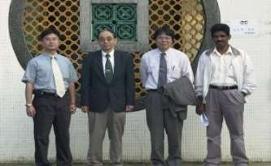 | National Taiwan Ocean University  Taiwan  (6th Jun - 10th Jul, 2010)
Dr. J. Jeyakanthan  Department of Bioinformatics | 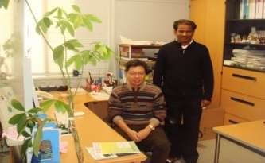 | RIKEN Harima Institute, SPring-8, Japan  (2nd - 8th Dec, 2012)
Dr. J. Jeyakanthan  Department of Bioinformatics | 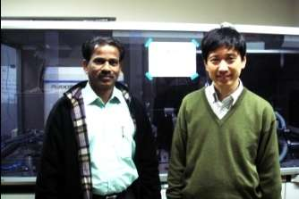 | Institute of Protein Research, Osaka University, Japan  (9th - 16th Dec, 2011)
Dr. J. Jeyakanthan  Department of Bioinformatics | 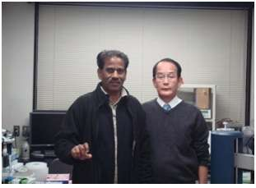 | School of Science  Osaka University, JAPAN  (9th - 16th Dec, 2011)
Dr. B. Vaseeharan  Department of Animal Health & Management | 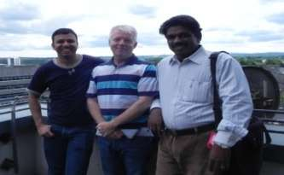 | Queen’s University Belfast, Belfast, Northern Ireland, UK  (5th - 21st Jun, 2011)
Dr. V. Dharuman  Department of Bioelectronics  and Biosensors | 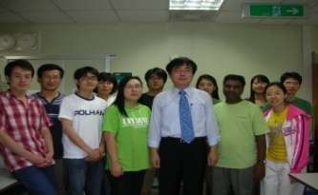 | Department of Chemistry, Pohang University of Science and Technology (POSTECH), South Korea  (20th Oct,2012 - 20th Apr, 2013)
Dr. G. Ravi  Department of Physics | 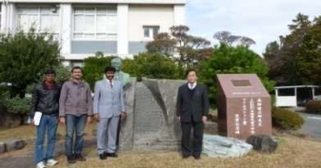 | Research Institute of Electronics  Shizuoka University, Hamamatsu, Japan  (01st Aug - 30 th Nov, 2012)
Dr. C. Sekar  Department of Bioelectronics  and Biosensors | 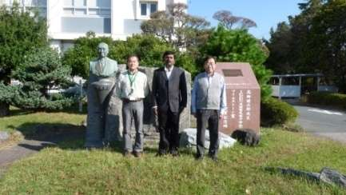 | Research Institute of Electronics  Shizuoka University, Hamamatsu, Japan  (1st Sep - 31st Oct, 2012)
Dr. J. Jeyakanthan  Department of Bioinformatics | 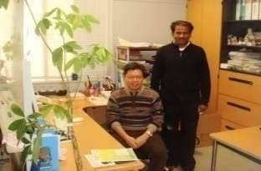 | RIKEN Harima Institute, SPring-8, Japan  Osaka University, JAPAN  (2nd - 8 th Dec, 2012)
Dr. V. Dharuman  Department of Bioelectronics  and Biosensors | 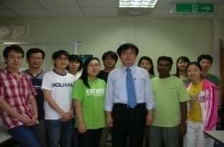 | Pohang University of Science and Technology (POSTECH), South Korea  (20 th Oct, 2012 - 20 th Apr, 2013)
Dr. P. Shakkthivel  Department of Nanoscience &  Technology | 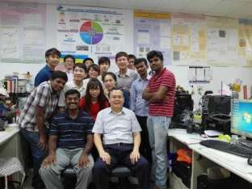 | National Taipei University of Technology, Taiwan, ROC
Dr. B. Vaseeharan  Department of Animal Health &  Management |  | Mohidol University, Thailand  (20 th May - 19 th Jun, 2014)
Dr. J. Jeyakanthan  Department of Bioinformatics | 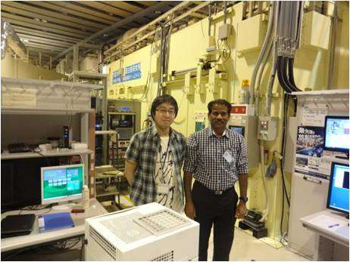 | RIKEN Harima Institute, SPring-8, Japan  Osaka University, JAPAN  (21st - 30th Jun, 2014)
Dr. P. Shakkthivel  Department of Nanoscience  and Technology | 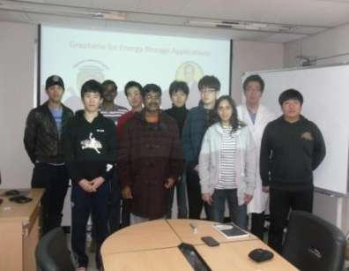 | Pohang University of Science and Technology (POSTECH) Pohang, South  Korea  (10th Nov - 9th Dec, 2014 )
Dr. C. Sekar  Department of Bioelectronics and Biosensor | 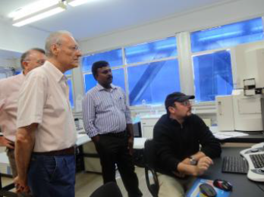 | Information and Decision at the Cellular Level at International Centre for Theoretical Physics (ICTP)-Trieste and DIECII, University of Messina, Italy.  (14th - 21st July, 2015)

Student Exchange Program
S.No. | Name |  | University/ Institute
 | Mr. Anand Chakroborthy  Department of Animal  Health & Management | 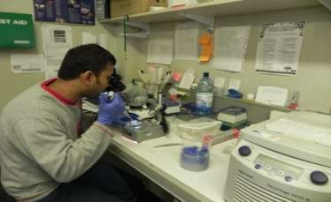 | Queen’s University Belfast, Belfast, Northern Ireland, UK  (Since 15th Oct, 2010)
 | Ms. Sureka Kanagarajan  Department of  Bioinformatics | 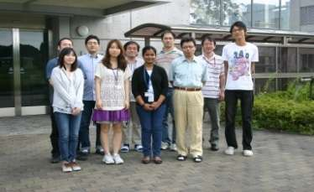 | RIKEN Harima Institute  SPring-8, Japan  (20th Jun - 20th Aug, 2010)
 | Ms. Lalitha Thiagarajan  Department of Animal  Health & Management | 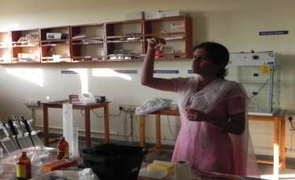 | Queen’s University Belfast, Belfast, Northern Ireland, UK  (Since 09th Jan, 2011)
 | Mr. M. Nachiappan  Department of  Bioinformatics | 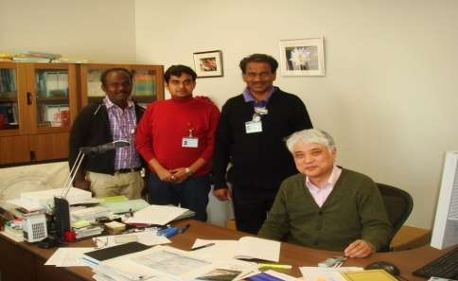 | RIKEN SPring-8 Center, JAPAN  (2nd - 8th Dec, 2012)
 | Ms. N. LAVANYA  Department of Bioelectronics and Biosensors | 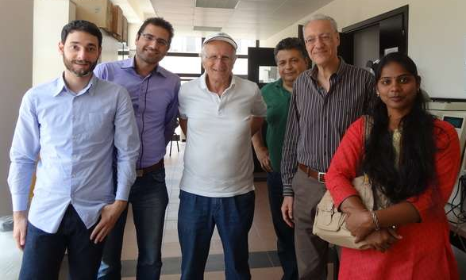 | Department of Electronic Engineering, Chemistry and Industrial Engineering,  University of Messina, Messina, Italy.  (April- July, 2015)

Visiting Professor
Department |  | Visiting Professor
Department of Physics | 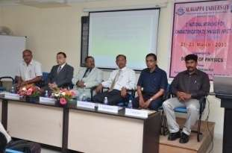 | Prof.Kenji Kitamura  National Institute for Materials science, Tsukuba, Japan  Visited Date: 29th - 30th Jan, 2013
Department of Physics | 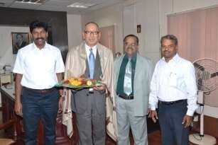 | Prof. Yasuhiro Hayakawa  Research Institute of Electronics, Shizuoka University, Hamamatsu, Japan  Visited Date: 22nd - 23rd Mar, 2013
Department of  Bioelectronics & Biosensors | 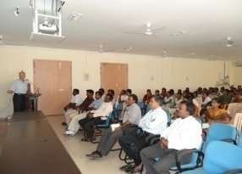 | Prof. Giovanni Neri  Department of Industrial Chemistry and Materials Engineering, University of Messina,Messina, Italy.  Visited Date: 17th - 25th Feb, 2013
Department of Industrial Chemistry | 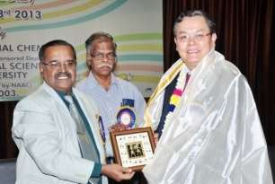 | Prof. Shen-Ming Chen  Department of Chem Engi and Biotechnology National Taipei University of Technology No. 1, Taipei, Taiwan
Department of Industrial Chemistry |  | Prof. Osama Abdel Abdelrahman Aly  National Research Centre, Textile Research Division, Tahrir St., Dokki, Cairo, Egypt  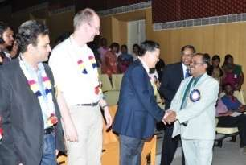  Prof. Frank Marken  Dept of Chemistry, University of Bath  Bath BA2 7AY, UK.  Visited Date: 20th - 25th Mar, 2013
Department of Bioinformatics | 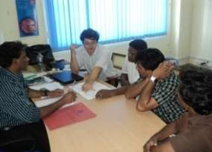 | Dr. Chun-Jung Chen  Division Head  Scientific Research Division,  Laboratory of Protein Crystallography and Structural Biology, National Synchrotron Radiation Research Center (NSRRC), Taiwan  Visited Date: 26th - 30th Mar, 2013
Department of Biotechnology | 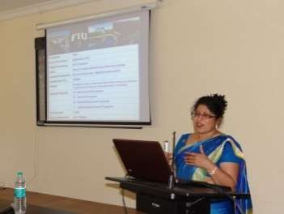 | Prof. Kalai Mathee  Department of Molecular Microbiology and Infectious Diseases, Herbert Wertheim College of Medicine, Florida International University, Miami, USA  Visited Date: 5th - 12th Apr, 2013
Department of Biotechnology | 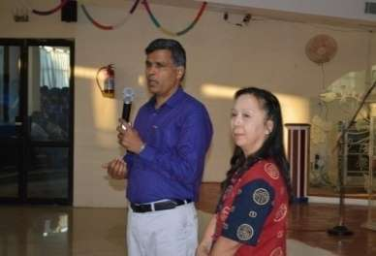 | Prof. Supayang Piyawan Voravuthikunchai  Department of Microbiology,  Director of Natural Products Research Center, Prince of Songkla University,  Thailand-90112.  Visited Date: 11th - 15th Apr, 2013
Department of Women’s studies | 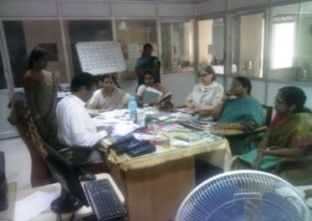 | Prof. Dr. Habil. Peto Andrea  Department of Gender Studies, Central European University, Hungary  Prof. Dr. Sherry Cummings  Department of Social Work  University of Tennessee, Nashville, US  Visited Date: 19th - 22nd Aug, 2013

