Alagappa University Environmental Awareness Club
Alagappa University Environmental Awareness Club's aim is to emphasize the awareness about the environmental issues and reinforce community involvement to protect nature as well as human life. Members of the Environmental Awareness Club learn and gain the knowledge about the environmental problems that are affecting our Earth and community, and work to control the environmental issues. The community begins with the objectives of the club and the activities used to meet specific target. With more dutiful to “green world” awareness of protecting the environment and its limited natural resources, this become a prominent issue. Promoting environmental awareness is an easy way to become an environmental steward and participate in creating a brighter future for our children. It is an integral part of the club's success.

Name | Designation & Dept./Division/College. | Status
Faculty | Dr. S. KARUPPUCHAMY  Associate Professor and Head (i/c)  Department of Energy Science  Alagappa University  Karaikudi – 630003 | Coordinator
Faculty | Dr. H. GURUMALLESH PRABHU  Professor  Department of Industrial Chemistry  Alagappa University | Member
Faculty | Dr. SANJEEV KUMAR SINGH  Professor  Department of Bioinformatics  Alagappa University | Member
Faculty | Dr.G. VINAYAGAMOORTHI  Assistant Professor  Department of Commerce  Alagappa University | Member

Aim and Purpose | To create an environmental awareness and impact of pollution to all stakeholders
Aim and Purpose | To organize special competitions to the students on the impact of Global warming
Aim and Purpose | To arrange Special lectures on Causes and Effects of Global Warming

Activities | Organizing competitions (Drawings/ Essay) for School, college and university students on environment and ecology
Activities | Preparing and Screening of Slides on Environment and Ecology
Activities | Encouraging Research on Safe Environment practices in Factories especially those in highly polluting activities like Textile, Tanning, etc.
Activities | Planting trees in the Ecologically Fragile Zones
Activities | Creating Public Awareness on Environment and Ecology Management

ACTIVITIES CARRIED OUT

The Environmental Awareness Club's goal is to raise the awareness of the Public /Community about environmental issues. This club conducted a variety of projects including tree planting, cleaning campaign etc.

TREE PLANTING AND CLEAN CAMPAIGN
Tree planting and clean campaign was organized by Village Placement Programme in association with Environmental Awareness Club at Kanadukathan, Sivagangai District (2011). Totally 100 saplings were planted in different places of Kanadukathan during the period of Village Placement Programme.
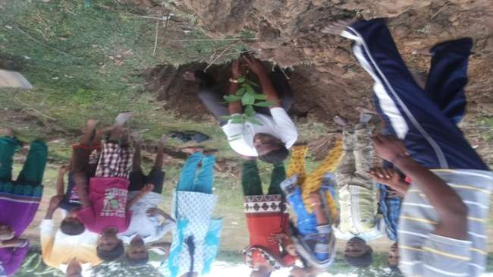

TREE PLANTING CAMPAIGN
Tree planting campaign was organized by Centre on Swachh Bharat & Swasth Bharat in association with National Service Scheme and Environmental Awareness Club on 17.12.2014 in the Management campus. Totally 125 saplings were planted in different places (Management campus, Science Campus, PG Block, DDE Campus ACP campus and Skill Development Centre) of Alagappa University and name board of two volunteers who would be taking care of each sapling was fixed.
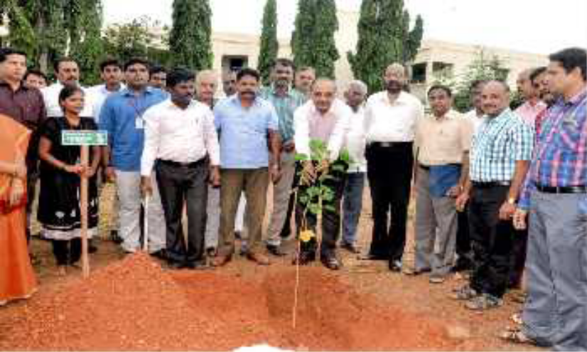

CLEANING CAMPAIGN

Cleaning campaign was organized by Centre on Swachh Bharat & Swasth Bharat in collaboration with National Service Scheme and Environmental Awareness Club on 19.12.2014 in the public place (Karaikudi Railway Station). A total of 225 students took part in the cleaning campaign. The Station master has appreciated the students of Alagappa University for their efforts in cleaning the entire Railway station.

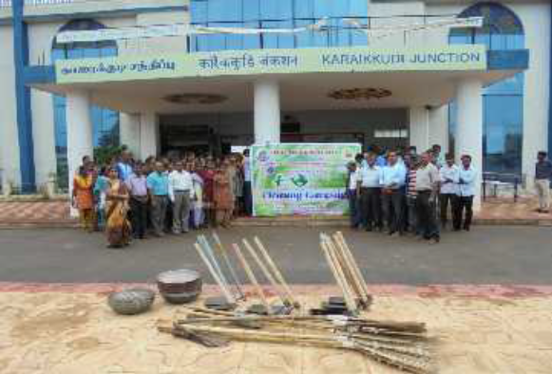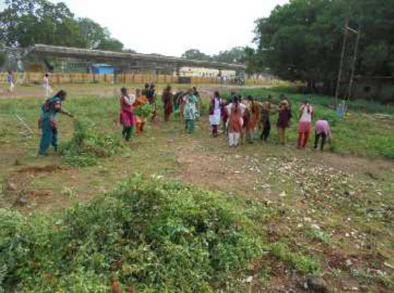

CAMPUS CLEANING CAMPAIGN

Campus cleaning campaign was organized by Centre on Swachh Bharat & Swasth Bharat in collaboration with National Service Scheme and Environmental Awareness Club on 12.08.2016 in the Alagappa University Science Campus. A total of 200 students took part in the cleaning campaign.

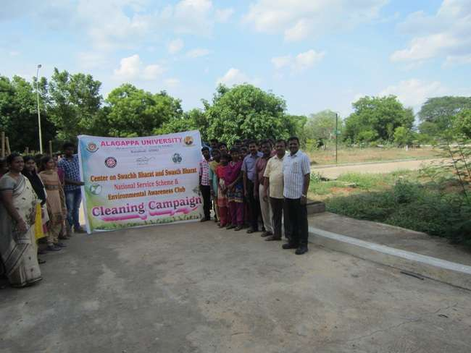

The National Institute of Cleanliness Education and Research has honoured our University with Clean and Green Campus Award. It presented the award to the university and Vice-Chancellor at the World Cleanliness Day celebrations held in Delhi on December 13 as part of the World cleanliness convention.

One Student –one tree programme

In order to make the campus green, we have launched one student- one tree programme on January 10th 2017 as part of the greenery programmes implemented by our University. As per the programme, a student, after the joining the University would be given a sapling and he/she should nurture the plant till the completion of their studies. In the first phase, thousands saplings were planted by the students.

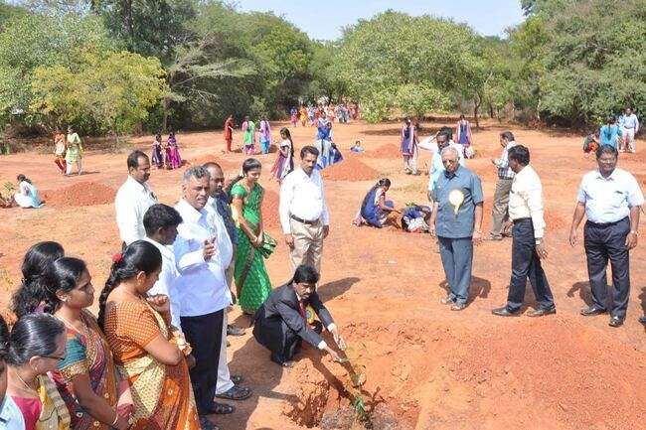

We have organized tree plantation programme in association with Centre on Swachh Bharath & Swasth Bharath, NSS and Department of Botany on February 10th and 20th 2017 as part of the greenery programmes implemented by our University. In the second and third phase, two thousand two hundred saplings were planted by the students.
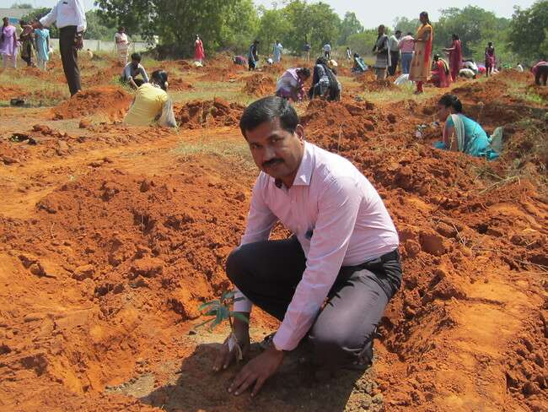

NATIONAL ENERGY CONSERVATION DAY

Environmental Awareness Club jointly organized National Energy Conservation Day programme in association with Department of Energy Science and Centre on Swachh Bharat & Swasth Bharat on February 14th 2017 in the Alagappa University Campus.

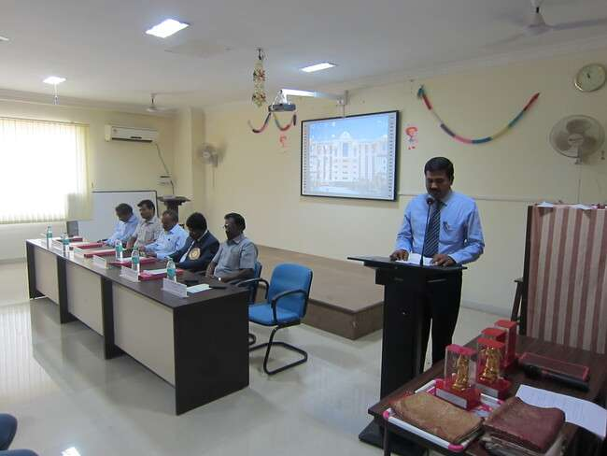

In his Presidential Address, Prof. S. Subbiah, Vice-Chancellor, said that modern man has forgotten to use the natural resources unlike the people of the earlier days. People in the past using all natural resources such as natural air and sunlight lived a healthy life; and it also helped to enhance productivity level of workers reducing the energy consumption. He added that the introduction of modern gadgets like A.C., Fan, Artificial Light, etc. has changed the life style of people resulting in the deterioration of normal health and this has also led to more use of non-renewable energy. He elaborated on the need for living close to nature. He also referred to the energy conservation challenges faced in the thickly populated countries and emphasized that energy audit and conservation are key factors that have to be taken note of seriously from the energy saving perspective. He appealed to the students to make use of the nature’s gift for a harmonious living and also for saving the country from energy crisis. Dr. M. Kottaisamy, Professor and Head of the Department of Chemistry, Thiagarajar College of Engineering, Madurai, delivered the Keynote Address, in which he insisted the need to create awareness among the people on the dire need for energy conservation and suggested the importance of practical steps to be evolved to overcome challenges. He highlighted the importance of renewable energy such as solar energy, bio-fuels and also the need for minimizing carbon emission to safeguard the environment. Dr. M. Sathish, Scientist, CSIR-CECRI, Karaikudi, in his Special Address, spoke about energy storage materials and made references to future challenges that are likely to surface in energy conservation and suggested for the creation of awareness in the society on the avoidance of unnecessary uses of energy and the efficient use of it for future usage. Dr. S. Karuppuchamy, Head of the Department of Energy Science and Coordinator for Environmental Awareness Club welcomed the gathering and elucidated the objectives and importance of the Energy Conservation and protection environment.

CAMPUS CLEANING CAMPAIGN
A quarter of all global deaths of children and five years old are due to unhealthy or polluted environments, including duty water and air, second hand smoke and a lack or adequate hygiene. According to the World Health Organization (WHO) polluted environment kills 1.7 million children a year. We have organized the Campus cleaning campaign in association with Centre on Swachh Bharat & Swasth Bharat and NSS on 04.03.2017 in the Alagappa University Campus.

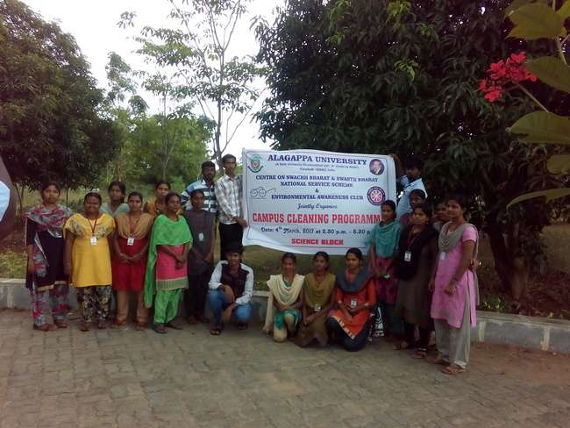

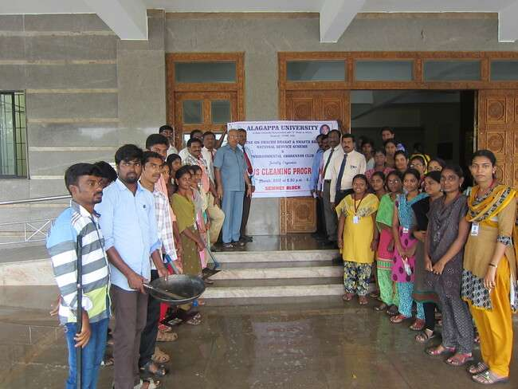

Future Plan
- Survey on Carbon Footprint
- Implementation of Reuse and Recycle of Materials
- Water conservation

