DE–6013
11
DISTANCE EDUCATION
M.Phil. (Mathematics) DEGREE EXAMINATION, MAY 2009.
COMMUTATIVE ALGEBRA
Time : Three hours Maximum : 100 marks
Answer any FIVE questions.
(5 × 20 = 100)
1. (a) Show that any two bases of a free module have the same cardinality.
(b) Show that any R-module  can be expressed as the quotient of a free R-module F. If is f 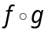, show that F can be chosen to be free of finite rank.
If  is an exact sequence then show that 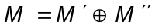.
2. (a) Show that the tensor product of two R–modules exists and it is unique upto isomorphism.
(b) Show that M is faithfully flat if and only if M is flat and for maximal ideal m of R, 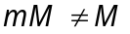.
3. (a) Let I be an ideal with 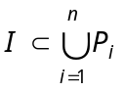, 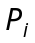 prime. Show that 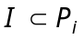 for some i.
(b) Let 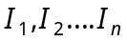 be mutually comaximal ideals of R. Show that 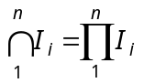.
(c) Show that for the polynomial ring 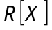 the nilradical is equal to the Jacobson radical.
4. (a) Let R be a local ring. Show that any , projective R–module is free.
(b) If R is Noetherian show that is Noetherian.
5. (a) State and prove the first uniqueness theorem for primary decomposition.
(b) State and prove structure theorem for Artinian rings.
6. (a) State and prove going down theorem.
(b) State and prove Noether’s normalisation theorem.
7. (a) Let R be a discrete valuation ring with maximal ideal m and I a non-zero ideal of R. Show that
(i) 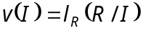
(ii) If 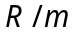 contains a field k then 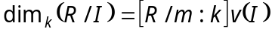.
(b) Let R be a local domain. Show that every non-zero fractionary ideal of R is invertible if and only if R is a DVR.
8. (a) Show that an abelian group is an injective
z-module if and only if it is invertible.
(b) Show that any R-module can be embedded in an injective R–module.

————————
DE–6017
14 B
DISTANCE EDUCATION
M.Phil. (Maths) DEGREE EXAMINATION, MAY 2009.
DATA STRUCTURES AND ALGORITHMS
(Upto 2006 Batch)
Time : Three hours Maximum : 100 marks
Answer any FIVE questions.
(5 × 20 = 100)
1. By giving suitable examples, explain the function overloading and function overriding concepts in C++.
2. Explain the purpose of the following in an object -oriented programming.
(a) Default arguments
(b) Inline function
(c) Scope resolution operator
(d) Virtual function.
3. Write a C++ routine to convert an infix expression into a postfix and a prefix form using stacks and explain the algorithmic steps.
4. Explain the features of a stack and a linear linked list and write a C++ class to implement push, pop and search operations of a stack using linked list.
5. Write an algorithm and a C++ routine to perform each of the following operations.
(a) Append an element to the end of a list
(b) Reverse a list, so that the last element becomes the first and so on
(c) Delete the n^{th} element from a list
(d) Return the sum of integers in a list.
6. Implement a C++ class for a queue using the sequential representation and overflow, underflow conditions.
7. Write the routines to implement the inorder, postorder and preorder tree traversals and give examples.
8. Explain the algorithms used to find number of paths of a given length and number of total paths existing between two particular nodes in a graph.
——————
DE-6016
14-A
DISTANCE EDUCATION
M.Phil. (Mathematics) DEGREE EXAMINATION, MAY 2009.
FUNDAMENTALS OF DOMINATIONS IN GRAPHS
(Upto 2006 batch)
Time : Three hours Maximum : 100 marks
Answer any FIVE questions.
All questions carry equal marks.
1. (a) If 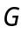 is a graph without isolated vertices and if S is a minimal dominating set of G then 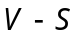 is a dominating set. Prove.
(b) If a graph G has no isolated vertices then prove that 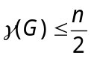.
2. For any tree T, 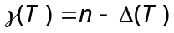 iff T is a wounded spider - Prove.
3. If a graph has 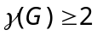 then prove that 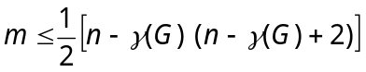 .
4. (a) Prove that every connected graph has a weakly connected independent dominating set.
(b) If G has no isolated vertices then prove that
Dir 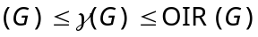 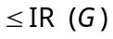
5. If 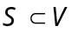 is a maximal irredundant set in a graph G, prove that it is a minimal external redundant set.
6. If T is a tree of order 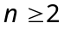 then prove that 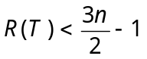 and 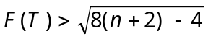.
7. (a) For any tree T with 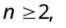 prove that there exists a vertex  such that 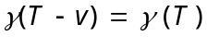.
(b) A vertex V is in 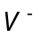 if and only if 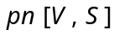 = 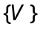 for some set S containing . - Prove.
8. (a) If a graph 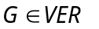 has order 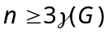 and prove that 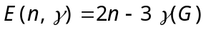.
(b) A graph 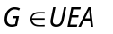 iff is empty - Prove.

——————
13
DE–6015
DISTANCE EDUCATION
M.Phil. (Mathematics) DEGREE EXAMINATION, MAY 2009.
TOPOLOGICAL VECTOR SPACES
(Upto 2006 batch)
Time : Three hours Maximum : 100 marks
Answer any FIVE questions.
(5 × 20 = 100)
1. (a) If 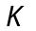 is a compact subset and 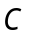 is a closed subset of a topological vector space  with 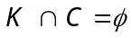 then prove that 0 has a neighborhood 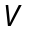 such that 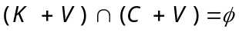.
(b) Prove that in a topological vector space , every convex neighborhood of 0 contains a balanced convex neighborhood of 0.
(c) Prove that every locally compact subspace  of a topological vector space is a closed subspace of .
2. If is a topological vector space with a countable local base, prove that there is a metric on such that (a) is compatible with the topology on (b) the open balls centered at 0 are balanced and (c) is invariant.
If in addition is locally convex, prove that can be chosen so as to satisfy (a), (b), (c) and all open balls are convex.
3. (a) If  is a convex absorbing set in a vector space , prove that :
(i) 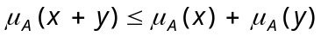
(ii) 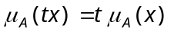 if 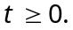
(iii) 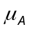 is seminorm if is balanced.
(iv) If 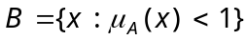 and 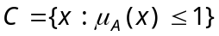 then 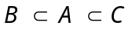 and 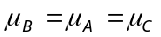.
(b) Let 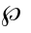 be a separating family of seminorms on a vector space and to each 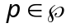 and a positive integer , let 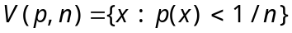. If  is the collection of all finite intersections of the sets 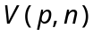. Prove that is a convex balanced local base for a topology on which turns into a locally convex space such that every is continuous and a set 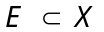 is balanced iff every is balanced on 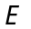.
4. (a) State and prove Baire’s theorem.
(b) State and prove Banach–Steinhaus theorem.
(c) Let and be topological vector spaces and 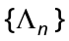 is a sequence of continuous linear mappings of into . If is the set of all 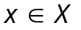 for which 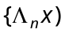 is a Cauchy sequence in and if is of the second category in prove that 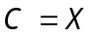.
5. (a) State and prove open mapping theorem
(b) Let be an 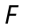–space and and  be topological vector spaces. If 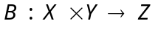 is bilinear and separately continuous, prove that 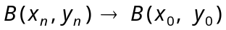 in whenever 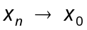 in and 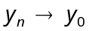 in .
6. (a) Suppose  is a subspace of a real vector space , 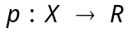 satisfies 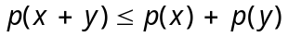 and 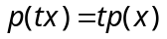 for 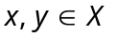 and 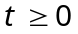 and 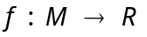is linear with 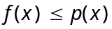 on , prove that there is a linear 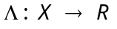 such that 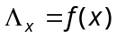 for 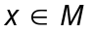 and 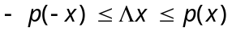 for .
(b) Show that in a locally convex space , every weakly bounded set is originally bounded and vice versa.
7. (a) State and prove that Krein–Milman theorem.
(b) If is a locally convex space and 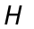 is the convex hull of a totally bounded set prove that is totally bounded.
8. (a) If and are normed spaces, prove that 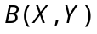 is also a normed space under the norm defined as 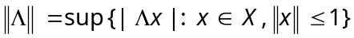. Also prove that if is a Banach space so is 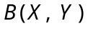.
(b) If is a Frechet space, is a complemented subspace of , is a compact group which acts as group of continuous linear operators on and 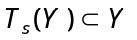 for every . Prove that there is a continuous projection  of onto which commutes with every 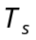.
————————
DE–6014
12
DISTANCE EDUCATION
M.Phil. (Mathematics) DEGREE EXAMINATION, MAY 2009.
MEASURE THEORY
Time : Three hours Maximum : 100 marks
Answer any FIVE questions.
Each question carries 20 marks.
- (a) If is a positive measure on a algebra M. Prove that
(i) 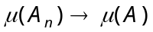 as if 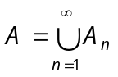, 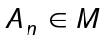 with 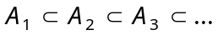
(ii) as if 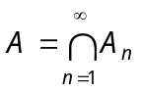, with 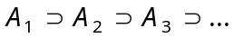 with 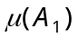 is infinite.
(b) If 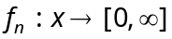 is measurable for 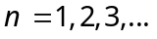 and 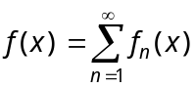 prove that 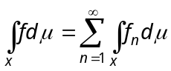.
- If f and 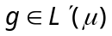 and and 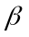 are complex numbers. Prove that 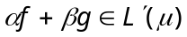 and 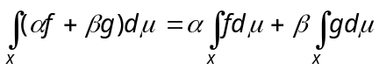.
- (a) State and prove Lebesgue’s Dominated convergence theorem.
(b) If 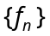 is a sequence of complex measurable functions defined a.e on x such that 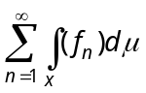 , Prove that the series converges for almost all x, 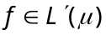 and .
- (a) Define convex function.
(b) State and prove Jensen’s inequality.
- State and prove Holder’s inequality.
- If and are positive bounded measure on a algebra in a set x, prove that there is a unique 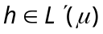 such that 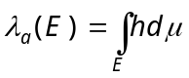, 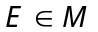.
- State and prove the Fubini theorem.
- If f, 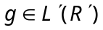 prove that 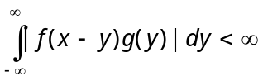 for almost all x. For these x, if we define 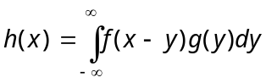 prove that 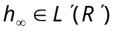 and 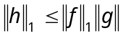, where 


