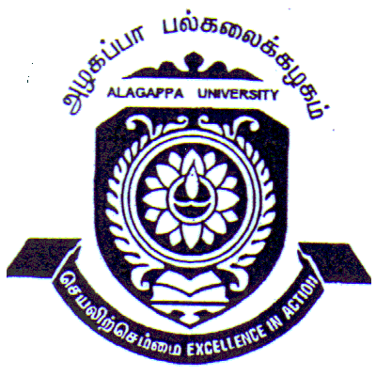 | ALAGAPPA UNIVERSITY  (Established by an Act of the Govt. of Tamilnadu and recognized by UGC)  (Accredited with “A” Grade by NAAC)  Karaikudi – 630 003 |  | 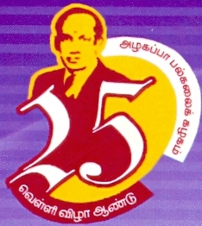
Applications are invited from the suitable Candidates for work in the following Projects as Project Fellow / Junior Research Fellow. Qualification: Master Degree in the relevant / related Discipline with not less than 55% marks in the qualifying Examination. Pass in NET / SLET / GATE is preferable. Research Experience in the related field and related skills are preferable. Age : Below 28 Years as on 01-04-2010
Name of Principal  Investigator & Department | Funding  Agency & Duration | Title of the Project |  | Emoluments
Dr. Sengottuvelan  (DDE –Chemistry) | DST-3 Years | Metallonuclease activity and structural analysis of binuclear metal cmplexes of Pendent functionalized fctraazamacrocyclic ligand. |  | Rs. 12000 /- p.m. +HRA
Dr. G. Jayabal  (Alagappa Institute of Management) | UGC – 18 Months | Impact of agricultural credit on the agricultural productivity and the standard of living of the farmers in Tamilnadu |  | Rs. 8000/ p.m.
Eligible candidates may send their bio-data along with the attested copies of the certificates and experience certificate if any to the Concerned Principal Investigator on or before 26-04-2010.

Karaikudi
15-04-2010 REGISTRAR

S.No | Name of Principal  Investigator & Department | Funding  Agency & Duration | Title of the Project | Name | AQ | RE | IP | Total  Marks | Remarks
1 | Dr. E. Kannapiran  (DDE- Marine Sciences / Zoology) | M o E & F, GOI  – 3 Years | Microbial pathogens of corais and the events of biotic and transformation in the progress of pathogensis

S.No | Name of Principal  Investigator & Department | Funding  Agency & Duration | Title of the Project | Name | AQ | RE | IP | Total  Marks | Remarks
2 | Dr. M. Karthikeyan (Bioinformatics) | UGC – 3 years | Genetic polymorphisms of the essential hypertension associated genes in random subjects of the south Indian general population

S.No | Name of Principal  Investigator & Department | Funding  Agency & Duration | Title of the Project | Name | AQ | RE | IP | Total  Marks | Remarks
3 | Dr. A. Arumugam  (Nanoscience & Technology) | UGC – 3 years | Micro propagation and germplasm conservation of endangered medicinal plants in Southern India
4 | Dr. P. Shakkthivel (Nano Science & Technology) | UGC – 3 years | Novel heterogeneous nanocatalysts for biodiesel synthesis from vegetable oils

5 | Dr. A. Subramania (Industrial Chemistry) | UGC – 3 years | Development of acidizing inhibitors for petroleum oil wells
6 | Dr. S. Thambidurai (Industrial Chemistry) | UGC – 3 years | Optimization study of salt-free reactive dyeing and fixing of seaweed nano particles on cotton fabric for permanent antibacterial finishing
7 | Dr. M. Sundrarajan  (Industrial Chemistry) | DST - 3 Years | Source reduction of pollutants from textile effluents by greener route

8 | Dr. M. Sivakumar  (Physics) | DST-3 Years | Synthesis and Characterization of Nano Crystalline LiFePO4 Cathode Materials for Lithium Battery Fabrication by Polyol Process

9 | Dr. Sengottuvelan  (DDE –Chemistry) | DST-3 Years | Metallonuclease activity and structural analysis of binuclear metal cmplexes of Pendent functionalized fctraazamacrocyclic ligand.

Minutes of the Selection Committee meeting held on 18-03-2010, 10 .00 a.m. at the Syndicate Hall of Alagappa University for the

selection of one Project Fellow in the UGC Project.

S.No | Name of Principal  Investigator & Department | Funding  Agency & Duration | Title of the Project | Name | AQ | RE | IP | Total  Marks | Remarks
10 | Dr. S. Subbiah (English) | UGC – 2 years | Enhancing scholastic Achievement of Primary Children with Mild Mental Retardation through a competency Updating Teaching Training Program for inclusive Education | S. Subramanian
 |  |  |  | M. Prabavathy
 |  |  |  | U. Veeramuthu

The Selection Committee recommends to select Mr. / Ms. ________________________ as Project Fellow based on merit and place Mr. / Ms.

__________________ as wait-listed candidate.

Dr. M. Akbar Shah Dr. M. Noel Dr. R. Thirumalaisamy

Dr. P. Prema Dr. S. Subbiah

Dr. S. Sudalaimuthu Dr.M. Selvam Dr. R. Natarajan

11 | Dr. D. Mani Azhagu (Physical Education and Health Sciences) | UGC – 2 years | Effects of Varied Packages of Yogic Practice on Health Related Fitness Physiological Hematological and Bio- Chemical Variables Among Obses Women

12 | Dr.B. Dharmalingam (Centre for Rural Development) | UGC – 2 years | Women Exclusion and Empowerment in Local Self Government of Rural Tamilnadu

13 | Dr. K. Manimekalai  (Centre for Women’s Studies) | UGC – 2 years | Constructing IDEAL Strategies for Countering Gender Violence

14 | Dr. G. Jayabal  (Alagappa Institute of Management) | UGC – 18 Months | Impact of agricultural credit on the agricultural productivity and the standard of living of the farmers in Tamilnadu

