
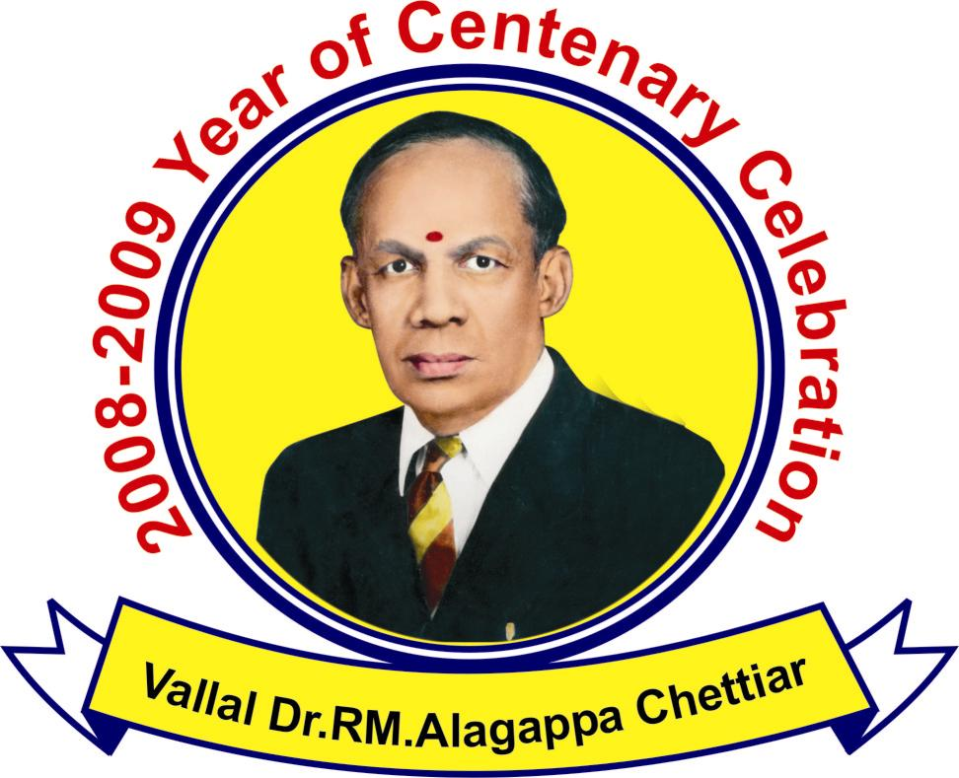

ALAGAPPA UNIVERSITY,Karaikudi
(Accredited with “A” grade by NAAC)

INTERNATIONAL COLLOQUIUM ON
“EMERGING BIOTECHNOLOGIES IN AGRICULTURE, ANIMAL HEALTH AND PRODUCTIVITY” (ICEB’09)

February, 23-27, 2009

On the eve of 100th Birth anniversary celebration of (Late) Dr. RM.Alagappa Chettiar, the Founder of the University.

Venue: L. CT. L. Palaniappa Chettiar Memorial Auditorium
Alagappa University
Organized by

(A)  School of Bio-Sciences  Alagappa University  Karaikudi - 630 003  Tamil Nadu, India. | (B)  School of Biological Sciences  The Queen's University of Belfast  University Road, Belfast,  BT7 1NN, Northern Ireland,  UK | (C)  Agri-Food and Biosciences Institute,  Stoney Road,  Stormont, Belfast,  Northern Ireland,  BT4 3SD.

Organizing Committee

Patron: Prof. P. RAMASAMY, Vice Chancellor, Alagappa University, Karaikudi

Organizing Chairmen

Dr.G.Brennan, Queen's University of Belfast, UK

Prof:- R.E.B.Hanna, Queen's University of Belfast, UK

International Steering Committee

S. No | SPEAKERS
 | Dr. Gerry Brennan (QUB, Belfast,UK)
 | Dr. Tim Day (Lowa, USA)
 | Dr. Ian Fairweather (QUB, Belfast)
 | Dr. Hugh Ferguson (Stirling, UK)
 | Dr. Colin Fleming (AFBI-Newforge, Belfast)
 | Dr. Bob Hanna (AFBI-Stormont, Belfast)
 | Dr. Seamus Kennedy (AFBI-Stormont, Belfast)
 | Dr. Dave Knox (Moredun, UK)
 | Dr. Dermot Mackie (AFBI-Stormont, Belfast)
 | Dr. Frank Malone (AFBI-Stormont, Belfast)
 | Dr. Aaron Maule (QUB, Belfast)
 | Dr. Bob McCracken (AFBI-Stormont, Belfast)
 | Dr. Roger Pritchard (McGill, Canada)
 | Dr. Joan Symth (Connecticut, USA)
 | Dr. Terry Spithill (Wagga Wagga, Australia)
 | Dr. Tracey Williams (Pfizer, USA)
 | Dr. Levon Khachigain (Sydney, Australia)
 | Dr. Ramnath Vairavan, California,USA

National Steering Committee
- Prof. S.P. Thiyagarajan, Sri Ramachandra University, Chennai
- Prof. G. Padmanaban, IISc, Bangalore, Karnataka
- Prof. R. Madhavi, Andhra University, Vishakapatnam, Andra Pradesh.
- Prof. K.Dharmalingam, Madurai Kamaraj University, Madurai.
- Prof. P. Gunasekaran, Madurai Kamaraj University, Madurai.
- Prof. A.K.Tyagi, University of Delhi, Delhi.
- Prof. K.Veluthambi, Madurai Kamaraj University, Madurai.
- Dr. V. Purushothaman, TN Veterinary and Animal Sciences University, Chennai.
- Dr. K. Kumanan, TN Veterinary and Animal Sciences University, Chennai.
- Dr. P. Nagarajan, Institute of Finger Printing, Hyderabad.
- Dr. R.C Kartha, Sri Chithra Thirunal Institute, Thiruvanathapuram.
- Prof. M. A. Akbar shah, Bharathidasan University, Tiruchirappalli.
- Prof. M.Krishnan, Bharathidasan University, Tiruchirappalli.
- Prof.D.Velmurugan, University of Madras, Chennai.
- Prof. G. Jayaraman, University of Madras, Chennai.
- Prof. P. Mullainadhan, University of Madras, Chennai.
- Prof.S.P .Singh, Saurashtra University, Rajkot

Local Organizing Committee
Dr. E. Ilamathian, Registrar
Dr. (Mrs) Umayal Ramanathan, Member of the Syndicate
Thiru V. Kasinathan, Member of the Syndicate
Thiru R. Arivuselvam, Member of the Syndicate
Prof. S. Sudalaimuthu, Member of the Syndicate
Prof:-M. Selvam, Member of the Syndicate
Prof: R.Natarajan, Member of the Syndicate
Prof. V. Manickavasagam, Controller of Examinations
Thiru R. Boominathan, Finance Officer
Dr.A. Ramakrishnan, Special Officer (E D&M)
Prof: V. Balachandran, Director, Distance Education
Prof. RM. Chidambaram, Dean, Faculty of Management
Prof: T.R.Gurumoorthy, Dean, College Development Council
Prof: S.Kaliyamoorthy, Director, Alagappa Institute of Management
Prof: P. Manisankar, Prof. & Head, Dept. of Industrial Chemistry
Prof. C.Sanjeeviraja, Prof. & Head, Dept. of Physics
Prof. S.Karuthapandian, Prof. & Head, Dept. of Biotechnology
Prof. P. Prema, Dean, Faculty of Education
Prof. S.Gokilavani, Director, Dept. of Women’ Studies
Prof. M. Pandi, Prof. & Head, Dept. of Tamil
Prof: A. Shenbagavalli, Prof. & Head, Dept. of Physical Education and Health Sciences
Prof. R. Krishnaraj, Dean, Faculty of Arts
Prof. K.Gurunathan, Prof. & Head, Centre for Nanoscience and Nanotechnology
Dr. C.Govindasamy, Reader & Head i/c, Dept. of Oceanography and Coastal Area Studies
Dr. B.Vaseeharan, Reader and Head, Centre for Animal Health and Management
Dr. P.Srinivasan, Lecturer,Dept. of Bioinformatics
Dr. V.Dharuman, Lecturer, Dept. of Bioelectronics and Biosensors
Dr.J.Wilson, Lecturer, Dept. of Bioelectronics and Biosensors

About us

Alagappa University, accredited with 'A' Grade by UGC’s National Assessment and Accreditation Council (NAAC), came into existence by a Special Act of the Legislature of the Government of Tamil Nadu in May 1985 with the objective of fostering research, development and dissemination of knowledge in various branches of learning. This University has emerged from the galaxy of institutions initially founded by the great philanthropist and educationist Padmabushan (Late) Dr. RM. Alagappa Chettiar.

Background

With the emergence of India in the 21st Century as a world-leading nation in terms of social, technological and economic development, there is an urgent need to modernize and expand agricultural productivity, particularly in the livestock sector, in order to maximize self-sufficiency in food supply and to augment GDP for a rapidly expanding and increasingly urbanized population. In response to this need, corporate farming enterprises in poultry, small ruminant, buffalo, dairy, meat, and aquaculture production have emerged and are developing rapidly. In addition to corporate ownership, such initiatives feature multiple site utilization throughout a wide geographical range, and instigation of modern intensive production methods.

In order to address the growing demand for appropriately trained staff to manage such enterprises on a local basis, Alagappa University has recently established a Department of Animal Health and Management. The aim is to provide industry-oriented, degree level training, comprising approximately 60% veterinary and 40% management content. Alagappa University is a nation-leading University in the novel ‘distance-learning’ concept, with particular strengths in Management, and it boasts of a rapidly developing Science faculty, incorporating an active School of Biosciences, but it has yet to establish a veterinary profile.

Rationale for the Colloquium

The purpose of this International Colloquium is to focus the attention of national policy-makers, academicians in agricultural biotechnology and industry-leaders throughout India on the vast opportunities in this area and develop strategies for harnessing the same. It is hoped that the colloquium will provide a forum for establishment of liaison and intellectual co-operation between Indian scientists and overseas experts in relevant areas of biotechnology and livestock-based agriculture.
Overseas Contributors

Through formal presentation and informal discussions, overseas contributors to the colloquium are invited to share their insights and experience regarding biotechnological approaches to emerging diseases and management problems in intensive agricultural production worldwide, and in provision of scientific and veterinary services to the agricultural industry. In particular, aspects relating to chemotherapy and prophylaxis, vaccine development, disease diagnosis and surveillance in large and small ruminants, poultry, fish and pigs will be of particular interest in the light of India’s evolving and modernizing agricultural economy. Further, emerging areas in basic research which are likely to impact future trends and developments in the agricultural sector will be highly relevant, for example, basic studies in genomic and proteomic variability and selection in pathogens, hosts and vectors, pathogen control and drug resistance (particularly relating to anthelminitics); drug target discovery, validation and rational drug design; host parasite interplay; molecular engineering and nanotechnology. Discussion and interaction centered on these and similar relevant aspects of basic bioscience will be particularly appreciated.
Areas of Focus
- Animal Biotechnology
- Animal Genomics and Proteomics
- Agriculture Biotechnology
- Veterinary Sciences
- Medical Biotechnology
- Microbial Biotechnology
- Bioinformatics
- Aquatic Animal Health
- Bioelectronics and Biosensors
- Nanobiotechnology
- Recombinant Vaccines
- Marine Biotechnology
- Marine Resource Management
- Animal Industry
- Farm Management

Venue:
L.CT.L.Palaniaapa Chettiar Memorial Auditorium, Alagappa University
Karaikudi 630 003, Tamil Nadu, India.

Call for Abstracts (for Poster Presentation only)
Research abstracts are invited from the interested on the areas of focus mentioned in the scope of the conference.

Poster Presentation

The poster should be limited to a space of 3 x 4`` feet.

Title: Font size 90-95, Times New Roman / Arial, Bold, Centrally aligned all word in capital
Authors: Font size 45-50, Times New Roman / Arial, Bold, Italic, Centrally aligned all (Name of the corresponding author should be underlined)
Institute Name: Font size 50-55, Times New Roman, regular, centrally aligned

Sub Headings: Font size 55-60, Times New Roman, Bold, aligned left

Text Body: Font size 30-35, Times New Roman, Regular, Justified

Table Heading: Font size 40-45, Arial, Bold, aligned left

Table: Columns, rows, Font size 25-30, Times New Roman, regular aligned left

Figures: Resolution 600dpi-800dpi, Gels should not be hazy

Acknowledgement: Font size 25-30, Times New Roman, regular, aligned left

Reference: Font size 30-35, Times New Roman / Arial, aligned left

Schedule of Important Dates

Submission of Abstracts: Feb 10th 2009
Acceptance of Abstracts: Feb 12th 2009
Last date for Registration: Feb 12th 2009

Level of Participants
Academicians / Scientists / Faculty, Ph.D Scholars, Post Graduate students from Universities/Colleges/R&D Institutions in the disciplines of Life Sciences, Biotechnology, Bioelectronics, Biosensors, Veterinary Sciences, Zoology, Animal and Plant Sciences and Pharmaceutical Sciences would be the participants of ICEB`09

Registration Fee

Foreign delegates: | US$ | : | 250
Delegates from Academic/Research Institutions: | Rs. | : | 1500
Student Delegates: | Free*
Delegates from industries: | Rs. | : | 5000

The selected participants have to pay the registration fee through bank draft drawn in favour of ‘The Registrar, Alagappa University’ payable at Karaikudi. Registration fee excludes Accommodation. *Students need to make their own accommodation and food.

Accommodation

1. | Hotel
 | Non-Air Conditioned
1A | Single Bed Room | : | Rs. 200 per day
1B | Double Bed Room | : | Rs. 425 per day
1C | Triple Bed Room | : | Rs. 600 per day
 | Air Conditioned
1D | Double Deluxe Room AC | : | Rs. 750 per day
1E | Double Special Deluxe Room AC | : | Rs. 1400 per day
1F | Triple Room AC | : | Rs. 900 per day
1G | Family Room AC | : | Rs. 1200 per day
2 | Hostel
 | Charges for Hostel | : | Rs. 50 per day
3 | Not Required
For further details:
Please visit - http://www.alagappauniversity.ac.in
Local Co-organizing Secretaries | International Organizing Secretaries
Dr.M.Selvam, | Dr.Gerry Brennan
Dr. S.Karuthapandian, | R.E.Bob Hanna
Dr. C. Govindasamy,
Dr.B.Vaseeharan,
Dr.P.Srinivasan

International Colloquium on Emerging Biotechnologies in Agriculture, Animal Health and Production (ICEB’09)
Alagappa University
Karaikudi – 630 003
Tamil Nadu, India.

Contact nos:- 04565-225206-07 Extn – 145
Mobile numbers - +91-9894720893,+91-9444154070,+91-9444482814
E.mail:- alagappauniversity@gmail.com, cahm2008@gmail.com

INTERNATIONAL COLLOQUIUM ON

EMERGING BIOTECHNOLOGIES IN AGRICULTURE,

ANIMAL HEALTH AND PRODUCTIVITY (ICEB`09)
February 23-27, 2009
Alagappa University, Karaikudi – 630 003, India

REGISTRATION FORM

Name : Prof./Dr./Mr./Mrs. _________________________________________________

Gender (M/F): ______ Designation: _____________________________________________

Affiliation / Institute: _________________________________________________________

Department / Division: ________________________________________________________

Mailing Address: ____________________________________________________________

___________________________________________________________________________

Phone: Landline____________________ Mobile ___________________________________

E-mail____________________________________Fax ______________________________

Title of the Paper: ___________________________________________________________

Accommodation: ____________________________________________________________
Please “√ “ mark(appropriate box /space)
I intend to participate with out poster presentation
I intend to make poster presentation
(Please specify the accommodation)
[1] Hotel |  |  |  | [2] Hostel
Non-Air Conditioned |  | Air Conditioned |  | [2] Hostel
(a) Single Bed Room (Rs. 200 per day) |  | (d) Double Deluxe Room AC (Rs. 750 per day) |  | Charges for Hostel (Rs. 50 per day)
(b) Double Bed Room (Rs. 425 per day) |  | (e) Double special Deluxe Room AC (Rs. 1400 per day) |  | Charges for Hostel (Rs. 50 per day)
(c) Triple Bed Room (Rs. 600 per day) |  | (f) Triple Room AC (Rs.900 per day) |  | [3] Not Required
(c) Triple Bed Room (Rs. 600 per day) |  | (g) Family Room AC (Rs. 1200 per day) |  | [3] Not Required
Filled up applications should be sent to Dr.B.Vaseeharan, Co-Organizing Secretary
International Colloquium on Emerging Biotechnologies in Agriculture, Animal Health and Productivity (ICEB’09)
Alagappa University, Karaikudi – 630 003, Tamil Nadu, India.
Mobile numbers - +91-9894720893, +91-9444154070, +91-9444482814
E.mail:- alagappauniversity@gmail.com, cahm2008@gmail.com

Signature of the Applicant
NB: Photocopy of the format may also be used.

