CULTURAL CLUB

Aim and Purpose | To give opportunities to involve students in cultural activities.
 | To organize Inter-Institution, Inter-Collegiate cultural competitions.
 | To exhibit talents in Inter-University Cultural competitions.

Name | Designation & Dept./Division/College. | Status
Dr.K.MAHESH | Professor,  Department of Computer Applications | Coordinator
Dr. M.JOTHI BASU | Assistant Professor,  Department of Botany. | Member
Dr. M. Parimala Fathima | Assistant Professor,  Department of Physical Science. | Member
Mrs.V.P.Malathi, | NAAC office | Member
Student Representative | (From Coordinator’s Dept.) | Member
Student Representative | (From other Faculties) | Member

Range of Activities | Alagappa University Inter department Talent Exhibit Show -ALUTES
 | Alagappa University Inter Collegiate Talent Exhibit Show – ALAGU AARAM
 | Alagappa University State Level Inter University Cultural Festival-VASANTHAM
Activities Carried out
Year | Description of Activity | Date | Participants/  Beneficiaries
2011 | In September, Alagappa University Talent Exhibit Show (ALUTES-2011) was conducted for our University Department students. 20 events were conducted and 450 participants were participated in the events. | 23rd September, 2011 | Students of Departments/Centre/ Constituent Colleges of Alagappa University
2012 | In October ,Alagappa University Talent Exhibit Show (ALUTES-2012) was conducted. Nearly 20 events were conducted and 400 participants participated in the events. | 19th October,2012 | Students of Departments/Centre/ Constituent Colleges of Alagappa University
2013 | Alagappa University Talent Exhibit Show (ALUTES-2013) was conducted in September, 2013. Nearly 21 events were conducted and 400 participants were participated in the events. M.A.Bhageerathi,Dr.R.Madhav,Dr.E.M.Sudharsana Nachiappan, Minister of State for Industries, Govt.of.India were inaugurated and felicitated the ALUTES. | 16-21 September, 2013 | Students of Departments/Centre/ Constituent Colleges of Alagappa University
2014 | Three days workshop on Street theatre and Folk Media was conducted to the University students in February, 2014.  Dr.R.Kaleeswaran,Director,Alternative Media Centre,Chennai gave training to the students. 31 students were participated from the various departments in this training. | 13-15 February,2014. | Students of Departments/Centre/ Constituent Colleges/ Affiliated Colleges of Alagappa University
2014 | ALAGU AARAM 2014, Alagappa University Inter-Collegiate Talent Exhibit Show-2014 was conducted to the affiliated colleges of Alagappa University in Februray, 2014. 15 events were conducted and 500 students participated from the affiliated colleges of Alagappa University. Mr.Vikramsugumaran and Mr.Aagathesi, Movie Director inaugurated and felicitated the Exhibit show. | 20-22 Februray, 2014. | Students of Colleges (including evening colleges) affiliated to Alagappa University
2014 | Our University cultural club students live recording of events was conducted by Doordharshan Pothigai Channel in March 2014. They conducted 10 events and 50 students were participated, which was telecasted on 14th April 2014 in the Podhigai channel. | 26th March 2014. | Students of Departments/Centre/ Constituent Colleges of Alagappa University
2014 | Alagappa University Talent Exhibit Show (ALUTES -2014) was conducted in October,2014. 20 events were conducted and 400 participants were participated in various events. Mr.Ayyapan, Movie Director, Kereala State Best Screenplay writer Award winner for the movie “Madhubana kadai, Mr.Velmurugan Veteran Folk/Movie Music Artist and Kalaimaamani Ms.Kollangudi Karuppaiye,Veteran Folk Artist were inaugurated and felicitated the ALUTES. | 6-11 October,2014. | Students of Departments/Centre/ Constituent Colleges of Alagappa University
2015 | Alagappa University in collaboration with Junior Vikadan,Bi-monthly, conducted a thought Provoking session “Thamizh Manne Vanakkam” for our University students in Februray 2015. 500 students were participated in the various events. Mr.Su.Venkatesan,Tamil Writer,Sahithya Academy Award Winner for Novel and Mr.Bharthi Krishnakumar,Tamil Orator,Movie Director were presided over this function. | 27th Februray 2015. | Students of Departments/Centre/ Constituent Colleges of Alagappa University
2015 | ALAGU AARAM 2015, Alagappa University Inter-Collegiate Talent Exhibit Show-2015 was conducted for the affiliated colleges of Alagappa University in March, 2015. 15 events were conducted and 500 participants were participated from the affiliated colleges of Alagappa University in the events. Mr.B.Lenin,National Award Winner-Best Movie Director and Virumandi Movie Fame Mr.Shanmuga Raja, Cinema Actor were inaugurated and felicitated during this occassion. | 19-21 March, 2015. | Students of Colleges (including evening colleges) affiliated to Alagappa University
2015 | Alagappa University Talent Exhibit Show (ALUTES-2015) was conducted for University Department students in October, 2015. 25 events were conducted and 863 participants were participated in various events. Mrs.Veena E.Gayathri, Vice Chancellor,Tamilnadu Music and Fine Arts University,Chennai,Mr.Bramma Veteran Movie Director, National Award Winner for the Best Tamil Movie in 2014, Dr.R.Kaleeswaran,Director,Alternative Media Centre,Chennai and Mr.Pandian Vocalist, Alumunus of Alagappa University were inaugurated and felicitated the ALUTES. | 6-10 October, 2015 | Students of Departments/Centre/ Constituent Colleges/ Affiliated Colleges of Alagappa University
2016 | ALAGU AARAM 2016 (Alagappa University Inter-Collegiate Talent Exhibit Show-2016) was conducted for the affiliated colleges of Alagappa University in March,2016. 15 events were conducted and 550 participants were participated from the Affiliated colleges in the events. Mr.M.Thirumurugan,Movie Director, Guinness World Record Holder were inaugurated and felicitated in the Exhibit show. | 18-19 March,2016 | Students of Colleges (including evening colleges) affiliated to Alagappa University
2016 | Alagappa University Talent Exhibit Show (ALUTES-2016) was conducted for the University Department students in October,2016. 22 events were conducted and 900 participants were participated in various events. Vice Chancellor Prof.S.Subbiah and Dr.R.Gunasekaran, Deputy Director, Department of Arts and Culture ,Tiruchirappalli inaugurated the ALUTES.Our University Registrar Dr.V.Balachandran and Mrs.Anuradha Krishnamurthy, Classical Carnatic Musician/Artist distributed the Prizes during the valedictory function of ALUTES. | 3-5 October,2016 | Students of Departments/Centre/ Constituent Colleges/ Affiliated Colleges of Alagappa University
2017 | ALAGU AARAM 2017 (Alagappa University Inter-Collegiate Talent Exhibit Show-2017) was conducted for the affiliated colleges of Alagappa University in February,2017. 11 events were conducted and 400 participants were participated from the Affiliated colleges in the events. In Valedictory function Mr.R.Pandiarajan,MovieDirector(Pasanga), delivered special address . | 24-25 February 2017 | Students of Colleges (including evening colleges) affiliated to Alagappa University
2017 | VASANTHAM 2017 (Alagappa University State Level Inter-University Cultural Fetival-2017) was conducted for the tamilnadu state university in March,2017.11 events were conducted and 12 State Universities and 250 students were particaipated in all the events.The fest was inaugurated by the Chief Guests Mr.V.Mahalaingam Veteran,Playback Singer and Valedicted by Mr.Kali Venkat Veteran Movie Artist delivered special address and distributed the prizes for the winners. | 10-12 March 2017. | Students of other University.

ALUTES 2016 (October 3-5, 2016)

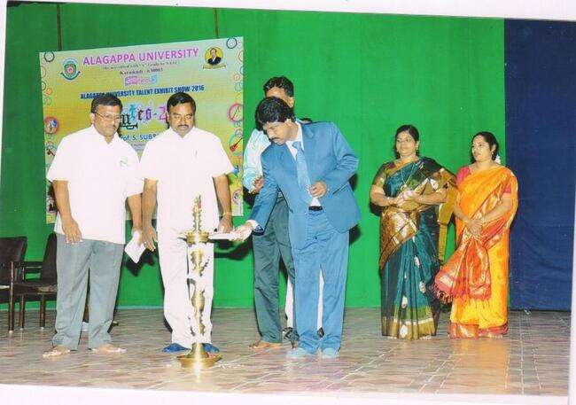

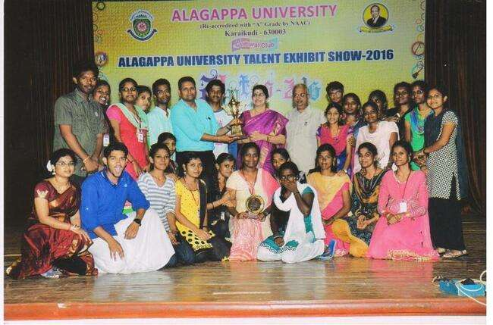

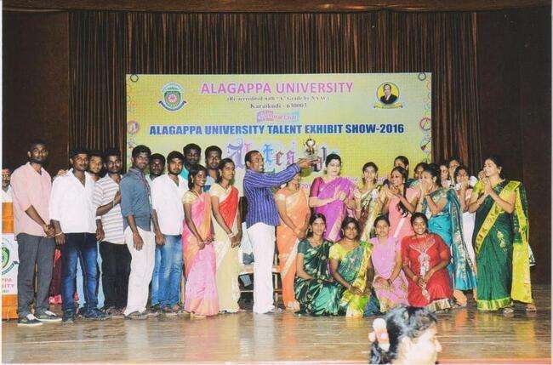

ALAGU AARAM 2017 (February 24th & 25th , 2017)

