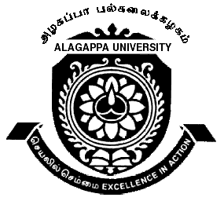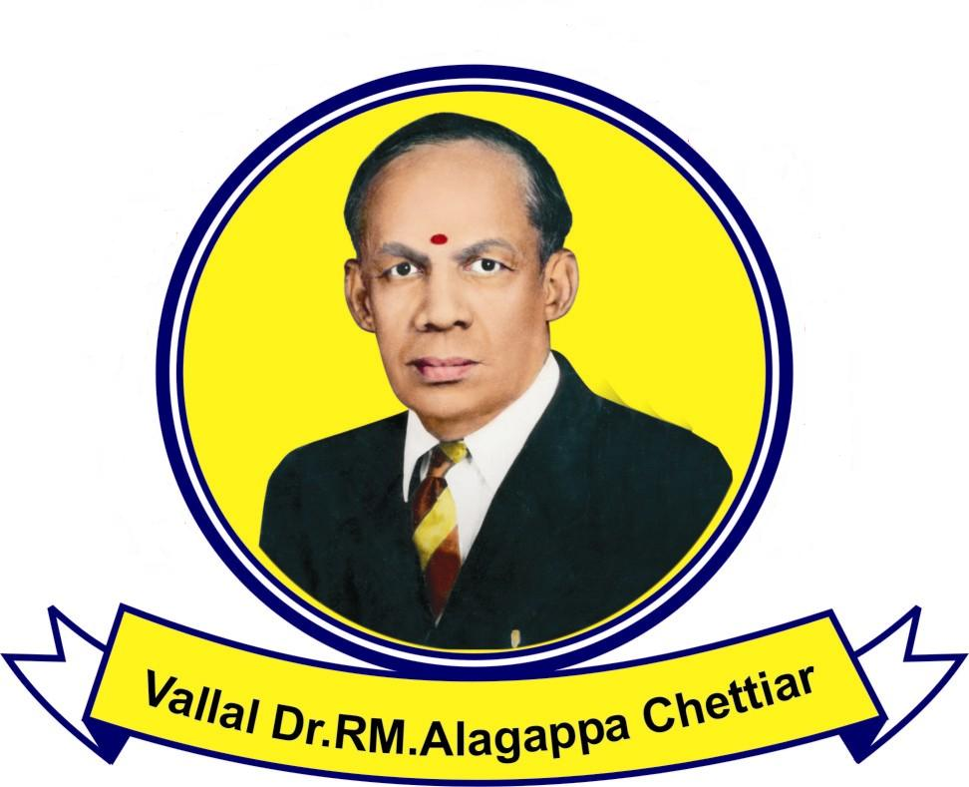ALAGAPPA UNIVERSITY
(Accredited with ‘A’ Grade by NAAC)
Karaikudi - 630 003
SCHOOL OF CHEMISTRY
Department of Industrial Chemistry
(DST FIST and UGC SAP Assisted Department)

Teaching Assistant in Industrial Chemistry

Applications are invited from the eligible candidate to work as Teaching Assistant in Industrial Chemistry.

Name of the post: Teaching Assistant in Industrial Chemistry

Qualification:
1. M.Sc. Industrial Chemistry / Chemistry / Polymer Chemistry / Physical Chemistry / any branch of Chemistry with 55% marks in the qualifying examination.
2. Preference will be given to candidates possessing Teaching experience / M.Phil / UGC/CSIR NET / GATE / SLET

Duration: Six months with a break in vacation
Honorarium: Rs.8000.00 per month (Consolidated)

Applicants may send their Biodata on or before 17.08.2009 to:
(Don’t forget to write your contact phone and email id in the biodata/application)
The Professor and Head
Department of Industrial Chemistry
Alagappa University, Karaikudi – 630 003

Date of interview: 21.08.2009
No TA/DA will be given for attending interview

Karaikudi
04.08.09

Professor & Head

NB : Kindly display in the notice board

