DE–888
11
DISTANCE EDUCATION
M.Sc. (Chemistry) DEGREE EXAMINATION,
DECEMBER 2010.
ORGANIC CHEMISTRY — I
(2008 onwards)
Time : Three hours Maximum : 100 marks
Answer any FIVE questions.
Each questions carries 20 marks.
- (a) Distinguish between :
(i) aromaticity and anti aromaticity
(ii) non aromaticity and homo aromaticity
(iii) resonance and hyper conjugation
(iv) benzenoid and nonbenzenoid compounds
(v) alternant and nonalternant hydrocarbons. (10)
(b) What are the nonkinetic methods of determining the reaction mechanism? Explain them in detail with examples. (10)
- (a) Distinguish between :
(i) Meisen heimer complex and benzyme intermediate
(ii) 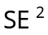(front) and 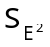 (back) mechanisms
(iii) 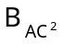and 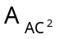 mechanisms. (9)
(b) Discuss the mechanism of Von Richter rearrangement. (4)
(c) Explain the effect of solvent polarity and the structure of the substrate on the course of the aliphatic nucleophilic substitution reactions. (7)
- (a) Explain the importance of hydroboration and show that the reaction is complementary to acid catalysed hydration of obfin. (4)
(b) Compare the reactivity of Grignard reagent and dimethyl lithium cuprate. (4)
(c) Write notes on Darzen glycidic ester synthesis and Reformatsky reaction. (6)
(d) Discuss the factors that decide the orientation of double bond during HX elimination of an alkyl halide. (6)
- (a) Explain the biosynthetic routes of alkaloids. (6)
(b) Establish the structure of zingeberene. (8)
(c) Describe the methods of preparing flavones and isoflavones. (6)
- (a) Describe how the primary structure of proteins can be ascertained. (6)
(b) Explain the biological roles of RNA and DNA. (6)
(c) Distinguish between enzymes and coenzymes. Discuss the role of enzymes as catalysts in the biological transformation. (8)
- (a) Discuss the aromaticity or otherwise of the following compounds : (i) fulvene (ii) cyclopentadienyl anion
(iii) cycloheptatrienyl anion and (iv) cyclooctatetraene. (8)
(b) Explain how carbocations are generated. Comment on their stability. (4)
(c) Write notes on :
(i) Friedel crafts acylation
(ii) Gattermann Koch formylation. (8)
- (a) What are phase transfer catalysts? Explain. (4)
(b) Explain why? (i) E₂ elimination in stereospecific and (ii) E₁ elimination is acid catalysed. (4)
(c) Discuss the mechanism of pyrolysis of xanthate. (4)
(d) What happens when (i) glyoxal is treated with potassium hydroxide and (ii) ethyl methyl ketone is treated with phosphorous ylide? (4)
(e) Explain the popular methods of preparing indole. (4)
- (a) Explain how atropine can be synthesised. (4)
(b) Indicate how (i) cis-norpinic acid is obtained and
(ii) camphoronic acid is obtained. (4)
(c) Establish the structure of cellobiose. (6)
(d) What are the structural similarities between starch and cellulose? Explain in detail.
(6)
—————
–
DE 889
12
DISTANCE EDUCATION
M.Sc. (Chemistry) DEGREE EXAMINATION,
DECEMBER 2010.
INORGANIC CHEMISTRY – I
(2008 Onwards)
Time : Three hours Maximum : 100 marks
Answer any FIVE questions.
Each question carries 20 marks.
- (a) Calculate the Lattice Energy of Sodium Iodide, by making use of Born Haber Cycle, from the following data :
Heat of Formation of Sodium Iodide = –288 kJ mol^{–1}
Heat of Sublimation of Sodium = +108.6 kJ mol^{–1}
Ionisation Potential of Sodium = +494.3 kJ mol^{–1}
Bond Dissociation Energy of Iodine molecule = +106.5 kJ mol^{–1}
Electron Affinity of Iodine = –305.7 kJ mol^{–1}. (4)
(b) Discuss the structure and bonding in
(i) Xenon Dioxodifluoride
(ii) Xenon Tetrafluoride and
(iii) Xenon Trioxide molecules. (2 + 2 + 2)
(c) State how hard and soft acids and Boses principle explain :
(i) Symbiosis
(ii) Prediction of Hordness and Softness and
(iii) Stability of complexes. (3 + 3 + 4)
- (a) Draw and explain the structure of the unit cell of Fluorite. (4)
(b) Distinguish between Metal Excess Defect caused by a missing negative ion with that due to an extra positive ion. (6)
(c) Define and illustrate :
(i) n-type semiconductor
(ii) p-type semiconductor and
(iii) Rectifier. (4 + 3 + 3)
- (a) Calculate the number of alpha and beta particles, emitted, when ₉₂Uranium²³⁸ changes into radioactive ₈₂Lead²⁰⁶. (4)
(b) Discuss the method of determining the age of an olden wooden bowl by radiocarbon dating method.
(6)
(c) Compare and contrast the salient features of Nuclear Fusion and Nuclear Fission. (10)
- (a) State the causes for and consequences of Lanthanide Contraction. (4)
(b) Discuss the position of Actinides in the Periodic Table. (6)
(c) How are Lanthanides separated by the following methods :
(i) Fractional Crystallization
(ii) Ion Exchange Chromatography and
(iii) Selective Oxidation and Reduction. (3 + 3 + 4)
- (a) Write the molecular formulae for the following silicates :
(i) Hemimorphite
(ii) Enstatite
(iii) Amosite and
(iv) Bentonite. (1 + 1 + 1 + 1)
(b) Draw and explain the Lacunary Keggin structures of
(i) Phosphonolybdic acid
(ii) Silicotungstic Acid and
(iii) Phosphotungstic acid and their anions.
(2 + 2 + 2)
(c) Distinguish between :
(i) Ortho silicates and chain silicates
(ii) Pyrosilicates and Sheet silicates
(iii) Three Dimensional Silicates and Cyclic silicates. (3 + 3 + 4)
- (a) What are the postulates of Valence Shell Electron Pair Repulsion Theory? How does it predict the shape of Methane? (4)
(b) Draw and explain the unit cell of Zinc Sulphide having Zinc Blende structure. (6)
(c) Compare the salient features of Neutron Activation Analysis and Isotopic Dilution Analysis. (10)
- (a) Give a brief account of the position of Lanthanides in the Periodic Table. (4)
(b) Write notes on :
(i) Anderson structure of poly acids and their salts.
(ii) Isomorphous Replacement in Silicates. (3 + 3)
(c) Compare the salient features of KAPUSTI-NSKI Equation and BORN-LANDE Equation. (10)
- (a) Discuss the causes and consequences of Frenkel. Defect in crystals. (4)
(b) Describe any Two methods for the detection and measurement of radio activity. (6)
(c) How is Uranium Dioxide prepared? How does it react with
(i) Silver Nitrate
(ii) Hydrofluoric Acid
(iii) Excess Chlorine and
(iv) Aluminium. (10)
______________
–
DE 890
13
DISTANCE EDUCATION
M.Sc. (Chemistry) DEGREE EXAMINATION,
DECEMBER 2010.
PHYSICAL CHEMISTRY – I
(2008 onwards)
Time : Three hours Maximum : 100 marks
Answer any FIVE questions.
Each question carries 20 marks.
- (a) Define entropy. Write on entropy changes in reversible and irreversible processes. What is meant by entropy of mixing. (12)
(b) How is the mean activity coefficient of an electrolyte determined? (8)
- (a) Write on the different types of electrodes and electrochemical cells. (10)
(b) Derive Butler-Volmer equation. (10)
- (a) Explain the inadequacy of classical mechanics in the light of photoelectric and compton effects. (10)
(b) Discuss the particle in one dimensional box problem, derive the solution. (10)
- (a) Compare ARRT with simple collision theory. (8)
(b) Write notes on :
(i) Potential energy surfaces.
(ii) Kinetic isotopic effect.
(iii) Principle of microscopic reversibility. (12)
- (a) Write on the different photophysical processes of the electronically excited states. (12)
(b) Discuss the photochemical kinetics of the decomposition of acetaldehyde. (8)
- (a) Derive any two of the Maxwell's relations. (10)
(b) Write notes on conductometric and potentiometric titrations. (10)
- (a) Derive de-Broglie equation and also describe the significance of Davisson - Gemmer experiment(s). (8)
(b) Write a short note on eigen values and degeneracy.
(6)
(c) Show how ARRT is applied to third order reactions?
(6)
- (a) What are explosion reactions? Explain with a suitable example. (6)
(b) Outline the NMR methods of study of fast reactions.
(6)
(c) Describe the reactions of hydrated electron in the light of radiation chemistry. (8)
______________
DE – 891
14
DISTANCE EDUCATION
M.Sc. (Chemistry) DEGREE EXAMINATION,
DECEMBER 2010
INSTRUMENTAL METHODS OF ANALYSIS
(2008 onwards)
Time : Three hours Maximum : 100 marks
Answer any FIVE questions.
Each question carries 20 marks.
- (a) Predict the 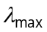 value for the following compounds in ethanol :
(i) 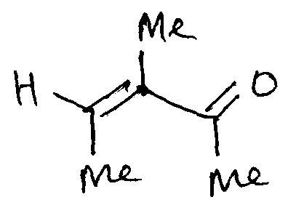
(ii) 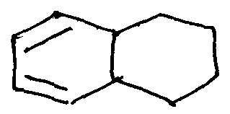
(iii) 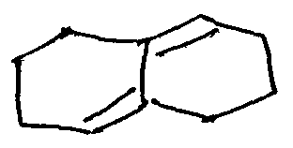
(iv) 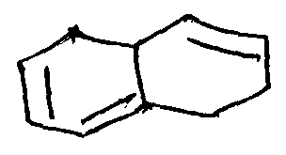
(v) 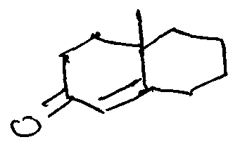 (10)
(b) Write notes on :
(i) Fingerprint region
(ii) Fermi resonance. (6)
(c) Explain the effect of increasing solvent polarity on the absorption position of 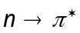 and 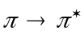 bands. (4)
- (a) Explain how 'H NMR spectroscopy can be employed to distinguish the different isomers of 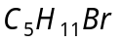. (8)
(b) Indicate the expected esr pattern for CD₃ radical. (3)
(c) Define 'g' value. (3)
(d) Explain the advantage of FT-pulse technique in recording NMR spectra. Explain the principle in detail. (6)
- (a) Explain how TLC is very helpful for identifying the extent of reaction that has gone? How are TLC plates prepared? Explain how TLC analysis is carried out. (8)
(b) Explain the terms :
(i) Amplitude of a cotton effect curve
(ii) Dichrograph
(ii) –haloketone rule. (6)
(c) What are metastable ions? Where are they generated? How are they noticed? What are the characteristics of metastable ions? How is it useful to identify a fragmentation route? (6)
- Write notes on :
(a) Feuorimetry
(b) Nephelometry
(c) Frame photometry (6 + 7 + 7)
- (a) Write a note on linear regression analysis. (8)
(b) Discuss the types of errors. (6)
(c) Explain the application of potentiometric methods.
(6)
- (a) Discuss how inductive effect and mesomeric effect affects the carbonyl stretching frequency. (4)
(b) Compare the carbonyl stretching band positions in the following pair of compounds :
(i) cyclohexanone and 2-cyclohexenone
(ii) salicylaldehyde and o-methoxybenzaldehyde.
(4)
(c) Write notes on :
(i) Amide I and amide II bands
(ii) Rocking vibration. (4)
(d) Explain how double resonance can be used to simplify complex 'H NMR spectra. (4)
(e) What is coupling constant? What is the unit for this parameter? Is it dependent on the applied magnetic field or not? (4)
- (a) What is ring current effect? What is the difference between ring current and anistropic effect? (4)
(b) Outline the principle of HPLC. (4)
(c) Using octant rule, predict the sign of the cotton effect curve for the following molecule :
(i) 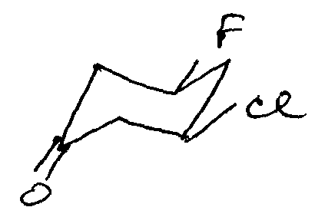
(ii) 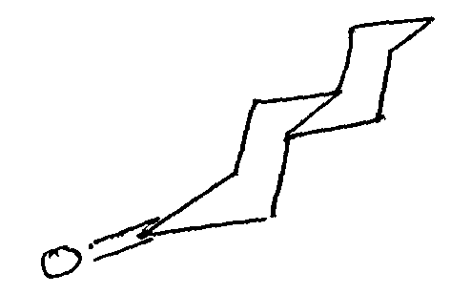 (4)
(d) Discuss the principle, working and application of turbidometry. (8)
- (a) Indicate the popular fragmentation routes for nitro compounds and alcohols in mass spectral studies. (4)
(b) List out the different thermo gravimetry techniques.
(4)
(c) Explain the applications of cyclic voltammetry. (6)
(d) Explain the principle of polarography. (6)
————————
DE–892
21
DISTANCE EDUCATION
M.Sc. (Chemistry) DEGREE EXAMINATION,
DECEMBER 2010.
ORGANIC CHEMISTRY — II
(2008 onwards)
Time : Three hours Maximum : 100 marks
Answer any FIVE questions.
Each question carries 20 marks.
- (a) Write the chemical equation including the structure of the major product for each of the following reactions. Indicate the stereochemistry of the products. (2 + 2 + 2)
(i) 1,2-dimethyl cyclobutane 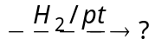
(ii) 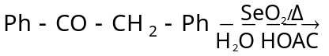?
(iii) 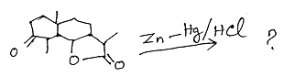
(b) Formulate reasonable mechanisms for the following reactions : (2 + 2 + 2)
(i) 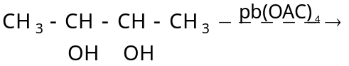?
(ii) 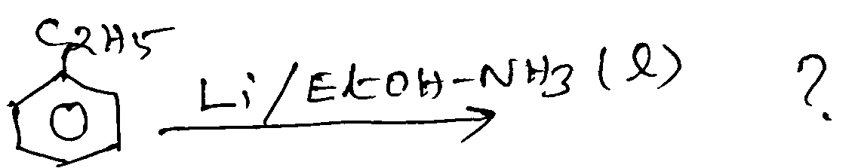
(iii) 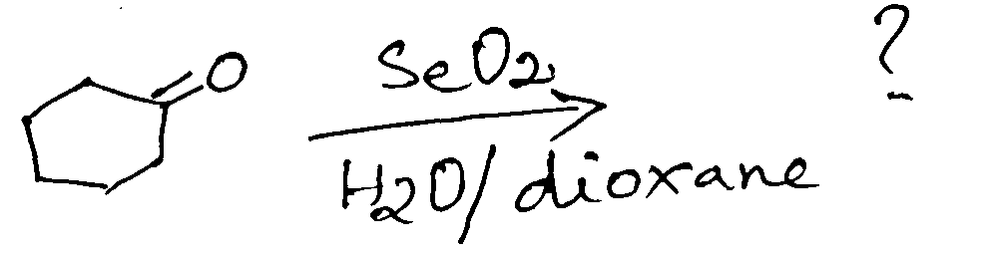
(c) Write a note on :
(i) Robinson annelation
(ii) Wagner-Meerwein rearrangement (4 + 4)
- (a) Write a note on E-Z notations. (4)
(b) What is Prelog’s rule? Explain its utility. (4)
(c) Describe a method for the determination of configuration of ketoximes. (4)
(d) What is asymmetric synthesis? Explain with an example. (4)
(e) What are stereospecific reactions? Give two specific examples. (4)
- (a) Account for the orientation of the double bond in E₂ elimination under Hoffmann and Saytzeff conditions. (4)
(b) Discuss in detail the neighbouring group participation reactions with halogens and sulphur as neighbouring groups. (8)
(c) Write notes on :
(i) Nucleophilic substitution at vinyl carbon
(ii) Gomberg reaction. (4 + 4)
- (a) Cyclisation of butadiene to cyclobutane is symmetry allowed via conrotation under thermal conditions whereas that of hexatriene to cyclohexadiene is symmetry allowed via disrotation. Why? (4)
(b) Write a note on Norrish type I reactions. (4)
(c) Construct a correlation diagram for the disrotatory opening of cyclohexadiene to hexatriene. Consider whether the reaction is thermally or photochemically allowed. (8)
(d) Explain the cycloaddition reaction between entadiene and ethylene using FMO method. (4)
- (a) Give the structure of Vitamin B₁ and explain the ring structure present in it. (4)
(b) What will happen when
(i) Equilenin is reduced with Na/C₂H₅OH
(ii) Oestrone is reacted with diazonium chloride
(iii) Cholesterol is reduced with hydrogen in presence of platinum. (2 + 2 + 2)
(c) Describe the structural elucidation and synthesis of Androsterone. (10)
- (a) Write notes on :
(i) di- methane rearrangment and
(ii) Favorskii rearrangement. (4 + 4)
(b) Explain the following reactions with mechanism
(i) Clemmensen reduction
(ii) MPV reduction. (4 + 4)
(c) What are convergent and relay approaches in total synthetic methods? (4)
- (a) How is cholesterol converted into progesterone? (4)
(b) How are free radicals generated? (4)
(c) Write notes on :
(i) Frontier molecular orbital theory and
(ii) Perturbation theory. (6 + 6)
- (a) Explain the following with suitable examples.
(i) Chirality
(ii) Stereoselective synthesis
(iii) Electrocyclic reaction. (3 × 3 = 9)
(b) Establish the structure of Vitamin A. (8)
(c) Mention any three physiological importance of vitamins. (3)
–––––––––––––––
DE – 893
22
DISTANCE EDUCATION
M.Sc. (Chemistry) DEGREE EXAMINATION,
DECEMBER 2010.
INORGANIC CHEMISTRY – II
(2008 onwards)
Time : Three hours Maximum : 100 marks
Answer any FIVE questions.
Each question carries 20 marks.
(5 × 20 = 100)
- (a) Draw and explain the molecular orbital energy level diagram of 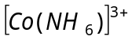. (6)
(b) Discuss the magnetic properties of the complexes of the transition metals on the basis of crystal field theory with suitable examples. (8)
(c) Calculate the crystal field stabilisation energy in terms of Dq for 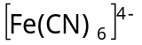 and 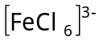 ions. (6)
- (a) Write briefly on the tunneling mechanism of electron transfer reactions, citing suitable illustration. (8)
(b) List out the factors which affect the stability of a metal complex. (6)
(c) Treatment of 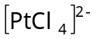 with 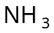 results in the exclusive product cis or trans. Explain. (6)
- (a) Sketch the EPR spectrum of bis (Salicylal dimine) copper (II) complexes and interpret. (7)
(b) Outline the Tanabe-Sugano diagram for 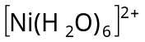and explain the electronic spectrum. (7)
(c) With suitable examples explain the effect of distortion and spin-orbit coupling on the electronic spectrum of metal complexes. (6)
- (a) Give the mechanism involved in the Zeigler-Natta polymerisation of propylene. (7)
(b) What are hydroformylation reactions? Discuss the mechanism in them. (7)
(c) How will you establish the aromatic character of cyclopentadienyl groups in ferrocene? (6)
- (a) What is ionophore? What are the different types of ionophores? Explain the mechanism involved in the ion-transport across membrane. (7)
(b) Write briefly on perutz mechanism of cooperativity.
(6)
(c) Give a schematic diagram to show how nitrogenase enzyme converts nitrogen from air into ammonia and explain. (7)
- (a) Explain the thermodynamic effects of crystal field splitting. (6)
(b) Rationalize the fact eg orbitals constitute a higher energy in oh while the converse is true in Td environment. (6)
(c) Discuss the splitting and energy level diagram of
d-orbitals of 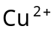 ion in an octahedral complex caused by Jahn-Teller effect. (8)
- (a) Discuss the mode of action of carboxy peptidase in the hydrolysis of an amide linkage in a polypeptide.
(7)
(b) Write briefly about toxicity of metals and chelate therapy. (7)
(c) Give an account of copper proteins. (6)
- (a) Illustrate the main catalytic cycle in the homogeneous hydrogenation of an alkene by rhodium-phosphine complex. (7)
(b) Discuss the problem of covalent versus ionic bonding using magnesocene and beryllocene. (6)
(c) Discuss the structure and bonding in the simplest olefin–metal complex. (7)
————————
DE – 894
23
DISTANCE EDUCATION
M.Sc. (Chemistry) DEGREE EXAMINATION,
DECEMBER 2010.
PHYSICAL CHEMISTRY — II
(2008 onwards)
Time : Three hours Maximum : 100 marks
Answer any FIVE questions.
Each question carries 20 marks.
- (a) Arrive the expressions for internal energy and entropy in terms of partition functions using Boltzman distribution law. (12)
(b) Explain about Debye theory of heat capacities and compare it with Einstein theory of heat capacity. (8)
- (a) Write down the schrodinger wave equation for hydrogen atom and obtain its normalised solution.
(12)
(b) Discuss the application of perturbation method to solve helium atom problem. (8)
- (a) Construct the character table for C₂V point group with the help of postulates of great orthogwanality theorem. (10)
(b) Carry out the normal mode analysis for NH₃ molecule. You are provided with the character table for C_{3v} point group. (10)
C_{3v} | E | 2C₃ | 3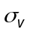
A₁ | 1 | 1 | 1 | Z | 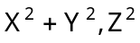
A₂ | 1 | 1 | –1 | R_{Z}
E | 2 | –1 | 0 | (x, y) (R_{z}, R_{y}) | 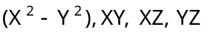
- (a) Discuss about the influence of pressure on reaction rates in solution. (8)
(b) Discuss in detail about the Michaelis-Menton type kinetics of enzyme catalysed reactions. (12)
- (a) Discuss in detail about BET adsorption isotherm. (8)
(b) Discuss about the Langmir-Hinshelwood and Langmir-Riedal mechanisms of surface catalysed bimolecular reactions and compare them. (12)
- (a) Derive the expression for Bose-Einstein statistics.
(8)
(b) Discuss the application of group theory is the study of electronic spectra of formaldehyde. (12)
- (a) Write short notes on negative absolute temperature.
(4)
(b) Discuss about the application of HMO method for solving different energy levels present in butadiene system. (12)
(c) Explain about the significance of volume of activation. (4)
- (a) Write notes on :
(i) Secondary salt effect (4)
(ii) Hammett equation. (4)
(b) Explain the following :
(i) Spreading of a liquid on another (4)
(ii) Micelles (4)
(iii) Factors influencing adsorption of gases on solids. (4)
————————
DE – 895
24
DISTANCE EDUCATION
M.Sc. DEGREE EXAMINATION, DECEMBER 2010
Chemistry
APPLIED CHEMISTRY
(2008 onwards)
Time : Three hours Maximum : 100 marks
Answer any FIVE questions.
All questions carry equal marks.
(5 × 20 = 100)
- (a) Write an extensive account of air pollution with special emphasis on green house gases emission and consequences. (12)
(b) Explore the importance of physicochemical and biological investigations of water quality. (8)
- (a) Give an introductory account of the basic aspects of corrosion and the importance of corrosion studies.
(12)
(b) Explain the principle and other aspects of composite coating and anodizing. (8)
- (a) Write on the classification of polymers. (8)
(b) Derive the mechanism of free radical polymerization, also write on specialty polymers. (12)
- (a) Indicate the usefulness of various physical methods in the synthesis of nanomaterials. (10)
(b) Write short notes on Laser Raman Spectroscopy and DSC. (10)
- (a) Show how pH, solubility product and bond energy can be calculated using computers. (12)
(b) Describe the role of search engines in the identification of databases. (8)
- (a) Write notes on acid rain and ozone hole. (10)
(b) Explain Pourbaix diagram for Fe–H₂O system and add a note on high temperature corrosion. (10)
- (a) Discuss the role of the various types of initiators in polymerization. (8)
(b) Describe chemical solution deposition, electrochemical deposition and spray pyrolysis deposition methods of preparation of nanomaterials.
(12)
- Write short notes on :
(a) Standard deviation and correlation coefficient
(b) E-mail
(c) Chemical Abstracts
(d) Importance of nanomaterials (20)
————————

