ALAGAPPA UNIVERSITY
FACULTY DETAILS

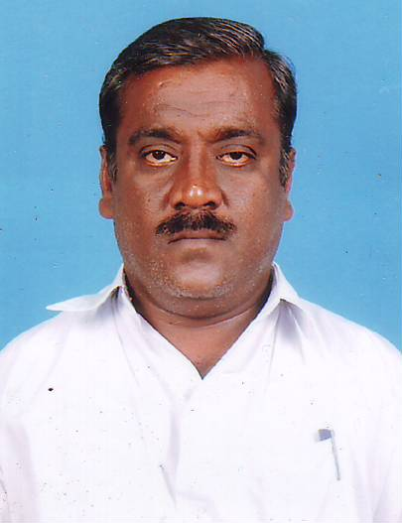 | Dr. K.KRISHNAMOORTHY
Date of Birth | 12.06.1966
Gender | Male
Department | Education , DDE
Qualification | M.A., M.Ed., M.Phil., Ph.D., Dip in Geog.
Designation | Lecturer in Education
Address | Directorate of Distance Education,  Alagappa University, Karaikudi
Pin code | 630 003
Phone | 9865725415
Email | kksmoorthy@gmail.com
Website
Fax | 04565 - 225202

University Studied UG and PG :

S.No | Degree | University | Year of Study
1 | B. A., | Bharathidasan University | 1983 - 1986
2 | M. A | Bharathidasan University | 1986 - 1988
3 | M. Ed., | Bharathidasan University | 1990 - 1991
4 | M.Phil | Bharathidasan University | 1990 - 1991
5 | Ph.D | Madurai Kamaraj University | 1992 - 1996
6 | Dip in Geog | University of Madras | 1990 - 1991

University Where Research done:

Name of the University | Year of Study | Area of Specialization
Madurai Kamaraj University | 1992- 1996 | Vocational education

PG Specialization (subjects) :

1. Teacher Education

Total Teaching Experience :

S.No | Institution | Position | Period
S.No | Institution | Position | From | To
1 | A.V.C.C,(Autonomous), Myladuthurai | Lecturer | 1996 - 1998
2 | Govt. High School, Tanjore Dist | BT Assistant | 1998 - 2009

Total Research Experience (No. of Years): 6 years

Current Research Field :

1. Education | 2 Vocational Education
3. Teacher Education | 4.Curriculam

No. of MPhil & PhDs Guided :

M.Phil | 2 | Ph.D | -

Projects done Minor/Major:

S.No | Title | Funding Agency | Year | Status (Ongoing/ Completed)
1 | Socio cultural study of the social groups: “A study on the Dikshithars of Chidambaram” in socio cultural perspective | Nehru Trust for the Indian collections, New Delhi. | 1998 - 1999 | Completed

Seminar/Workshops Attended :
(a) National
S.No | Title | Institution and Event Name | Period
1 | Seminar on “Adult Education program” thru NSS | Govt. college of Education, Pudukkottai | 1989 -1990
2 | Social science methods for educational research | Institute of social science, New Delhi | 1993
3 | Seminar on “Rapporater for principals of college’s arts and science, Affiliated Madurai Kamaraj Unviersity. | Madurai Kamaraj university | 1994
4 | Workshop on Faculty members of History | Bharathidasan university, Trichy | 1998
5 | Workshop on special refresher course | TIET, Aduthurai | 2001
6 | Workshop on “Lesson  Writers “ | Alagappa University, Karaikudi | 2009
7 | Seminar on “Significance of Distance Education in enhancing the enrollment in Higher education” | CDE, Bharathidasan university, Trichy | 2009

Papers Presented :
(a) National
S.No | Title | Institution and Event Name | Period
1 | Radio a means of developmental communication for rural illiterate | Madurai Kamaraj Unviersity | 1993
2 | “A critical study of the Engineering Trades of ITI’s in Tamilnadu “ | Institute of Social science research, New Delhi. | 1994
3 | Periyar and his economic policy | Tamilnadu History congress, Bharthidasan University | 1996
4 | Democratic values in Tamil Literature | A.V.C.College, (Autonomous), Myladuthurai | 1998

Membership in Professional Bodies

S.No | Name of the institution and place | Capacity / Status
1 | The Indian Science Congress Association | Life member

Awards/Rewards/Fellowship/any other Recognition

S.No | Name of the Award/ Fellowship | Institution awarding the Honor | Year
1 | for the Achievement of 100% result in 10th Social Science | Govt of Tamilnadu | 1999 - 2000
2 | for the Achievement of 100% result in 10th Social Science | Govt of Tamilnadu | 2008 - 2009

Additional Administrative Positions Held

S.No | Position | Period
S.No | Position | From | To
1 | Head Master , Full Additional Incharge, in Govt High School,Naduvikkurichi | 2005 - 2005

Service Seniority order Number (As per Attendance Register) : 20

