ALAGAPPA UNIVERSITY
FACULTY DETAILS

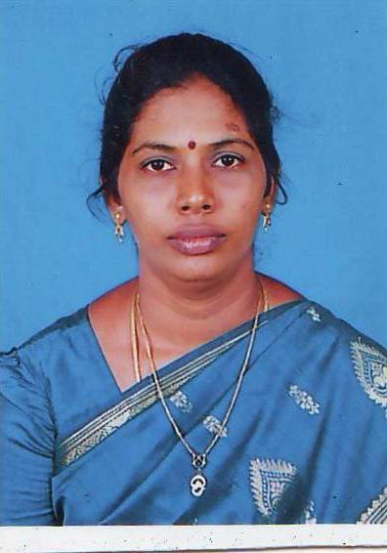 | Dr. S. MALATHI
Date of Birth | 12.01.1967
Gender | Female
Department | Education
Qualification | M.A.(socio),M.A.(Eng),M.Phil.,M.Ed.,Ph.d.
Designation | Lecturer in Education
Address | D.D.E, Alagappa university, Karaikudi.
Pin code | 630 003
Phone
Email | velmalu@gmail.com
Website
Fax | 04565 - 225202

University Studied UG and PG :

S.No | Degree | University | Year of Study
1. | B.Sc.,Ed | Mysore | 1989
2. | M.A (Socio) | M.K. University | 1998
3. | M.Ed. | M.K. University | 2000
4. | M.A (Eng) | Annamalai University | 2003
5 | M.Phil. (Eng) | Alagappa University | 2008
6 | Ph.D (Edu) | Tamil University | 2007

University Where Research done :

Name of the University | Year of Study | Area of Specialization
Tamil University | 2002-2007 | Women education

Total Teaching Experience :

S.No | Institution | Position | Period
S.No | Institution | Position | From | To
1. | Sri Bharathi MHSS, Kaikuruchi | Principal | 1996-2005
2 | Sri Bharathi College of Education | Principal | 2005-Jan 2009

Total Research Experience (No. of Years): 7 Years

Current Research Field :

1. Tribal education | 2. School dropouts

No. of MPhil & PhDs Guided :

M.Phil | 02 | Ph.D | -

Seminar/Workshops Attended :
(a) National

S.No | Title | Institution and Event Name | Period
1 | National Seminar on Reproductive Health and Education | Tamil University | March-2007
2 | National Seminar on Recent Trends in Environment Education | RIE, Mysore | Jan. 2008
3 | Workshop for lesson writers of distance education | Alagappa University, Karaikudi | June 2009

Papers Presented :
(a) National
S.No | Title | Institution and Event Name | Period
1 | National Seminar on Reproductive Health and Education | Tamil University | March-2007
2 | National Seminar on Recent Trends in Environment Education | RIE, Mysore | Jan. 2008

Papers Published
(a) National

S.No | Paper Title | Name of Journal, Volume No and Page | Year Publication
1 | Eco-Feminism | Seminar Proceedings,Vol. No-1, 44 | 2008
2 | The role of SHGs in women empowerment; A study of Erode district. | Vikas Vani Journal, 3, 1 | 2009

(a) International

S.No | Paper Title | Name of Journal, Volume No and Page | Year Publication
1 | A Socio-Educational perspectives of women teachers in pudukottai district | South asian journal of socio-political study | 2009

Membership in Professional Bodies

S.No | Name of the institution and place | Capacity / Status
1. | Indian Science Congress Association, Kolkata | Life Member

Awards/Rewards/Fellowship/any other Recognition

S.No | Name of the Award/ Fellowship | Institution awarding the Honor | Year
1. | IGNOU Program in-charge | IGNOU, New Delhi | 2006-2008

Service Seniority order Number (As per Attendance Register) | 13

