ALAGAPPA UNIVERSITY
FACULTY DETAILS

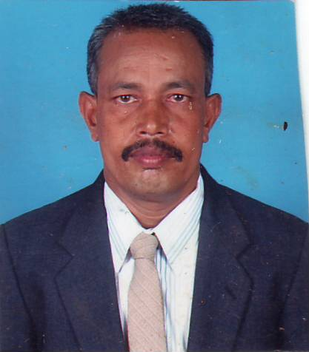 | DR. R. PERUMAL
Date of Birth | 03.12.1960
Gender | Male
Department | Directorate of Distance Education
Qualification | M..B.A., M. Com, M. A., M. Phil., Ph.D
Designation | Reader in Education
Address | DDE, Alagappa University, Karaikudi- TN
Pin code | 630 003
Phone | 09443077414
Email | drperumalraman@yahoo.com
Website | http://www.alagappauniversity.ac.in
Fax | 04565-225216

University Studied UG and PG :

S.No | Degree | University | Year of Study
 | M.A | Gandhigram Rural University | 1984
 | M. Com., | Annamalai University | 1993
 | M.B.A | Vinayaka Mission | 2006

University Where Research done :

Name of the University | Year of Study | Area of Specialization
M.Phil | 1986 | Service Co-operation
Ph.D | 1990 | Consumer Appraisal

PG Specialization (subjects) :
1.Marketing | 2. Co-operation
3.Accounts | 4. Personnel Management

Total Teaching Experience : 20

S.No | Institution | Position | Period
S.No | Institution | Position | From | To
1 | Govt. Arts College, Dharmapuri | Lecturer | 1989 -1997
 | Govt. Arts College, Dharmapuri | Senior Lecturer | 1997-1999
 | Govt. Arts College, Dharmapuri | Reader | 1999-10.04.2007
 | Alagappa Uiversity | Reader | 11.04.2007 Onwards

Total Research Experience (No. of Years):

Current Research Field :
1.Marketing | 2. Co-operation
3.Accounts | 4. Personnel Management

No. of MPhil & PhDs Guided :

M.Phil | 35 | Ph.D

Seminar/Workshops Attended : 33
(a) National: 27
(b) International : 3

Papers Presented : 22
(a) National : 18
(b) International: 4

Papers Published: 31
(a) National: 31
(b) International: NIL

Books Published / Course material written

S.No | Title | Publisher | Year
 | - Chairman for Text Book on ‘Cooperative Management’, (Tamil), | Tamilnadu Text Book Society, Chennai | 2006
 | - Chairman for Text Book on ‘Commercial Geography in India’, (Tamil), | Tamilnadu Text Book Society, Chennai, | 2006
 | - Book of “Compensation Management” | Course Material, Alagappa University | 2008
 | - 4E-Governance in India, Pride,. | - Course Material, Periyar University | 2009

Membership in Professional Bodies

S.No | Name of the institution and place | Capacity / Status
1 | Bharathidasan University, Trichirappalli | Served as Chairman Question Setter Board in Cooperation
2 | University of Madras, Chennai | Serving as Member Question Setter board in Cooperation
3 | Pondicherry University, Pondicherry | Serving as Member Question Setter board in Cooperation
4 | R.V.S. Arts and Science College, Coimbatore | Served as Member Question Setter board in Commerce
5 | Gandhigram Rural Institute (Deemed University), Gandhigram | Served as Member Question Setter board in Cooperation
6 | Madurai Kamaraj University, Madurai | Served as Member Question Setter board in Cooperation
7 | Periyar University, Periyar | Serving as Member Board of Studies in Cooperation
8 | Thiruvalluvar University, Vellore | Serving as Member Board of Studies in Cooperation
9 | G.T.N Arts College (Autonomous), Dindigul | Served as Member Examiner for PG course in Commerce
10 | Manomaniam Sundaranar University, Tirunelveli | Serving as Member Examiner for M.B.A. Degree
11 | Alagappa University, Karaikudi | Serving as Member Examiner in M.B.A. Degree
12 | Tamil Nadu Public Service Commission, Chennai | Served as Member Question Setter board for Group I services
13 | Madras University, Chennai | Served as Member in Lesson Writters Board in Cooperation
14 | Periyar University, Salem | Served as Member, Inspection Commission on Course in Cooperation
15 | Alagappa University, Karaikudui | Serving as Chairman for M.Phil in Public Administration Evaluation Board

Awards/Rewards/Fellowship/any other Recognition

S.No | Name of the Award/ Fellowship | Institution awarding the Honor | Year
1 | NET | University Grants Commission | 1985

Additional Administrative Positions Held
S.No | Position | Period
S.No | Position | From | To
1 | Hostel Warden (Residential), Alagappa University | 2007 onwards
 | Captain, NCC (Army Wing), Govt. Arts College, Dharmapuri | 1997-2007

Service Seniority order Number (As per Attendance Register): Third Position

