ALAGAPPA UNIVERSITY
FACULTY DETAILS

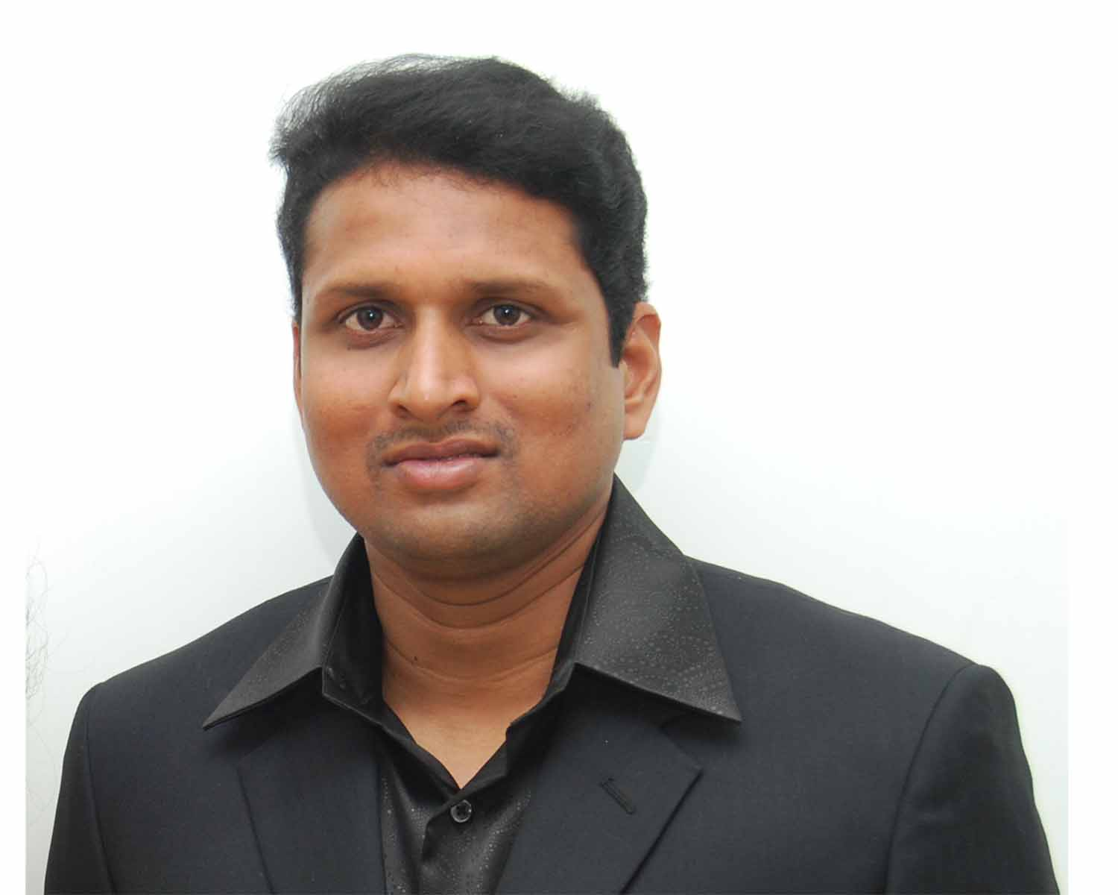 | Dr. P.Rameshthangam
Date of Birth | 04-04-1978
Gender | Male
Department | Biotechnology
Qualification | M.Sc. Ph.D.
Designation | Lecturer in Biotechnology
Address | Directorate of Distance Education  Alagappa University, Karaikudi
Pin code | 630 003
Phone | +91-9444834424
Email | rameshthangam@yahoo.com  rameshthangam@gmail.com
Website | http://www.alagappauniversity.ac.in
Fax | 04565225216

University Studied UG, PG & Ph.D :

S.No | Degree | University | Year of Study
1. | Ph.D | University of Madras | 2002- 2008
2. | M.Sc | Bharathidasan University | 1999 -2001
3. | B.Sc | Bharathidasan University | 1996 -1999

University Where Research done :

Name of the University/Institution | Year of Study | Area of Specialization
UNIVERSITY OF MADRAS | 2002 -2008 | Aquaculture, Virology
MADRAS DIABETES RESEARCH FOUNDATION, CHENNAI. | 2008-2009 | Diabetology

PG Specialization (subjects) :
1. Biochemistry | 2. Biotechnology
3. Immunotechnology | 4. Genetic Engineering

Total Teaching Experience :
S.No | University/Institution | Position | Period
S.No | University/Institution | Position | From | To
1 | UNIVERSITY OF MADRAS | Teaching cum research fellow (TRF) | 2002 - 2007
2 | ALAGAPPA UNIVERSITY | Lecturer in Biotechnology | 17-2-2009  to  Till date

Total Research Experience (No. of Years): 8 years

Current Research Field :
1.Aquaculture | 2. Virology
3. Diabetology | 4. -

Seminar/Workshops Attended :
National
S.No | Title | Institution and Event Name | Period
1 | Diagnostic technique like Animal cell culture, ELISA and PCR | One month training programme at Tamil Nadu Veterinary and Animal Sciences University, Chennai, India. | 21st November –  21st December 2001
2 | The Sixth Indian fisheries Forum | Orhanized by Asian fisheries Society (Indian Branch), Indian fisheries Association & Central Institute of Fisheries Education, Mumbai. | 17th – 20th December 2002
3 | Advances in Fish Disease Diagnostics | One month CAS training programme at Central Institute of Fisheries Education, Versova, Mumbai, India. | 25th February to 17th March 2003
4 | Genomics and Proteomics | National seminar organized by Department of Biotechnology, University of Madras. India. | February 19th and 20th , 2003
5 | Application of Radioisotopes and Radiation Technology for Societal Development | Awareness program organized by Anna University. India. | 13th and 14th July 2004
6 | Structural Biology | Seminar organized by Department of Crystallography and Biophysics, University of Madras. India. | 4th March 2005
7 | Science Seminar on Basic Sciences: SCOPE AND HOPE | Seminar organized by University of Madras. India. | 23rd August 2007
8 | Workshop on techniques in Genomics in relation to diabetes & related disorders. | Organized by Madras diabetes research foundation, Chennai  &  Indian Council of Medical Research | 3rd to 9th January 2009
9 | Recent Trends in Molecular Modeling and Drug Design | National Seminar organized by Department of Bioinformatics, Alagappa University, Karaikudi. | 18th and 19th March 2009
10 | Current Trends and Future Prospects of Nano Marine Sciences | National Seminar organized by Department of Oceoanography, Alagappa University, Karaikudi. | 23rd and 24th March 2009
11 | Application of Genomics and Bioinformatics in Animal Health and Management | National Seminar organized by Centre for Animal Health and Management, Alagappa University, Karaikudi. | 25 and 26th March 2009
12 | Workshop for lesson writers of Distance Education Programme | Workshop organized by the Directorate of Distance Education of Alagappa University, Karaikudi. | 11th and 12th June 2009

International
S.No | Title | Institution and Event Name | Period
1 | “Biosensors I and Biosensors II” | International seminar organized by Department of Biotechnology, University of Madras. India. | 23rd and March 23rd , 2004
2 | Ethics in Medical Research | Indo-UK Workshop | 11th October 2004
3 | “ International seminar on Immunotechnology and workshop on Immunoenzyme labeling in tissue sections, ELISA, 2D & Pulse field gel electrophoresis and Fermentor” | International seminar and workshop organized by Department of Biotechnology, University of Madras, Chennai. India. | 20th to 22nd October 2005
4 | Bio-ethics | International seminar organized by The Tamilnadu Dr. M.G.R Medical University & University of Madras, Chennai. India. | 26th -27th January 2006
5 | “International conference on Nanoscience and Nanotechnology (ICNSNT)” | International conference organized by centre for Nanoscience and Nanotechnology, University of Madras, Chennai. India. | 26th to 28th August 2006
6 | Techniques in Biotechnology – Immunocytochemistry | International seminar and workshop organized by Department of Biotechnology, University of Madras, Chennai. India. | 8th – 11th May 2007
7 | Computational Drug Discovery in Pharma R & D | International seminar organized by Bioinformatics Infrastructure Facility (BTBI – DBT funded), Department of Biotechnology & CAS in Crystallography and Biophysics, University of Madras, Chennai. India. | 25th July 2007

Papers Presented :
National
S.No | Title | Institution and Event Name | Period
1 | Serum protein pattern in Type 2 diabetes pateints. | Tamilnadu science council, 9th conference, Organized by Alagappa University, Karaikudi. Excel India Publishers Sec. 22.13, p 454-455 | 11th to 13th September
2 | Phytochemical and Bioinformatics analysis of anti-inflammatory and anti-pyretic compounds of Anisomeles malabarica. | Tamilnadu science council, 9th conference, Organized by Alagappa University, Karaikudi. . Excel India Publishers Sec. 22.04, p 443. | 11th to 13th September
2 | Protein expression in white spot syndrome virus infected  P. monodon Fabricius | Conference on “Microbiology of the Tropical Seas (COMITS)”, organized by National Institute of Oceanography (NIO), Dona Paula, Goa. | December 13th to 15th , 2004
3 | Protein profiles in White spot syndrome virus in shrimp | Proceedings of the sixth Indian Fisheries Forum, Central Institute of Fisheries Education (CIFE), Versova, Mumbai. | 17th – 20th December  2002.
4 | Modern approaches in Life Science | Inter Collegiate students seminar organized by FLORA (People of Biology) | 6th January 2001

International
S.No | Title | Institution and Event Name | Period
1 | Physicochemical and microbiological water quality of Chrompet Lake in Chennai | International Colloquium on “Emerging Biotechnologies in Agriculture, Animal Health and Productivity” organized by the School of Bio-Sciences, Alagappa University, Karaikudi | February 23-27, 2009

Papers /Patent Published

Patent
S.No | Title | Applicant/Inventor | Application/  Published | Patent Name
1 | “NOVEL ANTIVIRAL AGENT FROM THE PLANT PONGAMIA PINNATA AND A PROCESS FOR THE PREPARATION OF THE SAID AGENT” | Applicant:  1)University of Madras, Chepauk, Tamilnadu, India.  Inventor:  PALANIAPPAN RAMASAMY  2) PALANIVEL RAMESHTHANGAM | Application:  1390/CHE/2005  Published:  2007-09-28  Filed:  2005-09-30 | BIG PATENTS, INDIA

International
S.No | Paper Title/ Author | Name of Journal, Volume No and Page | Year of Publication
1 | Protein expression in white spot syndrome virus infected Penaeus monodon fabricius. /  Rameshthangam. P, & Ramasamy, P. | Virus Research, Volume 110, Issues 1-2,  Pages 133-141 | 2005
2 | Antioxidant and membrane bound enzymes activity in WSSV-infected Penaeus monodon Fabricius. / Rameshthangam. P, and Ramasamy, P. | Aquaculture, Volume 254, Issues 1-4, Pages 32-39. | 2006
3 | Antiviral activity of Bis(2-methylheptyl)phthalate isolated from Pongamia pinnata leaves against White Spot Syndrome Virus of Penaeus monodon Fabricius. | Virus Research. Volume 126, Issues 1-2, Pages 38-44. | 2007

Membership in Professional Bodies

S.No | Name of the institution and place | Capacity / Status
1 | The Indian Science Congress Association, Kolkata. | Life member  Membership Number: L14684

Awards/Rewards/Fellowship/any other Recognition

S.No | Name of the Award/ Fellowship | Institution awarding the Honor | Year
1 | Fellowship:  Project Assistant (PA) | Funded by UNIVERSITY GRANTS COMMISSION (UGC) with Potential for Excellence, Government of India, | 2003 Nov. – 2005 Dec. and  2006 July – April 2007.
2 | Fellowship:  Teaching- Cum – Research Fellow (TRF) | TRF was awarded by the University of Madras. | 2006 Jan. – 2006 April.
3 | Recognition:  Research Article Published in Virus Research 110(2005) 133 -141 was selected as 14th among the Science Direct TOP 25 articles in the subject area Immunology and Microbiology in the Journal Virus Research. | Science Direct, Elsevier Publications | April – June 2005

Service Seniority order Number (As per Attendance Register): 08

