DE–8795
11
DISTANCE EDUCATION
M.Sc. (Mathematics) DEGREE EXAMINATION, MAY 2010.
ALGEBRA
Time : Three hours Maximum : 100 marks
Answer any FIVE questions.
(5 × 20 = 100)
- (a) Show that if  is a finite group and 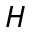 is a subgroup of then 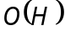 is a divisor of 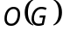.
(b) Show that 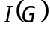 isomorphic to 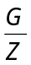 where is the group of inner automorphism of and  is the center of .
- (a) If 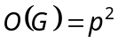 where p is a prime number then show that is abelian.
(b) Show that if 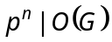, 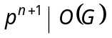 then has a subgroup of order 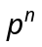.
- (a) Show that if  is a commutative ring with
unit element and M is an ideal of then M is a maximal ideal of if and only if 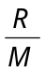 is a field.
(b) Show that if is a prime number then 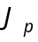 the ring of integers mod p is a field.
- (a) Show that Euclidean ring is a principal ideal ring.
(b) Show that 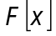 is an Euclidean ring.
- (a) Show that if  is finite dimensional over 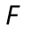 then any two basis of have the same number of elements.
(b) Show that if is finite dimensional then 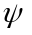 is an isomorphism of onto 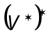.
- (a) Show that if A is an algebra with unit element over F then A is isomorphic to a subalgebra of 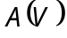 for same vector space over .
(b) Show that
(i) 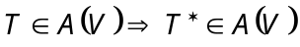
(ii) 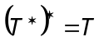
(iii) 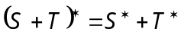
(iv) 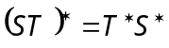
for all 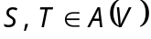.
- (a) Show that 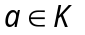 is algebraic over if and only if 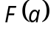 is a finite extension of .
(b) Show that if is of characteristic 0 and if 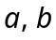 are algebraic over then there exists an element 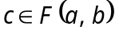 such that 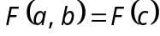.
- (a) Let  be a normal extension of and be a subgroup of 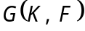, let 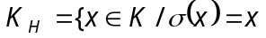 for all 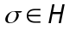} be the fixed field of . Show that
(i) 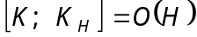
(ii) 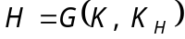.
(b) Show that the multiplicative group of non-zero elements of a finite field is cyclic.
————————
DE–8796
12
DISTANCE EDUCATION
M.Sc. (Mathematics) DEGREE EXAMINATION, MAY 2010.
REAL ANALYSIS
Time : Three hours Maximum : 100 marks
Answer any FIVE questions.
All questions carry equal marks.
- (a) Show that E is open iff its complement is closed.
(b) Prove that closed subsets of compact sets are compact.
(c) State and prove the Cantor Intersection Theorem.
- Let be an open covering of a closed and bounded set A in 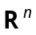. Then prove that a finite subcollection of also covers A.
- (a) State and prove Intermediate-value theorem for derivatives.
(b) Show that if f is differentiable at C, then f is continuous at C.
- State and prove the Implicit function theorem.
- Prove the following :
(a) If 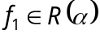 and 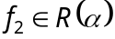 on 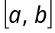, then 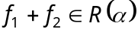, 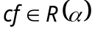 for every constant c and
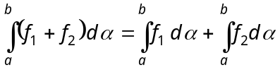, 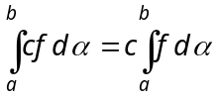.
(b) If 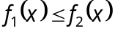 on , then 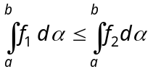.
(c) If 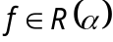 on and if 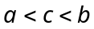, then on 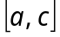 and on 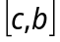, and
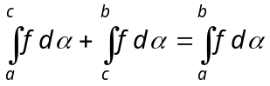.
- State and prove theorem on Interchanging the order of integration.
- Let c be a constant and f and g two measurable
real-valued functions defined on the same domain. Then show that the functions 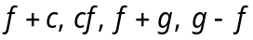 and 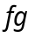 are also measurable.
- State and prove Lebesgue dominated convergence theorem.
————————
13
DE-8797
DISTANCE EDUCATION
M.Sc. (Maths) DEGREE EXAMINATION, MAY 2010.
DIFFERENTIAL EQUATIONS AND NUMERICAL METHODS
Time : Three hours Maximum : 100 marks
Answer any FIVE questions.
All questions carry equal marks.
- If 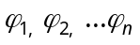 are n solutions of 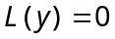 on an interval I, prove that they are independent if and only if the corresponding Wronskian not equal to zero for all x in I.
- Derive Bessels equation.
- (a) Find the solution of the equation
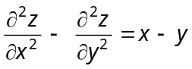.
(b) Find the complete integral of 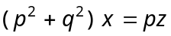.
- Show that the only integral surface of the equation 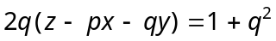 which is circumscribed about the paraboloid 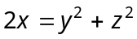 is the enveloping cylinder which touches it along its section by the plane 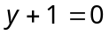.
- Calculate the polynomial of degree 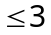 which minimizes 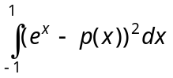 overall polynomials of degree .
- Find the uniform straight line approximation to 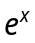.
- Let 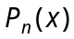 be the polynomial of degree 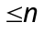 which interpolates 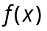 at the points 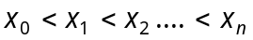 in 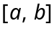. Prove that Lagrange polynomial is given by 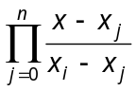 for 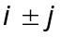.
- Evaluate 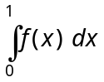 when 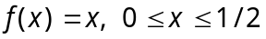 = 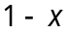 for 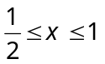 using (a) Trapezoidal rule (b) Simpsons rule.
————————
14
DE–8798
DISTANCE EDUCATION
M.Sc. DEGREE EXAMINATION, MAY 2010.
Mathematics
OPERATIONS RESEARCH
Time : Three hours Maximum : 100 marks
Answer any FIVE questions.
All questions carry equal marks.
- (a) Solve the following LPP by graphically.
Maximize 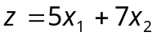 subject to the constraints 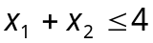, 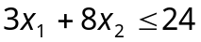, 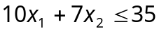, 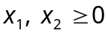.
(b) Use simplex method to solve the LPP.
Maximize 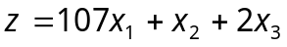 subject to the
constraints 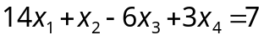 , 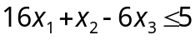 ,
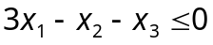, 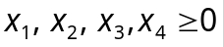.
- (a) Show, by an example, that the dual of a dual is primal.
(b) Find the integer solution to the LPP
Maximize 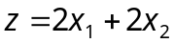 subject to the constraints 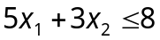, 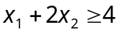, 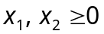 and are integers.
- (a) Solve the following LPP by dynamic programming.
Maximize 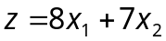 subject to the constraints :
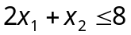, 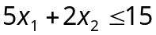, .
(b) Using dynamic programming approach, solve the reliability problem with the following data :
kj | j = 1 |  | j = 2 |  | j = 3
 | R₁ | C₁ | R₂ | C₂ | R₃ | C₃
1 | 0.6 | 2 | 0.8 | 3 | 0.7 | 1
2 | 0.7 | 4 | 0.8 | 5 | 0.8 | 2
3 | 0.9 | 5 | 0.9 | 6 | 0.9 | 3
The total capital available is 10 (in units of thousand rupees).
- (a) Use graphical method in solving the following game.
Player B | Player A
Player B | 2 | 2 | 3 | –2
Player B | 4 | 3 | 2 | 6
(b) Two players A and B match coins. If the coins match then A wins two units of value, if the coins do not match, then B wins 2 units of value. Determine the optimum strategies for the players and the value of the game.
- (a) Draw a network for the following project and number the events according to Fulkerson’s rules.
(i) A is the start event and K is the end event
(ii) J is the successor event to F
(iii) C and D are successor events to B
(iv) D is the preceding event to G.
(v) E and F occur after event C
(vi) E precedes J
(vii) C restrains the occurrence of G and G precedes H.
(viii) H precedes J.
(ix) Frestrains the occurrence of H.
(x) K succeeds event J.
(b) Find the critical path and calculate the slack time for the following PERT diagram :
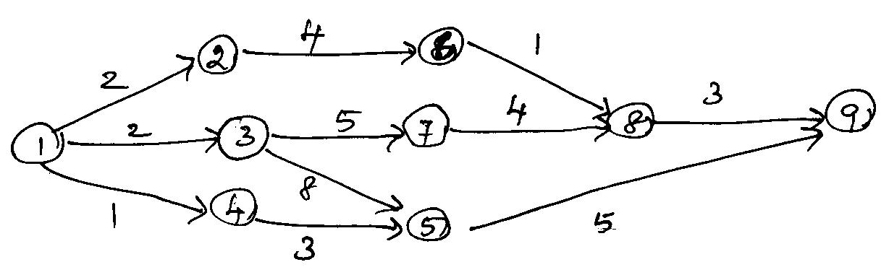
- (a) Find the optimal order quantity for a product for which the price breaks are as follows :
Quantity | Unit cost
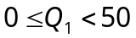 | Rs. 10.00
 | Rs. 9.00
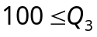 | Rs. 8.00
The monthly demand for the product is 200 units, the cost of storage is 25% of the unit cost and ordering cost is Rs. 20.00 per order.
(b) A manufacturer has to supply his customer with 600 units of his product per year, storages are not allowed and the storage cost amounts to Re. 0.60 per unit per year. The set-up cost per run is
Rs. 80.00. Find optimum run-size and the minimum average yearly cost.
- (a) Explain the Queueing model
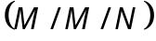 : 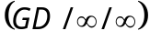.
(b) At what average rate must a clerk at a super market work in order ensure a probability of 0.90 that the customer will not wait longer than 12 minutes? It is assumed that there is only one counter, at which customers arrive in a Poisson fashion at an average rate of 15 per hour. The length of service by the clerk has an exponential distribution.
- (a) For the 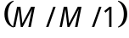 : , derive the expression for Lq using the basic definition, 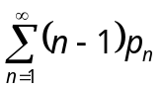.
(b) Customers arrive at a Thrift Bank according to a Poisson distribution, with a mean of 45 customers per hour. Transactions per customer last about
5 minutes and are expontentially distributed. The bank wants to are a single-line multiple-teller operation, similar to the ones used in airports and post offices. The manager is conscious of the fact that customers may switch to other banks if they perceive that their wait in line is “excessive”. For this reason, the manager wants to limit the average waiting time in the queue to no more than
30 seconds. How many tellers should the bank provide?
————————
DE–8799
15
DISTANCE EDUCATION
M.Sc. (Mathematics) DEGREE EXAMINATION, MAY 2010.
MATHEMATICAL STATISTICS
Time : Three hours Maximum : 100 marks
Answer any FIVE questions.
Each questions carry equal marks.
- (a) The joint probability density function of two variables  and  is given by 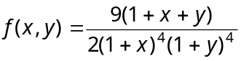 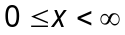, 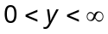. Find the marginal distributions of and and the conditional distribution of for 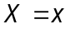.
(b) State and prove Cauchy-Schwartz inequality.
- Prove that the Poisson distribution is the limiting form of Binomial distribution.
- (a) State and prove the central limit theorem.
(b) Derive the constants of -distribution.
- (a) 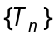 be a sequence of estimators such that for all 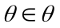 (i) 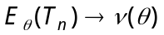, (ii) 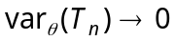 as prove that 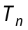 is a consistent estimator of 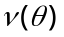.
(b) State and prove Rao-Blackwell theorem.
- State and prove Neyman-Pearson Lemma.
- The binomial distribution of two ’s and is given by 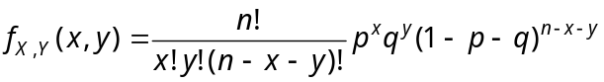 for 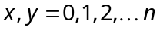 and 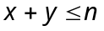, 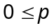, 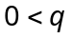 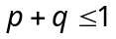.
(a) Find the marginal distribution of and
(b) Find the conditional distribution of and and obtain 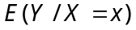 and 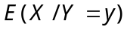.
(c) Find the correlation coefficient between and .
- (a) Derive the Mathematical model by two-way classification.
(b) Find the total sum of squares for the data given below :
City | Price per unit
A | 15 | 18 | 23 | 24
B | 23 | 19 | 18 | 24
C | 19 | 16 | 22 | 31
- Derive sequential probability Ratio Test.

———————
DE–8800
21
DISTANCE EDUCATION
M.Sc. (Mathematics) DEGREE EXAMINATION, MAY 2010.
COMPLEX ANALYSIS
Time : Three hours Maximum : 100 marks
Answer any FIVE questions.
All questions carry equal marks.
- (a) Describe stereographic projection in Riemann sphere. Show that two complex numbers and 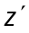 correspond to diametrically opposite on the Riemann sphere if and only if 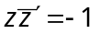.
(b) Construct the analytic function 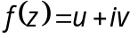 where 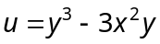.
- (a) What is the radius of convergence? If 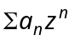 and 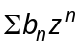 have radii of convergence 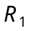 and 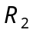, show that the radius of convergence of 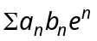 is atleast 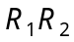.
(b) Discuss the mapping 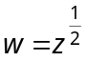.
- (a) State and prove Cauchy’s theorem for a rectangle.
(b) Show that a function which is analytic and bounded in the whole plane reduces to a constant.
- (a) If 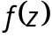 is analytic in a region , show that can be written in the form.
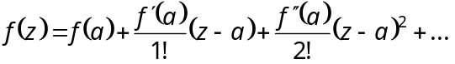
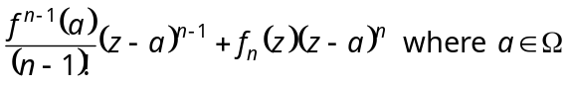
and 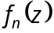 is analytic in .
(b) State and prove Schwarz lemma.
- (a) Find the Laurent expansion of 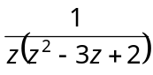 in the regions 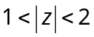 and 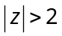.
(b) Evaluate : 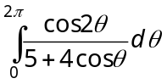.
- (a) State and prove mittag-Leffler’s theorem.
(b) Derive Jensen’s formula.
- (a) Prove that a discrete module consists either of zero alone, of the integral multiples of a single complex number , or of all linear combinations 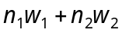 with integral coefficients of two numbers 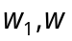 with non real ratio 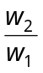.
(b) Prove that the zeros 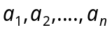 and poles 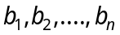 of an elliptic function statisfy 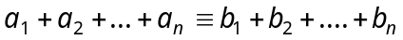 (mod M).
- (a) Show that any even elliptic function with periods 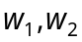 can be expressed in the form
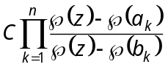 (c = const)
Provided that 0 is neither a zero nor a pole.
(b) Prove that
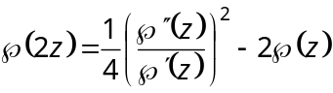.
–––––––––––––––
DE–8801
22
DISTANCE EDUCATION
M.Sc. (Mathematics) DEGREE EXAMINATION, MAY 2010.
TOPOLOGY AND FUNCTIONAL ANALYSIS
Time : Three hours Maximum : 100 marks
Answer any FIVE questions.
Each question carries 20 marks.
- (a) Let be a topological space. Then prove that any intersection of closed sets in is closed and any finite union of closed sets in is closed.
(b) Let be a topological space and A a subset of . Then show that
(i) 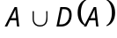 closed
(ii) A is closed 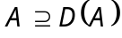.
(c) Let be a topological space. Then prove that any closed subset of is the disjoint union of its set of isolated points and its set of limit points.
- (a) Show that a topological space is compact iff every class of closed sets with empty intersection has a finite subclass with empty intersection.
(b) Prove that a topological space is compact if every basic open cover has a finite subcover.
(c) Show that a metric space is sequentially compact
iff it has the Bolzano Weierstrass property.
- (a) The product of any non-empty class of Hausdorff space is a Hausdorff space – Prove.
(b) Prove that every compact subspace of a Hausdorff space is closed.
- (a) Show that the product of any non-empty class of connected spaces is connected.
(b) Prove that a closed subspace of a normal space is normal.
- (a) State and prove the Closed Graph theorem.
(b) If B and 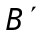 are Banach spaces and if T is a continuous linear transformation of B onto , then prove that T is an open mapping.
- (a) State and prove the ‘Uniform Boundedness
Theorem’.
(b) Show that the product of any non-empty class of connected spaces is connected.
- (a) If M is a proper closed linear subspace of a
Hilbert space H. Then show that there exist a vector 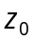 in such that 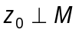.
(b) State and prove ‘Schwartz inequality’.
- (a) State and prove Bessel’s inequality.
(b) If 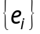 is an orthonormal set in a Hilbert space H, and if x is an arbitrary vector in H, prove that 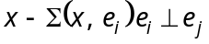 for each j.
(c) Prove that every non-zero Hilbert space contains a complete orthonormal set.
————————
DE–8803
24
DISTANCE EDUCATION
M.Sc. (Maths) DEGREE EXAMINATION, MAY 2010.
PROGRAMMING IN C/C++
Time : Three hours Maximum : 100 marks
Answer any FIVE questions.
All questions carry equal marks.
- (a) What are the basic concept of object oriented programming? Explain in detail. (10)
(b) Discuss the syntax of language and logic programming. (10)
- (a) Describe the structure of a C program with suitable example. (10)
(b) Discuss various datatypes and functions with examples. (10)
- (a) Explain puts( ) and putchar( ) with example. (10)
(b) Discuss the various operators in C++ with examples. (10)
- (a) Write a program in C to solve the quadratic equation. (10)
(b) Compare local and global variables with suitable example program. (10)
- (a) Illustrate the nested-if and switch command with examples. (10)
(b) Distinguish with example between do..while and while loop. (10)
- (a) Write a program to arrange the numbers in ascending order using array. (10)
(b) Write a program to find the string length using array. (10)
- (a) Explain structure with an example program. (10)
(b) Explain the pointer declaration and initialization with suitable example. (10)
- (a) With example explain input and output functions of file. (10)
(b) How can you read and print a disk file? Explain with suitable example. (10)
————————
DE–8804
25
DISTANCE EDUCATION
M.Sc. (Mathematics) DEGREE EXAMINATION, MAY 2010.
DISCRETE AND COMBINATORIAL MATHEMATICS
Time : Three hours Maximum : 100 marks
Answer any FIVE questions.
Each question carries 20 marks.
- (a) In how many ways can we select seven non consecutive integers from 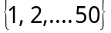?
(b) Find the number of r-digit-quaternary sequences in which each of the digits 1, 2, 3 appears atleast once.
(c) Find 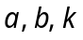 so that 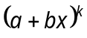 is the generating function for the sequence 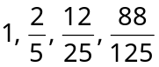.
- (a) Solve .
(b) Write the recurrence relation for Fibonacci number and solve it.
- State and prove the principle of inclusion and exclusion and it’s generalization.
- (a) Obtain the number of derangements 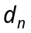of n objects, using a recurrence relation.
(b) Explain Rook polynomials with an example.
- (a) State and prove Burnside Lemma.
(b) Find the cycle index of the permutation group S₄, consisting all the permutations on 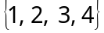.
- State and prove Polyas fundamental theorem.
- (a) State and prove cancellation rule for distributive lattice.
(b) Show that the product of two distributive lattices is a distributive lattice.
(c) Prove that if L is a distributive lattice with 0 and 1, then each element 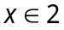 has atmost are complement.
- (a) Let B be a finite Boolean Algebra and let A be the set of all atoms of B. Prove that B is isomorphic to the Boolean algebra 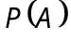.
(b) Explain how to obtain the principle disjunction normal form with the example 



