ALAGAPPA UNIVERSITY
FACULTY DETAILS
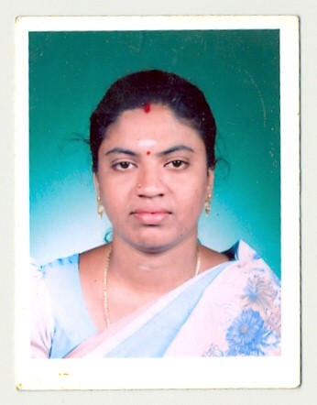

- Name : S. MAHESWARI

- Date of Birth : 27-01-1976

- Gender : Female

- Department : Computer Science & Engineering

- Qualification : M.C.A., M.Phil.,

- Designation : SYSTEM PROGRAMMER

- Address : Department of Computer Science & Engineering
Alagappa University
Karaikudi.

- Pin code : 630 003

- Phone : +91 – 04565 – 255874

- Email : mahitc@yahoo.in

- Website : --

- Fax : --

- University Studied UG and PG :
S.No | Degree | University | Year of Study
1. | B.Sc (Maths) | Madras | 1995-1998
2. | M.C.A | Alagappa | 2000-2003
3. | M.Phil | Annamalai | 2007-2008

- University Where Research done : Nil

- PG Specialization (subjects) :
1. Computer Networks | 2. Operation Research
3. Database Management Systems | 4. Principles of Information Technology
5. Software Engineering | 6. Data warehousing and mining

- Total Teaching Experience : 3 years
S.No | Institution | Position | Period
S.No | Institution | Position | From | To
1. | Dr. Umayal Ramanathan College for Women, Karaikudi | Lecturer | June 2007 – Jan 2008
2. | Alagappa University, Karikudi | System Programmer | Jan 2008 - till date

- Total Research Experience (No. of Years): 2 Years 2 months

- Current Research Field : Nil

- No. of MPhil & PhDs Guided : Nil

- Projects done Minor/Major: Nil

- Seminar/Workshops Organized : 1

S.No | Title | Period
1 | Recent Trends and Challenges in Information Technology | March 2009

- Seminar/Workshops Attended : 3
(a) National
S.No | Title | Institution and Event Name | Period
1 | Smart and Secure environment workshop | DCSE, Alagappa University, Karaikudi | June 2008
2. | Convergent Technologies in IT | DCSE, Alagappa University, Karaikudi | Feb 2009
3. | Advanced Computing Technologies | DCSE, Alagappa University, Karaikudi | March 2010

(b) International : Nil

National Seminar :2
- S.no | Title | Institution and Event name | Period
1. | Introduction to Web Design(Tamil) | Tamil Seminar  DCSE, Alagappa University, Karaikudi | 2009
2. | Image Restoration in Education | Seminar on Evolving strategies for employability of students in Higher Education,  in DCSE, Alagappa University, Karaikudi | April 2010

