ASSIGNMENT-6.1

Task-1

Create an Employee class with attributes (name, id, salary) and a method to calculate yearly salary. Generate the Employee class. And Analyze the generated code for correctness and structure. And add a method to give a bonus and recalculate salary

Code:

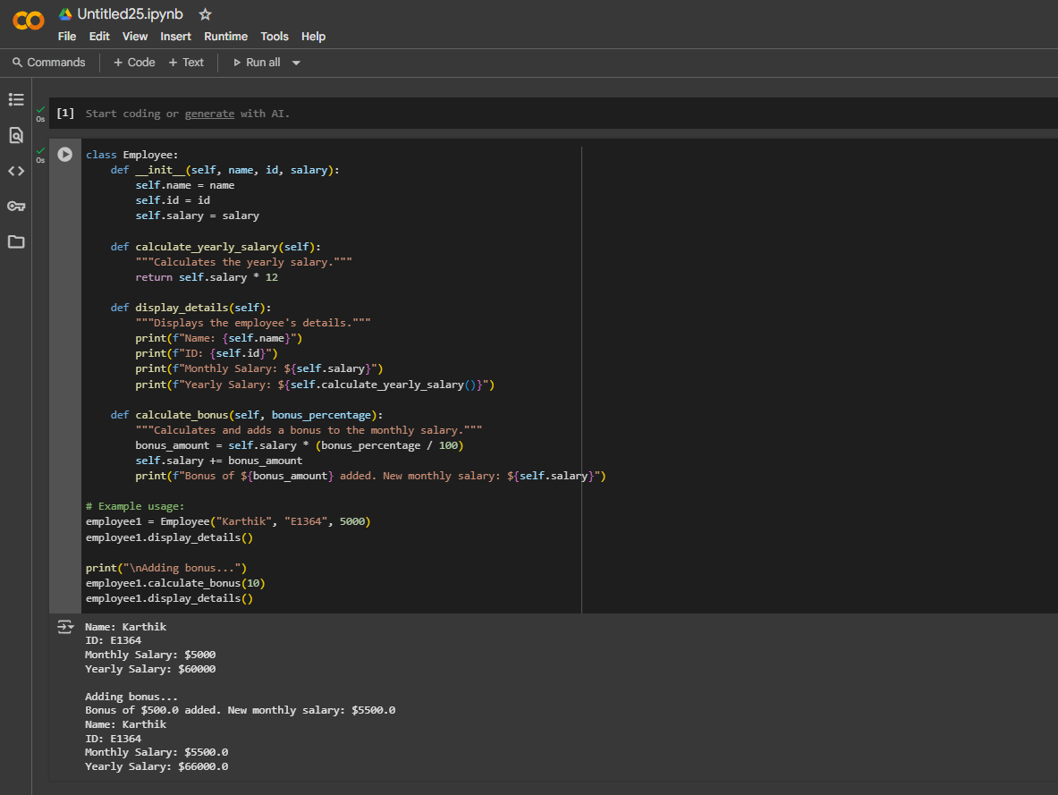

Task-2

# Generate a function that displays all Automorphic numbers between 1 and 1000 using a for loop. To get a generated code to list Automorphic numbers using a for loop. Analyze the correctness and efficiency of the generated logic. And to regenerate using a while loop and compare both implementations. Expected Output should be : Correct implementation that lists Automorphic numbers using both loop types, with explanation.

Code:

For Loop:

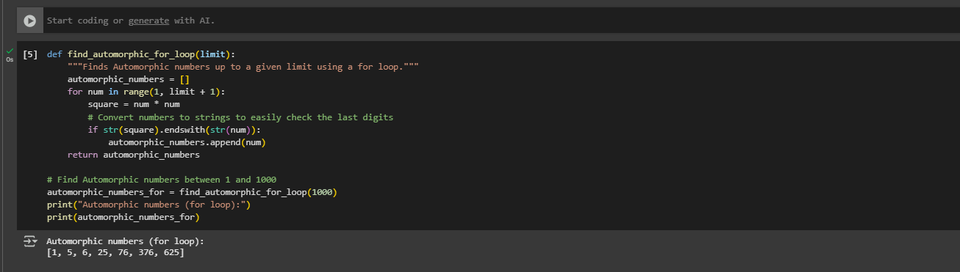

For while loop:

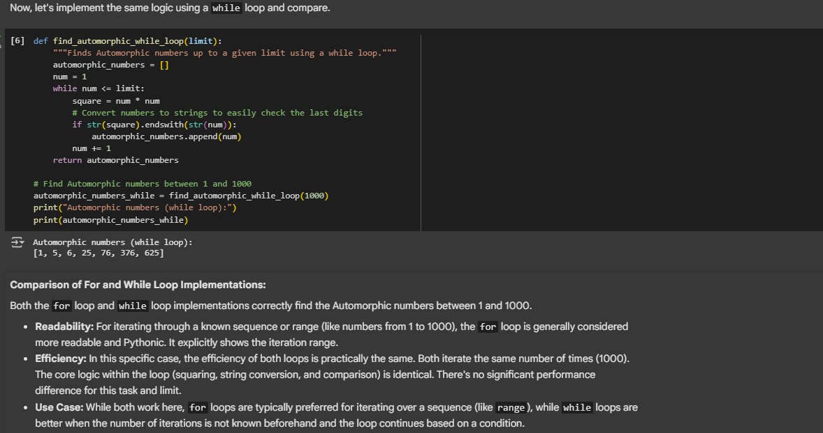

Task – 3

Write nested if-elif-else conditions to classify online shopping feedback as Positive, Neutral, or Negative based on a numerical rating (1–5).Generate initial code using nested if-elif-else. Analyze correctness and readability. And rewrite using dictionary-based or match-case structure.Expected Output : function with explanation and an alternative approach

**Code:**

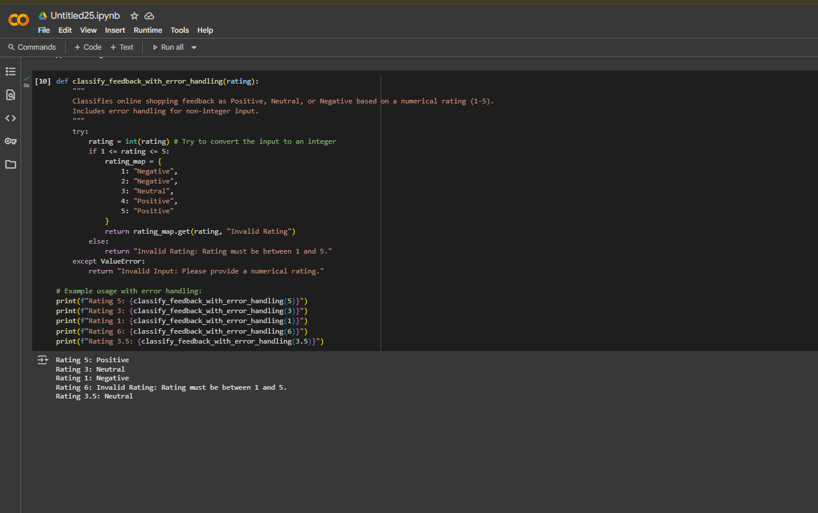

Task-4

Generate a function that displays all prime numbers within a user-specified range (e.g., 1 to 500).And Generate the code to list all primes using a for loop. Analyze the correctness and efficiency of the prime- checking logic. And regenerate an optimized version (e.g., using the square root method).Expected Output should be: Python program that lists all prime numbers within a given range

**Code:**

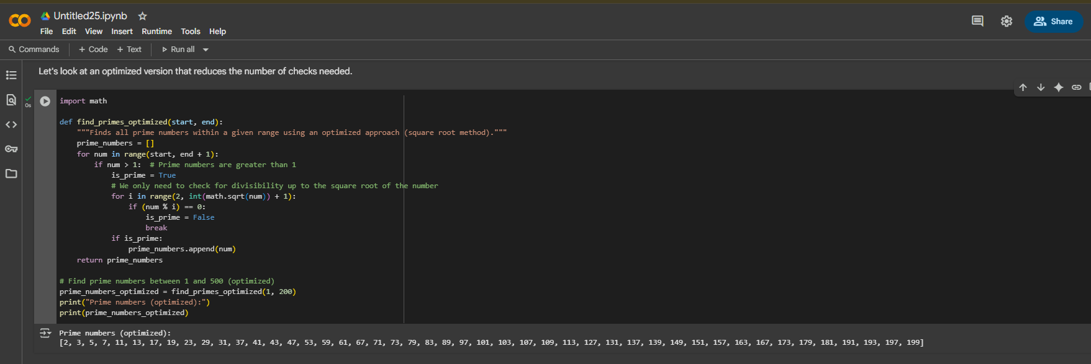

Task-5

Build a Library class with methods to add_book(), issue_book(), and display_books(). Generate Library class code.. Analyze if methods handle edge cases (e.g., issuing unavailable books). And add comments and documentation. Expected Output should be: Library class with all methods, inline comments, and explanation.

Code:

