ASSIGNMENT – 9.1

TASK – 1

# Task Description #1 (Documentation – Google-Style Docstrings for Python Functions) • Task: Use AI to add Google-style docstrings to all functions in a given Python script. • Instructions: o Prompt AI to generate docstrings without providing any input-output examples. o Ensure each docstring includes: ▪ Function description ▪ Parameters with type hints ▪ Return values with type hints ▪ Example usage o Review the generated docstrings for accuracy and formatting. • Expected Output #1: o A Python script with all functions documented using correctly formatted Google-style docstrings

CODE :

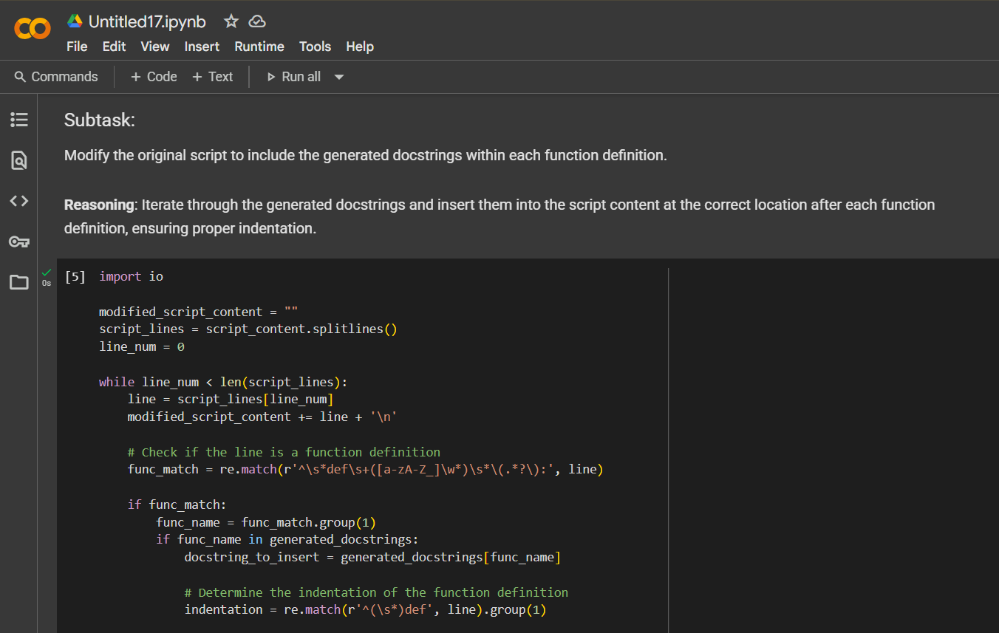

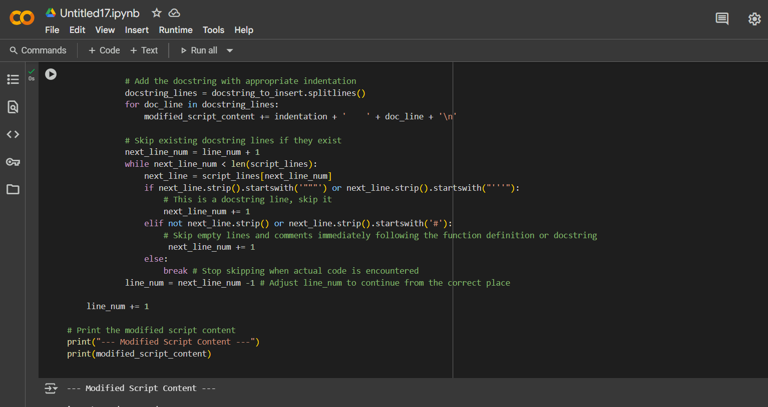

TASK – 2

## Task Description #2 (Documentation – Inline Comments for Complex Logic) • Task: Use AI to add meaningful inline comments to a Python program explaining only complex logic parts. • Instructions: o Provide a Python script without comments to the AI. o Instruct AI to skip obvious syntax explanations and focus only on tricky or non-intuitive code sections. o Verify that comments improve code readability and maintainability. • Expected Output #2: o Python code with concise, context-aware inline comments for complex logic blocks

CODE:

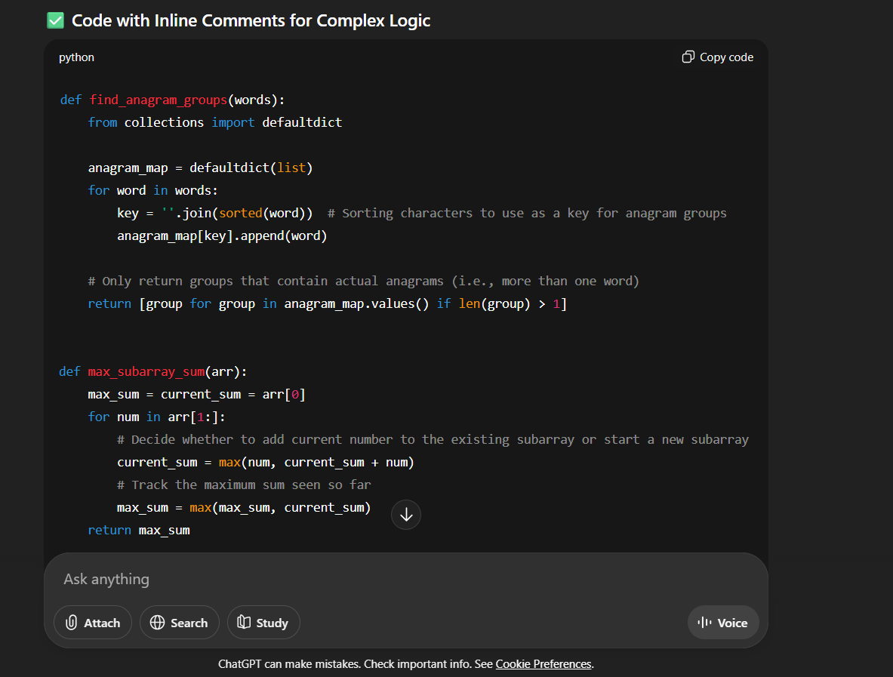

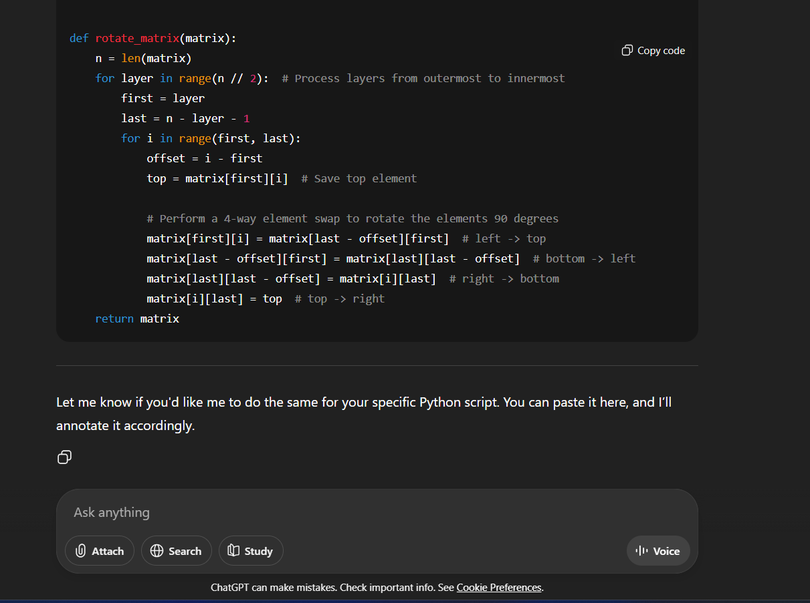

TASK – 3

Description #3 (Documentation – Module-Level Documentation)  
• Task: Use AI to create a module-level docstring summarizing the  
purpose, dependencies, and main functions/classes of a Python  
file.

• Instructions:  
o Supply the entire Python file to AI.  
o Instruct AI to write a single multi-line docstring at the top  
of the file.  
o Ensure the docstring clearly describes functionality and  
usage without rewriting the entire code.  
• Expected Output #3:  
o A complete, clear, and concise module-level docstring at  
the beginning of the file.

CODE:

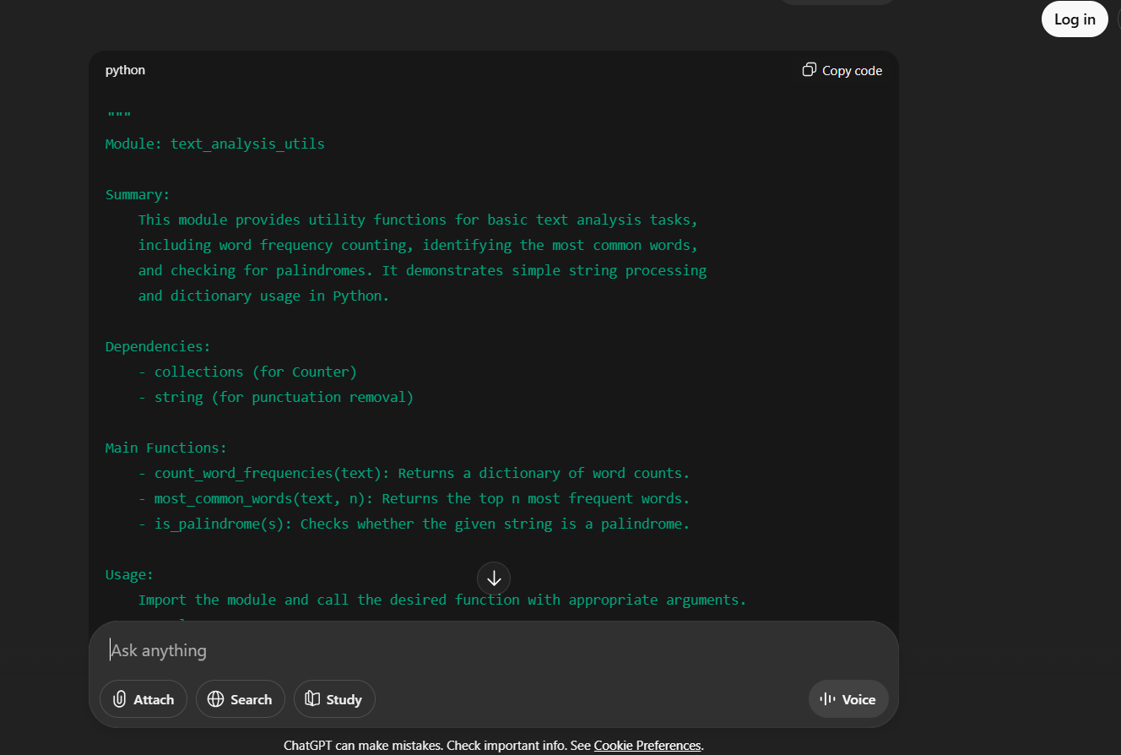

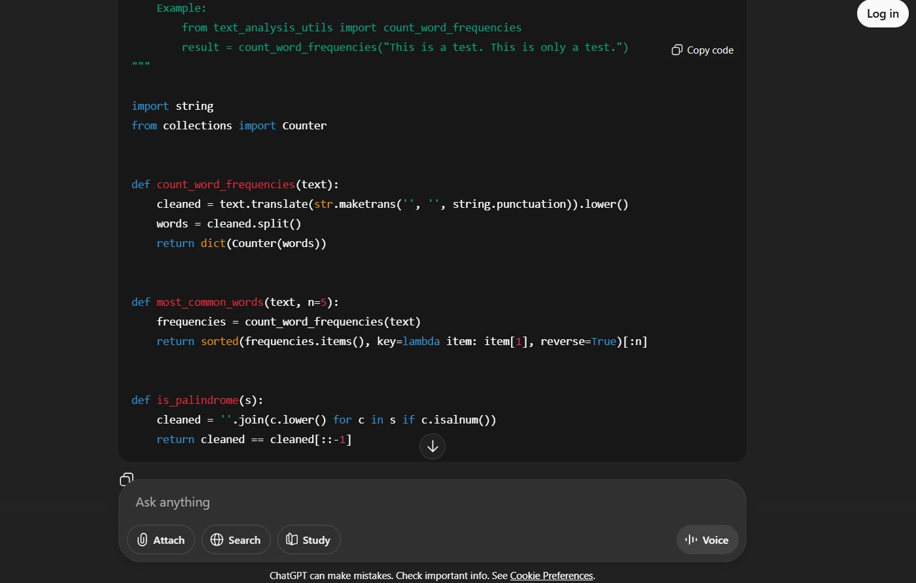

TASK – 4

Task Description #4 (Documentation – Convert Comments to  
Structured Docstrings)  
• Task: Use AI to transform existing inline comments into  
structured function docstrings following Google style.  
• Instructions:  
o Provide AI with Python code containing inline comments.  
o Ask AI to move relevant details from comments into  
function docstrings.  
o Verify that the new docstrings keep the meaning intact  
while improving structure.  
• Expected Output #4:  
o Python code with comments replaced by clear,  
standardized docstrings

CODE :

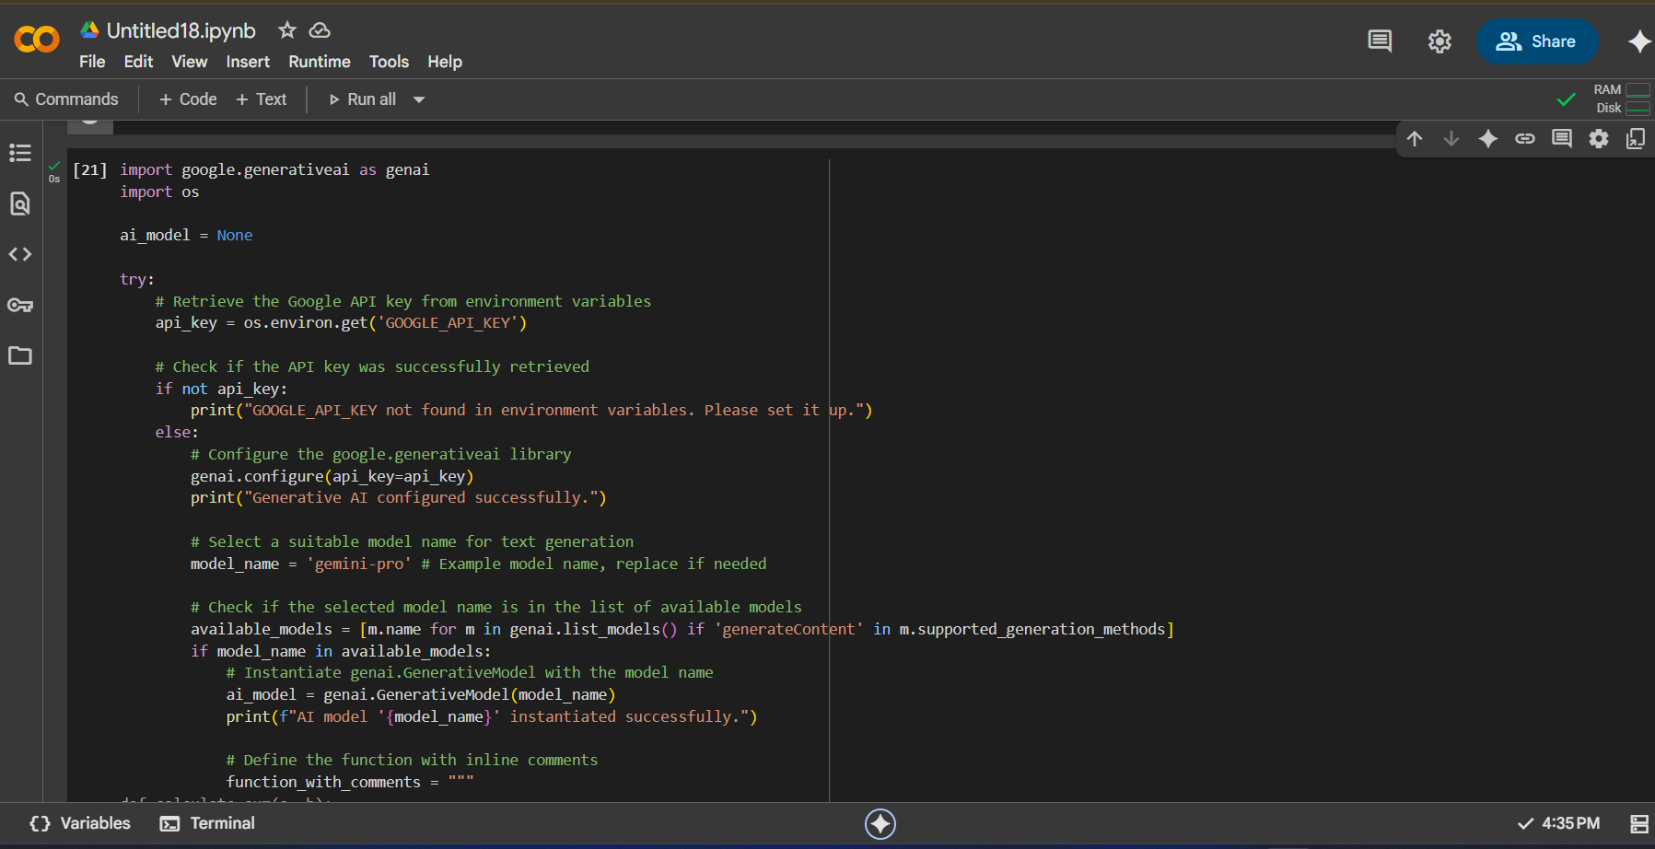

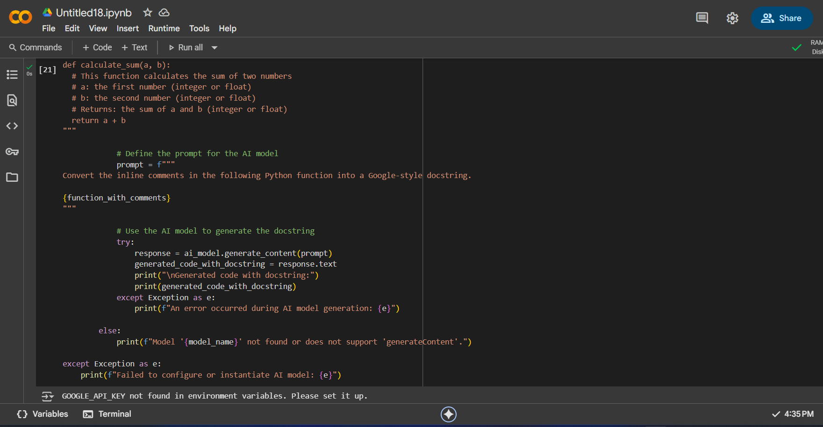

TASK – 5

Task Description #5 (Documentation – Review and Correct  
Docstrings)  
• Task: Use AI to identify and correct inaccuracies in existing  
docstrings.  
• Instructions:  
o Provide Python code with outdated or incorrect  
docstrings.  
o Instruct AI to rewrite each docstring to match the current  
code behavior.  
o Ensure corrections follow Google-style formatting.  
• Expected Output #5:  
o Python file with updated, accurate, and standardized  
docstrings

CODE :

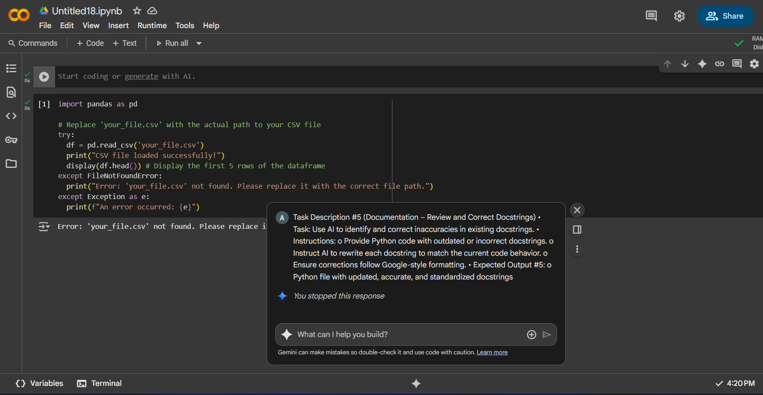

TASK – 6

• Task: Compare documentation output from a vague prompt and a  
detailed prompt for the same Python function.  
• Instructions:  
o Create two prompts: one simple (“Add comments to this  
function”) and one detailed (“Add Google-style docstrings  
with parameters, return types, and examples”).  
o Use AI to process the same Python function with both  
prompts.  
o Analyze and record differences in quality, accuracy, and  
completeness.  
• Expected Output #6:  
o A comparison table showing the results from both  
prompts with observations.

CODE :

