# **Name:Karthik**

# **2403A51364**

Assignment – 10.2

Task Description#1 AI-Assisted Code Review (Basic Errors)  
• Write python program as shown below.  
• Use an AI assistant to review and suggest corrections.

Code

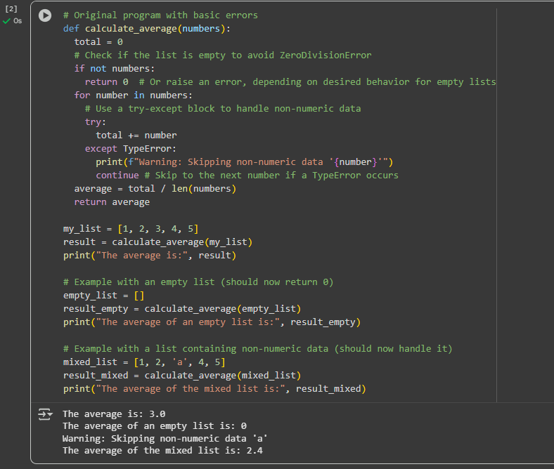

Task Description#2 Automatic Inline Comments  
• Write the Python code for Fibonacci as shown below and execute.  
• Ask AI to improve variable names, add comments, and apply PEP8 formatting  
(cleaned up).  
• Students evaluate which suggestions improve readability most. One

Code:

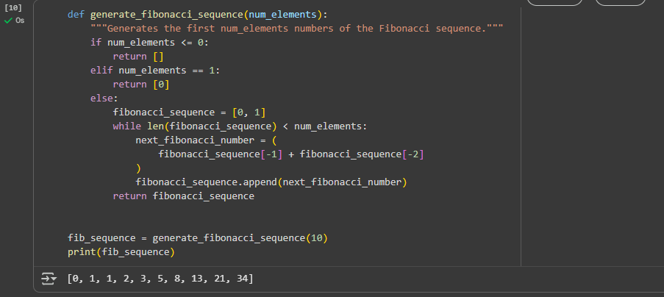

Task Description#3  
• Write a Python script with 3–4 functions (e.g., calculator: add, subtract, multiply,  
divide).  
• Incorporate manual docstring in code with NumPy Style  
• Use AI assistance to generate a module-level docstring + individual function  
docstrings.  
• Compare the AI-generated docstring with your manually written one.  
Code

