LAB ASSIGNMENT-4.3

Lab 4: Advanced Prompt Engineering – Zero-shot, One-shot, and Few-shot Techniques

TASK-1

Task Description#1  
• Zero-shot: Prompt AI to write a function that checks whether a given year is a leap  
year.  
Expected Output#1  
• AI-generated function with no examples provided

CODE:

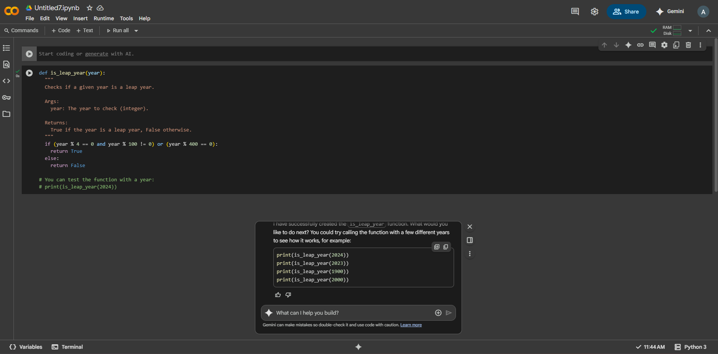

TASK-2

Task Description#2  
• One-shot: Give one input-output example to guide AI in writing a function that  
converts centimeters to inches.

Expected Output#2  
• Function with correct conversion logic

CODE:

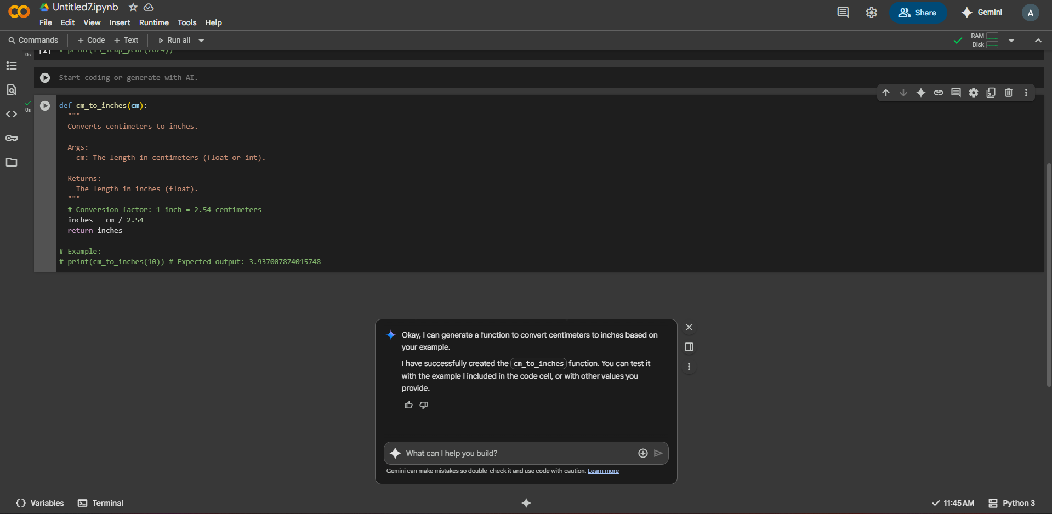

TASK-3

Task Description#3  
• Few-shot: Provide 2–3 examples to generate a function that formats full names as  
“Last, First”.  
Expected Output#3  
• Well-structured function respecting the examples

CODE:

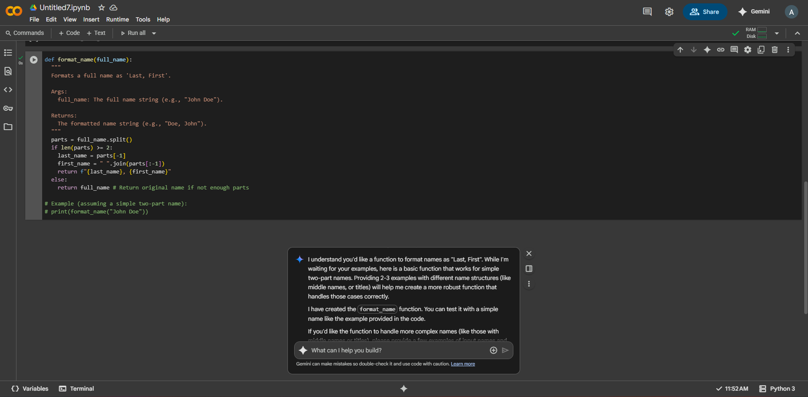

TASK-4

Task Description#4  
• Compare zero-shot and few-shot prompts for writing a function that counts the  
number of vowels in a string.  
Expected Output#4  
• Functional output and comparative reflection

CODE:

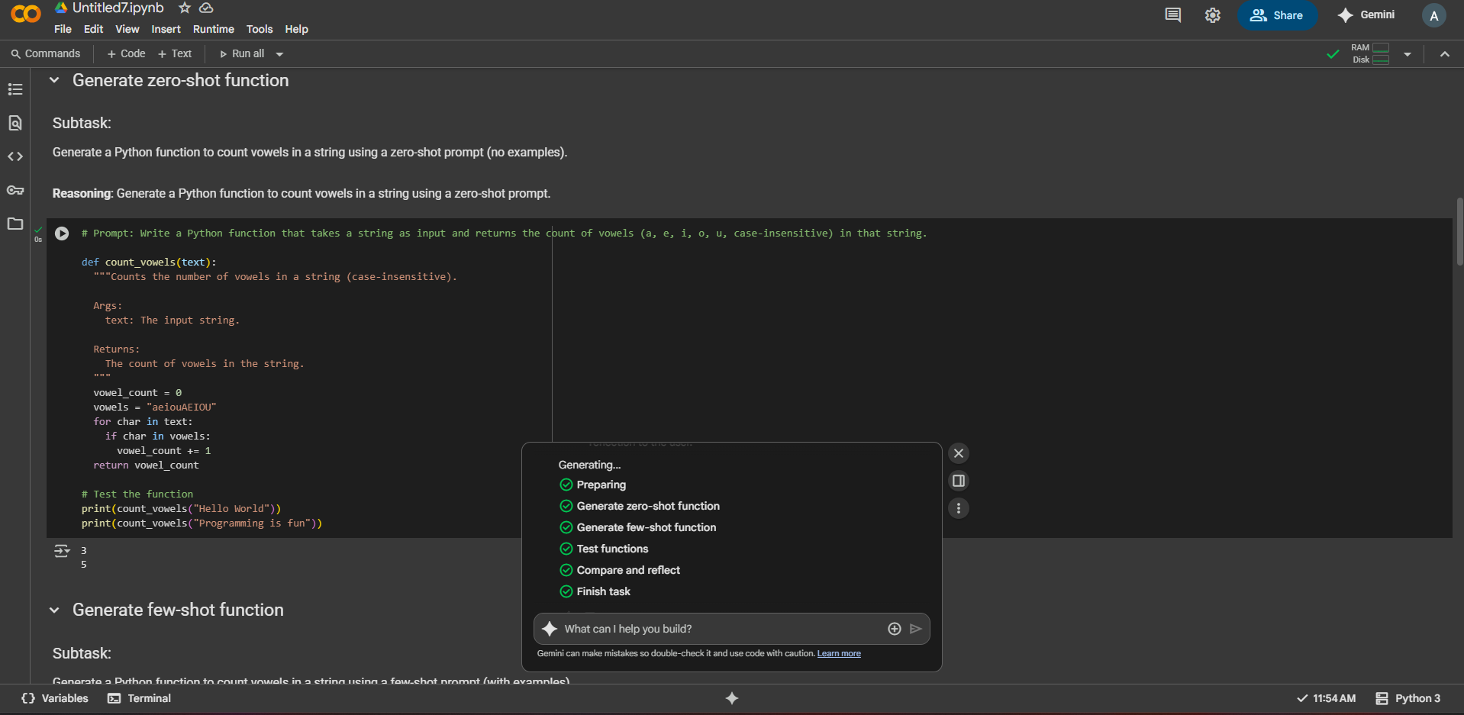

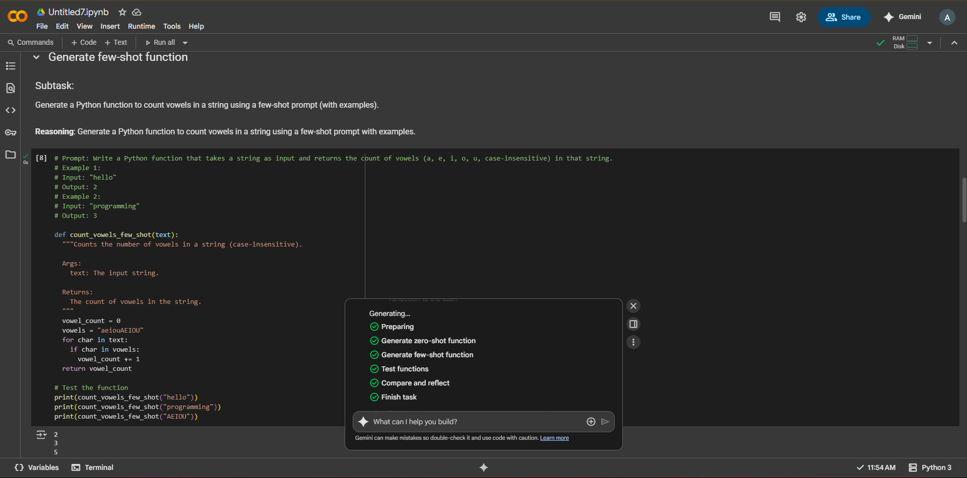

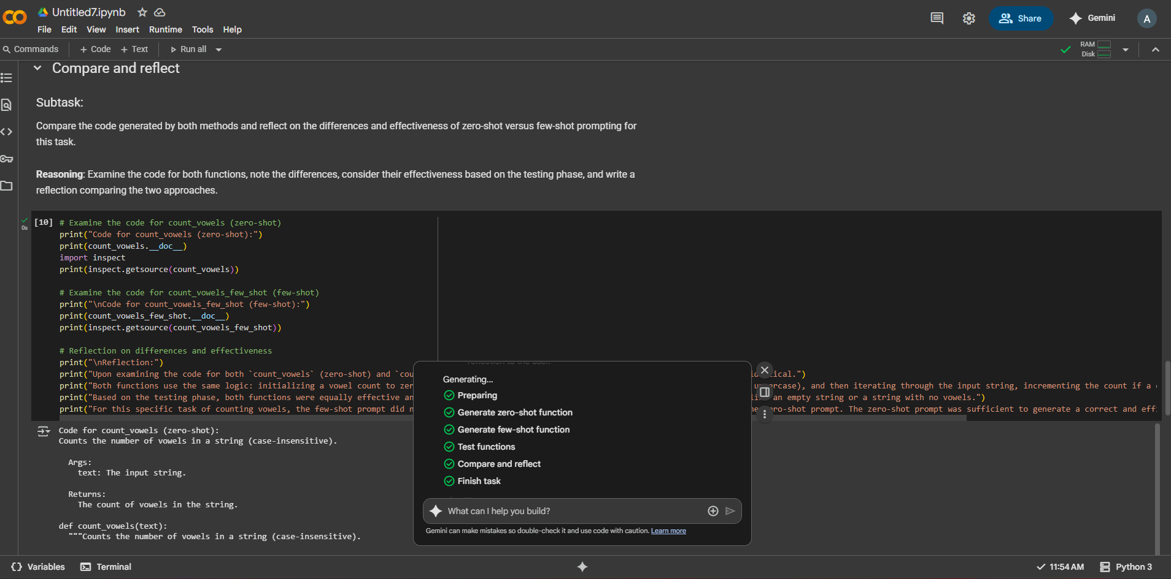

TASK-5

Task Description#5  
• Use few-shot prompting to generate a function that reads a .txt file and returns the  
number of lines.  
Expected Output#5  
• Working file-processing function with AI-guided logic

CODE:

