**Name : Mundgemane, Karthik**

**Class ID : 28.**

**Student ID : 16233000**

STEP 1:

Index page was formed with student to register by entering details of name, father name, address, level of education, course, semester, email id and phone number.

This page was validated by JavaScript code so that there is no error in filling and there is no blank fields.

If any errors found it is being displayed and the form must be filled completely.

Links for each course selected was formed and it was redirected to appropriate page using JavaScript.

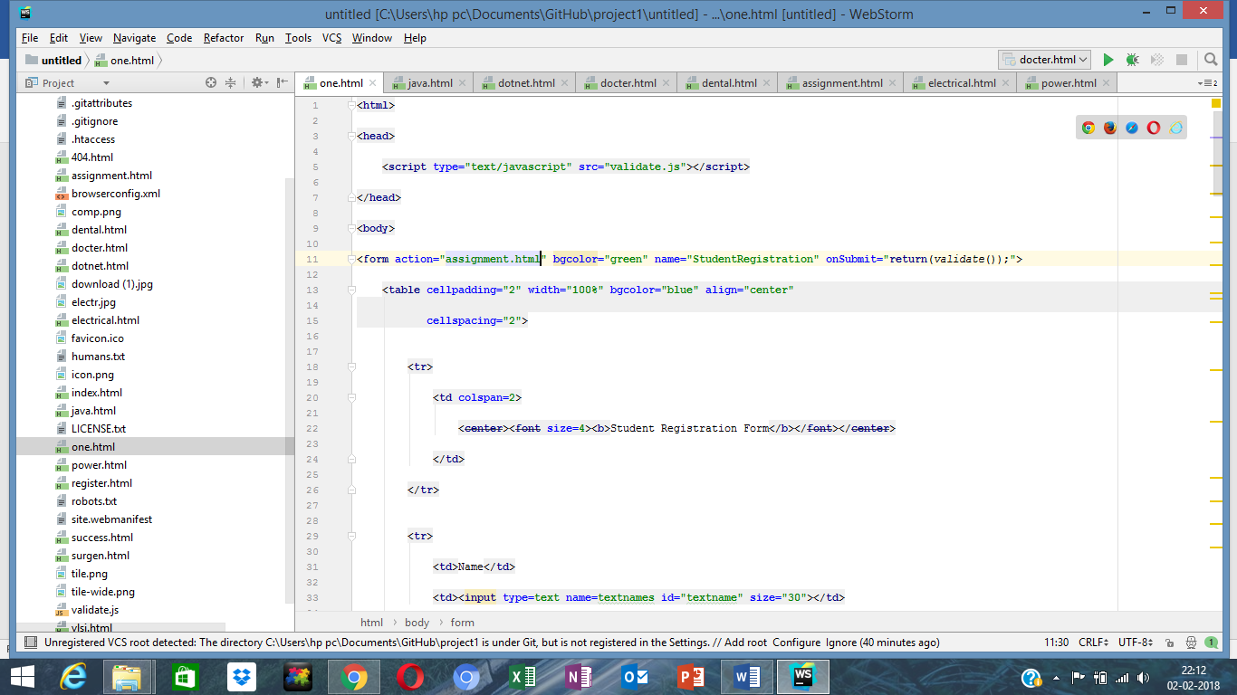

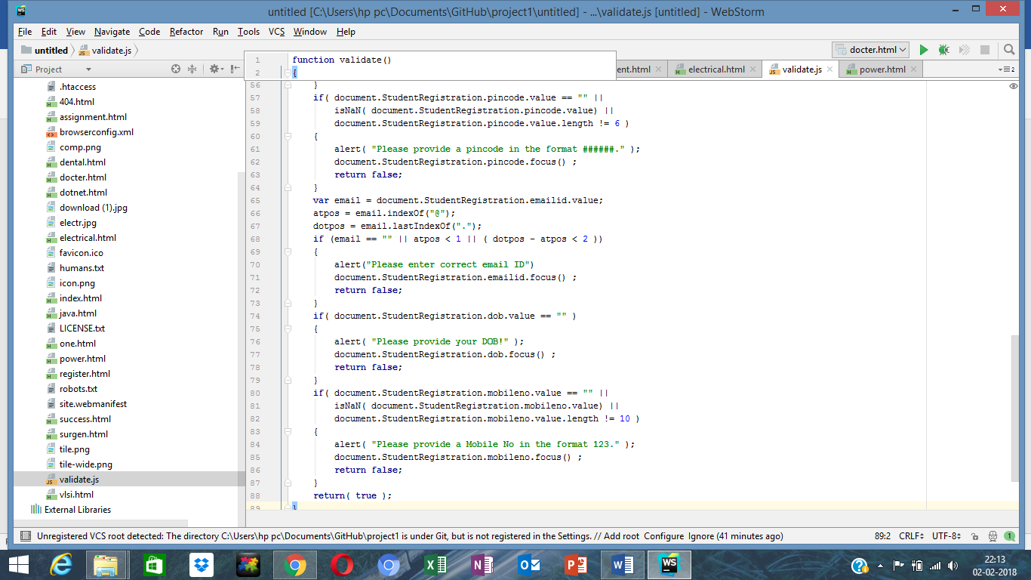

STEP 2:

On running this page the following is being displayed asking student to fill out the form:

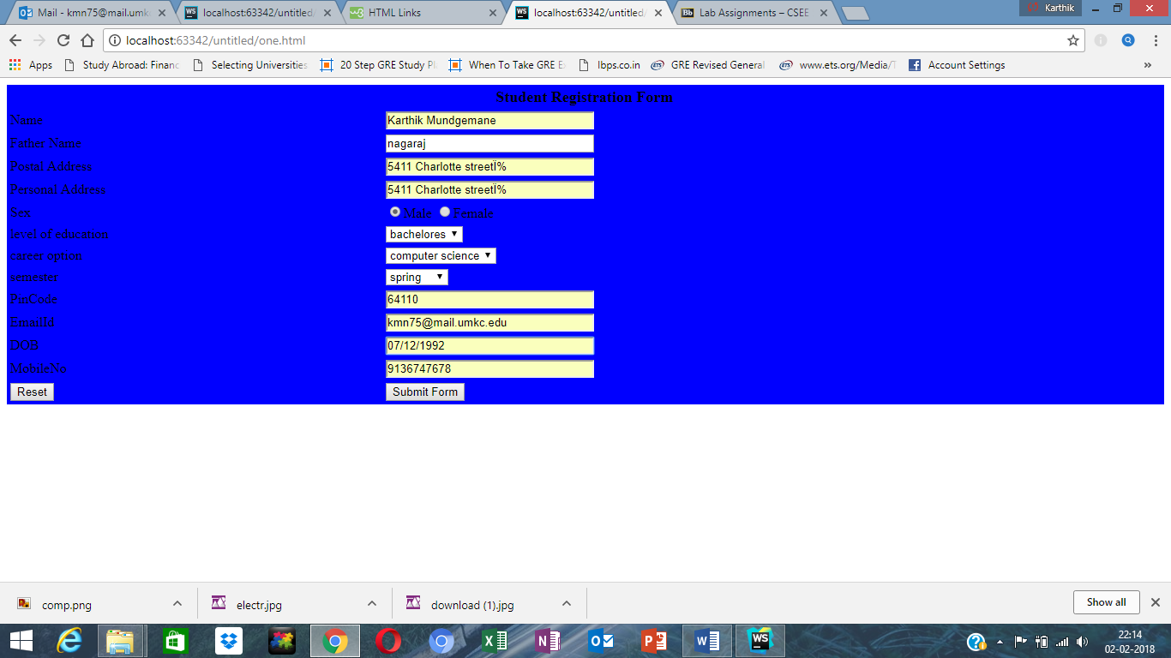

Error scenario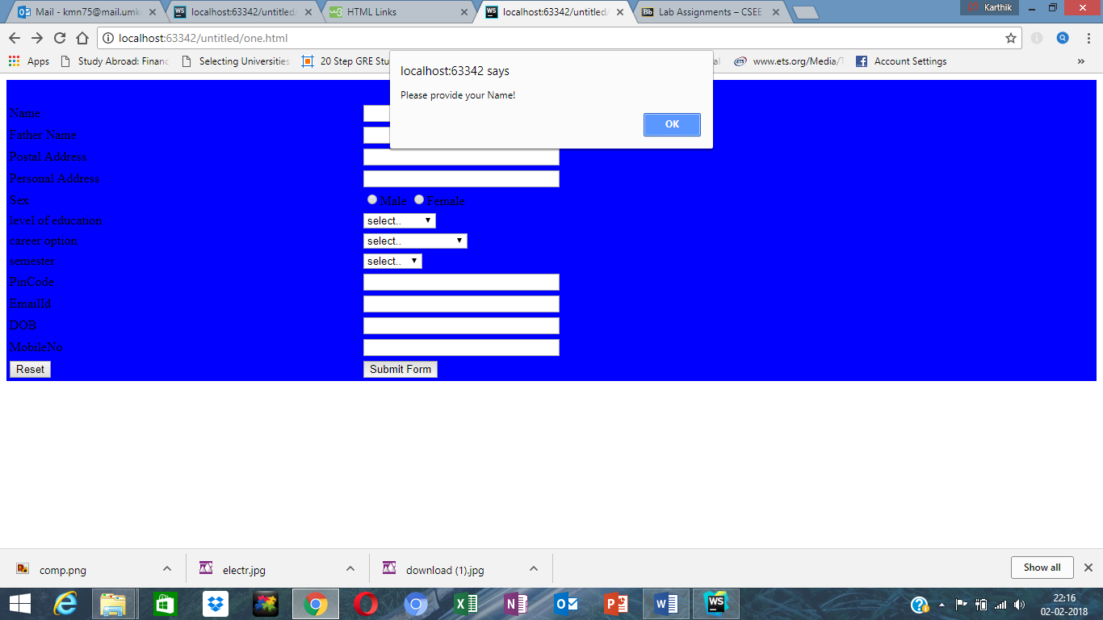

Step 3:

Next when student chooses different fields of course the respective page is displayed.

<**a href="java.html"**>click here to get details for java </**a**> is used for linking pages and

<**img src="comp.png" alt="Girl in a jacket"**>

Is used for image.

For computer science:

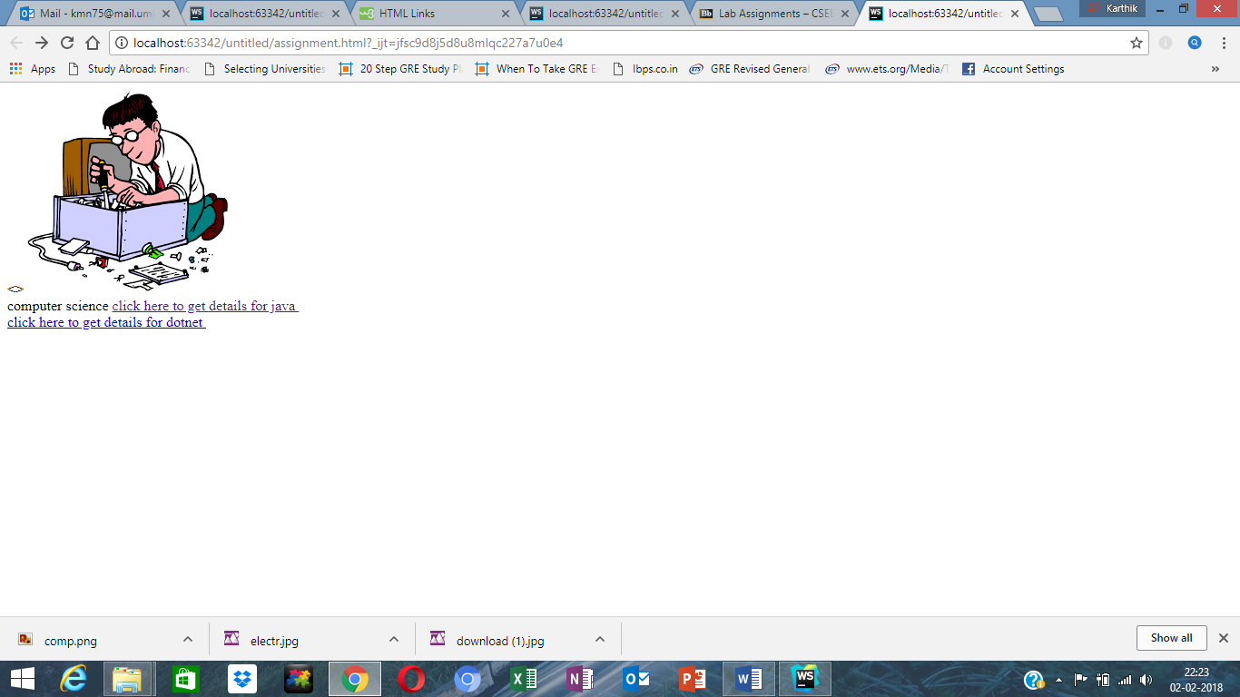

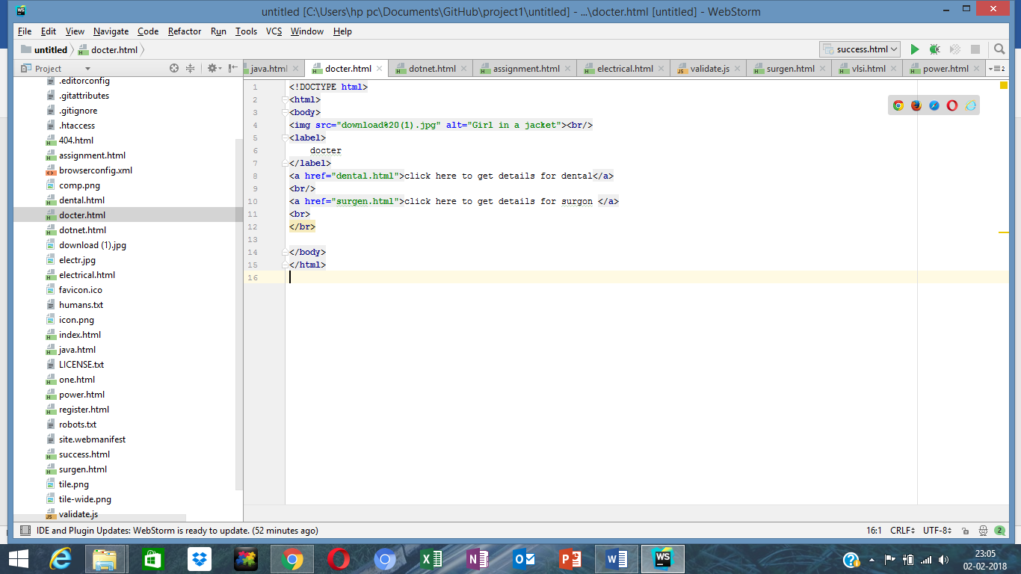

For doctor :

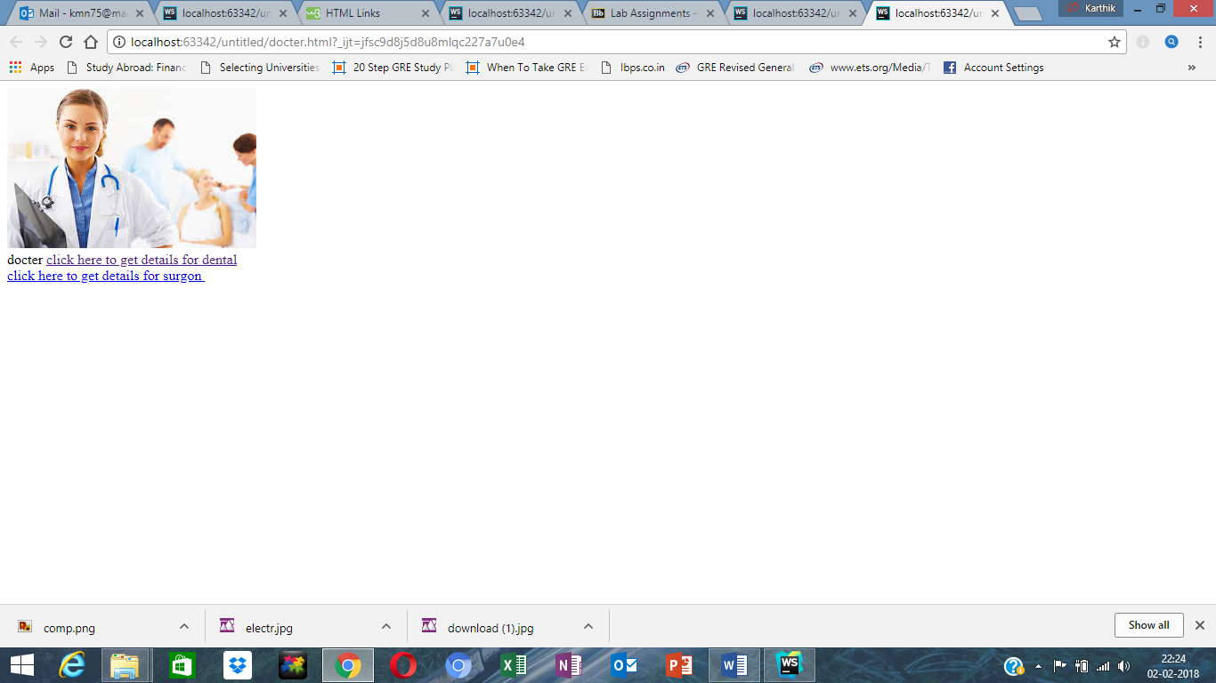

For electrical engineering

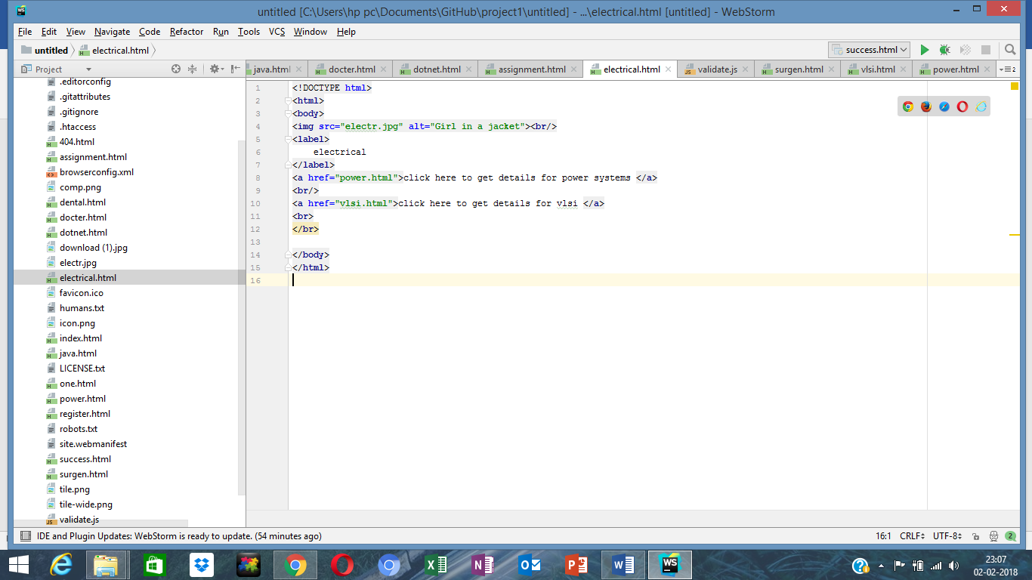

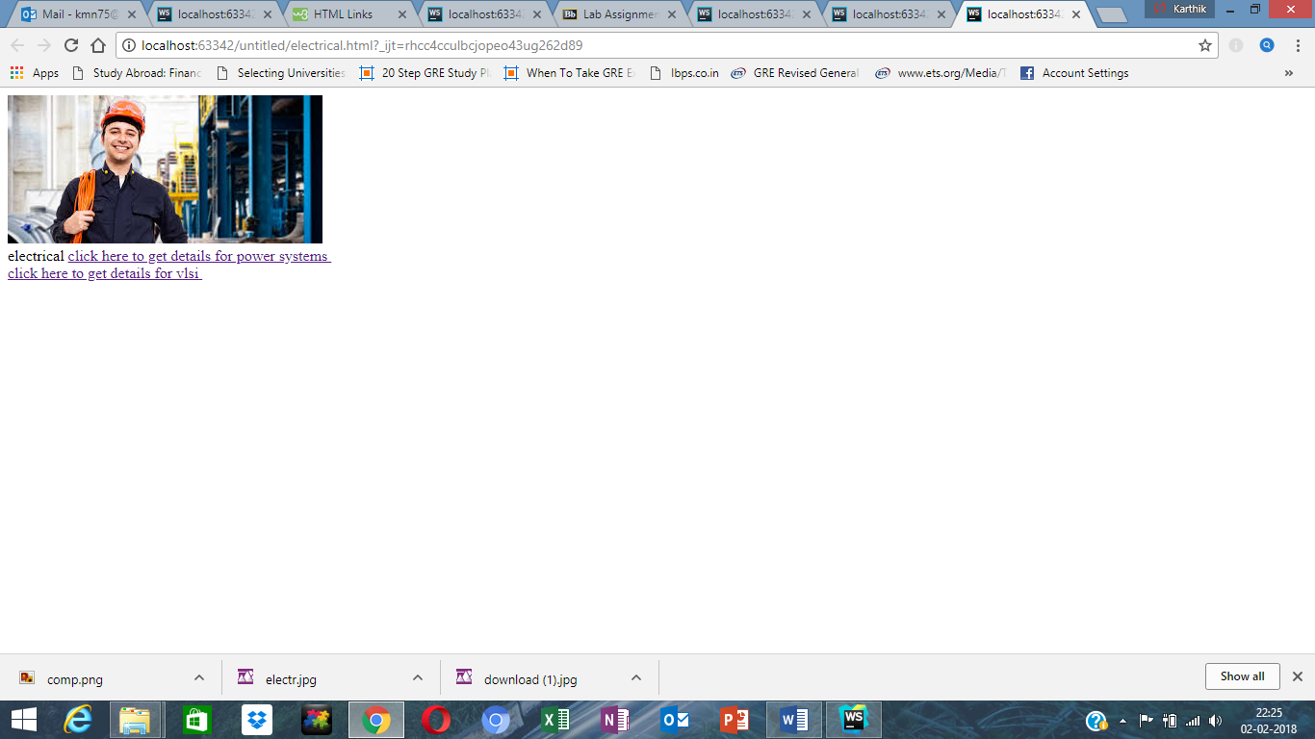

Step 4:

There are two courses in each major field of studies selected, each course lists the available classes with relevant information such as instructors, prerequisites, credit hours, duration, student is displayed with ratings and review for each course and instructor by previous students.

For computer science : java and dotnet are two classes:

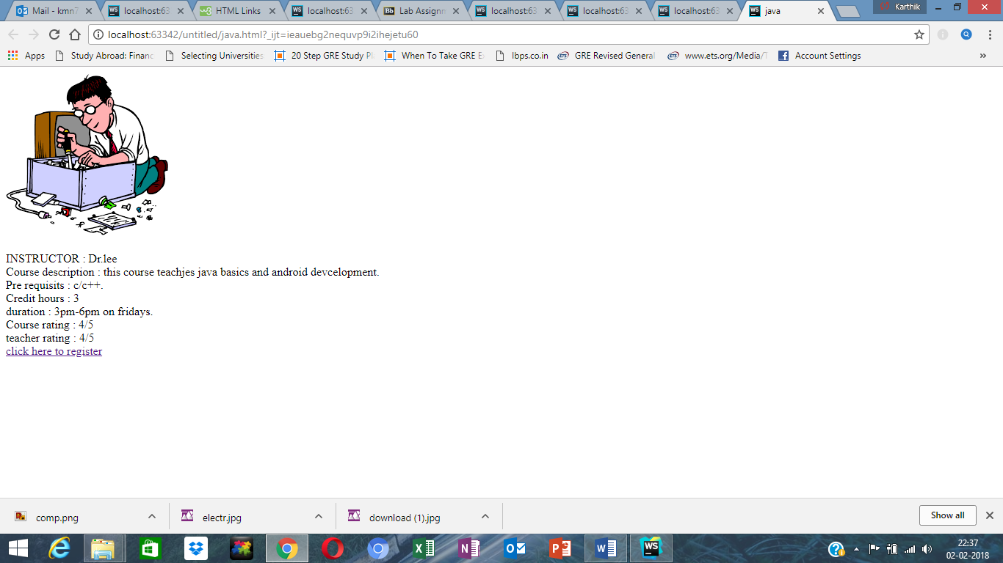

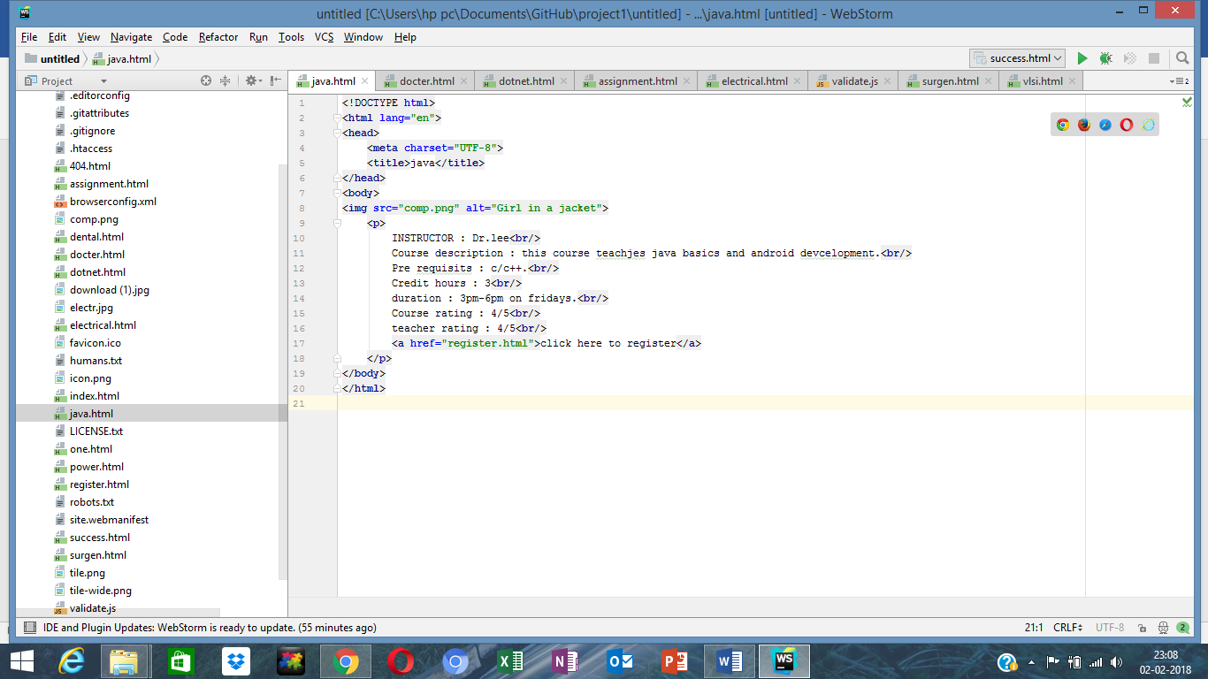

For dotnet:

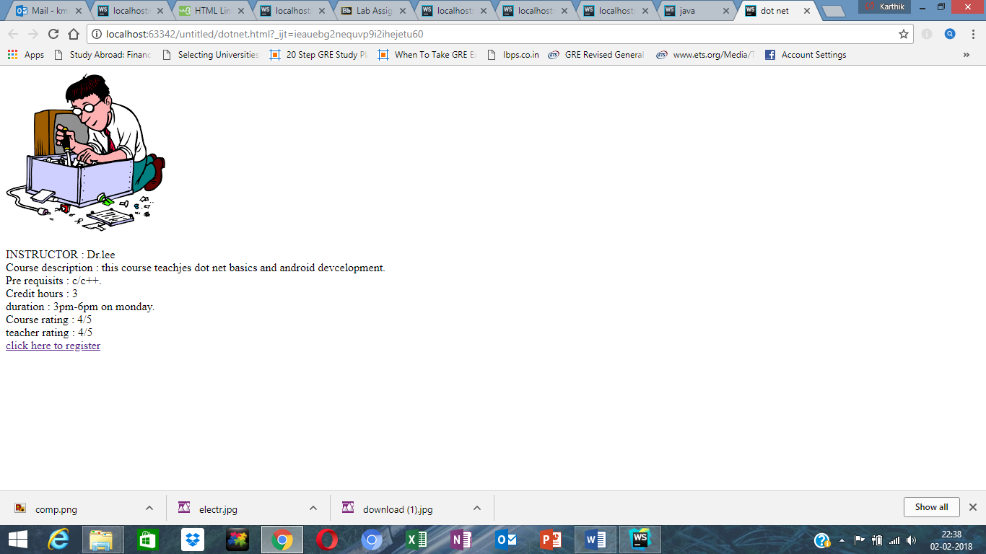

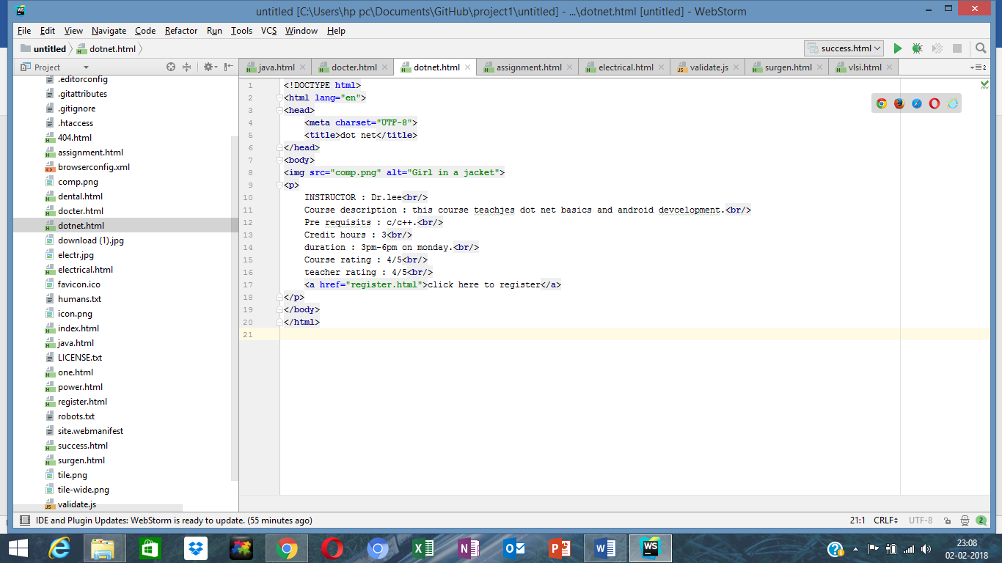

For electrical there are two options, vlsi and power systems.

For vlsi :

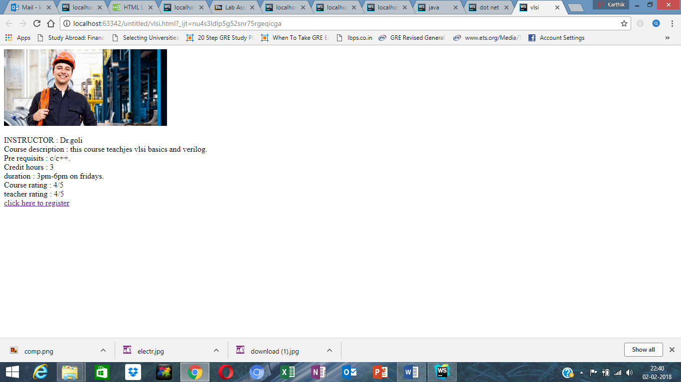

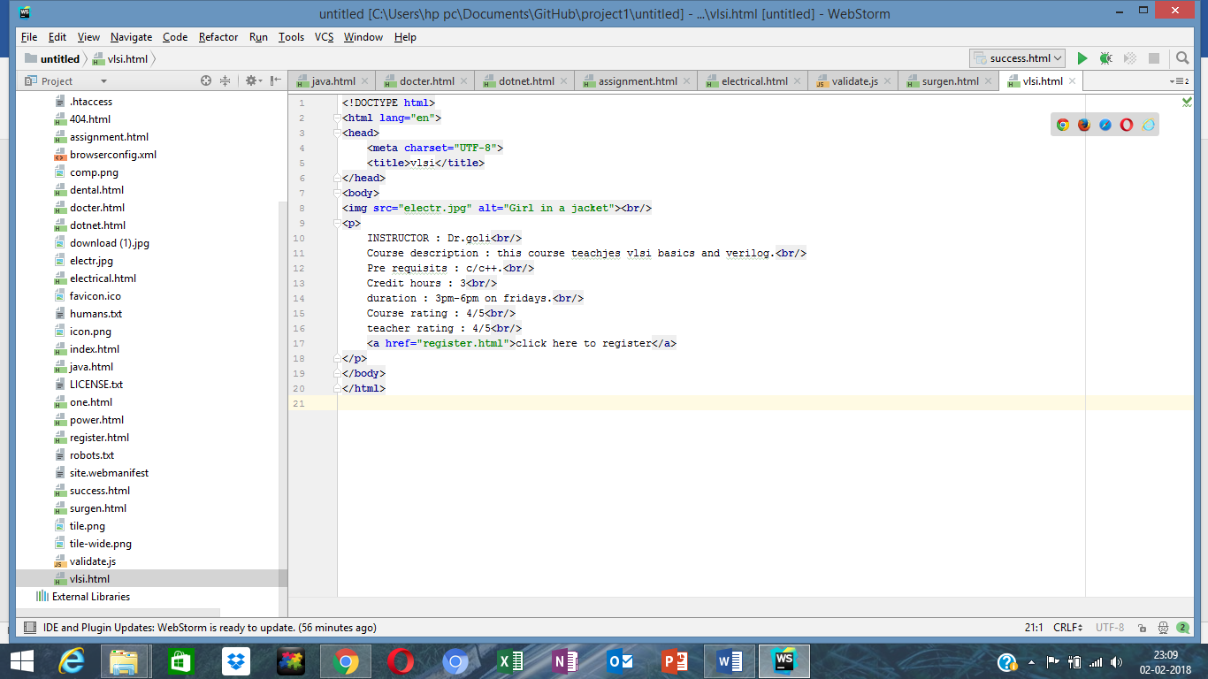

For power systems :

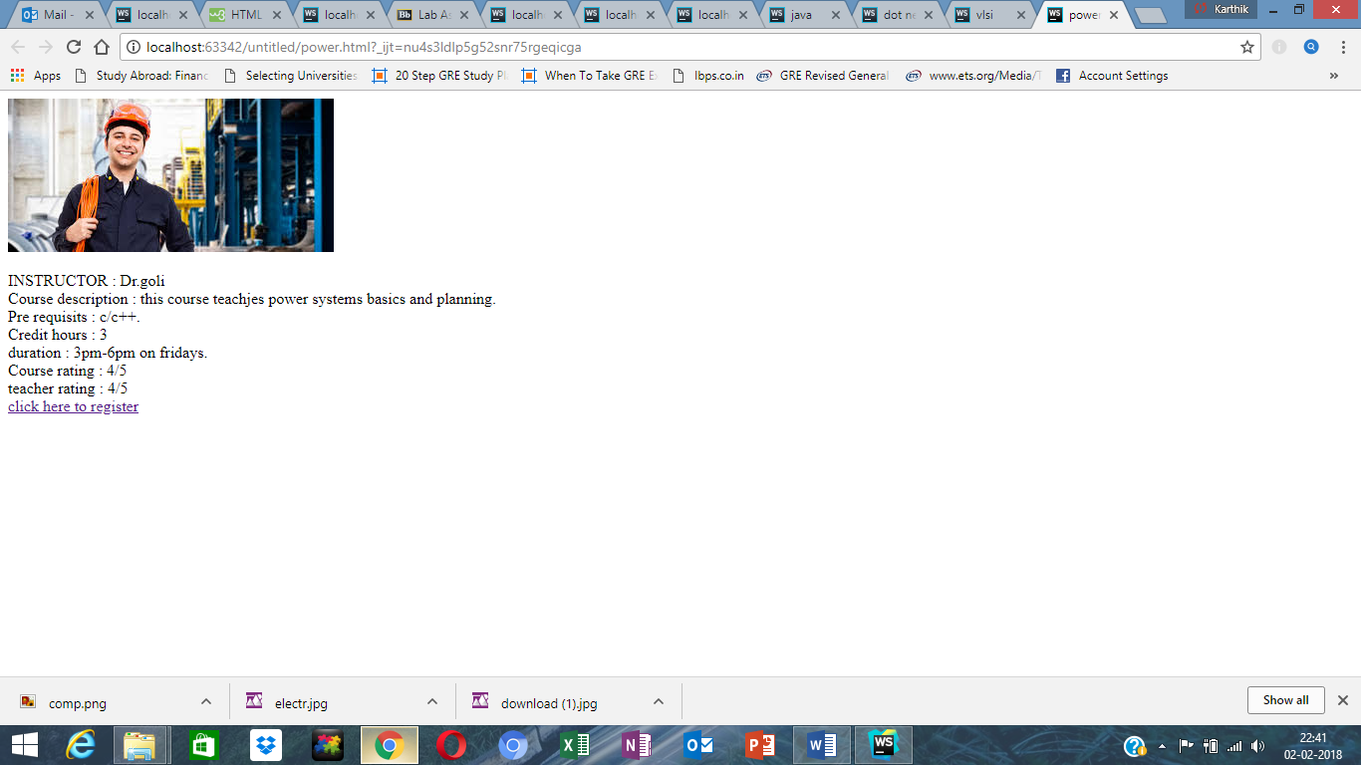

For doctor, two classes :

Dental 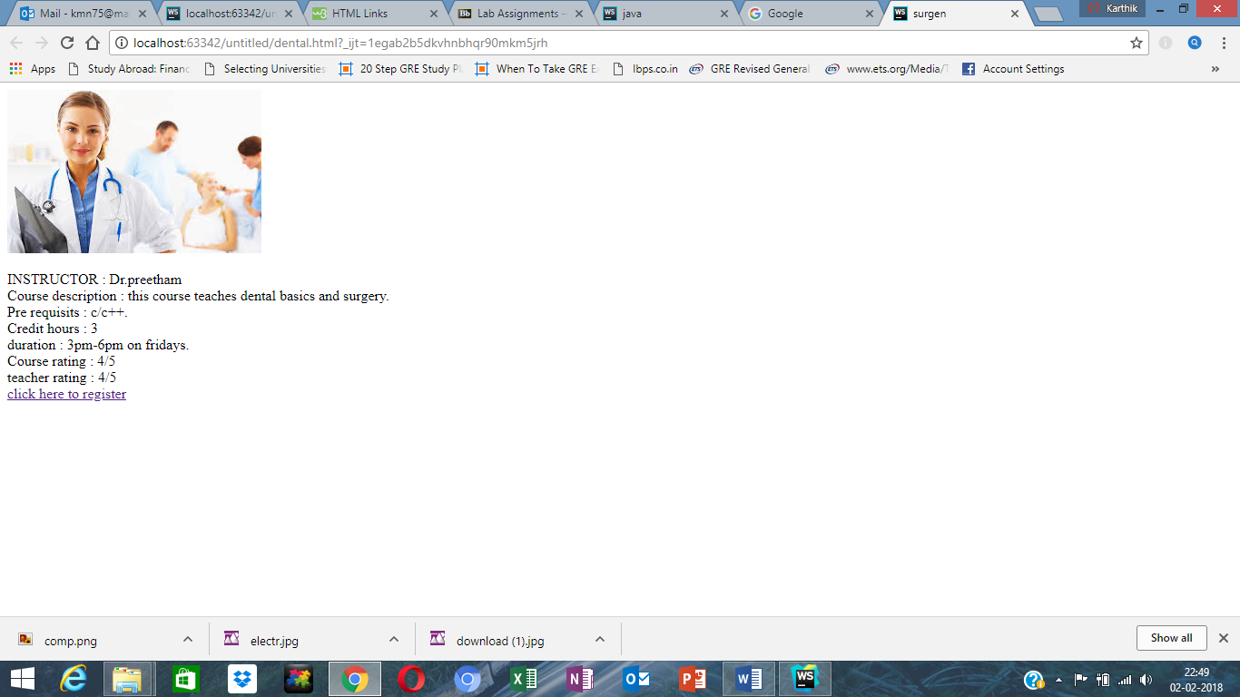

For surgeon : 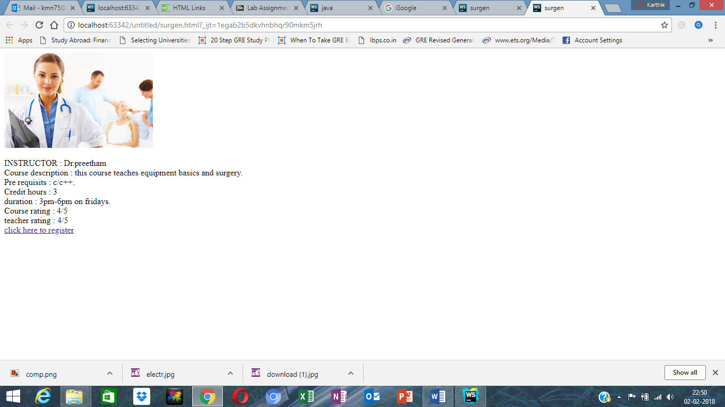

Step 6: next it redirects to registration page: it shows the total class seats and available seats:

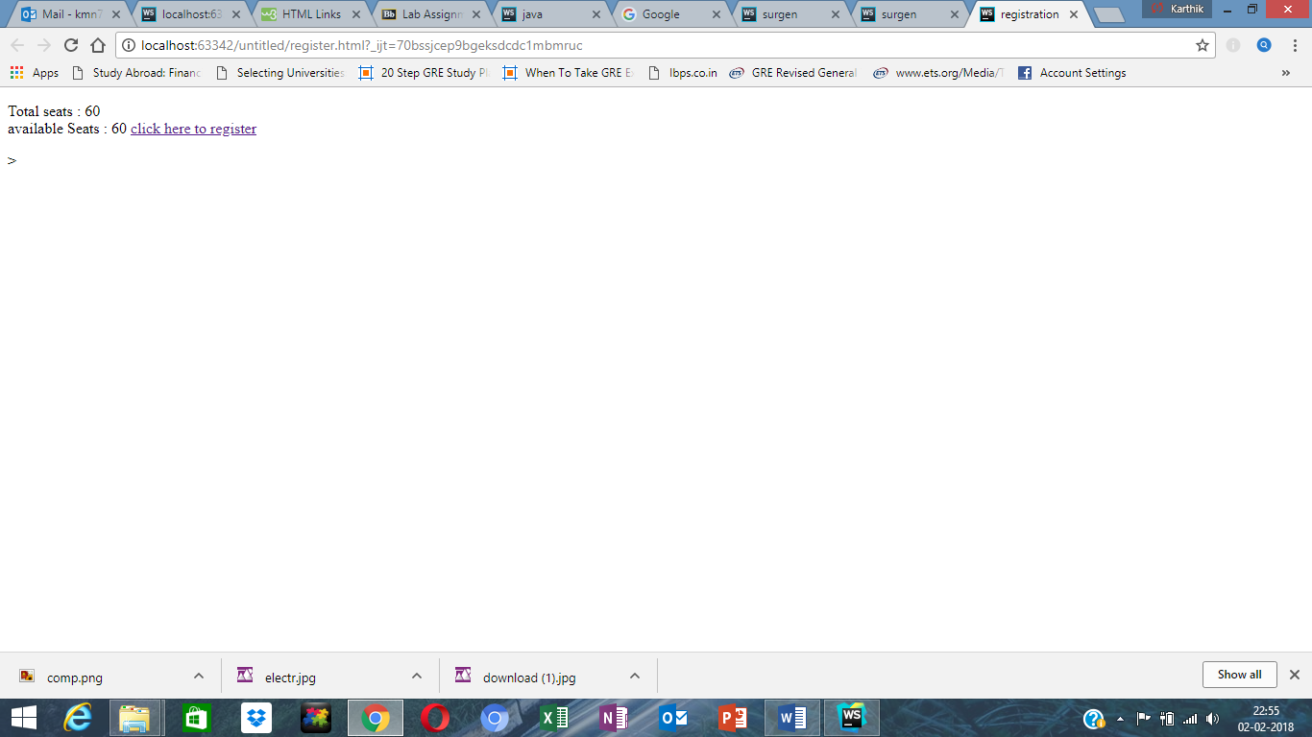

Step 7. Once the students register it redirects to success page

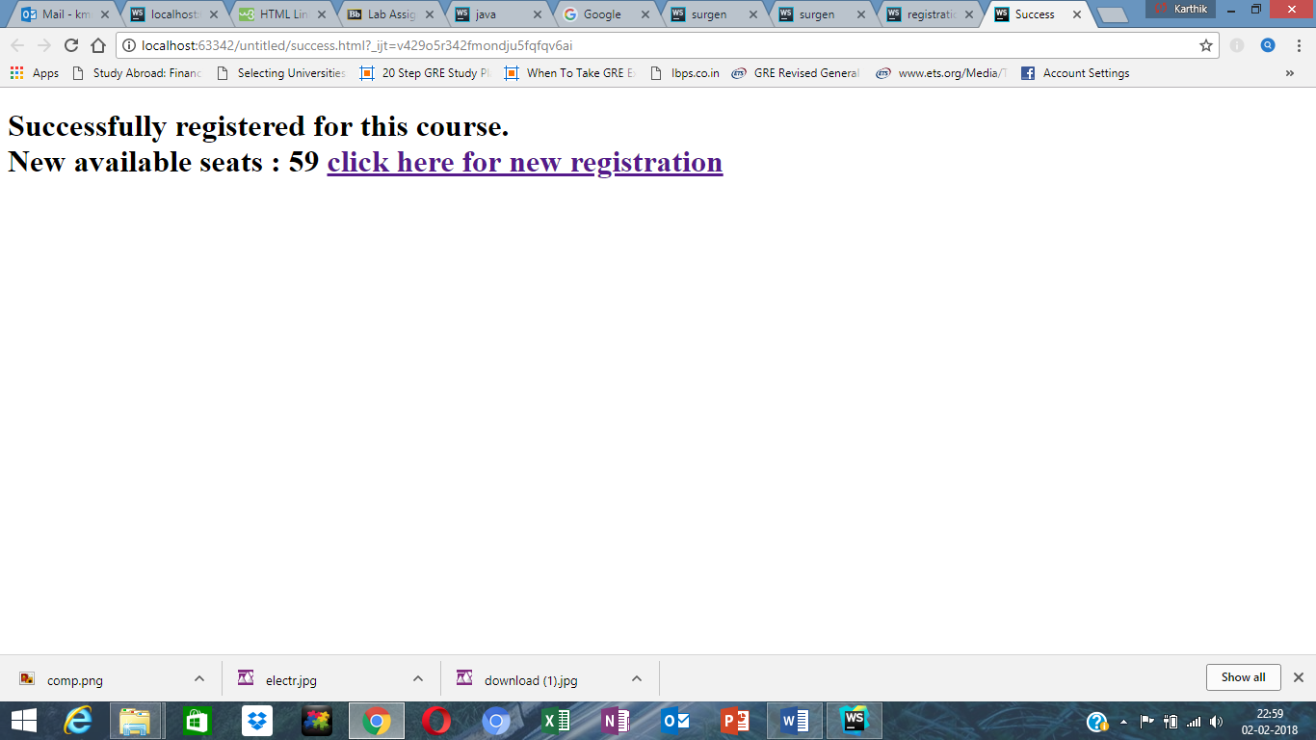

Thank You!