AI Guardian
Architecture, Flow, UI Screens & ML Integration
Companion Document — Version 1.0

1. What's New in This Version
This document walks through the system architecture and end-to-end flow in detail, screen by screen, and adds a new capability to the platform: an AI companion chat where a user can privately share how they're feeling. The chat is analyzed for sentiment and crisis-risk cues, and ties into the same escalation and support engine used by the safety-detection pipeline — so a user in emotional distress has a path to help even when there's no physical threat signal at all.

2. System Architecture
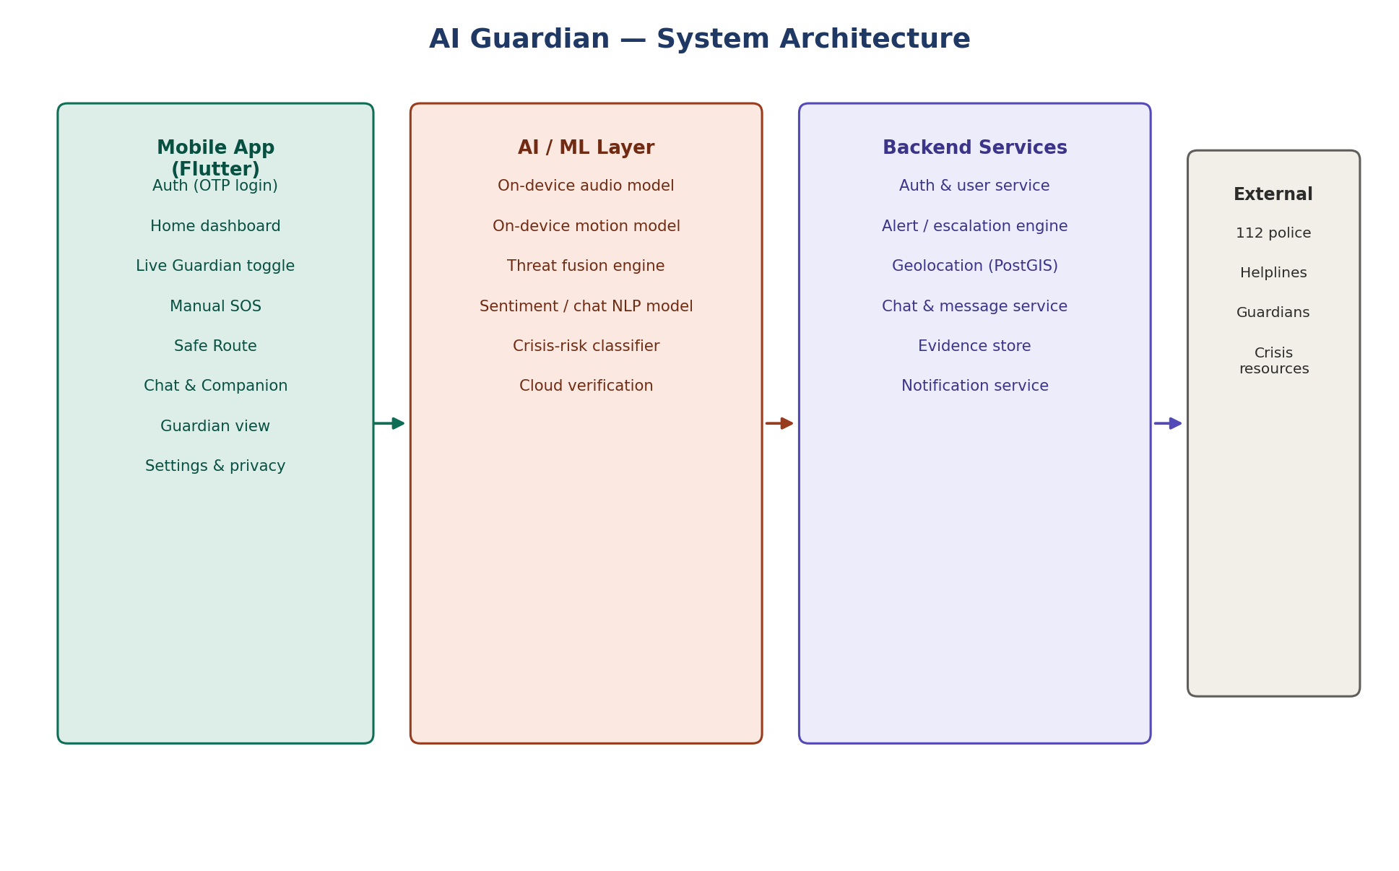
Figure 1. System architecture — mobile app, AI/ML layer, backend services, and external integrations.
The architecture keeps the same four layers as before, with the chat/companion feature threaded through all of them rather than bolted on as a separate app:

2.1 Mobile app layer
Everything the user directly touches. The Chat & Companion screen sits alongside the existing Live Guardian, SOS, and Safe Route screens — it's a first-class part of the home dashboard, not hidden in a settings menu, since normalizing “check in on how you feel” is part of what makes the feature get used.

2.2 AI/ML layer
Two models run side by side here now: the existing threat fusion engine (audio/motion/location → threat score), and a new sentiment / crisis-risk model that reads chat messages. They are kept as separate models with a shared output contract (a risk level), so one can be retrained or swapped without touching the other.

2.3 Backend layer
A new chat & message service stores conversation history (encrypted at rest) and mood trends over time. It publishes risk-level events to the same alert/escalation engine used by the physical-safety path, so there's one escalation engine, not two parallel ones.

2.4 External layer
Alongside 112, helplines, and guardians, this layer now includes a crisis-resources reference (e.g. helpline numbers for emotional distress) that the chat can surface directly in-app.

3. End-to-End Flow
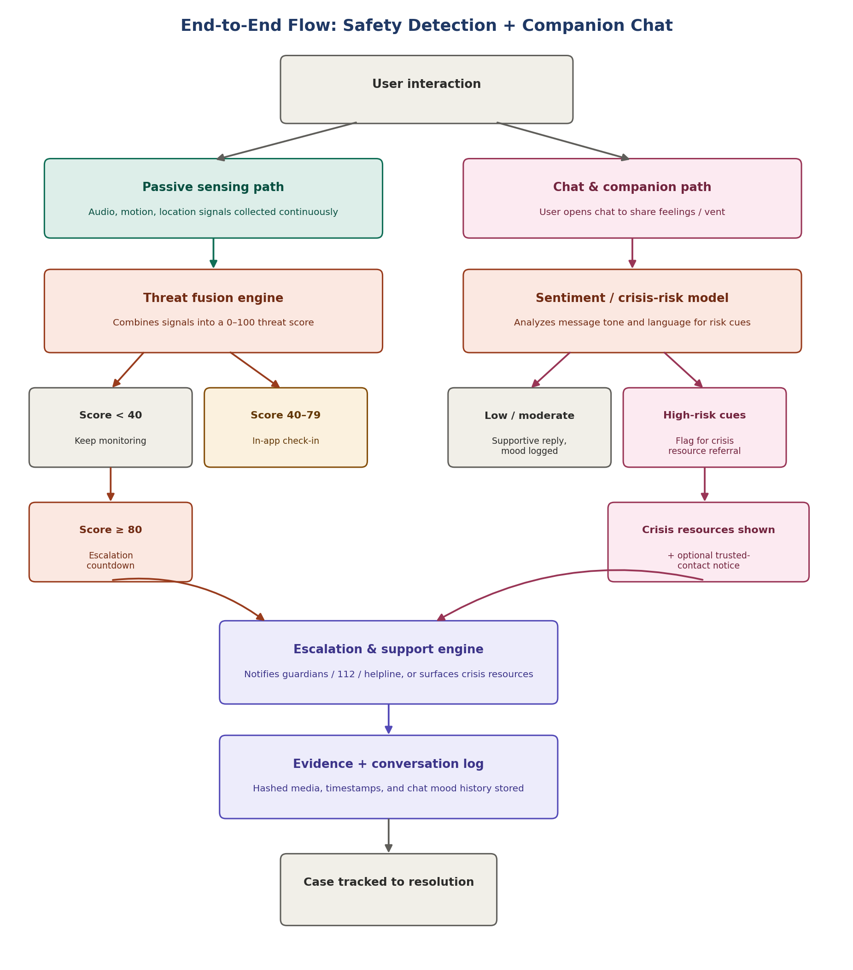
Figure 2. End-to-end flow, showing the passive-sensing path and the chat/companion path merging into one escalation and support engine.
Walking through it step by step:
- A user interaction starts either path: the phone is passively sensing in the background, or the user opens the chat to talk about how they're feeling.
- On the sensing side, signals feed the threat fusion engine exactly as in the core safety design: score < 40 keeps monitoring, 40–79 triggers an in-app check-in, 80+ starts an escalation countdown.
- On the chat side, each message is passed through the sentiment/crisis-risk model. Most conversations land in “low / moderate” — the companion replies supportively and the mood is logged for the user's own trend view.
- If the model flags high-risk language (explicit crisis or self-harm indicators), the app surfaces crisis resources immediately in the chat itself, and — only if the user has opted in to that setting — lets a trusted contact know, rather than silently auto-escalating a private conversation.
- Both paths converge on the same escalation and support engine, so guardians, 112, helplines, or crisis resources are all reachable from one consistent backend flow.
- Evidence (for physical threats) and conversation/mood logs (for chat) are both stored with timestamps, giving a single case record either way.
This design deliberately keeps the two trigger types on separate detection models but one shared response engine — a false trigger in one path never has to touch the other's logic, but a user in danger always ends up on the same well-tested escalation rails.

4. Screen-by-Screen UI Walkthrough
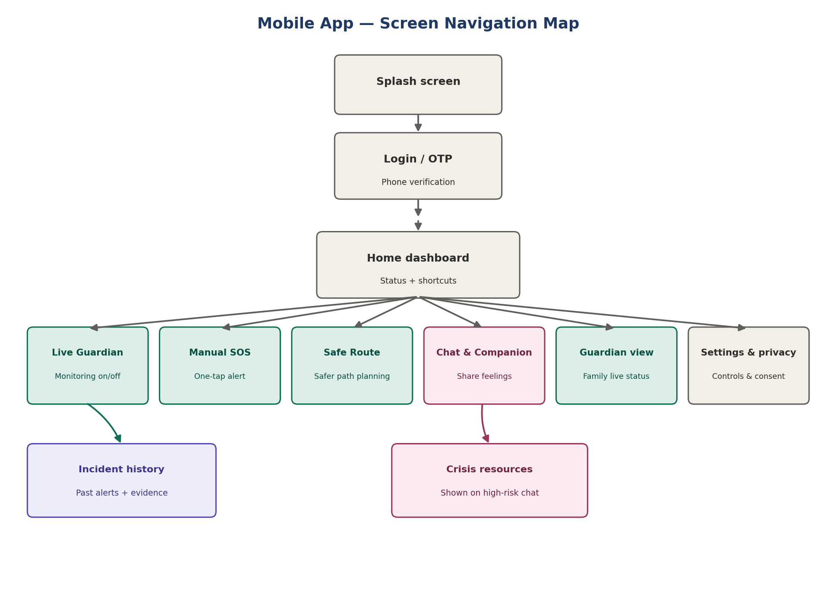
Figure 3. Mobile app screen navigation map.
Screen | UI purpose & key elements | Backend / ML involved
Splash screen | App logo, brief load while session/auth state is checked. | Auth service checks stored session token.
Login / OTP | Phone number entry, OTP code input, resend timer. | Auth service issues and verifies OTP; creates/loads user record.
Home dashboard | Current safety status banner, quick-access tiles for every other screen, current threat/mood indicator. | Pulls latest threat score and mood summary from backend on load.
Live Guardian | Single on/off toggle with a clear “monitoring active” indicator, battery-impact note, and a link to what data is collected. | Starts/stops the background sensing service; on-device audio + motion models begin running.
Manual SOS | Large press-and-hold button, visible cancel countdown once triggered, status of who has been notified. | Fires the alert/escalation engine directly, bypassing the threat-score wait.
Safe Route | Map view with a route toggle between “fastest” and “safer,” highlighting lit/crowded roads. | Geolocation service queries crime_areas and road-attribute data via PostGIS.
Chat & Companion | Familiar messaging UI, a gentle mood check-in prompt, and a quiet, non-alarming presentation even when resources are surfaced. | Sentiment/crisis-risk model scores each message; chat service stores history and mood trend.
Crisis resources | Shown inline within chat (not a separate forced navigation) when high-risk language is detected: helpline numbers, a call button, and continued conversation access. | Triggered by the crisis-risk model crossing its threshold; optionally notifies a trusted contact per user setting.
Guardian view | Family-facing live location, battery, and current status, shown only during/after an active alert or if the user has enabled ongoing sharing. | Reads live location + status feed via WebSocket from the backend.
Incident history | Timeline of past alerts, each expandable to its evidence and resolution notes. | Reads from emergency_events and evidence tables.
Settings & privacy | Consent toggles — background sensing, chat mood sharing with guardians, data retention — all explicit and revocable. | Writes user preference flags that gate what the backend is allowed to do or notify.

5. ML Integrations Summary
Model | Role
On-device audio classifier | TFLite model scoring scream / distress keyword / calm from a short rolling buffer; runs entirely on-device.
On-device motion classifier | TFLite model scoring fall / running / normal from accelerometer and gyroscope data.
Threat fusion engine | Tabular model (Random Forest / XGBoost) combining on-device scores with location and context features into one 0–100 threat score.
Sentiment / crisis-risk model | Classifies chat messages by emotional tone and flags explicit crisis or self-harm language, producing a risk level rather than a diagnosis.
Companion conversation model | Generates supportive, non-judgmental replies in the chat; kept separate from the risk classifier so response tone and risk detection can be tuned independently.
A note on the chat feature's design boundaries: the sentiment model's job is to route a user to the right resource, not to diagnose them. It should never present a clinical label to the user — only a risk level used internally to decide whether to surface crisis resources. Any guardian notification from a chat conversation should be opt-in and disclosed to the user up front, since a support space that secretly reports on someone will stop being used at exactly the moment it's needed most.

