# ***How to install Python on Windows?***

[www.Python.org](http://www.Python.org) use the link to install python for windows

### Download and Install Python.

**Beginning the installation.**

* Getting Started**:**

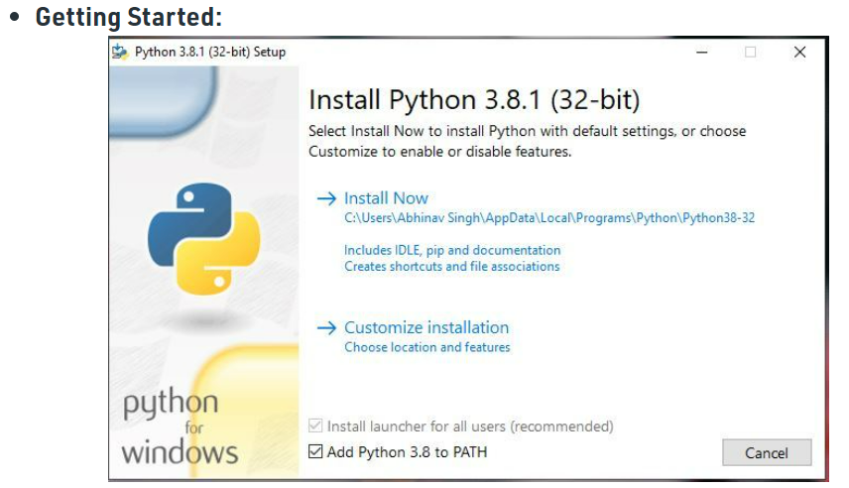

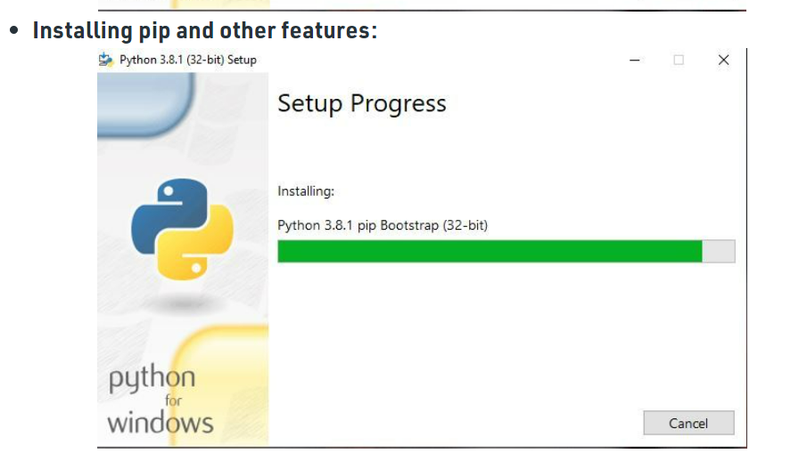

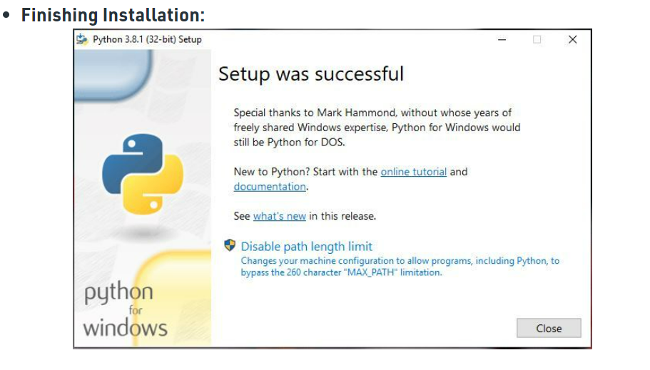

**Week 1**

1. Write a Python program to display the current date and time.
2. Write a Python program to get the Python version you are using
3. Write a Python program that accepts an integer (n) and computes the value of n+nn+nnn
4. Write a Python program to read and print various types of variables.
5. Write a Python program to print the calendar of a given month and year.

**Basic Syntax**

# Python code for "Hello World"

# nothing else to type...see how simple is the syntax.

Print ("Hello World")

# Python program to declare variables

myNumber = 3

print(myNumber)

myNumber2 = 4.5

print(myNumber2)

myNumber ="helloworld"

print(myNumber)

**output:**

**3**

**4.5**

**helloworld**

# Python program to illustrate a list

# creates a empty list

nums = []

# appending data in list

nums.append(21)

nums.append(40.5)

nums.append("String")

print(nums)

output:

[21, 40.5, String]

# Python program to illustrate

# getting input from user

name = input("Enter your name: ")

**#Enter your name: venkatrao kommuri**

print("hello", name)

**Output:**

**hello Venkatrao Kommuri**

# Python3 program to get input from user

# accepting integer from the user

# the return type of input() function is string ,

# so we need to convert the input to integer

num1 = int(input("Enter num1: "))

num2 = int(input("Enter num2: "))

num3 = num1 * num2

print("Product is: ", num3)

**Output:**

Enter num1: 8 Enter num2: 6 ('Product is: ', 48)

# Python program to illustrate

# selection statement

num1 = 34

if(num1>12):

print("Num1 is good")

elif(num1>35):

print("Num2 is not gooooo....")

else:

 print("Num2 is great")

Output:

Num1 is good

**PROGRAM-1**

**AIM**: Write a Python program to display the current date and time.

**PROGRAM**:

# Python3 code to demonstrate

# attributes of now()

# importing datetime module for now()

import datetime

# using now() to get current time

current_time = datetime.datetime.now()

# Printing attributes of now()

print("The attributes of now() are :")

print("Year :", current_time.year)

print("Month : ", current_time.month)

print("Day : ", current_time.day)

print("Hour : ", current_time.hour)

print("Minute : ", current_time.minute)

print("Second :", current_time.second)

print("Microsecond :", current_time.microsecond)

**Output:**

The attributes of now() are :

Year : 2022

Month : 6

Day : 20

Hour : 16

Minute : 3

Second : 25

Microsecond : 547727

**PROGRAM-2**

**AIM:** Write a Python program to get the Python version you are using

**PROGRAM:**

import platform

print(platform.python_version())

OUTPUT: 3.10.7

import sys

print(sys.version)

OUTPUT: 3.10.7 (tags/v3.10.7:6cc6b13, Sep 5 2022, 14:08:36) [MSC v.1933 64 bit (AMD64)]

import sys

print("Python version")

Python version

print (sys.version)

OUTPUT: 3.10.7 (tags/v3.10.7:6cc6b13, Sep 5 2022, 14:08:36) [MSC v.1933 64 bit (AMD64)]

print("Version info.")

Version info.

print (sys.version_info)

OUTPUT: sys.version_info(major=3, minor=10, micro=7, releaselevel='final', serial=0)

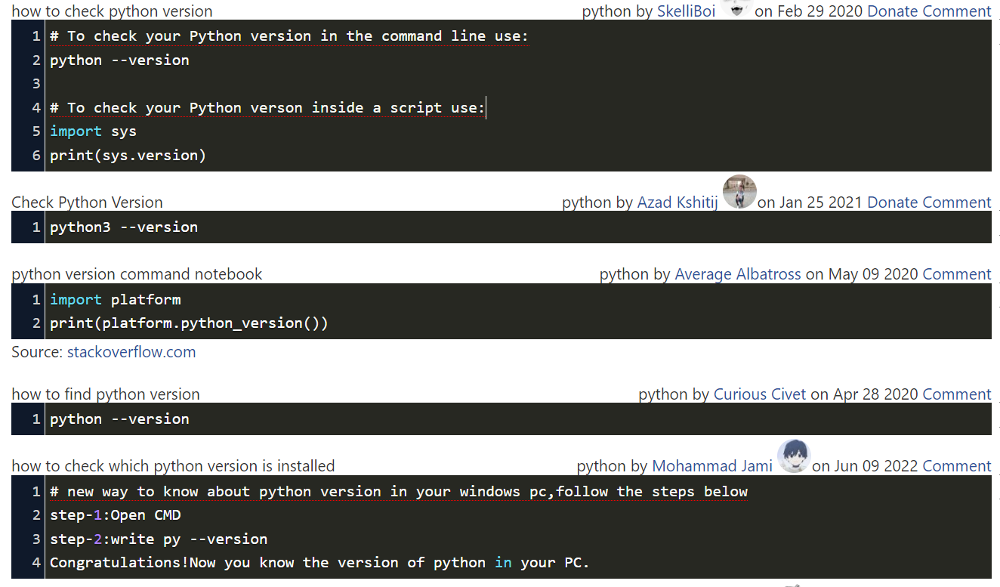

**PROGRAM-3**

**AIM:** Write a Python program that accepts an integer (n) and computes the value of n+nn+nnn

**PROGRAM:**

Write a program that computes the value of n+nn+nnn+nnnn+... nn...n ntimes with a given number as the value of n.

**Ex: if n=3 , output = 3+33+333=369 and if n=1 output =1**

a = int(input("Input an integer : "))

Input an integer : 3

n1 = int( "%s" % a )

n2 = int( "%s%s" % (a,a) )

n3 = int( "%s%s%s" % (a,a,a) )

print (n1+n2+n3)

**Output:**

**369**

**PROGRAM-4**

**AIM:** Write a Python program to read and print various types of variables.

**PROGRAM:**

**4.1**. How to use the **print()** function in Python

To print anything in Python, you use the print() function – that is the print keyword followed by a set of opening and closing parentheses,().

#how to print a string

print("Hello world")

#how to print an integer

print(7)

#how to print a variable

#to just print the variable on its own include only the name of it

fave_language = "Python"

print(fave_language)

**Output:**

Hello world

7

Python

**4.2. Creating Variables**

Python has no command for declaring a variable.

A variable is created the moment you first assign a value to it.

x = 5 **# x is of type int**  
y = "John" **# y is of type str**print(x)  
print(y)

**Output:**

5

John

## 4.3. Casting

If you want to specify the data type of a variable, this can be done with casting.

x = str(3)    **# x will be '3'**y = int(3)    **# y will be 3**z = float(3)  **# z will be 3.0**

print(x)

print(y)

print(z)

**Output:**

**3  
3  
3.0**

**4.4. Get the Type**

You can get the data type of a variable with the type() function

x = 5  
y = "John"  
print(type(x))  
print(type(y))

**Output:**

**<class 'int'>  
<class 'str'>**

**4.5. Single or Double Quotes?**

String variables can be declared either by using single or double quotes:

x = "John"  
#double quotes are the same as single quotes:  
x = 'John'

print(x)

**Output:**

**John**

**4.6. Case-Sensitive**

Variable names are case-sensitive.

a = 4

A = "Sally"

print(a)

print(A)

**Output:**

**4  
Sally**

**PROGRAM-5**

**AIM:** Write a Python program to print the calendar of a given month and year.

**PROGRAM:**

# importing the calendar module

import calendar

# initializing the year

year = 2020

# printing the calendar

print(calendar.calendar(year))

**Output:**

**5.1.** Write a python program which accept the year and month from user and print the calendar for that month and year

**PROGRAM:**

import calendar

year = int(input("Enter Year 'YYYY' : "))

month = int(input("Enter Month 'MM' : "))

print(calendar.month(year, month))

**Output:**

