Q1.

Q2.

SS1

SS2

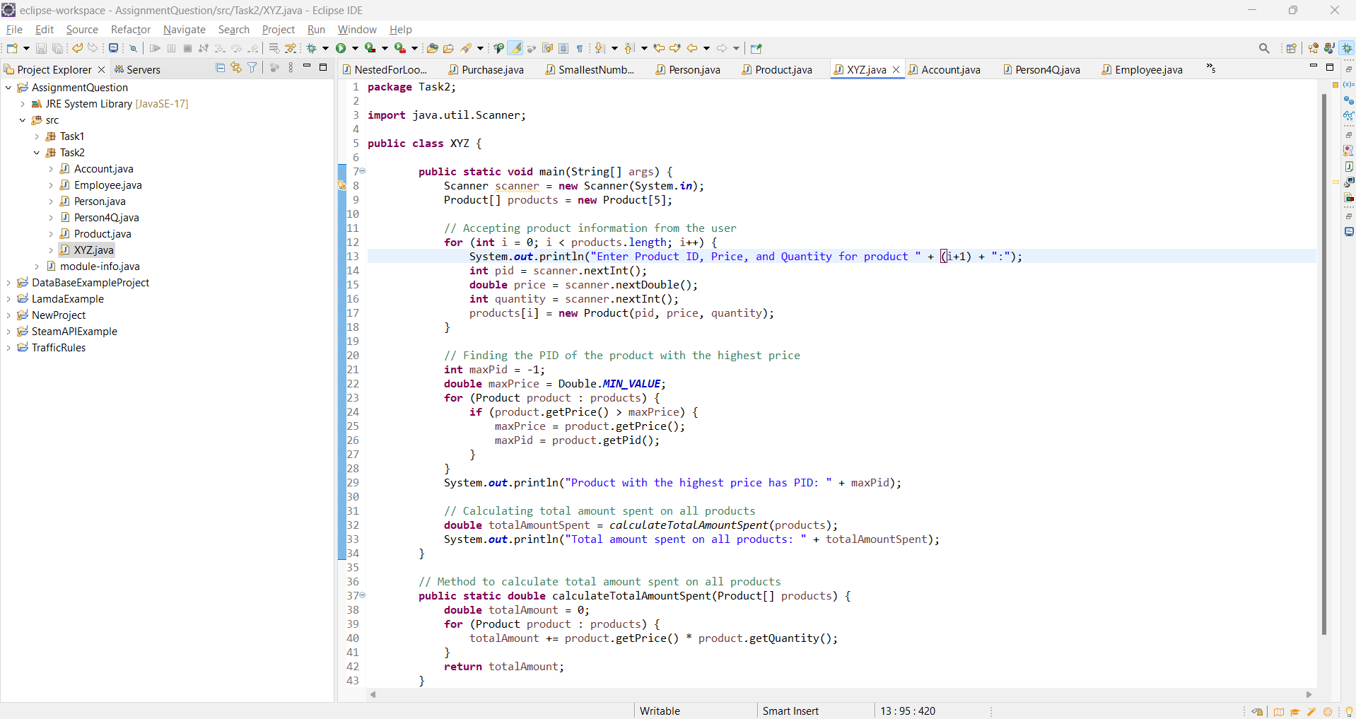

SS3

Q3.

SS1

SS2

SS3

Q4.

SS1

SS2

SS3

