Q1.

Student class in implementation package

NameNotValidException class in exceptionfile package

AgeNotWithinRangeException class in exceptionfile package

O/p

Valid check,

Invalid name check

Age out of range

Q2

Voter class in implementation package

InvalidAgeForVoteException class in exceptionfiles package

o/p

valid scenario:

Invalid scenario:

Q3

Weedays class in implementation package

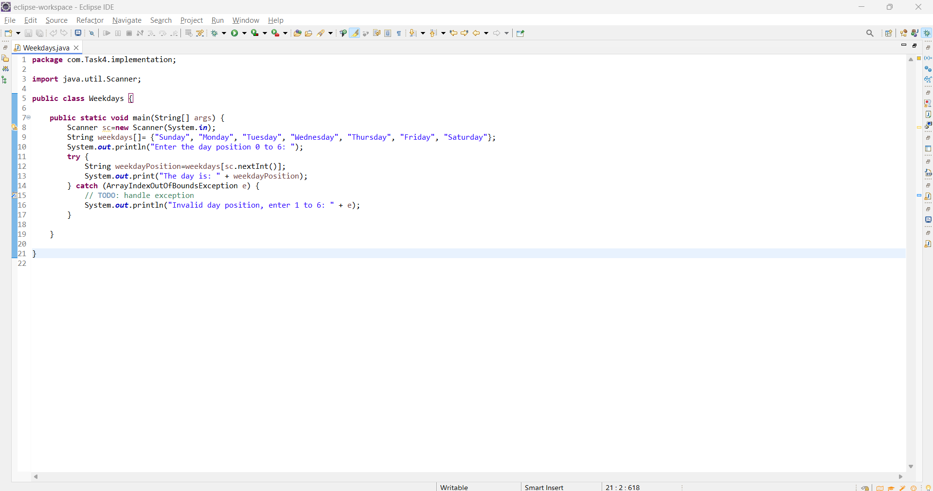

o/p

valid scenario:

Invalid Scenario:

Q4

Student grade in Implementation package

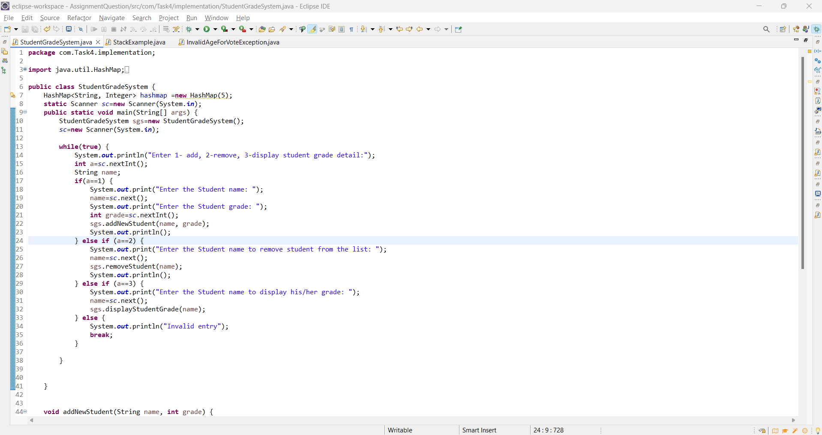

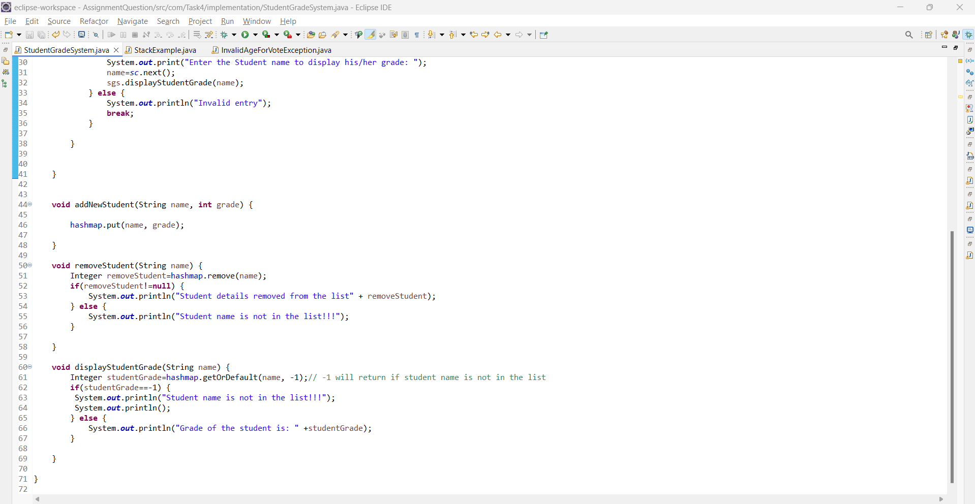

o/p

Q5

StackExample class in implementation package

O/p

