AI-Driven Personalized Yoga Instruction: Enhancing User Experience Through Adaptive Feedback Systems

¹Laxminarayan S Baviskar, ²Karthik Nallani Chakravartula, ³RushilKumar Patel, ⁴P.R. Sanjaya, ⁵Punam Kumari, ⁶Yatu Rani

¹Department of Innovation & Incubation,,SMBT- SRISHTI, Nashik, Maharashtra, India
E-mail; digital22kar@gmail.com
²Masters in Electrical and Computer Engineering, Farm Credit Bank of Texas, Austin TX, United States
E-mail; Karthik.chakravartula@gmail.com
³Senior Software Engineer, MS in Computer Science, Owings Mills, Maryland, USA ORCID ID: 0009-0004-7471-1275, E-mail; rushilnpatel@gmail.com
⁴Oral Pathology & Microbiology, Department: Basic Dental & Medical Sciences, College of Dentistry, University of Hail. Hail province, Kingdom of Saudi Arabia
E-mail; drsanjaynayak@gmail.com
⁵Department of journalism and mass communication IMS Ghaziabad University Courses Campus, India
E-mail; punam05_lucky@yahoo.co.in
⁶Department of Computer Science Engineering, ADGIPS, shastri park, Delhi
E-mail: yaturani@gmail.com

Abstract- Systems with artificial intelligence (AI) are able to learn and adjust over time in response to human input and changing demands for stress management. Long-term relevance and efficacy of the customised yoga experience are guaranteed by this adaptive learning process. Numerous facets of how artificial intelligence might improve the efficiency of yoga practices in lowering stress can be explored in research on AI with yoga for stress management. The convolutional Markov graph vector technique is used in this study to personalise the yoga positions. Chronic stress has wide-ranging effects that might affect one's physical and mental well-being. Conditions including anxiety, sadness, heart disease, and weakened immune systems are linked to elevated stress levels. AI-driven exercise solutions may advance in the future with wearable integration, injury avoidance, and personalised yoga regimens.
Keywords-Artificial Intelligence (AI), personalized yoga experience, wearable integration, chronic stress, fitness solutions
- INTRODUCTION
Yoga is an old Indian discipline that has gained international recognition as a personal exercise with comprehensive health advantages. It is a way of living that includes breathing techniques, or pranayama, meditation, and physical postures, or asanas, all of which aim to develop mental and physical well-being as well as strength and flexibility. Yoga positions The advantages of yoga practice depend on the quality of form, even if asanas are meant to encourage physical alignment, flexibility, and joint mobility [1]. Muscle and joint pain, damage, and/or strain can result from poor form, especially when doing yoga by yourself without trained supervision. In conventional yoga courses, the teacher gives students feedback while they are practicing to assist them maintain appropriate alignment of their posture. It is difficult to provide feedback for stance adjustment because of the popularity of home-based apps that make yoga practice easier. Simulated apps offer recorded segment practice, but they don't provide feedback, which reduces the exercise's efficacy. Deep learning and pose estimation, two applications of artificial intelligence in yoga, will help teachers and students in the classroom and, in our opinion, close a growing gap in the usage of personalised feedback on at-home yoga applications [2].
- RELATED WORKS
Recent developments in ML, computer vision, AI offer a rare chance to solve these issues by providing individualised, teacher-like instruction right in consumers' homes.Performing yoga regularly improves your flexibility, builds strength and helps lower stress with its mix of different practices. Findings from [3] clearly show that yoga done at home helped work-from-home individuals control their anxiety and tiredness. Optimizing motivation for a long period is important and gamification, adaptive planning and personalized data support have all been highlighted for that reason. For example, [4] pointed out that using personalized, feedback-oriented systems is much better than traditional online programs when it comes to helping people follow and change their behaviors. In [5], an angular approach was used, in which the angles between vectors in a skeletonized image were used to determine and classify poses. In [6], a yoga posture recognition system[8-10] was proposed that was able to recognize the pose and collect relevant information from various web-based resources to make users aware of the correct posture. The model proposed in [7] achieved excellent accuracy on large and diverse yoga datasets. However, it still has some drawbacks, as it may face generalization issues due to physiological variances among users[11-12], making it challenging to extrapolate findings to all individuals.
- PROPOSED YOGA POSES BASED PERSONALIZATION USING MACHINE LEARNING
It is currently difficult to locate an accurate and useful yoga-pose dataset online. YOGI dataset uses the entire body to illustrate every yoga pose and includes both standing and seated positions. The poses' diverse hand and leg folds make it challenging for posture identification method to function effectively. Understanding the aforementioned issue, YOGI dataset consists of ten yoga poses that were recorded with DSLR camera's burst capability. The photographs were captured with extreme accuracy and precision. Each of the ten yoga positions has between 400 and 900 photos. There are 5459 photos in the compiled Colour Image collection. Figure 1 depicts the general structure of the yoga asana classification system. Each class of asanas has unique structural characteristics in the dataset of yoga poses. The data must be allied in order to be more compatible with subsequent stages of the deep learning pipeline. As seen in the picture, we are putting the data through three distinct pre-processing processes during the pre-processing stage. Since the data were gathered from several sources, their size will vary. The initial preparation phase involves resizing data of various sizes to 100 by 100 pixels. The next stage involves using a Gaussian filter to remove noise from the data while maintaining crisp edges. Additionally, in the third and last phase, the image contrast is improved by using the Histogram Equalisation to normalise the distribution of image intensities.
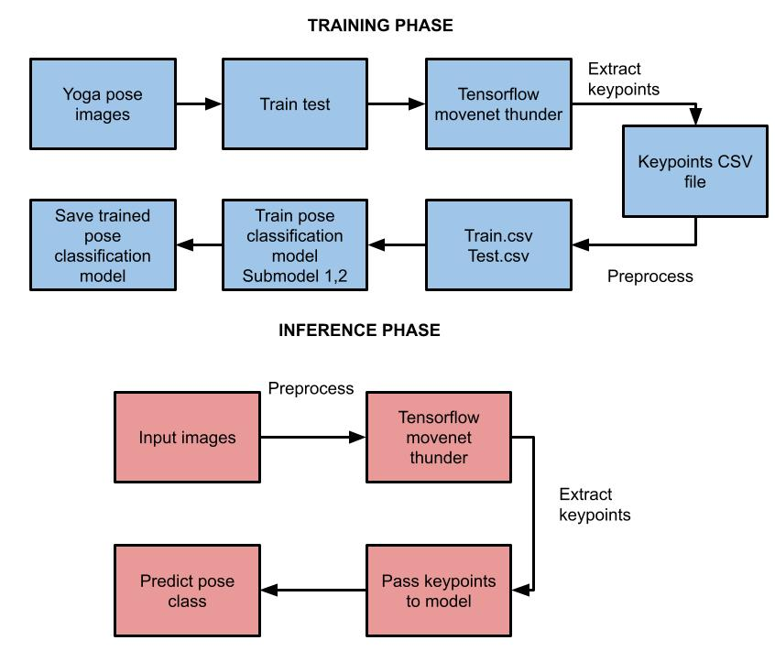
Fig.1. Overall architecture of yoga asana classification
- YOGA POSE BASED PERSONALIZATION USING CONVOLUTIONAL MARKOV GRAPH VECTOR ALGORITHM
An picture of (m × n × c) is transformed using a kernel of size (k × k × c). Additionally, apply d number of kernels and stack outputs if we want the output image to have d channels. Therefore, (m − ⌊k 2 ⌋)×(n − ⌊k 2 ⌋)×k × k × c × d is the number of multiplications required. We divided the depthwise separable convolution into two processes: pointwise convolution and depthwise convolution. Kernel is applied to every input channel separately in the first step, while the input image's depth is left unchanged. Final converted output is then obtained by using a 1 × 1 kernel with the input image's depth. The multiplications now total (m −⌊k 2 ⌋)×(n −⌊k 2 ⌋)×{c ×(k ×k ×1)+d ×(1×1×c)}. We benefit from certain computational advantages. It is determined that (m −⌊k 2 ⌋)×(n −⌊k 2 ⌋)×c ×{(k ×k ×d)−(k ×k +d)} reduces the number of multiplications. The typical convolution will take (100 − 2)×(100−2)×5×5×3×32 = 2,30,49,600 multiplications if the input image size is 100 × 100 × 3, the kernel size is 5 × 5 × 3, and we want 32 channels output. Once more, the number of multiplications needed if we use the depthwise separable convolution is (100 − 2)×(100 − 2)×{3×(5×5×1)+32×(1×1×3)} = 16,42,284, which is 92.88% fewer than that of standard convolution.
Yoga asana recognition is successful when the average deviation (𝛿) deviates from norm; if it does not, recognition is unsuccessful. Using the Softmax function, the acquired key points are normalised and compared to a prediction method made up of time-distributed CNN. Output probability for each of the six classes is also provided by the prediction model. This involves validating data by comparing a chosen yoga pose with the real-time yoga pose using a method fit generator. To evaluate the user's current yoga stance, a poseNet algorithm is also taken into consideration. The real-time yoga positions recorded by the webcam are processed using a pose estimation algorithm. The suggested study, however, is unable to process and compare the finger positions used in yoga poses. The suggested approach provides annotation for the assessment and tracking of yoga poses through the usage of a database, poseTrack. Additionally, the dataset provides thorough and efficient yoga annotation for each human video frame. The following is the expression for sequence of every frame t of human skeleton in space (1):
$f_{out}=\sum_{d=0}^{D}{W_{d}f_{in}(A_{d}^{-1/2}A_{d}A_{d}^{-1/2}⨂M_{d})}$ (1)
where D stands for the graph's maximum distance, fin and fot for the feature map's input and output values, ⊗ for multiplication function, A and d for joint pair's d-order adjacency matrix, Ad for normalisation operation's outcome. Adaptive adjustment parameters are denoted by Wd and Md. It is crucial to the execution of convolution and boundary correction processes. L is a preset hyperparameter that indicates the duration of the time window throughout the temporal feature extraction process. With this structure, a BatchNorm model and a ReLU module follow every time unit and space unit to create a whole.
- EXPERIMENTAL ANALYSIS
With the aid of tools like TensorFlow, Keras, Panda NumPy, OpenCV, and PIL, the task was implemented in Python. After resizing each image to 100 × 100, 4608 features were retrieved. Training and testing sets are created from the complete dataset. The classifier model is constructed using the training set, classifier's accuracy is assessed using the test set. Table I displays the evaluation of each classified posture's accuracy.
TABLE I. POSTURE ACCURACY AND FEEDBACK TO THE USER
Posture accuracy | Feedback
>85% | Excellent
>70% and <85% | Good
>40% and <70% | Could be better
<40% | poor
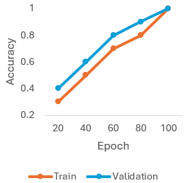
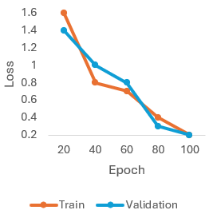
Fig. 2. (a) Model accuracy and (b) model loss during training and testing
This real-time validation not only highlights the model's effectiveness but also demonstrates its adaptability in diverse settings, reinforcing its value as a dependable resource for automated yoga posture detection systems. Such real-world applicability suggests that the model could be effectively integrated into both personal and professional yoga practice settings, offering accurate and consistent feedback to practitioners. Figure 6 presents graphs that depict model accuracy and model loss.
- CONCLUSION
Exploring many possibilities in transdisciplinary sectors is made possible by scientific and technological developments and inventions. Modern technologies like computer vision, machine learning, and artificial intelligence are employed to build several real-time applications in our daily lives. One of the most popular life routines for nourishing the body and mind is yoga. The novelty of the proposed system lies in its lightweight design and its ability to provide real-time feedback to practitioners on how closely they match the perfect pose of each exercise. By empowering yoga practitioners to execute postures with greater precision, the proposed system contributes to improving the effectiveness of yoga practice and promoting overall well-being. Future work could explore several enhancements. First, expanding the dataset with different Yoga poses and diverse body types can make the model more generalized. Additionally, some advanced techniques can be integrated, such as fine-tuning pre-trained models and transfer learning, to further increase the model performance.
REFERENCES
- Duppala, V. R., Marepalli, H. Y., Jain, K., Anusha, K., Thangavel, S. K., Kumar, B. S., ... & Sekar, J. (2024, April). Aatma yoga: Automation of yoga pose recognition and recommendation using deep learning. In 2024 International Conference on Inventive Computation Technologies (ICICT) (pp. 1315-1322). IEEE.
- Dhakate, H., Anasane, S., Shah, S., Thakare, R., & Rawat, S. G. (2024, February). Enhancing Yoga Practice: Real-time Pose Analysis and Personalized Feedback. In 2024 International Conference on Emerging Systems and Intelligent Computing (ESIC) (pp. 35-40). IEEE.
- Kumar, K. A., & Geethakalyani, V. (2025, June). Analysis of Yoga Position using Machine Learning based Approach. In 2025 3rd International Conference on Self Sustainable Artificial Intelligence Systems (ICSSAS) (pp. 345-351). IEEE.
- Tyagi, R., Yadav, R., & Mishra, D. (2024, May). Technological Insights into Yoga Posture Recognition: A State-of-the-Art Review. In 2024 International Conference on Communication, Computer Sciences and Engineering (IC3SE) (pp. 1-7). IEEE.
- Singh, R., Kumar, P., Ansari, M. H., & Dwivedi, M. (2024, March). Yoga Pose Detection Using Artificial Intelligence and Machine Learning. In 2024 2nd International Conference on Disruptive Technologies (ICDT) (pp. 887-892). IEEE.
- Umrao, M., & Bansal, V. (2025). A machine learning based personalized Yoga Asanas Recommendation Engine. Multimedia Tools and Applications, 84(2), 765-780.
- Xie, X. (2024, December). Yoga Pose Detection using MobileNetV3+ pose comparison and instruction. In 2024 4th International Conference on Information Technology and Contemporary Sports (TCS) (pp. 7-12). IEEE.
- Kumar, T., Pandey, B., Mussavi, S. H. A., & Zaman, N. (2015). CTHS based energy efficient thermal aware image ALU design on FPGA. Wireless Personal Communications, 85(3), 671-696.
- Azeem, M., Ullah, A., Ashraf, H., Jhanjhi, N. Z., Humayun, M., Aljahdali, S., & Tabbakh, T. A. (2021). Fog-oriented secure and lightweight data aggregation in iomt. IEEE Access, 9, 111072-111082.
- Jabeen, T., Jabeen, I., Ashraf, H., Jhanjhi, N. Z., Yassine, A., & Hossain, M. S. (2023). An intelligent healthcare system using IoT in wireless sensor network. Sensors, 23(11), 5055.
- Khan, N. A., Jhanjhi, N. Z., Brohi, S. N., Almazroi, A. A., & Almazroi, A. A. (2022). A secure communication protocol for unmanned aerial vehicles. CMC-Computers Materials & Continua, 70(1), 601-618.
- Kumar, M. S., Vimal, S., Jhanjhi, N. Z., Dhanabalan, S. S., & Alhumyani, H. A. (2021). Blockchain based peer to peer communication in autonomous drone operation. Energy Reports, 7, 7925-7939.

