CHAPTER 1
COMPANY
  - Company Profile
EduPhoenix Solutions is a dynamic and innovative company dedicated to providing cutting-edge solutions in the field of education technology. Established with a vision to revolutionize learning experiences, EduPhoenix Solutions offers a comprehensive range of products and services tailored to meet the evolving needs of educational institutions, students, and educators.
At EduPhoenix Solutions, we leverage the latest advancements in technology to develop intuitive and interactive educational platforms, tools, and resources. Our team of experts is committed to designing and delivering solutions that enhance teaching effectiveness, engage learners, and foster academic success.
From e-learning platforms and virtual classrooms to customized educational software and mobile applications, EduPhoenix Solutions offers a diverse portfolio of products aimed at transforming traditional learning paradigms. We prioritize user-centric design, ensuring that our solutions are user-friendly, accessible, and adaptable to diverse learning environments.

Figure 1.1 Company Logo
In addition to our innovative products, EduPhoenix Solutions provides consultancy services, training programs, and ongoing support to help educational institutions maximize the impact of technology on teaching and learning outcomes. Our collaborative approach enables us to work closely with clients to understand their unique challenges and goals, delivering tailored solutions that drive positive change and innovation.
EduPhoenix Solutions stands at the forefront of educational technology, driven by a passion for innovation and a commitment to excellence. With a deep understanding of the challenges facing modern educational institutions, we offer a comprehensive suite of solutions designed to elevate teaching and learning experiences to new heights.
Our team of experts combines extensive experience in both education and technology to develop cutting-edge platforms and tools that empower educators and engage learners. By harnessing the latest advancements in artificial intelligence, data analytics, and user-centric design, we create intuitive and immersive learning environments that foster creativity, critical thinking, and collaboration.
Beyond our innovative products, EduPhoenix Solutions provides strategic consultancy services and professional development programs to support educational institutions in leveraging technology effectively. From needs assessment and solution design to implementation and ongoing support, we partner with our clients every step of the way to ensure the success of their digital initiatives.
With a strong focus on user experience, accessibility, and scalability, our solutions are tailored to meet the unique needs of diverse educational settings, from K-12 schools to higher education institutions and corporate training programs. By delivering customizable, adaptable, and future-ready solutions, we empower educators to deliver high-quality instruction and empower learners to achieve their full potential in an increasingly digital world.
Driven by a shared vision of transforming education through technology, EduPhoenix Solutions is dedicated to pushing the boundaries of innovation and driving positive change in the education landscape. As we continue to evolve and expand our offerings, we remain steadfast in our commitment to delivering impactful solutions that inspire lifelong learning and shape the future of education.
With a commitment to excellence, integrity, and continuous improvement, EduPhoenix Solutions is dedicated to empowering educators, inspiring learners, and shaping the future of education through technology. We are proud to partner with educational institutions worldwide, helping them unlock the full potential of digital learning in the 21st century.

1.2 Company Overview
EduPhoenix Solutions is a dynamic and forward-thinking company that specializes in providing innovative educational technology solutions to institutions worldwide. Established with a vision to revolutionize the way education is delivered and experienced, EduPhoenix Solutions has quickly emerged as a leader in the field, offering a wide range of cutting-edge products and services tailored to meet the diverse needs of educators and learners alike.
At EduPhoenix Solutions, we believe that technology has the power to transform education by making learning more accessible, engaging, and effective. With this belief at the core of our mission, we strive to develop solutions that empower educators to deliver high-quality instruction and enable learners to reach their full potential.
Our comprehensive suite of products and services encompasses everything from learning management systems and virtual classrooms to interactive content authoring tools and professional development programs. Whether it's providing educators with the tools they need to create immersive learning experiences or offering learners access to dynamic and interactive learning environments, EduPhoenix Solutions is committed to driving positive change in education through technology.
One of the key strengths of EduPhoenix Solutions lies in our team of experts, who bring a wealth of experience and expertise from diverse fields such as education, technology, instructional design, and user experience. By combining our knowledge and skills, we are able to develop innovative solutions that address the evolving needs of the education sector and deliver measurable results.
In addition to our product offerings, EduPhoenix Solutions also provides consultancy services to educational institutions seeking to leverage technology effectively. From needs assessment and solution design to implementation and ongoing support, our team works closely with clients to develop customized strategies and solutions that align with their unique goals and objectives.
As a company, we are deeply committed to excellence, integrity, and customer satisfaction. We take pride in our ability to deliver high-quality products and services that meet the highest standards of quality and reliability. With a customer-centric approach and a focus on continuous improvement, we strive to exceed our clients' expectations and build long-lasting partnerships based on trust and mutual respect.

  - Company Departments
EduPhoenix Solutions operates across several departments, each contributing to the overall mission of delivering innovative educational solutions and services. These departments include:

Human Resources (HR) Department:
Recruitment and Talent Acquisition: This involves identifying staffing needs, sourcing candidates through job postings and recruitment agencies, conducting interviews, and selecting the best-fit candidates.
Employee Onboarding and Orientation: HR ensures that new hires receive necessary training, complete required paperwork, understand company policies, and integrate smoothly into their roles and the organization.
Performance Management: HR oversees performance evaluations, goal setting, feedback mechanisms, and recognition programs to foster employee growth, development, and engagement.
Employee Relations: This department handles employee grievances, conflicts, disciplinary actions, and ensures compliance with employment laws and regulations.
Training and Development: HR designs and implements training programs, workshops, and seminars to enhance employee skills, competencies, and professional development opportunities.
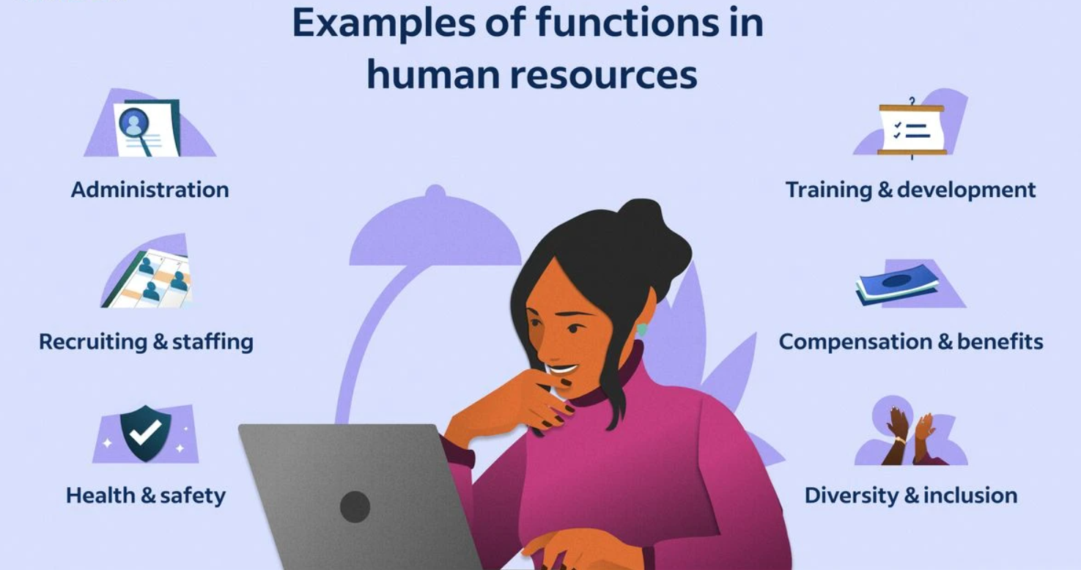
Figure 1.3.1 Functions of Human Resources (HR)

Information Technology (IT) and Technical Support Department:
Infrastructure Management: This includes managing servers, networks, hardware, and software systems to ensure seamless operation, security, and scalability.
Systems Administration: IT administrators monitor system performance, troubleshoot technical issues, install updates, and ensure data backups and recovery protocols are in place.
Cybersecurity: This team protects the organization from cyber threats by implementing firewalls, antivirus software, intrusion detection systems (IDS), and conducting regular security audits and assessments.
Software Development: IT professionals develop and maintain custom software applications, websites, and digital platforms to support internal operations and customer-facing solutions.
Technical Support: The IT helpdesk provides technical assistance, resolves user issues, and offers guidance on software usage, hardware configuration, and network connectivity.
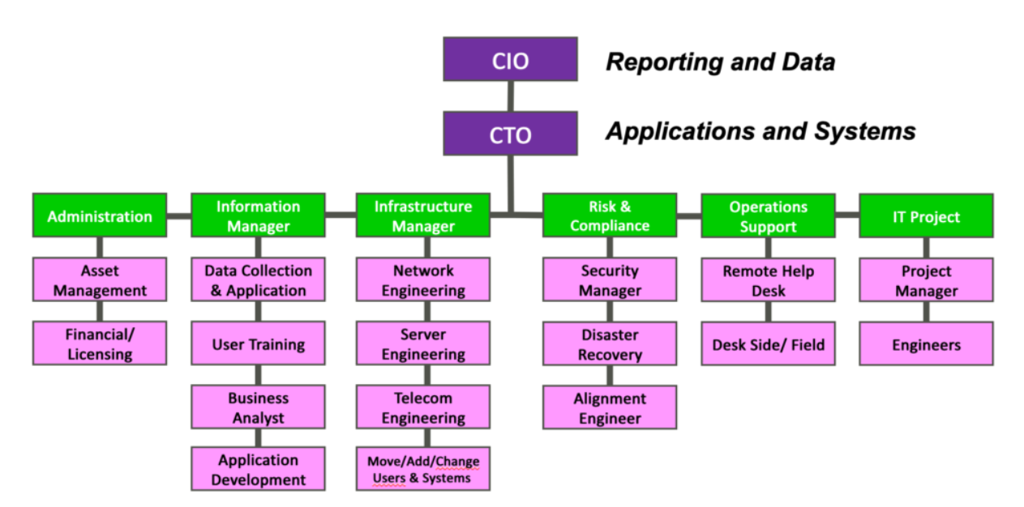
Figure 1.3.2 Information Technology (IT) Department Structure

Research and Development (R&D) Department:
Market Research and Analysis: R&D conducts market research to identify industry trends, customer preferences, and competitive landscapes to inform product development strategies.
Product Innovation: This team conceptualizes and prototypes new products, features, and services, leveraging emerging technologies and customer feedback to drive innovation.
Prototype Development: R&D builds and tests prototypes to validate concepts, assess feasibility, and gather user feedback before full-scale development and commercialization.
Intellectual Property Management: This involves securing patents, trademarks, and copyrights to protect the organization's innovations, inventions, and creative works from infringement.
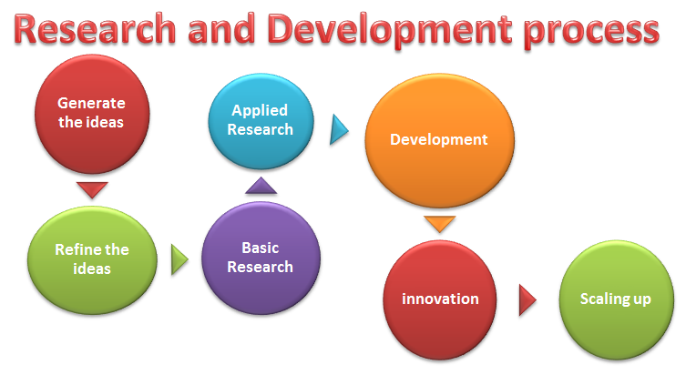
Figure1.3.3 Research & Development Process

Sales and Marketing Department:Market Segmentation and Targeting: Sales and marketing professionals identify and segment target markets based on demographics, behaviors, and preferences to tailor marketing messages and campaigns.
Lead Generation and Nurturing: This team generates leads through advertising, content marketing, and networking efforts, then nurtures those leads through email campaigns, follow-up calls, and personalized communication.
Brand Management: Sales and marketing professionals develop brand identity, messaging, and positioning strategies to differentiate EduPhoenix Solutions from competitors and build brand loyalty.
Digital Marketing: This involves leveraging digital channels such as websites, social media platforms, search engine optimization (SEO), and pay-per-click (PPC) advertising to reach and engage target audiences.
Sales Enablement: Sales enablement teams provide sales reps with the tools, resources, and training needed to effectively communicate product features, benefits, and value propositions to prospects and customers.

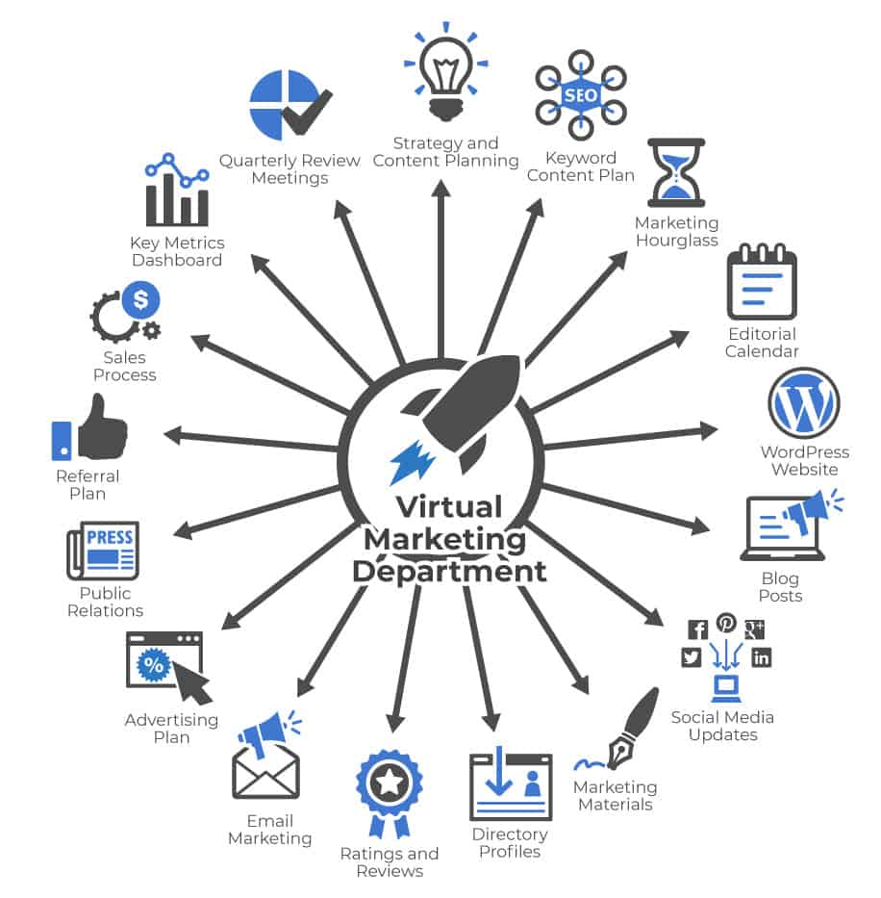
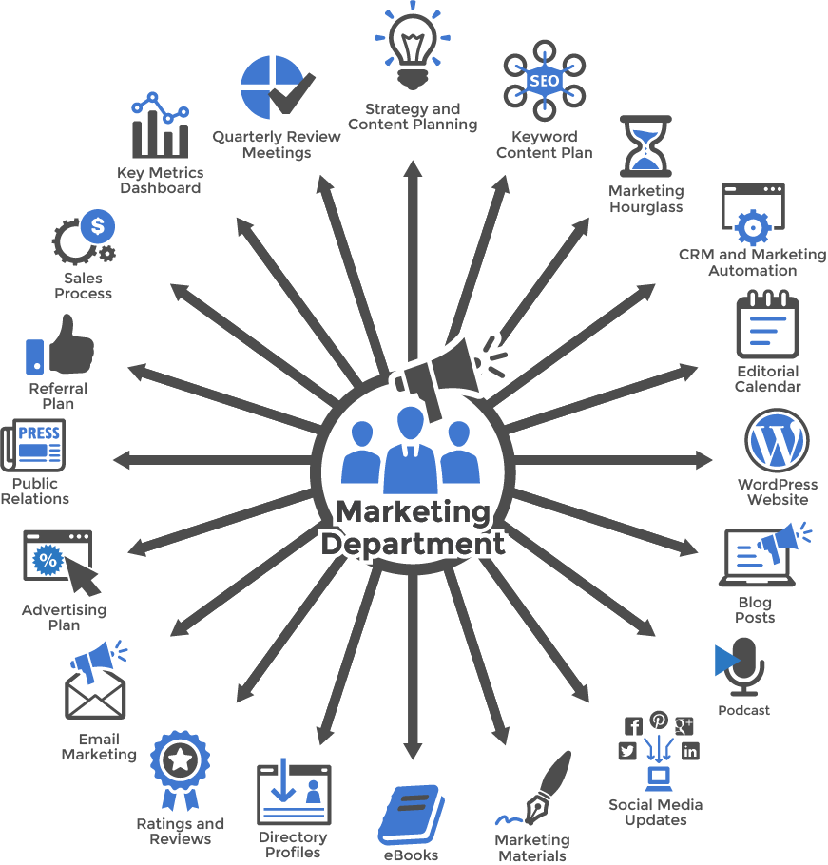
Figure 1.3.4(a) Virtual Marketing  Department | Figure 1.3.4(b) Marketing  Department

Customer Success Department:
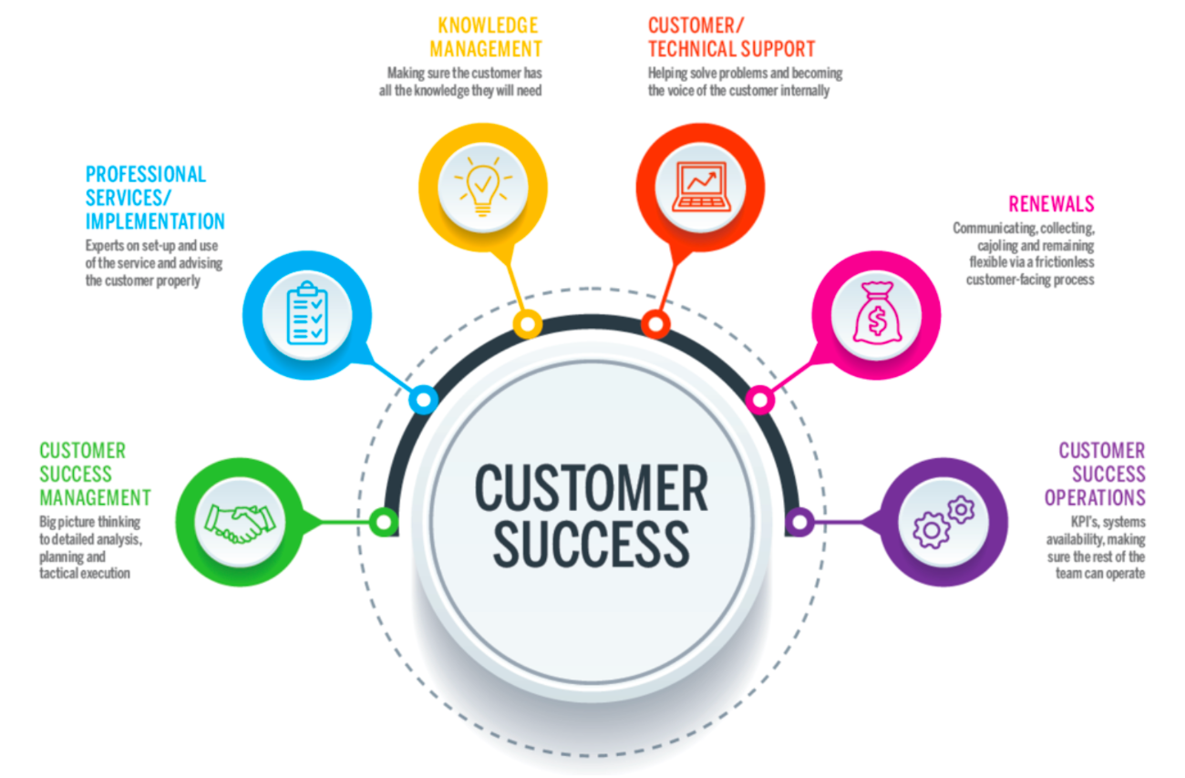
Customer Onboarding: This involves guiding new customers through the implementation process, providing training, support, and resources to ensure successful adoption and utilization of EduPhoenix Solutions.
Figure 1.3.5 Customer Success
Customer Relationship Management: Customer success managers build and nurture relationships with clients, acting as their advocate within the organization and ensuring their needs and expectations are met.
Account Management: This team is responsible for managing customer accounts, identifying upsell and cross-sell opportunities, and fostering long-term relationships to drive retention and expansion.
Customer Support: The customer support team provides responsive assistance, troubleshooting, and issue resolution to address customer inquiries, technical challenges, and service disruptions effectively.

Finance and Accounting Department:
Financial Planning and Analysis: This department is responsible for budgeting, forecasting, financial modeling, and providing insights to support strategic decision-making.
Accounts Payable and Receivable: Finance professionals manage payments to vendors, invoicing customers, and tracking receivables to ensure timely cash flow management.
Financial Reporting and Compliance: This team prepares financial statements, regulatory filings, and ensures compliance with accounting standards, tax laws, and industry regulations.
Treasury Management: Finance professionals oversee cash management, investment strategies, and risk mitigation to optimize liquidity and financial stability.

Figure 1.3.6 Finance & Accounting

Legal and Compliance Department:
Contract Management: Legal professionals draft, review, and negotiate contracts with clients, partners, and vendors to protect EduPhoenix Solutions' interests and mitigate legal risks.
Regulatory Compliance: This team ensures compliance with laws, regulations, and industry standards related to data privacy, security, intellectual property, and consumer protection.
Intellectual Property (IP) Management: Legal experts manage EduPhoenix Solutions' intellectual property portfolio, including patents, trademarks, copyrights, and trade secrets.
Risk Management: The legal and compliance department identifies, assesses, and manages legal and regulatory risks to minimize exposure and protect the organization from liabilities.

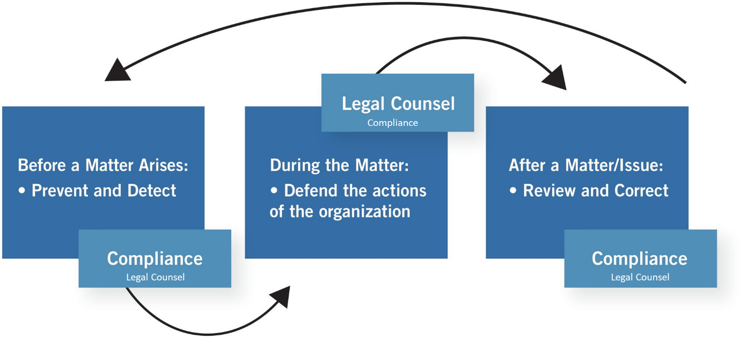

Figure 1.3.7 Legal & Compliance Procedure

Operations and Logistics Department:
Supply Chain Management: Operations professionals oversee procurement, inventory management, and logistics to ensure timely delivery of goods and services while optimizing costs and efficiency.
Facilities Management: This team maintains and manages office facilities, equipment, and infrastructure to create a safe, productive, and comfortable work environment.
Quality Assurance and Control: Operations experts develop and implement quality standards, processes, and metrics to ensure products and services meet or exceed customer expectations.

Figure 1.3.8(a) Operations  Management | Figure 1.3.8(b) Logistics

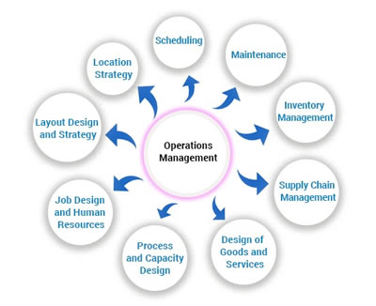
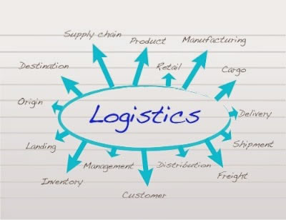
Project Management: Operations professionals coordinate cross-functional projects, allocate resources, and track progress to ensure timely completion and successful outcomes.

Customer Experience Department:
User Experience (UX) Design: This team focuses on designing intuitive, user-friendly interfaces and interactions for digital products and platforms to enhance customer satisfaction and engagement.
Customer Insights and Analytics: CX professionals analyze customer feedback, behavior data, and performance metrics to gain actionable insights and drive continuous improvement initiatives.
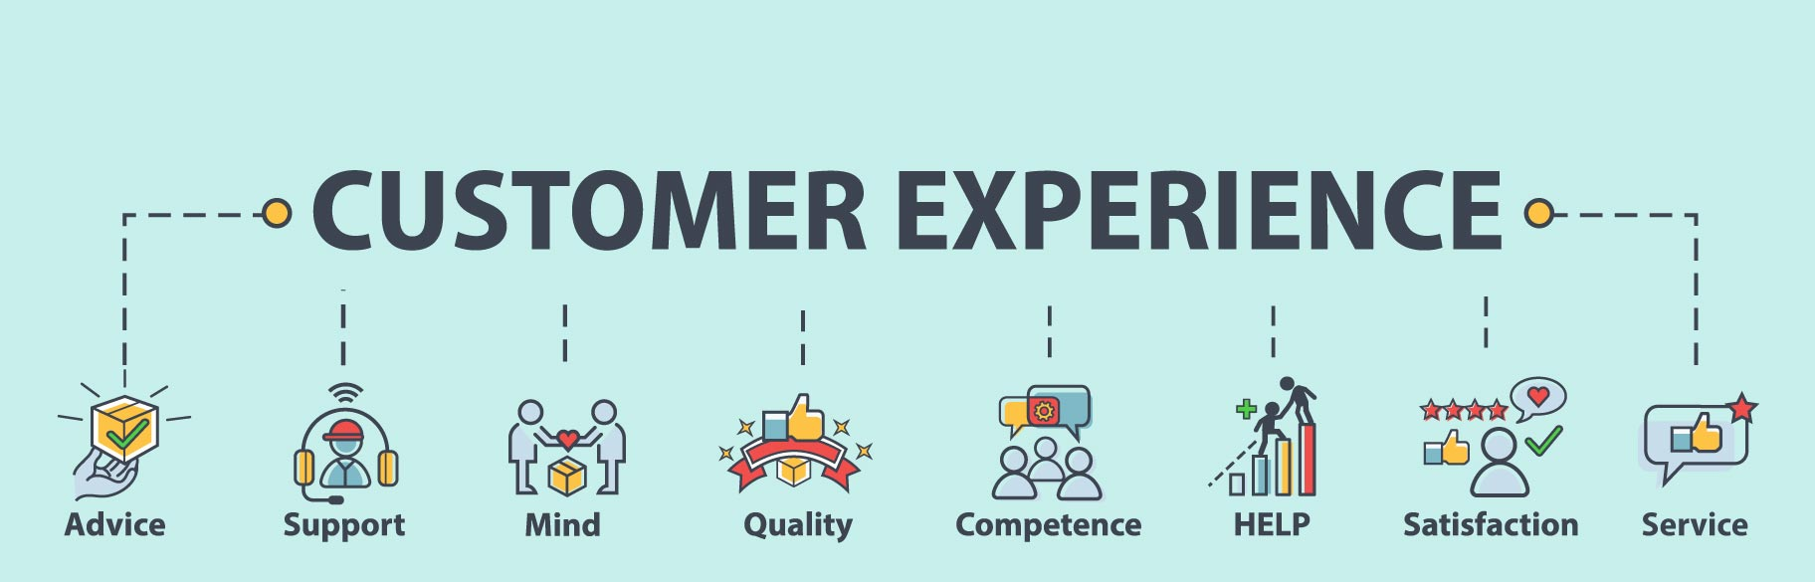
Customer Advocacy: This department represents the voice of the customer within the organization, advocating for their needs, preferences, and concerns to inform product development and decision-making.

Figure 1.3.9 Customer Experience
Customer Satisfaction and Retention: CX professionals develop strategies and programs to measure and improve customer satisfaction, loyalty, and retention rates through proactive engagement and personalized experiences.

Business Development and Partnerships Department:
Strategic Partnerships: Business development professionals identify and cultivate strategic alliances, joint ventures, and partnerships with other companies to expand market reach, access new resources, and drive growth.
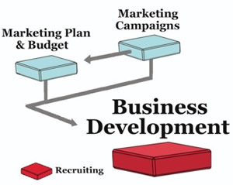
Market Expansion: This team explores new markets, geographies, and customer segments to identify growth opportunities and develop market entry strategies to capitalize on emerging trends.
Channel Development: Business development experts establish and manage distribution channels, reseller networks, and affiliate programs to extend EduPhoenix Solutions' reach and increase sales volume.
Competitive Intelligence: This department monitors competitors' activities, market trends, and industry developments to identify threats and opportunities, inform strategic decision-making, and maintain a competitive edge. Figure 1.3.10 Business Development

Quality Assurance and Testing Department:
Quality Assurance (QA) Testing is a critical function that ensures products and services meet specified quality standards before they are released to customers. This involves systematically testing various aspects of software, hardware, or other deliverables to identify defects or areas for improvement.
QA testers develop comprehensive test plans, scenarios, and scripts based on project requirements and specifications. These documents outline the testing approach, test cases, and expected outcomes for each test scenario.
Different types of testing are performed throughout the development lifecycle, including functional testing, which verifies that the system meets specified functional requirements, and regression testing, which ensures that new changes do not adversely impact existing functionality.

Figure 1.3.11(a) Quality Assurance | Figure 1.3.11(b) Testing

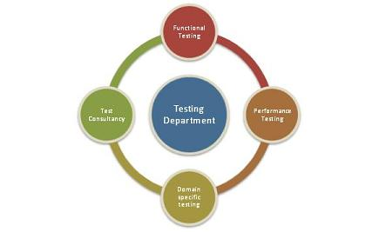
User acceptance testing (UAT) is conducted to validate the product against user expectations and requirements. This involves engaging end-users to evaluate the product's usability, accessibility, and overall user experience.
QA testers use a variety of testing techniques and tools to identify defects and bugs in the system. This may include manual testing, automated testing, performance testing, security testing, and usability testing, among others.
Throughout the testing process, QA testers document their findings, including any defects or issues discovered during testing. They work closely with development teams to prioritize and address these issues, ensuring that high-priority defects are resolved promptly.
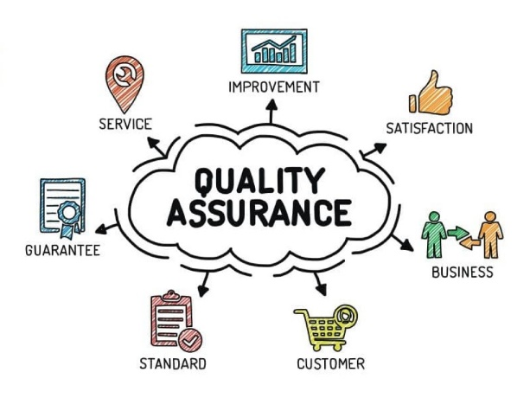
Continuous improvement is a key aspect of QA testing, with testers regularly reviewing and refining testing processes and methodologies to enhance efficiency and effectiveness. This may involve implementing new tools, adopting best practices, and incorporating feedback from stakeholders to drive quality improvements.
Grievance and Conflict Resolution Department:
The Grievance and Conflict Resolution department is responsible for managing disputes, grievances, and conflicts within the organization. This department serves as a neutral mediator, helping parties resolve issues in a fair and equitable manner.
One of the primary functions is to provide employees and stakeholders with a platform to express their concerns and grievances. This could involve setting up confidential reporting mechanisms, such as hotlines or online portals, where individuals can raise issues anonymously.
The department investigates complaints and conflicts thoroughly, gathering relevant information and evidence to understand the root causes of the problem. Depending on the nature of the issue, this may involve conducting interviews, reviewing documentation, or engaging in alternative dispute resolution methods like mediation or arbitration.
Once the investigation is complete, the department works towards finding a resolution that addresses the concerns of all parties involved. This could involve implementing corrective actions, revising policies or procedures, or providing training and support to prevent similar issues from arising in the future.
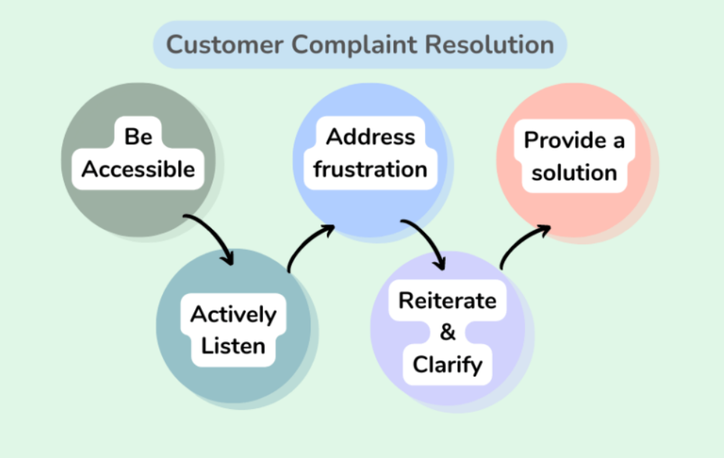
Figure 1.3.12 Customer Complaint Resolution
Additionally, the Grievance and Conflict Resolution department may play a role in promoting a positive organizational culture by fostering open communication, trust, and collaboration among employees. This includes promoting conflict resolution skills and providing resources for managing interpersonal conflicts effectively.

These departments play integral roles in ensuring the success and growth of EduPhoenix Solutions by effectively managing resources, delivering high-quality products and services, and delivers comprehensive educational solutions that empower learners, educators, and institutions to succeed in a rapidly evolving digital landscape.

  - Company Products/Applications
EduPhoenix Solutions prides itself on offering a diverse array of cutting-edge educational technology products and applications designed to cater to the evolving needs of educators and learners alike. Our commitment to innovation and excellence drives us to develop solutions that enhance teaching effectiveness, promote student engagement, and ultimately elevate the learning experience. Here's a detailed overview of our key products and applications:
- Learning Management System (LMS):
Our Learning Management System (LMS) serves as the cornerstone of our educational technology suite. This robust platform provides educators with the tools they need to create, deliver, and manage online courses and educational content seamlessly. With intuitive course creation features, comprehensive content management capabilities, and robust assessment tools, our LMS empowers educators to design dynamic and interactive learning experiences. Moreover, real-time analytics and reporting functionalities enable educators to monitor student progress and performance effectively.

- Virtual Classroom:
In today's digital age, our Virtual Classroom platform offers educators a versatile and immersive online learning environment. Equipped with video conferencing, screen sharing, interactive whiteboards, and chat functionality, this platform facilitates real-time collaboration and interaction between educators and students. Whether conducting live classes, webinars, or virtual workshops, educators can engage learners effectively and foster meaningful learning experiences. Seamless integration with our LMS ensures streamlined course delivery and administration.

- Interactive Content Authoring Tools:
Our suite of interactive content authoring tools empowers educators to create engaging and multimedia-rich learning materials with ease. Featuring user-friendly interfaces, customizable templates, and multimedia integration capabilities, these authoring tools enable educators to develop interactive presentations, quizzes, simulations, and games effortlessly. With built-in assessment and tracking features, educators can assess student comprehension and progress in real time, ensuring that learning objectives are met effectively.

- Professional Development Programs:
Recognizing the importance of continuous professional development, we offer a wide range of training courses and programs designed to enhance educators' skills and knowledge in educational technology and pedagogy. From digital literacy and blended learning to instructional design and technology integration, our professional development programs cover a diverse array of topics. Whether educators are looking to expand their expertise in specific areas or earn certifications in educational technology, our programs provide valuable opportunities for growth and advancement.

- Consultancy Services:
Our consultancy services cater to educational institutions seeking expert guidance and support in leveraging technology for teaching and learning. Our team of seasoned consultants collaborates closely with clients to assess their unique needs, develop tailored technology solutions, and provide ongoing training and support. From strategic planning and needs analysis to implementation and evaluation, our consultancy services empower institutions to maximize the impact of educational technology and achieve their educational goals effectively.

- IoT Projects:
Internet of Things (IoT) projects involve the integration of physical devices, sensors, and software applications to enable connectivity and data exchange. These projects often focus on leveraging IoT technologies to create smart systems, automate processes, and gather insights from real-world data. Eduphoenix Solutions offers a range of IoT projects aimed at providing hands-on learning experiences to students and professionals.
These projects typically cover areas such as:
Sensor Integration: Students learn to integrate various sensors such as temperature sensors, humidity sensors, motion sensors, and environmental sensors into IoT devices and systems.
Data Acquisition and Processing: Projects involve collecting data from sensors and processing it using microcontrollers or single-board computers like Arduino, Raspberry Pi, or ESP8266/ESP32.
Connectivity and Communication: Students explore different communication protocols such as Wi-Fi, Bluetooth, Zigbee, and LoRa to enable connectivity between IoT devices and networks.
IoT Applications: Projects may focus on developing IoT applications for smart homes, smart cities, industrial automation, healthcare monitoring, environmental monitoring, agriculture, and more.
Cloud Integration: Integration with cloud platforms such as AWS IoT, Google Cloud IoT, or Microsoft Azure IoT enables students to store, analyze, and visualize IoT data, as well as implement cloud-based services like remote monitoring and control.
Security and Privacy: Emphasis is placed on implementing security measures such as encryption, authentication, and access control to protect IoT systems from cyber threats and ensure data privacy.

- AI-ML Projects:
Artificial Intelligence (AI) and Machine Learning (ML) projects involve the development and application of algorithms and models to analyze data, make predictions, and automate tasks without explicit programming instructions. These projects harness the power of AI and ML techniques to solve complex problems, optimize processes, and extract insights from data. Eduphoenix Solutions offers a variety of AI-ML projects aimed at fostering understanding and proficiency in these transformative technologies.
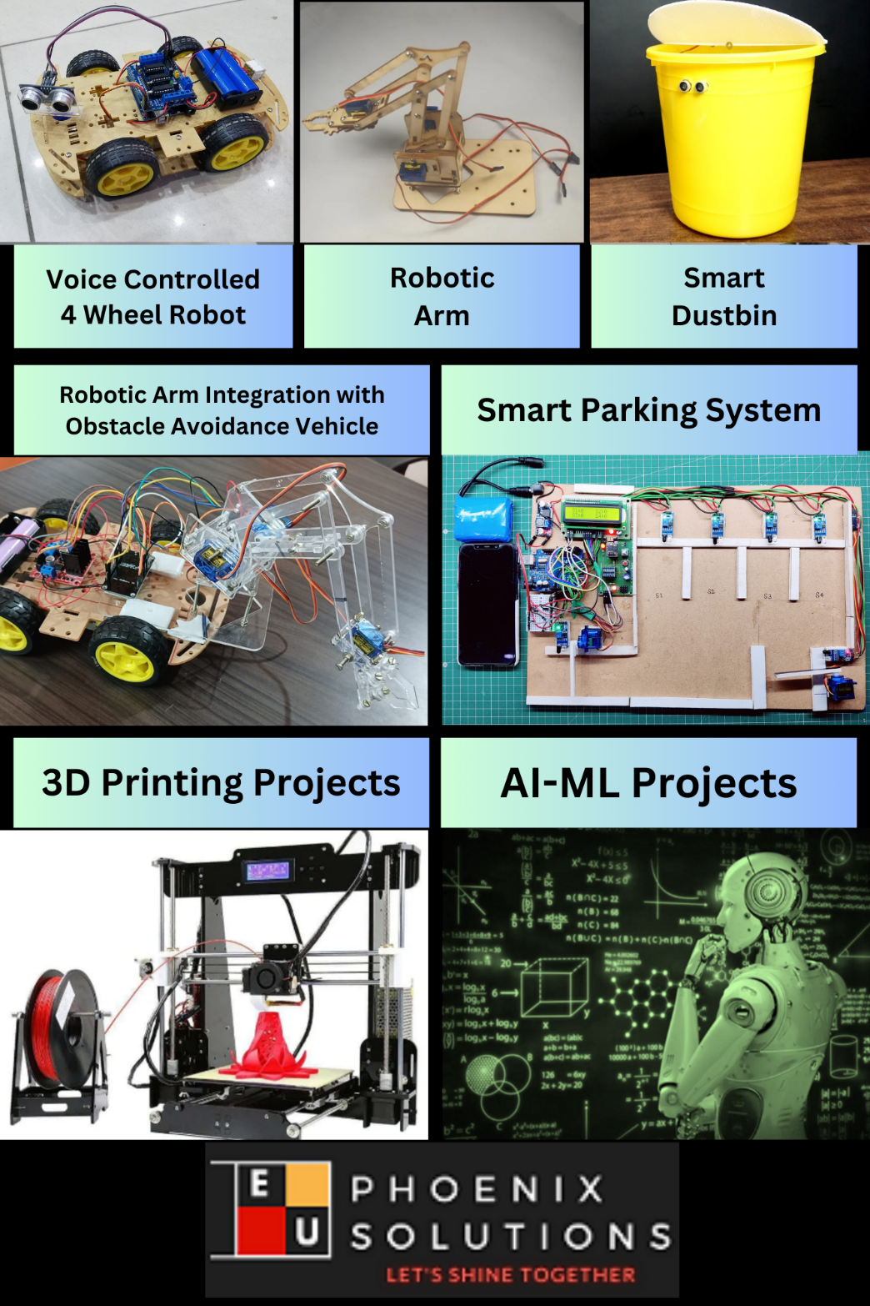

Figure 1.4.1 Company Products

Key components of AI-ML projects include:
Data Collection and Preparation: Projects begin with data collection from various sources such as sensors, databases, or web APIs. Data preprocessing techniques are then applied to clean, transform, and prepare the data for analysis.
Algorithm Selection and Model Development: Students explore different AI and ML algorithms such as regression, classification, clustering, neural networks, and deep learning to build predictive models and solve specific problems.
Model Training and Evaluation: The models are trained using abelled data, and their performance is evaluated using metrics such as accuracy, precision, recall, and F1-score. Hyperparameter tuning and cross-validation techniques are applied to optimize model performance.
Deployment and Integration: Once trained and evaluated, the models are deployed into production environments and integrated with existing systems or applications to deliver real-world value. This may involve deploying models on edge devices, cloud platforms, or IoT devices.

Overall, IoT and AI-ML projects offered by EduPhoenix Solutions provide participants with practical experience, critical thinking skills, and technical expertise in emerging technologies, preparing them for careers in the rapidly evolving fields of IoT and AI-ML.

CHAPTER 2
DOMAIN: CLOUD COMPUTING

1.1 Introduction
Cloud computing has revolutionized the way organizations and individuals use computing resources. Instead of purchasing and maintaining expensive hardware and software on local systems, cloud computing enables users to access computing resources such as servers, storage, databases, networking, software, and analytics over the internet. This approach allows businesses to focus on innovation while cloud service providers manage the underlying infrastructure.
Today, cloud computing has become one of the most important technologies in information technology (IT). It is widely adopted by startups, educational institutions, government organizations, healthcare providers, banking sectors, e-commerce companies, and multinational corporations. Popular cloud service providers include Amazon Web Services (AWS), Microsoft Azure, Google Cloud Platform (GCP), and Oracle Cloud Infrastructure (OCI).
The cloud provides users with on-demand access to computing resources from anywhere in the world using an internet connection. It eliminates the need for organizations to purchase costly physical servers and provides a scalable, flexible, and cost-effective solution for managing applications and data.
During this training, various concepts of cloud computing were studied, beginning with the fundamentals of cloud computing and progressing to cloud infrastructure, networking, security, monitoring, storage, databases, and serverless computing.

1.2 Definition of Cloud Computing
Cloud computing is the delivery of computing services such as servers, storage, networking, databases, software, analytics, and artificial intelligence over the internet ("the cloud") on a pay-as-you-go basis.
Rather than owning physical infrastructure, users can rent computing resources from cloud providers whenever needed. These resources are dynamically allocated and managed according to user demand.
In simple terms,
Cloud Computing is the practice of using remote servers hosted on the internet to store, manage, and process data instead of using local computers or private servers.

1.3 Evolution of Cloud Computing
The concept of cloud computing has evolved through several stages of technological advancement.

Main Stages of Evolution

Mainframe Computing (1960s)
- Centralized computers were used.
- Multiple users shared a single mainframe.
- Computing resources were expensive and limited.

Client-Server Computing (1980s)
- Personal computers became common.
- Applications were hosted on dedicated servers.
- Users connected to servers over local networks.

Internet Computing (1990s)
- The internet enabled global connectivity.
- Web applications became increasingly popular.
- Organizations started providing online services.

Grid Computing
- Multiple computers worked together to solve complex problems.
- Resources were shared across different locations.

Virtualization Era
- Physical servers could run multiple virtual machines.
- Hardware utilization improved significantly.
- Infrastructure became more flexible.

Cloud Computing (Present)
- Resources are delivered over the internet.
- Services are available on demand.
- Organizations pay only for what they use.
- Automatic scaling and high availability became standard features.

1.4 Need for Cloud Computing
Traditional IT infrastructure presents several challenges such as high hardware costs, maintenance expenses, limited scalability, and complex resource management.
Cloud computing addresses these challenges by offering:
- Reduced infrastructure costs
- Easy scalability
- Global accessibility
- Faster deployment of applications
- Automatic software updates
- Disaster recovery support
- Secure storage
- Business continuity
- High system availability
Organizations adopt cloud computing because it enables faster innovation while reducing operational costs.

1.5 Characteristics of Cloud Computing
Cloud computing possesses several key characteristics that distinguish it from traditional computing environments.

1. On-Demand Self-Service
Users can provision computing resources such as virtual machines, storage, and databases whenever required without direct interaction with the cloud provider.
Example:
A developer can launch an AWS EC2 instance within a few minutes.

2. Broad Network Access
Cloud services are accessible over the internet using desktops, laptops, tablets, and smartphones.
Users can access applications from anywhere with an internet connection.

3. Resource Pooling
Cloud providers pool computing resources to serve multiple customers simultaneously.
Resources include:
- CPU
- Memory
- Storage
- Network bandwidth
These resources are dynamically allocated based on customer demand.

4. Rapid Elasticity
Cloud resources can automatically increase or decrease according to workload.
For example:
- During festival sales, an e-commerce website can automatically add more servers.
- Once traffic decreases, unnecessary resources are released.

5. Measured Service
Cloud providers monitor resource usage continuously.
Customers are billed based on actual consumption such as:
- Compute hours
- Storage used
- Network traffic
- Database usage
This is commonly known as the Pay-as-you-Go pricing model.

1.6 Advantages of Cloud Computing
Cloud computing provides numerous benefits to organizations of all sizes.

Cost Efficiency
Organizations avoid purchasing expensive hardware and pay only for the resources they consume.

Scalability
Resources can be increased or decreased according to demand.

Flexibility
Employees can access cloud services from any location.

Reliability
Cloud providers offer redundant infrastructure and high availability.

Disaster Recovery
Data backup and recovery mechanisms ensure business continuity.

Security
Cloud providers implement encryption, firewalls, identity management, and continuous monitoring.

Automatic Updates
Cloud platforms automatically update operating systems and services.

Faster Deployment
Applications can be deployed within minutes instead of weeks.

1.7 Limitations of Cloud Computing
Although cloud computing offers many benefits, it also has certain limitations.

Internet Dependency
Cloud services require a stable internet connection.

Security Concerns
Sensitive information stored in the cloud may become a target for cyberattacks if not properly protected.

Vendor Lock-in
Migrating from one cloud provider to another can be complex and expensive.

Downtime
Service outages at cloud providers may temporarily affect business operations.

Compliance Issues
Organizations handling sensitive data must comply with industry regulations and legal requirements.

1.8 Applications of Cloud Computing
Cloud computing is widely used across multiple industries.

Education
- Online learning platforms
- Virtual laboratories
- Student information systems

Healthcare
- Electronic Health Records (EHR)
- Medical image storage
- Telemedicine

Banking
- Online banking
- Fraud detection
- Secure payment processing

E-Commerce
- Online shopping websites
- Inventory management
- Customer analytics

Government
- Digital citizen services
- Data management
- Smart governance

Entertainment
- Video streaming
- Online gaming
- Music platforms

Software Development
- Continuous Integration/Continuous Deployment (CI/CD)
- Application testing
- Cloud hosting

1.9 Major Cloud Service Providers
Several companies offer cloud computing platforms with a wide range of services.
Cloud Provider | Popular Services
Amazon Web Services (AWS) | EC2, S3, RDS, Lambda
Microsoft Azure | Virtual Machines, Azure SQL, Azure Functions
Google Cloud Platform (GCP) | Compute Engine, Cloud Storage, BigQuery
Oracle Cloud Infrastructure (OCI) | Compute, Storage, Autonomous Database
These providers offer scalable infrastructure, managed databases, AI services, networking, and security solutions for organizations worldwide.

1.10 Future Scope of Cloud Computing
Cloud computing continues to evolve with emerging technologies.
Future trends include:
- Artificial Intelligence (AI) integration
- Machine Learning services
- Internet of Things (IoT)
- Edge Computing
- Multi-Cloud environments
- Hybrid Cloud solutions
- Serverless architectures
- Green Cloud Computing
- Quantum Cloud Computing
These advancements are expected to improve efficiency, automation, scalability, and sustainability across industries.

1.11 Chapter Summary
Cloud computing is a modern computing paradigm that delivers IT resources over the internet on demand. It provides organizations with scalable, reliable, and cost-effective infrastructure while eliminating the need for extensive physical hardware. The chapter introduced the evolution of cloud computing, its characteristics, advantages, limitations, major applications, and leading cloud service providers. These foundational concepts form the basis for understanding more advanced topics such as service models, deployment models, virtualization, networking, storage, security, and cloud infrastructure covered in the subsequent chapters of this report. This chapter aligns with the introductory topics and cloud characteristics listed in the training log sheet.

CHAPTER 3
INTERNSHIP TASK/DAILY-LOGS

CHAPTER 4
PROJECT

CHAPTER 5
CAREER OPPORTUNITIES

5.1 Introduction
Cloud computing has become one of the fastest-growing domains in the Information Technology (IT) industry. Organizations across sectors such as banking, healthcare, education, e-commerce, manufacturing, telecommunications, and government are rapidly adopting cloud technologies to improve efficiency, scalability, and business continuity. As a result, the demand for skilled cloud professionals has increased significantly.
Cloud computing is no longer limited to data storage or virtual machines. Modern cloud platforms provide services related to artificial intelligence, machine learning, cybersecurity, networking, DevOps, big data analytics, Internet of Things (IoT), and application development. This has created numerous career opportunities for students and professionals with cloud computing knowledge.
With organizations migrating their applications and infrastructure to cloud platforms such as Amazon Web Services (AWS), Microsoft Azure, Google Cloud Platform (GCP), and Oracle Cloud Infrastructure (OCI), cloud professionals are among the most sought-after IT experts. Companies require individuals who can design, deploy, manage, secure, and monitor cloud-based systems efficiently.
This chapter discusses the various career opportunities, required skills, certifications, career growth, and future prospects in the field of cloud computing.

5.2 Importance of Cloud Computing Careers
Cloud computing has transformed traditional IT operations by providing on-demand access to computing resources over the internet. Organizations no longer need to invest heavily in physical infrastructure, making cloud technology an essential part of digital transformation.
The increasing adoption of cloud services has resulted in:
- High demand for cloud professionals.
- Better salary packages compared to traditional IT roles.
- Opportunities to work with multinational companies.
- Global career prospects.
- Continuous learning through emerging technologies.
- Diverse job roles across different industries.
Cloud computing professionals play an important role in helping organizations migrate their infrastructure, optimize cloud resources, ensure security, and maintain high availability of applications.

5.3 Career Roles in Cloud Computing
Cloud computing offers a wide range of career opportunities based on an individual's interests and technical expertise.

1. Cloud Engineer
A Cloud Engineer is responsible for designing, implementing, managing, and maintaining cloud infrastructure. They work with virtual machines, networking, storage services, and cloud security to ensure efficient cloud operations.
Responsibilities:
- Configure cloud resources.
- Deploy virtual machines.
- Manage cloud storage.
- Monitor system performance.
- Troubleshoot cloud-related issues.
- Maintain cloud infrastructure.
Required Skills:
- AWS, Azure, or GCP
- Linux
- Networking
- Scripting
- Virtualization
- Cloud Security

2. Cloud Administrator
A Cloud Administrator manages cloud environments and ensures that cloud services operate efficiently.
Responsibilities:
- User management
- Resource allocation
- Backup management
- Performance monitoring
- System maintenance
- Access management
This role requires knowledge of Identity and Access Management (IAM), cloud monitoring tools, and cloud networking.

3. Cloud Architect
Cloud Architects design complete cloud solutions for organizations based on business requirements.
Responsibilities:
- Design cloud infrastructure.
- Select cloud deployment models.
- Plan disaster recovery.
- Ensure scalability.
- Implement security architecture.
- Optimize cloud costs.
Cloud Architects require extensive knowledge of networking, databases, virtualization, and cloud platforms.

4. DevOps Engineer
DevOps Engineers automate software deployment and infrastructure management using cloud technologies.
Responsibilities:
- Continuous Integration (CI)
- Continuous Deployment (CD)
- Infrastructure Automation
- Server Configuration
- Monitoring
- Performance Optimization
Common tools include:
- Docker
- Kubernetes
- Jenkins
- Terraform
- Git
- AWS CodePipeline

5. Cloud Security Engineer
Cloud Security Engineers focus on protecting cloud resources from cyber threats.
Responsibilities:
- Configure IAM policies.
- Manage firewalls.
- Monitor cloud security.
- Perform vulnerability assessments.
- Encrypt sensitive information.
- Implement compliance standards.
As organizations migrate sensitive data to the cloud, security professionals are in high demand.

6. Cloud Developer
Cloud Developers build applications that run on cloud platforms.
Their work includes:
- Developing web applications.
- Integrating cloud APIs.
- Working with serverless computing.
- Managing databases.
- Deploying applications.
Programming languages commonly used include:
- Python
- Java
- JavaScript
- C#
- Node.js

7. Cloud Consultant
Cloud Consultants help organizations select appropriate cloud solutions based on business needs.
Their responsibilities include:
- Cloud migration planning
- Cost optimization
- Security recommendations
- Infrastructure planning
- Technology consulting

8. Solutions Architect
Solutions Architects bridge the gap between business requirements and cloud technologies.
They design scalable, secure, and cost-effective cloud solutions for organizations.

9. Site Reliability Engineer (SRE)
Site Reliability Engineers ensure cloud applications remain highly available and reliable.
Their responsibilities include:
- System monitoring
- Incident management
- Performance tuning
- Capacity planning
- Automation

10. Cloud Support Engineer
Cloud Support Engineers assist customers in resolving technical issues related to cloud services.
They provide:
- Technical support
- Troubleshooting
- Infrastructure maintenance
- Performance analysis
- Customer assistance

5.4 Skills Required for a Career in Cloud Computing
To build a successful career in cloud computing, professionals should develop both technical and soft skills.

Technical Skills
- Cloud Fundamentals
- AWS, Azure, or Google Cloud
- Linux Administration
- Networking
- Virtualization
- Storage Technologies
- Cloud Security
- Identity and Access Management (IAM)
- Cloud Databases
- Serverless Computing
- Infrastructure as Code (Terraform, CloudFormation)
- DevOps Tools
- Docker
- Kubernetes
- Python Programming
- Bash Scripting
- SQL
- Monitoring Tools

Soft Skills
- Problem-solving
- Communication
- Teamwork
- Critical Thinking
- Project Management
- Adaptability
- Time Management

5.5 Industry Certifications
Professional certifications enhance credibility and improve employment opportunities.
Popular cloud certifications include:

Amazon Web Services (AWS)
- AWS Certified Cloud Practitioner
- AWS Certified Solutions Architect – Associate
- AWS Certified Developer – Associate
- AWS Certified SysOps Administrator
- AWS Certified Security – Specialty

Microsoft Azure
- Microsoft Azure Fundamentals (AZ-900)
- Azure Administrator Associate
- Azure Developer Associate
- Azure Solutions Architect Expert

Google Cloud Platform
- Associate Cloud Engineer
- Professional Cloud Architect
- Professional Cloud Developer

Oracle Cloud Infrastructure
- OCI Foundations Associate
- OCI Architect Associate
Obtaining these certifications demonstrates practical knowledge and improves career prospects in cloud computing.

5.6 Industries Using Cloud Computing
Cloud computing is adopted across almost every industry.

Banking and Finance
- Online banking
- Digital payments
- Fraud detection
- Financial analytics

Healthcare
- Electronic Medical Records
- Medical Imaging
- Telemedicine
- Patient Management

Education
- Online Learning Platforms
- Virtual Classrooms
- Student Information Systems
- Digital Libraries

E-Commerce
- Product Catalog Management
- Online Shopping
- Recommendation Systems
- Inventory Management

Government
- Digital Governance
- Public Service Portals
- Secure Data Storage

Information Technology
- Software Development
- Cloud Hosting
- DevOps
- Data Analytics

5.7 Future Scope of Cloud Computing
Cloud computing continues to evolve with emerging technologies, creating even more employment opportunities.
Some future trends include:
- Artificial Intelligence Integration
- Machine Learning Services
- Internet of Things (IoT)
- Edge Computing
- Hybrid Cloud
- Multi-Cloud Architecture
- Serverless Computing
- Cloud Automation
- Green Cloud Computing
- Quantum Computing Services
As organizations increasingly adopt digital transformation strategies, professionals with cloud expertise will continue to be in high demand.

5.8 Career Growth Path
A typical career progression in cloud computing is as follows:
Experience Level | Job Role
Entry Level | Cloud Support Engineer / Junior Cloud Engineer
2–4 Years | Cloud Engineer / Cloud Administrator
4–6 Years | DevOps Engineer / Cloud Security Engineer
6–10 Years | Cloud Architect / Solutions Architect
10+ Years | Cloud Consultant / Cloud Practice Lead / Cloud Manager
With continuous learning and certifications, professionals can move into leadership and consulting roles.

5.9 Benefits of Choosing a Career in Cloud Computing
Choosing cloud computing as a career offers several advantages:
- High demand across industries.
- Attractive salary packages.
- Opportunities to work with global organizations.
- Continuous learning and career development.
- Exposure to emerging technologies.
- Flexible work opportunities, including remote work.
- Wide range of specialization options.
- Long-term career stability.
Cloud computing professionals also have opportunities to work in areas such as cybersecurity, artificial intelligence, DevOps, big data, networking, and software engineering.

5.10 Chapter Summary
Cloud computing has emerged as one of the most promising and rapidly growing fields in the IT industry. The increasing adoption of cloud technologies by organizations worldwide has created a wide range of career opportunities, including roles such as Cloud Engineer, Cloud Architect, Cloud Administrator, DevOps Engineer, Cloud Security Engineer, and Cloud Consultant. Success in this domain requires a combination of technical expertise, practical experience, industry-recognized certifications, and strong problem-solving skills. As technologies such as artificial intelligence, edge computing, and serverless architecture continue to evolve, cloud computing professionals will play a vital role in driving digital transformation. For students and aspiring IT professionals, developing cloud computing skills provides a strong foundation for a rewarding and future-ready career.

CHAPTER 6
FUTURE TRENDS

6.1 Introduction
Cloud computing has transformed the way organizations develop, deploy, and manage applications. As businesses continue to embrace digital transformation, cloud technologies are evolving rapidly to meet increasing demands for scalability, security, performance, and innovation. Emerging technologies such as Artificial Intelligence (AI), Machine Learning (ML), the Internet of Things (IoT), edge computing, and quantum computing are shaping the future of cloud computing.
Modern cloud platforms are moving beyond traditional infrastructure services by offering intelligent automation, advanced analytics, enhanced security, and distributed computing capabilities. Organizations are increasingly adopting hybrid and multi-cloud environments to improve flexibility, reduce operational risks, and optimize costs. As a result, cloud computing is expected to remain a key driver of technological advancement and business growth in the coming years.
This chapter discusses the major future trends that are expected to influence the development and adoption of cloud computing across various industries.

6.2 Artificial Intelligence and Machine Learning Integration
Artificial Intelligence (AI) and Machine Learning (ML) are becoming integral components of cloud computing. Cloud providers offer AI and ML services that enable organizations to build intelligent applications without investing in expensive hardware or specialized infrastructure.
Cloud-based AI services support applications such as image recognition, natural language processing, predictive analytics, recommendation systems, and intelligent chatbots. Businesses use these services to automate repetitive tasks, improve customer experiences, and make data-driven decisions.
Machine learning models can be trained and deployed on cloud platforms using scalable computing resources, allowing organizations to process large volumes of data efficiently. As AI technologies continue to advance, cloud platforms will become increasingly intelligent, offering automated resource management, predictive maintenance, and enhanced decision-making capabilities.

6.3 Hybrid Cloud and Multi-Cloud Strategies
Many organizations are adopting hybrid and multi-cloud strategies to improve flexibility, reliability, and performance.
A hybrid cloud combines private cloud infrastructure with public cloud services, allowing businesses to keep sensitive data in private environments while utilizing public cloud resources for scalability and cost efficiency.
A multi-cloud strategy involves using services from multiple cloud providers such as AWS, Microsoft Azure, Google Cloud Platform, and Oracle Cloud Infrastructure. This approach reduces dependency on a single provider, improves availability, and enables organizations to select the best services for different business requirements.
As organizations continue to diversify their cloud environments, hybrid and multi-cloud architectures are expected to become standard practices in enterprise IT infrastructure.

6.4 Edge Computing
Edge computing is an emerging technology that complements cloud computing by processing data closer to its source rather than transmitting all information to centralized cloud data centers.
With the increasing number of Internet of Things (IoT) devices, autonomous vehicles, smart factories, and connected healthcare systems, processing data at the network edge reduces latency and improves response times.
Benefits of edge computing include:
- Faster data processing
- Reduced network congestion
- Lower latency
- Improved real-time decision making
- Enhanced reliability for critical applications
Edge computing is expected to play an important role in supporting next-generation technologies that require immediate processing and low-latency communication.

6.5 Internet of Things (IoT) and Cloud Integration
The Internet of Things (IoT) refers to a network of interconnected devices capable of collecting and exchanging data. Cloud computing provides the infrastructure required to store, process, and analyze the enormous amount of data generated by these devices.
Cloud-based IoT platforms enable organizations to monitor equipment, automate industrial processes, manage smart cities, improve healthcare services, and optimize agricultural operations.
As IoT adoption continues to grow, cloud computing will provide scalable storage, real-time analytics, device management, and secure communication for billions of connected devices worldwide.

6.6 Serverless Computing
Serverless computing is becoming one of the most popular cloud computing models. In this approach, developers focus entirely on writing application code while the cloud provider automatically manages the underlying servers, operating systems, scaling, and maintenance.
Serverless services automatically allocate computing resources based on application demand, resulting in improved scalability and reduced operational complexity.
Key advantages include:
- Automatic scaling
- Lower operational costs
- Faster application development
- Reduced infrastructure management
- Pay-per-execution pricing
As organizations increasingly adopt microservices and event-driven architectures, serverless computing is expected to become a preferred deployment model for modern cloud applications.

6.7 Cloud Security Advancements
Security remains one of the most critical aspects of cloud computing. As cyber threats continue to evolve, cloud providers are investing heavily in advanced security technologies.
Future cloud security trends include:
- Artificial Intelligence-based threat detection
- Zero Trust Security Architecture
- Multi-Factor Authentication (MFA)
- Identity and Access Management (IAM)
- End-to-End Data Encryption
- Security Information and Event Management (SIEM)
- Automated Security Monitoring
- Compliance Automation
These technologies help organizations protect sensitive information while meeting regulatory and compliance requirements.

6.8 Green Cloud Computing
Environmental sustainability has become an important consideration in cloud computing. Green cloud computing focuses on reducing energy consumption, minimizing carbon emissions, and improving the efficiency of data centers.
Cloud providers are investing in renewable energy sources, energy-efficient hardware, and intelligent cooling systems to reduce the environmental impact of large-scale computing infrastructure.
Benefits of green cloud computing include:
- Lower energy consumption
- Reduced operational costs
- Improved resource utilization
- Sustainable IT infrastructure
- Reduced carbon footprint
As environmental awareness continues to grow, green cloud initiatives are expected to become an essential component of future cloud infrastructure.

6.9 Quantum Computing and Cloud Services
Quantum computing is an emerging technology that has the potential to solve highly complex computational problems significantly faster than traditional computers.
Although still in its early stages, several cloud providers have introduced cloud-based quantum computing platforms that allow researchers and developers to experiment with quantum algorithms without owning specialized hardware.
Potential applications include:
- Drug discovery
- Financial modeling
- Cryptography
- Climate prediction
- Optimization problems
- Scientific research
As quantum computing matures, cloud platforms are expected to make this technology more accessible to businesses and research organizations.

6.10 Future Career Opportunities
The continued advancement of cloud computing technologies will create new career opportunities across multiple domains.
Future job roles are expected to include:
- Cloud AI Engineer
- Cloud Security Specialist
- DevOps Engineer
- Site Reliability Engineer (SRE)
- Cloud Solutions Architect
- Cloud Automation Engineer
- Edge Computing Engineer
- IoT Cloud Developer
- Cloud Data Engineer
- Cloud Consultant
Professionals with expertise in cloud platforms, automation, cybersecurity, AI, and distributed systems will remain in high demand as organizations accelerate their digital transformation initiatives.

CHAPTER 7
CONCLUSION
Cloud computing has emerged as one of the most transformative technologies in the field of Information Technology, fundamentally changing the way organizations develop, deploy, and manage computing resources. By providing on-demand access to computing services such as servers, storage, networking, databases, software, and security over the internet, cloud computing has enabled businesses to achieve greater flexibility, scalability, and operational efficiency while significantly reducing infrastructure costs.
During this training, a comprehensive understanding of cloud computing concepts was developed, beginning with the fundamentals of cloud computing and its evolution. The study covered the essential characteristics of cloud computing, including on-demand self-service, broad network access, resource pooling, rapid elasticity, and measured services. These concepts provided a strong foundation for understanding how modern cloud environments operate and why organizations increasingly prefer cloud-based solutions over traditional on-premises infrastructure.
The training also provided detailed knowledge of various cloud service models such as Infrastructure as a Service (IaaS), Platform as a Service (PaaS), and Software as a Service (SaaS), along with cloud deployment models including Public Cloud, Private Cloud, Hybrid Cloud, and Community Cloud. Understanding these models highlighted how organizations select suitable cloud solutions based on their business requirements, security needs, and operational objectives.
A significant portion of the training focused on virtualization technologies, cloud infrastructure, networking concepts, and resource management. Topics such as hypervisors, resource pooling, elasticity, scalability, and multi-tenancy demonstrated how cloud platforms efficiently utilize computing resources while providing high availability and optimal performance. Networking concepts including IP addressing, Domain Name System (DNS), Content Delivery Networks (CDN), Load Balancers, Internet Gateways, and Virtual Private Clouds (VPCs) illustrated the importance of secure and reliable communication within cloud environments.
The practical understanding of major cloud service providers, including Amazon Web Services (AWS), Microsoft Azure, Google Cloud Platform (GCP), and Oracle Cloud Infrastructure (OCI), offered valuable insights into industry-standard cloud platforms. Services such as Amazon EC2, Azure Virtual Machines, Google Compute Engine, Amazon S3, Elastic Block Store (EBS), Elastic File System (EFS), Amazon RDS, DynamoDB, AWS Lambda, CloudWatch, CloudTrail, and Identity and Access Management (IAM) demonstrated how cloud providers offer scalable and fully managed solutions for modern applications.

The training also introduced emerging technologies such as Infrastructure as Code (IaC), serverless computing, cloud databases, web application hosting, and application deployment methodologies. These technologies simplify infrastructure management, reduce operational complexity, and improve software development efficiency through automation and scalable cloud services.
In addition to technical knowledge, this training highlighted the vast career opportunities available in cloud computing. With organizations worldwide accelerating their digital transformation initiatives, cloud professionals continue to be in high demand across industries such as banking, healthcare, education, manufacturing, retail, government, and information technology. Roles including Cloud Engineer, Cloud Architect, Cloud Administrator, DevOps Engineer, Cloud Security Engineer, and Cloud Consultant offer excellent career growth and professional development opportunities.
Furthermore, the study of future trends such as Artificial Intelligence integration, Machine Learning, Edge Computing, Internet of Things (IoT), Hybrid Cloud, Multi-Cloud, Green Cloud Computing, and Quantum Computing illustrates that cloud technology will continue to evolve rapidly in the coming years. These innovations will further enhance automation, intelligence, scalability, sustainability, and business agility, making cloud computing an indispensable component of modern digital infrastructure.
Overall, this training has provided a strong theoretical foundation and practical understanding of cloud computing technologies. The knowledge gained during this program has enhanced technical competency in cloud infrastructure, networking, security, storage, monitoring, and deployment while improving awareness of current industry practices and emerging technologies. The concepts learned throughout this training will serve as a valuable foundation for advanced studies, professional certifications, and future careers in cloud computing and related domains.
In conclusion, cloud computing has become a critical technology driving digital transformation across the world. As organizations increasingly migrate their applications and services to cloud platforms, professionals with cloud computing expertise will continue to play a vital role in designing, implementing, securing, and managing modern IT infrastructures. This training has significantly strengthened the understanding of cloud technologies and prepared a solid foundation for future learning, professional growth, and successful careers in the rapidly evolving cloud computing industry.
CHAPTER 8
REFERENCES
- Amazon Web Services (AWS). AWS Documentation. Available at: https://docs.aws.amazon.com/
- Microsoft. Microsoft Azure Documentation. Available at: https://learn.microsoft.com/azure/
- Google Cloud. Google Cloud Documentation. Available at: https://cloud.google.com/docs
- Oracle Corporation. Oracle Cloud Infrastructure Documentation. Available at: https://docs.oracle.com/
- National Institute of Standards and Technology (NIST). The NIST Definition of Cloud Computing (Special Publication 800-145).
- Rajkumar Buyya, Christian Vecchiola, and S. Thamarai Selvi. Mastering Cloud Computing. McGraw-Hill Education.
- Thomas Erl, Ricardo Puttini, and Zaigham Mahmood. Cloud Computing: Concepts, Technology & Architecture. Pearson Education.
- Barrie Sosinsky. Cloud Computing Bible. Wiley Publishing.
- Anthony T. Velte, Toby J. Velte, and Robert Elsenpeter. Cloud Computing: A Practical Approach. McGraw-Hill.
- VMware Documentation. Virtualization and Cloud Infrastructure. Available at: https://docs.vmware.com/
- Red Hat. Cloud Computing Resources. Available at: https://www.redhat.com/
- IBM Cloud Documentation. Available at: https://cloud.ibm.com/docs
- Cisco Networking Academy. Cloud and Networking Fundamentals. Available at: https://www.netacad.com/
- Kavis Gildardo. Cloud Native Infrastructure. O'Reilly Media.
- Eduphoenix Solutions Cloud Computing Framework

