Zarban — Complete Project Documentation
Scope of this document. An end-to-end explanation of the Zarban project from business, functional, technical, database, user, testing, deployment, and maintenance perspectives. Everything here is derived from the actual project files (schema, routes, engine, scripts, deployment). Where a detail is not present in the codebase it is marked “Information not available in the supplied project files.” Assumptions and non-implemented suggestions are labelled Assumption: and Recommendation: respectively.Live system:https://zarban.zarbanlabs-app.workers.dev · Repo:https://github.com/karthikLagudu/ZarbanAbbreviations (expanded on first use): CAT = Computerized Adaptive Testing; IRT = Item Response Theory; 3PL = three-parameter logistic; BKT = Bayesian Knowledge Tracing; CDM = Cognitive Diagnosis Model; DKT = Deep Knowledge Tracing; MLE = Maximum Likelihood Estimation; RBAC = Role-Based Access Control; JWT = JSON Web Token; ORM = Object-Relational Mapping; D1 = Cloudflare's serverless SQLite database; RSC = React Server Components; FK/PK = Foreign/Primary Key; NCERT = National Council of Educational Research and Training (India).

1. Project Overview
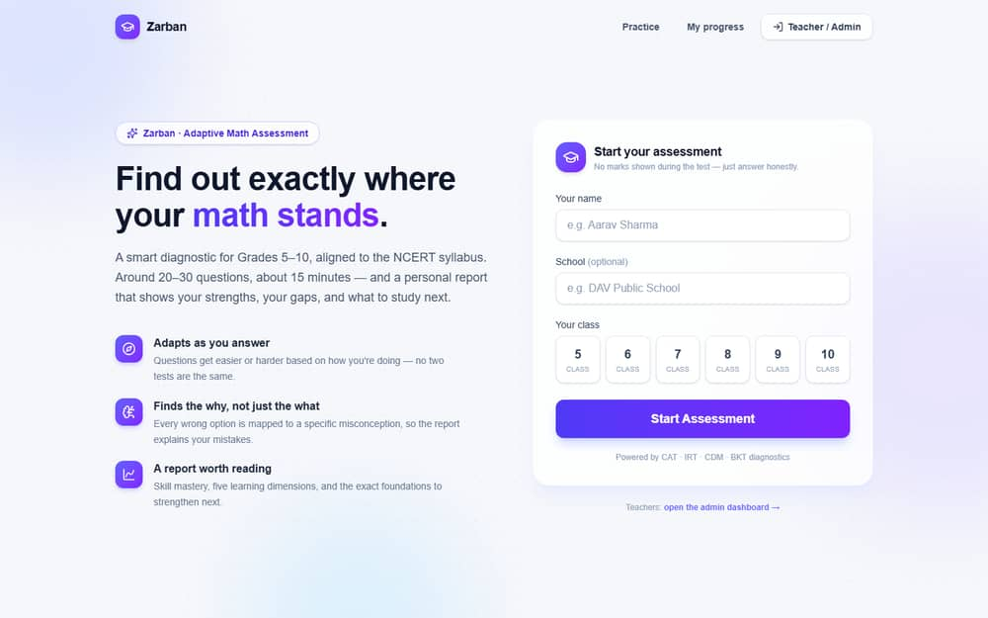
Figure — The student landing page (/).

1.1 Executive summary
Zarban is an adaptive math assessment and learning platform for Grades 5–10, aligned to the NCERT syllabus. Instead of returning a bare score, it runs a genuine multi-algorithm diagnostic that identifies why a student answers incorrectly — a calculation slip, a reading-comprehension gap, or a missing prerequisite skill — and closes the loop with targeted practice. It ships three role-scoped experiences (student, teacher, administrator) plus a content-authoring studio, and runs live and free on Cloudflare's edge platform.

1.2 Detailed technical summary
Zarban is a Next.js 16 (App Router / RSC) application compiled to a Cloudflare Worker via vinext, backed by Cloudflare D1 (serverless SQLite) through Prisma 6 with the D1 driver adapter. The adaptive engine (src/lib/engine/) is closed-form TypeScript implementing 3PL IRT (Newton–Raphson θ MLE), BKT, CDM answer-trap remediation, DKT-lite mastery propagation, and a Twin-Question reading-vs-maths probe. Authentication is a jose JWT in an HttpOnly cookie with a four-tier RBAC model. The system exposes 46 API route handlers, 27 pages, and a 20-table relational schema, and is verified by a 136-check end-to-end suite.

1.3 Overview attributes
Attribute | Detail
Project name | Zarban
Project category | Educational technology (EdTech) — adaptive assessment & learning web application (SaaS-style, single deploy)
Background | Math learning gaps compound across grades; teachers lack a tool that explains  why  a student fails, not just  that  they fail.
Problem addressed | Conventional tests give a score with no root cause and no next step; remediation is guesswork.
Why developed | To turn assessment into diagnosis + prescription, at zero infrastructure cost so schools can pilot it freely.
Existing difficulties before | Manual grading; no per-skill mastery tracking; no misconception analysis; no adaptivity; static difficulty.
Proposed solution | An adaptive engine that traverses a skill knowledge-graph, plus a full teacher/admin console and content studio.
Main objectives | Accurate diagnosis, actionable reports, teacher visibility, manageable content, low cost, fast UX.
Expected outcomes | Faster identification of learning gaps; targeted practice; data-driven teaching.
Target users | Students (Grades 5–10), teachers, school administrators, content authors.
User roles | Admin, Teacher, Viewer, Editor (RBAC). Students are unauthenticated.
Business value | Converts a score into an actionable diagnosis; $0 hosting; pilot-ready.
Technical value | Deterministic, auditable psychometrics; edge deployment; typed schema; a generic DB manager.
Project scope | See §1.4.

1.4 Scope
In scope (implemented): adaptive assessment; diagnostic report (web + PDF export); detailed session analysis/replay; practice mode; student learning hub; admin dashboard/analytics/students/classrooms/question-bank/syllabus/users/settings/system-audit; a generic Database manager; Content Studio (skills, knowledge graph, questions, curriculum, syllabus, Excel import/export, content-health); question-bank generation + QA; RBAC auth; audit log.
Out of scope (not present):
- Student self-registration / student accounts (students are anonymous per session). Information not available in the supplied project files beyond name/school/email capture at start.
- Payments / billing.
- Real-time collaboration / websockets.
- Localization / multi-language UI (English only).
- Native mobile apps.
- CI/CD pipeline. Information not available in the supplied project files.

1.5 Limitations & future possibilities
Limitations: single-region D1; module-memory caches are best-effort per isolate; no automated backups configured; demo credentials ship in the seed. Future possibilities: parent portal, adaptive practice paths, item-parameter recalibration from real response data, multi-subject expansion, offline mode. (Detailed in §36.)

2. Problem Statement
The original problem. A math test score (e.g. 60%) is diagnostically empty. It does not distinguish a student who computes well but misreads word problems from one who has a genuine conceptual gap two grades below — yet the correct remediation is opposite in each case.
Who experienced it. Teachers (who must remediate without a cause), students (who receive a grade but no path forward), and administrators (who lack cohort-level insight into where learning breaks down).
How the old/manual system worked.Assumption: the pre-project baseline is conventional paper or fixed online quizzes with manual grading. Fixed question sets at one difficulty; a single aggregate score; no per-skill tracking; no misconception mapping.
Weaknesses: slow manual grading; no adaptivity (strong students under-challenged, weak students overwhelmed); no root-cause; no cohort analytics; not scalable; error-prone.
Why a new system was required. To diagnose cause, adapt in real time, track per-skill mastery over time, and give teachers cohort visibility — none achievable manually at scale.

2.1 Problem → Solution → Benefit
Existing problem | Project solution | Expected benefit
Score with no cause | Root-cause diagnosis (CDM traps, dimension scores, twin probe) | Teachers know  what  to fix
One-size difficulty | CAT + 3PL IRT max-information item selection | Each student is met at their level
No per-skill mastery | BKT state per student × skill; DKT-lite propagation | Longitudinal mastery tracking
Manual grading | Instant automated scoring in the engine | Time saved; immediate feedback
Reading vs maths confounded | Twin-Question equation probe | Correct classification of the gap
No cohort insight | Admin dashboard, analytics, heatmap, prerequisite-gap tracker | Data-driven teaching decisions
Hard/expensive to run | Cloudflare Workers + D1 free tier | $0 pilot cost
Opaque authoring | Content Studio + Excel import/export + QA gate | Maintainable question bank

3. Project Objectives
Category | Objective | How achieved / status
Business | Diagnose, not just grade; zero-cost pilot | Adaptive engine + free Cloudflare hosting —  achieved
Functional | Adaptive test → report → practice loop | /assessment  ,  /report  ,  /practice  + engine —  achieved
Technical | Deterministic, auditable psychometrics on the edge | Closed-form IRT/BKT in a Worker —  achieved
User experience | Fast, no-stress test (no mid-test marks) | Instant-submit UI, skeleton loaders, page transitions —  achieved
Security | RBAC, hashed passwords, audit trail | jose  JWT, bcrypt,  requireRole  ,  AdminAuditLog  —  achieved
Performance | Sub-second interactions | Round-trip reduction + caching (§31) —  achieved (measured)
Data management | Manageable content + full DB access | Content Studio + Database manager —  achieved
Reporting & analytics | Diagnostic report + cohort analytics | Report (web/PDF),  /admin/analytics  , dimension scores —  achieved

4. Stakeholders and User Roles
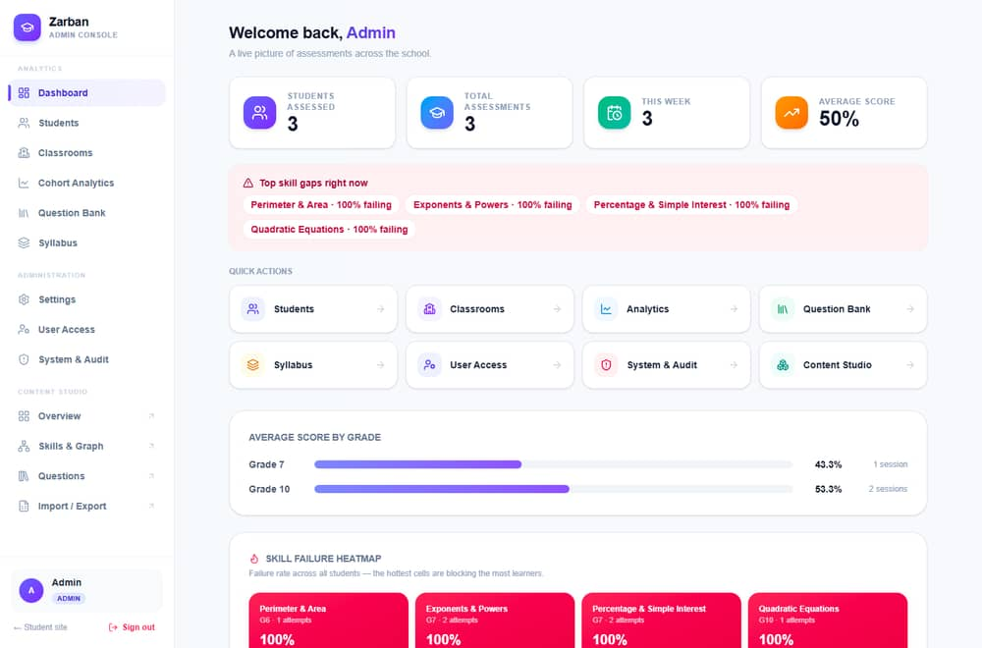
Figure — The role-scoped admin command center (/admin).
Roles are stored in AdminUser.role and enforced by requireRole(min) / requireContentRole() in src/lib/auth.ts. Ranking for analytics access: Admin > Teacher > Viewer; Editor is the content role. Students are unauthenticated (a Student row is created at assessment start).

4.1 Role details
- Admin — full reach. Responsibilities: manage everything. Accessible modules: all (Analytics, Administration, Content Studio, Database manager, System & Audit). Restricted: none. Main actions: create/modify staff & roles, edit content, run maintenance, manage the database. Errors: destructive actions require a typed confirmation phrase.
- Teacher — analytics + monitoring. Accessible: Analytics group (Dashboard, Students, Classrooms, Analytics, Question Bank read, Syllabus). Restricted: Administration (Settings, Users, System, Database) and Content authoring writes. Actions: view cohorts, drill into students, scope to own classrooms via the "Mine" filter.
- Viewer — read-only analytics. Accessible: Analytics views (read). Restricted: all writes, Administration, Content authoring. Errors: write attempts return HTTP 403 (verified by the e2e suite).
- Editor — content authoring. Accessible: Content Studio (skills, questions, curriculum, syllabus, import/export). Restricted: Administration and learner-analytics writes.
- Student (unauthenticated) — takes assessments and practice; views own report by session id. No login; identified by Student row + localStorage session handle.

4.2 Role-permission matrix
Module / action | Admin | Teacher | Viewer | Editor | Student
Take assessment / practice | – | – | – | – | ✅
View own report | – | – | – | – | ✅ (by session id)
Dashboard / analytics (read) | ✅ | ✅ | ✅ | ❌ | ❌
Students / classrooms (read) | ✅ | ✅ | ✅ | ❌ | ❌
Classrooms (write) | ✅ | ❌ | ❌ | ❌ | ❌
Question bank (read) | ✅ | ✅ | ✅ | ✅ | ❌
Content authoring (write) | ✅ | ❌ | ❌ | ✅ | ❌
Settings | ✅ | ❌ | ❌ | ❌ | ❌
User Access (staff/roles) | ✅ | ❌ | ❌ | ❌ | ❌
System & Audit / maintenance | ✅ | ❌ | ❌ | ❌ | ❌
Database manager | ✅ | ❌ | ❌ | ❌ | ❌

Derived from the guards in the API routes and the canSee(access, role) nav filter in src/app/admin/layout.tsx. Fine-grained per-route enforcement is the source of truth; the matrix summarizes it.

5. Complete Feature List (module-wise)
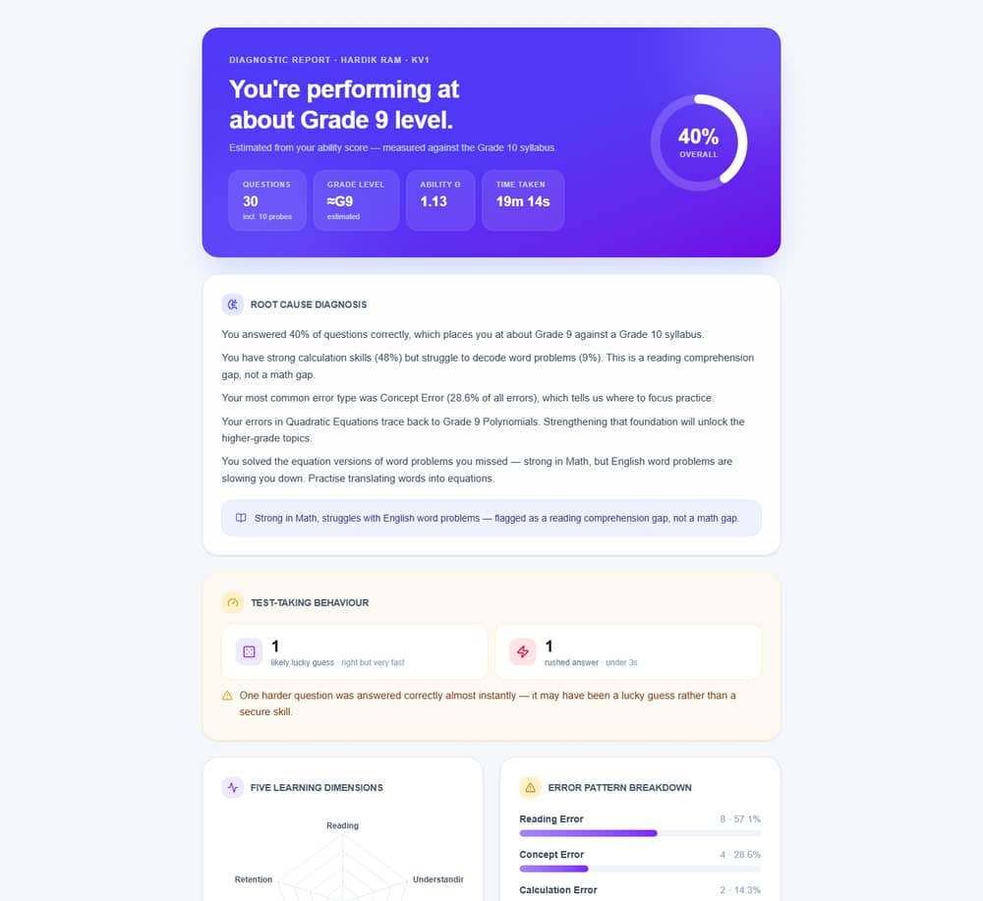
Figure — The diagnostic report (/report/).
Below, each feature notes the page/route, the primary user, processing, and DB tables. Small UI features (search, filters, pagination, validation, states) are covered in §5.9.

5.1 Student — Assessment (/assessment, POST /api/session/start, POST /api/session/respond, POST /api/session/finish)
- Purpose: run an adaptive diagnostic test. User: student.
- Preconditions: a grade selected (5–10) and a name on the landing page.
- Processing:startSession creates an AssessmentSession, serves the first question; each answer flows through processResponse (the master loop, §21). Tables:sessions, responses, bkt_state, traversal_events, review_flags, questions, answer_traps.
- Output: the next question, or session completion. Success: a served ServedQuestion or done:true. Failure: "Session not found" (404), "Question not found" (404).
- Edge cases: twin-probe missing question, skill exhausted (falls back a grade/band), timer expiry, refresh mid-test (resumes from localStorage).

5.2 Student — Diagnostic report (/report/[sessionId], GET /api/session/report/[sessionId], PDF at …/pdf)
- Purpose: explain results (grade equivalent, root cause, behaviour flags, dimensions, error patterns). User: student/teacher.
- Processing:generateReport(sessionId) aggregates the session. PDF variant renders via pdfkit (src/lib/pdf/report-pdf.ts, noto-font.ts). Tables:sessions, responses, questions, bkt_state, answer_traps, dimension_scores, traversal_events, review_flags, skills.
- Output: JSON report / downloadable PDF.

5.3 Student — Detailed analysis (/report/[sessionId]/analysis)
- Purpose: replay the session — θ journey, adaptive path, time-per-question. Data: same session aggregate + engineDecision snapshots on each Response.

5.4 Student — Practice (/practice, GET /api/practice)
- Purpose: drill any skill; instant feedback with the correct answer + traps. User: student. Tables:questions, skills, answer_traps.

5.5 Student — Learning hub (/learn, GET /api/learn/[studentId])
- Purpose: per-device progress (score trend, mastery, what to practise next). Empty state: "No progress yet on this device." Tables:sessions, responses, bkt_state.

5.6 Admin/Teacher — Console
- Dashboard (/admin, GET /api/admin/stats): totals, top skill gaps, quick actions, avg score by grade, failure heatmap.
- Cohort Analytics (/admin/analytics): performance trend, error types, prerequisite-gap tracker.
- Students (/admin/students, [studentId]): list, search, per-student drill-down; PATCH assigns a classroom.
- Classrooms (/admin/classrooms): CRUD rosters; assign a teacher; add/remove students; teacher "Mine" scoping.
- Question Bank (/admin/questions): filter/search/edit/delete; add; POST /api/admin/import for Excel.
- Syllabus (/admin/syllabus): NCERT textbooks/chapters by grade (read).
- Session replay (/admin/sessions/[sessionId], …/replay): step through an engine's decisions.
- User Access (/admin/users): staff CRUD + role changes (Admin only).
- Settings (/admin/settings): max_questions, test_timer_minutes.
- System & Audit (/admin/system): data snapshot, danger-zone maintenance (typed confirmation), audit log.
- Database manager (/admin/database): browse/search/edit/delete every table (Admin only, §7 of the technical handover).

5.7 Content Studio (Editor/Admin)
- Overview/health (/content, GET /api/content/overview): coverage grid + health issues via src/lib/content/health.ts.
- Skills & Graph (/content/skills): interactive knowledge graph; skill CRUD.
- Questions (/content/questions): authoring; validation via src/lib/content/question-validate.ts.
- Curriculum (/content/curriculum): subjects/topics/textbooks CRUD.
- Syllabus (/content/syllabus): grade-organized view.
- Import/Export (/content/import, GET /api/content/export, POST /api/content/import): Excel workbooks via xlsx (src/lib/excel/).

5.8 Authentication & session
- Login (/admin/login, /content/login → POST /api/admin/auth/login), logout (POST /api/admin/auth/logout), identity (GET /api/admin/auth/me, GET /api/content/me). Cookie zarban_admin (HttpOnly, Secure, SameSite=Lax). Password hashing bcrypt. Session = stateless JWT (12h max-age).

5.9 Cross-cutting small features
- Search: question bank (text/id), Database manager (all-column LIKE), students.
- Filters: questions by grade/skill/difficulty/type; classrooms "All/Mine".
- Pagination: Database manager (page/pageSize up to 200), audit log (limit).
- Form validation: login required fields; question validation; textbook pdfUrl URL check (e2e asserts 400 on invalid).
- Dropdowns / grade tabs: class 5–10 selector; syllabus grade tabs.
- Buttons/confirmation: typed-phrase confirmation on destructive maintenance and DB row delete.
- Notifications/toasts: transient success/error toasts across admin pages.
- File uploads: Excel import (.xlsx) parsed by src/lib/excel/parser.ts.
- Data exports: Excel workbook export; PDF report export.
- Empty/loading/error states: skeleton loaders on data pages; empty states (e.g. "No classrooms yet", "No progress yet"); inline error banners.
- Duplicate handling:Student.email unique (reused on re-registration in session/start); Subject.name, AdminUser.email, Setting.key unique; AnswerTrap (questionId, optionLabel) unique.

6. Functional Requirements
ID | Name | Role | Trigger | Main flow | Validation | Acceptance criteria | Module
FR-001 | Start assessment | Student | Submit name+grade | Create session → serve Q1 | name required; grade clamped 5–10 | Session id + first question returned | session/start
FR-002 | Submit answer & adapt | Student | Pick option / key A–D | processResponse  grades, updates IRT/BKT, routes next | session_id, question_id, option required | Correct next question or  done | session/respond
FR-003 | End on termination | System | max Q / timer / mastery / topics exhausted | endSession  sets  completed  , computes dimensions | — | status=completed  , report available | orchestrator
FR-004 | View report | Student/Teacher | Open  /report/:id | generateReport  aggregates | valid session id | Report renders; 404 if unknown | session/report
FR-005 | Export report PDF | Student/Teacher | Open  …/pdf | pdfkit  render | valid session id | PDF downloads | session/report/[id]/pdf
FR-006 | Practice a skill | Student | Open  /practice?skill= | Serve skill items + answers | — | Instant feedback per answer | practice
FR-007 | Admin login | Staff | Submit credentials | bcrypt verify → JWT cookie | email+password required | Cookie set; role in token | admin/auth/login
FR-008 | RBAC enforcement | All staff | Any admin route | requireRole  /  requireContentRole | valid JWT + sufficient role | 401 unauth / 403 forbidden | lib/auth
FR-009 | Dashboard stats | Analytics roles | Open  /admin | Aggregate counts + heatmap | role ≥ Viewer | Tiles/heatmap populated | admin/stats
FR-010 | Cohort analytics | Analytics roles | Open  /admin/analytics | Trends + error types + gaps | role ≥ Viewer | Charts populated | admin/analytics
FR-011 | Manage students | Admin/Teacher | Students page | List/search; assign classroom | — | Student list; PATCH updates classroom | admin/students
FR-012 | Manage classrooms | Admin | Classrooms page | CRUD + roster + teacher | name required | Classroom created; roster updated | admin/classrooms
FR-013 | Manage question bank | Admin/Editor | Questions page | CRUD; filter; import | question fields valid | Item saved | admin/questions  ,  content/questions
FR-014 | Manage skills & graph | Editor/Admin | Skills page | CRUD skills; parse prereqs | skill fields valid | Skill saved; graph updates | content/skills
FR-015 | Manage curriculum | Editor/Admin | Curriculum page | CRUD subjects/topics/textbooks | pdfUrl  valid URL | Item saved; 400 on bad URL | content/curriculum
FR-016 | Excel import/export | Editor/Admin | Import/Export | Parse/emit  .xlsx | file type  .xlsx | Workbook imported/exported | content/import  ,  content/export
FR-017 | Settings | Admin | Settings page | Upsert clamped values | 5≤maxQ≤100; 0≤timer≤180 | Values persisted; cache invalidated | admin/settings
FR-018 | Data maintenance | Admin | System page | Typed-phrase gated deletes | phrase must match | Rows purged; audit written | admin/maintenance
FR-019 | Audit log | Admin | System page | Read append-only log | role Admin | Entries listed | admin/audit
FR-020 | Database manager | Admin | Database page | List/browse/edit/delete tables | table/col whitelisted | Rows editable; injection rejected | admin/db
FR-021 | Session replay | Admin | Session page | Reconstruct decisions | valid session id | Ordered decisions shown | admin/sessions/[id]/replay

Each FR's alternate/exception flows are the error states in §23 and edge cases in §24. Inputs/outputs/processing are detailed per-endpoint in §13.

7. Non-Functional Requirements
Category | Implemented | Evidence / Notes
Performance | ✅ | Round-trip reduction + in-isolate cache; measured medians in §31.
Response time | ✅ | Assessment answer ~280–340 ms; dashboard ~170 ms (production, measured).
Scalability | Partial | Cloudflare Workers scale horizontally by design; D1 is single-primary.
Reliability | ✅ | 136 e2e checks; deterministic engine.
Availability | Partial | Cloudflare edge; no formal SLA configured.  Info not available.
Maintainability | ✅ | Typed schema/client; modular engine; scripts.
Portability | Partial | Schema notes PostgreSQL compatibility; runtime is Cloudflare-specific.
Compatibility | ✅ | Modern evergreen browsers (React 19).
Accessibility | Partial | Focus-visible rings, semantic HTML; no formal WCAG audit.  Recommendation:  audit to WCAG 2.1 AA.
Usability | ✅ | Skeletons, transitions, empty/error states.
Security | ✅/Partial | RBAC, bcrypt, HttpOnly cookie, audit, parameterized SQL. Gaps in §25.
Privacy | Partial | Minimal PII (name/email/school). No privacy policy artifact.  Info not available.
Data integrity | ✅ | FK constraints + cascade rules (§14).
Backup & recovery | ❌ | No automated backup configured.  Recommendation:  scheduled D1 export.
Auditability | ✅ | AdminAuditLog  append-only trail.
Logging | Partial | console.error  on failures; no aggregation.  Recommendation:  structured logs + sink.
Monitoring | ❌ | No monitoring/alerting configured.  Info not available.  Recommendation:  Workers analytics + alerts.
Browser compat | ✅ | Evergreen browsers.
Device responsive | ✅ | Tailwind responsive layout.
Localization | ❌ | English only.

8. Complete System Architecture
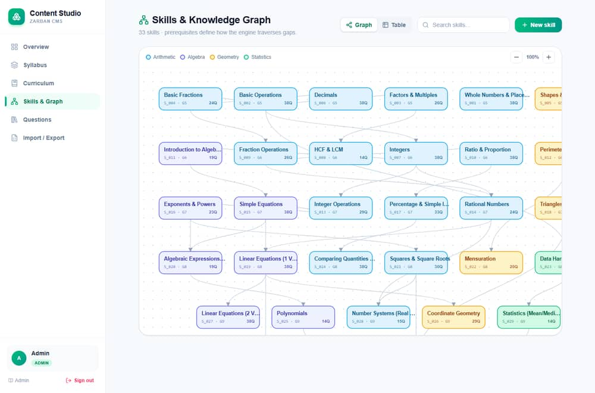
Figure — The skills knowledge graph the engine traverses.

8.1 Layers
- Client layer: browser (student site + admin console), React 19 client components, localStorage for in-progress test state.
- Presentation layer: Next.js pages (src/app/**/page.tsx), Tailwind styling, Recharts charts, lucide-react icons.
- Application/API layer: Next.js route handlers (src/app/api/**/route.ts) running in the Worker.
- Business-logic layer:src/lib/engine/* (adaptive engine), src/lib/content/*, src/lib/curriculum/*, src/lib/excel/*, src/lib/pdf/*.
- Authentication layer:src/lib/auth.ts (jose JWT, bcrypt, guards), src/lib/audit.ts.
- Data-access layer:src/lib/db.ts — lazy Prisma client over the D1 binding; src/lib/admin/db-admin.ts for generic raw access.
- Database layer: Cloudflare D1 (SQLite), 20 tables.
- Storage layer: no blob storage; PDFs generated on the fly; Excel parsed in-memory. No object store configured.
- Integration/external layer:No third-party runtime integrations (see §22). NCERT textbook links are external URLs only.
- Deployment infra: Cloudflare Workers + D1; build via vinext/Vite; deploy via wrangler.
- Monitoring/logging: minimal (console.error). Info not available on external monitoring.

8.2 Patterns & rationale
- Architectural pattern: layered, serverless edge (single Worker serving SSR pages + API). Chosen for edge latency, free tier, and one deploy artifact.
- Design patterns: lazy Proxy for the DB client (deferred binding); strategy-like routing in the orchestrator; repository-ish access via Prisma; guard/middleware via requireRole.
- Request–response cycle: browser → Worker route handler → guard → business logic → Prisma → D1 → response.
- Failure handling: try/catch per handler returning typed JSON errors + status; engine throws "not found" → mapped to 404; one silent client retry on the assessment submit.

8.3 Architecture diagram
%% Diagram (Mermaid source — renders in the Markdown/GitHub copy) flowchart TD subgraph Client Stu[Student Browser] Adm[Admin/Editor Browser] end subgraph Cloudflare_Worker[Cloudflare Worker · Next.js/vinext] Pages[SSR Pages · RSC] API[API Route Handlers] Auth[Auth Guard · jose JWT + bcrypt] Engine[Adaptive Engine · IRT/BKT/CDM/DKT] Content[Content/Curriculum/Excel/PDF libs] DBc[Prisma Client · lazy Proxy] Cache[In-isolate TTL cache] end D1[(Cloudflare D1 · SQLite · 20 tables)] Stu --> Pages Adm --> Pages Pages --> API Stu -->|fetch| API Adm -->|fetch| API API --> Auth API --> Engine API --> Content Engine --> Cache Engine --> DBc Content --> DBc Auth --> DBc DBc --> D1 Cache -.seeds from.-> DBc
Explanation. Both browsers talk to one Worker. Pages render server-side; interactive actions call API handlers. Every privileged handler passes through the auth guard. The engine and content libraries hold business logic and reach D1 through the lazy Prisma client; near-static reads are served from an in-isolate cache to cut round trips.

9. Technology Stack
Layer | Technology | Version | Purpose | Reason for selection
Framework | Next.js | 16.2.6 | UI + API + SSR/RSC | One codebase; file routing; server components
UI runtime | React / React-DOM | 19.2.6 | Component model | Current React; RSC support
Language | TypeScript | ^5.9.2 | Types across engine + app | Safety for complex engine state
Styling | Tailwind CSS | 4.2.1 | Design system | Consistency without CSS sprawl
Charts | Recharts | ^3.2.1 | Report/analytics charts | Declarative React charts
Icons | lucide-react | ^1.25.0 | Iconography | Consistent icon set
ORM | Prisma (+ @prisma/adapter-d1) | 6.19.3 | Typed data access to D1 | Typed client; D1 driver adapter
Database | Cloudflare D1 (SQLite) | — | Persistence | Serverless edge SQLite, free tier
Build/host | vinext + @cloudflare/vite-plugin + Vite | 0.0.50 / 1.37.1 / 8.0.13 | Compile Next.js → Worker | Edge deploy target
Deploy CLI | wrangler | 4.92.0 | D1 + deploy | Official Cloudflare CLI
Auth | jose | ^6.0.11 | JWT sign/verify | Web-Crypto, Workers-safe
Hashing | bcryptjs | ^3.0.2 | Password hashing | Pure-JS, Workers-safe
PDF | pdfkit (+ @types/pdfkit) | ^0.19.1 | Report PDF export | Programmatic PDF in JS
Spreadsheet | xlsx | ^0.18.5 | Excel import/export | Ubiquitous  .xlsx  handling
Testing | Vitest | 4.0.17 | Unit tests | Vite-native test runner
Scripting | tsx | ^4.20.5 | Run TS scripts (e2e, seed, generate) | Zero-config TS execution

Per-technology notes (selected).
- Prisma + adapter-d1 — used in src/lib/db.ts; solves typed DB access on D1; alternatives: Drizzle (the migration SQL folder is named drizzle/ but the runtime ORM is Prisma), raw D1. Limitation: D1 SQL subset (e.g. compound-SELECT term cap, §7 of handover). Config: DATABASE_URL for local; the DB binding for the Worker.
- jose — src/lib/auth.ts; signs/verifies the session JWT; chosen over jsonwebtoken (native crypto unavailable on Workers).
- bcryptjs — uses compareSync/hashSync (Workers-safe); alternative bcrypt (native) unavailable on Workers.
- pdfkit — src/lib/pdf/report-pdf.ts with an embedded Noto font (noto-font.ts) for Unicode.
- xlsx — src/lib/excel/parser.ts + importer.ts for the content workbook.

10. Project Folder & Code Structure
Zarban/ ├── prisma/schema.prisma # 20-model relational schema (source of truth) ├── drizzle/0000_initial.sql # generated schema+seed for remote D1 (6,680 stmts) ├── src/ │ ├── app/ # Next.js App Router │ │ ├── (student pages) # assessment, practice, learn, report/[id]/analysis │ │ ├── admin/ # console pages (dashboard, analytics, students, …, database, system) │ │ ├── content/ # Content Studio pages (skills, questions, curriculum, syllabus, import) │ │ └── api/ # 46 route handlers (admin/*, content/*, session/*, learn, practice) │ ├── lib/ │ │ ├── db.ts # lazy Prisma client over D1 binding │ │ ├── auth.ts # JWT + bcrypt + RBAC guards │ │ ├── audit.ts # append-only audit writer │ │ ├── engine/ # IRT, BKT, CDM, DKT, orchestrator, fetch-question, report, cache… │ │ ├── admin/db-admin.ts # generic table introspection + parameterized CRUD │ │ ├── content/ # health, question/skill helpers + validation │ │ ├── curriculum/ # NCERT data, syllabus builder, subject blurbs │ │ ├── excel/ # xlsx parser + importer │ │ └── pdf/ # pdfkit report + embedded font │ └── generated/prisma/ # generated Prisma client (do not edit) ├── scripts/ # e2e.ts, seed*.ts, generate/verify-workbook.ts, export-d1-migration.py, patch-d1.mjs ├── tests/ # Vitest unit tests ├── docs/ # documentation + screenshots + guide ├── public/ # static assets ├── package.json / wrangler(build config via vinext) / vite.config.ts / tsconfig.json
Classification:prisma/ = data; src/app/**/page.tsx = UI; src/app/api/** = application/API; src/lib/** = business logic/config; scripts/ = tooling; tests/ = test; drizzle/ + scripts/patch-d1.mjs = deployment/data. Engine files are explained in §21; DB in §14.

11. Frontend Explanation
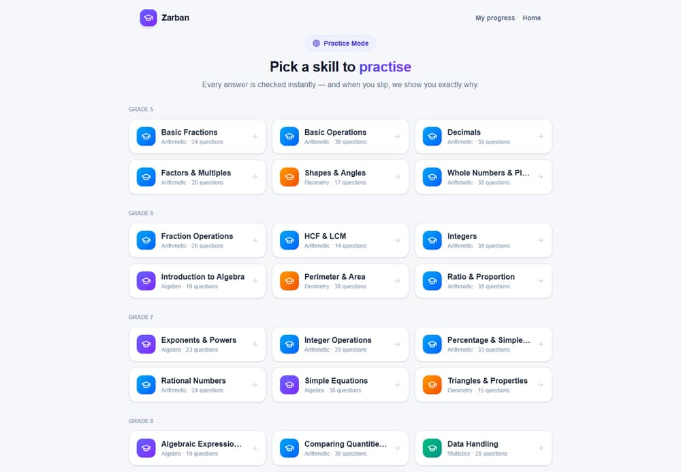
Figure — Practice mode (/practice).
- Entry / shells: student pages render standalone; the admin console uses src/app/admin/layout.tsx (sidebar + auth guard via GET /api/admin/auth/me); Content Studio pages sit under src/app/content/.
- State management: React hooks + localStorage (assessment in-progress state zarban_assessment); no global store (no Redux/Zustand present).
- API calls:fetch to the route handlers; JSON.
- Auth handling: cookie-based; the admin layout redirects to /admin/login on 401.
- Validation: client checks (required fields, option selection) + server validation.
- Loading/error/empty states: skeleton loaders (.skeleton), inline error banners, empty-state cards.
- Responsive/styling: Tailwind utilities; theme-aware components; page cross-fade templates.
- Charts/tables: Recharts (report, analytics); HTML tables (question bank, DB manager, audit).
- Search/filter/sort/pagination: question bank filters; DB-manager search + pagination.

11.1 Key screens (selected)
Screen | Purpose | Roles | Key elements | Primary API
/  Landing | Start a test | Student | name/school/grade, Start | session/start
/assessment | Take test | Student | question card, A–D, timer, progress | session/respond
/report/[id] | Diagnosis | Student/Teacher | gauge, root-cause, behaviour, dimensions | session/report/[id]
/report/[id]/analysis | Replay | Student/Teacher | θ chart, path grid, time chart | (same session data)
/practice | Drill | Student | skill grid, runner | practice
/admin/login | Sign in | Staff | email, password | admin/auth/login
/admin | Dashboard | Analytics roles | tiles, gaps, heatmap | admin/stats
/admin/analytics | Cohorts | Analytics roles | 3 charts | admin/analytics
/admin/database | DB manager | Admin | table list, grid, edit/delete | admin/db*
/content/skills | Graph | Editor/Admin | SVG graph, detail panel | content/skills*

Full screen-by-screen coverage is in §18. Information not available in the supplied project files for exact pixel-level layouts beyond the captured screenshots in docs/screenshots/.

12. Backend Explanation
- Startup/config: the Worker boots from the vinext build; the D1 DB binding is injected per request; src/lib/db.ts constructs the Prisma client lazily.
- Routes/controllers: each src/app/api/**/route.ts exports HTTP handlers; they parse input, run a guard, call a lib function, and return JSON.
- Services/models:src/lib/engine/* (assessment), src/lib/content/* (authoring), Prisma models = data models.
- Middleware/auth/authz:requireRole/requireContentRole (called at the top of each handler; there is no Next.js middleware.ts global — auth is per-handler).
- Business logic: orchestrator (§21), report generator, content health, syllabus builder.
- Validation:src/lib/content/question-validate.ts, src/lib/validate-question.ts, settings clamps, URL checks.
- Exception handling: try/catch → NextResponse.json({error}, {status}).
- Logging:console.error on failure paths.
- Background jobs: none at runtime. Content generation is offline scripts.
- File processing: Excel (xlsx) import/export; PDF (pdfkit) generation.
- DB connection: via the D1 binding; no connection pool (edge model).
- Env vars:AUTH_SECRET (JWT), DATABASE_URL (local), the DB binding (Worker). See §29.

13. API Documentation
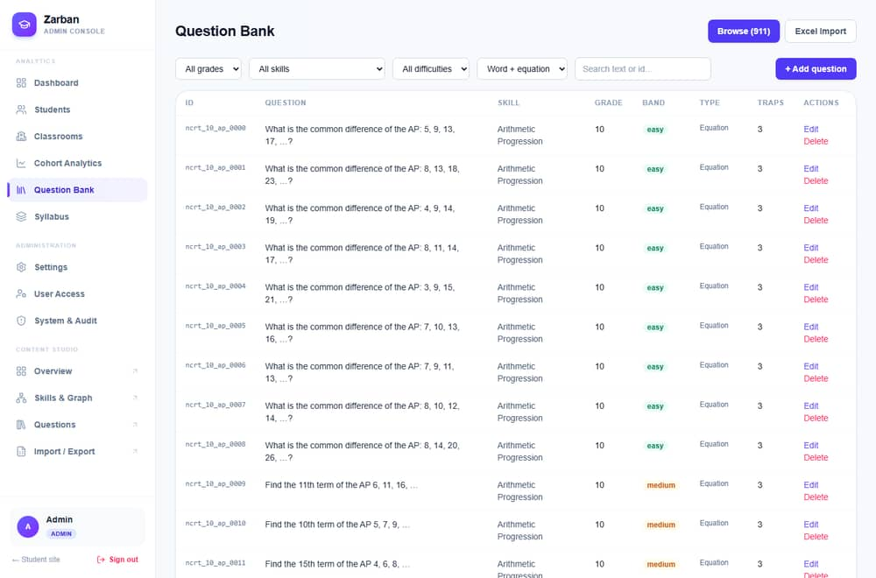
Figure — The question bank (/admin/questions).
46 handlers. All admin/content routes require the zarban_admin JWT cookie and a sufficient role; session/practice/learn are public (student-facing). Common error shape: { "error": "message" } with an appropriate status. Representative endpoints below; the rest follow the same conventions.

API: Start session
- Endpoint:/api/session/start · Method: POST · Auth: none.
- Body:{ name, school?, email?, grade }. Validation:name required; grade clamped to 5–10.
- Processing: reuse student by email if present, else create; startSession → first question. DB:students (read/create/update), sessions (create), questions/answer_traps (read).
- Success 200:{ student_id, session_id, step:{ question, … } }. Errors: 400 "Name is required"; 500 on engine failure.

API: Submit response
- Endpoint:/api/session/respond · Method: POST · Auth: none.
- Body:{ session_id, question_id, selected_option, response_time_ms? }. Validation: the three ids/option required.
- Processing:processResponse (grade → CDM → BKT → DKT → IRT → route → persist → serve). DB: many (see §5.1).
- Success 200:{ step:{ done?, question?, decision, bkt?, theta? } }. Errors: 404 "Session/Question not found"; 500.

API: Get report / PDF
- Endpoint:/api/session/report/[sessionId] (GET) and …/pdf (GET) · Auth: none.
- Processing:generateReport; PDF via pdfkit. Success: JSON report / application/pdf. Errors: 404 if unknown session.

API: Admin login
- Endpoint:/api/admin/auth/login · Method: POST · Auth: none (issues auth).
- Body:{ email, password }. Processing:bcrypt.compareSync → jose sign → Set-Cookie zarban_admin (HttpOnly, Secure, SameSite=Lax, Max-Age 43200). Success 200:{ user }. Errors: 400 missing; 401 invalid.

API: Database manager (Admin)
- /api/admin/db (GET): list tables + counts.
- /api/admin/db/[table] (GET/PATCH/DELETE): page/search rows; update/delete a row by rowid. Security: table/column whitelisted vs live schema; values parameterized; every write audited (db.update_row/db.delete_row). Errors: 400 "Unknown table" on injection attempt; 401 without Admin.

API: Settings (Admin)
- /api/admin/settings (GET/PUT): read/upsert max_questions (5–100) and test_timer_minutes (0–180); PUT invalidates the settings cache and writes an audit entry.
Remaining endpoints (students, classrooms, questions, skills, curriculum subjects/topics/textbooks, analytics, stats, audit, maintenance, import/export, replay, learn, practice, me, logout) follow identical patterns: guard → validate → Prisma op → typed JSON. Full per-field request/response schemas beyond the above are derivable from the route files; exhaustive body schemas for all 46 are not restated here to keep this document navigable — the source route handlers are authoritative.

13.1 Sequence — submit an answer
%% Diagram (Mermaid source — renders in the Markdown/GitHub copy) sequenceDiagram actor S as Student participant UI as Assessment Page participant API as /api/session/respond participant ENG as Orchestrator participant DB as D1 S->>UI: pick option A–D UI->>API: POST {session_id, question_id, option, time} API->>ENG: processResponse(...) ENG->>DB: read session + question (parallel) ENG->>DB: upsert BKT, propagate DKT ENG->>DB: read history, recompute θ ENG->>DB: create Response, update Session (parallel) ENG->>DB: fetch next question ENG-->>API: StepResult (next Q or done) API-->>UI: {step} UI-->>S: render next question / go to report

14. Database Design
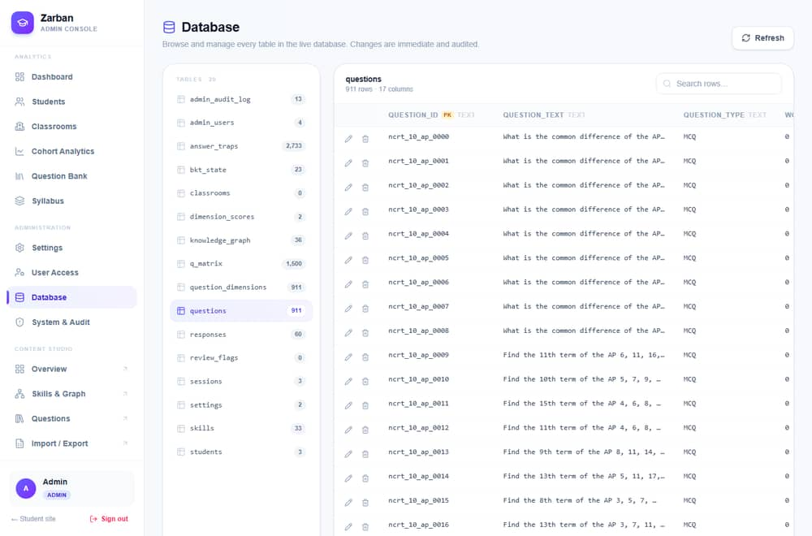
Figure — The Database manager (/admin/database).
Technology: Cloudflare D1 (SQLite dialect). Purpose: relational store for curriculum, learners, sessions, engine state, and ops. 20 tables (snake_case via Prisma @map). Audit fields: created_at/started_at/responded_at/last_updated defaults. Soft-delete: none — deletes are hard, with FK cascade. Backup: none configured (Recommendation: scheduled wrangler d1 export). Retention: indefinite; a "reset learner history" maintenance action exists.

14.1 Key tables (columns → type · constraint · purpose)
skills — assessable math skills (engine topics).
Column | Type | Constraint | Purpose
skill_id | String | PK | Stable skill code (e.g. S_016)
skill_name | String | not null | Display name
grade_level | String? | — | Grade(s), e.g. "9-10"
topic_area | String? | — | Arithmetic/Algebra/Geometry/Statistics
difficulty_band | String? | — | Baseline band
prerequisite_skill_ids | String? | — | Raw CSV (parsed into graph)

questions — item bank. PK question_id; FKs primary_skill_id→skills, equation_twin_id→questions (self, twin); IRT irt_a/b/c (defaults 1.0/0.0/0.25); indexes (primary_skill_id, grade_level, difficulty_band) and (grade_level, difficulty_band).
answer_traps — misconception mapping per wrong option. PK id (autoincrement); FK question_id; unique (question_id, option_label); trap_type, remedial_action, remedial_skill_id, remedial_grade.
knowledge_graph — prerequisite edges. Composite PK (child_skill_id, parent_skill_id); both FK→skills (cascade); index (parent_skill_id).
sessions (AssessmentSession) — a test attempt. PK session_id (uuid); FK student_id; engine state (current_theta, current_skill_id, consecutive_correct/failures, twin_probe_pending, bands_served, visited_skills, return_skill_id, max_questions); status (in_progress|completed), termination_reason; index (student_id).
responses — one row per answered item. PK response_id; FKs session_id(cascade), question_id; snapshot fields for replay (served_*, engine_decision, theta_after, p_mastery_after, response_time_ms); index (session_id).
bkt_state — mastery per student×skill. Composite PK (student_id, skill_id); p_mastery (default 0.10), attempts.
dimension_scores — per-session five-dimension percentages (PK session_id).
traversal_events, review_flags — prerequisite-traversal log and teacher review flags (FK session_id, cascade).
students — PK student_id (uuid); email unique; FK classroom_id→classrooms (SetNull); index (classroom_id).
classrooms — PK classroom_id; FK teacher_id→admin_users (SetNull); index (teacher_id).
admin_users — PK id; email unique; password_hash; role (default Viewer).
subjects / topics / textbooks — NCERT curriculum catalog; subjects.name unique; textbooks.pdf_url (external soft-copy link); indexes on grade.
settings — PK key, value. admin_audit_log — append-only; index (created_at).

14.2 Relationships
- One-to-many: Skill→Question (primarySkill), Session→Response, Student→Session, Student→BktState, Subject→Topic, Subject→Textbook, Classroom→Student, AdminUser→Classroom (teacher).
- One-to-one: Session→DimensionScore; Question→QuestionDimension.
- Many-to-many: Question↔Skill via q_matrix (secondary skills); Skill↔Skill via knowledge_graph (prereq graph).
- Self-reference: Question→Question (equation_twin_id).
- Cascade: deleting a Session cascades to responses/dimension_scores/traversals/review_flags; deleting a Student cascades to sessions + bkt_state; deleting a Question cascades to traps/q_matrix/dimensions.

14.3 ER diagram (core)
%% Diagram (Mermaid source — renders in the Markdown/GitHub copy) erDiagram SKILL ||--o{ QUESTION : "primary skill" SKILL ||--o{ KNOWLEDGE_GRAPH : "edges" QUESTION ||--o{ ANSWER_TRAP : "traps" QUESTION ||--o{ Q_MATRIX : "secondary skills" QUESTION ||--o| QUESTION_DIMENSION : "dimensions" STUDENT ||--o{ SESSION : takes STUDENT ||--o{ BKT_STATE : masters CLASSROOM ||--o{ STUDENT : rosters ADMIN_USER ||--o{ CLASSROOM : teaches SESSION ||--o{ RESPONSE : records SESSION ||--o| DIMENSION_SCORE : scores SESSION ||--o{ TRAVERSAL_EVENT : logs QUESTION ||--o{ RESPONSE : answered SUBJECT ||--o{ TOPIC : has SUBJECT ||--o{ TEXTBOOK : has SKILL { string skill_id PK } QUESTION { string question_id PK string primary_skill_id FK } SESSION { string session_id PK string student_id FK string status } RESPONSE { int response_id PK string session_id FK bool is_correct } BKT_STATE { string student_id PK string skill_id PK float p_mastery } STUDENT { string student_id PK string email } ADMIN_USER { int id PK string email string role }

15. Data Flow

15.1 Context diagram
%% Diagram (Mermaid source — renders in the Markdown/GitHub copy) flowchart LR Student((Student)) -->|answers| Zarban[Zarban System] Staff((Teacher/Admin/Editor)) -->|manage/monitor| Zarban Zarban -->|report / analytics| Student Zarban -->|dashboards / exports| Staff Zarban <-->|read/write| D1[(D1 Database)]

15.2 Level-1 (assessment)
%% Diagram (Mermaid source — renders in the Markdown/GitHub copy) flowchart TD A[Enter name+grade] --> B[Client validation] B --> C[/POST session/start/] C --> D[Create session · serve Q] D --> E[Render question] E --> F[Pick option] F --> G[/POST session/respond/] G --> H{Grade + engine} H --> I[Update IRT/BKT/DKT · persist] I --> J{Terminate?} J -- no --> K[Serve next Q] --> E J -- yes --> L[Complete · dimension scores] L --> M[/GET report/] --> N[Render diagnosis]
Explanation. Input is validated client-side, sent to the API, processed by the engine (which reads/writes D1), and either loops to the next question or terminates into a report. Logging is console.error on failures; notifications are client toasts; exports are the PDF/Excel endpoints.

16. Complete Workflow
%% Diagram (Mermaid source — renders in the Markdown/GitHub copy) flowchart TD Start([Open site]) --> Role{Student or Staff?} Role -- Student --> S1[Landing: name+grade] --> S2[Adaptive test loop] S2 --> S3{End condition?} S3 -- no --> S2 S3 -- yes --> S4[Diagnostic report] --> S5[Practice gaps] --> End1([Done]) Role -- Staff --> L1[/admin/login/] --> L2{Valid creds?} L2 -- no --> L1e[401: retry] --> L1 L2 -- yes --> L3[JWT cookie · role] L3 --> M{Role} M -- Analytics --> D1[Dashboard/analytics/students] M -- Editor --> C1[Content Studio] M -- Admin --> A1[All + DB manager + System] D1 --> Logout([Logout / 12h expiry]) C1 --> Logout A1 --> Logout
End/expiry: the JWT max-age is 12h; logout clears the cookie. Error recovery: invalid login re-prompts; engine "not found" → 404; destructive actions require a typed phrase.

17. Detailed User Walkthrough (with realistic data)
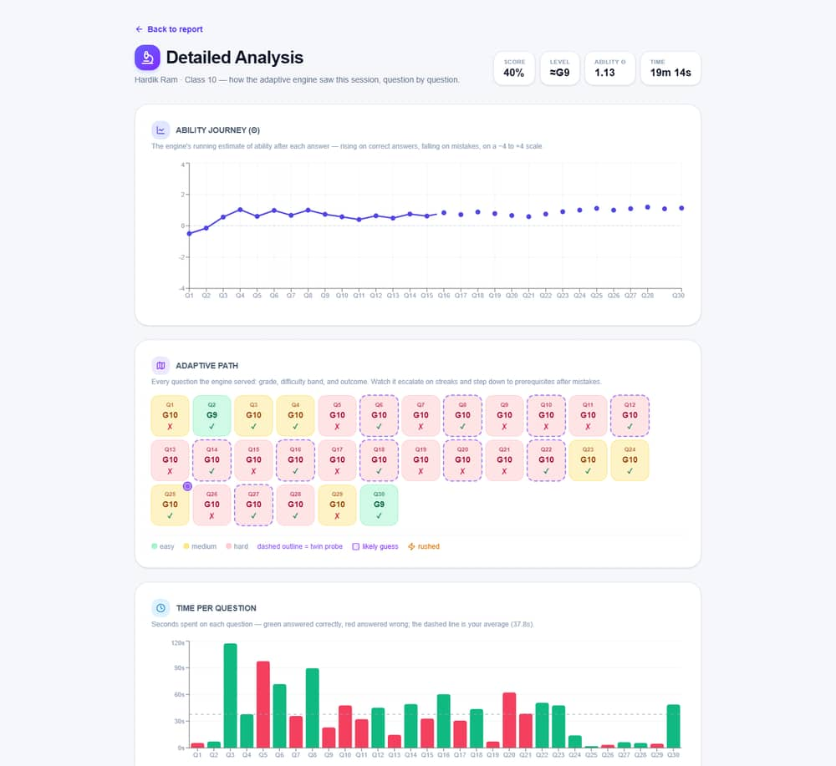
Figure — Detailed session analysis (/report//analysis).

17.1 Student (Aarav, Class 8)
- Sees: landing hero + start card. Enters: name "Aarav", school "DAV", class 8. Validation: name required, grade clamped. Internally:POST /api/session/start creates Student + AssessmentSession; reads questions. Result: first question appears.
- Sees: a question with A–D. Clicks: an option (or presses B). Internally:POST /api/session/respond → processResponse updates bkt_state, responses, sessions; fetches next. Result: next question; on a wrong word-problem, a twin equation may appear. On error: one silent retry, then an inline banner.
- Continues ~20–30 items until termination. Internally:endSession sets status=completed, writes dimension_scores. Result: redirect to /report/<id>.
- Sees: grade estimate, root-cause diagnosis, behaviour flags. Clicks: "Detailed analysis" → θ journey + path grid. Optionally: downloads the PDF (…/pdf).
- Next: opens /practice, picks a flagged skill, drills with instant feedback.

17.2 Admin (staff)
- Opens/admin/login, enters admin@zarban.local / admin123. Internally: bcrypt verify → JWT cookie. On error: 401 "Invalid credentials".
- Dashboard loads (/api/admin/stats): tiles, top gaps, heatmap.
- Students → open one: per-student mastery drill-down; assign a classroom (PATCH /api/admin/students/[id]).
- Question Bank: filter by grade/skill; edit an item; or Import an .xlsx.
- Database manager: open questions, search "AP", edit a row (PATCH /api/admin/db/questions) — audited.
- System & Audit: review the audit log; if needed, run a maintenance reset (type the phrase).
- Logout clears the cookie.

17.3 Editor
Signs in (Editor), opens Content Studio → Skills & Graph, adds a skill (prereqs parsed into knowledge_graph), authors a question (validated), and exports the workbook. Restricted: no Administration/Database.

17.4 Teacher/Viewer
Teacher: dashboard, classrooms (own via "Mine"), student drill-downs; cannot write content or manage staff. Viewer: read-only; write attempts → 403.

18. Screen-by-Screen Walkthrough
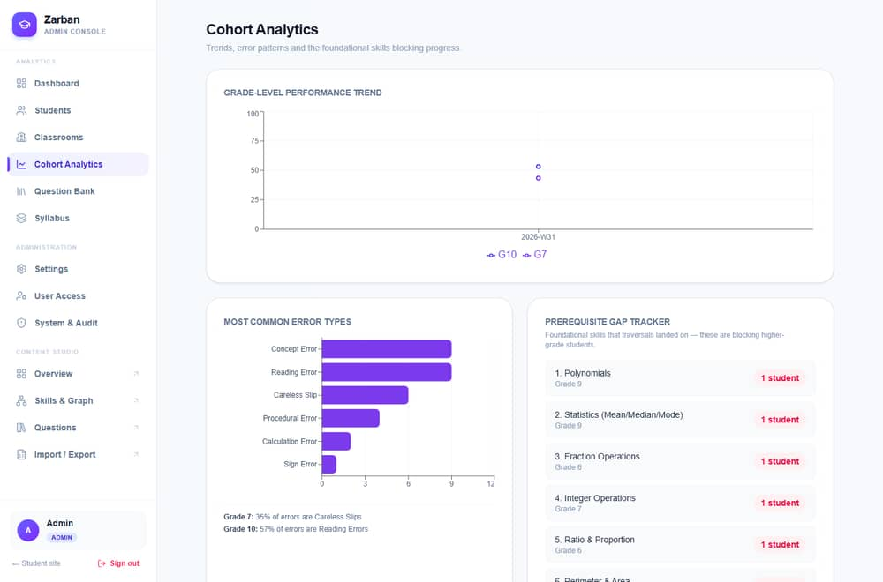
Figure — Cohort analytics (/admin/analytics).
For brevity each screen lists access + key elements + backend. Screenshots exist in docs/screenshots/; placeholders below map to them.
- Landing[Insert Screenshot: Landing Page] — Student. Hero, start card (name/school/class 5–10), Start. → session/start. Visible: CAT·IRT·CDM·BKT footnote, "Teacher/Admin" link.
- Assessment[Insert Screenshot: Assessment] — Student. Topic breadcrumb, timer, progress bar, question card, A–D buttons, "Recording your answer…". → session/respond.
- Report[Insert Screenshot: Report] — Student/Teacher. Grade header + gauge, Root Cause, Test-Taking Behaviour, Five Dimensions (radar), Error Patterns. → session/report/[id].
- Analysis[Insert Screenshot: Analysis] — θ line, adaptive-path grid (legend: easy/medium/hard, twin, guess, rushed), time-per-question bars.
- Practice[Insert Screenshot: Practice] — grade-grouped skill grid + runner.
- Admin login[Insert Screenshot: Admin Login] — email/password/Sign in.
- Dashboard[Insert Screenshot: Dashboard] — sidebar (grouped nav), 4 stat tiles, Top skill gaps, Quick actions, Score by grade, Heatmap. → admin/stats.
- Cohort Analytics[Insert Screenshot: Analytics] — trend line, error-type bars, prerequisite-gap tracker.
- Students[Insert Screenshot: Students] — searchable list; row → drill-down.
- Classrooms[Insert Screenshot: Classrooms] — list/empty state, New classroom, All/Mine, roster.
- Question Bank[Insert Screenshot: Question Bank] — filters, search, grid (id/skill/grade/band/traps), Edit/Delete, Excel Import.
- Syllabus[Insert Screenshot: Syllabus] — grade tabs, textbook/chapter counts, subjects.
- User Access[Insert Screenshot: Users] — staff list, roles (Admin only).
- Settings[Insert Screenshot: Settings] — max questions, timer minutes.
- System & Audit[Insert Screenshot: System] — data snapshot tiles, danger zone (typed phrase), audit table.
- Database manager[Insert Screenshot: Database] — table list + counts, row grid (PK badge, edit/delete), search, pagination.
- Content: Skills & Graph[Insert Screenshot: Skills Graph] — SVG graph, node selection, Graph/Table toggle, detail panel.
- Content: Curriculum / Questions / Import — subject/topic/textbook editors; question authoring; Excel import/export.
Under each placeholder, the listed elements describe every visible control, its action, validation, and the backend call.

19. Authentication & Authorization Workflow
- Registration:not present for staff (accounts are seeded / created by an Admin via User Access). Students have no auth.
- Login:POST /api/admin/auth/login → bcrypt.compareSync(password, hash) → jose HS256 sign {userId,email,name,role} → Set-Cookie zarban_admin (HttpOnly, Secure, SameSite=Lax, Max-Age 43200s).
- Session storage: stateless JWT in the cookie (no server session table).
- Role identification / permission checking:requireRole(min) decodes the cookie, checks rank; requireContentRole() allows Admin/Editor.
- Protected routes: every admin/content handler calls a guard first; the admin layout also verifies via GET /api/admin/auth/me.
- Expiration: 12h token; logout (POST /api/admin/auth/logout) clears the cookie.
- Password reset / brute-force / lockout:not implemented.Recommendation: add reset flow + rate limiting + lockout.
%% Diagram (Mermaid source — renders in the Markdown/GitHub copy) sequenceDiagram actor U as Staff participant UI as Login Page participant API as /api/admin/auth/login participant DB as admin_users U->>UI: email + password UI->>API: POST credentials API->>DB: find by email DB-->>API: user + password_hash API->>API: bcrypt.compareSync alt valid API->>API: jose sign JWT API-->>UI: 200 + Set-Cookie zarban_admin UI-->>U: redirect to /admin else invalid API-->>UI: 401 Invalid credentials UI-->>U: show error end
%% Diagram (Mermaid source — renders in the Markdown/GitHub copy) sequenceDiagram actor U as Staff participant API as Protected Route participant G as requireRole U->>API: request + cookie API->>G: verify JWT + role rank alt no/invalid cookie G-->>U: 401 else insufficient role G-->>U: 403 else authorized G-->>API: {session} API-->>U: 200 data end

20. Business Rules & Calculation Logic
Rule ID | Name | Logic / threshold | Code location
BR-01 | Mastery reached | p_mastery ≥ 0.95  → advance topic | types.ts  MASTERY_THRESHOLD, orchestrator
BR-02 | Foundational gap | p_new ≤ 0.30  AND (attempts ≥ 3 OR fail-streak ≥ 2) → traverse prereq | orchestrator  routeWrongAnswer
BR-03 | Careless slip | trap=Careless_Slip AND prior ≥ threshold → retry, no regression | orchestrator
BR-04 | Lucky-guess guard | correct AND prior < LUCKY_GUESS_PRIOR → serve confirmation | orchestrator  routeCorrectAnswer
BR-05 | Streak escalate | 2 consecutive correct → escalate band; all bands served → advance | orchestrator
BR-06 | Easy-fail traversal | difficulty=easy AND fail-streak ≥ 2 → cross-grade traverse | orchestrator
BR-07 | Twin probe | wrong word-problem with a twin → serve equation twin | orchestrator
BR-08 | Termination | max_questions reached / timer / all mastered / topics exhausted | orchestrator
BR-09 | Behaviour flags | rushed = time < 3000 ms; likely-guess = rushed AND correct AND band ≥ medium | report.ts
BR-10 | Settings clamps | max_questions∈[5,100]; timer∈[0,180] | admin/settings
BR-11 | DKT propagation | child p_mastery += coeff × (p_new − prior) | orchestrator  propagateDkt

Worked example (BKT update). With P(L₀)=0.10, P(T)=0.3, P(G)=0.2, P(S)=0.1 and a correct answer: posterior P(L|correct) = P(L)(1−S) / [P(L)(1−S) + (1−P(L))G] = 0.10·0.9 / (0.10·0.9 + 0.90·0.2) = 0.09 / 0.27 = 0.333; then learn: P(L') = 0.333 + (1−0.333)·0.3 = 0.533. So one correct answer lifts mastery from 0.10 → ~0.53.

21. Algorithms

21.1 Adaptive orchestration (processResponse)
- Purpose: grade an answer and choose the next question. Input: session id, question id, option, time. Output:StepResult.
- Steps: load session+question → grade → CDM trap lookup (if wrong) → BKT update + DKT propagation → IRT θ recompute over history → update counters → route (correct/wrong/twin decision tree) → persist response + session → check termination → serve next.
- Complexity: per answer O(n) in the number of prior responses (θ recompute); O(1) DB ops otherwise. Space: O(n) for history.
- Edge cases: twin missing, skill exhausted, timer expiry. Optimization applied: parallelized reads/writes + cached reference data (§31).

21.2 3PL IRT θ estimation (irt.ts)
Newton–Raphson MLE maximizing the 3PL likelihood; θ clamped [−4,4]. Item chosen by max Fisher information (|b−θ| minimal, tie → higher a). Pseudocode:
θ ← current repeat until |Δ| < ε or maxIter: compute Σ first/second derivatives of log-likelihood over responses θ ← clamp(θ − L'/L'', -4, 4)

21.3 BKT (bkt.ts)
Exact two-step posterior + learning update (worked in §20). O(1).

21.4 CDM remediation, DKT-lite, Twin-probe, CAT fetch ladder — described in §5.1/§20 and the technical handover; each is O(1)–O(candidates).

22. External Integrations
No third-party runtime service integrations are present (no payment, email, SMS, analytics SDK, or LLM calls in the codebase). The only external references are NCERT textbook soft-copy URLs stored in textbooks.pdf_url — these are links surfaced in the UI, not fetched/processed by the backend. Cloudflare (Workers/D1) is the hosting platform, not an application integration. Information not available in the supplied project files for any other external service.

23. Error Handling Catalogue
Error | Cause | User message | Internal action | Recovery
Validation | Missing name/fields | "Name is required" etc. | 400 JSON | Re-enter
Auth (401) | No/invalid JWT | Redirect to login | 401 | Sign in
Authorization (403) | Insufficient role | Access blocked | 403 | Use permitted role
Not found (404) | Unknown session/question/record | "… not found" | 404 | Check id
DB error | Query failure | Generic error | console.error  + 500 | Retry
Network | Fetch failure (client) | Inline banner | one silent retry | Tap to retry
API error | Bad input | {error}  + status | validation | Correct input
Duplicate | Unique constraint (email/name/key/trap) | Constraint message | 4xx | Use unique value
Invalid URL | Bad  pdf_url | 400 | reject | Fix URL
Injection attempt | Bad table/column name | "Unknown table" | 400 (whitelist) | —
Server error | Unhandled | Generic | 500 + log | Retry/report
Session expiry | JWT > 12h | Redirect to login | 401 | Re-login

24. Edge Cases
Case | Current handling | Improvement (Recommendation)
Empty input | Required-field validation | Add richer inline hints
Null values | Nullable columns; null-safe UI ("null" shown in DB manager) | —
Wrong format | URL check; grade clamp | Add schema validation (zod)
Duplicate entries | Unique constraints | Friendlier duplicate messages
Very large inputs | Page size capped (≤200) | Server-side result caps everywhere
Negative/invalid grade | clampGrade  to 5–10 | —
Invalid/future dates | N/A — few user-entered dates | —
Missing relationships | Engine fallbacks (skill/twin missing) | —
Deleted users | teacher_id  SetNull; audit keeps  actor_email | —
Simultaneous updates | Last-write-wins (no optimistic lock) | Add version/ETag
Network failure | One silent client retry | Exponential backoff
DB disconnection | Handler 500 | Retry/circuit-breaker
Partial/invalid file upload | xlsx  parse errors surfaced | Stricter schema + row-level errors
Session expiry | 401 → login | Refresh tokens
Unauthorized access | 401/403 guards | Rate-limit + lockout
API timeout | not explicitly handled | Add timeouts/AbortController

25. Security
Implemented: RBAC (four roles, per-handler guards); bcrypt password hashing; JWT in HttpOnly+Secure+SameSite=Lax cookie; parameterized SQL everywhere incl. the DB manager (identifier whitelisting + bound values); audit log of privileged actions; HTTPS (Cloudflare); secrets via AUTH_SECRET Worker secret; typed-phrase confirmation on destructive actions; Prisma prevents SQL injection in ORM paths.
Missing / not evidenced: rate limiting; account lockout / brute-force protection; password reset; CSRF tokens (mitigated by SameSite=Lax, but state-changing POSTs have no explicit CSRF token — Recommendation: add CSRF defense or verify SameSite coverage); CSP headers (Info not available); dependency-scanning/CI; formal secrets rotation; file-upload AV scanning; per-IP throttling.
Recommendations (prioritized): (1) rate-limit auth + login lockout; (2) password reset flow; (3) explicit CSP + security headers; (4) dependency audit in CI; (5) rotate AUTH_SECRET policy; (6) backups with restricted access.

26. Testing
Implemented:
- End-to-end:scripts/e2e.ts (npm run e2e) — 136 checks over the real HTTP API: assessment lifecycle (all-correct and all-wrong), report + analysis, admin auth + every admin view, content portal, and RBAC denial (403). Correct answers read from local D1.
- Unit: Vitest present (tests/, vitest.config.ts). Exact unit count/coverage not enumerated here — Info not available beyond the presence of the suite.
- Type checking:tsc --noEmit gates changes.
- Content QA:scripts/verify-workbook.ts gates the question bank.
Not evidenced: load testing, formal security testing, cross-browser matrix, UAT sign-off. Info not available.Recommendation: add load tests (k6), a browser matrix, and a security scan.

Sample test cases
Test ID | Module | Scenario | Steps | Input | Expected | Type
TC-01 | Assessment | Start valid | POST start | name+grade 8 | 200 + first Q | Positive
TC-02 | Assessment | Start missing name | POST start | grade only | 400 | Negative
TC-03 | Respond | Unknown session | POST respond | bad session_id | 404 | Negative
TC-04 | Auth | Valid login | POST login | admin creds | 200 + cookie | Positive
TC-05 | Auth | Invalid login | POST login | wrong pw | 401 | Negative
TC-06 | RBAC | Viewer writes | POST classrooms as Viewer | — | 403 | Security
TC-07 | Settings | Clamp bounds | PUT settings | maxQ=999 | stored=100 | Boundary
TC-08 | DB manager | Injection | GET db/  skills;DROP | — | 400 Unknown table | Security
TC-09 | Curriculum | Bad pdf_url | POST textbook | "notaurl" | 400 | Validation
TC-10 | Report | Unknown session | GET report | bad id | 404 | Exception

Actual/Status columns to be filled during a test run; the e2e suite currently reports 136 passed / 0 failed.

27. Deployment
Prerequisites: Node.js, a Cloudflare account, wrangler. Hardware: none (serverless). Software: repo dependencies (npm install).
One-time:
npx wrangler login npx wrangler d1 create zarban # capture database_id npx wrangler d1 execute zarban --remote --file=drizzle/0000_initial.sql -y
Every deploy:
npm run build node scripts/patch-d1.mjs <database_id> # writes the DB binding into dist/server/wrangler.json npx wrangler deploy # from the repo ROOT
Hardening:npx wrangler secret put AUTH_SECRET.
Hosting: frontend + backend + DB all on Cloudflare (Workers + D1) — one artifact. Domain/HTTPS:*.workers.dev subdomain with auto TLS (custom domain optional; §8 of handover). Reverse proxy / containers / CI/CD / rollback:not applicable / not configured (edge platform; rollback via Worker version pinning in the dashboard). Backup/recovery:not configured — Recommendation: scheduled wrangler d1 export.
%% Diagram (Mermaid source — renders in the Markdown/GitHub copy) flowchart LR Dev[Developer] -->|npm run build| Build[vinext/Vite bundle] Build -->|patch-d1| Cfg[dist/server/wrangler.json] Cfg -->|wrangler deploy| CF[Cloudflare Workers] CF --> D1[(D1 zarban)] User((Users)) --> CF

28. Installation & Setup Guide (local)
- Required software: Node.js (LTS), npm, Git. 2. Download:git clone https://github.com/karthikLagudu/Zarban. 3. Navigate:cd Zarban. 4. Install:npm install. 5. Config: set DATABASE_URL for local SQLite (see .env / datasource db). 6. Env:AUTH_SECRET (dev fallback exists). 7. Database + sample data:npm run setup (chains db:push → generate:workbook → verify:workbook → seed). 8. Run:npm run dev. 9. URL:http://localhost:3000. 10. Default login:admin@zarban.local / admin123 (and editor@zarban.local / editor123). 11. e2e:npm run e2e.
Common setup issues: if the local D1 schema is stale, re-run db:push and the sqlite-apply step; if the client build breaks, ensure no client component imports a server-only module. Troubleshooting: see §33.

29. Configuration & Environment Variables
Variable | Purpose | Required | Example | Security note
AUTH_SECRET | JWT signing secret | Prod: yes (dev fallback exists) | ‹48-byte-random› | Set via  wrangler secret  ; never commit
DATABASE_URL | Local SQLite datasource | Local: yes | file:./dev.db | Local only
DB  (binding) | Cloudflare D1 binding | Worker: yes | (binding, not a value) | Configured in  wrangler.json

No other secrets are present. Real credentials must never be committed; use placeholders as above.

30. Logging & Monitoring
Implemented:console.error on failure paths; the audit log (admin_audit_log) records privileged actions (auth.login, user.*, settings.update, data.*, db.update_row, db.delete_row). Not implemented: access logs, log levels/rotation, metrics dashboards, alerting, external log sink. Information not available in the supplied project files.Recommendation: ship Workers logs to a sink, add structured logging + alerts, and surface Cloudflare analytics.

31. Performance & Scalability
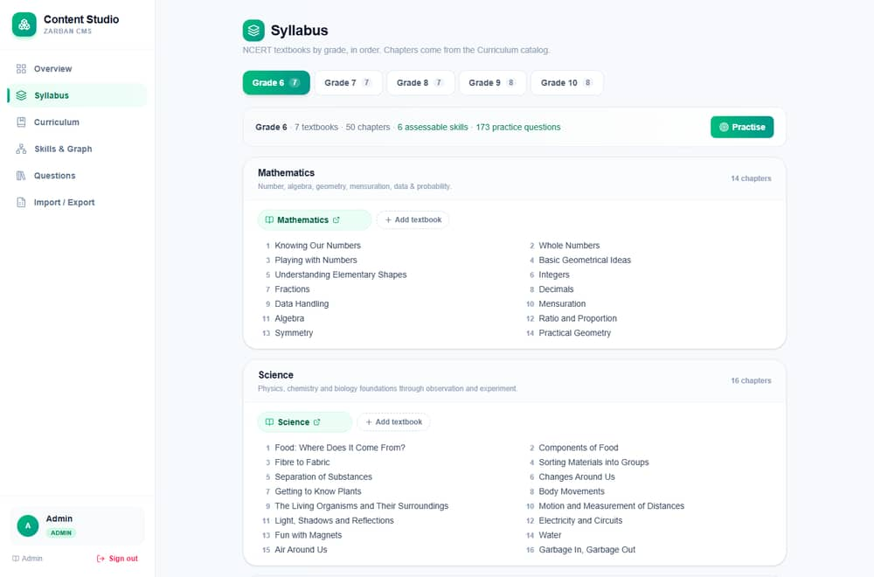
Figure — The syllabus view (/content/syllabus).
Current implementation & measured results (production):
Path | Before | After | Improvement
Assessment answer | ~480–610 ms | ~280–340 ms | ~45% (+ removed 350 ms client delay)
Dashboard stats | ~311 ms | ~170 ms | ~45%
Content hub | ~313 ms | ~150 ms | ~52%
Report | ~267 ms | ~215 ms | ~20%

Techniques: parallelized independent D1 reads/writes; use of update() return instead of re-reads; an in-isolate TTL cache for near-static data; trimmed history projections; skipping impossible checks. Indexing: composite indexes back the hot fetch paths. Pagination: DB manager (≤200/page). Bottlenecks / limits: D1 single-primary writes; module caches are best-effort per isolate; θ recompute is O(n) per answer. Scaling: Workers scale horizontally automatically; Recommendation: persist item params to avoid O(n) recompute, and consider read-replicas/edge-cache for analytics.

32. Maintenance Guide
- Dependencies: periodic npm update + npm audit. DB backup:wrangler d1 export (Recommendation — add a schedule). Restore:wrangler d1 execute --file=<backup>.sql. Log review: audit log + Worker logs. User management:/admin/users. Security updates: patch deps; rotate AUTH_SECRET. Config changes:/admin/settings (cache auto-invalidates). Data cleanup: System → maintenance (typed phrase). Content updates: Content Studio or Excel import → re-run verify-workbook for bulk changes. Version upgrades: bump deps, tsc, e2e, redeploy. Feature additions: follow the migration dance (§ handover Phase 1) for schema changes.

33. Troubleshooting Guide
Problem | Possible cause | Diagnostic steps | Solution
Local login fails | Seed not loaded | npm run setup  ran? | Re-seed; use demo creds
"DB binding unavailable" | Running outside Worker context | Check  src/lib/db.ts  proxy | Access via a request handler
Client build breaks | Client imports server module | Trace import of  db.ts | Split client-safe constants
Deploy config collision | Deployed from  dist/server | Read error | Deploy from repo root
HTTPS fails post-subdomain change | Cert not issued yet | curl  exit 35 | Wait; poll until 200
DB manager count error | Query limit | Check D1 error | Concurrent per-table counts (in place)
403 on a page | Insufficient role | Check  role  in token | Use Admin/Editor as needed
Excel import rejected | Wrong file / schema | Check parser error | Provide valid  .xlsx
Slow answer | Cold isolate | Re-test warm | Caches warm after first calls
git push  hangs | HTTP/2 + expired creds | Try HTTP/1.1 | Re-auth GitHub; force HTTP/1.1

34. Project Strengths
- Functional design: a genuine closed-the-loop diagnostic (test → cause → practice).
- Architecture: single edge artifact; clean layering; lazy DB proxy.
- UX: instant-submit test, skeletons, transitions, empty/error states.
- Data management: typed schema, cascade integrity, a generic DB manager, Excel + PDF I/O.
- Maintainability: modular engine, scripts, e2e harness.
- Security: RBAC + bcrypt + HttpOnly JWT + audit + parameterized SQL.
- Performance: measured, behaviour-preserving optimization.
- Scalability: horizontal by platform default.
- Reporting: rich diagnostic + cohort analytics.
- Automation: parametric question generation + QA gate + 136 e2e checks.

35. Limitations & Technical Debt
Item | Impact | Severity | Recommended correction
No automated backups | Data-loss risk | High | Scheduled  wrangler d1 export
No rate limit / lockout | Brute-force exposure | High | Add throttling + lockout
Demo creds in seed | Unauthorized access if unchanged | High | Force change on first prod login
Best-effort caches | Cross-isolate inconsistency (≤TTL) | Low | Acceptable; document TTLs
θ recompute O(n)/answer | Grows with test length | Medium | Persist item params on responses
No monitoring/alerting | Blind to incidents | Medium | Add Workers analytics + alerts
No password reset | Ops friction | Medium | Add reset flow
Unit-test coverage unquantified | Unknown gaps | Medium | Measure + expand coverage
No CI/CD | Manual deploys | Medium | Add pipeline + checks
Single-region D1 | Write latency far from primary | Low/Med | Consider replicas/caching
English only | No localization | Low | i18n if needed

36. Future Enhancements
- Immediate: scheduled backups; force-change demo passwords; auth rate-limit/lockout; monitoring/alerts.
- Short-term: password reset; CSP/security headers; CI/CD with tsc+e2e; persist IRT params to responses.
- Medium-term: parent portal; adaptive practice paths driven by the report; item-parameter recalibration from real data; richer accessibility (WCAG audit).
- Long-term: multi-subject expansion; offline/PWA mode; multi-tenant schools; localization.
For each: Purpose (close a gap), Business benefit (trust/reach), Technical benefit (safety/perf), Approach (as noted), Dependencies (platform features), Priority/Complexity/Risk (security items = high priority/low risk; multi-tenant = long-term/high complexity).

37. Project Demonstration Script (speakable)
"Good morning. I'm presenting Zarban, an adaptive math assessment platform for Grades 5 to 10. The problem: an ordinary test gives a score, but a score doesn't tell a teacher why a student struggled or what to do next. Our solution: Zarban adapts to each student as they answer and produces a diagnosis — for example, 'strong at the maths, but word problems reveal a reading gap.' The stack: Next.js and React on the front, a closed-form adaptive engine in TypeScript, Prisma over Cloudflare's D1 database, all deployed as a single Cloudflare Worker. Architecture: one edge Worker serves the pages and the API; the engine runs item-response theory, knowledge tracing and misconception modelling in milliseconds. Let me demonstrate. Here's the landing page — I enter a name and class 8 and start. The test adapts: correct answers get harder, mistakes step down to prerequisites. … When it ends, here's the diagnostic report — the estimated level, the root cause, and behaviour flags for lucky guesses and rushed answers. This detailed view replays the engine's exact path. For staff: signing in as admin, the dashboard shows the school at a glance — top skill gaps and a failure heatmap. The cohort analytics show error patterns. The Content Studio holds the knowledge graph the engine navigates, and this Database manager lets an admin manage every table safely. The database has 20 related tables; security uses role-based access, hashed passwords, an HttpOnly token, and an audit log. Testing: 136 automated end-to-end checks guard every release. Deployment: it's live and free on Cloudflare. Challenges: the biggest was latency — I measured it and cut per-answer time roughly in half by reducing database round trips. Limitations: no automated backups or rate-limiting yet — those are my first next steps. In summary: Zarban turns a score into an actionable diagnosis, for students, teachers, and administrators — and it's running today. Thank you; I'm happy to take questions."

38. Interview & Viva Questions (with model answers)
Beginner
- What does Zarban do? Adaptive math diagnosis + practice for Grades 5–10, with a teacher/admin console.
- Tech stack? Next.js/React, TypeScript, Prisma + Cloudflare D1, deployed as a Cloudflare Worker; jose JWT + bcrypt auth.
- What are the roles? Admin, Teacher, Viewer, Editor; students are unauthenticated.
Intermediate
- How does adaptivity work? 3PL IRT picks the max-information item at the student's estimated θ; wrong answers route to prerequisites via a knowledge graph.
- How is a "reading vs maths" gap detected? A missed word problem triggers an equation-only twin; word-wrong + equation-right ⇒ reading gap.
- How is RBAC enforced? Per-handler requireRole/requireContentRole decoding the JWT; the nav also filters by role.
- Why Prisma over raw SQL? Typed client + declarative schema; raw parameterized SQL is used only in the generic DB manager.
Advanced
- Why closed-form models instead of ML? Workers have no GPU/CPU budget for ML; analytic IRT/BKT are deterministic (replayable report) and run in <1 ms.
- Biggest performance lever? Reducing D1 round trips (each is a network hop); parallelize + cache; measured ~45% faster answers.
- How is the DB manager safe? Identifiers whitelisted against the live schema; values parameterized; Admin-only; audited; rowid addressing.
- Trade-off of the edge model? No long-lived connections, single-primary D1, best-effort per-isolate caches.
- What would you harden first? Backups, auth rate-limiting/lockout, and forcing a change of demo credentials.

39. Multi-length Explanations
One-minute: Zarban is an adaptive math platform for Grades 5–10 that doesn't just score a student — it diagnoses why they're wrong (a calculation slip, a reading gap, or a missing prerequisite) and sends them to targeted practice, with a full teacher and admin console. It runs a real adaptive engine and is deployed live and free on Cloudflare.
Five-minute:(the §37 script, condensed) — problem, solution, a live demo of test → report → console, the 20-table data model, security, testing (136 checks), and deployment, closing with the measured latency win and the honest next steps (backups, rate-limiting).
Fifteen-minute technical: add the engine internals (IRT/BKT/CDM/DKT/twin, §21), the request lifecycle and RBAC (§12/§19), the schema and relationships (§14), the migration/deploy pipeline (§27), and the performance method (§31).
Complete detailed: this entire document.
For management (non-technical): Zarban replaces a meaningless score with a clear diagnosis and a next step for every student, gives teachers a live view of where a class is struggling, and costs nothing to host. It's live today; the near-term work is operational hardening (backups, access controls), not new features.
For engineers:(the fifteen-minute version, plus) the lazy Prisma proxy over the D1 binding, the closed-form deterministic engine (replayable), the generic schema-introspecting DB manager with injection defenses, and the round-trip-count optimization strategy.
Interview-ready: "I built an adaptive math-assessment platform end to end — schema, a multi-algorithm psychometric engine, three role-scoped UIs, a full admin console, and a live Cloudflare deployment — then measured and halved its per-answer latency, all guarded by 136 automated checks."

40. Required Diagrams
Diagrams for context (§15.1), architecture (§8.3), workflow (§16), data-flow L1 (§15.2), ERD (§14.3), auth/authz sequences (§19), feature sequence (§13.1), and deployment (§27) are provided in-line above. The remaining requested diagrams:
Module hierarchy
%% Diagram (Mermaid source — renders in the Markdown/GitHub copy) flowchart TD App[Zarban App] --> Student[Student] App --> Console[Admin Console] App --> Studio[Content Studio] Student --> Assess[Assessment] & Report[Report/Analysis] & Practice[Practice] & Learn[Learn Hub] Console --> Dash[Dashboard/Analytics] & People[Students/Classrooms] & Ops[Settings/Users/System/DB] Studio --> Skills[Skills/Graph] & Qs[Questions] & Curr[Curriculum/Syllabus] & IO[Import/Export]
User-role diagram
%% Diagram (Mermaid source — renders in the Markdown/GitHub copy) flowchart LR Admin --> Teacher --> Viewer Admin --> Editor Admin -.full.-> All[All modules] Teacher -.read.-> Analytics Viewer -.read-only.-> Analytics Editor -.write.-> Content Student((Student)) -.no auth.-> Assess[Assess/Practice/Report]
Session state-transition
%% Diagram (Mermaid source — renders in the Markdown/GitHub copy) stateDiagram-v2 [*] --> in_progress: start in_progress --> in_progress: answer (adapt) in_progress --> completed: max_questions / time_up / all_mastered / topics_exhausted completed --> [*]
Error-handling workflow
%% Diagram (Mermaid source — renders in the Markdown/GitHub copy) flowchart TD Req[Request] --> V{Valid input?} V -- no --> E400[400 + message] V -- yes --> A{Authenticated?} A -- no --> E401[401 → login] A -- yes --> R{Authorized?} R -- no --> E403[403] R -- yes --> P[Process] P --> Ok{Success?} Ok -- yes --> S200[200 + data] Ok -- no --> Log[console.error] --> E500[4xx/5xx + error]
Reporting workflow
%% Diagram (Mermaid source — renders in the Markdown/GitHub copy) flowchart LR Sess[Completed session] --> Gen[generateReport] Gen --> Web[Report page] Gen --> PDF[pdfkit → PDF download]
File-upload (Excel) workflow
%% Diagram (Mermaid source — renders in the Markdown/GitHub copy) flowchart LR U[Upload .xlsx] --> P[xlsx parser] --> V[validate rows] --> DB[(upsert content)] --> R[result summary]
Each diagram's plain-language meaning is given in its section; the ones here read directly.

41. Requirements Traceability Matrix
Req ID | Requirement | Module (page) | API | DB tables | Test
FR-001 | Start assessment | /assessment | POST session/start | students, sessions, questions | TC-01/02
FR-002 | Submit & adapt | /assessment | POST session/respond | sessions, responses, bkt_state, traversal_events | (e2e lifecycle)
FR-004 | View report | /report/[id] | GET session/report/[id] | sessions, responses, dimension_scores | TC-10
FR-005 | Report PDF | /report/[id] | GET …/pdf | (same) | (e2e)
FR-006 | Practice | /practice | GET practice | questions, skills, answer_traps | (manual)
FR-007 | Login | /admin/login | POST admin/auth/login | admin_users | TC-04/05
FR-008 | RBAC | (all admin) | (all guarded) | admin_users | TC-06
FR-009 | Dashboard | /admin | GET admin/stats | sessions, responses, skills | (e2e)
FR-010 | Analytics | /admin/analytics | GET admin/analytics | responses, traversal_events | (e2e)
FR-011 | Students | /admin/students | GET/PATCH admin/students | students, classrooms | (e2e)
FR-012 | Classrooms | /admin/classrooms | admin/classrooms* | classrooms, students | TC (RBAC)
FR-013 | Question bank | /admin/questions | admin/questions*  ,  admin/import | questions, answer_traps | (e2e)
FR-014 | Skills & graph | /content/skills | content/skills* | skills, knowledge_graph | (e2e)
FR-015 | Curriculum | /content/curriculum | content/curriculum* | subjects, topics, textbooks | TC-09
FR-016 | Excel I/O | /content/import | content/import  ,  content/export | (content tables) | (manual)
FR-017 | Settings | /admin/settings | GET/PUT admin/settings | settings | TC-07
FR-018 | Maintenance | /admin/system | admin/maintenance | sessions, responses, bkt_state, students | (manual)
FR-019 | Audit | /admin/system | GET admin/audit | admin_audit_log | (e2e)
FR-020 | DB manager | /admin/database | admin/db* | (all) | TC-08
FR-021 | Session replay | /admin/sessions/[id] | GET …/replay | sessions, responses | (manual)

42. Final Project Evaluation
Dimension | Assessment
Overall completion | High — all core surfaces implemented and deployed live.
Functional completeness | High for the assessment/console/content scope; student accounts, payments, i18n are intentionally out of scope.
Technical quality | Strong — typed, modular, deterministic engine; clean layering.
Code-structure quality | Strong — clear  app  /  lib  /  scripts  separation; 46 focused route handlers.
Database quality | Strong — normalized, indexed, cascade-consistent 20-table schema.
Security quality | Good, with gaps — RBAC/bcrypt/JWT/audit/parameterized SQL present; missing rate-limiting, lockout, reset, backups.
Testing quality | Good — 136 e2e checks + type gate + content QA; load/security/browser testing not evidenced.
Documentation quality | Strong — README, technical handover, client brief, interactive guide, this document.
Deployment readiness | High — repeatable, documented, live.
Production readiness | Conditional.  The application is deployed and functional, but true production hardening requires: automated backups, auth rate-limiting/lockout, forced rotation of demo credentials, and monitoring/alerting.  It should not be called fully production-ready until those are in place.

Main risks: no backups; open auth (no throttling/lockout); shipped demo credentials; no monitoring. Recommended next steps (in order): (1) backups, (2) auth hardening + credential rotation, (3) monitoring/alerts, (4) CI/CD with tsc+e2e, (5) persist IRT params for O(1) θ updates.
Prepared from the supplied Zarban project files. Companion materials: docs/TECHNICAL-HANDOVER.md (deep-dive), docs/Zarban-Client-Brief.pdf (non-technical), docs/guide.html (interactive tour), docs/VIDEO-SCRIPT.md (screencast script).

