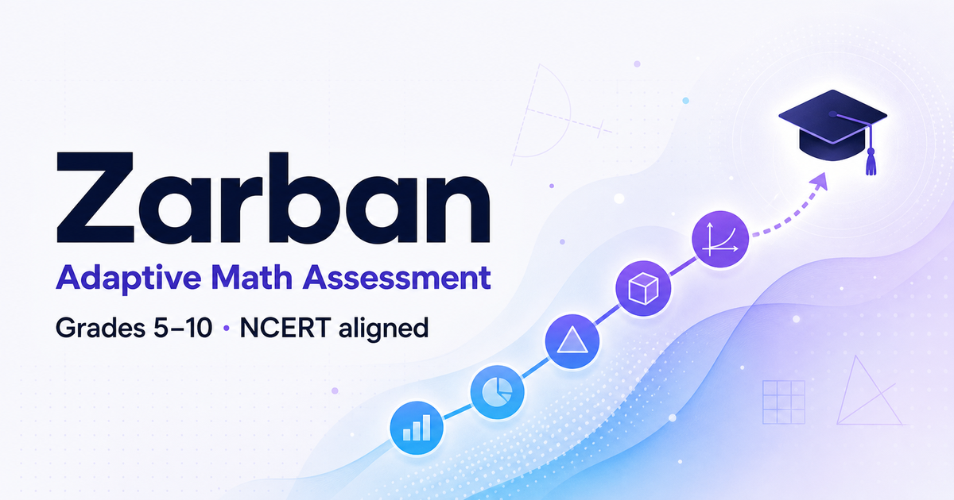
Zarban
Adaptive Assessment & Learning Ecosystem
Grades 5–10 · NCERT-aligned
Project Overview & Technical Documentation
911-question bank · 5-algorithm engine · full RBAC · Cloudflare Workers + D1

Contents

1. Introduction
Zarban is a production-grade, full-fledged adaptive assessment and learning ecosystem for school students in Grades 5–10, aligned to the NCERT curriculum. Where a typical assessment tool reports a score, Zarban reports the cause of each mistake and the concrete next step to fix it.
It combines five diagnostic techniques into a single next-question-selection engine: Computerised Adaptive Testing (CAT) with Item Response Theory (IRT), Cognitive Diagnosis Modelling (CDM), Bayesian Knowledge Tracing (BKT), a Deep Knowledge Tracing (DKT)-lite prerequisite router, and a Twin-Question diagnostic probe. Every wrong answer option is pre-mapped to a specific misconception, so the report explains errors rather than merely counting them.
Crucially, Zarban closes the learning loop: a student is assessed, receives a detailed diagnostic report, is guided into targeted practice on their weak skills (with instant feedback and the exact misconception behind each wrong choice), and tracks their progress over time. Teachers monitor their classes and see who needs attention; administrators control users, content, and the whole platform.
It is delivered as a single deployable web application — Next.js (App Router) running on Cloudflare Workers with a Cloudflare D1 database — one process, with all engine mathematics implemented as closed-form TypeScript (no external ML service).

1.1 At a glance
- Question bank: 911 NCERT-aligned MCQs across Grades 5–10, with 2,733 misconception traps (every wrong option diagnosed) and 149 word-problem / equation-twin pairs.
- Skills & knowledge graph: 33 skills with prerequisite edges that the engine traverses to find foundational gaps.
- Curriculum catalog: 4 subjects (Mathematics, Science, Social Science, English), 239 topics/chapters, and 37 NCERT textbooks across Grades 6–10, each with a soft-copy link.
- Quality: 39 engine unit tests and a 136-check end-to-end suite exercising the whole platform.
- Roles: Admin, Teacher, Viewer and Editor, enforced by role-based access control.

2. The three experiences
Zarban serves three audiences from one application, each with a distinct experience routed from a shared front door.

2.1 Student — assess, understand, practise, track
Screen | Route | What it does
Landing | / | Enter name and grade, resume an in-progress test, or jump to Practice / My progress.
Assessment | /assessment | One question at a time, a running elapsed clock, keyboard A–D answering, and no right/wrong feedback — the test adapts silently.
Diagnostic report | /report/:id | Grade equivalent, five learning dimensions (radar), skill-mastery bars, error-pattern breakdown, fluke/rushed behaviour flags, foundational-gap chains, per-question analysis, and focus areas that link into Practice. PDF export.
Detailed analysis | /report/:id/analysis | The ability (theta) journey, the adaptive path taken, time-per-question, skill/topic deep-dives, and a mistakes & misconceptions table.
Practice Mode | /practice | Pick a skill and drill it with instant right/wrong feedback and, on a miss, the exact misconception behind the option chosen. Keyboard 1–4 / A–D and Enter.
My Learning | /learn | Score trend across assessments, current skill mastery, what to practise next, and links to every past report.

2.2 Teacher — monitor the class, spot who needs help
- My Classes: the classrooms a teacher owns, each with a badge showing how many students need review.
- Attention flags: each student is flagged when not yet assessed, scoring under 50%, or carrying a mastery gap in a skill.
- Drill-down: open any student to see sessions and BKT mastery, replay any session step-by-step, and view cohort analytics.

2.3 Administrator — full control
- Control Center: User Access (create staff, change roles, reset passwords — with guardrails that prevent deleting the last admin or your own account), System & Audit (danger-zone data resets gated behind a typed confirmation phrase, plus an append-only audit log), and Settings (max questions, optional time limit).
- Oversight: dashboards, students, cohort analytics, the question bank, classrooms, curriculum and syllabus.

2.4 Editor — author the content
The Content Studio (Admin or Editor) provides: a content health/coverage overview; the Syllabus (NCERT textbooks by grade); the Curriculum editor (subjects to chapters); Skills & Graph (a visual, interactive knowledge tree); a Questions authoring surface (MCQs with options, Q-matrix skills, learning dimensions, and per-option misconception traps); and Excel Import / Export of the entire bank.

3. The adaptive engine
Every response updates the student model before the next item is chosen. Five techniques cooperate in one closed-form TypeScript engine located in src/lib/engine/.
Technique | Detail
CAT + IRT (3PL) | The 3-parameter logistic model P(theta) = c + (1 − c) / (1 + e^(−a(theta − b))). A Newton–Raphson maximum-likelihood estimate re-computes ability theta (bounded to [−4, 4]) over the whole session history; the next item is the one that maximises Fisher information at the current theta. Item parameters (a discrimination, b difficulty, c guessing) are derived from grade and difficulty band at import.
BKT | An exact Bayesian mastery update per skill, with prior P(L0) = 0.10, transit P(T) = 0.3, guess P(G) = 0.2 and slip P(S) = 0.1. Mastery is reached at 0.95; a foundational gap is flagged at 0.30 or below.
CDM | Cognitive Diagnosis via a Q-matrix and answer traps. Each wrong option maps to a misconception type — Concept, Sign, Calculation, Reading, Procedural, or Careless Slip — and to a remedial routing action.
DKT-lite | Sequence-aware routing that walks the prerequisite knowledge graph downward when foundational gaps appear, so the engine can drop a grade or move to a prerequisite skill.
Twin Question | A parallel equation-only probe that confirms whether a correct word-problem answer reflected mastery or a lucky guess — the basis for the reading-vs-mathematics gap diagnosis.
Design note: BKT and IRT updates run on every response before routing. This is a deliberate correction to the specification's pseudocode, which returned early on wrong answers; the specification's prose requires the update to happen first.

3.1 How an assessment flows
- The student picks a grade; the engine serves the maximum-information item at the starting ability.
- On each answer, the response is scored, BKT mastery is updated, theta is re-estimated by IRT, and — if wrong — CDM classifies the misconception.
- The engine routes the next item: stay at the same level, step down a grade, or walk to a prerequisite skill; a Twin probe may fire to confirm a suspicious correct answer.
- The session ends when mastery is reached, all target topics are covered, or the question cap is hit — after which the diagnostic report is generated.

4. Reporting & diagnostics
The diagnostic report turns the session into an explanation and a plan.
- Grade equivalence: a data-grounded estimate of the grade level the student is actually performing at, with a low-confidence caveat when a score is close to random guessing.
- Five learning dimensions: Reading, Understanding, Application, Calculation and Retention, shown on a radar chart.
- Skill mastery: per-skill Bayesian mastery bars (Mastered / Developing / Gap).
- Error taxonomy: the distribution of misconception types across all mistakes.
- Behaviour flags: detection of likely lucky guesses (correct but very fast on a harder item) and rushed answers (answered in under three seconds), with plain-English notes.
- Foundational-gap chains: when the engine walked down the prerequisite graph, the chain from the surface error to its root cause is shown.
- Reading-vs-math gap: flagged when the equation versions of missed word problems were solved correctly.
- Actionable focus areas: the weakest skills, each linking directly into Practice Mode; plus a full question-by-question analysis and a PDF export.

5. The learning loop — Practice Mode
Practice Mode is the learning half of the ecosystem. From a report's focus areas, the learning hub's recommendations, or the syllabus, a student enters a skill drill. Unlike the graded assessment, practice reveals: each answer is checked instantly, and on a wrong choice the specific misconception behind the chosen option is shown, so the student learns from the mistake. A running score and an end-of-set summary encourage another round. The catalog and question sets are served by a public API and draw on the same 911-question bank and its 2,733 misconception traps.

6. Architecture & technology
The browser (student site, admin console, and content studio) talks to Next.js App Router API routes, which invoke the adaptive engine and the RBAC layer, persist through the Prisma ORM to Cloudflare D1, and produce PDF and Excel outputs.
Layer | Choice
Frontend + API | Next.js 16 (App Router), TypeScript 5.9, Tailwind CSS 4, Recharts, lucide-react
Runtime / deploy | Cloudflare Workers via vinext and wrangler
Engine | Pure TypeScript (src/lib/engine/) — closed-form, single process
Database | Prisma ORM to Cloudflare D1 (SQLite-compatible; schema is PostgreSQL-portable)
Authentication | bcrypt (bcryptjs) with a signed JWT cookie (jose); roles Admin, Teacher, Viewer, Editor
Documents | pdfkit with an embedded Noto Sans font subset (no filesystem font — safe on Workers)
Content pipeline | SheetJS (xlsx) — one parser powers import, export and the seed

6.1 Data model
The relational schema (prisma/schema.prisma) comprises these core tables:
- Content: skills, questions, q_matrix, answer_traps, question_dimensions, knowledge_graph.
- Curriculum: subjects, topics, textbooks.
- Learners: students, sessions, responses, bkt_state, dimension_scores, traversal_events, review_flags.
- Platform: admin_users, admin_audit_log, classrooms, settings.
Key relationships: a teacher (admin_user) owns classrooms; a classroom enrolls students; a student takes sessions; a session records responses and traversal events; a question has answer traps and a primary skill; a student × skill pair has a BKT mastery state; a skill has prerequisite edges in the knowledge graph; a subject contains topics and has textbooks.

7. Roles & access control
Role | Access
Admin | Everything — analytics, classrooms, User Access, System & Audit, settings, Content Studio, Syllabus and Curriculum.
Teacher | Dashboards, students, cohort analytics, and a My Classes monitoring view for classrooms they own.
Viewer | Read-only analytics and syllabus.
Editor | Content Studio and Curriculum authoring (no analytics).
Every admin API is gated by a minimum-role check (Admin > Teacher > Viewer); content APIs require the Admin or Editor role. Authentication is a signed, HttpOnly JWT cookie; the Content Studio shares the same session, so an administrator moves between the console and the studio without signing in again. Destructive maintenance actions require a typed confirmation phrase and are written to an append-only audit log.

8. Curriculum, Syllabus & the question bank
- Curriculum catalog: 4 subjects, 239 topics/chapters, Grades 6–10, editable in the Content Studio and separate from the assessable question bank.
- Syllabus: NCERT textbooks laid out grade-by-grade, each with a soft-copy link to the official free NCERT source; a subject overview; and, per grade, the count of assessable skills and available practice questions with a one-click jump into Practice.
- Question bank: 911 parametrically generated, NCERT-aligned MCQs with full-signature de-duplication, 2,733 misconception traps (every wrong option diagnosed), and 149 word-problem / equation-twin pairs. A QA gate enforces answer integrity, complete trap coverage, valid twins, no duplicates, and at least three items per skill-and-difficulty cell.
Note: the seeded chapter and textbook lists follow the well-known NCERT editions and are fully editable; they should be verified against the exact (2023–24 rationalised) edition in use. Textbook links point to the official free NCERT source — the application never hosts copyrighted files.

9. Getting started
Prerequisites: Node.js and npm. From the project root:
- npm install — install dependencies.
- npm run setup — push the schema, generate the SME workbook, verify it, and seed everything.
- npm run build && npm start — production server at http://localhost:3000 (recommended).
- npm run dev — hot-reload development server.

9.1 Seeded sign-in credentials
Surface | URL | Credentials
Student | / | — (enter name + grade)
Admin console | /admin | admin@zarban.local / admin123
Teacher | /admin | teacher@zarban.local / teacher123
Viewer | /admin | viewer@zarban.local / viewer123
Content Studio | /content | editor@zarban.local / editor123
Important: these are seeded development credentials. Set a strong AUTH_SECRET and rotate every password (via User Access) before going live.

10. Testing & quality
- npm test — 39 engine unit tests (BKT, IRT, CAT, difficulty, content health).
- npm run typecheck — strict TypeScript.
- npm run e2e — a 136-check end-to-end suite driving the running server through its real HTTP API.
- npm run verify:workbook — the QA gate on the question bank.
The end-to-end suite asserts the whole platform: the student lifecycle (all-correct and all-wrong runs), the report, detailed analysis and PDF, fluke/rushed detection, the learning hub, Practice Mode, admin authentication and RBAC, classrooms and teacher monitoring, the curriculum and syllabus, content-portal CRUD, and cross-role denial.

11. Deployment
Zarban is Cloudflare-native (Workers + D1) and hosts for free on Cloudflare's free plan; because the code uses the Workers runtime and D1 directly, Cloudflare is both the free option and the platform it runs on unmodified. The deploy flow (see DEPLOY.md): authenticate wrangler, create a free D1 database, apply the migration drizzle/0000_initial.sql, build, point the built config at the database with the patch-d1 helper, and deploy. A fresh D1 comes up fully seeded (911 questions, curriculum, staff accounts), so sign-in works immediately after the first deploy.

12. Configuration & security
- AUTH_SECRET — signs the admin JWT. A stable development fallback exists so it works out of the box; a real secret must be set in production.
- DATABASE_URL — SQLite locally (file:./dev.db); the D1 binding DB in production.
- Security posture: passwords are bcrypt-hashed; sessions are HttpOnly, SameSite=Lax, and secure in production; reads are role-gated and writes gated more tightly; destructive actions need a typed confirmation and are audit-logged. Rotate the seeded staff passwords immediately after first sign-in.

13. Summary
Zarban is a complete, production-ready learning ecosystem: an adaptive, explainable diagnostic engine; a report that names the cause and the next step; a practice loop that teaches from mistakes; a progress hub for students; a monitoring console for teachers; a control plane and content studio for administrators and authors; and an NCERT curriculum, syllabus and 911-question bank behind it all — deployable as one application on Cloudflare's free tier.
Built with the Claude Agent SDK · Grades 5–10 · NCERT-aligned · one deployable app

