AIROPA GLOBAL
GCC Prospect Scoring Engine
Public Lead Engine, Signal Specification and Scoring Model
Engineering input document, Version 3.0
Prepared for: AI Engineering
Owner: Varada Nama, CEO and Co-Founder
Date: 11 September 2026
Status: Draft for build. Thresholds marked TUNE are v1 defaults to be calibrated against the back-test set.

Contents

1. Purpose and scope
This document specifies the signals, exclusion rules and scoring logic for an automated engine that assesses a European company's India Global Capability Centre opportunity from its website alone.
The engine drives two surfaces. The PUBLIC surface is the primary product: a page where a prospective client enters their own company website and receives a one-page snapshot designed to make them contact Airopa, which then delivers a full business case in two weeks. The INTERNAL surface produces the complete assessment for Airopa's own pipeline. Both run the same pipeline and the same signals, and differ in what they are permitted to disclose.
Read Section 9 before Section 5
The public surface is the commercial point of this system. Section 9 specifies it, including what the snapshot reveals, what it deliberately withholds, and why that balance is what converts.
Section 9.9 shows the intended public page. If you only read two pages of this document, read that one and Section 3.
The engine takes a company domain or URL as its only input and produces a scored, evidenced assessment as output. It replaces a manual research process that Airopa currently runs company by company. The manual process works; this is an exercise in industrialising it, not inventing it.

1.1 What every run produces
Three scores out of 100, each answering a different question for a different audience, plus the narrative that justifies them. The scores are deliberately never combined into a single number, for the reasons given in Section 8. Only two of the three are ever shown to a prospect.
Score | Audience | Question it answers
GCC Fit | Internal only. Never published | Should Airopa approach this company, and with what urgency?
India Market Opportunity | Public and internal | Is India a revenue market for what they sell, not only a cost location?
Technology Hub Readiness | Public and internal | Can India supply the specific talent and capability they need, and would their IP be better protected?

Section 9.9 shows the public snapshot and Section 10.2 shows the internal assessment, both as visual mockups. Read those first if you want the shape of the deliverable before the detail of how it is computed.

1.2 What qualifies a prospect
Airopa sells the building and operation of owned, permanent teams in India for European mid-market companies. The ideal prospect therefore has three properties at once:
- A meaningful body of work that could move to India.
- A real, dated reason to act now.
- No existing India technology capability, because a company that already runs one does not need a first GCC built.

The third property is the one most commonly modelled backwards. See Section 3.

1.3 Design principles
These are binding on the implementation, not advisory.
- Never fabricate a value. UNKNOWN is a valid and expected output. An assessment with three UNKNOWNs is worth more than one with three plausible inventions, because outreach built on an invented figure gets caught in the first call.
- Every claim carries a value, a date, a source URL and a confidence level. A claim without a source is not stored.
- Deterministic before probabilistic. Any step that can be a lookup, a comparison or a dictionary match must be exactly that. Language models are used for classification and extraction, not for arithmetic and not for recall of facts.
- Exclusions run before scoring. They are the cheapest operation and they prevent the most waste.
- Coverage is reported alongside every score, separately per score. A score of 78 computed from four resolved signals is not the same object as a score of 78 computed from thirty, and the output must make that visible.
- Reference data about India is looked up, never generated. A market size, a growth rate or a salary benchmark produced inline by a model is a defect, not a value. See Section 6.2.
- The engine proposes, a human disposes. Nothing reaches outreach without human approval, and public output is sampled for human review as specified in Section 9.6.
- On the public surface, omission always beats estimation. An unverified figure is dropped, not hedged, because it is published rather than merely circulated.

1.4 Model selection guidance
The engineer is free to choose models on cost. The following allocation keeps cost low without putting correctness at risk. Cost per assessment is dominated by Tier 3, so the discipline that matters is keeping records out of Tier 3, not shaving cents off the model.
Task | Implementation | Model requirement
All gate arithmetic, threshold comparisons, score computation | Deterministic code | No model. A model must never compute a score
Entity resolution, registry lookups, headcount counts | API calls plus deterministic matching | No model, except for fuzzy name matching fallback
Job title classification (Section 3.3) | Dictionary match first, model only on unmatched titles | Small and cheap. Classification only, with a fixed label set
Text extraction from pages, filings, job ads | Parsing first, model for unstructured residue | Small and cheap
Peer set definition, scope inference, product category classification, conflict reconciliation | Reasoning over assembled evidence | Stronger model, Tier 3 only, low volume
India market size, salary benchmarks, talent pool depth, policy facts | Lookup against the shared reference dataset | NO MODEL. A model must never generate these
Narrative output, the opening argument | Generation from resolved facts only | Stronger model, Tier 3 only

Rule for the dictionary-first pattern: the title dictionary in Section 3.3 must resolve the large majority of titles at zero model cost, and any title that falls through to a model is written back into the dictionary after human review, so the model cost per title trends to zero over time.

2. Pipeline architecture
Three tiers, executed in order. A record that fails a tier never reaches the next one. This shape is what makes the engine affordable at volume: thousands of companies can pass through Tier 1 for the cost of a handful of Tier 3 assessments.
Tier | Input | What runs | Typical cost and time | Output
Tier 0  Resolve | Domain or URL | Entity resolution, group structure, alternate domains, registry IDs | Cents, seconds | Resolved entity record, or RESOLUTION_FAILED
Tier 1  Screen | Resolved entity | All hard exclusions in Section 4, including the India gate. Scale band check | Cents, seconds | PASS, DISQUALIFIED with reason code, or CAUTION
Tier 2  Triage | Tier 1 survivors | Cheap signals: firmographics, financials, hiring counts, technology stack, leadership presence, product category | Tens of cents, minutes | Provisional GCC Fit score, coverage, tier assignment
Tier 3  Assess | Above-threshold only, and every public run that passes Tier 1 | Full signal set, peer research, India reference lookups, evidence gathering, narrative | Dollars, tens of minutes | All three final scores, public snapshot, internal brief

Tier 3 threshold is a configurable provisional score. Start at 55 so that the borderline band is inspected rather than silently discarded, and raise it once the back-test shows where the useful boundary sits.

2.1 Tier 0: entity resolution
This is the highest-risk component in the entire system and it is not glamorous. Every downstream signal is wrong if the entity is wrong. Two real historical failures at Airopa were entity resolution failures, not research failures.
The resolver must produce, from a domain:
- The legal entity name and a registry identifier. KVK for the Netherlands, Handelsregister or Bundesanzeiger for Germany, BCE or KBO for Belgium, Companies House for the United Kingdom.
- The ultimate parent, if the input resolves to a subsidiary or a division.
- All subsidiaries, particularly any with a different trading name in India. An India entity frequently trades under a locally adapted name rather than the parent name, so a search on the parent domain alone returns nothing and produces a false negative.
- All alternate and country domains, including local top level domains and legacy domains from acquisitions.
- The group versus entity boundary, explicitly labelled, so that headcount and revenue are never silently mixed across it.

Mandatory behaviour
If the resolver cannot produce a registry identifier, the record is marked RESOLUTION_FAILED and routed to manual review. It is not scored and it is not passed to Tier 1.
Group headcount, entity headcount and LinkedIn profile count are three different numbers. Each is stored in its own field with its own year. They are never substituted for one another.

3. The India gate: the primary disqualification rule
This is the single most important rule in the engine. It runs before scoring, it is deterministic, and it overrides every other signal. If this rule is implemented incorrectly, the engine produces confident recommendations to pitch a first India centre to companies that already run one, which is the worst possible failure in front of a prospect.
The rule in one sentence
A company that already has an India entity AND has technology roles staffed in India is DISQUALIFIED as a GCC prospect.
An India entity on its own is NOT disqualifying. It is a positive signal, because it removes entity setup risk. The disqualifier is the combination of entity and technology headcount.

3.1 Why the combination, and not the entity alone
An earlier version of Airopa's model awarded points for having an India entity. That turned out to predict already having a captive, which is the opposite of a qualified prospect. The correction is that entity presence and technology presence are two separate signals with opposite meanings:
India entity | India technology roles | Meaning | Disposition
Yes | Yes | A capability centre already exists, whether or not it is publicly called one | DISQUALIFIED. Not a GCC prospect
Yes | No | Ideal profile. Entity risk already removed, technology work still entirely in Europe | QUALIFY. Score executability high
No | No | Greenfield. Highest upside, highest execution risk | QUALIFY. Score executability low
No | Yes | Anomalous. Usually contractors, an acquisition not yet consolidated, or a resolution error | CAUTION. Manual review, do not score

Two real cases, both of which public sources missed and which are the origin of this rule: Hettich and BHS Corrugated were both assessed as clear prospects from websites and press releases, and both were later found to have technology staff in India through a people search. Websites and press releases announce factories and market entries. They do not announce a quiet forty-person IT team.

3.2 Gate computation
Compute these fields first. All are required. Any that cannot be resolved is set to UNKNOWN, and UNKNOWN is never treated as zero.
Field ID | Field | Type | Primary source
GATE.01 | india_entity_exists | boolean or UNKNOWN | India corporate registry (MCA), plus company website and filings
GATE.02 | india_entity_names | list of strings | Registry, including locally adapted trading names
GATE.03 | india_entity_nic_codes | list of strings | MCA activity codes. NIC 62xx and 63xx indicate software and IT services
GATE.04 | india_headcount_total | integer or UNKNOWN | People search across all resolved domains, location India
GATE.05 | india_titles_raw | list of strings | Same search. Raw job titles, unnormalised
GATE.06 | india_tech_role_count | integer | Derived. Count of GATE.05 classified TECH by Section 3.3
GATE.07 | india_tech_role_share | float 0 to 1 | Derived. GATE.06 divided by GATE.04
GATE.08 | india_tech_job_postings_12m | integer | Company careers site and job boards, India location, technology titles
GATE.09 | public_gcc_announcement | boolean | Press, GCC trackers, company newsroom
GATE.10 | parent_has_india_gcc | boolean | Same checks run against the ultimate parent from Tier 0
GATE.11 | india_divestment_36m | boolean | Press and filings. Closure, sale or exit of India operations
GATE.12 | gate_evidence_records | integer | Total India records returned. Used to detect thin data

Decision logic
Implement exactly as written. This is deterministic code, not a model call.
# ---------- INDIA GATE ----------
# Returns one of: CONFIRMED | CLEAR | CLEAR_GREENFIELD | CAUTION

# Step 1. Insufficient data check, runs first
if GATE.01 == UNKNOWN or GATE.12 < 10:
return CAUTION # do not score, send to manual review

# Step 2. Technology presence, any one path is sufficient
tech_present = (
GATE.06 >= 5 # TUNE
or (GATE.07 >= 0.20 and GATE.04 >= 10) # TUNE
or GATE.08 >= 1 # India tech role advertised, 12m
or GATE.09 == True # public GCC / CoE / R&D centre
or any(c.startswith(('62','63')) for c in GATE.03) # IT NIC codes
)

# Step 3. Parent override. The decision sits at group level
if GATE.10 == True:
return CONFIRMED

# Step 4. Main decision
if GATE.01 == True and tech_present:
return CONFIRMED # -> DISQUALIFIED, reason code X1
if GATE.01 == True and not tech_present:
return CLEAR # -> ideal profile, executability bonus
if GATE.01 == False and tech_present:
return CAUTION # anomalous, manual review
if GATE.01 == False and not tech_present:
return CLEAR_GREENFIELD # -> qualify, exec penalty

Thresholds marked TUNE
The values 5 and 0.20 are v1 defaults chosen to be deliberately conservative, because a false negative (pitching a company that already has a centre) costs a relationship, while a false positive (skipping a good prospect) costs one record.
Both must be recalibrated against the back-test set before the engine is used at volume. Store them in configuration, never hard-coded.

3.3 Job title classification
This determines whether a role counts as technology. It is the component that decides disqualification, so it must be auditable and reproducible. Implement as a dictionary match first, with a model call only for titles the dictionary does not resolve.

Normalisation, applied before matching
- Lowercase, strip punctuation, collapse whitespace.
- Strip seniority prefixes and suffixes: senior, sr, jr, junior, lead, principal, staff, associate, head of, deputy, assistant, trainee, intern, I, II, III, IV, and numeric grades.
- Strip location and entity suffixes appended to titles.
- Translate non-English titles. German, Dutch and French titles appear in European multinationals. Maintain the translation map in the dictionary rather than calling a model per title.
- Preserve the qualifying noun. 'manufacturing engineer' and 'software engineer' must not both reduce to 'engineer'.

TECH: counts toward disqualification
Family | Representative titles
Software engineering | software engineer, developer, programmer, full stack, backend, frontend, mobile developer, application developer, web developer
Architecture | solution architect, enterprise architect, technical architect, data architect, cloud architect, integration architect
Platform and operations | devops engineer, site reliability engineer, platform engineer, cloud engineer, infrastructure engineer, systems engineer, network engineer, database administrator, middleware engineer, mainframe developer
Quality engineering | qa engineer, test engineer, test automation engineer, sdet, performance engineer
Data and AI | data engineer, data scientist, machine learning engineer, ai engineer, analytics engineer, bi developer, etl developer, data analyst (technical context)
Enterprise applications | sap consultant, abap developer, sap basis, s4 consultant, erp consultant, salesforce developer, dynamics developer, servicenow developer, workday integration
Security | security engineer, cybersecurity analyst, soc analyst, iam engineer, application security engineer
Product engineering | embedded engineer, firmware engineer, r&d engineer, design engineer (cad or bim context), plm engineer, simulation engineer
Technology management | cto, cio located in india, vp engineering, engineering manager, technical lead, delivery manager (technology), scrum master, technical product owner, release manager
Technical delivery support | technical writer (product documentation), build engineer, configuration manager

NON-TECH: does not count
Family | Representative titles
Commercial | sales manager, account manager, business development, key account, inside sales, sales engineer (pre-sales), channel manager, distributor manager
Marketing | marketing manager, brand, communications, digital marketing, content, events
People and finance | hr, recruiter, talent acquisition, payroll, finance manager, accountant, controller, accounts payable, accounts receivable, treasury, tax
Supply chain and plant | procurement, purchasing, sourcing, buyer, logistics, warehouse, planner, production supervisor, plant manager, maintenance technician, quality inspector
Plant and process engineering | manufacturing engineer, process engineer, industrial engineer, quality engineer, tool designer, production engineer
Field and service | service technician, field service engineer, installation engineer, application engineer (customer facing), commissioning engineer
Corporate and legal | legal counsel, compliance, company secretary, admin, office manager, facilities, ehs
Country leadership | managing director, country manager, branch manager, regional head, general manager (non-technology)
Local IT support | it support, helpdesk, service desk, desktop support, it administrator (site level), end user computing

Local IT support is deliberately excluded from the technology count
Almost every sales office or plant in India employs one or two people to keep laptops and the local network running. That is not a capability centre and must not disqualify the prospect.
If the only technology-adjacent titles found are IT support, helpdesk or desktop support, the gate returns CLEAR, not CONFIRMED.
Exception: if IT support headcount exceeds 15 people, this is a shared service desk rather than site support. Escalate to CAUTION for manual review.

AMBIGUOUS: never auto-counted
These titles carry no reliable signal on their own and must be resolved with context, meaning the employer's sector, the reporting line where visible, and the rest of the India title mix. Route them to a model call with the surrounding context, and log the decision.
Ambiguous title | Why it is ambiguous | Default when context is missing
engineer (unqualified) | Could be software or plant | NON-TECH
project manager | Domain dependent | NON-TECH
analyst | Business or data | NON-TECH
consultant | Functional or technical | NON-TECH
product manager | Physical product or software | NON-TECH
designer | Industrial, graphic, or UI | NON-TECH
operations manager | Business operations or IT operations | NON-TECH
automation engineer | Factory automation or test automation | NON-TECH
technical manager | Depends entirely on sector | NON-TECH

The default of NON-TECH for ambiguous titles is intentional. It biases the gate toward qualifying rather than disqualifying, so that a borderline company reaches a human instead of being silently dropped. The counterweight is the CAUTION rule: if ambiguous titles exceed 40 percent of the India title mix, the gate returns CAUTION regardless of the counts.

Required outputs from classification
- Per title: the raw string, the normalised string, the assigned class, the method used (dictionary or model), and the confidence.
- Per company: counts by class, the share by class, and the full classified list retained for audit.
- The classified list must be reproducible. Two runs on the same input data must produce the same classification.

4. Exclusions and flags
Exclusions run at Tier 1, before any scoring. Each returns a reason code that is stored on the record, so that a disqualified company can be re-evaluated later if the reason expires. Nothing is deleted; disqualification is a state, not a removal.
Three dispositions exist. DISQUALIFY removes the record from the pipeline. FLAG allows scoring to continue but attaches a warning that a human must read before outreach. CAUTION halts scoring and routes to manual review, and is used wherever the data is too thin to decide.

4.1 Exclusion table
Code | Rule | Disposition | Rationale
X1 | India entity exists AND technology roles present, per Section 3.2 | DISQUALIFY | A capability centre already exists. There is no first GCC to build
X2 | Public announcement of a GCC, CoE, R&D centre, delivery centre or technology centre in India | DISQUALIFY | Same as X1, detected through a second independent path
X3 | Ultimate parent runs an India capability centre | DISQUALIFY | The decision sits at group level. The subsidiary cannot buy this independently
X4 | India operations divested, closed or exited within the last 36 months | DISQUALIFY | An active decision against India. Revisit after 36 months, not before
X5 | Revenue below EUR 200m  TUNE | DISQUALIFY | Cannot fund 20 to 100 FTE plus entity and governance overhead
X6 | Revenue above EUR 5bn  TUNE | FLAG, manual review | Very likely already has a captive that the gate did not detect. Review rather than auto-drop
X7 | Headcount below 500  TUNE | DISQUALIFY | Too small to carry a separate delivery organisation
X8 | Majority state, municipal or sovereign ownership | DISQUALIFY | Data residency and procurement rules usually prohibit offshore delivery
X9 | In insolvency, administration, receivership or liquidation | DISQUALIFY | No capex decision is available
X10 | Announced acquisition of the company in progress | FLAG | Decisions are frozen until close. Requeue after the transaction completes
X11 | Published client of adesso | FLAG, joint approach only | Channel partner. Approach jointly or not at all
X12 | Published client of DATAGROUP, CONET, akquinet or Arvato Systems | FLAG, conflict review | These SIs are simultaneously Airopa prospects. Judge severity by scope: a narrow dated scope is manageable, a full estate is not
X13 | Regulated or sovereign work above threshold: defence, ITAR, sovereign cloud mandate, clinical GxP-restricted | FLAG | Reduces addressable scope sharply. Score scope down rather than dropping the record
X14 | Outside target geography  Default: NL, BE, DE, UK, Nordics, FR | DISQUALIFY | Configurable. Match to current Airopa coverage
X15 | Sector on the configured exclusion list | DISQUALIFY | Configurable. Maintained by Airopa, not by the engine
X16 | Company founded less than 5 years ago | DISQUALIFY | No stable scope, no governance maturity
X17 | Already present in Airopa CRM as client, active prospect, or partner | DISQUALIFY, route to CRM | Deduplication, not disqualification on merit
X18 | Entity resolution failed, no registry identifier | CAUTION | Never score an unresolved entity
X19 | India gate returned CAUTION, per Section 3.2 | CAUTION | Thin or contradictory India data. Must be resolved by a human before contact
X20 | Signal coverage below 40 percent after Tier 2  TUNE | CAUTION | Insufficient evidence to produce a defensible score

Order of evaluation
Evaluate in this order: X18, X19, X17, X1, X2, X3, X4, then the remainder. Cheap deduplication and resolution checks run before any external research spend.
Stop at the first DISQUALIFY. Do not continue evaluating, and do not spend on further enrichment.

5. Signal specification
Every signal below is a field on the company record. Each is stored with the full evidence envelope described in Section 7. Tier indicates the earliest stage at which the signal is collected: T1 signals are cheap and collected for every record, T3 signals are collected only for companies that reach full assessment.
Direction notation in the scoring column: plus means it raises the score, minus means it lowers it, GATE means it feeds an exclusion, ROUTE means it does not score but determines who is contacted.

5.1 Identity and resolution (IDENT)
ID | Signal | Type | Source and tier | Scoring effect
IDENT.01 | Input domain or URL as supplied | string | Input, T0 | n/a
IDENT.02 | Resolved legal entity name | string | Registry, T0 | n/a
IDENT.03 | Registry identifier and jurisdiction | string | KVK, Handelsregister, KBO, Companies House, T0 | n/a
IDENT.04 | Ultimate parent entity and identifier | string or null | Registry, ownership filings, T0 | Feeds X3
IDENT.05 | Subsidiary list with countries and trading names | list | Registry, annual report, T0 | Feeds GATE.02
IDENT.06 | Alternate and country domains | list | DNS, website, acquisitions, T0 | Feeds GATE search
IDENT.07 | Entity versus group boundary label | enum | Derived, T0 | Prevents mixed figures
IDENT.08 | Founding year | integer | Registry, T1 | GATE, X16
IDENT.09 | Sector code, NACE or SIC, and sub-sector label | string | Registry, enrichment, T1 | Feeds peer set, X15
IDENT.10 | Headquarters country and city | string | Registry, T1 | GATE, X14

5.2 India gate signals (GATE)
Specified in full in Section 3.2. Fields GATE.01 through GATE.12. All are T1 and all feed exclusions X1 through X4. They are repeated here only for completeness of the field list.

5.3 Scale fit (SCALE), 15 points
ID | Signal | Type | Source and tier | Scoring effect
SCALE.01 | Revenue, latest full year, with year and currency | money + year | Filings, registry, T1 | plus, GATE X5 X6
SCALE.02 | Revenue for the previous 4 years | series | Filings, T2 | plus if growing
SCALE.03 | Revenue CAGR over 4 years | float | Derived, T2 | plus
SCALE.04 | Total headcount, latest, with year | integer + year | Filings, T1 | plus, GATE X7
SCALE.05 | Headcount for the previous 4 years | series | Filings, T2 | plus if growing
SCALE.06 | Revenue per employee and its 4 year trend | float series | Derived, T2 | plus if falling
SCALE.07 | IT and engineering headcount as share of total | float | LinkedIn function breakdown, T1 | plus
SCALE.08 | White collar versus blue collar mix | float | Derived from title mix, T2 | plus
SCALE.09 | Country count and office count | integer | Website, filings, T1 | plus
SCALE.10 | Location count trend versus headcount trend | derived flag | Derived, T2 | plus if locations grow while headcount is flat
SCALE.11 | Number of legal entities in group | integer | Registry, T2 | plus, complexity proxy
SCALE.12 | Listed or private, and market capitalisation | enum + money | Registry, market data, T1 | context
SCALE.13 | Autonomy: standalone or division of a larger group | enum | Derived from IDENT.04, T1 | minus if not autonomous

5.4 Addressable scope (SCOPE), 35 points
ID | Signal | Type | Source and tier | Scoring effect
SCOPE.01 | ERP platform and version, notably SAP ECC versus S/4HANA | enum + version | Job ads, tech-stack data, SI pages, T1 | plus
SCOPE.02 | Other named enterprise systems: Oracle, Salesforce, Workday, ServiceNow, Dynamics | list | Job ads, tech-stack data, T1 | plus
SCOPE.03 | Modern data stack: Snowflake, Databricks, dbt and equivalents | list | Tech-stack data, job ads, T1 | plus
SCOPE.04 | Cloud provider and migration stage | enum | Job ads, T1 | plus
SCOPE.05 | Legacy stack indicators: mainframe, AS/400, COBOL, on-premise Oracle | list | Job ads, T2 | plus, migration work
SCOPE.06 | Ships software as a product, versus internal IT only | boolean | Website, GitHub, T2 | plus
SCOPE.07 | R&D spend as a share of revenue | float | Annual report, T2 | plus
SCOPE.08 | Engineering, CAD or BIM function size | integer | LinkedIn title mix, T2 | plus
SCOPE.09 | Existing shared services centre anywhere: Poland, Portugal, Romania, Philippines | boolean + location | Website, job ads, T2 | plus, strongly
SCOPE.10 | Externalised scope already visible: named systems, user counts, delivery model | structured | SI reference pages, tender records, T3 | plus, strongly
SCOPE.11 | Number of ERP instances or M&A integration backlog | integer | Press, job ads, T3 | plus
SCOPE.12 | Back office volume: AP, AR, order management, contact centre | structured | Org structure, job ads, T2 | plus
SCOPE.13 | Announced digital, data or AI initiatives | list + dates | Press, careers, T2 | plus
SCOPE.14 | Non-offshorable share: plant floor OT, on-site trades, field service, client-facing judgement | float estimate | Derived from sector and model, T3 | minus
SCOPE.15 | Public developer portal, API documentation or engineering blog | boolean | Domain, T1 | plus
SCOPE.16 | GitHub organisation presence and commit activity | integer | GitHub API, T1 | plus

5.5 Dated pressure (PRESS), 30 points
Points require a date
Every PRESS signal must carry an event date. A signal without a date scores zero, no exception.
Apply a freshness decay: full weight within 12 months, half weight at 24 months, zero beyond 36 months unless the event is still in flight.

ID | Signal | Type | Source and tier | Scoring effect
PRESS.01 | Operating margin direction in latest results | float + date | Filings, T2 | plus if compressing
PRESS.02 | Profit growth lagging revenue growth | derived flag + date | Derived, T2 | plus
PRESS.03 | Cost reduction programme with a stated target and deadline | money + date | Press, investor deck, T2 | plus, strongly
PRESS.04 | Restructuring, layoffs or hiring freeze announced | event + date | Press, T2 | plus
PRESS.05 | S/4HANA migration in flight, or ECC end-of-support exposure | boolean + date | Job ads, press, SI pages, T2 | plus, strongly
PRESS.06 | Major SI contract renewal or expiry approaching | date | Tender records, press, T3 | plus, strongly
PRESS.07 | Private equity owner, sponsor name, stake and vintage year | structured | Ownership data, press, T2 | plus in hold years 3 to 5
PRESS.08 | IPO preparation announced | boolean + date | Press, T2 | plus
PRESS.09 | Acquisition completed requiring integration | event + date | Press, T2 | plus
PRESS.10 | New CIO, CTO or CDO appointed in last 12 months | person + date | LinkedIn, press, T2 | plus, strongly
PRESS.11 | New CEO, CFO or COO in last 12 months | person + date | Press, T2 | plus
PRESS.12 | Public executive statement naming a capacity, talent or delivery bottleneck | quote + date + URL | Press, podcasts, conference talks, T3 | plus, strongly
PRESS.13 | Stated pain points quoted verbatim from their own materials | quote + date | Annual report, interviews, T3 | plus
PRESS.14 | Local vacancy duration and salary inflation for their scarce roles | float | Job boards, national statistics, T2 | plus
PRESS.15 | Regulatory deadline creating IT work: NIS2, CSRD, DORA, EUDR, EU AI Act | list + dates | Sector and geography mapping, T2 | plus
PRESS.16 | Missed guidance, activist shareholder or analyst pressure | event + date | Filings, press, T2 | plus
PRESS.17 | Family succession event | event + date | Press, registry, T3 | plus
PRESS.18 | Facility closure, relocation or capacity consolidation | event + date | Press, T2 | plus

5.6 Executability (EXEC), 20 points
ID | Signal | Type | Source and tier | Scoring effect
EXEC.01 | India entity exists without technology roles | boolean | GATE.01 and GATE.06, T1 | plus, strongly
EXEC.02 | Existing offshore or nearshore delivery anywhere | boolean + location | Website, job ads, T2 | plus, strongly
EXEC.03 | Existing outsourcing relationships of any kind | boolean | SI pages, tenders, T2 | plus
EXEC.04 | Decision concentration: family, owner managed, PE controlled, partner count | enum + integer | Ownership, T2 | plus if concentrated
EXEC.05 | Cash position and recent capex trend | money series | Filings, T2 | plus
EXEC.06 | Works council exposure, by country and headcount | enum | Country, sector, headcount, T1 | minus
EXEC.07 | Union density in home country and sector | float | Public statistics, T1 | minus
EXEC.08 | Track record of executing announced programmes | qualitative | Press history, T3 | plus
EXEC.09 | English as a working language | boolean | Careers site, job ads, T1 | plus
EXEC.10 | Time zone tolerance of the candidate work | qualitative | Derived from work type, T3 | context
EXEC.11 | Existing India trade, sourcing or travel relationship | boolean | Press, supplier lists, T3 | plus
EXEC.12 | Prior failed offshoring attempt | boolean + date | Press, reviews, T3 | minus, and a known objection
EXEC.13 | Data residency commitments in customer contracts | boolean | Filings, terms, T3 | minus
EXEC.14 | Certification burden: GxP, TISAX, ISO 27001, sector specific | list | Website, filings, T3 | minus, setup friction
EXEC.15 | No public technology executive exists | boolean | LinkedIn, website, T2 | context, changes the buying centre

5.7 Hiring signals (HIRE)
The freshest evidence available. A press release about capacity is a year old by the time it is read. Job postings are current.
Do not trust job board keyword counts
Aggregators match keywords against the full job body, so a construction firm shows hundreds of 'software development' matches when it has one such role.
Always parse actual job titles from the company's own careers site, and count titles, not keyword hits.

ID | Signal | Type | Source and tier | Scoring effect
HIRE.01 | Total open roles, current | integer | Company careers site, T1 | plus
HIRE.02 | Open roles trend over 90 days | series | Repeated collection, T2 | plus if rising
HIRE.03 | Composition by parsed job title | structured | Careers site, T2 | plus
HIRE.04 | Technology roles as a share of all openings | float | Derived, T2 | plus
HIRE.05 | Delivery scaling while hiring no engineers | derived flag | Derived from HIRE.04 and SCALE, T3 | plus, strongly. A capacity gap
HIRE.06 | Days a role has remained open, and repeated repostings | integer | Repeated collection, T2 | plus, strongly
HIRE.07 | Roles already posted in low cost countries | integer + location | Careers site, T2 | plus
HIRE.08 | Published salary bands versus local benchmark | money | Postings, benchmarks, T2 | plus if above benchmark
HIRE.09 | Contractor or agency reliance visible in postings | float | Postings, T2 | plus
HIRE.10 | Any India located postings | integer | Careers site, T1 | GATE.08
HIRE.11 | Graduate or trainee programme scale | integer | Careers site, T2 | plus, organic talent build is a pain proxy
HIRE.12 | Postings mentioning shared services, offshore, nearshore or global delivery | integer | Postings text, T2 | plus
HIRE.13 | Applicant tracking system in use | enum | Careers site, T1 | context, HR maturity proxy
HIRE.14 | Careers site country selector: where they actually hire | list | Domain, T1 | context

5.8 Competitor and peer India signals (PEER)
This cluster produces the most persuasive content in the final brief and is the most expensive to research. It must be implemented as a shared, persistent database keyed by company, not researched afresh for each prospect. See Section 6.

5.8.1 Peer set definition
ID | Signal | Type | Source and tier | Scoring effect
PEER.01 | Peer set: same country, same sub-sector, same revenue band | list | Filings, NACE cohort, lookalikes, T3 | Defines the cohort
PEER.02 | Self-declared competitors, quoted from their own filings | list + quote | Annual report, prospectus, T3 | Strongest peer evidence
PEER.03 | Analyst or trade press declared competitors | list | Analyst notes, trade press, T3 | Medium confidence
PEER.04 | Trade association and industry body co-membership | list | Association member lists, T3 | Peer influence channel
PEER.05 | Peer set size and source confidence per peer | integer + enum | Derived, T3 | Weights the cohort metrics

5.8.2 Per competitor record, held in the shared database
ID | Signal | Type | Source and tier | Scoring effect
PEER.10 | Verified India centre: yes, no or unknown | enum | Registry, press, people search, T3 | Unknown is never scored as no
PEER.11 | Centre city or cities | string | Press, T3 | context
PEER.12 | India headcount with year | integer + year | Press, people search, T3 | The figure used in outreach
PEER.13 | Function mix: engineering, IT, R&D, shared services, back office | list | People search title mix, T3 | Proves the work is offshorable in that industry
PEER.14 | Year established | year | Press, registry, T3 | Sets the time lag argument
PEER.15 | Announcement date and source URL | date + URL | Press, T3 | Drives freshness weighting
PEER.16 | Trajectory: opened, expanded, doubled or flat | enum | Repeated collection, T3 | Expansion beats existence
PEER.17 | Model used: captive, BOT, GCC as a service, outsourced to SI | enum | Press, T3 | Informs the recommended model
PEER.18 | Advisor or partner they used | string | Press, T3 | Competitive intelligence for Airopa
PEER.19 | Publicly stated rationale and claimed savings | quote + URL | Press, T3 | Reusable language
PEER.20 | Centre closed, shrank or was divested | boolean + date | Press, T3 | Critical. This is the objection the prospect will raise

5.8.3 Derived cohort metrics
Individual competitor facts are inputs. These derived figures are what actually score and what appears in outreach.
ID | Signal | Type | Source and tier | Scoring effect
PEER.30 | Peer India penetration rate: share of the named peer set with a verified centre | float | Derived, T3 | plus. The single most persuasive number
PEER.31 | Adoption curve position: early, majority or laggard | enum | Derived, T3 | plus if laggard
PEER.32 | Recency density: peer centres opened in the last 24 months | integer | Derived, T3 | plus, strongly
PEER.33 | Nearest analogue: closest peer by country, sector and size with a centre | company | Derived, T3 | The name used to open the call
PEER.34 | Headcount gap: peer India headcount as a share of their total | float | Derived, T3 | plus
PEER.35 | Country cohort penetration rate | float | Derived, T3 | plus
PEER.36 | Average lag between first mover and later movers in the cohort | float years | Derived, T3 | context
PEER.37 | Peer margin or revenue per employee advantage | float | Derived, T3 | plus. Label as inference, never as fact

Non-linear rule for peer penetration
Penetration between 20 and 70 percent with recent movement: highest score. The prospect is inside the decision window.
Penetration above 85 percent with the prospect at zero for more than five years: do NOT auto-score high. Set a flag for investigation. A structural reason usually exists, such as contractual restrictions, an owner who has ruled it out, or a failed attempt that was never reported.
Penetration below 10 percent: low peer pressure. The case must rest on the prospect's own numbers instead.

5.8.4 Live competitor movement
ID | Signal | Type | Source and tier | Scoring effect
PEER.40 | Competitors currently advertising roles located in India | integer | Peer careers sites, T3 | plus, fresher than any announcement
PEER.41 | Competitors hiring in India for the prospect's own scarce roles | integer | Parsed peer postings, T3 | plus, strongly
PEER.42 | Competitor India headcount growth over 90 days | float | Repeated people search, T3 | plus
PEER.43 | Competitor India expansion, new site or capacity announcement | event + date | Press, T3 | plus
PEER.44 | Competitor signed an Indian SI relationship | event + date | SI pages, press, T3 | plus
PEER.45 | Competitor moved work out of India or reshored | event + date | Press, T3 | minus, and a known objection

5.8.5 Adjacent peers
Direct competitors create defensiveness. These create curiosity, and several are stronger evidence than a direct competitor.
ID | Signal | Type | Source and tier | Scoring effect
PEER.50 | Named clients of the prospect that run India GCCs, verified on both sides | list | Client lists cross-referenced, T3 | plus, strongly. The sharpest opening line
PEER.51 | Suppliers of the prospect with India presence | list | Supplier lists, T3 | plus
PEER.52 | Companies sharing a board or supervisory board member that run a centre | list | Board data, T3 | plus, strongly
PEER.53 | People who joined the prospect from a company with an India GCC | list | People data, T3 | plus, strongly. A likely internal champion
PEER.54 | People who left the prospect for a company with a centre | integer | People data, T3 | plus, talent leakage narrative
PEER.55 | Other clients of the prospect's own SI or advisor, same sector, with India centres | list | SI reference pages, T3 | plus
PEER.56 | If PE owned, portfolio siblings with India centres | list | Sponsor portfolio, T3 | plus, strongly. The sponsor has a playbook

5.9 India market fit (MKT)
These signals convert a cost argument into a growth argument, which is materially easier for a growth-minded board to approve.
ID | Signal | Type | Source and tier | Scoring effect
MKT.01 | Existing India revenue or named India customers | money or list | Filings, press, T3 | plus
MKT.02 | India sales office or distributor | boolean | Website, T1 | plus
MKT.03 | Their sector growing in India | float | Market data, T3 | plus
MKT.04 | Their own clients expanding into India | list | Client cross-reference, T3 | plus, strongly
MKT.05 | India regulatory approval or certification held | boolean | Filings, T3 | plus

5.10 Routing signals (ROUTE), not scored
These determine who is contacted and how, not whether the company qualifies. They are collected at Tier 3 only.
ID | Signal | Type | Source and tier | Scoring effect
ROUTE.01 | Public CIO, CTO, CDO or Head of IT, with name and appointment date | person | LinkedIn, website, T2 | ROUTE. Absence is itself a finding
ROUTE.02 | Innovation or transformation unit and its leader | person | Website, LinkedIn, T3 | ROUTE
ROUTE.03 | Owner of the relevant cost line: COO, CSCO or CFO | person | Org structure, T3 | ROUTE. Often the best first contact
ROUTE.04 | Board members with India experience | list | LinkedIn, T3 | ROUTE
ROUTE.05 | Executives whose previous employer ran an India GCC | list | LinkedIn, T3 | ROUTE, strongly. They have done this before
ROUTE.06 | Warm path: shared connections, alumni overlap, association membership, event attendance | list | Airopa network, enrichment, T3 | ROUTE
ROUTE.07 | Has any executive ever publicly used the words offshore, nearshore, GCC, India or capability centre | boolean + quote | Press, podcasts, T3 | ROUTE and PRESS
ROUTE.08 | Executive content cadence and reachability | qualitative | LinkedIn, press, T3 | ROUTE
ROUTE.09 | Verified email pattern, confirmed against a known sibling address | string | Enrichment plus verification, T3 | ROUTE. Never store an unverified address
ROUTE.10 | Consultancies and SIs already advising them | list | Reference pages, press, T3 | ROUTE and conflict check
ROUTE.11 | Who to avoid as first contact, with reason | person + reason | Derived, T3 | ROUTE

5.11 Sentiment and internal evidence (VOICE)
ID | Signal | Type | Source and tier | Scoring effect
VOICE.01 | Employee review themes mentioning legacy systems, backlog, understaffing or tooling | structured | Glassdoor, Kununu, Indeed, T2 | plus
VOICE.02 | Review volume and recency, to weight VOICE.01 | integer + dates | Same, T2 | confidence weighting
VOICE.03 | Executive vocabulary captured verbatim, for mirroring in outreach | list of quotes | Press, talks, T3 | ROUTE
VOICE.04 | Annual report language on efficiency, operating leverage or cost targets | quotes + dates | Annual report, T3 | plus

5.12 India demand and market signals (DEM)
These feed the India Market Opportunity Score. They answer a different question from the rest of the specification: not whether work can move to India, but whether India is a place where this company can sell what it makes.
The engine must first understand what the company actually sells, because every signal below is category specific. A generic India market figure is worthless. The figure that matters is the market for their category, in their segment, at their price point.
ID | Signal | Type | Source and tier | Scoring effect
DEM.01 | Product and service taxonomy: what they sell, to whom, at what price point | structured | Website, catalogue, filings, T1 | Keys every other DEM signal
DEM.02 | India market size for their primary category, with year | money + year | Market data, industry reports, T2 | plus
DEM.03 | India market growth rate for that category | float + period | Market data, T2 | plus
DEM.04 | Macro context: GDP growth, industrial production, sector-relevant indicators | series | Public statistics, T1, shared reference data | context
DEM.05 | Customer segment present in India: industrial B2B, consumer, government, institutional | enum | Derived from DEM.01, T2 | plus
DEM.06 | Segment purchasing power against their price point | qualitative | Market data, T3 | plus
DEM.07 | Product adaptation required: specification, price tier, localisation | qualitative | Category analysis, T3 | minus if heavy
DEM.08 | Import tariff and duty position for their category | float | Customs schedule, T2 | minus if high
DEM.09 | Local manufacturing requirement or preference in their category | boolean | Policy documents, T2 | context
DEM.10 | Their current India revenue, if disclosed | money | Filings, T2 | plus
DEM.11 | India revenue of named competitors, where disclosed | money | Peer filings, T3 | plus, proof the market pays
DEM.12 | Named Indian companies in their customer category | list | Market research, T3 | plus, a real buyer list
DEM.13 | Growth of their downstream industry in India | float | Market data, T2 | plus
DEM.14 | Comparable foreign entrants succeeding in their category in India | list + evidence | Press, case studies, T3 | plus, the proof-by-example panel
DEM.15 | Existing route to market: distributors, partners, direct sales, e-commerce | structured | Website, press, T2 | plus
DEM.16 | Certification or regulatory approval required to sell, with typical lead time | structured | Regulatory sources, T3 | minus if slow

5.13 Policy, incentive and relocation signals (POL)
Largely reference data rather than company data. Collected once per sector and per state, shared across every assessment, and refreshed on a schedule. See Section 6.2.
ID | Signal | Type | Source and tier | Scoring effect
POL.01 | Sector covered by a production-linked incentive or equivalent scheme | boolean + detail | Government sources, T2, shared | plus
POL.02 | FDI route for their sector, automatic or approval, and any cap | enum | Policy documents, T2, shared | plus if automatic
POL.03 | State-level incentives at candidate locations | structured | State policy documents, T3, shared | plus
POL.04 | GCC-specific or SEZ policy applicable to them | structured | Policy documents, T3, shared | plus
POL.05 | Corporate tax position, transfer pricing and safe harbour treatment | structured | Tax sources, T3, shared | context
POL.06 | Trade agreement status affecting their category, including EU and India negotiations | structured | Trade sources, T2, shared | plus
POL.07 | China plus one relevance for their sector | qualitative | Sector analysis, T3, shared | plus
POL.08 | Named customers or suppliers relocating production from China into India | list + dates | Press, T3 | plus, strongly. Company specific
POL.09 | Government programmes that name their sector explicitly | list | Government sources, T3, shared | plus
POL.10 | Recent policy changes affecting their category, with dates | list + dates | Policy sources, T2, shared | context

5.14 Talent and capability signals (TAL)
These feed the Technology Hub Score. The question is not whether India has technology talent in general, which is never in doubt and therefore carries no information. It is whether India has depth in the specific skill families this company needs, at a cost and a hiring speed that solve a problem they actually have.
Derive the skill families from the prospect, never from a generic list
TAL.01 must be computed from the company's own technology estate and its own open roles, before any India-side figure is looked up.
A generic statement that India has many software engineers is worthless in a brief. A statement that India has deep supply in SAP S/4 functional, embedded C and test automation, which are exactly the three families they have been unable to fill for four months, is the argument.

ID | Signal | Type | Source and tier | Scoring effect
TAL.01 | Required skill families, derived from their estate and their open roles | list | Derived from SCOPE and HIRE, T2 | Keys every other TAL signal
TAL.02 | India talent pool depth per required skill family | enum or integer | Talent market data, people data, T2, shared | plus
TAL.03 | India supply growth per skill family | float | Talent market data, T3, shared | plus
TAL.04 | Relevant graduate output per year in their domain | integer | Public education data, T3, shared | plus
TAL.05 | Domain-specific talent: their vertical's experience base in India | qualitative | Peer centres, SI presence, T3 | plus
TAL.06 | Time to fill in India per skill family | weeks | Market benchmarks, T2, shared | plus
TAL.07 | Time to fill in their home market, observed from their own open roles | weeks | Their careers site over time, T2 | plus, this is the pain figure
TAL.08 | Attrition rate by candidate city and skill family | float | Market benchmarks, T3, shared | minus if high
TAL.09 | India salary benchmark per skill family | money | Market benchmarks, T2, shared | context
TAL.10 | Home market salary benchmark per skill family | money | Market benchmarks, T2, shared | context
TAL.11 | Fully loaded cost differential, expressed as a range | range | Derived, T2 | plus
TAL.12 | Candidate city shortlist with rationale | list | Derived from TAL.02, 08, and entity location, T3 | plus
TAL.13 | City infrastructure: office supply, connectivity, direct flight links | qualitative | Reference data, T3, shared | plus
TAL.14 | English proficiency and time zone overlap for their working pattern | qualitative | Reference data, T3, shared | plus
TAL.15 | Sector delivery precedent: peers and SIs already delivering this work type from India | list | PEER cluster, SI pages, T3 | plus, strongly
TAL.16 | GCC and SI density in the candidate city for their skill families | integer | Reference data, T3, shared | plus. Also an attrition risk

5.15 Cost position and existing external spend (COST)
The cost argument is strongest when it is built from work the company already pays an outside party to do, because moving already-externalised work is a vendor decision rather than an offshoring decision, and it does not trigger the same internal resistance.
ID | Signal | Type | Source and tier | Scoring effect
COST.01 | Disclosed external IT and engineering spend | money + year | Filings, T3 | plus
COST.02 | Named externalised scope and its stated size | structured | SI reference pages, tenders, T3 | plus, strongly
COST.03 | Contractor and interim share of open roles | float | Their postings, T2 | plus
COST.04 | Their cost base by country for the addressable roles | money | Benchmarks plus their locations, T2 | plus
COST.05 | Estimated fully loaded saving, as a range | range | Derived from TAL.09 to 11 and COST.04, T2 | plus
COST.06 | Cost of the capacity gap: unfilled roles multiplied by duration | money estimate | Derived from HIRE.06, T3 | plus
COST.07 | Whether their incumbent SI has India delivery capability | boolean | SI research, T3 | Determines displacement versus capacity framing

5.16 Sovereignty, data and risk (SOV)
These reduce the Technology Hub Score and constrain scope. Naming them in the brief before the prospect raises them is a credibility asset, so they are collected deliberately rather than avoided.
ID | Signal | Type | Source and tier | Scoring effect
SOV.01 | Data residency commitments in customer contracts | boolean + detail | Filings, terms, T3 | minus
SOV.02 | Sector regulatory restrictions on offshore processing | structured | Regulatory sources, T2, shared | minus
SOV.03 | Defence, ITAR or sovereign scope share | float | Website, filings, T2 | minus, feeds X13
SOV.04 | Certifications held, and which the India entity would need | list | Website, filings, T3 | minus, setup friction
SOV.05 | IP sensitivity of the candidate work | qualitative | Derived, T3 | context, drives access design
SOV.06 | Works council and union exposure by country | enum | Country, sector, headcount, T1 | minus
SOV.07 | Customer consent required for offshore delivery | boolean | Contract terms, T3 | minus
SOV.08 | GDPR transfer mechanism already in place | boolean | Privacy notices, T3 | plus if present

5.17 Intellectual property and vendor exposure (IPR)
This cluster carries one of the strongest arguments Airopa has, and it is the one most often left out of a cost-led pitch. It is specified in detail for that reason.
The argument this cluster exists to support
An outsourcing vendor's team is shared, rotating, and frequently staffed by people who also work on accounts in the client's own sector. The client's design files, source code and product data sit inside another company's security perimeter, under a contract rather than under their control.
An owned capability centre inverts that. The team is exclusive, badged, permanent, bound by the client's own employment terms, and inside the client's own perimeter.
For a company with real intellectual property, that difference is often worth more than the cost saving, and it converts a procurement conversation into a board conversation.

5.17.1 Does this company actually have IP worth protecting
Run this first. The whole argument is void for a company with no proprietary technology, and asserting IP risk to such a company reads as a generic scare tactic. Score the dimension low and drop the panel.
ID | Signal | Type | Source and tier | Scoring effect
IPR.01 | R&D or engineering function exists, with size and locations | structured | LinkedIn function mix, website, filings, T2 | Gates the whole cluster
IPR.02 | R&D spend, absolute and as a share of revenue, over 4 years | money series | Annual report, T2 | plus
IPR.03 | Patent portfolio: count, jurisdictions, and filing rate by year | structured | Patent registers, T2 | plus, strongly
IPR.04 | Patent filings in the last 36 months | integer + dates | Patent registers, T2 | plus. Proves innovation is live, not historic
IPR.05 | Registered designs and trademarks | integer | IP registers, T3 | plus
IPR.06 | Proprietary software, platforms or embedded code as product IP | boolean + detail | Website, job ads, GitHub, T2 | plus, strongly
IPR.07 | Trade secret dependent know-how: process, formulation, tooling | qualitative | Sector plus their own description, T3 | plus. Often larger than the patent estate
IPR.08 | Named inventors on recent filings, and where they sit | list | Patent registers, T3 | Maps the R&D centre of gravity
IPR.09 | Product lifecycle length | qualitative | Sector, catalogue, T3 | plus if long. Long lifecycles raise the cost of knowledge loss

5.17.2 Where that IP is currently exposed
The exposure signals are what make the argument concrete. A general statement that outsourcing carries IP risk persuades nobody. A statement that their design files currently sit with a named engineering services vendor that also serves two companies in their sector is a different conversation.
ID | Signal | Type | Source and tier | Scoring effect
IPR.10 | R&D, design or engineering work already outsourced, and to whom | structured | SI and ESO reference pages, tenders, press, T3 | plus, strongly. The core exposure signal
IPR.11 | Engineering services outsourcing vendors used for CAD, BIM, simulation or design | list | Vendor reference pages, T3 | plus, strongly
IPR.12 | Vendor access to source code, design files, PLM or product data | boolean + scope | Contract scope descriptions, job ads, T3 | plus
IPR.13 | Vendor concentration: share of IP-adjacent work held by a single partner | float | Derived from IPR.10 to 12, T3 | plus if concentrated
IPR.14 | Whether that vendor publicly serves competitors in the same sector | boolean + named | Vendor reference pages cross-referenced with PEER.01 | plus, strongly. The sharpest single fact in this cluster
IPR.15 | Shared or blended vendor teams versus a dedicated named team | enum | Contract descriptions, vendor model, T3 | plus if shared
IPR.16 | Offshore delivery already happening through a vendor, without the client owning it | boolean | Vendor delivery footprint, T3 | plus, strongly. Their IP is already offshore, just not theirs
IPR.17 | Contractor and interim share of engineering roles | float | Their postings, T2 | plus
IPR.18 | Contractual IP assignment position with existing vendors, where visible | qualitative | Public contract terms, tenders, T3 | context

IPR.16 is the argument that closes
Many mid-market companies believe they have not offshored anything, while their European SI quietly delivers their work from India through its own centre.
Where that is true, the prospect's IP is already in India, inside a vendor's perimeter, under a vendor's staff, with no control and no visibility. An owned centre is then not a new risk, it is the removal of an existing one.
Where this signal resolves TRUE, it must appear in the output. It reframes the entire conversation.

5.17.3 Risk history and security posture
ID | Signal | Type | Source and tier | Scoring effect
IPR.19 | Past IP disputes, trade secret litigation or infringement actions | list + dates | Court records, press, T3 | plus. Evidence they already care
IPR.20 | Public security incidents, breaches or leaks | list + dates | Press, disclosure filings, T3 | plus
IPR.21 | Counterfeiting or grey market exposure in their category | qualitative | Sector analysis, press, T3 | plus
IPR.22 | Security certifications held: ISO 27001, TISAX, SOC 2 or sector equivalent | list | Website, filings, T2 | context. Sets the bar the India entity must meet
IPR.23 | Whether their products embed customer IP, creating a downstream obligation | boolean | Contracts, product description, T3 | minus on scope, plus on urgency
IPR.24 | Public statements by their executives on IP, security or sovereignty | quotes + dates | Press, filings, T3 | ROUTE. Their own vocabulary

5.17.4 Derived exposure measures
ID | Signal | Type | Source and tier | Scoring effect
IPR.30 | IP asset strength: is there meaningful IP at all | enum: none, moderate, high | Derived from IPR.01 to 09 | Gates the dimension
IPR.31 | Current third-party exposure level | enum: none, indirect, direct, high | Derived from IPR.10 to 18 | Sets the dimension score
IPR.32 | Competitor-shared vendor flag | boolean + named vendor | Derived from IPR.14 | Single highest-impact fact
IPR.33 | Already-offshore-through-vendor flag | boolean | Derived from IPR.16 | Reframes the conversation
IPR.34 | IP control uplift: how much better protected the IP would be in an owned team | enum: low, moderate, high | Derived from IPR.30 and IPR.31 | The scored value

Rules on how this cluster may be expressed in output
State exposure as structure, never as an accusation. Correct: 'design work is delivered by an external vendor that publicly lists two companies in your sector as clients'. Incorrect: any claim or implication that a named vendor has leaked, misused or mishandled anything.
Never name a vendor in a public-facing output. Describe the structure and withhold the name. Names appear in the internal brief only. See Section 13.4.
If IPR.30 resolves to none, omit the entire IP panel. Do not soften it, do not generalise it, remove it.

6. Shared reference data
Two datasets sit behind every assessment. Neither is company specific, both are expensive to research, and both must be shared across runs rather than recollected per prospect. This is the difference between an engine that costs cents per company and one that costs dollars, and it is also what keeps two assessments in the same sector internally consistent.

6.1 The peer and India GCC database
Peer research is the most expensive cluster in the specification and produces the most persuasive output. Implement it as a persistent store keyed by resolved entity identifier, which every assessment reads from and writes back to.
- Keyed by registry identifier, never by name or domain.
- Every record carries the full evidence envelope, including the date the India fact was verified.
- Records expire. An India headcount figure older than 12 months is refreshed before use, and a centre marked unknown is retried on a schedule.
- Writes are additive. A later assessment that finds a better source improves the record for every future assessment.
- Seeded from Airopa's existing verified India capability centre reference list.

Assessing one Dutch precision components manufacturer requires checking roughly a dozen peers. Assessing the next one hits the same dozen, and should cost nothing the second time.

6.2 The India reference dataset
The India Market Opportunity Score and the Technology Hub Score both depend heavily on facts about India rather than facts about the prospect: category market sizes, growth rates, policy schemes, tariff positions, salary benchmarks, talent pool depth, city attrition rates, graduate output. Every signal in Sections 5.13 and 5.14 marked shared belongs here.
Consistency requirement
Two companies assessed in the same sector in the same quarter must receive the SAME India market figures. If the engine researches these separately per company, the numbers will disagree, and a prospect who compares notes with a peer will notice.
Therefore these values are looked up, not researched per run. A model may never generate a market size, a growth rate or a salary benchmark inline.

Structure
Layer | Keyed by | Refresh | Contents
Macro | Country and year | Annual | GDP growth, industrial production, urbanisation, per capita income
Sector | Category code and year | Semi-annual | Market size, growth rate, downstream industry growth, competitive intensity, comparable foreign entrants
Policy | Sector and state | On policy change, reviewed quarterly | Incentive schemes, FDI route, tariffs, tax treatment, trade agreement status, government programmes
Talent | Skill family and city | Quarterly | Pool depth, supply growth, time to fill, attrition, salary benchmark, graduate output
Location | City | Annual | Office supply, connectivity, flight links, GCC and SI density, cost index
Home market | Country and skill family | Quarterly | Salary benchmark, vacancy duration, market tightness, works council norms

Every value in this dataset carries its own source and date, exactly as company signals do, and the assessment output cites them. A market figure quoted in a client-facing brief without a source and a year is not usable.

This is the defensible asset
The scoring logic is replicable by a competitor within weeks. A dated, headcount-level, function-level map of which European mid-market companies run India centres, combined with a category-level India market and talent dataset built for this specific sales argument, is not.
Weight engineering effort toward these two stores and toward entity resolution, and away from user interface work.

7. Data model and evidence envelope
Every signal value is stored as an object, never as a bare value. A bare number with no date and no source cannot be used in outreach and must not exist in the system.
{
"signal_id": "PRESS.01",
"value": -1.8,
"unit": "percentage_points_yoy",
"as_of_date": "2026-03-14", // the date the FACT refers to
"collected_at": "2026-09-11T08:14:22Z",
"source_url": "https://...",
"source_type": "filing | press | company_site | job_posting |",
"people_data | registry | review_site |",
"reference_data | inference",
"source_authority": "primary | secondary | inferred",
"confidence": 0.0 - 1.0,
"method": "api | parser | dictionary | model | lookup | human",
"conflicting_values": [ { "value": .., "source_url": ".." } ],
"notes": "free text, optional"
}

Rules the storage layer must enforce
- A signal with no source_url cannot be written, except where source_type is inference, in which case the inputs to the inference must be listed.
- Where sources conflict, store every value in conflicting_values and present the result as a range. Never silently select one.
- as_of_date and collected_at are different fields and must never be conflated. A 2023 revenue figure collected today is still a 2023 figure.
- UNKNOWN is a first-class value, distinct from null and distinct from zero. The scoring layer treats UNKNOWN as no points, never as a low value.
- Values taken from shared reference data carry source_type reference_data and method lookup, and inherit that dataset's own source and date.
- Every record stores its full signal set, its three scores, its coverage, the configuration version and the threshold values used, so any historical score can be reproduced exactly.

7.1 Coverage and confidence
Coverage is computed per score, not once for the record, because the three scores draw on different signal sets and can have very different evidence quality.
for each score S in {gcc_fit, india_market, technology_hub}:
coverage[S] = resolved_signals_with_evidence(S) / applicable_signals(S)

# applicable excludes signals irrelevant to the sector, for example
# CAD and BIM signals for a financial services company

confidence[S] = f(coverage[S], mean(source_authority),
conflict_count, staleness)

# Presentation rule: never display any score without its own
# coverage figure beside it

7.2 Recomputation triggers
- New financial results published.
- A change in CIO, CTO, CDO, CEO, CFO or COO.
- A peer in the cohort opens, expands or closes an India centre.
- A change in India headcount or India title mix that could move the gate.
- An ownership change, including a private equity transaction.
- A refresh of the India reference dataset that materially moves a sector or talent figure.
- Elapsed time. Recompute every 180 days regardless of events.

8. The three scores
Every run produces three scores out of 100. They answer three different questions, for two different audiences, and they are deliberately not combined into a single number.
Score | Audience | Question it answers | Decides
GCC Fit | Internal, Airopa only | Should Airopa approach this company, and with what urgency? | Whether to contact, and the ranking
India Market Opportunity | Client facing | Is India a revenue market for what they sell, not only a cost location? | Which narrative to lead with
Technology Hub | Client facing | Can India supply the specific talent and capability they need? | Whether the delivery case holds

Do not average the three into one number
They are not commensurable. A company can be a perfect Airopa prospect with a weak India sales market, and averaging that into a single figure destroys the only information the second score carries.
Ranking is done on GCC Fit. The other two shape the pitch and gate the delivery case, as specified in 8.5.

8.1 Score A: GCC Fit, 100 points
Airopa's qualification score, unchanged from the current manual methodology.
Dimension | Max | What earns the points
Addressable scope | 35 | How much work could actually move. Named systems, named programmes, named externalised scope, and the headcount behind it. Deduct for work that must stay local
Dated pressure | 30 | A real, dated, public event that creates urgency. No date means no points. Score higher the fresher the date
Executability | 20 | Whether they can actually do it. India entity without technology roles, offshoring history, decision concentration, capex appetite, works council exposure
Scale fit | 15 | Revenue and headcount in the mid-cap band that can fund 20 to 100 FTE but is too small to have already built one

Calibration anchors
- Addressable scope. 32 to 35: a named, sizeable, already externalised or already planned body of work. 25 to 31: a real body of work, partially identified. 15 to 24: plausible scope with no named systems. Under 15: mostly on-site, regulated or client-facing judgement work.
- Dated pressure. 26 to 30: multiple hard dates inside the last twelve months. 18 to 25: a programme in flight plus older dated events. 10 to 17: one dated event, or several two years stale. Under 10: pressure asserted, not evidenced.
- Executability. 17 to 20: India entity exists with HR and finance but no technology roles, plus a concentrated decision. 12 to 16: no entity, but international operations are routine and they already outsource IT. 6 to 11: greenfield, consensus governance, no offshoring history. Under 6: works council exposure plus no externalised work plus no capex appetite.
- Scale fit. 13 to 15: roughly EUR 500m to 3bn, 2,000 to 15,000 people. 8 to 12: at either edge. Under 8: too small to fund, or so large a captive almost certainly exists.

8.2 Score B: India Market Opportunity, 100 points
The revenue case. This score converts the conversation from cost reduction into market access, which is materially easier for a growth-minded board to approve. It is computed from the DEM and POL clusters, keyed to what the company actually sells.
Dimension | Max | What earns the points | Primary signals
Addressable demand | 25 | Size and growth of the India market for their specific category, not for their industry in general, and the growth of the downstream industry that buys from them | DEM.02, DEM.03, DEM.13, DEM.04
Product and segment fit | 20 | Whether what they sell translates: is the buying segment present in India, does the price point meet its purchasing power, and how much adaptation is needed | DEM.01, DEM.05, DEM.06, DEM.07
Competitive position | 15 | Whether peers already earn revenue in India, whether the category is crowded or open, and whether comparable foreign entrants have succeeded | DEM.11, DEM.14, DEM.12
Policy and incentives | 15 | Incentive schemes naming their sector, FDI route, tariff position, tax treatment, trade agreement status | POL.01 to POL.06, POL.09
Route to market | 15 | Feasibility of actually selling: existing distribution or partners, regulatory approval lead time, local manufacturing preference | DEM.15, DEM.16, DEM.09
Supply chain and China plus one | 10 | Whether their sector is part of the relocation flow, and specifically whether named customers or suppliers are moving production into India | POL.07, POL.08

Calibration anchors
- Addressable demand. 21 to 25: a category market measured in billions, growing at a double-digit rate, with a named and growing downstream industry. 15 to 20: a real and growing market, sized only at industry rather than category level. 8 to 14: a market that exists but is small, flat, or only inferable. Under 8: no evidenced India demand for what they sell.
- Product and segment fit. 17 to 20: the buying segment is present at scale, the price point works, minimal adaptation. 12 to 16: the segment exists but a variant or price tier is needed. 6 to 11: substantial adaptation or a segment that barely exists. Under 6: the product does not translate.
- Competitive position. 13 to 15: peers earn disclosed India revenue and the precision or premium end of the category is open. 9 to 12: peers are present, the category is contested. 4 to 8: crowded with entrenched local competition. Under 4: no evidence either way, or the category is closed.
- Policy and incentives. 13 to 15: their sector is explicitly named in an incentive scheme, FDI is automatic, tariffs favour local presence. 9 to 12: favourable but not sector specific. 4 to 8: neutral. Under 4: approval-route FDI, restrictive policy, or an adverse tariff position.
- Route to market. 13 to 15: distribution or partners already in place and short approval lead times. 9 to 12: partial presence, or a manageable certification path. 4 to 8: no presence and a long approval path. Under 4: no feasible route identified.
- Supply chain and China plus one. 8 to 10: named customers or suppliers relocating into India, dated. 5 to 7: sector-level relocation flow, no named accounts. 2 to 4: weak relevance. Under 2: not applicable to their category.

8.3 Score C: Technology Hub, 100 points
The delivery case. Whether India can supply the specific capability this company needs, at a cost and a hiring speed that solves a problem they already have. Computed from the TAL, COST, IPR, SOV and PEER clusters.
Specificity is the whole value of this score
A high score must be traceable to the skill families the company itself cannot fill, not to a general statement about India's technology workforce.
The engine derives the required skill families from the prospect's own estate and open roles (TAL.01) before looking up any India-side figure.

Dimension | Max | What earns the points | Primary signals
Talent pool depth for their stack | 25 | Depth of India supply in the specific skill families they need, supply growth, relevant graduate output, and vertical domain experience in their industry | TAL.01 to TAL.05
Cost arbitrage | 18 | Fully loaded cost differential against their actual cost base for the addressable roles, plus the size of the scope already externalised | TAL.09 to TAL.11, COST.02, COST.04, COST.05
IP control and security | 15 | How much better protected their intellectual property would be inside an owned team than in its current arrangement. Scores high only where there is real IP AND it is currently exposed to third parties | IPR cluster, chiefly IPR.30 to IPR.34
Hiring velocity | 12 | Time to fill in India against time to fill observed on their own open roles. This dimension is where a capacity gap becomes a number | TAL.06, TAL.07, HIRE.06, COST.06
Sector delivery precedent | 12 | Whether peers and system integrators already deliver this type of work from India, so the model is established rather than novel | TAL.15, PEER.13, PEER.30
Sovereignty and data risk | 10 | How much of the candidate scope is free of data residency and regulatory constraints | SOV.01 to SOV.08
Location and infrastructure fit | 8 | A defensible city recommendation: talent density for their families, attrition, existing entity location, infrastructure and connectivity | TAL.08, TAL.12 to TAL.14, TAL.16

Calibration anchors
- Talent pool depth. 22 to 25: deep supply in every required family, with vertical domain experience present in India. 16 to 21: deep in most families, thin in one. 8 to 15: supply exists but is shallow, contested, or lacks domain context. Under 8: a required family is genuinely scarce in India.
- Cost arbitrage. 16 to 18: a saving above 50 percent on the fully loaded cost of the addressable roles, with a meaningful share of that scope already externalised. 11 to 15: a saving of 35 to 50 percent. 5 to 10: a saving below 35 percent, or an addressable base too small to matter. Under 5: no material cost case.
- IP control and security. 13 to 15: a real IP estate, currently exposed through a vendor that serves sector peers or already delivers from India, so an owned team measurably improves control. 9 to 12: real IP with indirect third-party exposure. 4 to 8: real IP, little external exposure, so the argument is preventative rather than corrective. Under 4: no meaningful IP estate. Omit the panel entirely at this level.
- Hiring velocity. 11 to 12: their own roles have stayed open for months while the India fill time is weeks. 7 to 10: a clear differential but no evidenced local pain. 3 to 6: modest differential. Under 3: they fill roles at home without difficulty, so speed is not an argument.
- Sector delivery precedent. 11 to 12: multiple direct peers deliver this exact work type from India. 7 to 10: adjacent-sector precedent. 3 to 6: precedent only from unrelated industries. Under 3: no precedent, the model would be novel in their sector.
- Sovereignty and data risk. 8 to 10: no regulatory barrier and only minor scoping constraints. 5 to 7: identified constraints that remove part of the scope. 2 to 4: constraints that remove most of the scope. Under 2: the work cannot leave the jurisdiction.
- Location and infrastructure fit. 7 to 8: a clear city recommendation supported by talent density, acceptable attrition and an existing entity or footprint. 4 to 6: a defensible city with a trade-off to manage. 2 to 3: no strong location case. Under 2: no suitable location identified.

8.4 Output bands
The same band labels apply to all three scores, so the output reads consistently.
Range | Band label | Meaning for GCC Fit | Meaning for the two client-facing scores
80 to 100 | Very strong | Contact now | Lead the conversation with this
65 to 79 | Strong | Contact with a specific hook | A real argument, present it with its caveats
50 to 64 | Moderate | Keep warm, revisit when a date lands | Present only if asked, do not lead with it
Under 50 | Weak | Do not contact | Do not make this argument at all

8.5 How the three scores interact
The scores are independent in computation and linked in interpretation. Implement these three rules explicitly.
# Rule 1. Delivery gate. You cannot sell what you cannot staff.
if technology_hub < 50:
gcc_fit = min(gcc_fit, 60)
flag('DELIVERY_CASE_WEAK')

# Rule 2. Narrative mode. Decides which case the brief leads with.
if india_market >= 65: narrative = 'DUAL: cost and capacity, plus market access'
elif india_market >= 45: narrative = 'COST_LED: market access as a secondary note'
else: narrative = 'COST_ONLY: make no market-access claim'

# Rule 3. Ranking. Rank on GCC Fit, within cohort only.
# Use technology_hub as the tie-breaker, never india_market,
# because delivery feasibility outranks commercial upside.

Rule 2 matters more than it looks. A brief that asserts an India growth opportunity for a company whose products have no Indian market is the fastest way to lose credibility in a first meeting, and the engine must be structurally incapable of producing that claim.

8.6 Ranking
Rank within cohort, never globally
A leaderboard that ranks a biotech company against an electronics manufacturer is noise.
Rank within country, sub-sector and revenue band. Expose the cohort definition alongside the rank so the number can be interpreted.
Also expose the percentile within cohort, which is more stable than the rank as the database grows.

8.7 Score revision
When a recomputation changes any of the three scores, the record stores the previous value, the new value, and a stated reason for the delta, and the output surfaces it. Silent revisions destroy trust in the pipeline and have caused problems in the manual process.

9. The public self-serve surface
One engine, two surfaces. The internal surface produces the full assessment for Airopa's own use, specified in Section 10. The public surface is the primary product: a page where a prospective client enters their own company website and receives a one-page snapshot of their India opportunity.
The public surface is a lead generation engine. Its job is not to inform, and not to be complete. Its job is to make a qualified executive reach out. Everything in this section follows from that.
The commercial model this surface serves
A prospect enters their domain and receives a free one-page snapshot within about 90 seconds.
The snapshot is specific enough about their own company that it is obviously not a template, and incomplete enough that acting on it requires Airopa.
The conversion offer is a full business case, built by Airopa in two weeks, at no obligation.
Success is measured in qualified inbound enquiries, not in page views and not in user satisfaction.

9.1 The conversion mechanic
The snapshot must sit in a narrow band. Too generic and it reads as marketing, and nobody responds. Too complete and the prospect thanks you and does nothing, because they have what they came for.
The rule that keeps it in that band is simple and should be applied literally:
Show | Withhold | Why
Facts about their own company | Nothing | This is what proves a human-grade analysis actually ran. Their own open roles, their own margin trend, their own entity, their own patent filings
Counts, shares and ranges | The underlying list | Seven of eleven peers is compelling. Which seven is the deliverable
That a structural exposure exists | The names involved | Their vendor serves competitors in their sector. Which vendor, and which competitors, is the deliverable
Indicative scale as wide ranges | Any costed model | 50 to 60 percent creates interest. A costed team against their own salary bands is the deliverable
The shape of the opportunity | The plan to capture it | What could move. Not the sequence, the location rationale, or the ownership model

The single strongest withhold is the peer names
The headline number, seven of eleven, is the most persuasive fact the engine produces, and the identity of those seven is the first thing any executive will want.
Give the count, the cohort definition, the recency and the aggregate headcount. Never give the names on the public surface.
This one decision does more for conversion than the rest of the page combined, so do not let it erode over time.

9.2 What the public snapshot contains
Nine blocks, in this order. The order is deliberate: the peer number comes before the scores, because a number about their competitors holds attention in a way a score about themselves does not.
# | Block | Contents | Source cluster
1 | Input echo and resolved company | Their domain, resolved company name, sector, country, revenue, headcount | IDENT
2 | Peer headline | Penetration count and cohort definition, recency, aggregate peer India headcount. No names | PEER.30 to PEER.32
3 | India status line | Whether they have an India entity, and whether it contains technology roles, stated as fact not as a verdict | GATE
4 | India Market Opportunity score | Score, band, three named sub-dimensions at word level rather than points | DEM, POL
5 | Technology Hub Readiness score | Score, band, three named sub-dimensions at word level | TAL, COST, IPR
6 | Indicative scale | First phase team size range, saving range, time to first team live. Ranges only | COST.05, benchmarks
7 | Their own evidence, three panels | Hiring they cannot fill, timing that is not neutral, IP exposure | HIRE, PRESS, IPR
8 | What this snapshot does not show | The explicit withhold list. This is a conversion device, not an apology | n/a
9 | Call to action | The two week business case, work email capture | n/a

Block 8 is counter-intuitive and it matters. Telling a prospect precisely what you are not showing them converts better than quietly omitting it, because it names the gap in their own knowledge and attaches a specific remedy to it.

9.3 What the public surface must never show
- The GCC Fit Score, or any derivative of it. It answers whether Airopa should approach them, which is not their question, and being visibly graded as a sales target by a vendor is an unrecoverable first impression.
- The names of peer companies, their centres, headcounts or cities.
- The name of any vendor, system integrator or outsourcing partner.
- The name of any individual. No executives, no entry points, no contacts. The internal brief names people; the public page names nobody.
- Any claim or implication of misconduct, negligence or breach by any named third party.
- Any negative claim about a competitor's India centre, including that one has closed or shrunk.
- Internal scoring mechanics: sub-scores as points, weights, thresholds or exclusion codes.
- Any figure the engine could not verify. Omission is always correct; estimation never is.

9.4 Response modes
A public tool receives every kind of visitor. The engine must have a defined, useful response for each, because the modes that are not the ideal prospect still contain revenue and still deserve a good experience.
Mode | Trigger | What the visitor sees | Lead treatment
STANDARD | Gate CLEAR or CLEAR_GREENFIELD, inside scale band | The snapshot specified in 9.2 | Primary. Business case offer
EXISTING_CENTRE | Gate CONFIRMED | A different snapshot: their existing centre benchmarked against peer centres on scale and function mix, with the gap named. Never the word disqualified, never any suggestion they have nothing to gain | Primary, and often higher value. Offer is a scale-up or transformation review
SUB_SCALE | Below the revenue or headcount floor | Market opportunity content only, no delivery case, plus a lighter offer such as a sector briefing | Nurture. Capture email, do not pursue
ENTERPRISE | Above the upper revenue band | A short snapshot and an immediate route to a person rather than a form | Route to a named partner within one working day
INSUFFICIENT_DATA | Coverage below the publication floor, or gate CAUTION | An honest page: what could and could not be verified publicly, and an invitation to supply the missing pieces | This is a lead, not a failure. The form asks for exactly the missing facts
EXCLUDED | Sanctioned, state owned, known competitor, or an Airopa client | Generic content about India capability centres. No assessment, no scores | No lead capture

EXISTING_CENTRE is not a dead end
Internally, gate CONFIRMED disqualifies a company as a first-GCC prospect. On the public surface it must never read that way.
A company with an existing India centre that is smaller or narrower than its peers has a visible gap, and closing that gap is a service Airopa sells.
Expect a meaningful share of public traffic to land here, and design the mode properly rather than treating it as an error state.

INSUFFICIENT_DATA converts better than it looks
A page that says plainly which facts could not be verified from public sources, and asks for those specific facts, demonstrates rigour in a way a confident but thin score never does.
It also collects exactly the inputs needed to complete the assessment, which makes the follow-up conversation concrete.
Never fill a low-coverage assessment with plausible content in order to avoid this mode. That is the failure this entire specification exists to prevent, and on a public surface it is published rather than merely wrong.

9.5 Lead capture design
The recommended design, to be confirmed by Airopa.
- No gate on the snapshot itself. The page renders in full with no email required. A gated result cannot be forwarded, and forwarding is how this reaches the people who actually decide.
- Every snapshot gets a persistent, shareable URL. A CEO who receives this forwards it to a COO. Design for that rather than against it.
- The email capture sits on the business case request, which is the point at which the visitor wants something specific enough to pay attention for.
- Ask for a work email and nothing else. Every additional field costs conversion, and the engine already knows the company.
- The business case offer is stated as unconditional: theirs whether or not they engage Airopa. This is both true and the strongest possible trust signal.
- A snapshot is regenerated rather than cached indefinitely. If someone returns in three months and a peer has opened a centre since, the page should say so.

9.6 Publication safety
An internal brief with a wrong figure is embarrassing in a meeting. A public page with a wrong figure is published, indexed, and about a real company. The controls below are therefore requirements, not suggestions.
Control | Rule
Publication coverage floor | Below 55 percent coverage on a score, that score is not displayed at all. Below 40 percent overall, the response mode becomes INSUFFICIENT_DATA. TUNE
Per-claim confidence floor | An individual claim is published only above a confidence threshold. Claims below it are dropped silently, never softened with hedging language
Third-party naming | No third party is named on the public surface: no peer, no vendor, no individual. Structural descriptions only
No adverse inference | Nothing may state or imply wrongdoing, negligence, weakness or failure on the part of any named or identifiable third party
Dated figures | Every figure displayed carries, or can be traced to, the date of its source. Any figure older than its cluster's staleness limit is dropped
Ranges not point estimates | Savings, team size and timelines are always ranges, and always carry the indicative and not-an-offer wording
Standing footer | Sources, source count, the statement that unverified items were omitted rather than estimated, and the disclaimer that nothing is a statement about any third party's conduct
Human review sampling | The first 100 public snapshots are reviewed by a person before or immediately after publication, then a rolling sample of at least 5 percent thereafter
Correction path | A visible route for a company to contest or correct anything shown about them, with a defined response time. Log every request
Traceability | Every published sentence traces to at least one signal ID, and every published run is retained in full so any page can be reconstructed and defended

9.7 Abuse and misuse
- Anyone can enter any domain, including a competitor's. Everything shown comes from public sources and names no individuals, which is what makes this acceptable. That constraint exists for this reason, so do not relax it.
- Rate limit by IP and by domain. Cache by resolved entity so repeated lookups of the same company cost nothing.
- Validate that the input is a company domain. Reject free email providers, personal sites and known non-companies before spending anything.
- Maintain a blocklist: Airopa's own competitors, existing clients, sanctioned entities. These return EXCLUDED.
- Competitors will use the tool to study the methodology. Accept this. The engine is replicable; the peer database and the India reference dataset are not.

9.8 The two week business case
The conversion offer must be as concrete on the page as the snapshot is, because a vague promise converts poorly. Specify what it contains and hold to it.
- The named peer group, with each centre's location, scale and function mix.
- Named vendor exposure, and which of their competitors those vendors also serve.
- A costed team model against their own salary bands, with first phase composition.
- What moves and what stays, role by role, with the constraints that decide it.
- City recommendation with attrition, salary and talent depth data behind it.
- Ownership model recommendation and the reasoning.
- Works council sequencing and data residency handling.
- A 100 day plan with named workstreams.

9.9 Public snapshot mockup
The page below is the intended public output. The company shown is fictional and every figure is illustrative, included to demonstrate the reveal and withhold balance rather than to state any fact about a real company.
Read it against Section 9.1. Every specific fact on the page is about the visitor's own company, which is what makes it credible. Every fact that would let them act without Airopa is a count, a range or a structural description with the names removed.
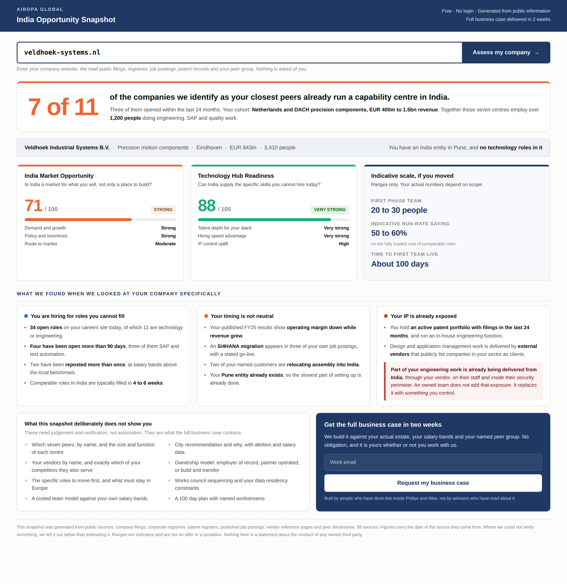
Mockup: the public self-serve snapshot, response mode STANDARD. Illustrative data.

9.10 Conversion metrics
The internal engine is measured on precision. The public surface is measured on conversion, and needs its own instrumentation from day one.
Metric | Definition | Why it matters
Run rate | Visitors who enter a domain, as a share of page visits | Measures whether the promise on the page is compelling enough to try
Completion rate | Runs that produce a STANDARD or EXISTING_CENTRE snapshot | Low values mean the entity resolver or the coverage floor is failing, not that traffic is bad
Mode distribution | Share of runs by response mode | Tells Airopa who is actually arriving, which should steer marketing spend
Request rate | Snapshots that convert to a business case request | The headline number for this surface
Share rate | Snapshots reopened from a different session or referrer | Proxy for forwarding. The main organic growth channel
Qualified rate | Business case requests that are genuine target companies | Guards against optimising for volume over fit
Meeting rate | Requests that become a meeting | The number that connects this surface to revenue
Correction rate | Snapshots a company contests | A rising value is an early warning on data quality. Target near zero
Cost per qualified request | Fully loaded engine cost divided by qualified requests | The figure that decides whether this stays free

Instrument all of these before launch. Retrofitting conversion analytics onto a live funnel wastes the first cohort of traffic, which is also the cohort that tells you most.

10. The internal assessment output
Three outputs per assessed company. The first two are machine readable, the third is the human deliverable.
Output | Contents
Record | Full signal set with evidence envelopes, gate result, all three scores with their dimension sub-scores, per-score coverage and confidence, cohort rank and percentile, narrative mode, exclusion and flag codes, configuration version
Summary | Gate result, three scores with bands, per-score coverage, top three scoring signals per score with their dates, recommended engagement model, ranked entry points, conflict flags
Brief | The written prospect brief and the on-screen assessment, generated only from resolved signals. Structure shown in Section 10.2

Mandatory on every output
- Gate result, stated explicitly as CONFIRMED, CLEAR, CLEAR_GREENFIELD or CAUTION, with the India title mix that justified it.
- Per-score coverage percentage, displayed beside each score.
- Narrative mode from rule 2 in Section 8.5.
- Every exclusion and flag code triggered, including flags that did not stop the assessment.
- The delta against any previous scores, with reasons.
- A flat list of every source URL used, company signals and reference data alike.

10.1 Every claim is generated, never asserted
Each narrative bullet in the output is generated from one or more resolved signals and carries their date and source. The generation layer has no licence to add facts. If a panel has no supporting signals, the panel is omitted, not filled with plausible text.
The one hard test for the narrative layer
Every sentence in the output must be traceable to a signal ID. If a reviewer asks where a sentence came from, the system must be able to name the signals behind it.
A sentence that cannot be traced is a defect, regardless of whether it happens to be true.

10.2 Output mockup
The following three pages show the intended assessment output for a single run. The company shown is fictional and every figure in it is illustrative, included to demonstrate layout and the relationship between the scores rather than to state any fact about a real company.
Screen 1 shows the assessment header: the resolved entity, the gate result with the title mix that justified it, the three scores with bands and cohort position, and the dimension breakdown for each score with a one-line evidenced basis under every bar.
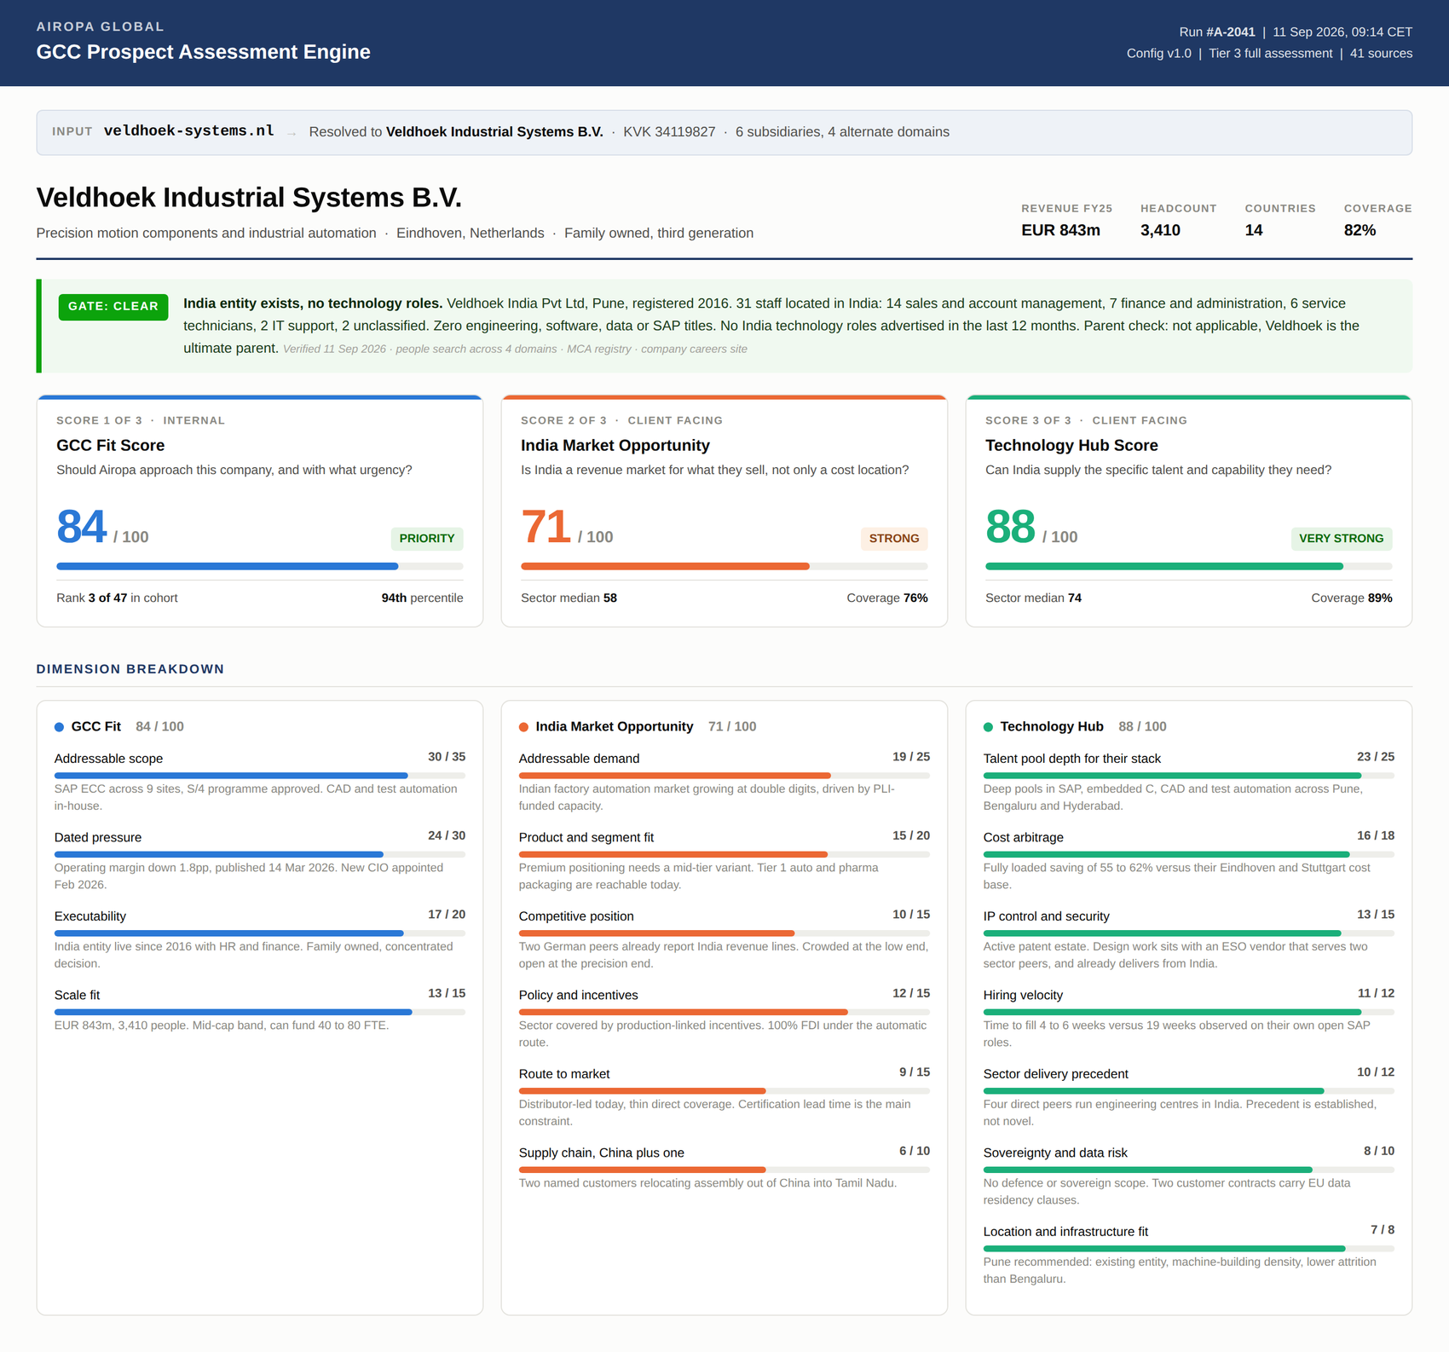
Mockup, screen 1 of 3: resolved entity, gate result, three scores, dimension breakdown. Illustrative data.

Screen 2 continues into the narrative. Each panel is generated from resolved signals and carries its dates and sources. Note that the peer table names UNKNOWN where a headcount could not be verified rather than estimating it, and that counter-evidence is carried deliberately in the peer panel because it is the objection the prospect raises first.
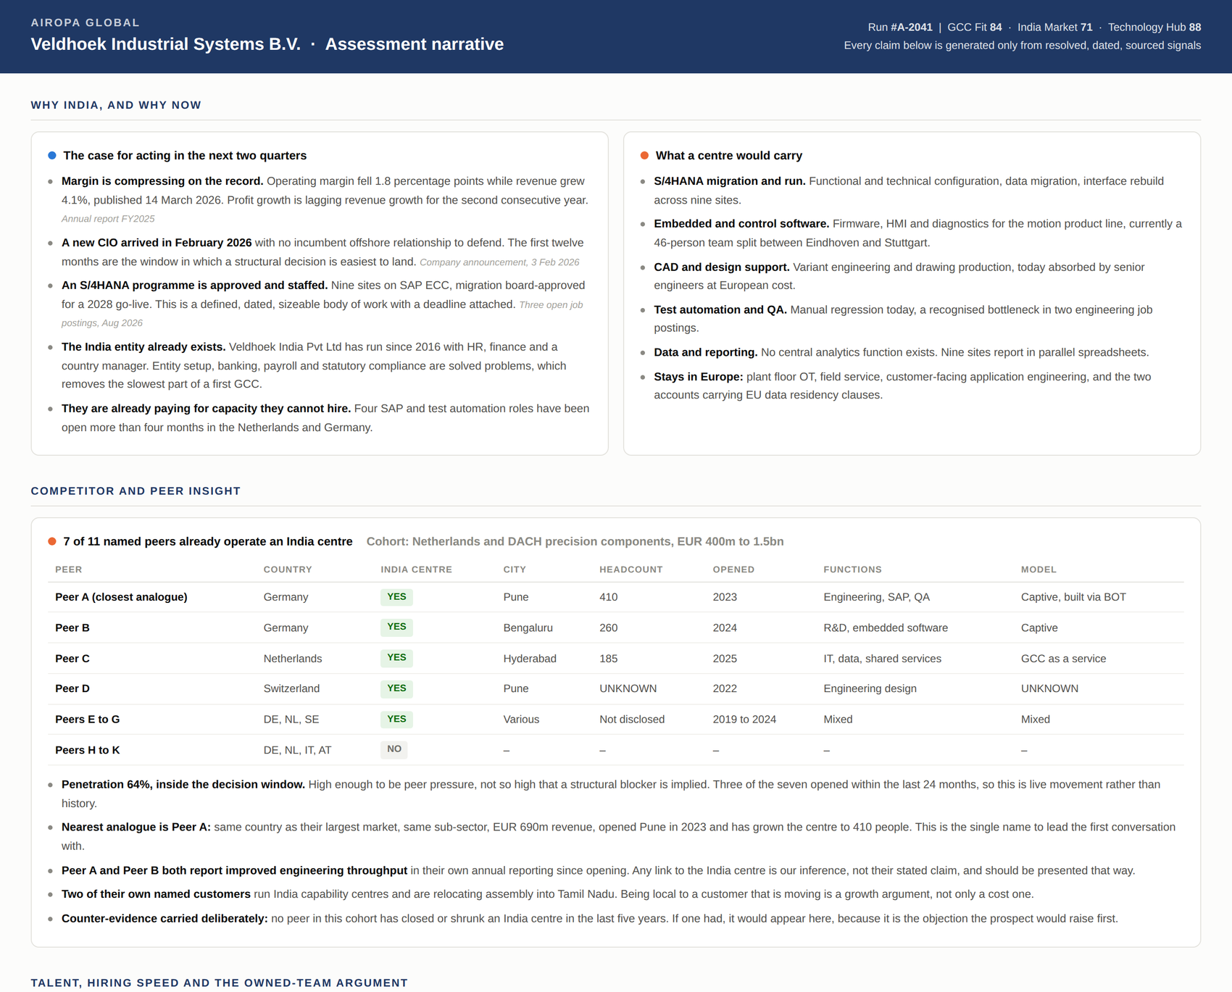
Mockup, screen 2 of 3: the case for acting now, candidate scope, and peer insight with cohort penetration. Illustrative data.

Screen 3 covers the delivery argument and the recommendation. The talent table is keyed to the skill families derived from the prospect's own estate and open roles, and sets the India fill time against the fill time observed on their own vacancies. The sovereignty panel names the constraints rather than omitting them.
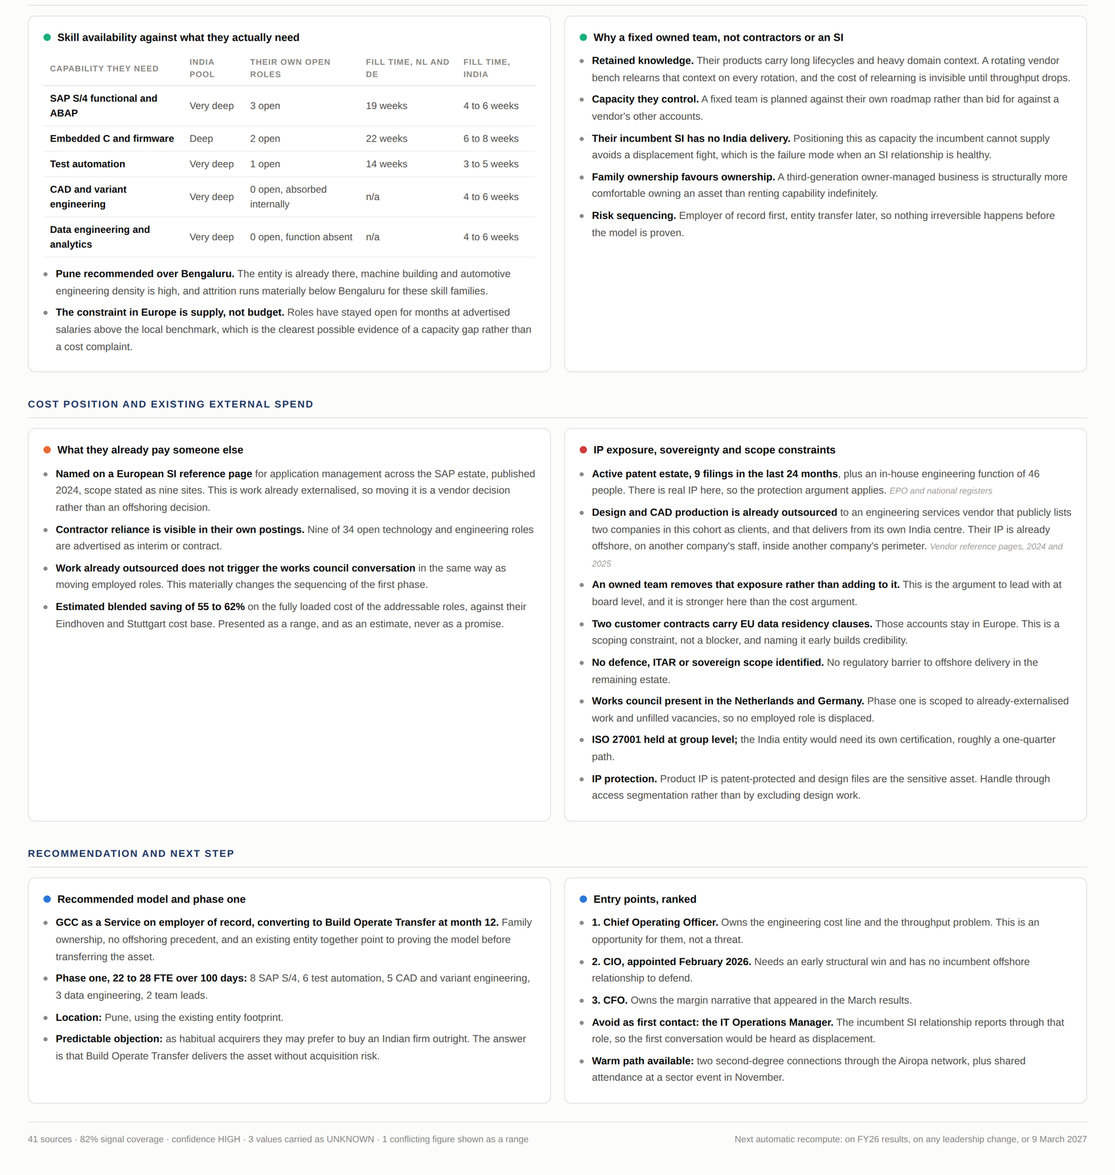
Mockup, screen 3 of 3: talent and hiring speed, the owned-team argument, cost position, sovereignty, recommended model and entry points. Illustrative data.

10.3 Panel inventory
The panels below are the required set. Each is generated only if its supporting signals resolved.
Panel | Drawn from | Purpose
The case for acting now | PRESS cluster | The dated urgency argument. Every bullet carries a date
What a centre would carry | SCOPE, SOV.03 to SOV.05 | Named candidate scope, and explicitly what stays in Europe
Peer and competitor insight | PEER cluster | Cohort penetration, nearest analogue, peer table, and counter-evidence
Skill availability | TAL.01 to TAL.07 | Required families against India depth and both fill times
Why a fixed owned team | TAL.15, COST.07, EXEC.04, SOV.06 | The owned-team argument against contractors and against an SI
Cost position and existing spend | COST cluster | Saving range, and the already-externalised scope that makes it a vendor decision
Sovereignty and constraints | SOV cluster | Named constraints, stated before the prospect raises them
India market access | DEM, POL clusters | Only rendered when narrative mode is DUAL or COST_LED
Recommended model and phase one | EXEC cluster, Section 10.4 | Model, FTE composition, location, predictable objection
Entry points | ROUTE cluster | Ranked contacts, who to avoid, warm paths

10.4 Recommended engagement model
A lookup from the executability profile, not a judgement call.
Condition | Recommended model
Can fund capex, wants to own the asset, has an ownership-relevant event such as a PE exit or an S/4 go-live | Build Operate Transfer, or Build Operate Transform Transfer
Wants the entity but not the operating burden | Company Owned Partner Operated
Family firm, partner owned, no offshoring history, or needs proof before ownership | GCC as a Service on employer of record. This is the default

11. Acceptance criteria
The engine is accepted when it reproduces the following outcomes, all of which come from Airopa's existing manual assessments. These are regression fixtures and must be re-run after every change to the gate, the dictionary, the reference data or the scoring weights.

11.1 Gate fixtures
Company | Expected gate | Why it is a test
Hettich | CONFIRMED, disqualify | Technology roles in India were found only through a people search, not through press or the website. Tests that the engine does not rely on public announcements
BHS Corrugated | CONFIRMED, disqualify | Second case missed by public-source research. Same test as above
Merck KGaA | CONFIRMED, disqualify | Large, publicly announced Bengaluru centre. Tests the announcement detection path
Hoermann KG | CLEAR, qualify | India entity exists since 2012 under a different trading name, Shakti Hoermann, with HR, finance and a managing director but no technology roles. Tests subsidiary-name resolution and the central rule that an entity alone does not disqualify
Drees und Sommer SE | CLEAR_GREENFIELD, qualify | No India entity, no India staff. Tests the greenfield path and the executability penalty
Statkraft | DISQUALIFY, code X4 | India divestment in 2025. Tests the divestment exclusion

11.2 GCC Fit score fixtures
Accepted within plus or minus 6 points of the manual assessment, with the sub-score pattern matching.
Company | Target | Sub-score pattern that must be reproduced
Hoermann KG | 84 / 100 | Scope 30, Pressure 22, Executability 19, Scale 13. Executability is high specifically because the India entity exists without technology roles
Drees und Sommer SE | 86 / 100 | Scope 32, Pressure 28, Executability 12, Scale 14. Executability is low because of greenfield plus a 48-partner consensus culture plus no CIO. Pressure is high because of dated peer moves and a publicly stated bottleneck

These two companies score within two points of one another by very different routes. A model that cannot reproduce both patterns is fitting to the total rather than to the dimensions, and will not generalise.

11.3 Fixtures still to be created
The two new scores have no manual precedent, so fixtures must be built before they can be validated. This is an Airopa task, listed in Section 12.
- Six companies scored manually for India Market Opportunity, chosen to span the range: two that clearly sell into India, two marginal, two whose products have no Indian market. The third pair is the important one, because it tests that the engine produces a low score and suppresses the market narrative rather than inventing an opportunity.
- Six companies scored manually for Technology Hub, spanning skill families: at least one whose required skills are genuinely scarce in India, so that a low score is observable.

11.4 Behavioural acceptance
- No output contains a numeric value without a source URL and a date. This includes every market size, growth rate and salary benchmark drawn from reference data.
- Running the same input twice on the same underlying data produces identical classifications and identical scores.
- A company with fewer than 10 India records returns CAUTION and is not scored.
- A company whose only India technology-adjacent titles are IT support or helpdesk returns CLEAR, not CONFIRMED.
- Two companies in the same sector assessed in the same quarter receive identical India market and talent reference figures.
- When narrative mode is COST_ONLY, the output contains no market-access claim anywhere, including in the summary.
- When Technology Hub is below 50, GCC Fit is capped at 60 and the DELIVERY_CASE_WEAK flag appears on the output.
- Every narrative sentence is traceable to at least one signal ID.
- Disqualified records are retained with their reason codes and are recoverable, not deleted.
- Tier 3 is never reached by a record that failed Tier 1.

Public surface acceptance
- No public payload contains the GCC Fit Score, any of its sub-scores, or any value derived from it. Assert this in code and test it, because it is the disclosure failure with the highest cost.
- No public payload contains the name of a peer company, a vendor, a system integrator, or any individual person.
- No public sentence states or implies wrongdoing, negligence or failure by any identifiable third party.
- A score with coverage below the publication floor is absent from the page entirely, rather than shown with a caveat.
- A gate CONFIRMED company receives the EXISTING_CENTRE mode and sees no language suggesting it is unqualified or has nothing to gain.
- A company below the scale floor receives SUB_SCALE, not an error and not a blank page.
- Every sentence on a public page traces to at least one signal ID, and every published run is retained in full and can be reconstructed.
- Entering a competitor domain, a free email provider domain or a non-company domain produces a safe, defined response rather than an assessment.

11.5 Success metrics, measured after the first 50 assessments
Metric | Definition | Baseline to establish
Coverage, per score | Mean share of applicable signals resolved with dated evidence | Measure on the back-test set first
Precision at the top | Of companies with GCC Fit 80 and above, the share that reply or take a meeting | From historical outreach outcomes
Analyst agreement | On a held-out set, how often each engine band matches the manual band | Target 80 percent or better per score
Gate accuracy | False CONFIRMED and false CLEAR rates against manual verification | Target zero false CLEAR. That is the costly error
Narrative defect rate | Share of briefs containing an untraceable or unsourced sentence, found in review | Target zero
Cost and time per assessment | Fully loaded, by tier | Compare against the manual process
Public conversion set | Run rate, request rate, share rate, qualified rate, meeting rate | Specified in full in Section 9.10. Instrument before launch
Correction rate | Public snapshots a company contests | Early warning on data quality. Target near zero

12. Open items for Airopa to resolve
These require a decision from Airopa, not from engineering. They are listed so the build is not blocked waiting for them and so the assumptions are visible.
# | Item | Needed by
1 | Back-test labels: outcome for every company already assessed, recorded as no reply, reply, meeting, proposal, won or dead, with the reason | Before weight tuning. This turns the scoring hypothesis into a model
2 | Manual fixtures for the two new scores, per Section 10.3 | Before those scores are used in client-facing material
3 | Final values for all thresholds marked TUNE | Before volume running
4 | Data sources for the India reference dataset: which market research, talent benchmark and policy sources Airopa will license or maintain | Before Score B and Score C can be computed at all. This is the critical path item
5 | Category taxonomy for DEM.01: the list of product and service categories Airopa will score against, and their mapping to market data | India reference dataset build
6 | Confirmed target geography list and sector exclusion list | Tier 1 build
7 | Seed export of the verified India capability centre reference list | Peer database build
8 | Current SI conflict list, confirmed and dated | Tier 1 build
9 | CRM export for deduplication under X17 | Tier 1 build
10 | Decision on internal-only versus a public facing score | Not needed until Tier 2 is complete. The data layer is identical either way
11 | Owner of the human review queue, and the review service level | Before first production run
12 | Confirmation of the lead capture design in Section 9.5: no gate on the snapshot, email only on the business case request | Public surface build
13 | Content design for EXISTING_CENTRE mode: what a company with an existing centre is benchmarked against and what is offered | Public surface build. Expect meaningful traffic here
14 | Blocklist: Airopa competitors, current clients, and any entity to be excluded from public assessment | Before public launch
15 | Owner and response time for the correction path in Section 9.6, and where contested claims are logged | Before public launch
16 | Legal review of the public page wording, in particular the IP exposure panel and the standing footer | Before public launch. Not optional
17 | Delivery capacity for the two week business case at expected request volume, and what happens when demand exceeds it | Before public launch. An unmet promise here is worse than no tool
18 | Domain, brand and placement for the public tool, and whether it sits on the Airopa site or its own | Public surface build

Items 4, 16 and 17 gate the public launch
Item 4, the India reference dataset, is the technical critical path. Items 16 and 17 are the commercial ones: a public page carries legal exposure that an internal brief does not, and a public offer of a two week business case creates a delivery obligation that must be capacity-checked before it is made.
The India Market Opportunity Score and the Technology Hub Score cannot be computed from public web research alone at acceptable quality. Category market sizes, salary benchmarks and talent pool depth need a source that is consistent, dated and licensed.
Until that source is chosen, build Score A and the two client-facing scores' structure, and leave their reference lookups stubbed. Do not let the engine improvise these figures. An invented market size inside an internal brief is embarrassing; the same figure on a public page, about a named real company, is a different order of problem.

13. Explicitly out of scope for version 1
- Any interface beyond the public snapshot page, the review queue, and the internal assessment view shown in Section 10.2.
- Automated outreach. The engine produces briefs; a human decides and sends.
- Self-serve delivery of anything beyond the snapshot. The business case is produced by people, not by the engine.
- Unsampled public publication. Section 9.6 sets the review requirement.
- Predictive modelling on conversion. That requires the back-test labels in item 1 and a materially larger sample.
- Live interactivity in the assessment view. The mockup shows a static render; hover detail and filtering are a later addition.

End of specification. Version 3.0, 11 September 2026.

