Weekly Report

On

“Job Portal For Informal Job Sector”

GETEMPLOYED



Prepared

By

Karthika Bingi

(STU629998f7812341654233335)

Department of Computer Engineering

Gokaraju Rangaraju Institute of Engineering And Technology

Autonomous under JNTU

November 2022

**WEEK 1**

**Problem Statement:**

Finding a good domestic worker or a driver is a task. But it’s also a difficult task for that good domestic worker or a driver to find a job. It has always been a problem in the unorganized sector to match the skills of blue-collar workers with available jobs. To bridge this gap, we decided to build a job portal website for an informal sector job.

**Background of the Problem:**

The current scenario has made it excessively difficult for people to find good domestic workers and those engaged in multiple odd jobs, mostly attributed to the informal sector. Those classified as informal sector occupations have difficulty finding jobs that match their skills. Web technologies can fill this gap by matching the work that needs to be done by the experts available locally with just a simple search. This approach also helps in negotiating money as both client and worker know the current market rate for a particular task and are paid accordingly**.**

**User / Customer:**

The end user of the website can be classified in two categories:

1. Worker: People who will register on the website to get a job related to their expertise.

2. Admin: Person who post jobs and required detail about jobs and view applied user for

posted jobs. All the rights and authority of website is with that person i.e., Admin of

website.

**WEEK 2**

**Proposed Solution:**

Our website (Our website (GETEMPLOYED) is dedicated to the informal job sector and shall enable the job seekers of this category to become independent, in terms of employment generation and income management. Our goal is to not only bridge the extensive gap between employers and blue or grey collar job workers but to organize the unorganized sector as well. GETEMPLOYED is interactive and accessible to the enriched employers and digitally backward workers. Our current and prospective employers/job seekers will find valuable information about our features on the homepage itself. Having a web-based portal has no agenda to question the less competitive workers who barely understand Internet and its services, it is to make them comfortable with the digitalized hiring solutions. In order to lessen their difficulty, we have built a simple login and register page for potential job seekers and they shall see numerous job opportunities with/without login.) is dedicated to the informal job sector and shall enable the job seekers of this category to become independent, in terms of employment generation and income management. Our goal is to not only bridge the extensive gap between employers and blue or grey collar job workers but to organize the unorganized sector as well. GETEMPLOYED is interactive and accessible to the enriched employers and digitally backward workers. Our current and prospective employers/job seekers will find valuable information about our features on the homepage itself. Having a web-based portal has no agenda to question the less competitive workers who barely understand Internet and its services, it is to make them comfortable with the digitalized hiring solutions. In order to lessen their difficulty, we have built a simple login and register page for potential job seekers and they shall see numerous job opportunities with/without login.

**Example of Existing Solution:**

• Naukri.com (https://www.naukri.com/)

• Just Jobs (<https://www.just.jobs/>)

**Comparison with Existing Solution:**

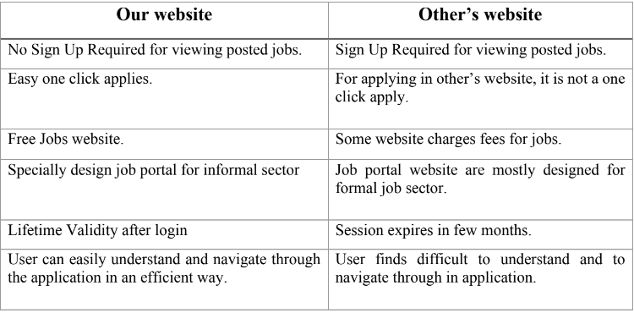

**WEEK 3**

**User Flow:**

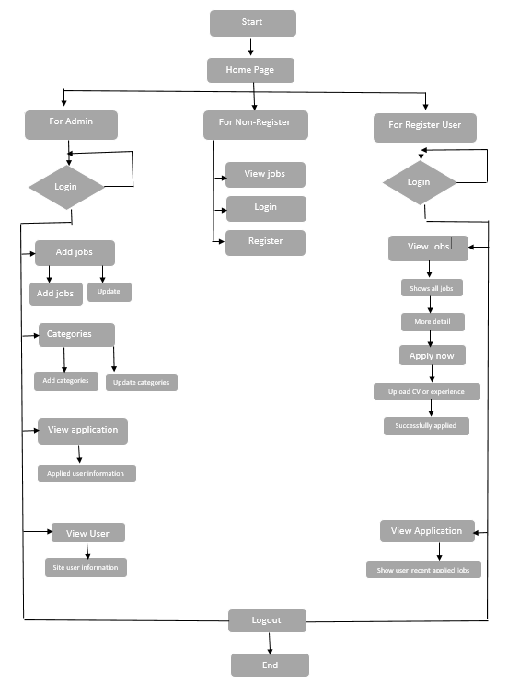

**Timeline Chart (Gantt Chart):**

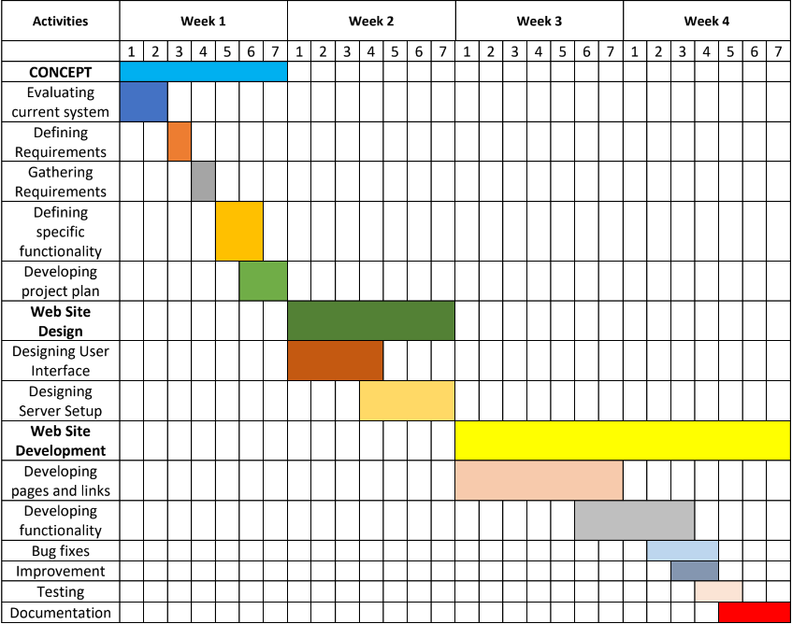

**WEEK 4**

**Link for the Website (Hosted on GitHub):**

**https://github.com/karthika-49/IBM-FS-Project-JOB-PORTAL-FOR-INFORMAL-JOB-SECTOR**