MUSIC PLAYER APPLICATION

case 1 : Create Database ( MusicPlayer) and Table(MusicFiles)

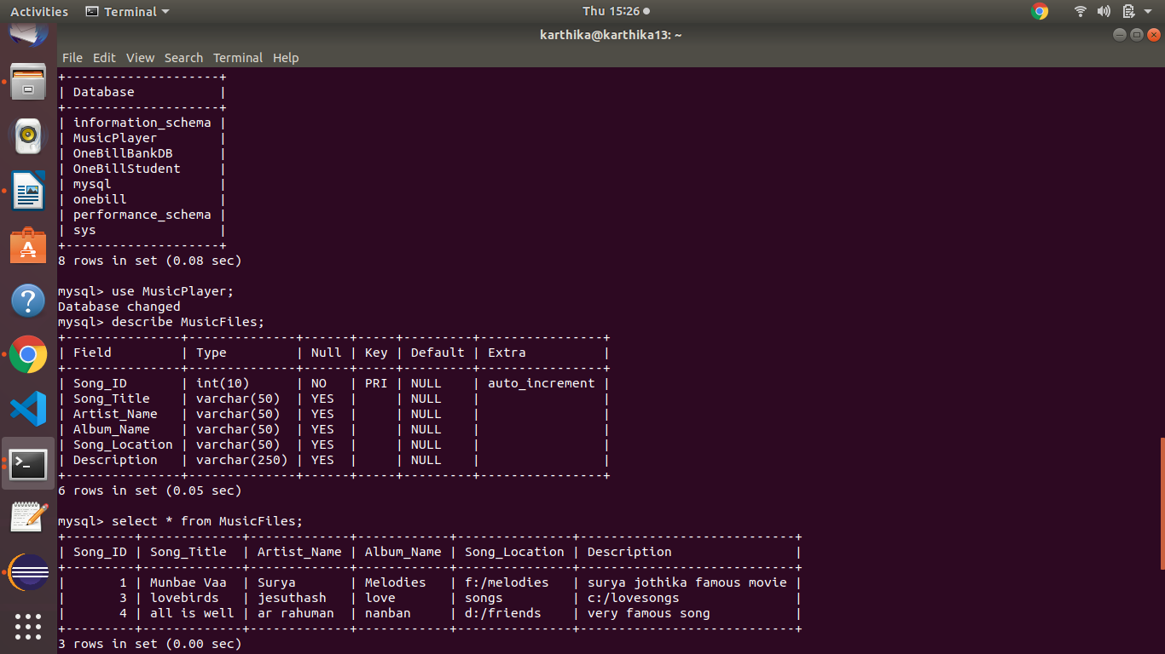

case 1 : Play a Song (All songs/Randomly/particulary)

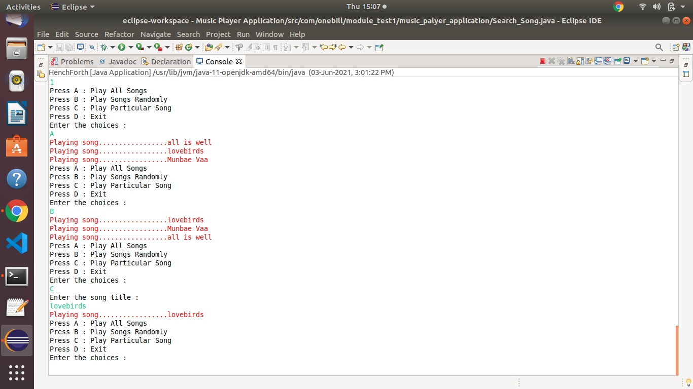

Case 2 : Search all songs

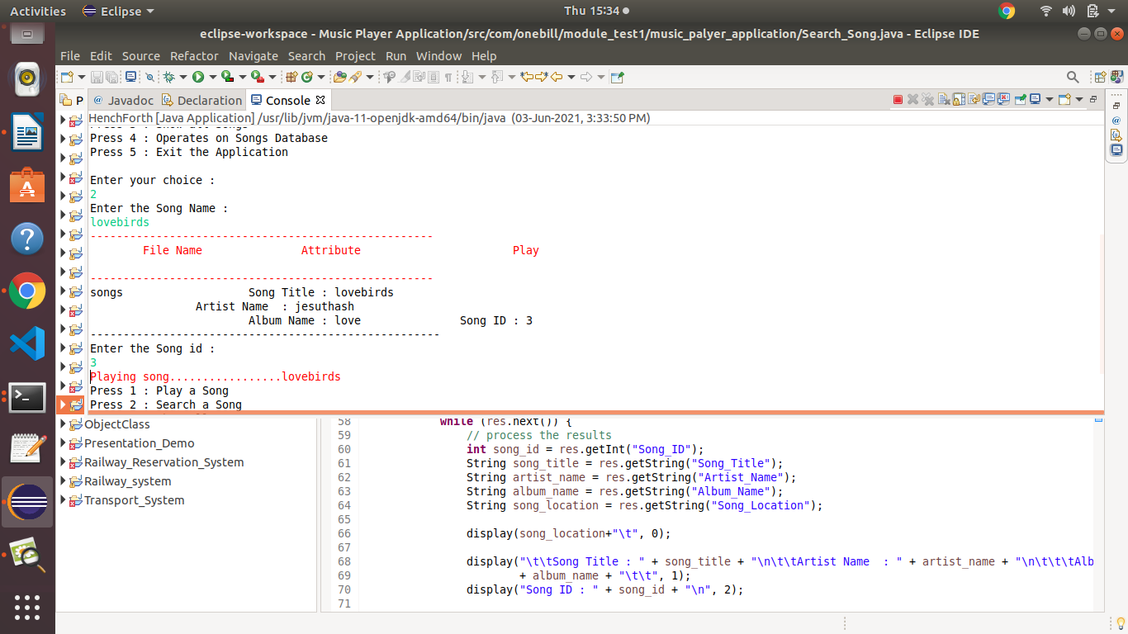

case 4 : Adding new song

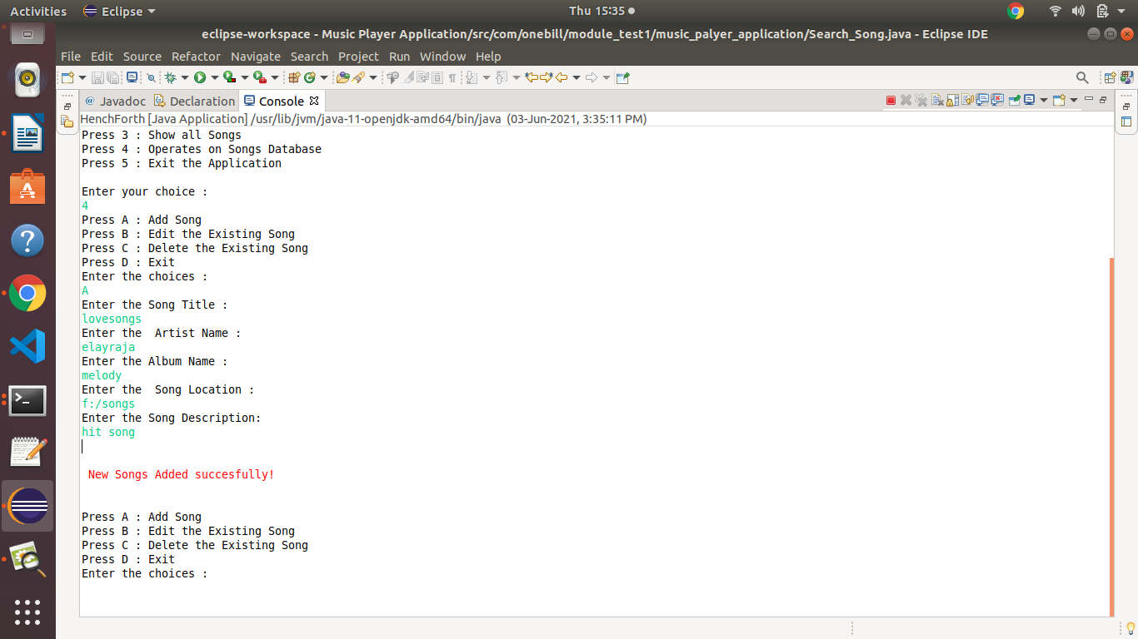

case 4: Edit & delete the song

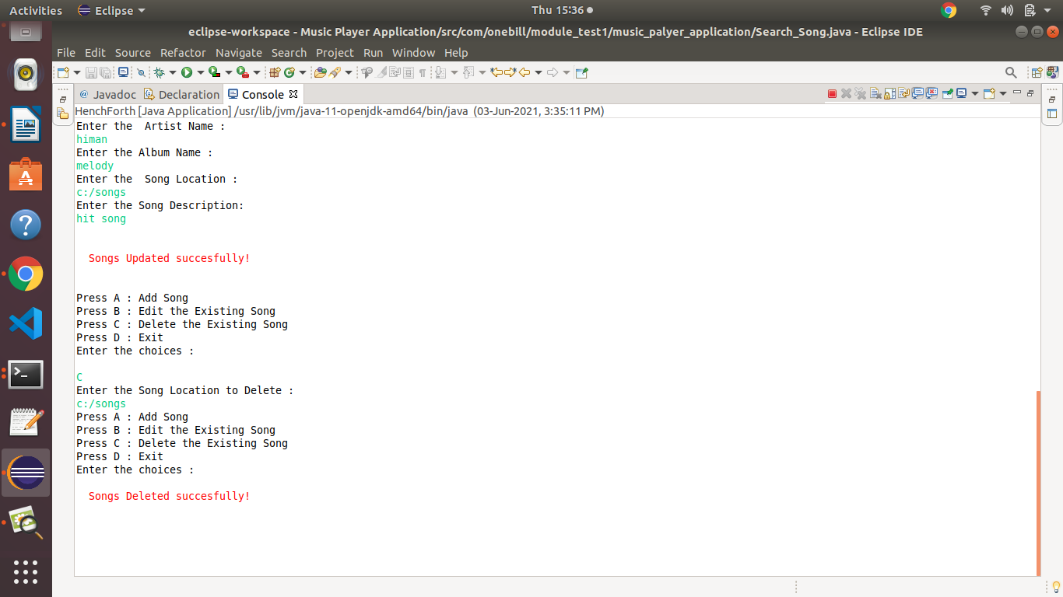

Case 3 : Show all the song

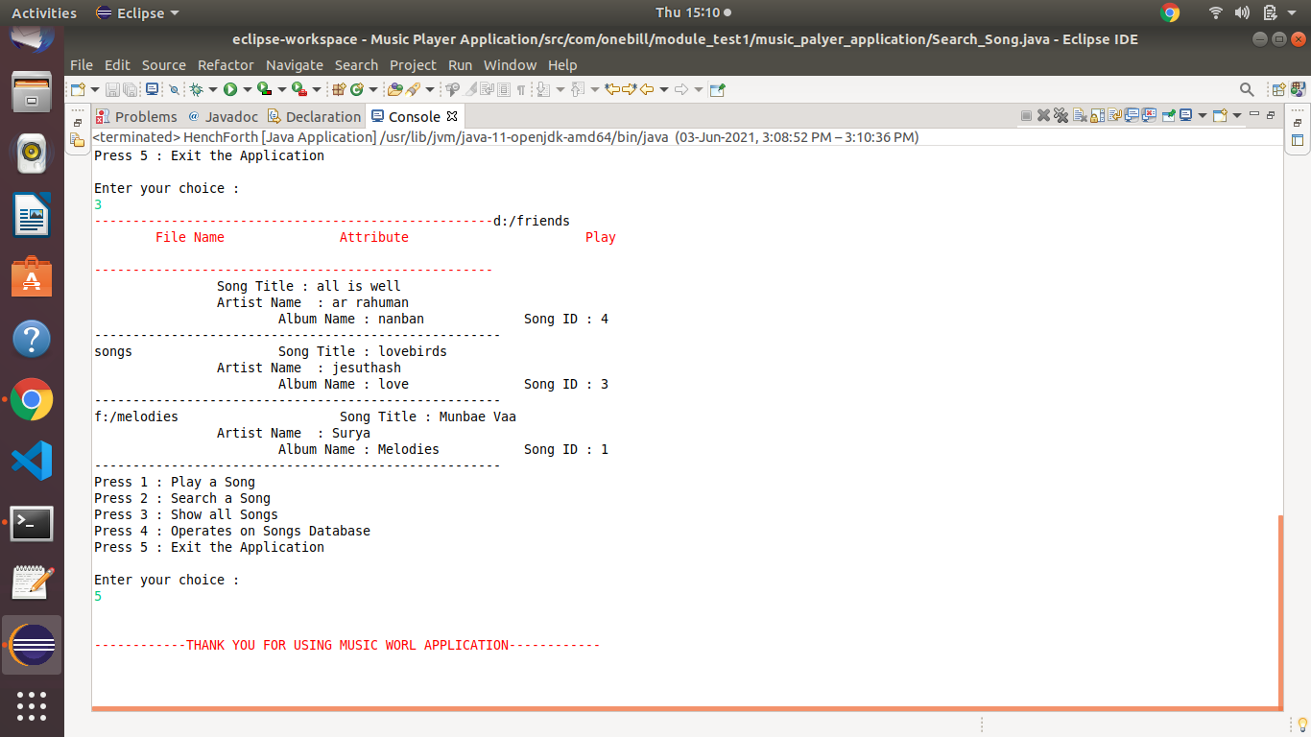

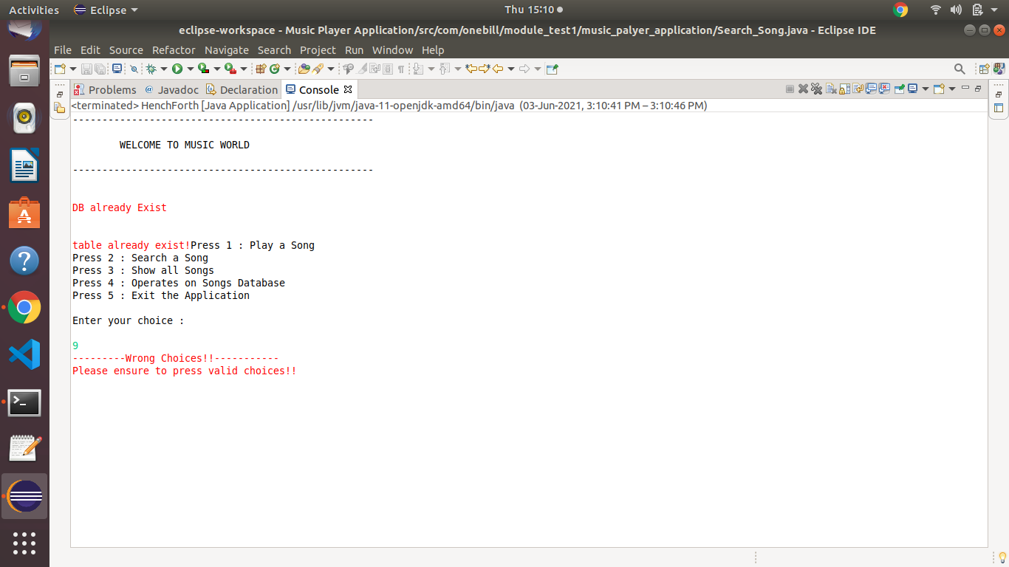
Error Controlling :

