Spring Data JPA - Quick Example
Create a Eclipse Project using Spring Initializr
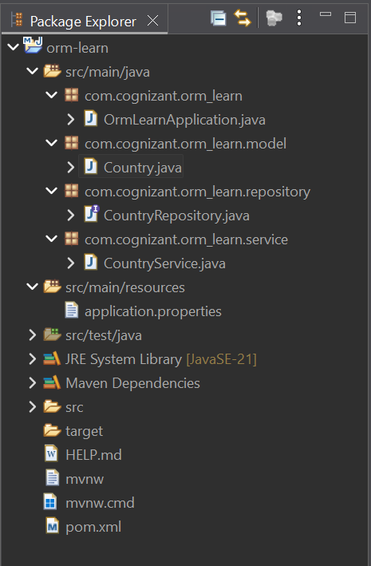

src/main/resources/application.properties
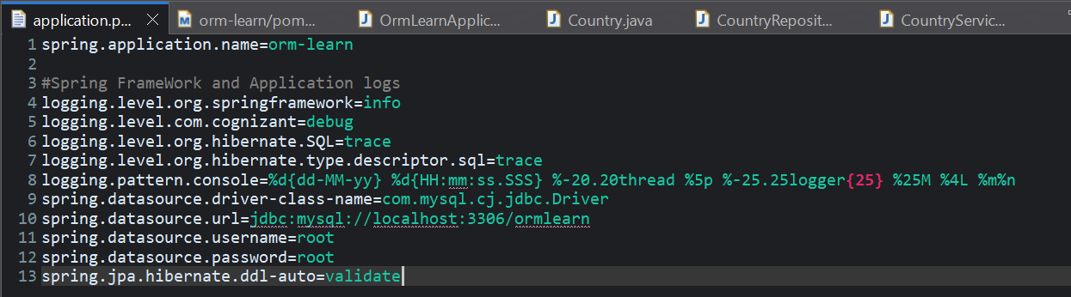

OrmLearnApplication.java
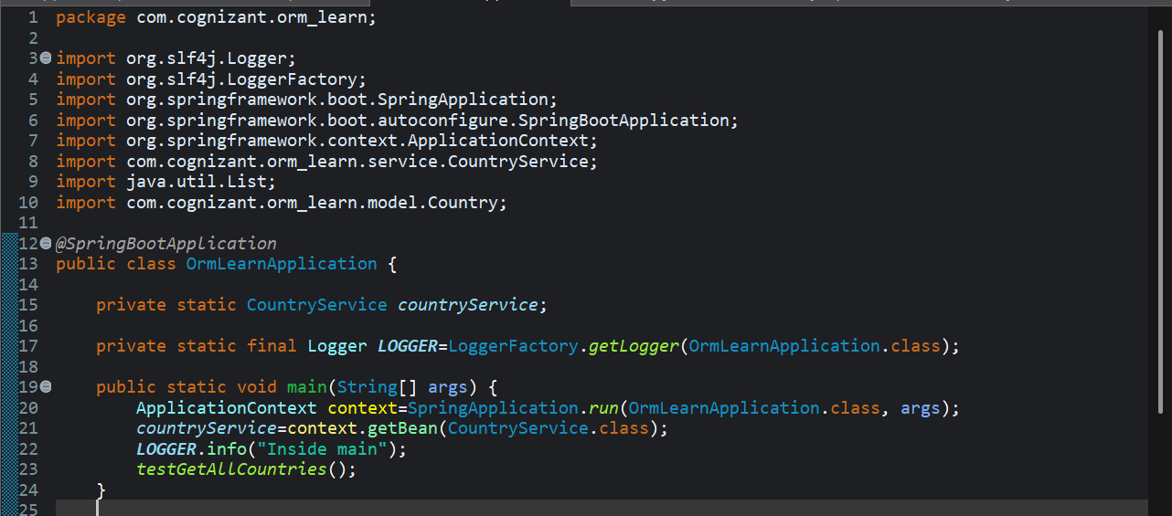

Country table creation
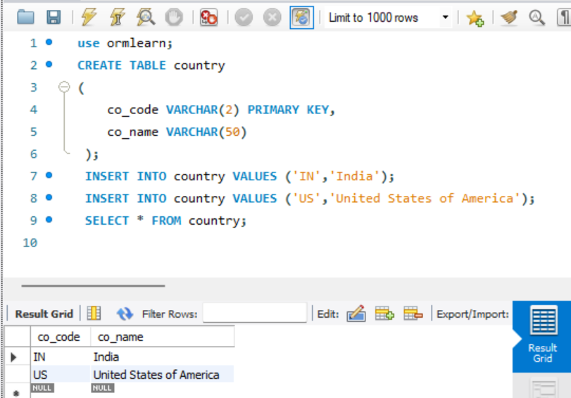

Persistence Class - com.cognizant.orm-learn.model.Country
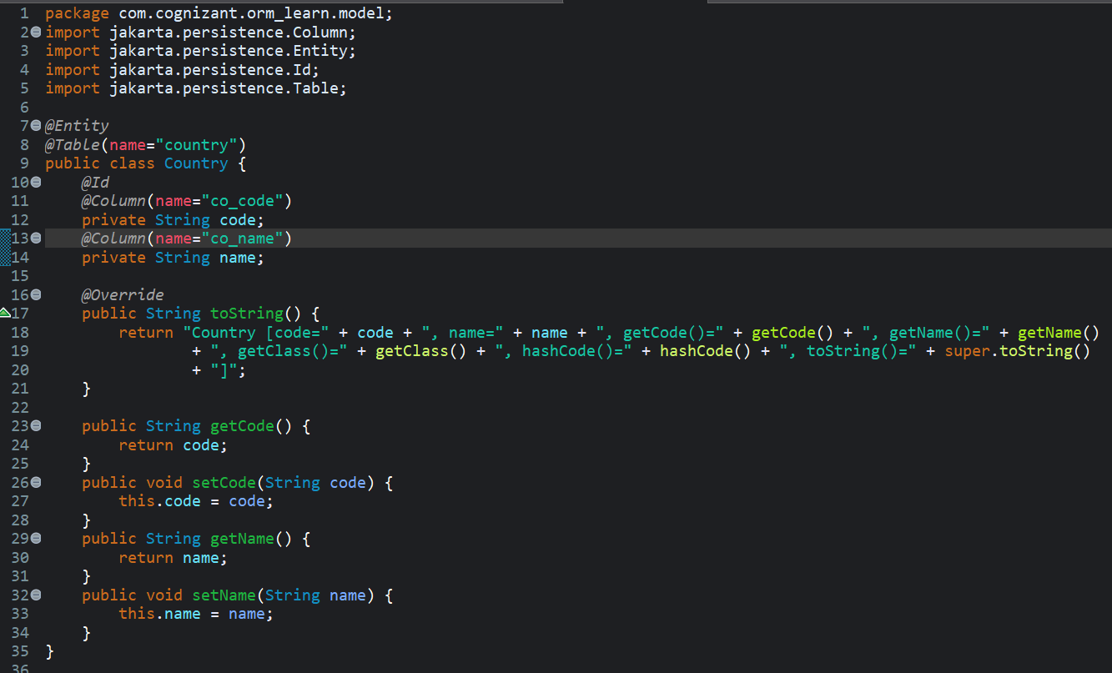

Repository Class - com.cognizant.orm-learn.CountryRepository
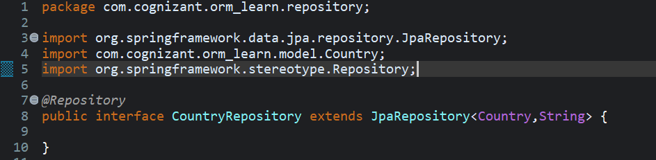

Service Class - com.cognizant.orm-learn.service.CountryService
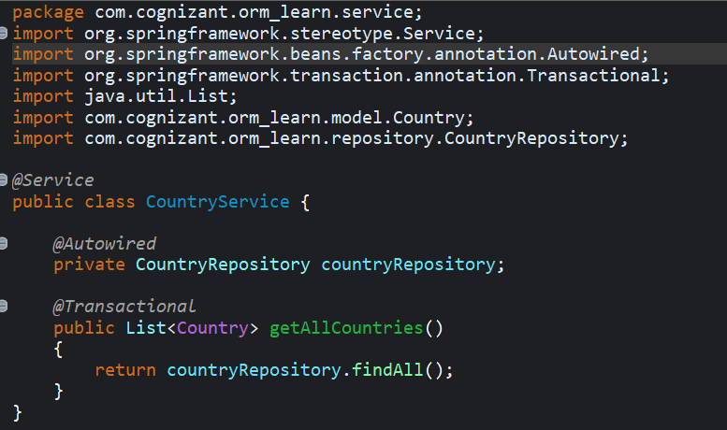
Testing in OrmLearnApplication.java
