Exercise 1 Code:
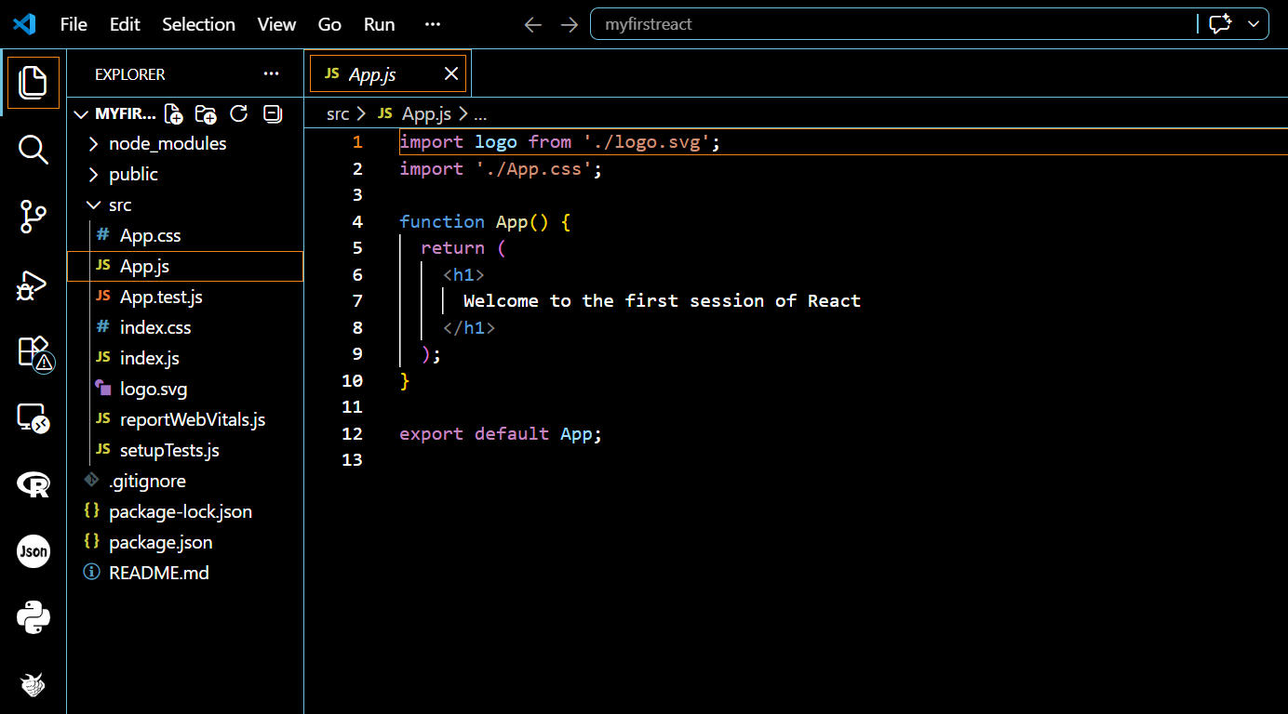

Exercise 1 Output:
