**Muthoot Institute of Technology and Science**

**Varikoli P.O, Puthencruz,**

**Ernakulam – 682308**



**Master of Computer Applications**

**LAB RECORD**

***Course Name: 20MCA133 WEB PROGRAMMING LAB***

NAME………………………………………..................

REG. NO………………………. SEMESTER………….

MONTH & YEAR…………………………………………

**Course Outcome 2**

# Program#1

**1.**: Generate the calendar using JavaScript code by getting the year and month from the user.

**PROGRAM CODE:**

<html><!DOCTYPE html>  
<!DOCTYPE html>  
<html lang="en">  
<head>  
<meta charset="UTF-8">

<meta name="viewport" content="width=device-width, initial-scale=1.0">

<title>Calendar Display</title>  
 <style>  
    table {  
      border-collapse: collapse;  
      width: 50%;  
      margin: 20px;  
    }  
  
    table, th, td {  
      border: 1px solid black;  
    }  
  
    th, td {  
      padding: 10px;  
      text-align: center;  
    }  
  
    #calendarContainer {  
      text-align: center;  
    }  
</style>  
</head>  
<body>  
  
<h1>Calendar</h1>  
  
  <div>  
    <label for="year">Enter Year:</label>  
    <input type="number" id="year" min="1900" max="2100" value="2023">  
    <label for="month">Enter Month:</label>  
    <input type="number" id="month" min="1" max="12" value="11">  
    <button onclick="displayCalendar()">Show Calendar</button>  
  </div>  
  
  <div id="selectedDate"></div>  
  
  <div id="calendarContainer"></div>  
  
  <script>  
    function displayCalendar() {  
      var year = document.getElementById("year").value;  
      var month = document.getElementById("month").value;  
      var selectedDate = document.getElementById("selectedDate");  
      var calendarContainer = document.getElementById("calendarContainer");  
 if (year < 1900 || year > 2100 || month < 1 || month > 12) {  
        alert("Invalid year or month");  
        return;  
      }  
  selectedDate.innerHTML = "<h2> " + getMonthName(month) + " " + year + "</h2>";  
 var firstDay = new Date(year, month - 1, 1);  
  var daysInMonth = new Date(year, month, 0).getDate();  
 var table = <th>Sat</th></tr><tr>";  
"<table><tr><th>Sun</th><th>Mon</th><th>Tue</th><th>Wed</th><th>Thu</th><th>Fri</th   
 for (var i = 0; i < firstDay.getDay(); i++) {  
 table += "<td></td>";  
      }

for (var day = 1; day <= daysInMonth; day++) {  
        table += "<td>" + day + "</td>";  
  
        if ((firstDay.getDay() + day) % 7 === 0) {  
          table += "</tr><tr>";  
        }  
      }  
  
      table += "</tr></table>";  
  
      // Display the calendar  
      calendarContainer.innerHTML = table;  
    }  
  
    function getMonthName(month) {  
      var monthNames = [  
        "January", "February", "March", "April", "May", "June",  
        "July", "August", "September", "October", "November", "December"  
      ];  
      return monthNames[month - 1];  
    }  
</script>  
</body>  
</html>

**OUTPUT:**

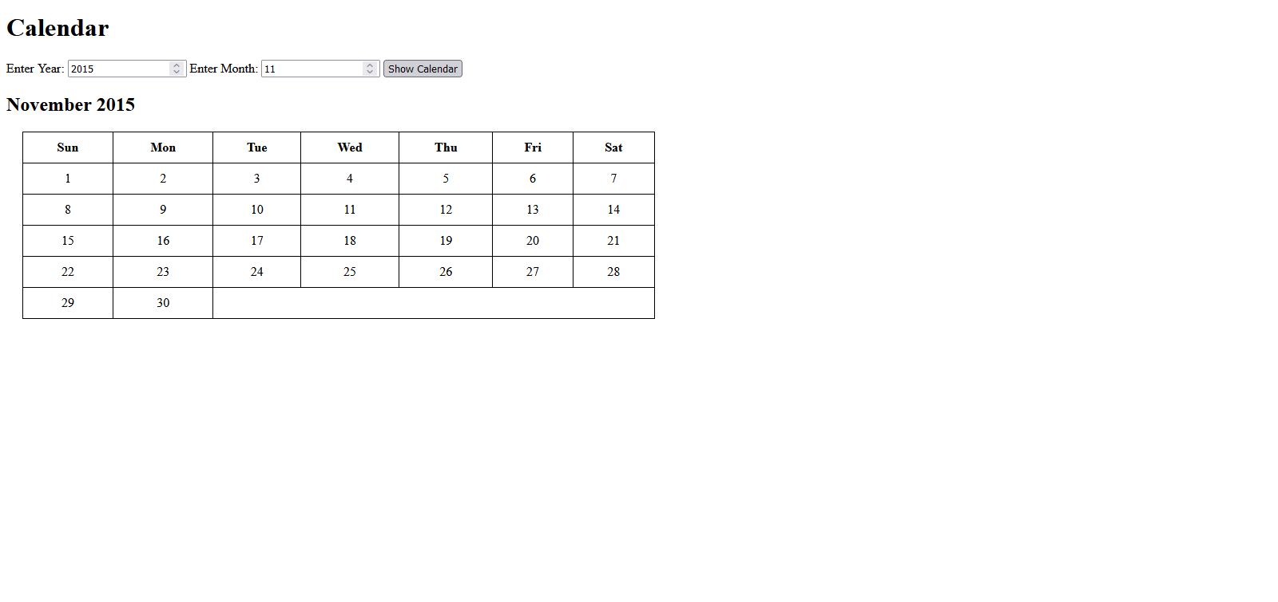

**Course Outcome 1**

# Program#2

**2.** Create an HTML page to explain the use of various predefined functions in a string and mathobject in java script.

**PROGRAM CODE:**

Form.html

<html>  
<head>  
<frameset cols="30%,60%">  
<frame SRC="mathfunction.html">  
<frame SRC="string.html">  
</frameset>  
</head>  
</html>

mathfunction.html

 <html>  
  <head>  
  </head>  
  <body>  
  <div>  
  <h2>Math Functions</h2>  
  <table>  
  <tbody>  
 <tr>  
                    <th>Enter Numbers (comma-separated)</th>  
                    <td> <input type="text" id="input_numbers"></td>  
                </tr>  
                <tr>  
                    <th>Power term</th>  
                    <td> <input type="text" id="input_pow"></td>  
    </tr>  
    </tbody>  
    </table>  
<input type="button" value="Generate" class="selector" onclick="math_func()">  
 <br><br>  
 <ul id="output_math"> </ul>  
 </div>  
  <script>  
        function math_func() {  
            let inputNumbers = document.getElementById('input_numbers').value.split(',').map(Number);  
            let power = document.getElementById('input_pow').value;  
            let li_O = '<li>';  
            let li_C = '</li>';  
            let list_items;  
  
            list_items = li_O + 'Value of PI  : ' + Math.PI + li_C;  
            list_items += li_O + 'Minimum of the list is : ' + Math.min(...inputNumbers) + li_C;  
            list_items += li_O + 'Maximum of the list is : ' + Math.max(...inputNumbers) + li_C;  
            list_items += li_O + 'Round of the first number is : ' + Math.round(inputNumbers[0]) + li_C;  
            list_items += li_O + 'Power of the first number is : ' + Math.pow(inputNumbers[0], power) + li_C;  
            list_items += li_O + 'Square root of the first number is : ' + Math.sqrt(inputNumbers[0]) + li_C;  
            list_items += li_O + 'Absolute value of the first number is : ' + Math.abs(inputNumbers[0]) + li_C;  
            list_items += li_O + 'Ceil value of the first number is : ' + Math.ceil(inputNumbers[0]) + li_C;  
            list_items += li_O + 'Floor value of the first number is : ' + Math.floor(inputNumbers[0]) + li_C;  
            list_items += li_O + 'Sin value of the first number is : ' + Math.sin(inputNumbers[0] * Math.PI / 180) + li_C;  
            list_items += li_O + 'Cos value of the first number is : ' + Math.cos(inputNumbers[0] * Math.PI / 180) + li_C;  
            list_items += li_O + 'A Random number is : ' + Math.random() + li_C;  
  
            document.getElementById('output_math').innerHTML = (list_items);  
        }  
    </script>  
  </body>  
</html>

**OUTPUT:**

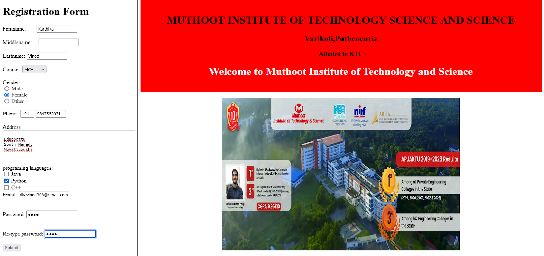

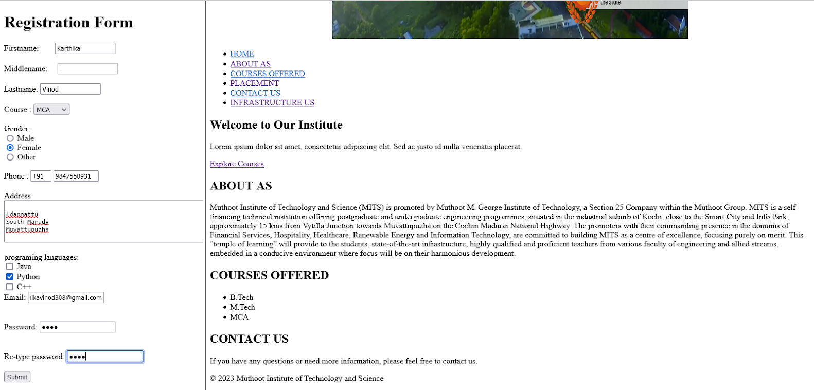

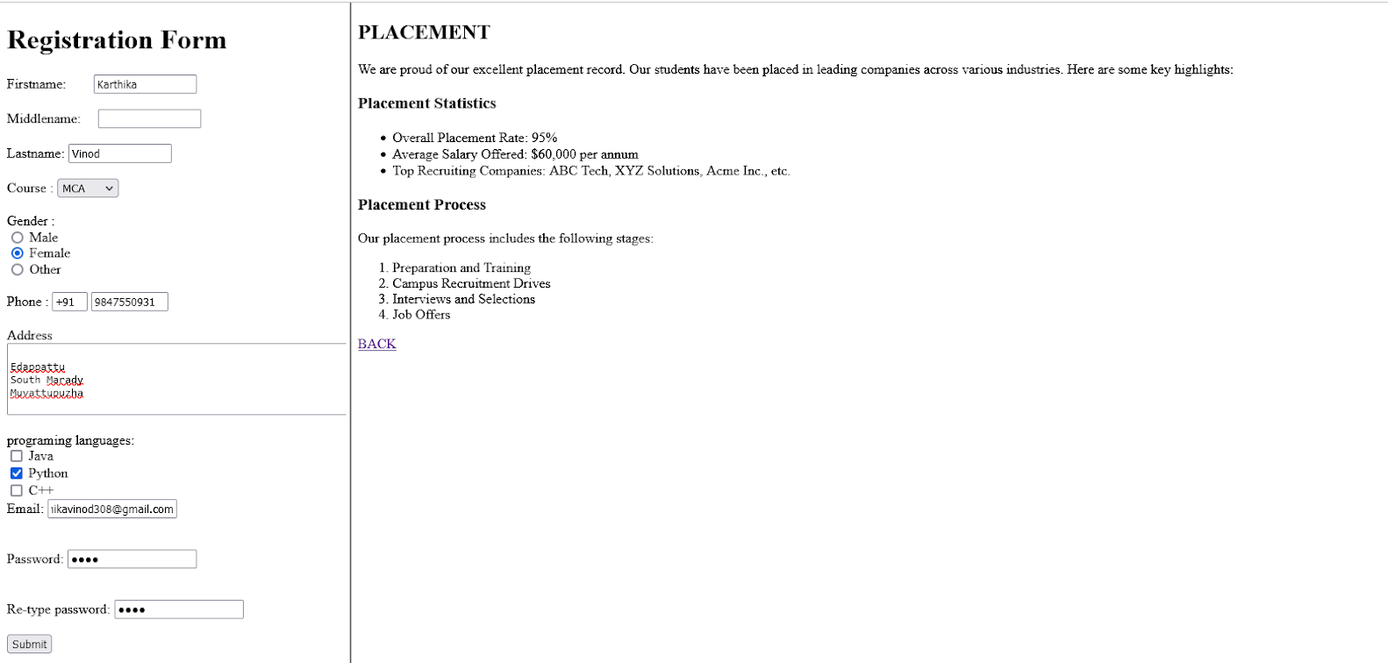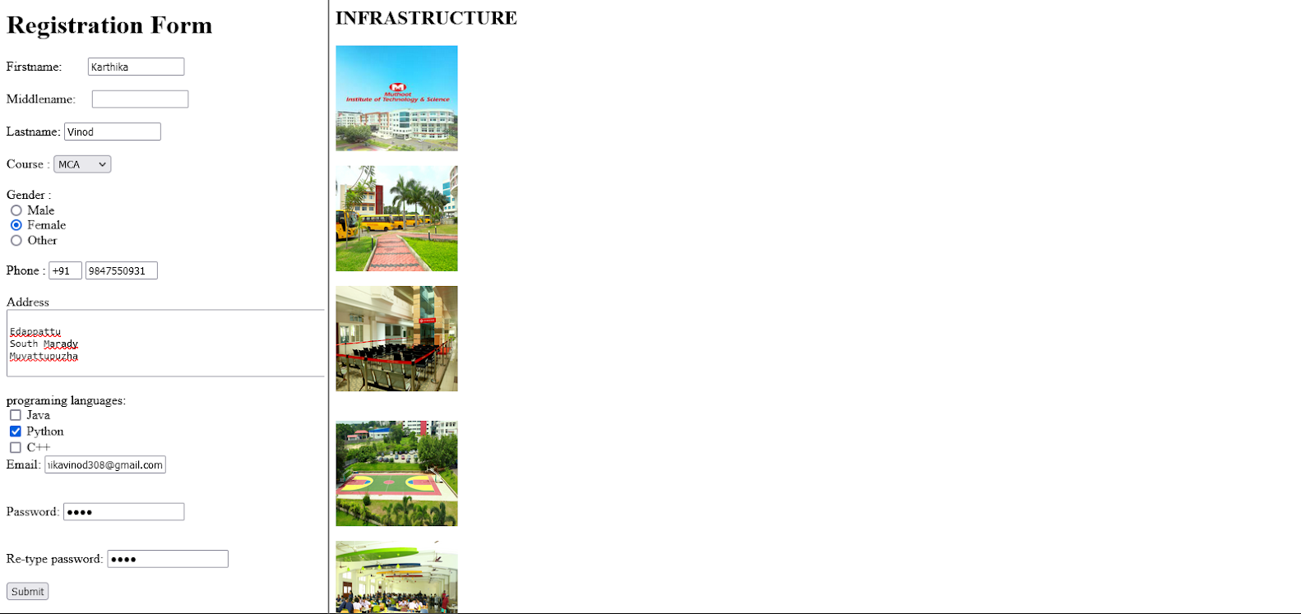

**Course Outcome 1**

# Program#3

**3.** Create a web page showcasing the attractions and highlights of your hometown using Html, and External, Internal, and inline CSS. In the webpage the following elements should be included.a. Html text formatting tags. b. Links to external web site pages for further references e.g.: Wikipedia c. External, Internal, and Inline CSS d. CSS should include font colour, positioning, background colours, text alignment etc.

**PROGRAM CODE:**

marady.html

<!DOCTYPE html>  
<html lang="en">  
<head>  
<meta charset="UTF-8">  
<meta name="viewport" content="width=device-width, initial-scale=1.0">  
<title>Marady - Tourist Attractions</title>  
<!-- External CSS -->  
<link rel="stylesheet" href="styles.css">  
</head>  
<body>  
<header>  
<center> <img src="marady.jpg" width="700" height="450"></center>  
<h1 align="center" style="color: red;">Welcome to Marady</h1>  
<nav>  
<ul>  
<li><a href="#ABOUT">ABOUT MARADY</a></li>  
<li><a href="PLACES">MAIN PLACES</a></li>  
<li><a href="EDUCATION">EDUCATIONAL ORGANISATIONS</a></li>  
 <li><a href="tourism.html">TOURISM</a></li>  
<li><a href="spirit.html">SPIRITUAL VISIT</a></li>  
<li><a href="<https://www.onefivenine.com/india/villages/Ernakulam/Muvattupuzha/Marady>">LEARN MORE</a></li>  
<li><a href="<https://www.youtube.com/watch?v=z7izOvzn59M>">CLICK TO SEE VIDEO</a></li>  
 </ul>  
</nav>  
 <section id="about">  
<div class="container">  
<h2>ABOUT MARADY</h2>  
<p>Marady is a village in Ernakulam district in the Indian state of Kerala.[1]  
  
Marady Grama Panchayath office is located in South Marady. Areas near to MC Road is Known as East Marady. Areas which is near to Muvattupuzha town is known as North Marady. All remaining areas are known as South Marady which is covered by Muvattupuzha piravam Road.  
  
Major Hindu Religious attractions are Marady Bhagavathy temple ( Marady Kavu), Aruvikkal Devi Temple, Trikka Mahadeva temple and Sree krishna temple.  
  
Major Christian Churches are St. Mary's Jacobite Syrian Church in Kurukkunnapuram, St. George Jacobite Syrian Church in Erattayanikkunnu, Mor Gregorios Jacobite Syrian Church in North Marady, Mount Horeb St. Thomas Jacobite Syrian Church in South Marady and St. George Catholic Church in East Marady.  
  
Marady Grama Panchayath comes under Muvattupuzha assembly constituency, which in turn is a part of Idukki (Lok Sabha constituency).[2]  
  
The Marady Grama Panchayath consists of thirteen wards and the present panchayath president is Sheri O.P. Baby udf .</p>  
</header>  
 <section id="about">  
<div class="container">  
<h2>MAIN PLACES</h2>  
<ul>  
<li><a href="#EAST MARADY">EAST MARADY</a></li>  
<li><a href="SOUTH MARADY">SOUTH MARADY</a></li>  
 <li><a href="NORTH MARADY">NORTH MARADY/a></li>  
<li><a href="KAYANDU">KAYANADU</a></li>  
</ul>  
<a href="tourism.html">next</a>  
</body>  
</html>

Tourism.html

<html>  
<head>  
</head>  
<body>  
<section id="places">  
<div class="container">  
<h2>TOURISM</h2>  
<nav>  
<ul>    
 <li><a href="#<https://www.youtube.com/shorts/ea11hHRxhWo>">AREEKAL WATERFALL</a></li>  
 <li><a href="<https://www.youtube.com/shorts/5qa4DJkKAsk>">SHOOLAM WATERFALL</a></li>  
 <li><a href="<https://www.youtube.com/shorts/NYj6eFCNpEIE>">KOCHAREEKAL CAVE</a></li>  
 </ul>  
</nav>  
 <section id="about">  
<div class="container">  
<h2>AREEKAL WATERFALL</h2>  
<P>Great place to hangout with family. Went in with no expectations. But surprisingly good. Went in a weekday therefore there was no crowd at all and so explored the place to its fullest. I felt safe for babies also my daughter had a blast there spend till the sun down. This place has a better toilet and dress changing facilities. The food options are limited nearby better to have it from the town itself. Nearby there is a toddy shop and a bakery which serves food but the options are limited such as appam, Kappa, beef, pork, fish etc.</P>  
<center> <img src="aree1.jpg" width="600" height="250"></center>  
<br>  
 <section id="about">  
<div class="container">  
<h2>SHOOLAM WATERFALL</h2>  
<P>The waterfalls is beautiful but felt that it may get dried out during summer. The best time to visit will be June to September. There are no much shopping around. One should have costume for getting in water as it is allowed to be under the waterfall which will be a very good experience. There are change rooms to change your clothing. A prepared visit will be worth to spend few hours.</P>  
<center> <img src="shoolam1.jpg" width="400" height="250"></center>  
<center> <img src="shoolam2.jpg" width="400" height="250"></center>  
<center> <img src="shoolam3.jpg" width="400" height="250"></center>  
<br>  
<section id="about">  
<div class="container">  
<h2>KOCHAREEKAL CAVE</h2>  
<p>Quite a good place to visit and relax with friends and family. Aged people might find it difficult to walk down. There is no paved pathway. You'll have to walk down through the soil pathway and there are a few steps also. Lush greenery. Good atmosphere. Kinda hidden place, you'll be able to locate with gmaps. Not crowded. The place is not kept very clean.Parking space is available and they charge for it.  
I guess it is better to visit during the rainy season or at a time when there is water. We paid a visit during February so there was very little water.  
You can also visit the Areekal waterfall along with this place. Which is just about 10 minutes away.</p>  
<center> <img src="koch.jpg" width="400" height="250"></center>  
<br>  
<a href="mardy.html">back</a>  
</body>  
</html>

Sprit.html

 <html>  
<head>  
</head>  
<body>  
<section id="places"> <div class="container">  
 <h2>EDUCATIONAL ORGANISATIONS</h2>  
<nav>  
<ul>    
<li><a href="#SCHOLL">GVHSS E MARADY</a></li>  
<li><a href="SCHOOL">GUPS SOUTH MARADY</a></li>  
<li><a href="SCHOOL">HOLY FAMILY</a></li>  
<li><a href="#SCHOLL">GLPS MARADY</a></li>  
<li><a href="SCHOOL">GLPS KAYANAD</a></li>  
<li><a href="COLLEGE">COCHIN INSTITUTE OF TECHNOLOGY</a></li>  
<li><a href="COLLEGE">MOOKAMBIKA TECHNICAL CAMPUS</a></li>  
</ul>  
</nav>  
<br>  
<section id="places">  
<div class="container">  
<h2>SPIRITUAL VISIT</h2>  
<nav>  
<ul>    
<li><a href="#AMBALAM">MARADY KAVU DEVI TEMPLE</a></li>  
<li><a href="KAV">AREEKAL KAV</a></li>  
<li><a href="KSHETHRAM">THRIKA MAHADEVA SHEKTHRAM</a></li>  
<li><a href="#CHURCH">ST.GEORGE JACOB'S CHURCH ERATTIYANIKUNN</a></li>  
<li><a href="CHURCH">ST.MARYS KURUKKUNNAPURAM</a></li>  
<li><a href="CHURCH">ST.GEORGE E.MARADY</a></li>  
</ul>  
</nav>

</body>

</html>

**OUTPUT:**

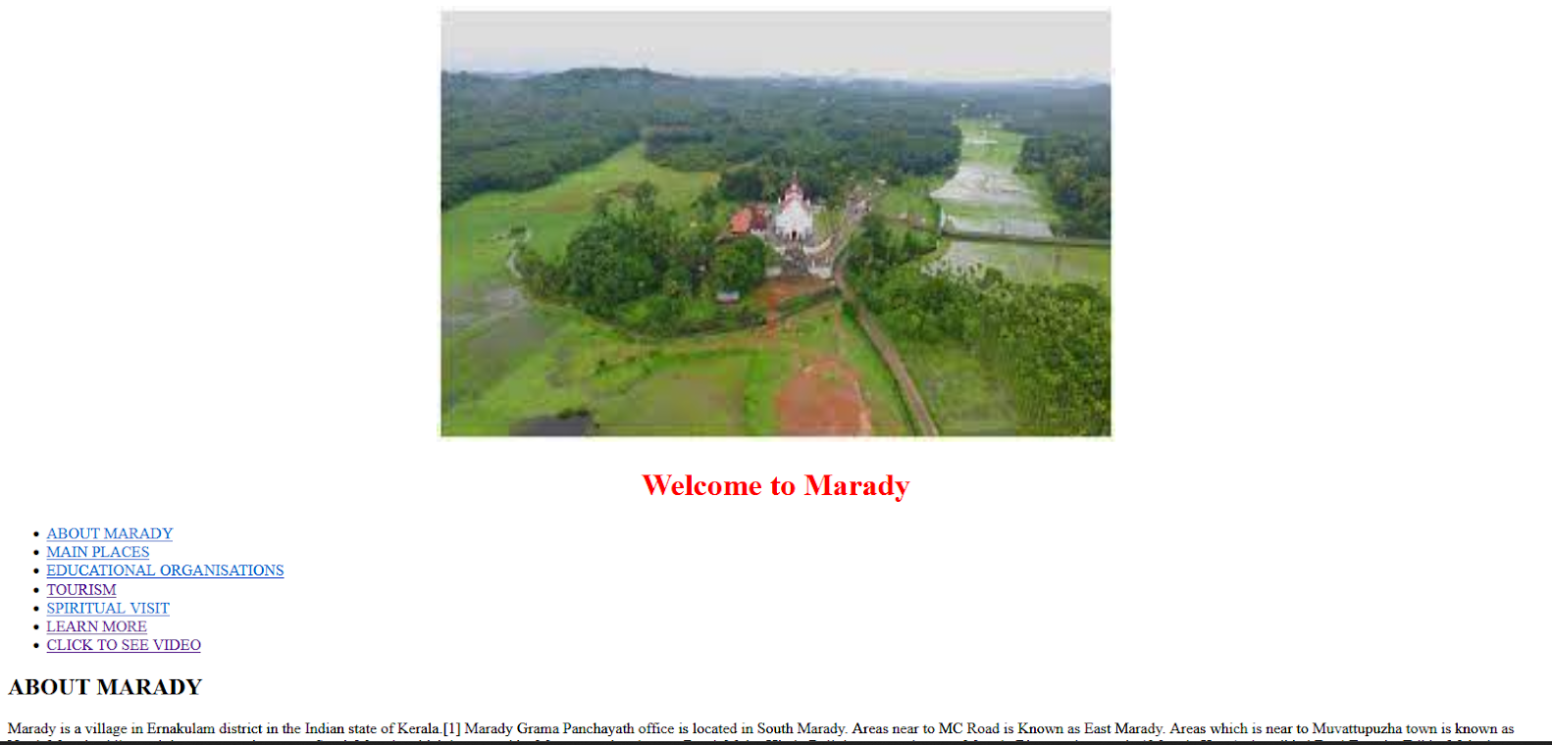

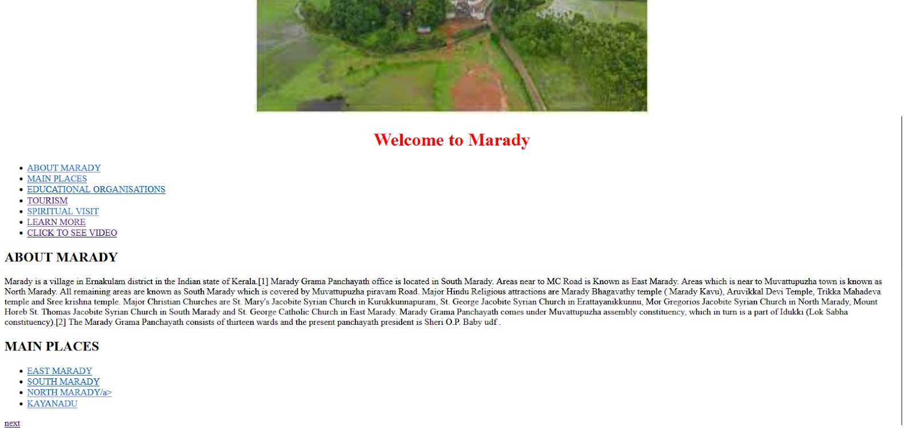

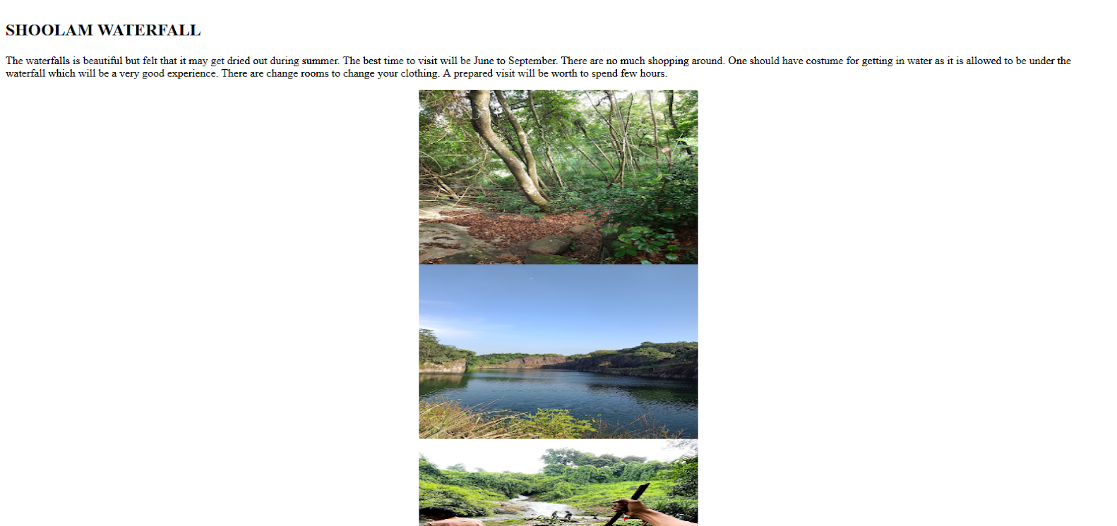

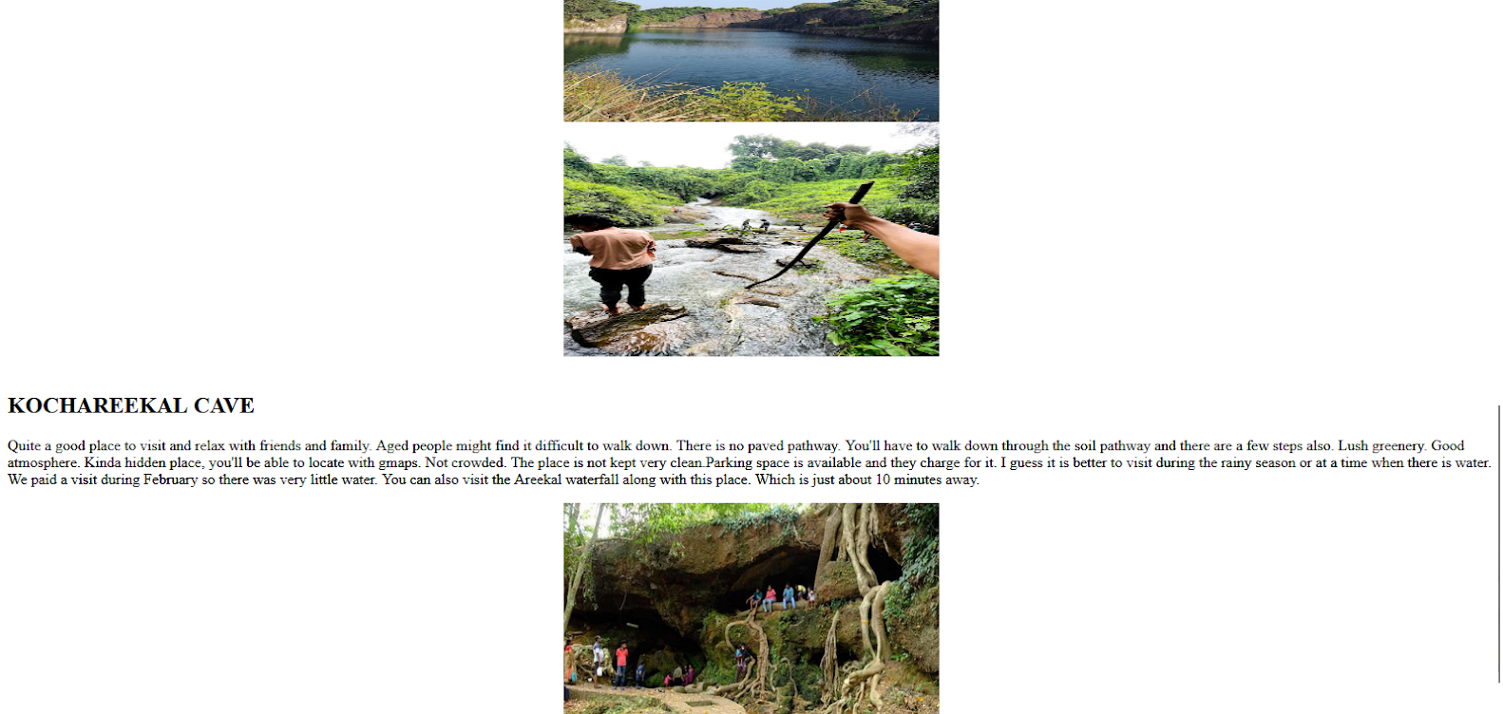

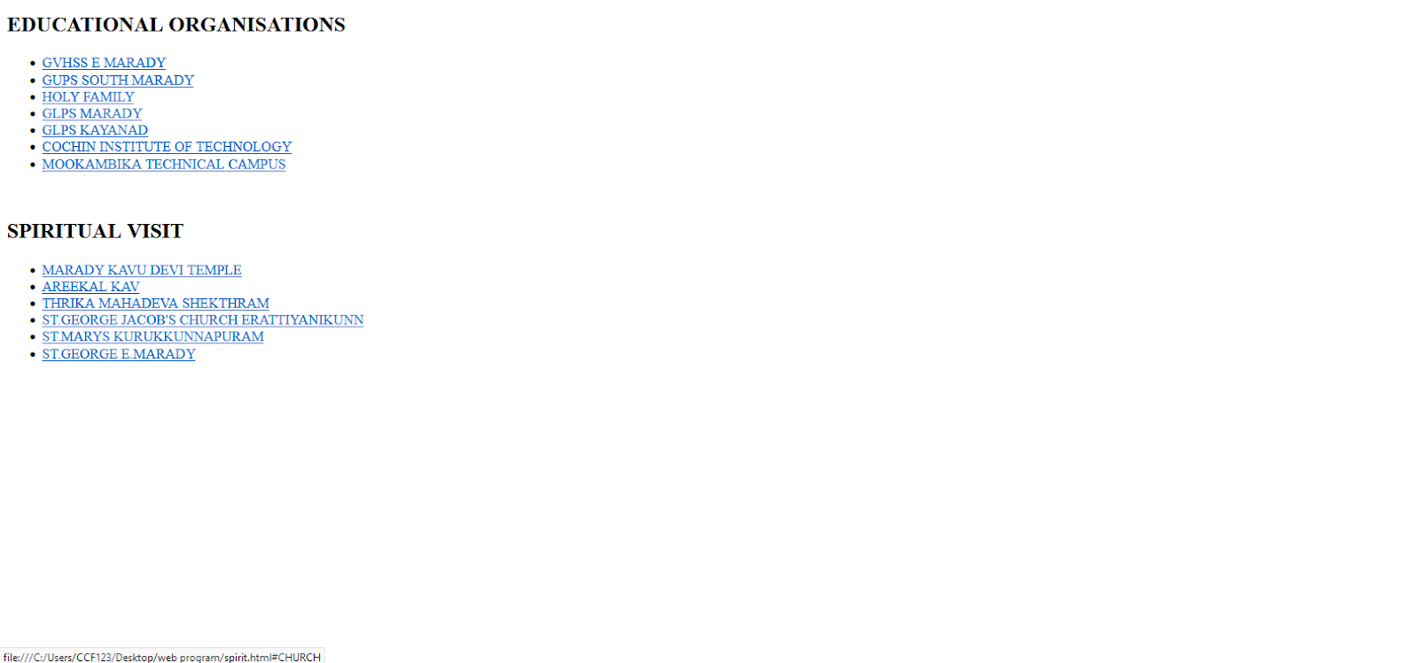

**Course Outcome 1**

# Program#4

**4.**Create MITS college Website with the help of style sheets, background colours, images, tables, and lists. Create multiple webpages which are easily navigable. Apply floating, mixed, and navigation frames to design the webpages.

**PROGRAM CODE:**

reg.html

<html>    
<head>  
  
<title>    
 Registration Form  
</title>    
</head>    
<body>  
<center> <img src="logo.jpg" width="150" height="150"></center>  
<br>  
<h1><font color="black"> Registration Form</font></h1>  
<form>    
   
<label> Firstname: &nbsp &nbsp;&nbsp;&nbsp;&nbsp; </label>          
<input type="text" name="firstname" size="15"/> <br> <br>    
<label> Middlename: &nbsp;&nbsp;&nbsp;</label>      
<input type="text" name="middlename" size="15"/> <br> <br>    
<label> Lastname: </label>          
<input type="text" name="lastname" size="15"/> <br> <br>    
   
<label>    
Course :    
</label>    
<select>    
<option value="Course">Course</option>    
<option value="BCA">BCA</option>    
<option value="BBA">BBA</option>    
<option value="B.Tech">B.Tech</option>    
<option value="MBA">MBA</option>    
<option value="MCA">MCA</option>    
<option value="M.Tech">M.Tech</option>    
</select>    
   
<br>    
<br>    
<label>    
Gender :    
</label><br>    
<input type="radio" name="male"/> Male <br>    
<input type="radio" name="female"/> Female <br>    
<input type="radio" name="other"/> Other    
<br>    
<br>    
   
<label>    
Phone :    
</label>    
<input type="text" name="country code" value="+91" size="2"/>    
<input type="text" name="phone" size="10"/> <br> <br>    
Address    
<br>    
<textarea cols="80" rows="5" value="address">    
</textarea>    
<br> <br>  
programing languages:<br>  
<input type="checkbox" id="java" name="languages[]" value="Java">  
        <label for="java">Java</label><br>

 frame.html

<html>  
<head>  
<frameset cols="20%,60%">  
<frame SRC="reg.html">  
<frame SRC="web.html">  
</frameset>  
</head>  
</html>

web.html

<!DOCTYPE html>  
<html lang="en">  
<head>  
<style>  
header{  
background-color:#5D6D7E;  
padding:20px;  
}  
</style>  
</head>  
<body>  
  
<body>  
<header>  
<h1 align="center" style="color: black;">MUTHOOT INSTITUTE OF TECHNOLOGY SCIENCE AND SCIENCE</h1>  
<h2 align="center" style="color: black;">Varikoli,Puthencuriz</h2>  
 <h3 align="center" style="color: black;">Afliated to KTU</h3>  
     
        <h1 align="center" style="color: white;"> Welcome to Muthoot Institute of Technology and Science</h1>  
</header><br>  
<center> <img src="image.jpg" width="700" height="450"></center>  
        <nav>  
            <ul>  
                <li><a href="#HOME">HOME</a></li>  
                <li><a href="#ABOUT">ABOUT AS</a></li>  
                <li><a href="#COURSES">COURSES OFFERED</a></li>  
                <li><a href="p.html">PLACEMENT</a></li>  
                <li><a href="#CONTACT">CONTACT US</a></li>  
                <li><a href="i.html">INFRASTRUCTURE US</a></li>  
            </ul>  
        </nav>  
    </header>  
  
    <section id="home">  
        <div class="container">  
            <h2>Welcome to Our Institute</h2>  
            <p>Lorem ipsum dolor sit amet, consectetur adipiscing elit. Sed ac justo id nulla venenatis placerat.</p>  
            <a href="#courses" class="button">Explore Courses</a>  
        </div>  
    </section>  
  
    <section id="about">  
        <div class="container">  
            <h2>ABOUT AS</h2>  
            <p>Muthoot Institute of Technology and Science (MITS) is promoted by Muthoot M. George Institute of Technology, a Section 25 Company within the Muthoot Group. MITS is a self financing technical institution offering postgraduate and undergraduate engineering programmes, situated in the industrial suburb of Kochi, close to the Smart City and Info Park, approximately 15 kms from Vytilla Junction towards Muvattupuzha on the Cochin Madurai National Highway.  
  
The promoters with their commanding presence in the domains of Financial Services, Hospitality, Healthcare, Renewable Energy and Information Technology, are committed to building MITS as a centre of excellence, focusing purely on merit. This “temple of learning” will provide to the students, state-of-the-art infrastructure, highly qualified and proficient teachers from various faculty of engineering and allied streams, embedded in a conducive environment where focus will be on their harmonious development.</p>  
</div>  
</section>  
<section id="courses">  
<div class="container">  
<h2>COURSES OFFERED</h2>  
<ul>  
<li>B.Tech</li>  
<li>M.Tech</li>  
<li>MCA</li>  
<!-- Add more courses here -->  
</ul>  
</div></section>  
<section id="contact">  
<div class="container">  
<h2>CONTACT US</h2>  
<p>If you have any questions or need more information, please feel free to contact us.</p>  
</div>  
</section>  
<footer>  
<p>&copy; 2023 Muthoot Institute of Technology and Science</p>  
</footer>  
</body>  
</html>

i.html

<html>  
<head>  
</head>  
<body>  
<section id="INFRASTRUCTURE">  
<div class="container">  
<h2>INFRASTRUCTURE</h2>  
 <img src="mits.jpg" align="center" width="150" height="130"><br><br>  
<img src="yard.jpg" align="center" width="150" height="130"><br><br>  
<img src="c.jpg" align="center" width="150" height="130"><br><br><br>  
<img src="bcort.jpg" align="center" width="150" height="130"><br><br>  
<img src="canteen.jpg" align="center" width="150" height="130"><br>  
<a href="web.html">BACK</a></strong></div></td>  
</body>  
</html>

p.html

<html>

<head>

</head>

<body>

<section id="placement">

<div class="container">

<h2>PLACEMENT</h2>

<p>We are proud of our excellent placement record. Our students have been placed in leading companies across various industries. Here are some key highlights:</p>

<h3>Placement Statistics</h3>

<ul>

<li>Overall Placement Rate: 95%</li>

<li>Average Salary Offered: $60,000 per annum</li>

<li>Top Recruiting Companies: ABC Tech, XYZ Solutions, Acme Inc., etc.</li>

</ul>

<h3>Placement Process</h3>

<p>Our placement process includes the following stages:</p>

<ol>

<li>Preparation and Training</li>

<li>Campus Recruitment Drives</li>

<li>Interviews and Selections</li>

<li>Job Offers</li>

</ol>

<a href="web.html">BACK</a></strong></div></td>

</body>

</html>

**OUTPUT:** 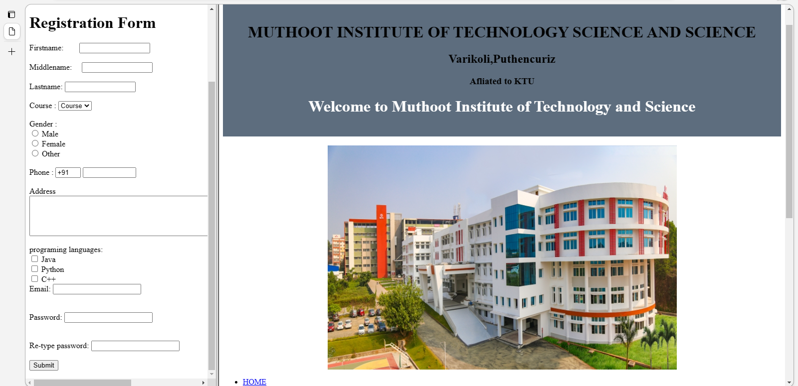







**Course Outcome 1**

# Program#5

**5.** Analyse CSS by applying various positioning methods of elements on a webpage with div elements and their classes using two external style sheets.

**PROGRAM CODE:**

<!DOCTYPE html>  
<html lang="en">  
<head>  
<meta charset="UTF-8">  
<meta name="viewport" content="width=device-width, initial-scale=1.0">  
<link rel="stylesheet" type="text/css" href="box.css">  
<link rel="stylesheet" type="text/css" href="box2.css">  
<title>Positioning Example</title>  
</head>  
<body>  
<h1 align="center" style="color: black;">MUTHOOT INSTITUTE OF TECHNOLOGY SCIENCE AND SCIENCE</h1>  
<div class="box relative">  
<p>>Muthoot Institute of Technology and Science (MITS) is promoted by Muthoot M. George Institute of Technology, a Section 25 Company within the Muthoot Group. MITS is a self financing technical institution offering postgraduate and undergraduate engineering programmes, situated in the industrial suburb of Kochi, close to the Smart City and Info Park, approximately 15 kms from Vytilla Junction towards Muvattupuzha on the Cochin Madurai National Highway.</p>  
</div>  
<div class="box absolute">  
<p>Absolute</p>  
</div>  
</body>  
</html>

<html>

**OUTPUT:**

