SALESTORM | SYSCRAFTERS 2026

SYSTEM DESIGN HACKATHON
Course Name
System Design
Team Members:
Ashwathkrishnaa PV - 24CC006
Dhevavarshana DK - 24CC014
Monika Sree D - 24CC031
Sabarikarthika S - 24CC044
Complete System Design Document

Document Contents
1. Requirements & Assumptions
2. System Context Diagram
3. HLD Architecture
4. Container Diagram
5. Component Diagram
6. Deployment Diagram
7. Database / ER Diagram
8. Class Diagram
9. Purchase / Reservation Sequence Diagram
10. Payment Sequence Diagram
11. Order Sequence Diagram
12. Order / Reservation State Diagram
13. SOLID Mapping
14. Design Pattern Mapping
15. API Specification
16. Scalability & Reliability Design
17. Security & Observability Design
18. Architecture Decision Record
19. AI-Assisted Prototype / Simulation Evidence
20. AI Usage Note / Prompt Summary
21. Final Presentation

1. Requirements & Assumptions Document
Purpose: define the functional requirements, non-functional requirements, constraints, business rules and assumptions that drive all later design artefacts.

1.1 Problem Statement
The FlashSale E-Commerce Platform must support a sudden increase in customer traffic during a limited-time sale. The primary design challenge is to handle up to 10,000 concurrent purchase requests when only 100 units are available, while preventing overselling, duplicate reservations and duplicate payments. The platform must also provide reliable payment processing, order creation, inventory reservation, failure recovery and traceable order lifecycle management.

1.2 Functional Requirements
- FR-01 Customer registration and authentication
- FR-02 Product browsing and discovery
- FR-03 Cart management
- FR-04 Flash-sale / deal management
- FR-05 Inventory availability check
- FR-06 Inventory reservation
- FR-07 Reservation expiry and release
- FR-08 Checkout
- FR-09 Payment processing
- FR-10 Order creation and status tracking
- FR-11 Order cancellation where permitted
- FR-12 Shipment and delivery tracking
- FR-13 Customer notifications
- FR-14 Duplicate request handling with idempotency

1.3 Non-Functional Requirements
- Scalability: services must scale horizontally during traffic spikes.
- Availability: the platform should remain usable during flash-sale load.
- Consistency: inventory must never become negative or oversold.
- Reliability: payment and order failures need recovery mechanisms.
- Performance: critical purchase operations should remain responsive under load.
- Security: authentication, HTTPS, validation and rate limiting are required.
- Observability: logs, metrics, traces and alerts must be available.
- Fault tolerance: downstream failures must not silently lose valid transactions.

1.4 Critical Business Rules
- Available inventory must never become negative.
- A reservation may be created only when sufficient stock exists.
- Every reservation has an expiry time.
- Expired or failed reservations release stock.
- Duplicate purchase requests must not create duplicate reservations.
- Duplicate payment requests must not create duplicate charges.
- An order is confirmed only after successful payment.
- A successful payment must remain recoverable if the Order Service is temporarily unavailable.

1.5 Assumptions — Proposed Team Design
- PostgreSQL is the transactional source of truth for inventory, reservation, payment and order data.
- Redis is used for cacheable reads and hot product information.
- A message queue is used for asynchronous events and recovery workflows.
- The external payment gateway is treated as an unreliable dependency and is protected with timeout, retry and circuit-breaker controls.
- Inventory consistency is guaranteed at the transactional database boundary.
- Customers are authenticated before purchase operations.
2. System Context Diagram
The system context shows the platform as one system and identifies its external actors and systems.
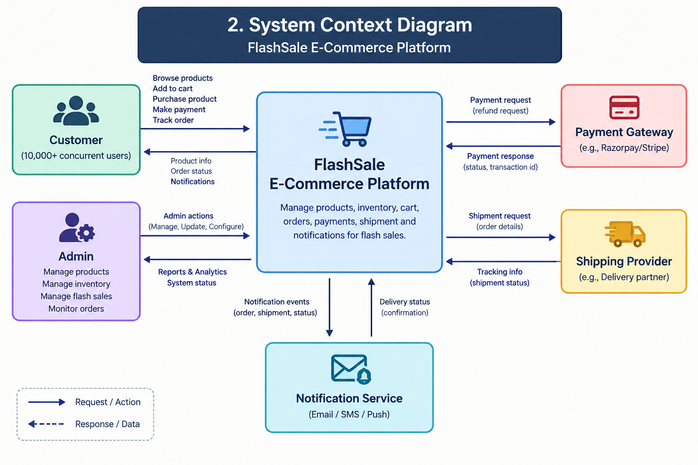

External interactions
External Actor/System | Interaction
Customer | Browse products, add to cart, buy products, pay and track orders.
Admin | Manage products, inventory, flash sales and operational information.
Payment Gateway | Processes payment requests and returns success, failure or timeout outcomes.
Shipping Provider | Receives shipment requests and provides tracking updates.
Notification Service | Delivers customer notifications for relevant order/payment events.
Design note: the context diagram intentionally avoids internal service details; those are introduced in the HLD and container diagrams.
3. HLD Architecture
Proposed team design: layered, service-oriented architecture with an API Gateway, horizontally scalable business services, Redis cache, message queue and PostgreSQL.
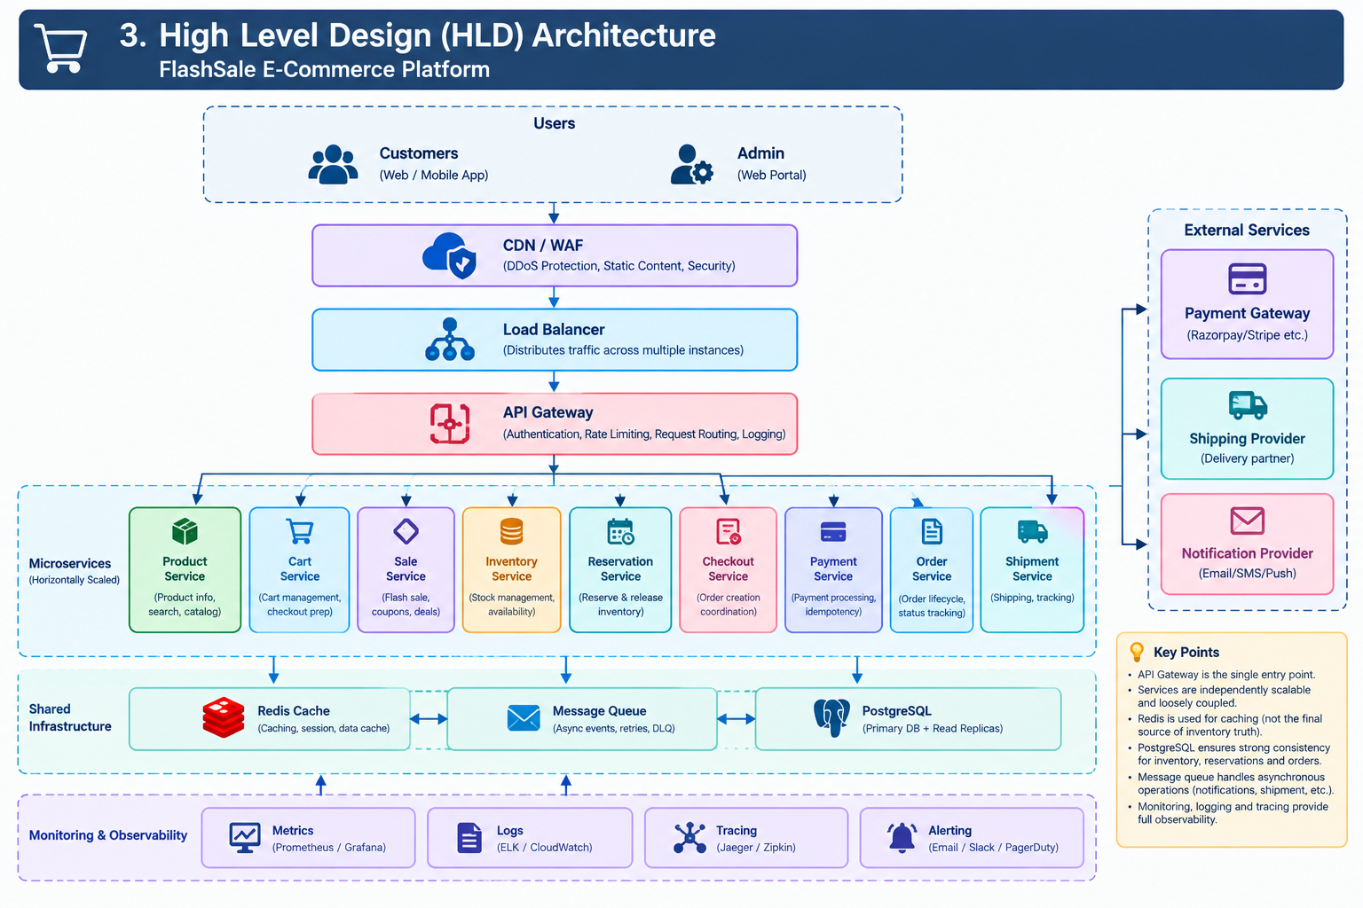

Major layers
- Edge: CDN/WAF protects and absorbs web traffic.
- Traffic management: Load Balancer distributes requests across gateway/application instances.
- API Gateway: common entry point for authentication, routing, rate limiting and request policies.
- Business services: Product, Cart, Sale, Inventory, Reservation, Checkout, Payment, Order, Shipment and Notification.
- Data and messaging: Redis for cache, PostgreSQL for transactional data, message queue for asynchronous work.
- Operations: monitoring, centralized logging and distributed tracing.

Critical design principle
Redis may accelerate reads, but the transactional database remains the final consistency boundary for inventory reservation. The architecture therefore does not rely on a cache-only decrement to prevent overselling.
4. Container Diagram
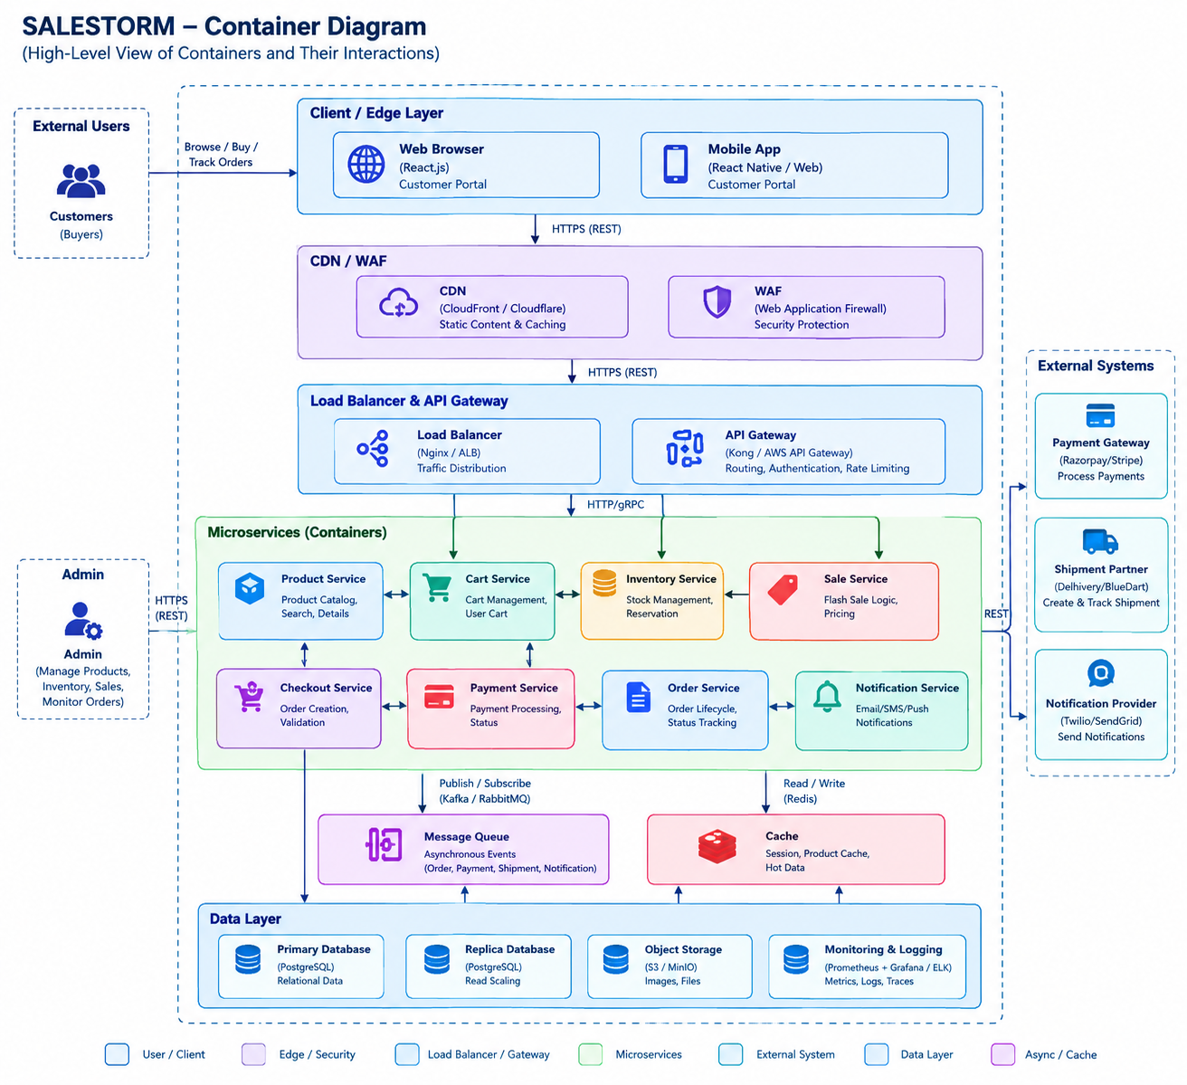

Container responsibilities
Container | Primary responsibility
Product Service | Product information and discovery.
Cart Service | Customer cart and cart items.
Sale Service | Flash-sale/deal information.
Inventory Service | Authoritative inventory quantity and stock operations.
Reservation Service | Temporary reservation lifecycle and expiry.
Checkout Service | Coordinates checkout and purchase orchestration.
Payment Service | Payment creation, status and idempotency.
Order Service | Order lifecycle and order state transitions.
Shipment Service | Shipment creation and delivery tracking.
Notification Service | Asynchronous customer notifications.
Redis | Cache for high-read data.
Message Queue | Asynchronous events, retries and recovery workflows.
PostgreSQL | Transactional persistent storage.

5. Component Diagram
The critical component view focuses on Inventory Service because inventory consistency is the highest-risk business requirement.
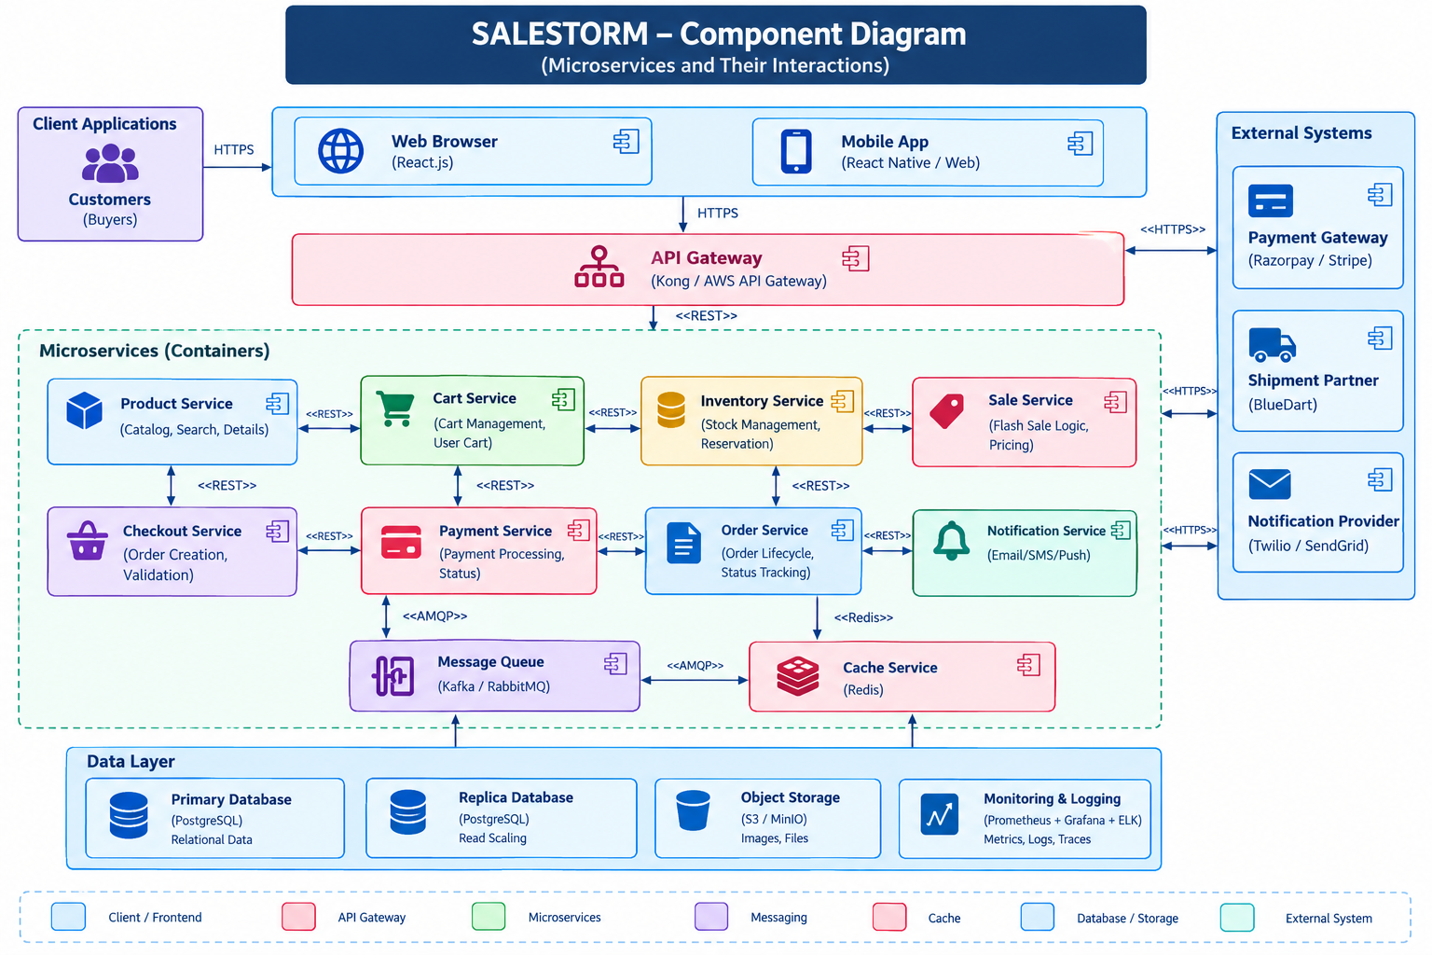

Component responsibilities
Component | Responsibility
InventoryController | Accepts and validates inventory/reservation API requests.
InventoryService | Coordinates inventory business rules.
IdempotencyManager | Detects repeated requests using idempotency keys.
ConcurrencyController | Applies the selected concurrency-safe reservation operation.
ReservationManager | Creates, confirms, expires and releases reservations.
InventoryRepository | Encapsulates transactional database access.
EventPublisher | Publishes reservation/payment-related events for asynchronous consumers.

6. Deployment Diagram
Proposed deployment: stateless application instances are horizontally scaled behind a load balancer. Stateful infrastructure is separated into cache, messaging and database tiers.
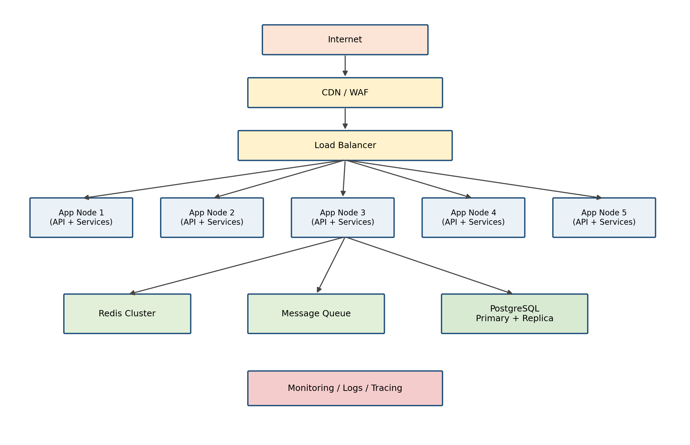

Deployment decisions
- Multiple application nodes allow horizontal scaling.
- Redis is deployed as a shared cache tier.
- The message queue is shared by asynchronous workers.
- PostgreSQL uses a primary/replica arrangement for scaling read-heavy workloads; transactional writes remain on the primary.
- Monitoring, logs and tracing collect operational evidence from all nodes.

7. Database / ER Diagram
The following ER design covers the core entities named by the hackathon brief and adds the fields required to support reservation and idempotency.
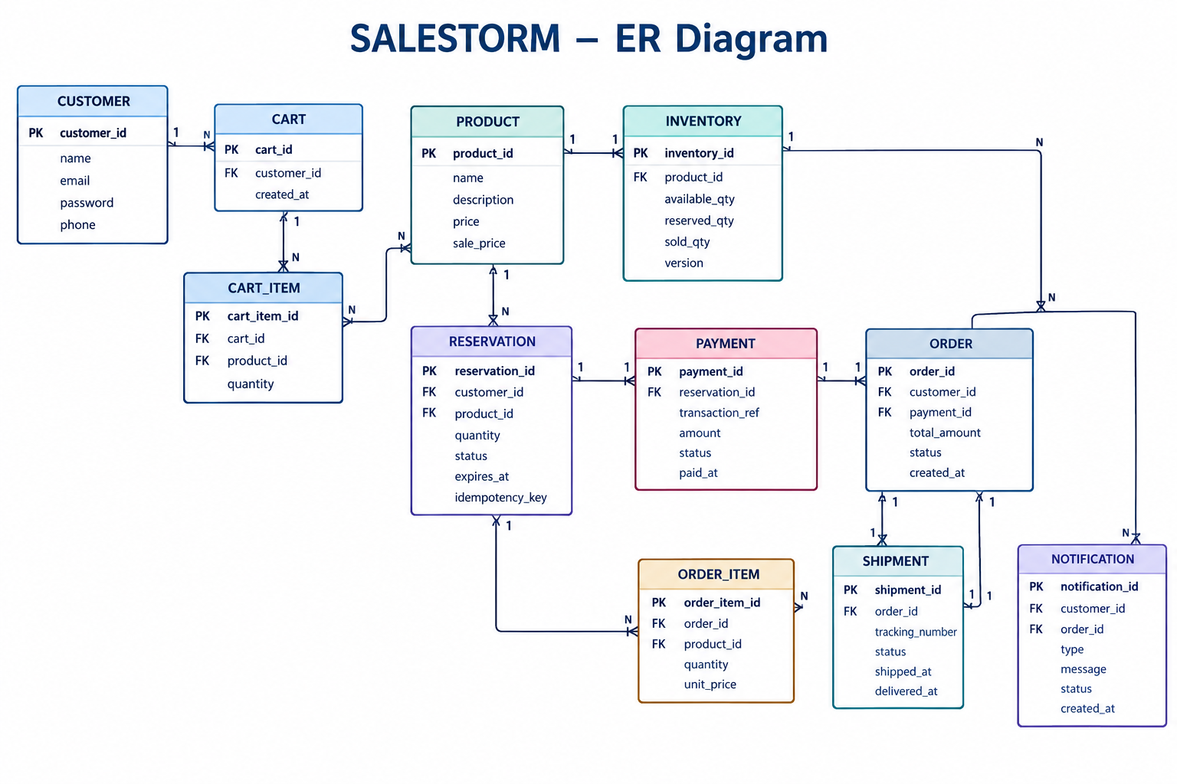

Important inventory fields
INVENTORY(inventory_id, product_id, available_quantity, reserved_quantity, sold_quantity, version, updated_at)
The reservation record contains reservation_id, product_id, customer_id, quantity, status, expires_at and idempotency_key. Primary keys, foreign keys, indexes, uniqueness constraints and transaction boundaries should be implemented in the actual database design.

8. Class Diagram
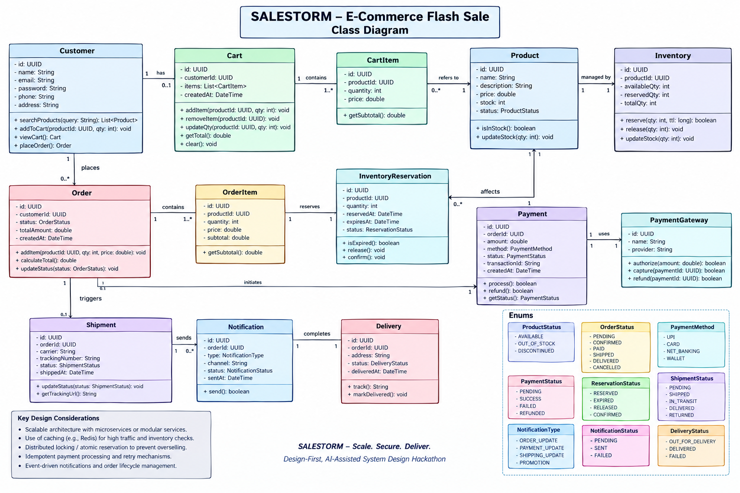

9. Purchase / Reservation Sequence Diagram
This is the critical concurrency path. The design must ensure that 10,000 simultaneous purchase attempts cannot reserve more than 100 available units.
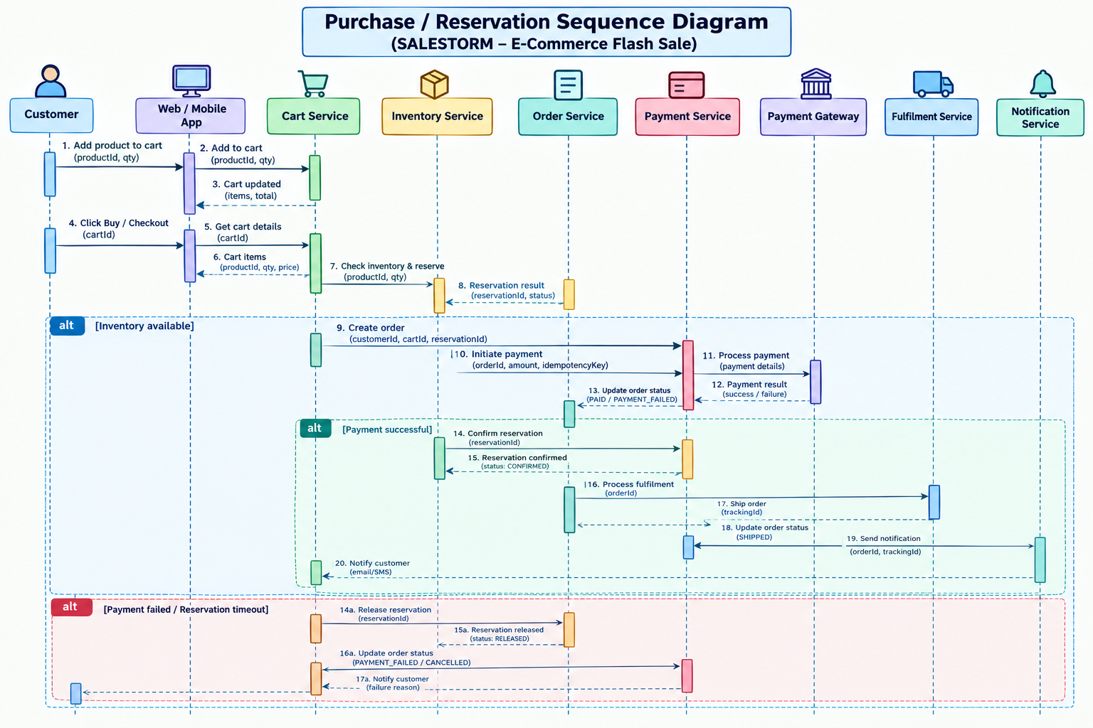

Detailed flow
- Customer sends a Buy request.
- API Gateway authenticates, validates and forwards the request.
- Inventory Service checks the idempotency key.
- The inventory transaction checks available quantity and performs an atomic reservation.
- If the transaction succeeds, a reservation is created with an expiry time.
- Checkout/payment processing starts for the reserved quantity.
- Payment success confirms the reservation; payment failure or timeout releases it.
- When stock is exhausted, later requests receive an out-of-stock response.

Concurrency guarantee
For the challenge scenario, successful reservations must be at most 100. The database update is the final contention point that prevents negative inventory and overselling.

10. Payment Sequence Diagram
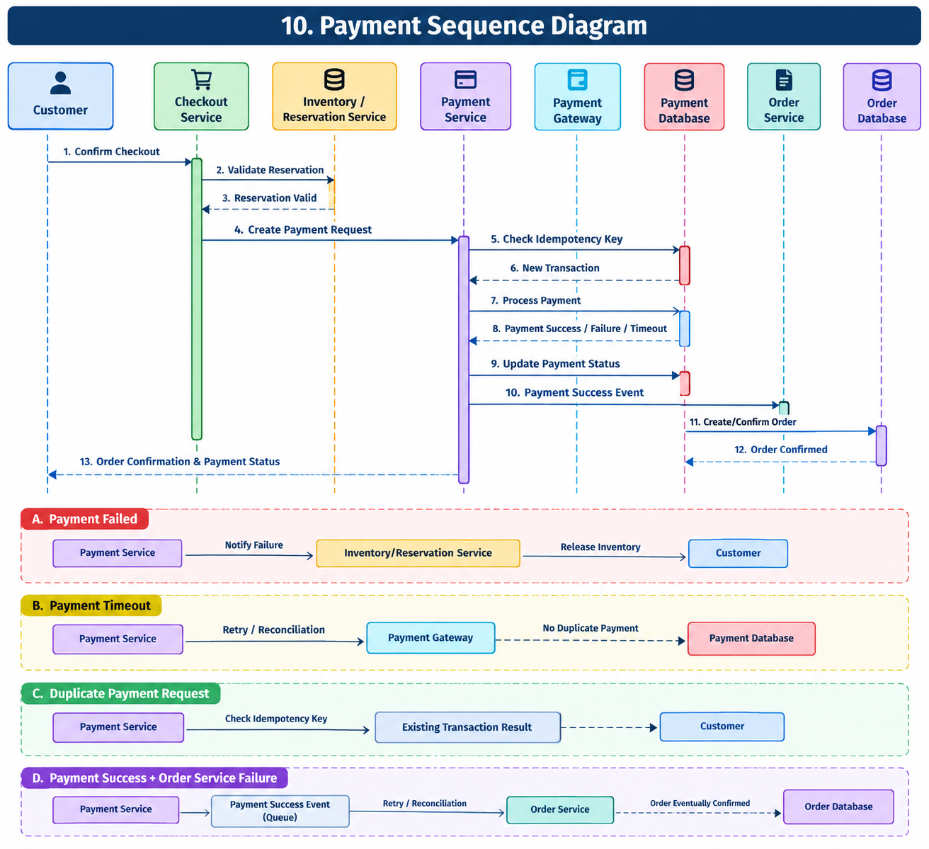

Payment cases
- Success: payment is recorded and the order workflow proceeds.
- Failure: payment is marked failed and the reservation is released according to the reservation workflow.
- Timeout: the payment request is not blindly retried without idempotency; status is reconciled with the provider.
- Duplicate request: the same idempotency key returns the existing payment result instead of charging again.
- Payment success + Order Service failure: the payment result is retained as an event/state and retried until order creation is reconciled.

11. Order Sequence Diagram
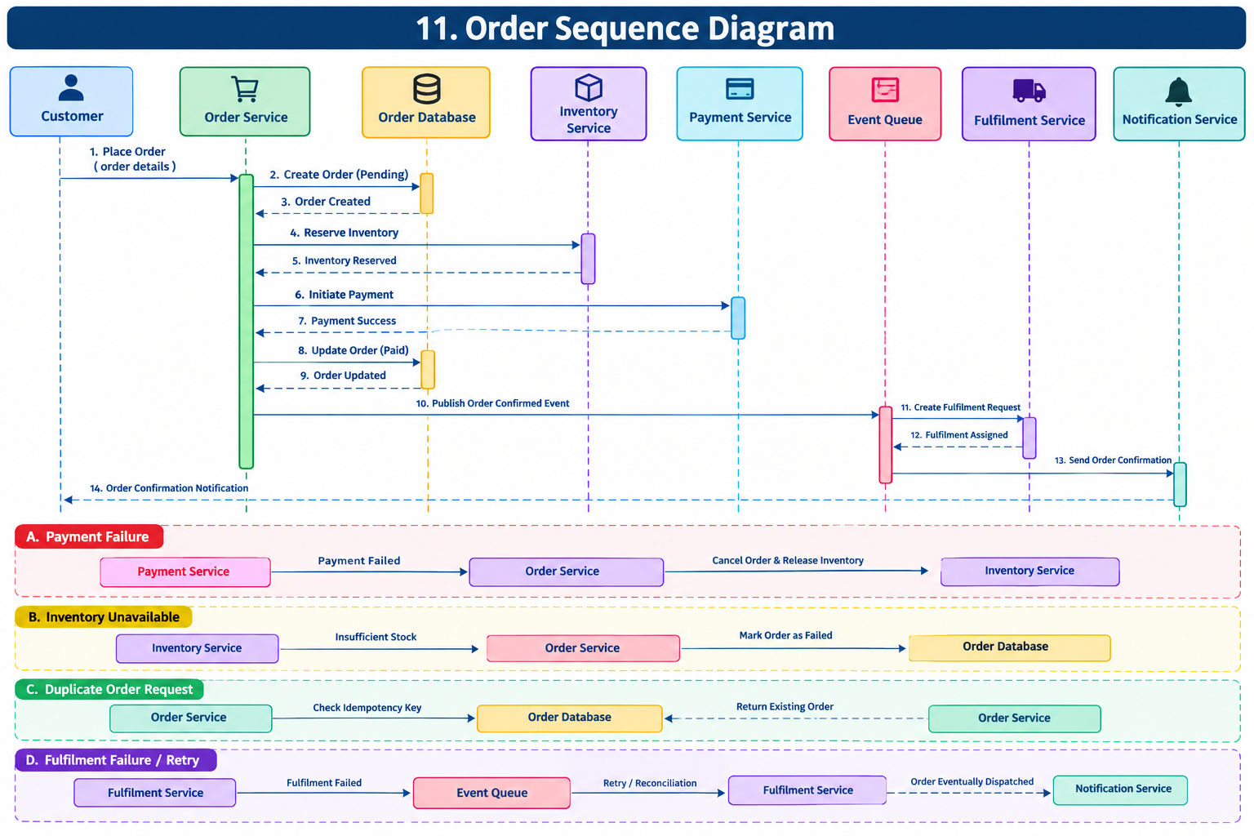

Order recovery flow
After payment succeeds, Order Service creates the order. If Order Service is temporarily unavailable, the payment result is retained in the asynchronous workflow. A retry worker reprocesses the event and reconciliation ensures that a successful payment eventually maps to a valid order or a controlled compensation path.

12. Order / Reservation State Diagram
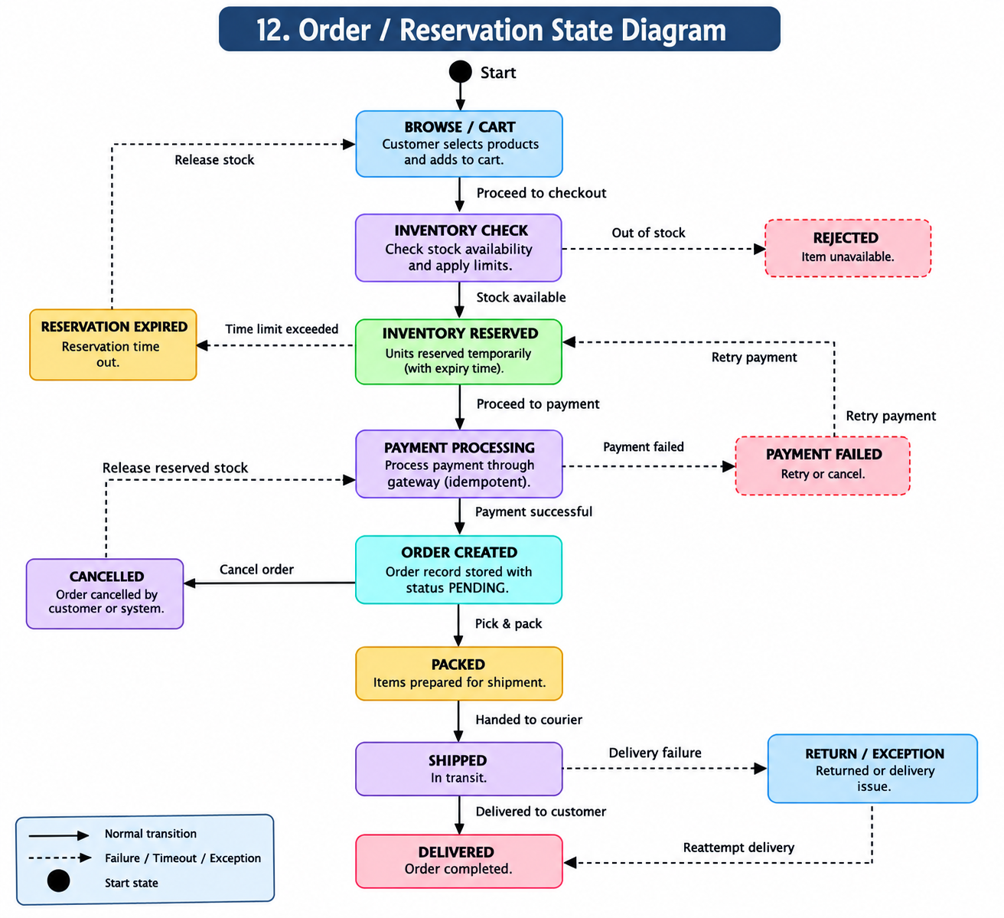

Reservation states
AVAILABLE → RESERVED → PAYMENT_PENDING → CONFIRMED → SOLD
RESERVED → PAYMENT_FAILED → RELEASED → AVAILABLE
RESERVED → TIMEOUT → RELEASED → AVAILABLE

Order states
CREATED → PAYMENT_PENDING → CONFIRMED → PROCESSING → SHIPPED → OUT_FOR_DELIVERY → DELIVERED
Cancellation is a controlled transition from an eligible state, subject to the business rule being applied.

13. SOLID Mapping
Principle | Application in this design
Single Responsibility | InventoryService handles inventory use cases; PaymentService handles payment; OrderService handles order lifecycle.
Open/Closed | New payment provider implementations can be added behind an existing provider abstraction.
Liskov Substitution | All payment provider implementations conform to the same provider contract.
Interface Segregation | Separate interfaces are used for payment, notification, shipment and persistence responsibilities.
Dependency Inversion | Business services depend on abstractions such as repository and payment-provider interfaces rather than concrete infrastructure classes.

Example
PaymentService → PaymentGateway interface → ProviderAdapter implementations
14. Design Pattern Mapping
Pattern | Application
Strategy | Select a payment processing strategy without changing checkout orchestration.
Factory | Create the appropriate payment provider/adapter.
State | Represent reservation and order lifecycle states and valid transitions.
Observer | Publish order/payment events to notification and other consumers.
Adapter | Wrap external payment and shipping provider APIs.
Repository | Abstract transactional database access.
Facade | Checkout Facade coordinates reservation, payment and order workflow.
Circuit Breaker | Protect calls to external payment/shipping dependencies from cascading failures.

15. API Specification
The following is the proposed API surface. Exact schemas can be expanded in Swagger/OpenAPI during implementation.
Method | Endpoint | Purpose
POST | /api/v1/customers | Register customer
POST | /api/v1/auth/login | Authenticate customer
GET | /api/v1/products | List/search products
GET | /api/v1/products/{productId} | Get product
GET | /api/v1/inventory/{productId} | Read inventory/availability
POST | /api/v1/inventory/reservations | Create reservation
POST | /api/v1/inventory/reservations/{id}/confirm | Confirm reservation
POST | /api/v1/inventory/reservations/{id}/release | Release reservation
POST | /api/v1/checkout | Start checkout
POST | /api/v1/payments | Create payment
GET | /api/v1/payments/{paymentId} | Get payment status
POST | /api/v1/orders | Create/reconcile order
GET | /api/v1/orders/{orderId} | Get order
POST | /api/v1/orders/{orderId}/cancel | Cancel eligible order

Idempotency
Idempotency-Key: <unique-request-id>
The idempotency key is required for operations where repeated delivery could create duplicate reservations or charges.

Example reservation response
{
"reservationId": "RES123",
"status": "RESERVED",
"expiresAt": "2026-10-05T10:15:00Z"
}
16. Scalability & Reliability Design
The hackathon asks teams to reason about normal high traffic and flash-sale spikes. This section provides the proposed controls for those conditions.

16.1 Scalability
- Horizontal scaling of stateless API/service instances.
- Load balancing across instances.
- CDN/WAF at the edge.
- Redis caching for frequently read data.
- Asynchronous message queue for non-critical downstream operations.
- Database indexing and connection pooling.
- Read replicas for read-heavy workloads.
- Rate limiting, throttling and controlled rejection when capacity is exceeded.

16.2 Inventory concurrency alternatives
Approach | Strength | Limitation | Decision
Pessimistic row locking | Strong serialization of inventory updates | High contention during a flash sale | Considered, but less attractive under extreme contention
Optimistic/conditional atomic update | Short transaction; directly enforces available_quantity >= requested quantity | Requires retry/handling of conflicts | Selected for proposed design

16.3 Selected inventory operation
UPDATE inventory
SET available_quantity = available_quantity - :qty,
reserved_quantity = reserved_quantity + :qty,
version = version + 1
WHERE product_id = :product_id
AND available_quantity >= :qty;
If the affected-row count is 1, the reservation succeeds. If it is 0, stock is unavailable or the transaction lost the concurrency race. The application then returns a controlled failure rather than overselling.

16.4 Reliability controls
- Timeouts on external calls.
- Bounded retries for transient failures.
- Circuit breaker for unstable external dependencies.
- Dead-letter queue for repeatedly failing asynchronous messages.
- Idempotent message handling.
- Compensation and reconciliation for payment/order mismatches.
- Monitoring and alerting for inventory, payment, order and queue anomalies.
17. Security & Observability Design

17.1 Security
- Authentication for customers and operators.
- Role-based authorization for administrative operations.
- HTTPS for all external communication.
- Input validation and schema validation.
- Rate limiting at the gateway.
- Secure payment integration without storing sensitive payment credentials unnecessarily.
- Secret management for credentials and provider keys.
- Audit logs for sensitive operations.

17.2 Observability
Area | What to collect
Metrics | Requests/sec, latency, error rate, reservation success/failure, payment success/failure, queue depth, DB connections.
Logs | Request ID, customer ID, reservation ID, payment ID, order ID, service, timestamp and error context.
Tracing | Trace the same request across gateway, inventory, reservation, payment and order services.
Alerts | Inventory anomalies, payment failure spikes, order creation failures, queue backlog and database saturation.
Correlation identifiers such as request ID, reservation ID, payment ID and order ID make the complete purchase lifecycle traceable.
18. Architecture Decision Record

ADR-001
Decision: Service boundaries
Reason: Separate Product, Cart, Inventory, Reservation, Payment, Order, Shipment and Notification responsibilities.
Benefit: Different workloads and failure domains can scale independently.
Trade-off: More distributed-system complexity.

ADR-002
Decision: PostgreSQL as transactional source of truth
Reason: Use PostgreSQL for inventory, reservation, payment and order transactions.
Benefit: Strong transactional consistency is required.
Trade-off: Database contention must be controlled.

ADR-003
Decision: Redis cache
Reason: Use Redis for hot read paths and product information.
Benefit: Reduces database read pressure.
Trade-off: Cache invalidation/staleness must be controlled.

ADR-004
Decision: Message queue
Reason: Use asynchronous events for notifications, shipment updates and recovery.
Benefit: Decouples non-critical work and supports retry.
Trade-off: Introduces eventual consistency in asynchronous flows.

ADR-005
Decision: Idempotency keys
Reason: Require idempotency for purchase/reservation and payment operations.
Benefit: Prevents duplicate side effects.
Trade-off: Requires idempotency-key storage and lookup.

19. AI-Assisted Prototype / Simulation Evidence (Optional)
This deliverable is optional in the hackathon brief. If included, keep it small and directly connected to a design assumption.
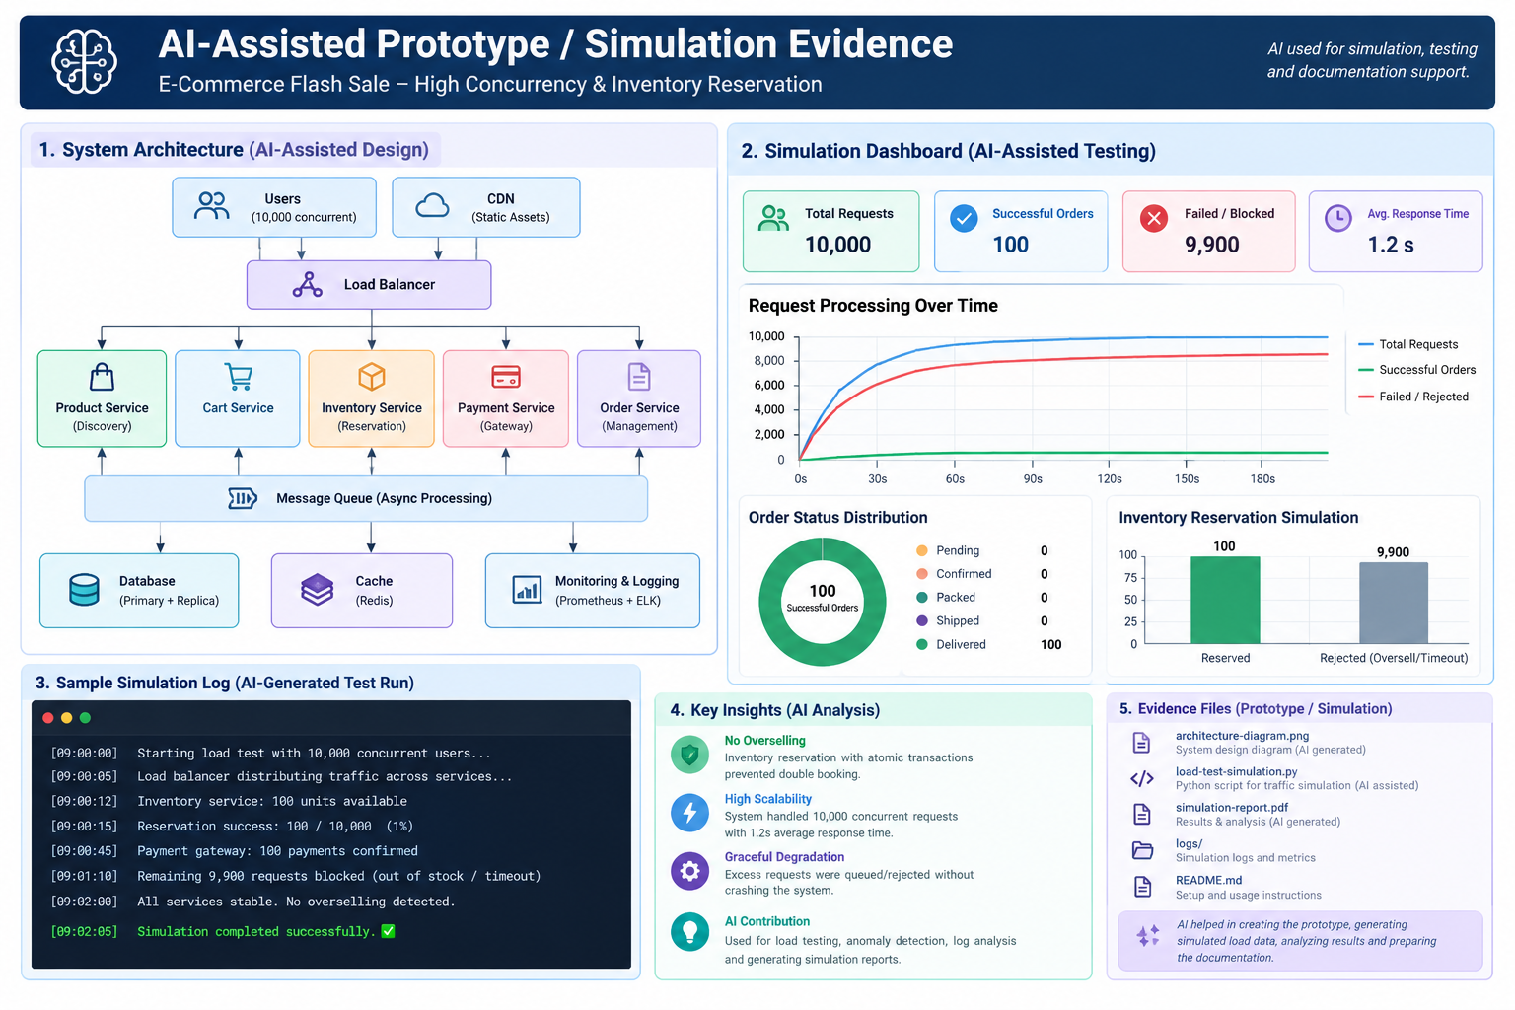

Recommended simulation configuration
Parameter | Value
Initial inventory | 100 units
Concurrent users | 10,000
Payment success | 95%
Payment failure | 5%
Duplicate requests | 2%
Order Service unavailable | 30 seconds

Expected evidence
- Successful reservations ≤ 100.
- Overselling = 0.
- Negative inventory = 0.
- Duplicate payment = 0.
- Failed/expired reservations release stock.
- Order recovery succeeds after temporary Order Service unavailability.
Suggested tools from the brief include JMeter, Locust and Postman Collection Runner.
20. AI Usage Note / Prompt Summary
AI tools were used as engineering assistance for brainstorming, document structuring, UML representation, API drafting, test-scenario generation and prototype/simulation assistance. The final architecture, service boundaries, inventory concurrency strategy, reservation lifecycle, payment/order recovery approach, security decisions and trade-offs were reviewed and finalized by the team.

Validation statement
AI-generated outputs were treated as suggestions. The team reviewed the outputs for correctness, consistency with the hackathon requirements and alignment with the final architecture before inclusion.

Prompt categories used
- Architecture alternatives and HLD.
- Inventory concurrency and reservation reasoning.
- UML and sequence-diagram structure.
- API specification drafts.
- Failure and recovery scenarios.
- SOLID and design-pattern mapping.
- Load/concurrency test scenarios.
- Documentation and presentation structure.
Appendix — Source Alignment
This master document is based on the uploaded SALESTORM | SYSCRAFTERS 2026 brief. The brief lists 21 expected deliverables, marks 1–18 and 21 as mandatory, marks the AI-assisted prototype/simulation as optional, and requires an AI usage note when AI is used. The brief also states that the design should come before code and that any submitted prototype should be small, targeted and linked to a design assumption or practical scenario.
The architecture and detailed design choices in this document are a proposed, internally consistent team design built to satisfy those requirements; they are not presented as text copied from the brief.

