MicroGoal Project

Title:
Micro goal -Small Steps to Achieve Big Success

Program:
Naan Mudhalvan

Prepared By:
A.Sowndharya-sowndharyamariyappan@gmail.com
P.Karthika – karthika14595@gmail.com
G.Soni Priya- sonipriya2404@gmail.com
S.Kaviya- kaviyasara07@gmail.com


Short Introduction:
Micro goals are small, specific, and manageable tasks that help individuals achieve larger goals step by step. Instead of focusing only on big ambitions, breaking them into micro goals makes progress easier and more achievable. Micro goals improve productivity, motivation, and confidence.

Introduction to Micro Goals:
Micro goals are small and clearly defined actions that help people move towards bigger goals. Many people fail to achieve their dreams because the goals feel too big or difficult. Micro goals help break those large goals into smaller and manageable steps.
For example, if a student wants to become a software engineer, the big goal may seem difficult. But by setting micro goals like learning one programming concept every day or practicing coding for 30 minutes daily, the goal becomes achievable.
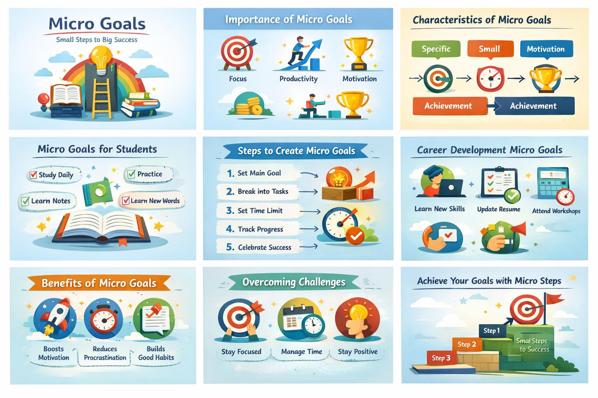
Micro goals also help reduce stress and increase motivation because every small success builds confidence. They are useful in education, career development, health improvement, and personal growth.

Importance of Micro Goals:

Micro goals play a very important role in achieving success. They help people stay focused and organized. When a person divides a large goal into smaller tasks, the work becomes easier and less stressful.
Micro goals improve time management because individuals can plan their daily activities clearly. They also increase productivity by encouraging consistent effort. Achieving small goals regularly creates a sense of accomplishment and motivation to continue.
Students, professionals, and entrepreneurs use micro goals to improve their performance. Micro goals also help people track progress and identify areas that need improvement.

Characteristics of Micro Goals:
Micro goals have several important characteristics that make them effective.
- Specific – The goal must be clear and well defined.
- Small – It should be simple and achievable within a short time.
- Measurable – Progress can be tracked easily.
- Time-bound – Each micro goal should have a specific deadline.
- Realistic – The goal should match the individual’s abilities.

Benefits of Micro Goals:

Micro goals provide many benefits for personal and professional growth.
First, they improve motivation because small achievements create positive feelings. Second, they reduce procrastination since tasks are small and easier to start. Third, they increase productivity by encouraging consistent work.
Micro goals also help build discipline and good habits. Over time, these habits lead to bigger achievements. They also make it easier to monitor progress and make improvements when necessary.
Many successful people use micro goals to manage their daily activities and reach long-term goals.


Examples of Micro Goals for Students:
Students can use micro goals to improve their academic performance.
Examples include:
- Study one chapter every day.
- Learn five new English words daily.
- Practice mathematics problems for 30 minutes.
- Complete homework before 7 PM.
- Revise class notes every evening.
These small goals help students stay consistent and organized. When students follow micro goals regularly, they can improve their knowledge and academic results.


Micro Goals for Career Development:
Micro goals are also useful for building a successful career.
For example:
- Spend 20 minutes daily learning a new skill.
- Watch one educational video related to the career field.
- Improve communication by practicing English speaking.
- Update resume every three months.
- Attend online workshops and seminars.
- These micro goals help students gradually develop professional skills required for future jobs.

Steps to Create Micro Goals:

Creating micro goals is simple and effective when following these steps.
- Step 1: Identify the main goal.
- Step 2: Break the goal into
- smaller tasks.
- Step 3: Set a realistic time limit.
- Step 4: Track progress regularly.
- Step 5: Celebrate small achievements.
For example, if the main goal is to improve health, micro goals could include drinking enough water daily, walking for 20 minutes, and eating healthy food.

Challenges in Achieving Micro Goals:
Even though micro goals are simple, some challenges may occur.
People may lose motivation or become distracted by other activities. Lack of proper planning can also make it difficult to follow micro goals regularly.
Another challenge is inconsistency. Sometimes individuals start with enthusiasm but fail to maintain regular effort.
These challenges can be overcome by staying disciplined, setting reminders, and maintaining a positive mindset.

Tips for Successfully Achieving Micro Goals:

- To achieve micro goals successfully, some useful tips can be followed.
- Write goals clearly in a notebook or planner.
- Focus on one task at a time.
- Avoid distractions like excessive mobile usage.
- Review progress weekly.
- Stay motivated by remembering the bigger goal.
- Consistency is the most important factor. Small daily efforts can lead to significant achievements over time.

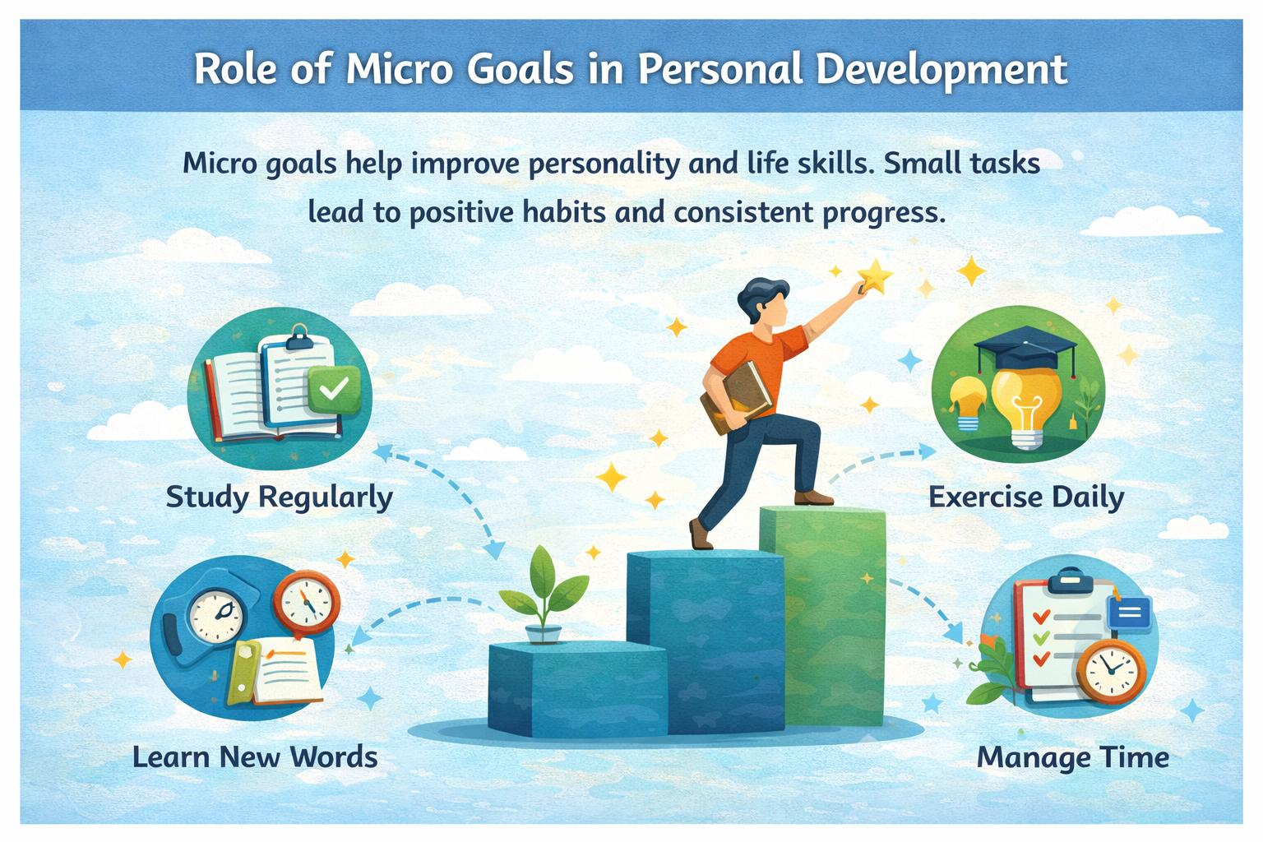
Role of Micro Goals in Personal Development:

Micro goals help individuals improve their personality and life skills. By completing small tasks regularly, people develop discipline, confidence, and time management skills.
Micro goals also help individuals develop positive habits such as regular studying, exercising, reading, and learning new skills.
Personal growth happens gradually, and micro goals make the process easier and more structured. They encourage individuals to become more focused and responsible.

Conclusion:
Micro goals are powerful tools for achieving success. They help individuals break big goals into smaller, manageable tasks. By focusing on small actions every day, people can gradually move closer to their dreams.

Micro goals improve motivation, productivity, and confidence. They also help develop discipline and positive habits.
For students participating in the Naan Mudhalvan program, micro goals can play a vital role in academic success and career development. By setting and achieving micro goals consistently, anyone can achieve long-term success and personal growth.



