SOFTWARE REQUIREMENTS SPECIFICATION

**For**

**Library Management System**

**Prepared by:-**

*Fleeta rini V(721220104009)*

*Karthikayani G (721220104015)*

*Sindhuja D (721220104045)*

*Sivaranjani T (721220104047)*

**Academic Year:** *2020-2024*

# Introduction

## Purpose

The main objective of this document is to illustrate the requirements of the projectE-Commerce. The document gives the detailed description of the both functional and non-functional requirements proposed by the client. The purpose of e-commerce is to enable the online buying and selling of goods and services. It offers convenience, global reach, cost-efficiency, and a diverse product range. E-commerce simplifies comparison shopping, personalizes experiences, and collects valuable data for analysis. It's accessible, scalable, and accommodates various payment methods. E-commerce reduces time and effort for both buyers and sellers while fostering transparency through customer reviews. It also serves as a vital marketplace for small businesses, leveling the playing field and providing marketing opportunities. Overall, e-commerce revolutionizes commerce by leveraging digital technology to facilitate transactions, expand markets, and enhance customer experiences. This project describes the hardware and software interface requirements using ER diagrams and UML diagrams.

## Document Conventions

* + - Entire document should be justified.
    - Convention for Main title

Font face: Times New Roman Font style: Bold

Font Size: 14

* + - Convention for Sub title

Font face: Times New Roman Font style: Bold

Font Size: 12

* + - Convention for body

Font face: Times New Roman Font Size: 12

## Scope of Development Project

The scope of an e-commerce development project encompasses a wide range of activities aimed at creating, improving, or expanding an online platform for buying and selling goods and services. Within a project of this nature, several key aspects need consideration:

1. Platform Development: This involves creating a user-friendly and secure website or mobile app with essential features such as product listings, shopping carts, payment gateways, and user authentication.

2. Design and User Experience (UX): A visually appealing and intuitive design is crucial. UX considerations involve optimizing the website or app layout, navigation, and responsiveness across various devices.

3. Product Management: Implementing tools for adding, editing, and categorizing products. It may also include features like inventory management and automated restocking.

4. Payment and Checkout Process: Integrating secure and seamless payment options is vital. This involves working with payment gateways, implementing SSL certificates for security, and optimizing the checkout process to reduce cart abandonment.

5. Security and Privacy: Ensuring data security and privacy compliance with regulations like GDPR. Implementing measures to protect customer information and financial transactions.

6. SEO and Marketing: Implementing search engine optimization (SEO) techniques to improve visibility in search engines. Also, integrating marketing tools like email marketing, social media integration, and analytics to track user behavior.

7. Mobile Responsiveness: Ensuring the platform is mobile-friendly, given the increasing number of users shopping on smartphones and tablets.

8. Scalability: Designing the system to handle increased traffic and data as the business grows.

9. Testing and Quality Assurance: Rigorous testing to identify and rectify bugs, glitches, and performance issues.

10. Content Management: Enabling easy content updates and management, including product descriptions, images, and promotional materials.

11. Customer Support: Implementing customer support features, such as chatbots or helpdesk systems, to assist users and resolve queries.

12. Analytics and Reporting: Integrating tools for tracking website traffic, user behavior, sales, and other key performance indicators (KPIs).

13. Compliance and Legal Considerations: Ensuring the platform complies with relevant e-commerce regulations, tax laws, and consumer protection laws in different regions.

14. Internationalization: Adapting the platform for different languages, currencies, and markets if the business is global.

15. Post-launch Support and Maintenance: Providing ongoing support, updates, and maintenance to ensure the platform's continued smooth operation.

16. Budget and Timeline: Clearly defining the project's budget, timeline, and resource allocation.

The scope of an e-commerce development project can vary significantly depending on the

## Definitions, Acronyms and Abbreviations

JAVA -> platform independence SQL-> Structured query Language ER-> Entity Relationship

UML -> Unified Modeling Language

IDE-> Integrated Development Environment SRS-> Software Requirement System

ISBN -> International Standard Book Number

IEEE ->Institute of Electrical and Electronics Engineers

## References

* + - Books

 Software Requirements and Specifications:

Book Title : "Software Requirements" (3rd Edition)

Author : Karl E. Wiegers and Joy Beatty

This book, although not exclusive to e-commerce, provides comprehensive guidance on the process of gathering, documenting, and managin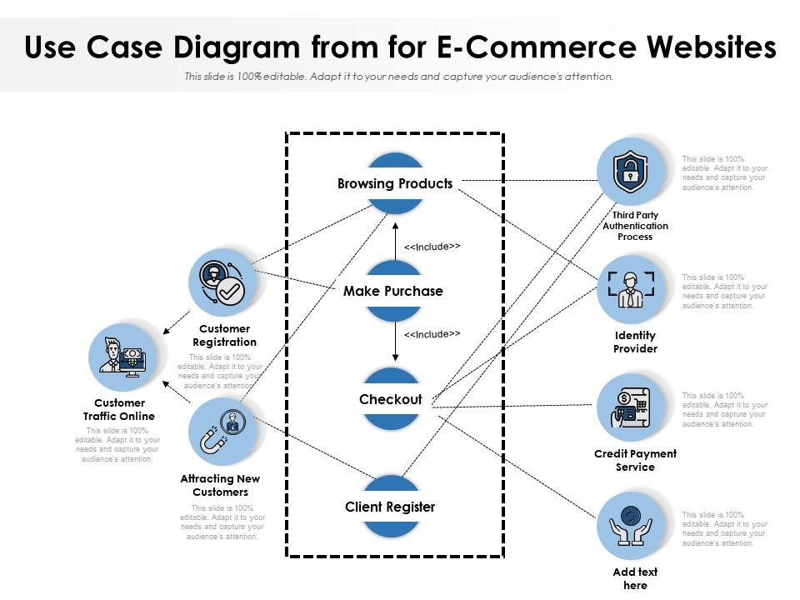g software requirements. It covers various aspects of requirements engineering, including elicitation, analysis, specification

* + - Websites

**Amazon** ([www.amazon.com](http://www.amazon.com/))

**eBay** ([www.ebay.com](http://www.ebay.com/))

# Overall Descriptions

## Product Perspective

# Actors:

# 1. Customer: Represents the primary users of the e-commerce platform who browse, search, and make purchases.

# 2. Administrator: Represents the staff or administrators who manage the e-commerce system, including adding products, managing orders, and handling customer support.

# - The Customer can initiate all the customer-related use cases.

# - The Administrator can initiate all the administrator-related use cases.

# This is a simplified representation, and in a real-world scenario, there could be more actors, use cases, and interactions involved. Use case diagrams provide a high-level view of system functionality and help in understanding how users interact with the e-commerce system.



## Product Function

## Product functions in an e-commerce context refer to the features and capabilities that an e-commerce platform offers to enable the buying and selling of products online. These functions are essential for the platform to provide a seamless and efficient shopping experience for both customers and sellers. Here are some key product functions in e-commerce:

## 1. Product Listings: The ability to display products for sale, including detailed product descriptions, images, prices, and availability status.

## 2. Search and Filtering: Robust search functionality and filtering options to help customers find products based on keywords, categories, price ranges, brands, and other criteria.

## 3. Product Details: Detailed product pages with information such as product specifications, reviews, ratings, and related products.

## 4. Shopping Cart: A virtual shopping cart where customers can add, view, and manage the products they intend to purchase.

## 5. Checkout Process: A streamlined and secure checkout process that includes options for shipping, payment, and order review.

## 6. User Accounts: User registration and account management to store customer information, order history, and preferences.

## 7. Inventory Management: Tools for sellers to manage their product inventory, including tracking stock levels, restocking notifications, and managing product variations (e.g., sizes, colors).

## 8. Payment Processing: Integration with various payment gateways to facilitate secure and convenient payment transactions.

## 9. Order Tracking: The ability for customers to track the status of their orders in real-time and receive notifications about order updates.

## 10. Wishlists and Favorites: Features that allow customers to save products for future reference or easy access.

## 11. Product Reviews and Ratings: Customer-generated reviews and ratings to help others make informed purchase decisions.

## 12. Recommendation System: Product recommendation algorithms that suggest relevant products to customers based on their browsing and purchase history.

## 13.Returns and Refunds: A process for initiating returns and refunds, including clear policies and guidelines for customers and sellers.

## 14. Product Comparison: Tools that enable customers to compare multiple products side by side based on features, prices, and specifications.

## 15. Product Availability Alerts: Notifications to inform customers when out-of-stock products become available again.

## 16. Multilingual and Multi-currency Support: The ability to cater to international customers by supporting multiple languages and currencies.

## 17. Mobile Responsiveness: Ensuring that the platform is accessible and user-friendly on mobile devices through responsive design or mobile apps.

## 18. Security Features: Robust security measures to protect customer data and financial transactions, including SSL encryption and fraud detection.

## 19. User Support: Access to customer support channels, such as chat, email, or phone, to address inquiries and issues.

## 20. Seller Tools: Tools and dashboards for sellers to manage their product listings, orders, and customer interactions.

## These product functions are essential for creating a successful and competitive e-commerce platform that meets the needs of both customers and sellers, ensuring a positive and efficient shopping experience.

## 2.3 User Classes and Characteristics

## In e-commerce, there are two primary user classes: customers and administrators.

## 1. Customers: They are the end-users of the platform, seeking to buy products or services. Characteristics include the need for a user-friendly interface, product search and comparison features, secure payment options, and access to order tracking.

## 2. Administrators: They manage the e-commerce system. Admins require functionalities like product management (add, edit, delete), order management, user account management, and analytics tools for monitoring sales and website performance.

## Both classes demand a seamless, secure, and responsive platform, but their specific needs and interactions differ, highlighting the importance of catering to their distinct characteristics for a successful e-commerce operation.

## Operating Environment

The product will be operating in windows environment. The Library Management System is a website and shall operate in all famous browsers, for a model we are taking Microsoft Internet Explorer,Google Chrome,and Mozilla Firefox.Also it will be compatible with the IE 6.0. Most of the features will be compatible with the Mozilla Firefox & Opera 7.0 or higher version. The only requirement to use this online product would be the internet connection.

The hardware configuration include Hard Disk: 40 GB, Monitor: 15” Color monitor, Keyboard: 122 keys. The basic input devices required are keyboard, mouse and output devices are monitor, printer etc.

## Requirement

Software Configuration:-

This software package is developed using react as front end which is supported by sun micro system. Postgresql as the back end to store the database.

Operating System: Windows NT, windows 98, Windows

Front end:react

Back end:spring boot

Database:Postgresql

Hardware Configuration:- Processor: Pentium(R)Dual-core CPU Hard Disk: 40GB

RAM: 256 MB or more

## Data Requirement

In e-commerce, data requirements encompass the information necessary to operate, optimize, and enhance the online shopping experience. This includes product data with descriptions and prices, customer information for personalization, order records for tracking and processing, inventory details for stock management, transaction data for payments, website analytics to understand user behavior, user interaction data to improve usability, reviews and ratings for social proof, shipping and logistics data for efficient delivery, and marketing data for targeted campaigns. Properly managing and analyzing these data types is essential for e-commerce success, enabling businesses to make informed decisions and provide a seamless shopping experience.

# External Interface Requirement

## 3.1`GUI

The software provides good graphical interface for the user and the administrator can operate on the system, performing the required task such as create, update, viewing the details of the book.

* + 1. It allows user to view quick reports like Book Issued/Returned in between particular time.
    2. It provides stock verification and search facility based on different criteria.
    3. The user interface must be customizable by the administrator

All the modules provided with the software must fit into this graphical user interface and accomplish to the standard defined

* + 1. The design should be simple and all the different interfaces should follow a standard template
    2. The user interface should be able to interact with the user management module and a part of the interface must be dedicated to the login/logout module

# 3.System Features

E-commerce systems require a range of features to facilitate online buying and selling. These include product listings with detailed descriptions and images, user-friendly search and filtering options, secure and streamlined checkout processes, customer account management, order tracking, inventory management, multiple payment options, robust security measures, product reviews, recommendation engines, mobile responsiveness, multilingual support, and analytics tools for data-driven decision-making. These features collectively create a seamless and convenient shopping experience for customers while enabling effective product management and sales for businesses operating in the e-commerce space.

# Other Non-functional Requirements

## Performance Requirement

# Performance requirements in e-commerce are critical for ensuring a smooth and responsive user experience. These include fast page loading times (typically under 3 seconds), high system availability (ideally 99.9% uptime), efficient search functionality, quick checkout processing, secure and rapid payment processing, scalability to handle traffic spikes, low latency in real-time order tracking, and reliable inventory management. Additionally, mobile responsiveness is vital, with the site performing well on various devices and browsers. These requirements collectively enhance user satisfaction, reduce bounce rates, and optimize sales conversion, contributing to the success of an e-commerce platform.

## Safety Requirement

## Safety requirements in e-commerce are critical to protect customer data and ensure secure transactions. These include implementing SSL encryption for data transmission, complying with data protection regulations (e.g., GDPR), safeguarding payment information, regularly updating security patches, employing firewalls and intrusion detection systems, monitoring for suspicious activities, providing secure authentication methods, conducting vulnerability assessments, and ensuring robust password policies. E-commerce platforms must also have contingency plans for data breaches, establish incident response protocols, and educate users about online safety. These measures build trust, protect against cyber threats, and maintain the integrity of e-commerce operations.

## Security Requirement

## Security is paramount in e-commerce to protect sensitive customer data and ensure trust. Key security requirements include:

## 1. Secure Sockets Layer (SSL) Encryption: Encrypt data transmission to safeguard payment and personal information.

## 2. Payment Card Industry Data Security Standard (PCI DSS) Compliance: Comply with standards to protect cardholder data.

## 3. User Authentication: Implement strong password policies and multi-factor authentication for user accounts.

## 4. Firewalls and Intrusion Detection Systems (IDS) Employ network security measures to prevent unauthorized access.

## 5. Regular Security Audits: Conduct routine security audits and vulnerability assessments.

## 6. Data Backups: Regularly backup critical data to prevent loss in case of breaches.

## 7. Secure Payment Gateways: Utilize trusted payment gateways with robust security measures.

## 8. User Data Protection: Safeguard customer data, including names and addresses.

## 9. Privacy Policies: Clearly communicate data usage and privacy policies to customers.

## 10. Monitoring and Incident Response: Continuously monitor for threats and have a plan for responding to security incidents.

## Requirement attributes

## E-commerce platforms should prioritize several key attributes to succeed. First, a user-friendly interface is crucial, ensuring easy navigation and seamless transactions. Security measures are paramount to protect sensitive customer data. Robust payment options and a smooth checkout process enhance convenience. Mobile responsiveness is vital as more users shop via smartphones. A wide product catalog and effective search functionality aid in product discovery. Customer reviews and ratings foster trust and informed choices. Personalization through data-driven recommendations boosts engagement. Efficient order management and reliable shipping are essential for customer satisfaction. Lastly, responsive customer support ensures assistance when needed, enhancing overall user experience.

## Business Rules

## 

## E-commerce business rules are foundational guidelines for successful online operations. They dictate pricing strategies, product categorization, and inventory management. Return and refund policies must be clearly defined. Shipping and delivery terms, including costs and timeframes, need transparency. Data privacy and security measures protect customer information. Marketing rules cover promotions, email campaigns, and customer targeting. Payment processing rules ensure secure transactions. Customer engagement rules encompass communication channels and responsiveness. Compliance with legal and regulatory standards is essential. These rules collectively create a framework for ethical and efficient e-commerce operations, fostering trust and loyalty among customers while driving business growth.

## User Requirement

## User requirements in e-commerce are critical for a satisfying online shopping experience. Users demand a user-friendly interface for easy navigation, a secure and seamless payment process, responsive customer support, and efficient order tracking. They expect a diverse product selection, detailed product information, and user reviews for informed decisions. Personalization, including tailored recommendations, enhances user engagement. Mobile compatibility is vital for convenience. Clear return and refund policies, transparent shipping costs and times, and data privacy assurances build trust. Effective search and filtering options simplify product discovery. Overall, meeting these user requirements ensures customer satisfaction and loyalty in the competitive e-commerce landscape.

# Other Requirements

## Data and Category Requirement

## Data and category requirements are vital for efficient e-commerce operations. Data encompasses product information, pricing, customer details, and transaction history. It must be organized, accurate, and easily accessible. Categories and product taxonomy help users find items swiftly. They should be intuitive and well-structured, allowing for easy navigation and filtering. Categories must align with customer preferences, adapting as trends evolve. Accurate categorization aids search functionality and enhances the overall shopping experience. To ensure success, e-commerce businesses must continually update and maintain both data and categories to stay competitive and meet user expectations.

## Appendix

A: Admin, Abbreviation, Acronym, Assumptions; B: Books, Business rules; C: Class, Client, Conventions; D: Data requirement, Dependencies; G: GUI; K: Key; L: Library, Librarian; M: Member; N: Non-functional Requirement; O: Operating environment; P: Performance,Perspective,Purpose; R: Requirement, Requirement attributes; S: Safety, Scope, Security, System features; U: User, User class and characteristics, User requirement;

## Glossary

The following are the list of conventions and acronyms used in this document and the project as well:

* + 1. Administrator: A login id representing a user with user administration privileges to the software
    2. User: A general login id assigned to most users
    3. Client: Intended users for the software
    4. SQL: Structured Query Language; used to retrieve information from a database
    5. SQL Server: A server used to store data in an organized format
    6. Layer: Represents a section of the project
    7. User Interface Layer: The section of the assignment referring to what the user interacts with directly
    8. Application Logic Layer: The section of the assignment referring to the Web Server. This is where all computations are completed
    9. Data Storage Layer: The section of the assignment referring to where all data is recorded
    10. Use Case: A broad level diagram of the project showing a basic overview
    11. Class diagram: It is a type of static structure diagram that describes the structure of a system by showing the system’s cases, their attributes, and the relationships between the classes
    12. Interface: Something used to communicate across different mediums
    13. Unique Key: Used to differentiate entries in a database

## Class Diagram

A class is an abstract, user-defined description of a type of data. It identifies the attributes of the data and the operations that can be performed on instances (i.e. objects) of the data. A class of data has a name, a set of attributes that describes its characteristics, and a set of operations that can be performed on the objects of that class. The classes’ structure and their relationships to each other frozen in time represent the static model.

