**Prediction Using Unsupervised ML**

**Author: karthika N**

The k-means clustering is one of the method to identify the similar things in the data

**Load datasets**

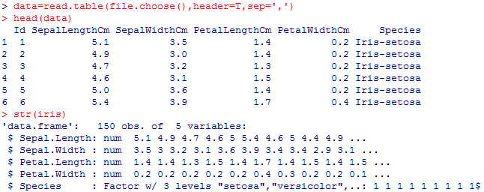

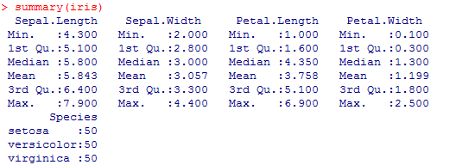

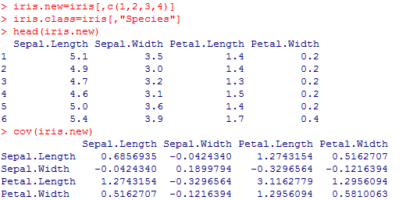

The positive covariance is between petal length and petal width and negative covariance is between petal length and sepal width

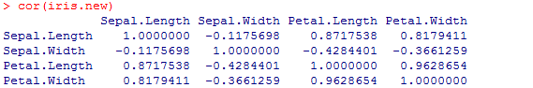

The negative correlation is between petal length and sepal width and positive correlation is between petal length and petal width

K-means clustering alogorithm

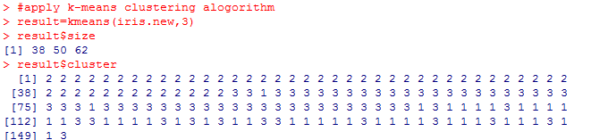

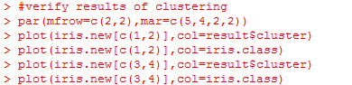

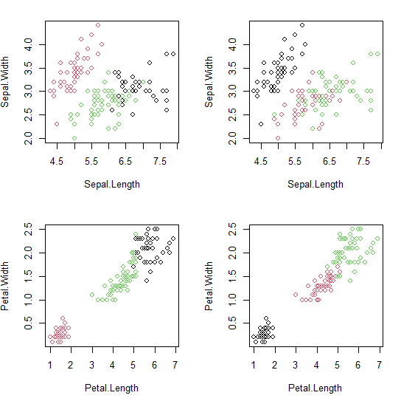



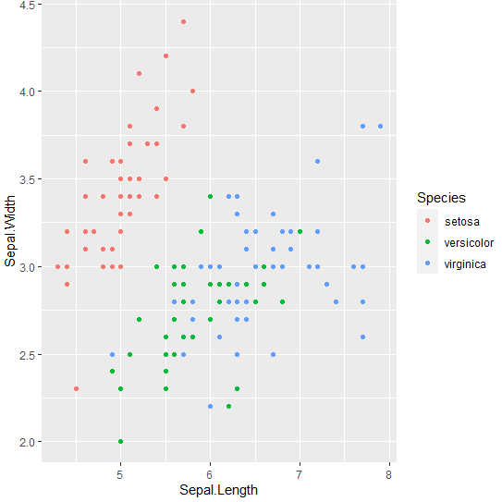

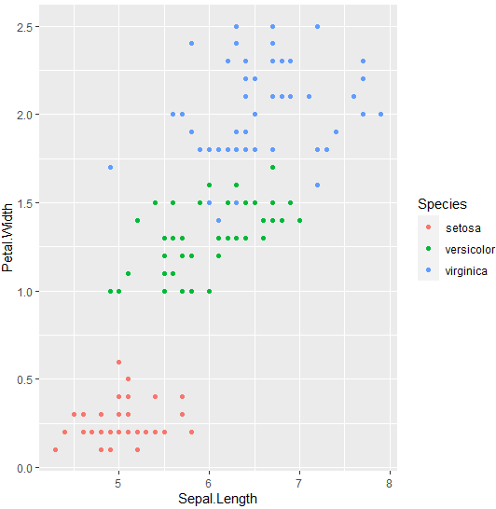**Finding the optium number of clusters using Elbow Method**

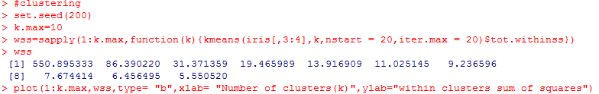

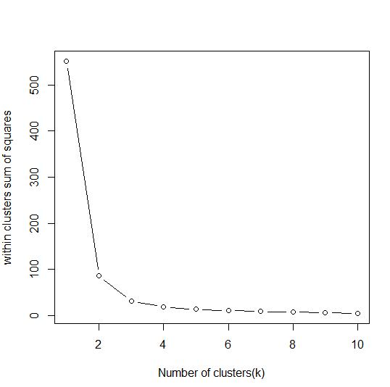

The elbow method from the above graph, the optimum clusters is where the elbow occurs. This is when the within cluster sum of squares (WCSS) doesn't decrease significantly with every iteration. So that we have the optimum amount of cluster and we choose the number of cluster 3