**1. INTRODUCTION**

**ANALYZING THE PERFORMANCE & EFFICIENCY OF THE RADISSON HOTELS USINF DATA VISUALIZATION**

The hotel industry is a broad category of businesses that provide lodging services for travellers and tourists. This can include a wide range of establishments, from luxury resorts to budget-friendly motels, as well as extended stay hotels, boutique hotels, and more. Hotels can be found in nearly every corner of the world, and are often a major component of the tourism and travel industry in a given area. Radisson owns multiple five-star hotels across India.

They have been in the hospitality industry for the past 100 years. Due to strategic moves from other competitors and ineffective decision-making in management, Radisson is losing its market share and revenue in the luxury/business hotels category. As a strategic move, the managing director of Radisson wanted to incorporate Business and Data Intelligence in order to regain their market share and revenue. Our task is to create an analytics dashboard & story to provide them insights to make better business decisions.

**2. Problem Definition & Design Thinking**

EMPATHY MAP

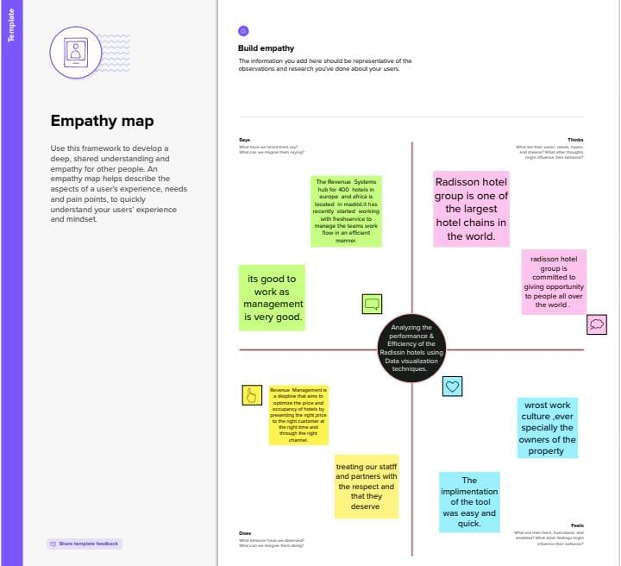

BRAINSTROMING AND IDEA PRIORITAZION

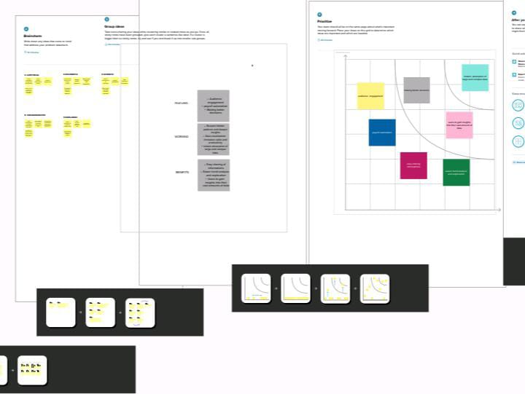

RESULTS

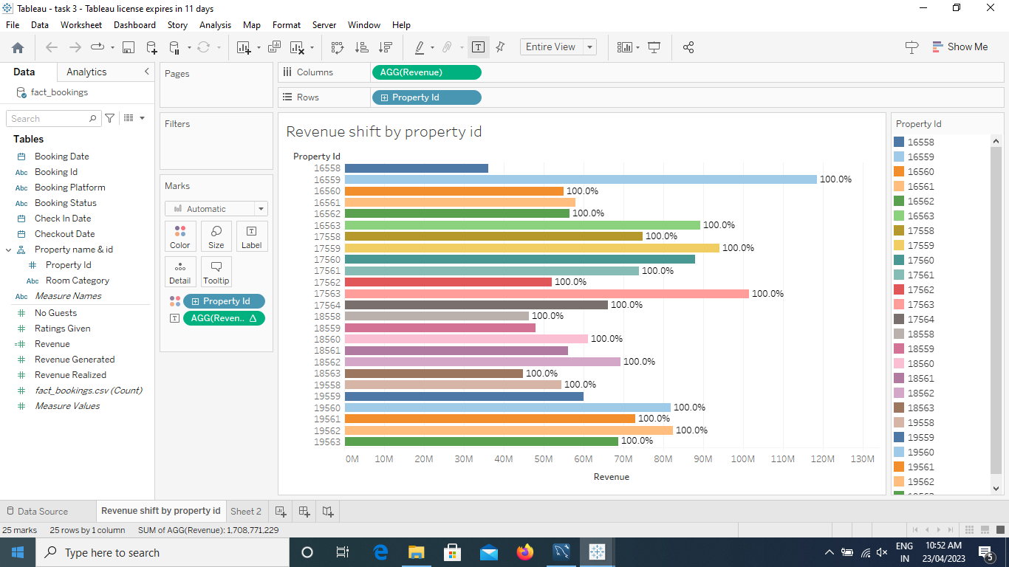

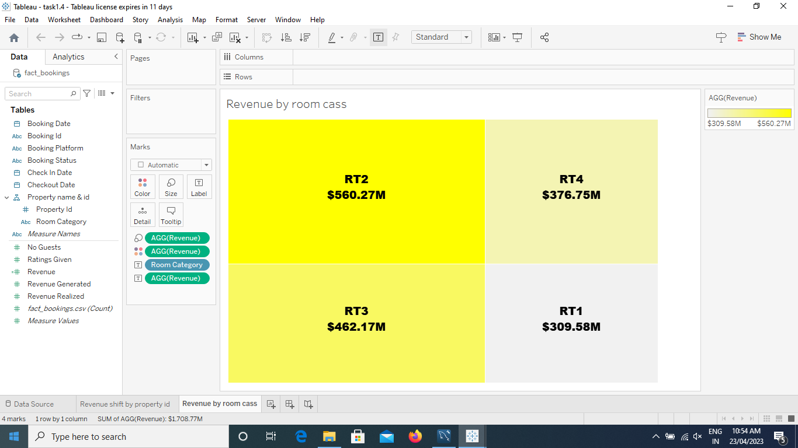

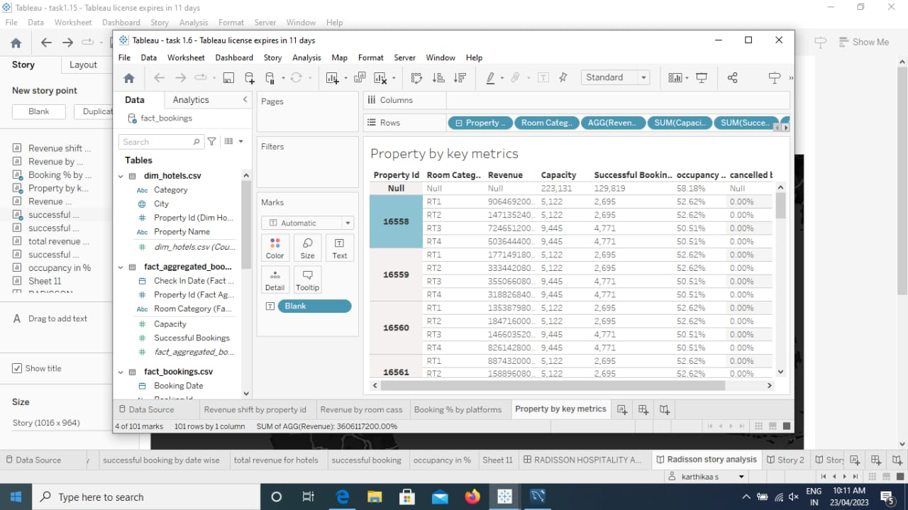

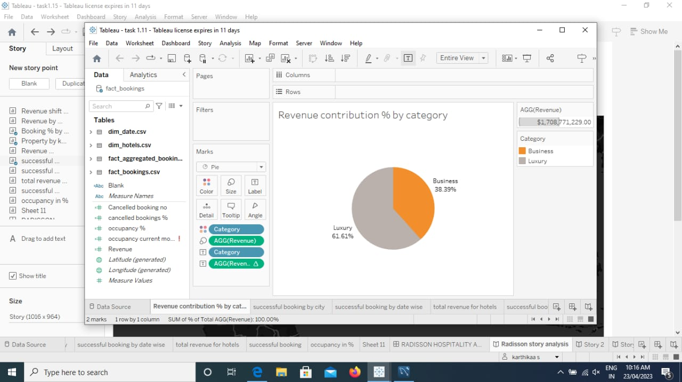

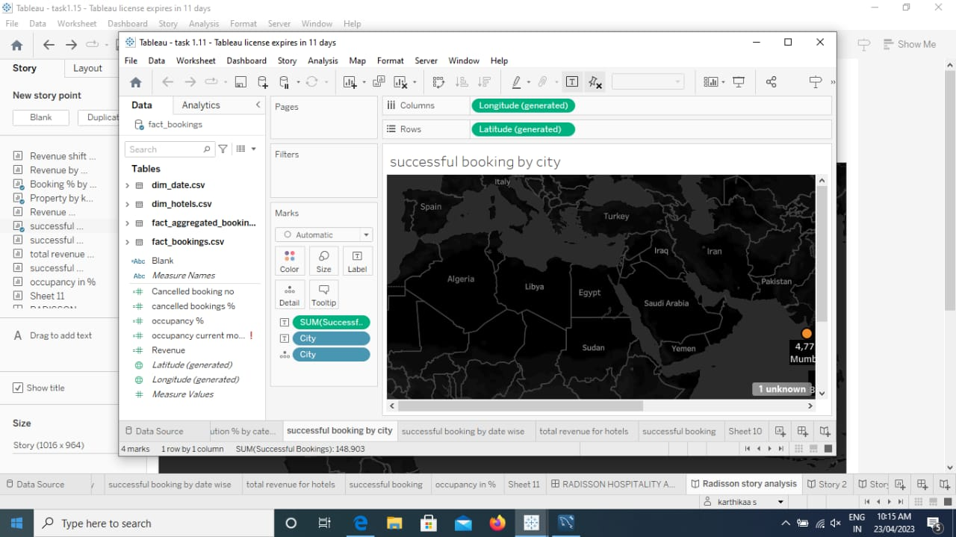

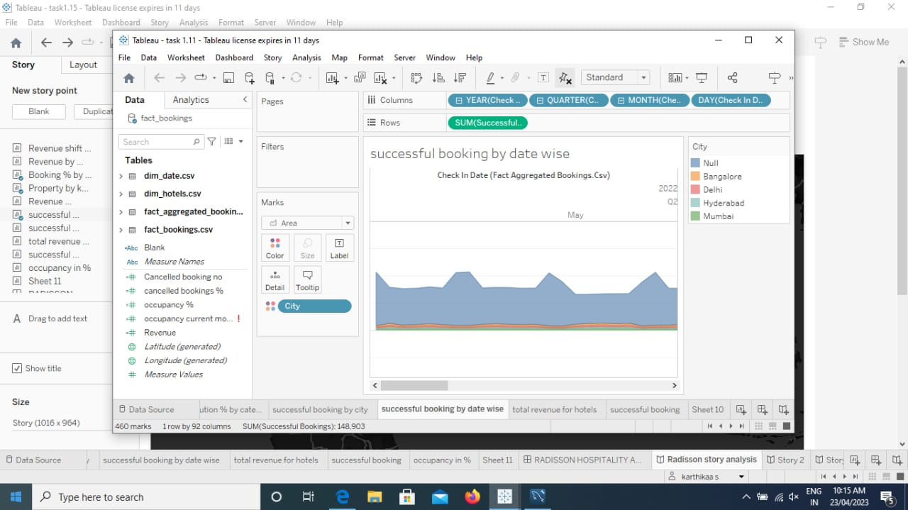

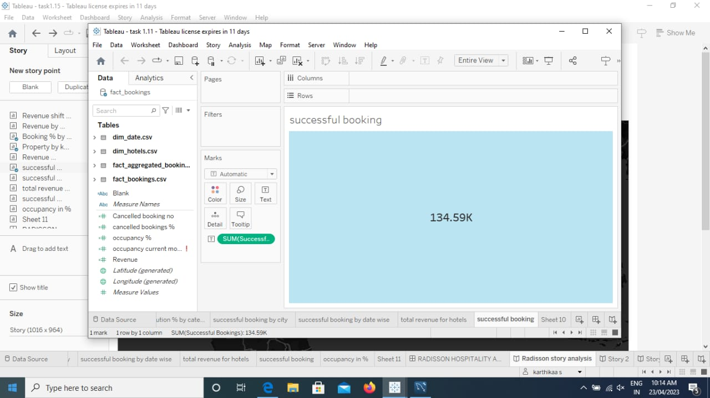

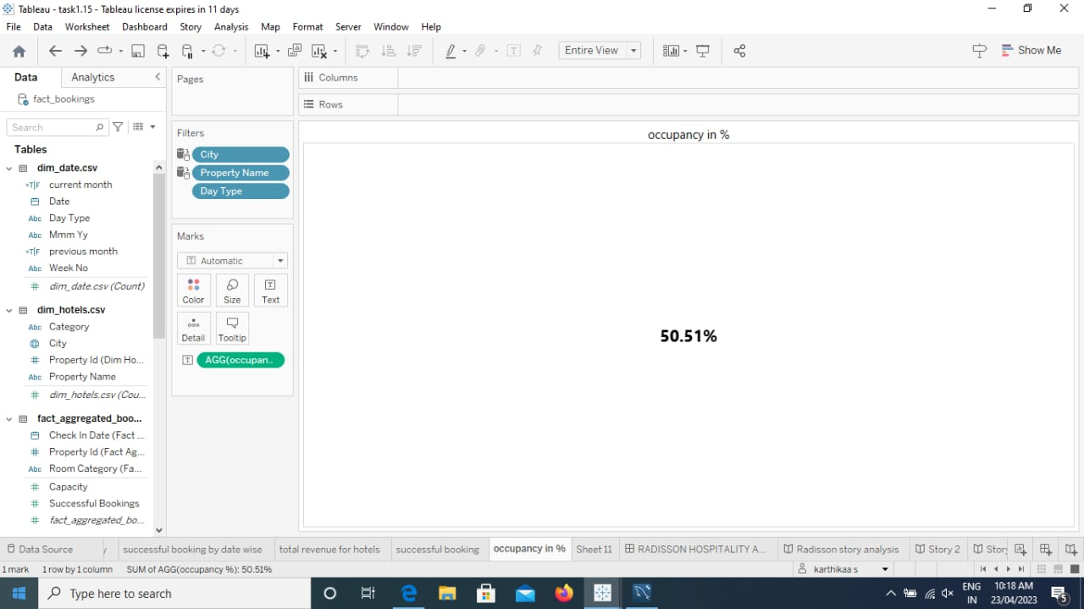

**DASHBOARD**

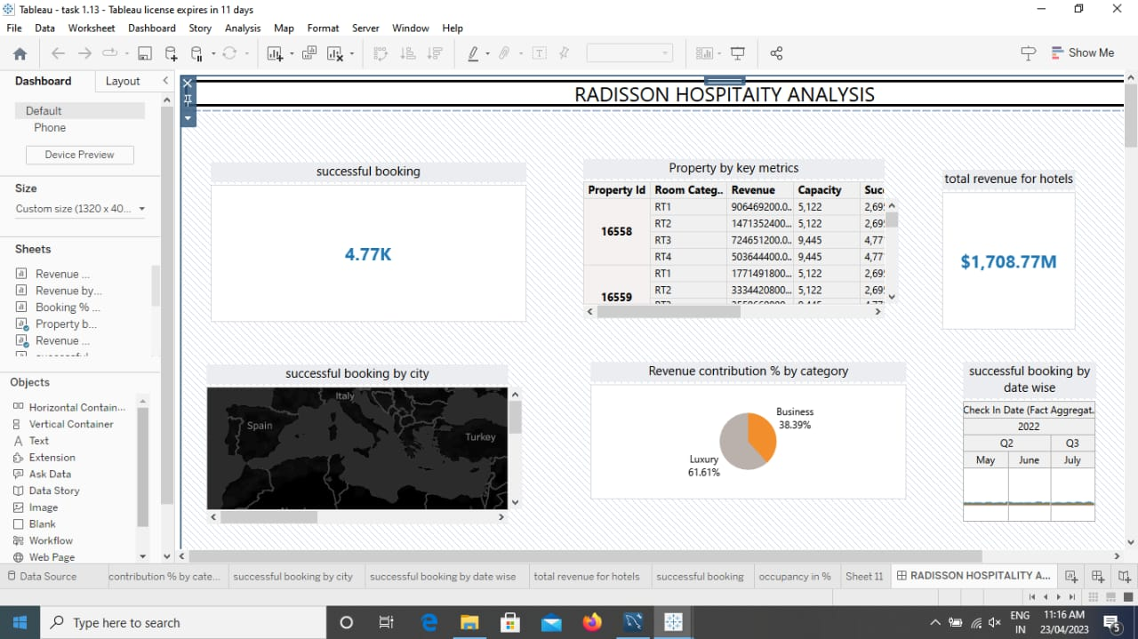

**STORY**

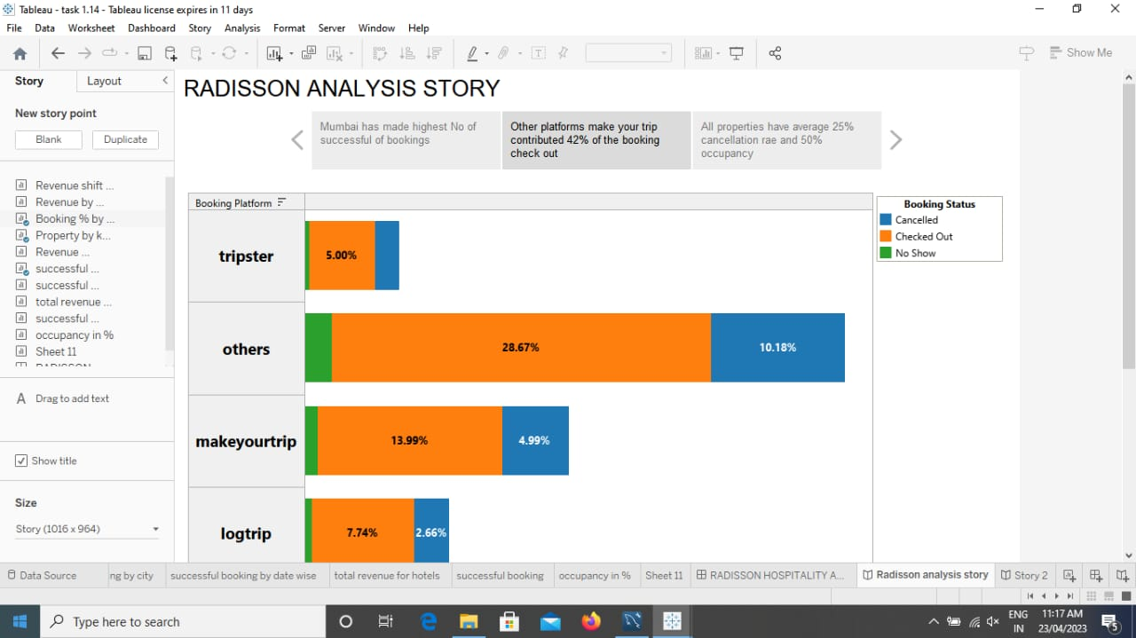

**Advantages of Data Visualization :**

1. **Better agreement**

In business numerous a period it happens that we need to look at the exhibitions of two components or two situations. A conventional methodology is to experience the massive information of both the circumstances and afterward examine it. This clearly will kill a great deal of time.  

1. **A superior method**   
   It can tackle the difficulty of placing the information of both perspectives into the pictorial structure. This will unquestionably give a superior comprehension of the circumstances. For instance, Google patterns assist us with understanding information identified with top ventures or inquiries in pictorial or graphical structures.
2. **Simple sharing of data**   
   With the representation of the information, organizations present another arrangement of the correspondence. Rather than sharing the cumbersome information, sharing the visual data will draw in and pass on across the data which is more absorbable.
3. **Precise investigation**

With the assistance of information perception, it gets more obvious the patterns

hence draws a superior surmising of the information. Accordingly, giving

associations an edge over the adversaries.  

1. **Deals investigation**   
   With the assistance of information representation, a salesman can without much of a stretch comprehend the business chart of items. With information perception instruments like warmth maps, he will have the option to comprehend the causes that are pushing the business numbers up just as the reasons that are debasing the business numbers.  Information representation helps in understanding the patterns and furthermore different variables like sorts of clients keen on purchasing, rehash clients, the impact of topography, and so forth.
2. **Adjustment of information**   
   The solid purpose of information perception is that the information based on which the data is introduced in a visual configuration can be changed or altered along these lines giving a possibility for the business personals to build up a better correspondence with the crowd.

**DISADVANTAGES OF DATA VISUALIZATION**

1. **It gives assessment not exactness**  
   While the information is exact in foreseeing the circumstances, the perception of similar just gives the assessment. It without a doubt is anything but difficult to change over the robust and protracted information into simple pictorial configuration yet such a portrayal of data may prompt theoretical ends now and then.
2. **One-sided**   
   The essential arrangement of information representation occurs with the human interface, which means the information that turns out to be the base of perception can be one-sided. The individual bringing the information for the equivalent may just think about the significant part of the information or the information that requirements center and may reject the remainder of the information which may

prompt one-sided results.  

1. **Absence of help**   
   One of the downsides of information perception is that it can’t help, which means an alternate gathering of the crowd may decipher it in an unexpected way.
2. **Inappropriate plan issue**   
   On the off chance that information perception is viewed as such a correspondence. At that point, it must be certifiable in clarifying the reason. In the event that the plan isn’t legitimate, at that point, this can prompt disarray in correspondence.
3. **Wrong engaged individuals can skip center messages**

One of the issues with information perception is however it could be logical its clearness in clarification is totally subject to the focal point of its crowd.

**APPLICATIONS**

Data visualization allows hoteliers to consolidate information and integrate multiple data sources into one view to easily and efficiently see the relationships between data points. For instance, by examining RevPAR data alongside seasonal data, hoteliers can easily spot trends.

Tableau is basically a data visualization tool which provides pictorial and graphical

representations of data. In Tableau ,you can gain insights that you never thought

possible.You can play with interactive visualizations,deploy data drilling tools and

explore various data that is available and with tableau ,it is all about an easy and

interactive approach.

MySQL is a relational database management system based on SQL Structured Query

Language.The application is used for a wide range of purposes, including data

Warehousing e-commerce,and logging applications.

**CONCLUSION**

From this we can learned briefly about the tableau how can use it and its

Applications .We can understand the team work importance,understanding and

knowledge capacity. We are learned more about Business requirements ,Data

collection,social impacts,SQL operators ,Data preparation,data Visualization and

Dashboard.

**FUTURE SCOPE**

The demand for Data visualization is increasing rapidly and businesses are gaining a

huge advantage since it allows them to get actionable insights in very little time so

Tableau is most used software for data visualization.This Software provides rapid

visualizations and as a result, it helps businesses to make decisions quickly.This

project is very useful to my future courier .So thank you for Naan muthalvan team.

**APPENDIX**

<https://drive.google.com/file/d/1En0I0MRtIbsUaFge7eY2TSqi7PULXAsw/view?usp=drivesdk>

<https://github.com/karthikaa0713/Data-visualisaion.git>