**Docker**

In docker, We need to create container similar to hyper wiser contains VM’s.

In container, we can deploy our application. It will expose the application to outside world. Easily access the application it won’t have any unnecessary packages like OS.

Container only contains the application oriented package(Python,JAVA,nginx,httpd,Ubuntu,centos) related to that package

Docker is lightweight and save the huge cost

Before Docker, Need to know about Hypervisors are helps us to convert physical hardware to multiple Virtual machine(OS).

VMware workstation,oracle virtual box are the softwares to create the multiple VM. These are the hypervisor only.

* Hosted Architecture : Steps – Hardware, Host OS   
  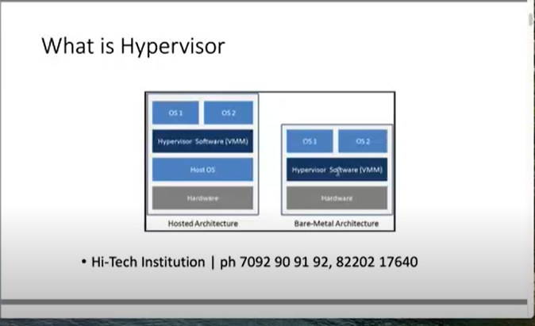
* Bare-metal architecture

In production , Bare-metal architecture reommended.

**Issues with hypervisors** : It involves Lot of cost for RAM,CPU,HDD,OS Licenses. If install VM(Operating System), there will be extra application installed. We are using it or not.It should install automatically. It will require higher hardware.

**Containers** are light weight in size.it doesn’t have extra packages are installed. Hardware->Operating System ->Docker->containers

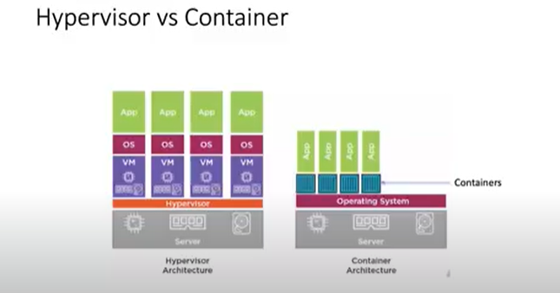

**Steps to connect the EC2 instance for working docker commands**

**Link :** [**https://www.clickittech.com/aws/connect-ec2-instance-using-ssh/**](https://www.clickittech.com/aws/connect-ec2-instance-using-ssh/)

Login with puttygen and convert the file into pem to ppk

Login with putty :

SSH-> Auth -> Credentials -> give the ppk file in private key file for authenticatio

username : ec2-user

Sudo su - converting into root user

Yum install docker

Systemctl status docker

Systemctl start docker

Docker ps -

Docker images

Docker pull centos

docker run -it --name con-1 ubuntu -> IT (interactive terminal)

Google search “Docker hub” and register it. Search for image and download the application

**Docker part2 video**

When you expose the application publicly we need to use port number. If we have multiple container on top of docker.We need to differentiate using port number

**Hosting the web application publically**

1. 1.Create container: docker run -it --name web-app1 -p 8081:80 ubuntu -> 8081for container , 80 for localhost EC2 instance.
2. 2.apt-get update – update the packages
3. apt-get install nginx git –y – install nginx and git
4. service nginx status – check the status of nginx
5. service nginx start – If not running, need to start the nginx
6. Go to EC2 instance security group and add the port 8081(Web app container) and 80 (HTTP)