**Practice Work – 1**

1. Create the following page layout by using *Bootstrap.*

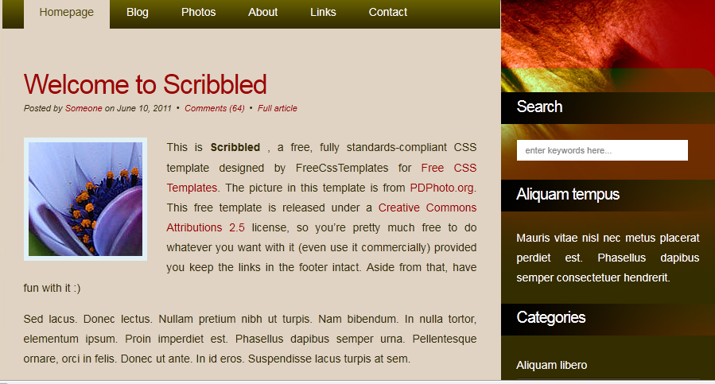

2. For the content area, have one division for the left panel and one division for the right panel and have different background for them. Create two divisions for Links and Main content area within the left panel and have different background for Links section.

3. In your html code, do not use the *table* element for any purpose.

4. Your page should not contain any HTML code that is generated by a web design tool (FrontPage, PageMaker, Dreamweaver and etc.)

**Deliverables:**

1. Snapshot of your web page

2. Html file