**Component name**

### Document Properties

| Item | Details |
| --- | --- |
| Document | Technical Specification Document |
| Application | Coach Mark |
| Author | Karthika Karthikeyan |
| Creation Date | 09/19/2020 |
| Last Updated | 09/19/2020 |
| Status | Completed |

Contents

Document Properties 1

1. Component Overview 3

1.1 Objective 3

1.2 Use Cases 3

2. Technical Specifications 3

2.1 NPM details 3

2.2 NPM repo 3

3.Unit Testing 3

4. Assumptions 3

5. Concerns and Issues 3

1. Component Overview

Coach Mark is used to show hints to the users, which will guide them on the screen

1.1 Objective

Coach Mark are brief hints that guide the users to what they need to do on the app

1.2 Use Cases

User can see the detailed information about the feature that they want to see and proceed on all over the screen which they want to know. It helps teach a new user about the feature.

2. Technical Specifications

Provide detailed technical specifications for required component such as properties used to generate button or any other component.

2.1 NPM details

|  |  |
| --- | --- |
| Package | Version |
| npm install -g @orxe3/cli | V2.0.20 |
| orxe new cw my-project | N.A. |
| orxe generate c coach-mark | N.A. |
| npm install @orxe-components/icon | 1.0.14 |
| npm install @orxe-components/icons | 1.0.9 |
| orxe serve | N.A. |
| orxe test --coverage | N.A. |

2.2 NPM repo

https://packages.common.cnxloyalty.com/repository/npm-group/

3.Unit Testing

The test cases written for orxe-dropdown component it consists two test suites. One is default dropdown axe file and other dropdown spec file. All function and line coverage are done with spec file.

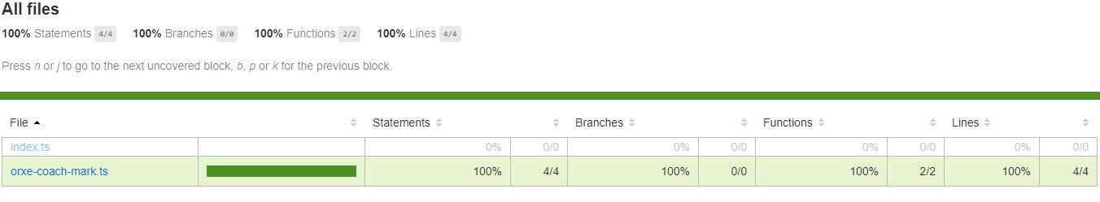

4. Assumptions

This component is developed based on the design guidelines provided by Tavisca on the confluence page.

5. Concerns and Issues

NA.