DARKTRACE 2.0: An Evidence-Preserving, Human-in-the-Loop Platform for Dark Web Threat-Actor Correlation and Authorized Application Security Assessment
Team SIH26151 — Blockchain & Cybersecurity Track
[Author names] · [Institution] · [Email]
Abstract—Investigators of dark web crime face two recurring problems: criminal personas are fragmented across forums, marketplaces and blockchain addresses, and the tooling that exists to connect them rarely preserves evidence or communicates uncertainty. We present DARKTRACE 2.0, a prototype analyst console that unifies (i) multi-signal threat-actor correlation using PGP, wallet, stylometric, infrastructure, temporal and behavioral evidence, fused through an actor graph and a graph-neural-network (GNN) link predictor, and (ii) an authorized dynamic application security testing (DAST) pipeline orchestrated around OWASP ZAP. The design rests on three principles: every relationship is reported as a candidate with a confidence estimate, never as an identity determination; every artifact is recorded in a SHA-256 hash-chained evidence store; and every active action is gated by allowlists, authorization attestation and role-based access control. We describe the architecture, a formal multi-signal fusion model, a weighted character n-gram stylometry method, the evidence-integrity scheme and the safety controls. We then report functional experiments on the implemented components: a 21-pair stylometry test on synthetic posts (mean fused score 71.6% for same-persona pairs versus 45.5% for different-persona pairs), a length-sensitivity and component-ablation analysis, a tamper-detection test of the hash chain, and a 17-host test of the target allowlist that exposed two validation weaknesses. We state plainly which components are implemented algorithms and which are simulated placeholders, and we specify the empirical protocol required before operational use.
Index Terms—dark web, threat-actor attribution, stylometry, blockchain analysis, graph neural networks, OWASP ZAP, digital forensics, chain of custody, responsible AI.

I. Introduction
Illicit activity on Tor hidden services is organized around personas rather than people. A vendor banned from one marketplace commonly reappears under a new alias, reusing a PGP key, a payment wallet, a writing style or a hosting provider. Linking those aliases is central to investigation, yet the evidence is scattered across heterogeneous sources and each individual signal is weak: wallets are shared by services, PGP keys are copied, and writing style is imitable. Analysts therefore spend considerable effort reconciling signals by hand, and the conclusions they reach are only as defensible as the provenance of the underlying evidence.
At the same time, organizations that investigate such actors must also defend their own web applications. Security teams run DAST tools such as OWASP ZAP, but findings, evidence and reports are typically kept in separate systems from threat intelligence, so exposure of an organization’s own assets cannot easily be correlated with the adversary activity that targets them.

A. Problem Statement
Given public or authorized observations of dark web personas, how can an analyst be helped to propose, inspect and confirm candidate links between personas, in a way that (a) combines heterogeneous weak signals, (b) never overstates certainty, (c) leaves a verifiable evidence trail, and (d) coexists safely with active security testing of the analyst’s own applications?

B. Objectives
- Provide a single console for threat-actor intelligence, dark web collection, network telemetry, application security testing and case management.
- Fuse PGP, wallet, stylometric, infrastructure, temporal and behavioral signals into per-pair confidence estimates that are explicitly labeled as candidate relationships.
- Generate unobserved candidate links with a GNN and route every one of them to human confirmation or rejection.
- Record every artifact in a tamper-evident evidence chain and every action in an immutable audit log.
- Constrain active testing and collection with allowlists, authorization attestation, rate and time limits, and role-based access control.

C. Contributions
- A multi-signal correlation framework (Section V) with a formal fusion model, reliability weighting and three-band reporting.
- A hash-chained evidence scheme and case workflow (Section VII) with a demonstrated tamper-detection test.
- An authorized DAST pipeline with twelve stages, eight safety guards and a catalog of 21 OWASP/CWE-mapped finding types (Section VIII).
- Functional experiments on the implemented components (Section X), including a stylometry component ablation and a security review of the target allowlist that found two concrete weaknesses with recommended fixes.
- A safety-by-design posture and an explicit validation protocol (Sections XI and XIII) intended to prevent over-claiming.

D. Paper Organization
Section II reviews related work. Section III states requirements and the threat model. Section IV describes the architecture and data model. Sections V–VIII present the correlation, intelligence, evidence and application-security methods. Section IX covers implementation, Section X reports experiments, Section XI proposes the full evaluation protocol, and Sections XII–XVI discuss ethics, limitations, future work and conclusions.

II. Background and Related Work

A. Dark Web Measurement
Measurement studies of anonymous marketplaces showed that listings, vendor behavior and transactions can be collected from public pages and analyzed longitudinally [1], [2]. Tor itself is a legitimate privacy tool used by journalists, activists and ordinary users [3]; accordingly, our design never treats Tor use as evidence of wrongdoing and restricts collection to public or authorized sources.

B. Blockchain Analysis
Bitcoin is pseudonymous rather than anonymous. Address-clustering heuristics, notably the multi-input co-spending heuristic, can group addresses that are likely controlled by one entity [4], [5]. These heuristics yield probabilistic clusters that can be wrong, for example when custodial services, CoinJoin-style mixing or shared wallets are involved, so cluster membership must be treated as a signal, not as a fact.

C. Stylometry and Cross-Persona Linking
Authorship attribution has long used character n-grams and lexical features [6], [7], and has been shown to scale to large candidate sets under favorable conditions [8]. Work on underground forums specifically demonstrated that stylometry can link multiple accounts of one author across marketplaces [9]. However, attribution accuracy degrades for short texts, and adversarial obfuscation or imitation can defeat standard methods [10]. These findings motivate our use of stylometry as one weighted signal among many, and our explicit length-sensitivity analysis in Section X.

D. Graph Learning for Link Prediction
Graph convolutional, attention and inductive embedding methods [11]–[13] and subgraph-based link predictors [14] allow missing edges to be inferred from structure and node attributes, which suits entity resolution over an actor–artifact graph. A known caveat is that neural scores are frequently miscalibrated [15]; we therefore specify calibration as a prerequisite for presenting GNN output as a probability.

E. Web Application Security Testing
The OWASP Top 10 and the CWE catalog provide the taxonomies used to classify DAST findings [16], [17]. OWASP ZAP offers spidering, passive analysis and active attack modes that can be driven programmatically. Automated scanners are known to produce both false positives and false negatives, which is why every finding in our system is flagged for analyst verification.

F. Evidence Integrity and Access Control
Digital-forensics guidance emphasizes documented identification, collection and preservation of evidence and a demonstrable chain of custody [18], [19]. Cryptographic hashing [20] is the standard mechanism for integrity checking. For access control we adopt role-based access control [21] with JSON Web Tokens for session assertions [22].

G. Positioning
Table I contrasts the typical scope of single-purpose tool categories with the integrated scope targeted here. The comparison is qualitative and describes categories of tooling in general, not specific products.
Table I. Scope of tool categories versus DARKTRACE 2.0
Capability | Blockchain analytics | Stylometry tools | DAST scanners | Case-management | DARKTRACE 2.0
Wallet clustering | Typical | — | — | — | Signal
Stylometric linking | — | Typical | — | — | Signal
Multi-signal fusion | Partial | — | — | — | Yes
GNN candidate links | Varies | — | — | — | Yes (target)
Application DAST | — | — | Typical | — | Yes
Hash-chained evidence | Varies | — | Varies | Varies | Yes (design)
Mandatory human review | Varies | — | — | Varies | Enforced
Safety guards on active actions | — | — | Varies | — | Enforced

III. Requirements and Threat Model

A. Functional Requirements
Table II. Functional requirements
ID | Requirement | Realized in
FR1 | Collect indicators from public or authorized sources with de-duplication and relevance filtering | Dark Web Intelligence, Crawler
FR2 | Score pairwise actor relationships across twelve forensic dimensions | Correlation Matrix
FR3 | Compare text corpora with a stylometric similarity measure | Stylometry Engine
FR4 | Relate wallets to clusters, counterparties and risk indicators | Blockchain Tracer
FR5 | Visualize actors, keys, wallets, domains, posts, evidence and applications as a graph | Actor Identity Graph
FR6 | Propose candidate links and require analyst confirm/reject | GNN Link Prediction
FR7 | Run authorized DAST with live progress and stop control | Application Scanner
FR8 | Map findings to OWASP and CWE with remediation guidance | Vulnerability Findings
FR9 | Maintain cases, evidence records and exportable dossiers | Case, Evidence, Dossier
FR10 | Record every action in an audit log; enforce roles | Settings, Profile, Audit

B. Non-Functional Requirements
- Integrity: evidence tampering must be detectable.
- Accountability: every analyst action is attributable and time-stamped.
- Safety: active operations must be impossible against non-allowlisted or unauthorized targets, regardless of client behavior.
- Transparency: each score shows its supporting signals and its limitations.
- Responsiveness: live scan progress and monitor feeds update without page reloads.

C. Threat Model
We consider four classes of adversary. (1) A deceptive persona operator who imitates another style, copies a PGP key or routes payments through shared wallets in order to induce false links or hide true ones. (2) A malicious or careless insider who attempts to run scans against unauthorized targets or to alter evidence. (3) An external attacker who targets the console or the Scan Manager itself. (4) A well-intentioned analyst who over-trusts a high score. The corresponding mitigations are summarized in Table III.
Table III. Threat model and mitigations
Threat | Consequence | Mitigation
Style imitation or key copying | False link between unrelated personas | Multi-signal fusion; candidate-only labels; human review
Shared wallet or custodial service | Spurious cluster | Cluster confidence; risk indicators; never auto-proof
Out-of-scope scan | Unauthorized testing of a third party | Allowlist; authorization attestation; server-side enforcement
Evidence alteration | Loss of defensibility | SHA-256 hash chain; verification on export
Privilege abuse | Unreviewed export or confirmation | RBAC; audit log; role-limited actions
Over-reliance on scores | Misattribution | Persistent disclaimers; confidence bands; limitations section in dossier
Attack on console or scanner | Compromise of the platform | Scanner not exposed to browser; JWT; rate limits; TLS

D. Out of Scope
The system does not de-anonymize Tor users, does not attempt to locate individuals precisely, does not interact with real hidden services in the demonstration build, and does not claim to establish real-world identity. Geographic displays use generalized regions only.

IV. System Architecture
DARKTRACE 2.0 follows a layered architecture (Fig. 1). A React/TypeScript analyst console communicates with a FastAPI back end over REST and a WebSocket/SSE channel for live events. The back end hosts two pipelines that share a common human-review and evidence layer. Persistent state is split by workload (Table IV).
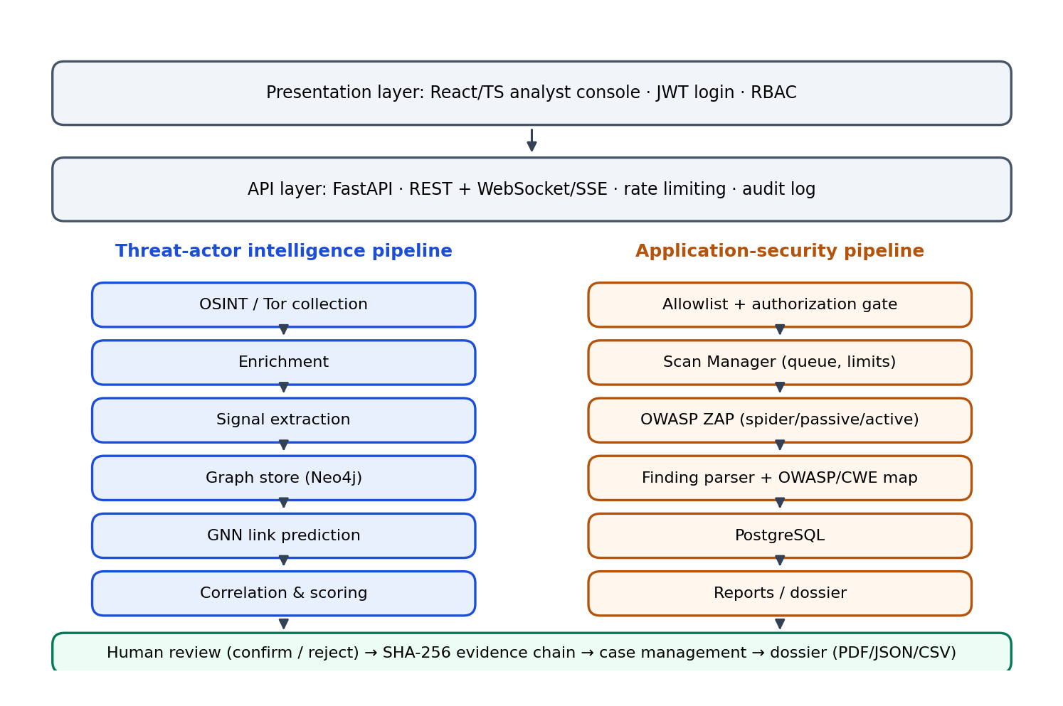
Fig. 1. Layered architecture with the threat-actor and application-security pipelines sharing a human-review and evidence layer.
Table IV. Technology stack
Component | Role
React / TypeScript | Analyst console: 40 or so views, charts, graph canvas, terminal view for scan events
FastAPI | REST endpoints, WebSocket/SSE channel, JWT validation, RBAC, rate limiting
PostgreSQL | Scans, findings, cases, evidence records, audit log, users
Neo4j | Actor identity graph (nodes, typed relationships, candidate links)
Elasticsearch | Full-text index over collected records and posts
Kafka | Event streaming for monitor feed and ingestion pipeline
OWASP ZAP | Spidering, passive and active scanning, driven by the Scan Manager
GNN service | Candidate link prediction over the actor graph

A. Module Catalog
The console groups its views into seven sections (Table V). The grouping mirrors the analyst workflow, from situational awareness through investigation to reporting.
Table V. Console modules
Section | Views
Dashboard | SOC command dashboard; threat intelligence map; actor timeline query
Threat Actor Intelligence | Actor intelligence; behavioral profiler; blockchain tracer; correlation matrix; stylometry engine; actor identity graph
Dark Web Intelligence | Collection center; Tor intelligence; connection scanner; autonomous crawler; hidden service intelligence
Application Security | Scanner; scan history; findings; attack surface; technology fingerprint; security headers; TLS; API security
Network Intelligence | Network nodes; traffic flow; threat intelligence; advanced analytics; pattern recognition; AI predictions; real-time monitor
Investigation | New investigation; case management; evidence chain; intelligence reports; dossier export
System | System health; settings; profile; logout

B. Data Model
The actor graph is heterogeneous (Fig. 2). Node types are Actor, PGP key, Wallet, Domain/IP, Forum post, Evidence and Application. Edges carry a relationship type, a supporting-signal list and a confidence value. Candidate links between actors produced by the GNN form a distinct edge type that is excluded from any export until an analyst confirms it.
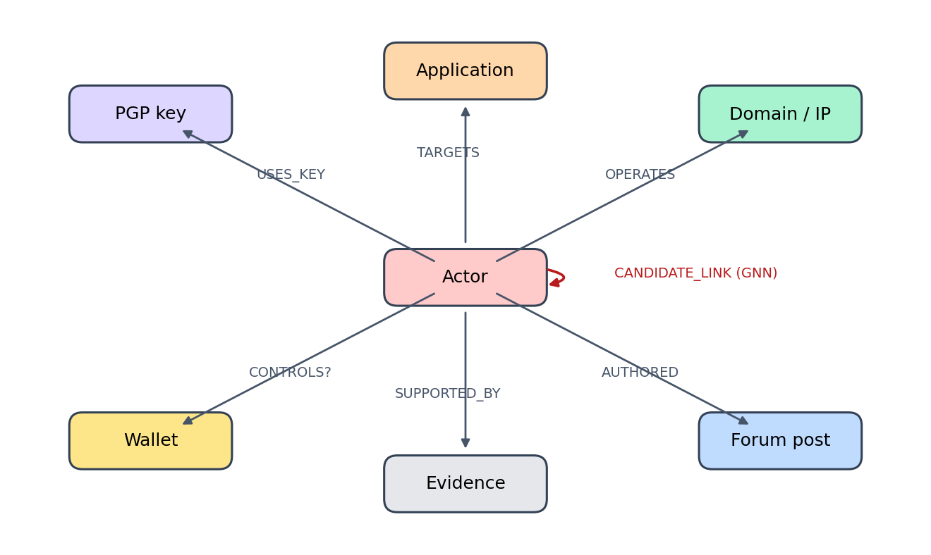
Fig. 2. Heterogeneous actor graph schema. The wallet-control edge is a probabilistic cluster relationship, hence the question mark.

C. Access Control and Audit
Four roles are defined (Table VI). Authentication uses JWT, all analyst actions are written to an audit log, and the Scan Manager enforces limits server-side so that the front end cannot bypass them.
Table VI. Role-based access control
Role | Permissions | Sessions (demo)
Admin | Full control, user management, system configuration | 1
Analyst | Investigations; confirm/reject AI-proposed edges; dossier export | 4
Researcher | Read-only intelligence and graph exploration | 6
Viewer | Dashboard and alert viewing only | 11

V. Threat-Actor Correlation Methodology

A. End-to-End Pipeline
Collected records move through seven stages: OSINT collection, enrichment, signal extraction, graph construction, GNN prediction, correlation scoring and analyst review. Collection is limited to public or authorized sources; duplicates are removed and relevance filtering is applied before indicators enter the graph. In the prototype’s synthetic collection run, 1,247 sources were scanned, 18,642 records collected, 1,980 duplicates removed and 342 new indicators extracted, of which 96 were judged relevant and 58 became evidence items.

B. Evidence Signals
Each actor pair is compared across twelve dimensions. Table VII lists what each dimension captures and the main way it can mislead. The “failure mode” column is a core design input: it determines how much weight the dimension deserves and what disclaimers accompany it.
Table VII. Forensic dimensions and failure modes
Dimension | What is compared | Main failure mode
PGP | Key fingerprints, key reuse across personas | Keys copied or published; reuse by unrelated parties
Wallet | Shared addresses, cluster overlap | Custodial services, mixers, shared wallets
Writing style | Character n-grams, lexical features | Short texts, imitation, translation
Posting time | Hourly activity histogram similarity | Scheduled posts; coincident time zones
Timezone | Inferred UTC offset from activity | Night-shift workers; VPN-independent but weak
Language | Primary language, translation artifacts | Machine translation hides native language
Infrastructure | Hosting, technology stack, uptime patterns | Shared hosting and common software stacks
Domain | Registration, naming patterns | Bulk registrars; templated names
IP pattern | Network ranges, exit/guard overlap | Shared exits; dynamic addressing
Behavior | Dispute handling, escrow use, vocabulary of trade | Community norms shared by many vendors
Pricing pattern | Price anchors, discount frequency | Market-driven prices converge
Operational pattern | OPSEC habits, listing cadence | Copied playbooks

C. Formal Fusion Model
Let a and b be two actor personas and let K = {1,…,12} index the dimensions. For each dimension k an extractor returns a similarity s_{k}(a,b) ∈ [0,1] or reports that the dimension is unavailable. Each dimension has a prior weight w_{k} ≥ 0 and a reliability r_{k} ∈ [0,1] reflecting the quality of the underlying data for this pair (for example, text length for stylometry). With A(a,b) ⊆ K the set of available dimensions, the design-target agreement score is
C(a,b) = Σ_{k∈A} w_{k}·r_{k}·s_{k} / Σ_{k∈A} w_{k}·r_{k} (1)
Normalizing by the available weight prevents missing data from silently lowering the score, while the coverage Σ_{k∈A} w_{k} / Σ_{k∈K} w_{k} is reported alongside C so that an analyst can see how much of the evidence base supports the number. The score is mapped to the three reporting bands
band(C) = likely (C ≥ 0.80) | possible (0.60 ≤ C < 0.80) | weak (C < 0.60) (2)
A calibrated alternative replaces Eq. (1) with a logistic model P(same) = σ(β₀ + Σ β_{k} s_{k}) fitted on labeled pairs; this requires ground-truth data and is therefore listed as future work (Section XV). In either form the output is the probability or agreement that two personas are linked, never that a named individual is responsible.
In the current prototype, the headline figure of 84% for DarkPhantom_v2 and its candidate aliases, the per-signal ratings (PGP high, stylometry high, wallet medium, infrastructure medium) and the pairwise matrix cells are demonstration values. The matrix cells in particular are deterministically derived from the actor names rather than computed from evidence, and must not be read as measurements.

D. Stylometric Similarity
The stylometry engine, which is genuinely computed, takes two text corpora A and B. Both are lower-cased and stripped of characters other than letters, digits and spaces. For n ∈ {2,3} it builds character n-gram frequency vectors and takes their cosine similarity, giving c₂ and c₃. A lexical term captures the difference Δw between the mean word lengths (non-space characters per whitespace-delimited token) of the two texts. The fused score is
S = 0.45·c₃ + 0.35·min(1, c₂) + 0.20·L, L = max(0, 1 − Δw/8) (3)
Scores S ≥ 72% are reported as a likely same-author match, 55–71% as a possible link and lower values as different authors. The weights and thresholds are heuristic defaults. Algorithm 1 gives the procedure.
Algorithm 1. Stylometric similarity
function STYLOMETRY(A, B):
A ← normalize(A); B ← normalize(B) # lower-case, keep [a-z0-9 ]
for n in {2, 3}:
VA ← count_char_ngrams(A, n); VB ← count_char_ngrams(B, n)
c[n] ← dot(VA, VB) / (‖VA‖ · ‖VB‖)
Δw ← | meanWordLen(A) − meanWordLen(B) |
L ← max(0, 1 − Δw / 8)
S ← 0.45·c[3] + 0.35·min(1, c[2]) + 0.20·L
return S, band(S; 72, 55) # likely / possible / different

E. Blockchain Relationship Analysis
For a queried wallet the tracer reports transaction count, first and last activity, number of counterparties, cluster size, number of risk indicators, a cluster-confidence value in [0,1] and the balance. In the synthetic example the wallet shows 127 transactions, 23 counterparties, a cluster of three addresses, two risk indicators and a cluster confidence of 0.84. Each transaction row is tagged with a risk flag. Wallet overlap and clustering are surfaced as candidate relationship signals only. The demonstration build accepts synthetic DEMO-WALLET-* addresses exclusively and rejects real ones, so no real address can be traced from the prototype.

F. Behavioral Profiling
The profiler derives four families of features. (1) Timezone inference from the hourly posting histogram: a peak window of 14:00–22:00 UTC yields an estimate of UTC+1 in the synthetic example. (2) Language analysis: a primary-language estimate with a confidence value (German, 86%) and a warning when machine-translation artifacts are detected, since the author may then not be a native speaker. (3) An OPSEC score from 0 to 100 where lower values indicate more careless operational security (34/100 in the example). (4) A pricing profile: average and range of listing prices (0.30 BTC, range 0.12–0.78 BTC), discount frequency (23%), pricing style (volume seller) and a consistency score (93%). Stable pricing anchors across aliases are treated as a weak linkage signal because vendors often keep psychological price points when rebranding.

G. GNN Link Prediction
Actors, keys, wallets, domains/IPs, posts, evidence items and applications form the heterogeneous graph of Fig. 2. A GNN encoder produces node embeddings from neighborhood structure and node attributes; a decoder scores each unobserved actor pair. In the prototype graph of 1,284 nodes and 3,912 edges, 47 candidate links were generated and 12 were predicted, with a displayed model confidence of 87%. Every predicted edge is tagged “AI prediction — human review required” and exposes confirm and reject actions that are logged. Because neural scores can be miscalibrated [15], the production design calls for temperature scaling or isotonic calibration on a held-out set before any score is shown as a percentage.

H. Analyst Review as a First-Class Step
The workflow is deliberately asymmetric: the system may propose, only an analyst may confirm. Confirmed edges are written to the graph with the analyst’s identity and a timestamp; rejected edges are retained as negative examples so that they can later be used for training and for measuring false-positive rates. The identity card for each actor always states “Real-world identity: NOT ESTABLISHED”.

VI. Dark Web and Network Intelligence Modules

A. Collection and Source Analysis
The Dark Web Intelligence Center runs a collection over public or authorized sources and reports counters for sources scanned, records collected, new indicators, duplicates removed, relevant indicators and evidence items. A public-onion source analyzer extracts metadata only. The interface states that Tor usage itself is never classified as evidence of criminal activity.

B. Tor Integration, Scanner and Crawler
The Tor Intelligence view models a SOCKS5 connection (127.0.0.1:9050) with connect, disconnect and test operations and a session identifier. The connection scanner records, for each target, status, latency, circuit, HTTP status, page title and last-seen time. The autonomous crawler indexes sources by category and last-seen time. In the demonstration build all of these are simulated, and only synthetic demo-*.onion targets are accepted. Connectivity metadata is explicitly labeled as not constituting attribution.

C. Hidden Service Intelligence
For each tracked service the system stores status, 30-day uptime, detected technology, referenced PGP keys, referenced wallets and related actors. These fields feed the actor graph as Domain/IP and Evidence nodes. The interface notes that uptime or technology overlap does not attribute activity to any person.

D. Network Nodes, Traffic and Threat Classification
The Network Nodes view tracks six nodes (four active) with 891 connections and 98.7% average uptime. The Traffic Flow Monitor lists flows with source, destination, protocol, size, duration and a threat status; in the synthetic sample, 4 of 10 flows are malicious with 1 critical alert and 26.25 MB of data. The Threat Intelligence Center summarizes 128 threats in 24 hours, 34 active, 94 blocked and a 2.3 s mean response time, broken down by type: port scanning (45), DDoS (28), malware command-and-control (22) and exfiltration (15). Detection labels are analytical classifications; blocking or quarantine in production requires analyst approval.

E. Analytics, Pattern Recognition and Forecasting
Advanced Analytics reports peak traffic of 3.2K requests/s, a 4.2% threat rate and a 95.8% success rate, with a protocol distribution and top threat sources. Pattern Recognition plots detection patterns by hour for DDoS, scanning, exfiltration and normal traffic on a radar view. The AI Predictions view forecasts traffic with an LSTM [23] over 24-hour, 7-day and 30-day horizons with a 75% confidence threshold, flags high-anomaly points, and compares models. Displayed accuracy (93.7%), MAE (5.0) and RMSE (5.7) are demonstration values; no model was trained or evaluated on real traffic in this work.

F. Real-Time Monitor
A consolidated live feed merges active connections, threat events, application events, scanner events, AI alerts, evidence events and onion-site availability counters. In production this feed would be driven by the Kafka event stream through the WebSocket/SSE channel.

VII. Evidence Integrity and Case Management

A. Hash-Chained Evidence
Each evidence record m_{i} (finding, scan or case identifier, timestamp, target, URL, method, scanner and confidence) is appended to an ordered chain. With h₀ = 0²⁵⁶ and ‖ denoting concatenation, the chain value is
h_{i} = SHA-256( h_{i−1} ‖ m_{i} ), i = 1,…,n (4)
Altering any record m_{j} changes h_{j} and, because each later value depends on its predecessor, every h_{i} for i ≥ j. Verification therefore recomputes the chain in O(n) and reports the first index at which the stored and recomputed values diverge. The pipeline stages recorded for each item are source, collect, normalize, hash, analyze, graph, review and report. Each record also carries an analyst status of pending, verified or rejected.

B. Cases
Cases follow a seven-step template: (1) scope and authorization documented; (2) indicators collected from public or authorized sources; (3) multi-signal correlation; (4) GNN candidate links generated; (5) human analyst review of each edge; (6) evidence chain sealed with hashes; (7) dossier exported as PDF, JSON or CSV. Cases carry an identifier in the DT-2026 series, a priority (low to critical), a lead analyst, the indicator list and a status (open, investigating or closed). The seeded demonstration includes three cases: a cluster review, a pricing-pattern link and an application exposure case.

C. Dossier
The dossier export assembles a numbered, forensic-style report for a scan: executive summary, target scope, authorization, scan configuration, attack surface, technology stack, findings, evidence and further sections, concluding with a limitations section that states that automated findings require analyst verification and that “not detected” never means “completely secure”.

VIII. Authorized Application Security Assessment

A. Orchestration
An analyst submits a target and a profile; the Scan Manager validates the target, queues the job, applies limits and drives OWASP ZAP. The browser never talks to the scanner directly. Results are parsed into findings, stored in PostgreSQL, converted to evidence records and streamed to the interface. Five profiles are offered: passive, standard, deep, API and authenticated. The scan advances through twelve stages (Fig. 3); active DAST (stage 8) is the only intrusive stage and is skipped by the passive profile.
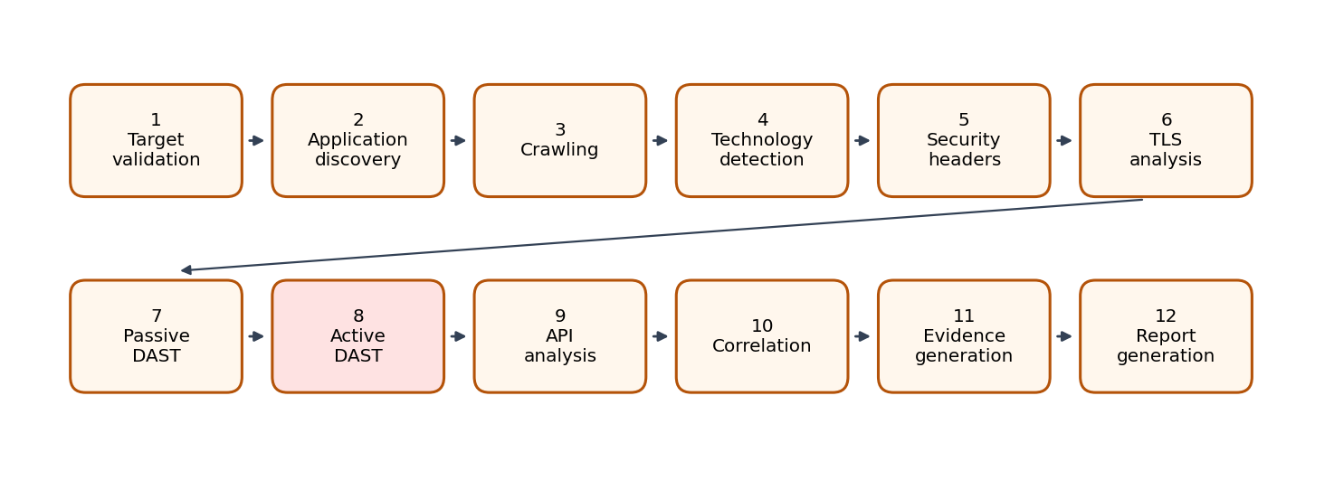
Fig. 3. Twelve-stage scan pipeline. Stage 8 (active DAST) is the only intrusive stage.

B. Safety Guards
Eight guards are enforced by the Scan Manager on every run (Table VIII). The interface also warns that active scanning must not begin unless authorization is confirmed.
Table VIII. Safety controls enforced by the Scan Manager
Control | Purpose
Target allowlist | Only registered hosts; the demo accepts *.example, *.test, *.localhost, loopback and private ranges
Authorization check | Operator must attest ownership or explicit permission; attestation is audit-logged
Rate limit | Bounds requests per second
Scan time limit | Bounds scan duration (minutes)
Maximum crawl depth | Bounds spider depth
Maximum request count | Bounds total requests
Stop button | Operator can pause or stop a running scan
Audit log | Every action recorded immutably

C. Finding Catalog and Classification
The finding catalog contains 21 types, each mapped to an OWASP Top 10 category [16] and a CWE identifier [17] and carrying a description, impact and remediation (Appendix A). By severity the catalog has 2 high, 10 medium, 6 low and 3 informational types. Security misconfiguration (A05) dominates with 8 types, followed by identification and authentication failures (A07) with 3, and injection (A03) and software/data integrity failures (A08) with 2 each. Finding confidence is reported separately from severity. Passive scans draw only from informational, low and medium types.

D. Passive Analyses
The security-header view checks Content-Security-Policy, Strict-Transport-Security, X-Content-Type-Options, X-Frame-Options, Referrer-Policy, Permissions-Policy and Cache-Control and reports each as pass, warning or missing. The technology view lists detected components with a confidence and the evidence observed; versions are shown only when explicitly observed in responses and are never invented. The TLS view reports protocol version, certificate subject and expiry, issuing authority, HTTP-to-HTTPS redirect, HSTS and cipher suite. The API view parses an uploaded OpenAPI/Swagger definition and reports each operation’s method, path, authentication and rate-limit status, together with analytical security observations.

E. Seeded Demonstration Scan
The seeded scan of the fictional host demo-darktrace.example (standard profile) records 142 pages, 1,284 requests, 87 endpoints, 216 parameters, 23 forms, 41 JavaScript resources and 6 authentication routes over 151 s. Detected technologies were Nginx (95%), PHP 8.2 (78%), OpenSSL (86%), JavaScript (99%), React (72%) and FastAPI (81%). The Content-Security-Policy and Permissions-Policy headers were missing, X-Frame-Options and Cache-Control produced warnings, and the TLS handshake was TLS 1.3 with forward secrecy. In the prototype, the findings themselves are drawn at random from the catalog; when connected to the back end the interface is designed to display only the scanner’s own output.

IX. Implementation
The prototype is a single-file web application. Implemented as working client-side logic are: the stylometry engine (n-gram extraction and cosine similarity), target-allowlist validation, authorization gating, role gating, case creation, audit logging, the scan state machine, dossier generation and CSV/JSON export. Charts and the graph canvas are drawn on HTML canvas elements. Simulated are: the Tor connection, collection and crawling, blockchain data, the GNN, ZAP orchestration, forecasting and network telemetry. The login screen provides demo credentials and a guest view-only mode; sessions are held in the browser only.
The back-end contract is specified as a REST and WebSocket surface (Appendix B). Scan lifecycle operations (create, start, pause, stop) are separate from retrieval operations (progress, findings, attack surface, technologies, headers, TLS, evidence, report), so that read-only roles can be granted retrieval without lifecycle control.

X. Functional Experiments
This section reports experiments on the components that are genuinely implemented. They are functional tests on small, synthetic inputs and are not claims about performance on real dark web data. All scripts re-implement the prototype’s own functions, and all numbers below were produced by running them.

A. Stylometry on Synthetic Posts
We wrote seven short synthetic marketplace-style posts representing three personas: A (friendly, em-dash, “Hello friends” register; A1–A3), B (terse formal; B1–B2) and C (informal forum chatter; C1–C2). Persona-internal posts share a register but differ in content words. Each of the 21 unordered pairs was scored with Eq. (3).
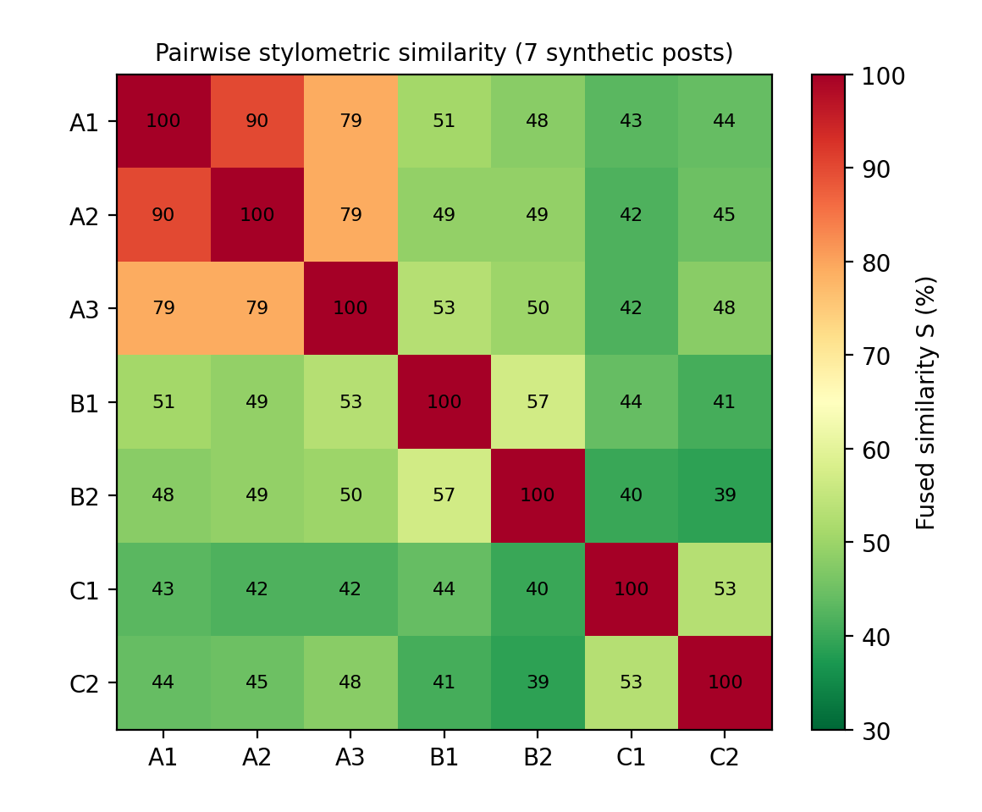
Fig. 4. Pairwise fused similarity S (%) for seven synthetic posts. Diagonal = identical text.
Table IX. Fused score by pair type
Pair type | Pairs | Mean S | Range | Verdicts
Same persona (A–A, B–B, C–C) | 5 | 71.6 | 53–90 | 3 likely, 1 possible, 1 different
Different persona | 16 | 45.5 | 39–53 | 16 different
Identical text | — | 100 | — | likely

Different-persona pairs were never mis-classified above the “possible” threshold (maximum 53), and the three closest same-persona pairs (all within persona A) exceeded the “likely” threshold. Persona B and C pairs, however, fell in the possible or different bands (57 and 53), because their two posts share little vocabulary. This illustrates the main weakness of character n-gram methods on very short texts and supports their use as one weighted signal and not as a sole criterion.

B. Sensitivity to Text Length
We truncated both texts of selected pairs to 40, 80, 120 and 160 characters (Fig. 5). Same-persona scores are stable above roughly 80 characters but the weaker pair (A1–A3) drops from 79 to 64 at 40 characters, falling below the “likely” threshold. Different-persona scores fall toward 28 at 40 characters. Short texts therefore both depress genuine matches and enlarge variance, which is why the reliability factor r_{k} in Eq. (1) should include text length.
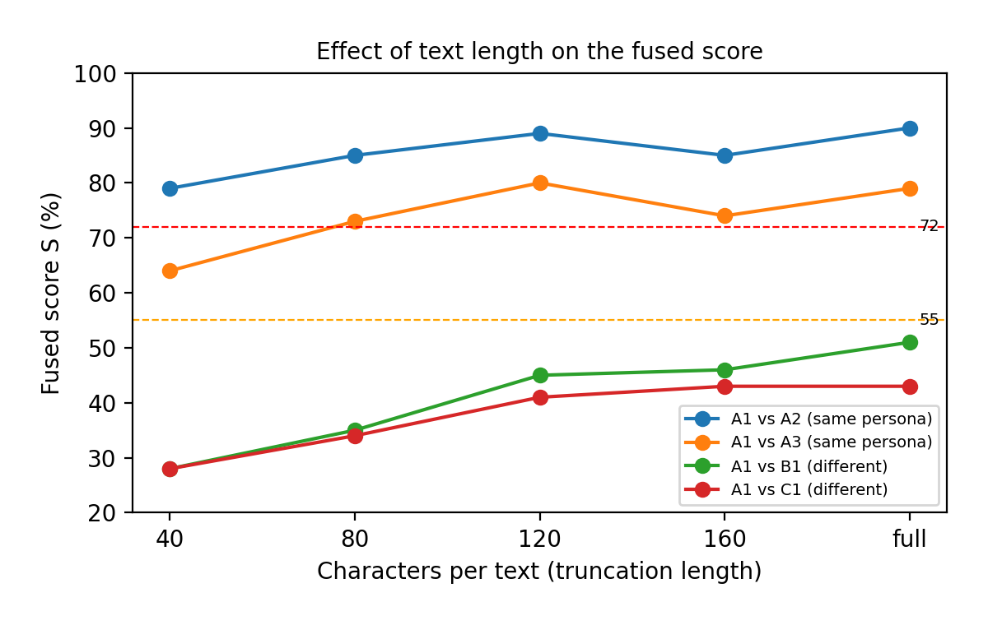
Fig. 5. Fused score as a function of truncation length for two same-persona and two different-persona pairs. Dashed lines mark the 72% and 55% thresholds.

C. Component Ablation
We recomputed the mean scores of same-persona and different-persona pairs using each component alone and in alternative weightings (Fig. 6). The separation (gap) between the two means was 26.1 points for the fused score, 36.6 for trigrams alone, 29.3 for trigram plus bigram with no lexical term, 22.5 for bigrams alone and only 8.9 for the lexical term alone. The lexical term is the least discriminative because mean word length varies little between English texts: its mean was 94.8 for same-persona and 85.9 for different-persona pairs, so including it at weight 0.20 raises every score by a nearly constant offset and compresses the usable range. On this small set, trigrams alone separated the groups best, although the fused score is more tolerant of vocabulary changes. Weights should be learned from labeled data rather than fixed; we make no claim that the present weights are optimal.
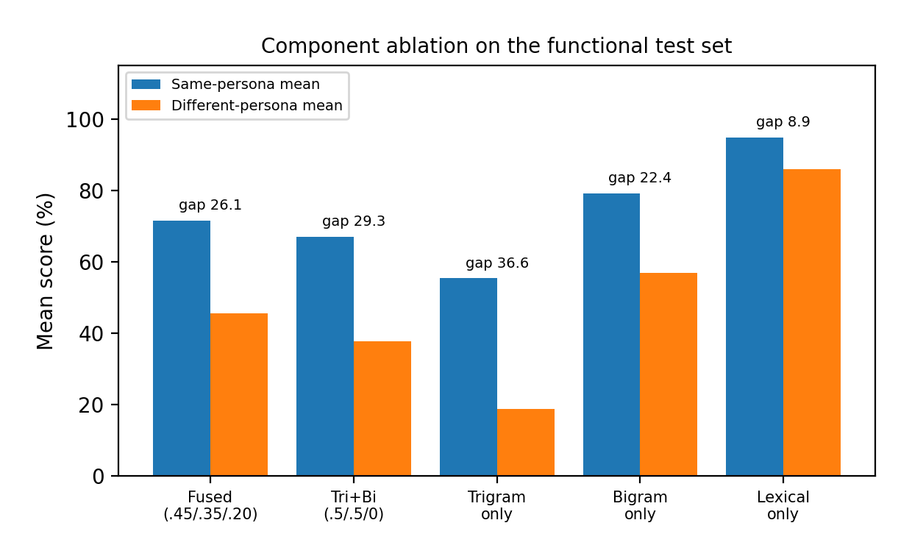
Fig. 6. Mean scores by component configuration; “gap” is same-persona mean minus different-persona mean.

D. Target Allowlist Validation
We ran the prototype’s allowlist predicate on 17 hostnames (Table X). Correct decisions were made for suffix-matched reserved names and loopback, and for public hosts. Two weaknesses were found. First, the private-range test is a prefix match on the hostname string, so DNS names that merely begin with “10.” or “127.” (for example 127.evil.com and 10.example.org) are accepted although they are ordinary domains that could resolve to a third party. Second, the 172.16.0.0/12 block is not covered even though the interface describes RFC 1918 ranges as allowed (the host 172.16.4.2 was rejected). In addition, validation is performed on the name only, with no resolution check, which leaves a DNS-rebinding window, and the suffixes .local and .internal are not guaranteed to be non-routable on every network.
Table X. Allowlist predicate results on 17 hosts
Host | Accepted | Assessment
demo-darktrace.example | Yes | Correct (reserved suffix)
app.test; api.localhost; EXAMPLE.TEST | Yes | Correct (case-insensitive)
localhost; 127.0.0.1 | Yes | Correct (loopback)
10.0.0.5; 192.168.1.20 | Yes | Correct (private IP literals)
172.16.4.2 | No | Gap: RFC 1918 172.16/12 not covered
test.internal | Yes | Acceptable only if truly internal
evil.example.com | No | Correct
example.com; google.com; 8.8.8.8; abc123.onion | No | Correct
127.evil.com; 10.example.org | Yes | Flaw: prefix match accepts public DNS names

Recommended remediation, to be implemented in the Scan Manager: parse IP literals with a proper address library and test CIDR membership; for names, resolve all A/AAAA records and require every address to fall inside registered scope, repeating the check at connection time; and replace pattern-based allowlisting with explicit scope registration backed by proof of ownership such as a DNS TXT record or a well-known file token. These checks must run server-side, since a client-side check can be bypassed.

E. Evidence-Chain Tamper Detection
We implemented Eq. (4) and applied it to five evidence records (EV-1001 to EV-1005) from the seeded scan. We then altered the wording of record 3 (“wildcard” to “permissive”) and recomputed the chain. Chain values for records 1 and 2 matched the originals; those for records 3, 4 and 5 all differed (Table XI). Verification thus localizes the first altered record and shows that all later records depend on it. A limitation is that a chain alone cannot prevent an attacker with write access from recomputing every later hash; production deployment should anchor the latest chain head in an external, append-only store or a public timestamp. The prototype’s displayed evidence hashes are random placeholders and do not implement Eq. (4).
Table XI. Hash-chain verification after altering record 3
Record | Original hᵢ (first 12 hex) | After tampering | Match
1 | 7d3b22567cb6 | 7d3b22567cb6 | Yes
2 | 39badccd6cde | 39badccd6cde | Yes
3 | cd55c26b4fbb | 9ee6e8181729 | No — first divergence
4 | f9dac755649b | c839341949f8 | No
5 | 0fe6eaecf07c | 6180147b0c79 | No

F. Illustrative Prototype Output
Table XII. Illustrative prototype output (synthetic data; not measurements)
Item | Displayed value
Overall multi-signal confidence (DarkPhantom_v2) | 84% (candidate relationship; identity not established)
GNN candidate link, DarkPhantom_v2 ↔ phantom_ops | 87%
Signal ratings | PGP high; stylometry high; wallet medium; infrastructure medium
Prototype graph | 1,284 nodes; 3,912 edges; 47 candidates; 12 predicted
Timezone / language | UTC+1 / German, 86% (machine translation suspected)
OPSEC score | 34/100 (careless)
Pricing profile | 0.30 BTC average; 93% consistency; 23% discounts
Collection run | 1,247 sources; 18,642 records; 342 new; 96 relevant

XI. Proposed Evaluation Protocol
The experiments above verify that components behave as designed. Establishing that the platform is useful and safe requires the following protocol, which we propose but have not executed.

A. Data
- Ground-truth pairs: personas known to be operated by the same person (for example from public law-enforcement disclosures or consented research datasets) and persona pairs known to be distinct.
- Non-adversarial and adversarial subsets: the latter with deliberate style imitation, key copying and wallet sharing.
- For application security: deliberately vulnerable applications with known flaw inventories, run in isolated environments owned by the evaluators.

B. Metrics
Table XIII. Proposed metrics
Area | Metric | Purpose
Pair classification | Precision, recall, F1, ROC-AUC, PR-AUC | Discrimination of each signal and of the fusion
Calibration | Expected calibration error; reliability diagram | Whether 84% means 84%
Link prediction | Hits@k, mean reciprocal rank, AUC | GNN candidate ranking
Robustness | Score drop under imitation, truncation, translation | Adversarial resilience
DAST | True/false positive rate against known inventory | Scanner accuracy
Safety | Out-of-scope request count (target = 0) | Guard effectiveness
Integrity | Tamper detection rate; verification time | Evidence scheme
Human factors | Time to decision; agreement; over-trust rate | Usability and automation bias

C. Baselines and Ablations
Compare the fused model with each single signal, with simple averaging, with a logistic-regression fusion and with the GNN. Perform leave-one-signal-out ablation to measure each dimension’s marginal contribution, and measure performance as a function of text length and graph density.

D. Human-Subject Evaluation
Run a within-subject study in which analysts decide candidate links with and without the tool, measuring accuracy, time and confidence, and specifically whether displayed scores induce automation bias. Include an ethics review before recruiting participants.

E. Threats to Validity
- Label noise: even public ground truth may be wrong or partial.
- Dataset shift: markets and norms change; models trained on past forums may not transfer.
- Selection bias: publicly disclosed cases are those that were solved, and so are easier than the average case.
- Leakage: copied text or shared infrastructure between train and test splits may inflate results.

XII. Discussion
Three observations stand out. First, the stylometry experiments reinforce that no single signal should decide a link: text-based similarity is informative with a few hundred characters but unreliable at tens of characters, and personas with different content words can look dissimilar even when written by one person. The twelve-dimension framing, with reliability weighting and coverage reporting, is a direct response. Second, safety controls are only as strong as their implementation: the allowlist review shows how a small pattern error can silently admit unintended targets, which is why guards belong on the server and should be tested adversarially. Third, usability and honesty reinforce each other: persistent “candidate”, “synthetic” and “human review required” labels cost little interface space yet shape how a score is read.
The integrated design has a further benefit that single-purpose tools lack. Because scan findings are stored as evidence in the same chain and case structure as threat-intelligence signals, an organization can document, in one dossier, both the adversary activity of interest and the exposure of its own applications to it. We have not yet evaluated this benefit empirically.

XIII. Ethics, Legal Considerations and Responsible Use
Attributing activity to individuals carries a risk of serious harm if wrong, including wrongful suspicion, and the same techniques could be misused for surveillance. The design therefore includes the following commitments.
- Candidate language only: no output asserts real-world identity; every identity card states that identity is not established.
- Human decision authority: AI-proposed edges cannot enter exported intelligence until an analyst confirms them.
- Source restriction: collection is limited to public or authorized sources; the demonstration build blocks real onion addresses and real wallets.
- Privacy by generalization: maps show generalized regions, never precise locations of individuals.
- Authorized testing only: DAST requires allowlisting and attestation of ownership or permission; scanning third-party systems without authorization is prohibited and, in many jurisdictions, unlawful.
- Tor neutrality: use of Tor is never treated as an indicator of crime.
- Accountability: all analyst actions are written to an audit log.
Operational use would additionally require legal authority appropriate to the jurisdiction, data-protection and retention policies, independent oversight, and procedures for correcting or retracting erroneous links.

XIV. Limitations
- All demonstration data are synthetic. Several displayed values, including the twelve-dimension matrix scores, the 84% and 87% confidence figures, scan findings, forecasting metrics (93.7% accuracy, MAE 5.0, RMSE 5.7) and network telemetry, are generated placeholders and not the output of validated models. No precision, recall or false-positive rates on real data are reported.
- The GNN, graph database, live Tor connectivity, ZAP orchestration, Kafka/Elasticsearch services and evidence hashing in the interface are architectural targets that are simulated in the front-end prototype.
- The stylometry experiments use seven short synthetic texts written by the authors. They show behavior of the method, not its accuracy on real forum data, and differences between configurations are not statistically tested.
- Stylometric weights and thresholds are uncalibrated and sensitive to text length, language, translation and deliberate imitation.
- Wallet clustering and infrastructure overlap can arise from shared services, producing false links.
- The allowlist weaknesses identified in Section X-D must be fixed before any non-demo use.
- Automated DAST results contain false positives and false negatives and need manual verification; absence of a finding does not imply security.
- A hash chain detects but does not prevent tampering by a party able to rewrite the whole chain.

XV. Future Work
- Build a labeled evaluation set and execute the protocol of Section XI, reporting calibration as well as accuracy.
- Replace heuristic weights with a learned, calibrated fusion model; estimate per-signal reliability weights from data quality.
- Train and evaluate the GNN on real graph data, with ablations by node and edge type and tests of robustness to adversarial edges.
- Fix and formally test the target-allowlist logic; add DNS-resolution and connection-time checks and proof-of-ownership registration.
- Implement the true hash chain with external anchoring, and add signed analyst actions.
- Connect the Scan Manager to a live ZAP instance and measure accuracy on deliberately vulnerable applications.
- Add explainability views that show, for any link, which signals contributed and how reliable each was.
- Conduct a usability and automation-bias study with analysts, and an independent legal and ethics review.

XVI. Conclusion
DARKTRACE 2.0 shows how threat-actor correlation and authorized application security testing can share one console built around uncertainty-aware reporting, mandatory human review and tamper-evident evidence. The functional experiments confirm that the implemented stylometry, hash-chain and allowlist components behave as designed, quantify the sensitivity of stylometry to text length and component choice, and exposed two allowlist weaknesses that we document with fixes. The prototype demonstrates the workflow and safety posture; demonstrating operational value will require the empirical validation outlined in Section XI.

References
[1] N. Christin, “Traveling the Silk Road: A measurement analysis of a large anonymous online marketplace,” in Proc. 22nd Int. World Wide Web Conf. (WWW), 2013, pp. 213–224.
[2] K. Soska and N. Christin, “Measuring the longitudinal evolution of the online anonymous marketplace ecosystem,” in Proc. 24th USENIX Security Symp., 2015, pp. 33–48.
[3] R. Dingledine, N. Mathewson, and P. Syverson, “Tor: The second-generation onion router,” in Proc. 13th USENIX Security Symp., 2004, pp. 303–320.
[4] S. Meiklejohn et al., “A fistful of Bitcoins: Characterizing payments among men with no names,” in Proc. ACM Internet Measurement Conf. (IMC), 2013, pp. 127–140.
[5] F. Reid and M. Harrigan, “An analysis of anonymity in the Bitcoin system,” in Security and Privacy in Social Networks, Springer, 2013, pp. 197–223.
[6] E. Stamatatos, “A survey of modern authorship attribution methods,” J. Amer. Soc. Inf. Sci. Technol., vol. 60, no. 3, pp. 538–556, 2009.
[7] P. Juola, “Authorship attribution,” Found. Trends Inf. Retr., vol. 1, no. 3, pp. 233–334, 2008.
[8] A. Narayanan et al., “On the feasibility of internet-scale author identification,” in Proc. IEEE Symp. Security and Privacy, 2012, pp. 300–314.
[9] S. Afroz, A. Caliskan-Islam, A. Stolerman, R. Greenstadt, and D. McCoy, “Doppelgänger finder: Taking stylometry to the underground,” in Proc. IEEE Symp. Security and Privacy, 2014, pp. 212–226.
[10] M. Brennan and R. Greenstadt, “Practical attacks against authorship recognition techniques,” in Proc. 21st Innovative Applications of Artificial Intelligence Conf. (IAAI), 2009.
[11] T. N. Kipf and M. Welling, “Semi-supervised classification with graph convolutional networks,” in Proc. ICLR, 2017.
[12] W. L. Hamilton, R. Ying, and J. Leskovec, “Inductive representation learning on large graphs,” in Proc. NeurIPS, 2017, pp. 1025–1035.
[13] P. Veličković et al., “Graph attention networks,” in Proc. ICLR, 2018.
[14] M. Zhang and Y. Chen, “Link prediction based on graph neural networks,” in Proc. NeurIPS, 2018, pp. 5165–5175.
[15] C. Guo, G. Pleiss, Y. Sun, and K. Q. Weinberger, “On calibration of modern neural networks,” in Proc. 34th Int. Conf. Machine Learning (ICML), 2017, pp. 1321–1330.
[16] OWASP Foundation, “OWASP Top Ten,” https://owasp.org/www-project-top-ten/.
[17] MITRE, “Common Weakness Enumeration (CWE),” https://cwe.mitre.org/.
[18] ISO/IEC 27037:2012, Guidelines for identification, collection, acquisition and preservation of digital evidence, 2012.
[19] K. Kent, S. Chevalier, T. Grance, and H. Dang, Guide to Integrating Forensic Techniques into Incident Response, NIST SP 800-86, 2006.
[20] T. Hansen and D. Eastlake 3rd, “US Secure Hash Algorithms (SHA and SHA-based HMAC and HKDF),” RFC 6234, IETF, 2011.
[21] D. F. Ferraiolo and D. R. Kuhn, “Role-based access controls,” in Proc. 15th National Computer Security Conf., 1992, pp. 554–563.
[22] M. Jones, J. Bradley, and N. Sakimura, “JSON Web Token (JWT),” RFC 7519, IETF, 2015.
[23] S. Hochreiter and J. Schmidhuber, “Long short-term memory,” Neural Computation, vol. 9, no. 8, pp. 1735–1780, 1997.

Appendix A. Finding Catalog
The 21 finding types available to the scanner module, with OWASP Top 10 category and CWE mapping. Severities are the catalog defaults; real severity depends on context.
Table A1. Finding catalog
Finding | Severity | OWASP category | CWE
Reflected input in response (XSS heuristic) | HIGH | A03 Injection | CWE-79
SQL injection pattern (time-based, passive) | HIGH | A03 Injection | CWE-89
Missing Content Security Policy | MEDIUM | A05 Security Misconfiguration | CWE-1021
Cookie missing HttpOnly flag | MEDIUM | A05 Security Misconfiguration | CWE-1004
Verbose error message | MEDIUM | A09 Logging & Monitoring | CWE-209
Sensitive token in URL | MEDIUM | A07 Identification & Auth. Failures | CWE-598
CORS wildcard origin | MEDIUM | A05 Security Misconfiguration | CWE-942
Outdated client component (jQuery 1.x) | MEDIUM | A06 Vulnerable & Outdated Components | CWE-1104
Session token without rotation after login | MEDIUM | A07 Identification & Auth. Failures | CWE-384
Open redirect observed | MEDIUM | A01 Broken Access Control | CWE-601
Debug endpoint exposed (/debug) | MEDIUM | A05 Security Misconfiguration | CWE-489
SSRF-susceptible fetch parameter | MEDIUM | A10 Server-Side Request Forgery | CWE-918
Missing Strict-Transport-Security | LOW | A02 Cryptographic Failures | CWE-319
X-Frame-Options / frame-ancestors missing | LOW | A05 Security Misconfiguration | CWE-1021
Directory listing enabled | LOW | A05 Security Misconfiguration | CWE-548
Missing X-Content-Type-Options | LOW | A05 Security Misconfiguration | CWE-693
Clickjacking via nested iframe | LOW | A04 Insecure Design | CWE-451
Subresource Integrity absent on CDN asset | LOW | A08 Software & Data Integrity Failures | CWE-829
Server banner disclosure | INFO | A05 Security Misconfiguration | CWE-200
Missing rate limiting (login) | INFO | A07 Identification & Auth. Failures | CWE-770
Source map publicly accessible | INFO | A08 Software & Data Integrity Failures | CWE-200

Appendix B. Back-End API Surface
Table B1. Specified REST and WebSocket interface
Method | Path | Purpose
POST | /api/scans | Create a scan (target, profile, limits, authorization flag)
GET | /api/scans | List scans
GET | /api/scans/{id} | Scan metadata and status
POST | /api/scans/{id}/start | pause | stop | Lifecycle control
GET | /api/scans/{id}/progress | Stage and percentage
GET | /api/scans/{id}/findings | Findings with OWASP/CWE mapping
GET | /api/scans/{id}/attack-surface | Pages, endpoints, parameters, forms
GET | /api/scans/{id}/technologies | Technology fingerprint
GET | /api/scans/{id}/headers | Security header analysis
GET | /api/scans/{id}/tls | TLS observations
GET | /api/scans/{id}/evidence | Evidence records and hashes
GET | /api/reports/{id} | Generated report
WS | /ws/scans/{id} | Live progress and terminal events

Appendix C. Abbreviations
Term | Meaning
DAST | Dynamic Application Security Testing
GNN | Graph Neural Network
OSINT | Open-Source Intelligence
OPSEC | Operational Security
PGP | Pretty Good Privacy
RBAC | Role-Based Access Control
JWT | JSON Web Token
ZAP | Zed Attack Proxy (OWASP)
CWE | Common Weakness Enumeration
TLS / HSTS | Transport Layer Security / HTTP Strict Transport Security
CSP | Content-Security-Policy
SOC | Security Operations Center
MAE / RMSE | Mean absolute error / root mean square error

